Pioneer Sunday
Ideas and Resources for All-Age Worship

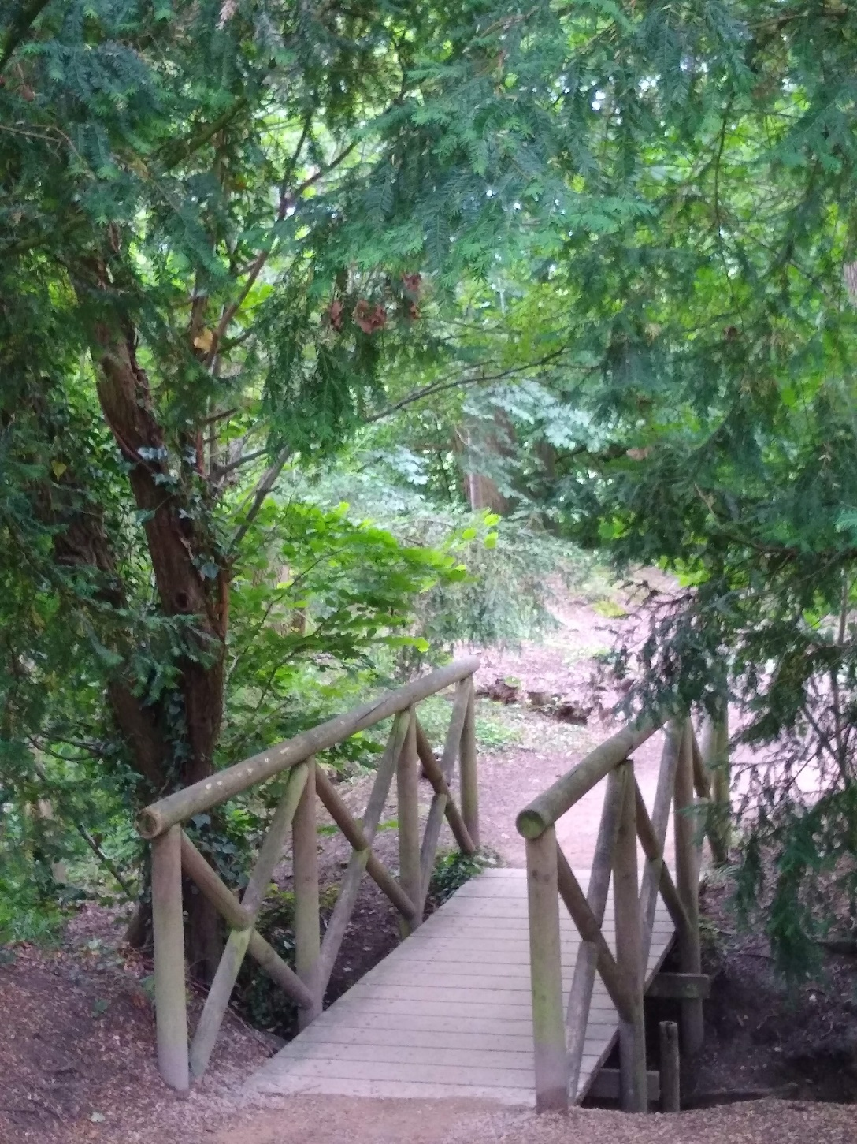

Would you like to hold a Pioneer Sunday in your church?
Then these resources are for you. Don’t worry about the exact date: you are flexible and can organise a Pioneer Sunday whenever it suits you. These special Sundays are not thought of as “fundraising events” but as times of celebration of local Pioneers, moments of reflection on New Places for New People and opportunities to pray together and gather new ideas.
How to use this material
You may use as much or as little of the material as you feel suits your context. There are some general opening questions on pioneering, which you can use with the whole congregation or in small groups.
Thoughts are offered on three Bible passages and All-Age activities are guaranteed to engage everyone – experiment and use the material as you see fit for your context.
Finally, on page 4, you will find links to further resources and addresses.

Contents
Would you like to hold a Pioneer Sunday in your church? 2
Small Group Work 4
Reflections for Small Groups 4
Pioneer Sunday 6
Prayer 6
Preaching Notes and related All-Age Worship Ideas 7
Reflections on Acts 2: The Day of Pentecost 7
All-Age Worship Ideas for Acts 2 10
Reflections on Acts 8: Persecution of the Church 11
All-Age Worship Ideas for Acts 8 12
Reflections on Hebrews 12: Jesus the Pioneer 13
All-Age Worship Ideas for Hebrews 12 14
More ideas to engage your congregation 15
Prayer labyrinth 15
Interview a Pioneer: here are some starter questions: 15
Blessing 15
Links and Addresses 16

Small Group Work

Reflections for Small Groups

Make sure you advertise your Pioneer Sunday well in advance and, if you wish, invite a Pioneer in good time. Think how you can make the day special: why not have a faith tea after the service, or celebrate outside? Below are some ideas for sermons, prayers and reflective activities.

The following areas for discussion and questions are ideal for small group work and can help you to reflect deeper on what pioneering means in your context and to prepare for a Pioneer Sunday in your church.

Pioneering is not new. It is something that God and Christians have been doing for generations. Whilst the word ‘pioneer’ is relatively new, the basic theological thrust is not. It is part of our being. Our desire is always to reach new people with the gospel message.
Are there any legendary (!) stories about how your church was formed? What do these say about the passion and determination of those who have formed churches in the past? How does this challenge us moving forward?
What new people have come to this church in the past decade? Even if a church has not grown, or is facing numerical decline, God can still be reaching new people. Perhaps we can celebrate the good in this?
How did people find their way to church? Can you remember initiatives or projects that attracted new people to your church? Did they move house and found your church?
Has the church opened up a new space or a new place for worship? What kind of “alternative” worship forms are happening in your church (e.g. midweek café service, shoppers’ service etc)
Pioneering as love for the neighbour. Sometimes, pioneering can bear the notion of ‘invasion’ and ‘colonisation’, and we need to steer clear of this understanding. Good pioneering does not ‘headhunt’ members from other churches, but develops new contexts.
Can you find examples of church projects that have grown from nothing that you can explore? Pioneers need to be able to ‘meet people where they are’ and continue to do faithfully the same, albeit with a changing approach, in different places, times, styles etc.
Have you thought of doing a community survey? How would you go about this? What would you like to find out? What could you do with the results?
Pioneering is about mutual learning and engagement. Everyone can be involved in pioneering, even if your local church is not engaged directly in a New Places for New People (NPNP) project.
How could you (as an individual and a group/ congregation) grow through an engagement with a pioneer project? Shaping the idea of an NPNP project or getting directly involved with an existing one will help you reflect on pioneering and will result in mutual learning.
Can you think of examples where older people support younger people, or new people encourage the faithful? Many people can relate positively to how young people teach older generations new things (think about smartphones!). On the other hand, older people offer wisdom and the assurance of stability in a challenging world. NPNP work helps us to see this with fresh eyes.
Pioneering is a necessity, not an option. Historically, for certain groups pioneering has arisen from hostility and persecution, and the need to pioneer has been a matter of life and death.
Are you aware of churches, e.g. in refugee camps, where people have clearly travelled with their faith? You can find references online to churches based in refugee camps. What does this say about how the Christian faith travels?
Pioneering is about building a Christ-centred community. Witnessing in word and action can be a particular challenge for us. Generally, we are excellent at outreach projects but struggle to build worshipping communities.
How can you encourage people to explore discipleship? What could you do as a church or congregation to practice sharing your faith in a non-threatening way?
How do you feel nourished in your discipleship? What excites you about your faith? How could you tell other people about this?
Each person in your group has two minutes to tell about their faith by answering one of the following questions: How have you experienced God in the last week? When did you feel closest to God? At what point in your life did you call yourself a follower of Christ?

Pioneer Sunday

Make sure you advertise your Pioneer Sunday well in advance and, if you wish, invite a Pioneer in good time. Think how you can make the day special: why not have a faith tea after the service, or celebrate outside? Below are some ideas for sermons, prayers and reflective activities.

Prayer
Tent-dwelling God,
We thank you for those among us who are gifted to be pioneers.
Who see opportunity and can encourage others.
Who seek out love in most unlikely places.
Who build community in the midst of loneliness.
Who move and shout and point towards the Kingdom
In big and small acts of prophecy.

Leader: God, you are going ahead of us.
All: Let us take risks and follow you.

We pray for [Name] and their ministry in [place].
Thank you for calling them and guiding them along an unknown path.
Thank you for sustaining them with ideas, inspiration and the motivation to keep going.
Thank you for times of joy and times of challenge, as both are needed for growth.
Thank you for what we can learn from each other
even when we think we know it all.

Leader: God, you are going ahead of us.
All: Let us take risks and follow you.

We ask your blessing on our community – inside and outside of the Church.
Bless those who are lonely or don’t seem to fit in.
Bless families of all constellations and those still in the making.
Bless the triers, the believers, the doubters and the seekers;
Bless the preachers, pastors, and pioneers.
Bless each one of us, and let us hear your call upon our lives.

Leader: God, you are going ahead of us.
All: Let us take risks and follow you.

We ask you to challenge us, God of the Upside-down Kingdom.
Challenge our traditionalism and help us to cherish what is still good.
Challenge our beliefs and help us to live out radical Gospel truths.
Challenge our prejudices and help us to love unconditionally.
Challenge our ideas of fairness and help us fight for justice.

Leader: God, you are going ahead of us.
All: Let us take risks and follow you.

Wherever we go, God, you are ahead of us. We ask you to guide us and help us follow The Way in Christ’s name. Amen

Preaching Notes and related All-Age Worship Ideas
To help you with ideas for a Bible study or sermon during your Pioneer Sunday, we have chosen three pieces of Scripture: Acts 2, Acts 8 and Hebrews 12 – we leave it up to you to select specific verses from these chapters. You might come up with your own choice of Bible passage!

Reflections on Acts 2: The Day of Pentecost
Strangely, whilst the very purpose of Pentecost is to empower early Christians to spread the Good News of Jesus, the pioneering aspects of this are yet to come. The context from which God calls us, and the themes which will drive this change, are evident. There are rich themes for all-age worship engagement, although it is important to look at this passage through the lens of pioneering (hence my preamble to all-age worship).
In Acts 1, Jesus ascends to heaven, and there is no time to waste; ‘“Men of Galilee,” they said, “why do you stand here looking into the sky?” To be fair, what else would you be looking at – there is room for humour here. We then see the vacancy left by Judas’ demise filled, by Matthias. It is a practical response to a practical need. The use of lots is perhaps an antidote to the misnomer that discerning God’s will is easy. There is perhaps something of value in this; one of the inherited understandings of pioneering is that whilst we might not be clear of our destination, we do know about the immediate practical needs to which we must attend (people, resources, policy), and when unsure we seek to simply honour God wherever we find ourselves.
In Acts 2 we read of the coming of the Holy Spirit. I find the nature of the Spirit, and Jesus reference to how the wind blows as it chooses profound, ‘The wind blows where it chooses, and you hear the sound of it, but you do not know where it comes from or where it goes. So it is with everyone who is born of the Spirit.’ John 3:8. Whilst we can plan, Pioneer ministry is equally about seeing where the wind of the Holy Spirit is blowing and responding. It may well be that the window of opportunity for us to encourage someone or follow up on an opportunity to ask for someone’s support or help is narrow. Imagine leaving church longing to be invited to be part of an event about which you had overheard and yet not being asked. Whether our ministry is in new places for new people or established places for established people, there is often a window of opportunity that, if we miss it, will delay our work.
The focus on the visible signs of the spirit (wind, tongues of fire), inevitably leads us to note the importance of us being open to the gifts of the spirit (1 Corinthians 12), and to growing so that we each manifest the fruits of the Spirit (Galatians 5). In terms of pioneer ministry – and of wider church ministry in general – our focus is on being co-creators of spaces where people experience koinonia (a Greek word that features in Acts 2, which reflects a level of sharing and fellowship that is deeper than we find in other community spaces.) This then requires a level of spiritual maturity, in understanding that the Holy Spirit is in us and works through us, that God will give us the gifts we need at any time, and in terms of prophecy (reflecting on Paul’s frustration over how the gift of tongues is valid, yes but foolishly elevated above others), our task is to build each other up.
The gift of tongues here is clearly the ability for one person to speak in the language that another understands (we will leave further exploration of how a ‘tongue’ can also be an ecstatic utterance within prayer for a different time). The crucial point is that language and the ability to spread the message in a way the intended recipient understands is key. Moreover, actions speak louder than words. Crucially, the Day of Pentecost illustrates how the early Christians, (once huddled away in fear of persecution, greeted by Jesus behind locked doors with the words ‘Peace be with you’, but huddled in Jerusalem, become part of a movement that travels across the globe. After the day of Pentecost, they are given boldness.
Sadly, the reference to those who experience this move being labelled as ‘drunk’ is a clear record of how some could not recognise this move of the Holy Spirit or sought to discredit it deliberately. Peter’s words to the crowd serve as both a rebuttal to this and a word of teaching to the audience. You will prophesy, you will dream, you will see visions, you will experience great things, and God will redeem those who seek Him. Notice how this is an intergenerational move of the Holy Spirit. In his retelling, Luke (the author of Acts) emphasises that a faithful retelling of the life of Jesus leads to this mass following and leads to people requesting baptism. 3,000 in one day.
Perhaps one reflection from this is that what starts in an Upper Room – for equivalent’s sake, we might say 'a prayer meeting’ – spills onto the street and becomes uncontrollable in human terms. Do not be surprised when this happens. Another helpful reflection might be that whilst the disciples expect something – Jesus commands that they stay in Jerusalem until he comes in power – no one can realistically envisage what this is. (Acts 1:4). Another would be that if you are not outside (in a spiritual sense), you are not in the right place.
One further helpful point of reflection that can encourage believers and churches to revisit how they are living is to follow the tried and tested exploration of Acts 2:42-47 that appeared within the Mission Shaped Ministry course offered by Fresh Expressions (which still exists). Congregations may do well to ask themselves:
- What do the early believers do?
- What do we do?
- What do the early believers that we do not do?
- What do we do that they do not do?
Hence whilst this passage does not appear to be pioneering initially, it lays the foundation for the faith carried when the diaspora hits the early church and Christians flee persecution. However, the above reflection, coupled with the broader examination of Acts 2, may lead churches to question:
- Whilst we attend to practical matters, to what extent are we open to the work of the Holy Spirit and opportunities to respond in mission when they arise?
The desire to build a community where Christian fellowship (which runs deeper than other forms of social meeting) exists. Whilst we are excellent at reaching out and meeting practical needs as a Church, we may struggle more with building worshipping congregations.
The focus on tongues here highlights the importance not just of communicating well (and being clear about the core belief of our trusting Jesus as Lord and embracing the death and resurrection of Christ), but the struggle of engaging cross-culturally. We need pioneers to help us do this.
The experience of Pentecost is a timely reminder that we can never predict what God will do. It is refreshing because what happens inside a small room can spill out into the marketplace.

The reflection on Acts 2:42-47 gently reminds churches to question how Christ-centred they are and opens up a healthy dialogue about why we do some things that we do not really need to be doing and why we are not doing other things we should. This needs careful guidance (lest we oversell the option of selling our homes - if we are a homeowner - and our possessions to sustain the ongoing work of the Church). It does need putting into context (against, for example, Paul’s mention of wider collections being made for the work of the churches. However, this exercise, especially in a group setting, may uncover a sense of holy disquiet with some about what is holding them back. This could be fruitful beginnings for an ongoing dialogue over New Places for New People and Pioneer Ministry.

This Photo by Unknown Author is licensed under CC BY-NC-ND

All-Age Worship Ideas for Acts 2
- The birthday of the Church is being celebrated across the world!
  - Material needed: cake, a map of the world, and buttons or pins: Display the map visibly in the church and ask the congregation to place a button/ pin on the country where they have met other Christians. Ask them to pray for this country. Those countries that have not been marked: can people find something on the internet about the Church there? Finish this activity by eating birthday cake together.
- God calls us to love all people, including those different from us. Encourage the congregation to think of differences between people. Discuss who sets the norms – who decides what is “normal”, “healthy”, or “desirable”. What are the challenges? Who sets the norms in the Kingdom of God?
- Speaking in a language people understand
  - What languages are known to the people in the room?
  - Can you say a sentence in a different language?
  - What shared words can you find in English, French, German, or Spanish?
  - Practice signing “Happy Birthday” in British Sign Language:

Reflections on Acts 8: Persecution of the Church
This a tougher passage to deal with, but it is crucial and a much clearer example of how pioneering ministry can be encouraged. Acts 8 tells of how the Church is persecuted and scattered. Sadly, the diaspora (which arose through the persecution of early Christians) is one way the gospel message spread, as people were forced out of Jerusalem. It has been said that the blood of the martyrs is the seed of the faith. Granted, this is not an easy link to all-age worship but put it simply and less gory: we carry our faith with us on the move.
In Acts 7, Stephen is called to account in front of the Sanhedrin; the word of God is spreading, God’s grace, wonders and signs are plain to see, and there is an attempt to undermine Stephen’s work by accusing him of blasphemy. We see a false charge, false witnesses, and the xenophobic threat that the Jesus movement threatens to overturn their way of life. Stephen gives an account of the Jewish salvation history (going back to Abraham) and brings the conflict to a head. Worship leaders and preachers need to be careful here to delineate between this particular group of leaders, who happened to be Jewish, rather than unwittingly, and by generalising, feeding a portrayal of events that could become the foundation for antisemitism.
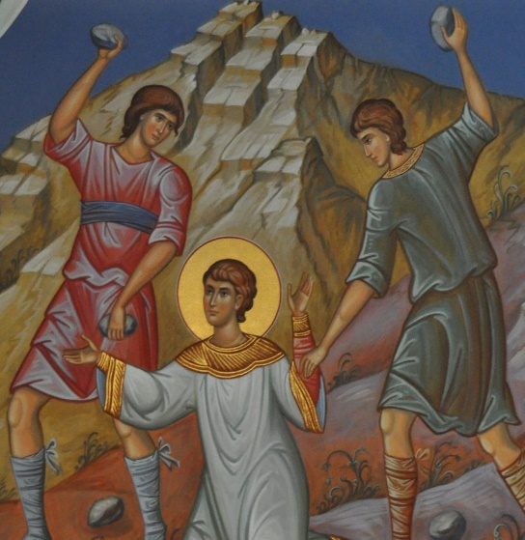
Stephen is stoned and becomes one of the earliest martyrs. Saul is present in the background. Yes, this is Saul who became the Apostle Paul – but we will return to that later. The important thing is that we read in Acts 8 that the Church is persecuted and scattered. This (look at Phillip’s ministry in Samaria), is a turning point for the early Christians since they preached the word wherever they went. Samaria is significant because it is a gentile country – the Word is now moving across borders. This follows in the tradition of Jesus, who similarly ministered on the Eastern side of Galilee (Samaritan woman at the well, healing of the man possessed demons). Moreover, we see Simon the Sorcerer come to faith, and the Ethiopian Eunuch. These are very different people! These two examples arguably link well with the notion of being active and open to the opportunities the spirit provides.
This Photo by Unknown Author is licensed under CC BY-SA
Saul’s conversion in chapter 9 is a wonderful assurance of those who may be against a move of God to start out with can be changed by God in the next moment. Perhaps the most important reflection is in how, without knowing it, our hospitality as Christians and local churches can give rise to us nurturing the next apostle. And beyond this, churches have the capacity to embrace those who were at one time so opposed to their work.
Again, this might not seem a particularly pioneering passage, apart from when you recognise that either deliberately or by circumstance, the gospel message is transported from one context to another, and people start afresh. Whilst our immediate focus is on preaching in the marketplace, the early apostles would have employed a strategy of seeing who was open to faith and exploring this.
We know that as time passes, the Apostles visit both Jewish synagogues and find their way into guilds and public meetings so that the message of Jesus can be heard. And there can be no doubt that some families move, in line with the persecution, and take their particular new form of what we now call ‘church’ with them.

All-Age Worship Ideas for Acts 8
- If we can lay the gory stories to one side, we can look at how our faith travels naturally, and not only as a result of persecution. One particular model worthy of consideration is of how we move house.
  - Ask the congregation how often they have moved house in their lives. Why did they move? What did they enjoy? What was difficult?
  - What items do we pack especially carefully when we move? Do people have things they never unpacked? Can faith be similar?
  - Hermit crabs are brilliant at fashioning their homes with whatever they have. They can inhabit sections of plant stems, broken coconut shells, and other objects. They are opportunistic omnivores that will scavenge, kill, browse and graze whatever plant or animal matter is available. They even make friends who live on the outside of their shells to protect them from predators. Encourage the congregation to imagine their ideal abode: where would they live? Who would be their neighbours?
  - Churches also exist in places like refugee camps. What can the kids club find out about these? How do they worship? Is it easy being Church in a refugee camp?
  - Material needed: plenty of empty cardboard boxes gathered in two piles at one end of the room. Who can build the highest tower in two minutes? When the two minutes are over, ask the two teams to dismantle their tower and rebuild it on the other side of the room as fast as they can. Fastest team wins! Was the move easy? What went wrong/ right?
This Photo by Unknown Author is licensed under CC BY-SA

Reflections on Hebrews 12: Jesus the Pioneer
Hebrews is written by the Apostle Paul to encourage the Jewish members of the early church to remain steadfast in their faith, as they sought to rebalance their former tradition with their faith in Christ. We would do well to remember that in the first instance, early churches were Jewish-Christian in nature, and this gave rise to questions about what aspects of their tradition the congregants needed to pack for the journey, and what could be discarded. Hebrews 11 is a helpful summary of what faith looks like – holding on to the broader promises of God without quite knowing what this would look like in the future. Paul presents Jesus Christ as the fulfilment of the promises that had been offered to the Israelite heroes that had gone before.
Paul presents Jesus as the Pioneer of our Christian faith, the ultimate trailblazer who we follow, who models how we should live. The imagery is powerful. As we look to remain faithful here on the ground, we are surrounded by heavenly witnesses, as in an amphitheatre, who are rooting for us, longing for us as we look to Jesus in a bid to remain faithful as we witness.
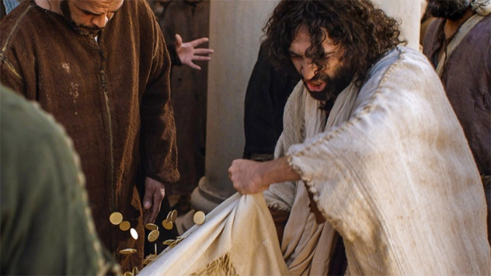
Jesus sat, unquestionably, on the fringes of the religious institution of His day. He perplexed people with the authority and wisdom of his teaching. He was uncompromising in speaking out against those who oppressed others. He was wise to with those who sought to undermine Him. He also faced betrayal and the worst that the world could throw at Him, but refused to do anything but live by love. He is the source of strength to all of us as we follow Jesus and are part of, in our own ways, God’s pioneering mission to the World.
This Photo by Unknown Author is licensed under CC BY-NC-ND
Discipline is a word that we perhaps recoil from. It carries elements of the worst of school discipline, and our being forced to do what we do not want to do. But discipline can be a good thing that ensures we are fit enough to face the world. We need to be just as disciplined in developing a prayer life, and reading of the scriptures, being part of a small group team of people that supports each other, and in meeting to talk and review our work, as one does in training for a race. We need to build ourselves up to serve in what can be a hostile world.
Verse 14 is helpful as we consider how when we become stressed with the pressures of life and ministry, it can be easy for bitterness and misplaced resentment to grow, between ourselves and others in the Church. This material celebrates the work of NPNP but also seeks to enable mutual learning between those working with well-established congregations and those working in new areas. We are both valuing the same thing in different ways. We all exist under God’s grace and are equally valued by God. God sees the joys and the tears in us all. Above all, we focus on honouring Jesus and giving glory to God.

All-Age Worship Ideas for Hebrews 12
- Set up a small racecourse outside. Agree the number of laps every participant should run and have jelly babies or other sweets available a bell ready to announce the last lap. It is easy to be so preoccupied with a race that you forget the number of laps you have run. Hence the bell. Also the bell informs all of the official and helpers that they need to be ready to record and support the finishers. Make sure you cheer the runners! After the race, talk about how the race went. How does it feel to persevere? What was it like to hear the bell? How did it feel to be cheered on?
- Cross-country running is fun too! You know where to start, but can’t necessarily know the exact route or where the finish line is. Pioneering is similar: we know roughly where we want to be headed, but we never know what obstacles we might meet on the way. How can you keep motivated on your run?
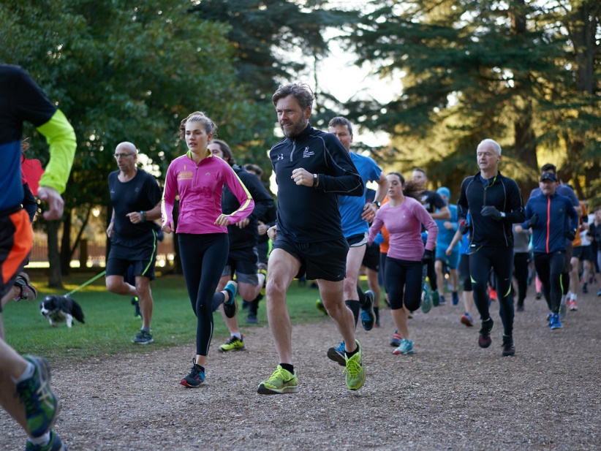
- Once you’ve run one race, you can run another, but every race is different. There are other athletes, a different terrain, and the weather might be different, too. No two races are the same. Life as a pioneer is about learning from experience and learning something new each day. How can we make sure that we celebrate learning and experimenting? What should we do when something doesn’t work out?
This Photo by Unknown Author is licensed under CC BY-NC-ND

More ideas to engage your congregation

Prayer labyrinth
Mark out a labyrinth in the church or outside. You can find patterns and instructions for this on the Methodist Website: https://www.methodist.org.uk/our-faith/worship/singing-the-faith-plus/prayer-in-worship/creative-prayer-ideas/sacred-spaces-and-labyrinths/ There are many ways to do labyrinths – here are a few suggestions for prayer stations along the way:
- A pile of pebbles can be dropped into a bowl of water inviting people to think of issues, thoughts and challenges that hold back their “inner pioneer”.
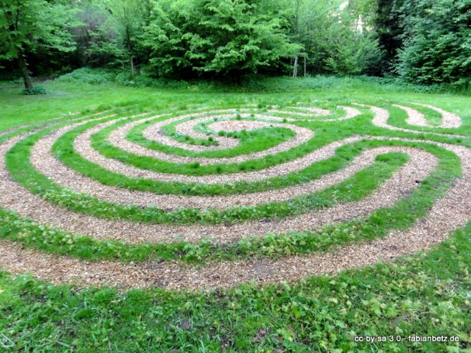
- Arrange a display of hiking gear, including walking shoes, compass, and an emergency ration or distress signal/ whistle. Cut an old map into smaller pieces and invite people to write prayers of encouragement for the pioneer to support them in times when they might feel disorientated and lost. In the end, the pioneer will receive this collection of prayers.
This Photo by Unknown Author is licensed under CC BY-SA
- You’ll need a dish full of different buttons. As people take a button and put it in their pockets, invite them to identify one “pioneering action” that they’d like to take up. This could be a further conversation with the pioneer, a visit to a New Place for New People, or working on their own pioneering ideas, learn more about NPNP etc. Whenever they find the button in their coat, they will remember their action (and hopefully carry it out!)

Interview a Pioneer: here are some starter questions:
- What do you enjoy most about your ministry?
- Why do you do what you do?
- What motivates you?
- What is the greatest challenge you face as a pioneer?
- Thinking back over the past month or so, where have you experienced God?
- What is “pioneering” about your project?
- What message do you bring from your community?
- How do you worship in a pioneer community?
- What are the main differences between a pioneer community and a traditional church?
- Can you identify something distinctively Methodist about your project?
- How can we help you?

Blessing
As we go out of this place
to worship God with our lives,
may love surround us wherever we go,
may we love the world around us,
and may we see Christ in those we meet.
Amen

Links and Addresses
https://www.eauk.org/idea/is-there-a-theology-for-pioneering.cfm
https://www.methodist.org.uk/our-work/our-work-in-britain/evangelism-growth/new-places-for-new-people/

