Barton & Brigg Methodist Circuit

THE KNITTED BIBLE
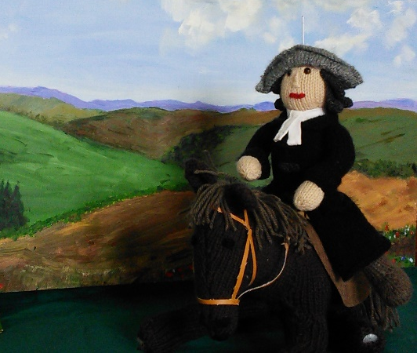
&
WESLEY IN WOOL
(a new exhibition of knitted scenes from the life of John Wesley)

at BartonTrinity Methodist Church

Schools Pack

Contents

Introduction

Knitted Bible descriptions and pictures

Wesley in Wool descriptions and pictures

Worksheets
Introduction

The Knitted Bible – created by St. George’s United Reformed Church, Hartlepool
Back in 2008 the Hobby Group at St. George’s United Reformed Church in Hartlepool welcomed the challenge when it was suggested that they knit the Last Supper. It was finished so quickly that they decided to add other scenes as well, with the aim of working their way through the whole Bible.

Within 2 months they had produced the Palm Sunday procession, the crucifixion and the resurrection, while some had even started on Adam and Eve, Moses and David and Goliath.

They got the patterns from various sources: nativity patterns and the Noah’s Ark animals from toy patterns. Over their first Easter a photo appeared in their local paper which caught the attention of Tyne Tees TV who came to film the scenes after Easter Sunday worship.

From then on things developed quickly and now the Knitted Bible Exhibition comprises 34 scenes which have been displayed in hundreds of churches of many different denominations throughout Britain. We hope you have enjoyed seeing them here!

Their minister at the time writes that ‘Our hope is that in depicting some of the best-known stories in the Bible, everyone who sees them will be able to understand and enjoy them and may discover some detail that they had forgotten or never noticed before – while learning more about God and God’s love for this world and its people.’

Wesley in Wool – created by members of Barton & Brigg Methodist Circuit

When we knew we were having the Knitted Bible to our churches we had an idea to make a display of the life of John Wesley to go with it. The display was designed by Jill Greenhalgh and Angela Kipling and knitted by many different people from local Methodist Churches and community groups over six months.

It contains 143 knitted figures in 15 scenes, each with their own backdrops which have been painted or crafted by different people. The scenes tell the story of the life of John Wesley, the founder of the Methodist Church.

The Knitted Bible
1 Creation Genesis 1:1-2:3
In the beginning there was nothing but deep, dark emptiness. Then God said, “Let there be light”, and there was light. God saw that it was good and separated the light from the darkness. God called the light ‘Day’ and the darkness ‘Night’.

Next God separated the waters of the heavens from the waters of the earth and called what lay between then ‘Sky’.

Then God brought all the waters of the earth together to make oceans and seas and to form dry land between them.

God covered the dry land with flowers, trees and grass and saw that it was good.

God created the sun, moon and stars, birds and fish and animals of every kind.

Then God made man and woman in God’s image and put them in charge of all that God had created.

When God had finished the work of creation, God saw that everything was very good indeed.

2 Adam and Eve Genesis 2:4b-9, 15-17; 3:1-7
God planted a garden in Eden and put the man and woman he had formed there. They were called Adam and Eve.

God told them that they could eat of the fruit of any tree in the garden except for the fruit of the ‘tree of knowledge of good and evil’ – because if they ate that fruit, they would die.

One day a crafty snake persuaded Eve to eat some of the forbidden fruit and she gave some to Adam as well.

Immediately they knew that they had done something terribly wrong and they were ashamed of themselves.

Because of what they had done Adam and Eve had to leave the Garden of Eden which meant that they could no longer eat the fruit from the ‘tree of life’, but would have to work hard to grow the food they needed and would eventually die.
3 Noah’s Ark Genesis 6-8
God saw that there was a great deal of wickedness among the people of the world that God had made to be good and God was sorry for creating human beings.

God decided to start again. God spoke to a man called Noah, who was a good man. God gave Noah instructions for building a big boat, an Ark, into which Noah, his family and a pair of every living creature had to go in order to be saved for the new beginning God wanted to make.

Then the heavens opened and rain fell on the earth for 40 days and forty nights, until the whole earth was flooded with water. For about six months the Ark sailed on the water before coming to rest on the mountain of Ararat.

40 more days passed before Noah sent a raven out of the Ark and then a dove to see if they could find somewhere dry to perch, but it was another week before the dove returned with a fresh olive leaf.

When Noah was sure that the floods had gone down, he opened the Ark and the animals, birds, reptiles and all the creatures God had saved went out onto dry land.

God blessed Noah and his family and made a solemn promise never to wash everything and everyone from the earth again.

Then God put a rainbow in the sky, saying that whenever people saw a rainbow they should remember that it was a sign of God’s promise.

4 Abraham and Sarah Genesis 12:1-9; 15:5-6; 17: 15-17; 18:1-12; 21:1-7
God wanted to have a closer relationship with people. God chose Abraham to be the founder of a nation that would be especially blessed by God.

Abraham was told to pack up everything he owned and to take his wife Sarah and all his family to the land of Canaan.

God promised Abraham that he would have children and as many descendants as there are stars in the sky. But years and years went by and still Abraham and Sarah had no children.

When God repeated the promise, Abraham found it hard to believe because he and Sarah were growing old. When three strangers arrived at their camp and one of them said that Sarah would give birth to a son, Sarah laughed.

However, God’s promise did come true and Abraham and Sarah had a son. They called their son Isaac.
5 Jacob’s Ladder Genesis 27 and 28
Abraham’s son Isaac grew up and married Rebekah. They had twin boys, Esau and Jacob.

As Isaac grew old, he lost his sight and Jacob pretended to be Esau so that Isaac would give him the blessing – the promise that God would look after him and help him do well.

The blessing should have been given to Esau, who was the twin born first, so when Esau found out that Jacob had cheated him, he was very angry.

Esau wanted to kill Jacob, so Isaac and Rebekah told him to go and stay with his Uncle Laban.

It was quite a long journey, so Jacob had to camp overnight on the way.

During the night Jacob dreamt that a ladder was reading up to heaven from the earth and that angels were going up and down on it.

Then Jacob dreamt that God stood beside him and promised that Jacob would return to the land of Canaan and that he would be blessed.

When he woke up, Jacob realised that he had spent the night in a holy place, the gateway to heaven.

6 Joseph and his brothers Genesis 35:22-26; 27:1-11, 23-36; 44:14
Jacob had 12 sons, but Joseph was his favourite.

When Joseph was 17, he had a strange dream and told his older brothers about it. The dream showed that Joseph would become so important that his brothers would bow to the ground in front of him. The brothers thought that Joseph was becoming too big-headed and they plotted together to get rid of him.

They threw him into a dried up well and were going to leave him there, but a camel-train of traders on their way to Egypt came along and so they sold Joseph to the traders.

When they arrived in Egypt, the traders sold Joseph to Potiphar, the captain of Pharaoh’s guard.

Years later there was a long drought and people in many countries suffered from famine. Jacob sent Joseph’s brothers to Egypt to buy food, because he had heard that someone in Egypt had foreseen what would happen and had built up stores of grain.

The ‘someone’ turned out to be Joseph, who had worked his way up into the highest position in Pharaoh’s court and there his brothers really did bow down to the ground in front of him, just as he had dreamed many years ago.

7 Moses in the bulrushes Exodus 2:1-10
Abraham’s descendants, who had by then become the ‘people of Israel’, settled in Egypt.

They grew to number so many that the Pharaoh and his advisers were afraid that they would turn against the Egyptians. So they made a plan to deal with the Israelites.

First of all, all the Israelites were put into forced labour, building great cities for Pharaoh. But as the Israelites continued to thrive and to have children, Pharaoh became more afraid of a revolt. So he ordered the midwives to kill all the Israelite baby boys at birth, but they pretended that it was impossible. Pharaoh then commanded the Egyptian people to throw every Israelite baby boy into the River Nile.

When Moses was born to an Israelite woman, she was afraid that he would be killed. She hid him at home for 3 months and then made a waterproof basket for him and hid it among the reeds on the river bank.

Moses’ sister, Miriam, watched to see what would happen to him. She was worried when Pharaoh’s daughter came down to the river and found baby Moses. But Pharaoh’s daughter felt sorry for the baby and decided she wanted to adopt him and bring him up as her own son. Miriam asked the princess if she wanted someone to help her and then went to get her mother.

Pharaoh’s daughter gave Moses’ mother money to live on until Moses was old enough to go and live in Pharaoh’s palace.

8 Moses and the Ten Commandments Exodus 24:12-18; 32:1-6 & 16; Deuteronomy 5:1-21
When Moses was grown up, he discovered who he really was. God told him to free the Israelites from their slavery in Egypt.

After overcoming many difficulties, Moses finally managed to get the Israelites away from Egypt and they all set out towards the land promised to Abraham many generations earlier.

The people soon got fed up with travelling and became bad-tempered and unmanageable. So God told Moses that God would help him with the task of leading the people onwards. Moses met with God at the top of a mountain and God gave him stone tablets with the rules for living as God’s people written on them.

Moses was up on the mountain for 40 days and 40 nights and while he was away the people grew restless. Moses’ brother, Aaron, who had been left in charge, gathered all the gold jewellery that the people had and made a statue of a golden calf and told them to worship the statue. Moses returned from the mountain while the people were worshipping the statue and he was so angry that he threw the stone tablets he was carrying to the ground, where they broke into pieces. He then destroyed the golden calf before going back up the mountain to plead with God to give the people another chance.

God gave Moses another two tablets of stone and Moses told the people what was written on them. These are what are known as the 10 Commandments by which God’s people should live.

Moses told the people that God had said:
- I am the Lord your God, you shall have no other gods but me;
- You shall not make any idols or worship anything other than me;
- Do not use the name of the Lord your God wrongfully;
- Observe a day of rest and keep it holy;
- Honour your father and mother;
- Do not murder;
- Do no go with someone else’s wife or husband;
- Do not steal;
- Do not tell lies about anyone;
- Do not want for yourself what belongs to someone else.

9 Samson and Delilah Judges 15:1-31
Much later, following a succession of leaders called ‘Judges’, the Israelite people made God sad again, because they had abandoned God’s way of life.

The Israelites were taken captive by the Philistines, who treated them badly and prayed that God would help them.

One of the Israelites, a man called Manoah, was a good man and God promised that he and his wife would have a son who would be special and would save the people from the Philistines.

When he was born Manoah’s son was called Samson and God blessed him. Samson was very strong and God said he would be as long as he didn’t cut his hair.

When he grew up, Samson fell in love with a Philistine woman called Delilah.

The Philistine leaders, who had become afraid of Samson’s enormous strength, bribed Delilah with silver pieces so that she would find out how to overpower Samson before he overpowered them so they could take him prisoner.

After sever attempts, Delilah discovered that if Samson’s hair was cut off he would lose his strength completely. One night, while Samson was asleep, Delilah got a man to shave the hair from Samson’s head. Then the Philistines seized Samson, blinded him and took him in chains to a prison in their city of Gaza. While he was in prison Samson’s hair started to grow again.

When the Philistines held a great feast to celebrate their victory over Samson and the Israelites, they sent for Samson so that they could make fun of him. Samson was chained to the pillars of the banqueting hall. He prayed to God asking for one more burst of strength and then stretched out his hands to the pillars on either side. He strained with all his might and the whole lot came crashing down, killing everyone there, including Samson – but he had saved his people from the Philistines.

10 Samuel in the Temple 1 Samuel 3:1-10
Samuel was also a child promised by God because his mother, Hannah, had prayed for a son.

Hannah made God a promise that if she had a son, she would bring him up to be set apart for God’s service.

When Samuel was still very young he was taken to live at the temple in Shiloh and began to help Eli, the old priest there, with all the services. Hannah visited him regularly. As Samuel grew older he did more of the work and God and the people thought highly of him.

One night when he and Eli were asleep, Samuel heard someone calling his name. He went to Eli’s room but Eli said he hadn’t called and told Samuel to go back to bed. Samuel heard someone calling his name again and went to Eli again and Eli told him to go back to bed again. A third time Samuel heard a voice and went to Eli. This time Eli told him that he thought God was calling him and told Samuel that if he heard the voice again he should say ‘Speak Lord, your servant is listening.’

Samuel went and lay down in his bed and when he heard the voice again he did what Eli said. God gave Samuel a message that he was about to do something that would make people remember him again.

After that time God spoke to Samuel a lot, helping him to make sure that the people listened to God.

Eventually, in response to the people’s demand, it was Samuel who anointed and crowned the first King of Israel, a man named Saul.

11 David and Goliath 1 Samuel 17:12-50
Saul was at war with the Philistines, who had gathered their armies for battle.

One of the Philistines, a giant of a man called Goliath, challenged the Israelites to send out a man to fight against him.

The Israelites were too afraid to fight Goliath, even though they knew that the King would give a big reward to anyone who killed Goliath.

David had been to the battlefield regularly, although he was too young to be in the army, taking food to his brothers who were soldiers.

When David saw that none of the Israelites would fight Goliath, he volunteered to do it himself. King Saul gave David his own suit of armour, but it was too big for David so he took it off.

David went up to Goliath armed with only 5 smooth stones and his sling – a kind of catapult which he had used to protect his sheep from bears and lions. Goliath laughed at the sight of David because he was so small and young, but David took a stone and used his sling to throw it at Goliath. It hit Goliath on the forehead, knocking him out.

All the Philistines ran away and David was treated as a hero. God blessed David and later David became a great King of Israel, loved by everyone.

12 Elijah 1 Kings 17: 1-24; 19:1-18
Elijah was a prophet, a man to whom God gave words to speak to the people and through whom God showed his power.

At the beginning of Elijah’s ministry, God told him to tell the King that it wouldn’t rain for a long time because God was unhappy with things the people were doing. God then told Elijah to go and wait in the wilderness. While he was there ravens brought Elijah bread and he drank water from a stream, until it dried up because there had been no rain.

Then God sent Elijah to the house of a widow who lived alone with her son. The widow only had a handful of flour in a jar and a little oil in a jug left because of the drought and she was preparing to die. Elijah told her that God had said that he would not let the flour or oil run out until the drought was over. She believed him and baked some bread every day for many days and the flour and the oil did not run out.

Shortly afterwards the woman’s son became ill and stopped breathing. Elijah prayed to God asking God to save the boy and the boy came back to life again. Because of this and other great deeds, Elijah became well-known and people could see that God was with him.

The King, Ahab wanted to kill Elijah because Elijah spoke the truth about Ahab’s bad behaviour. Elijah was afraid of Ahab’s anger and ran for his life into the wilderness where he thought he would die anyway. He lay under a tree and slept, but twice an angel touched him and told him to get up and eat the bread and drink the water that God had provided for him. After that Elijah walked through the wilderness for 40 days and 40 nights, until he came to Horeb, the mountain of God, where he spent the night in a cave.

Then Elijah heard God asking what he was doing there and he told God that he was the only prophet left in Israel and that Ahab and the Israelites wanted to kill him so he had run away. God told Elijah to stand out on the mountain. When he did, a great strong wind blew up, there was an earthquake and after that a fire and then nothing but a sheer silence. God spoke in the silence, telling Elijah that he was not alone but that there were 7000 other people in Israel who still followed him and would help him to bring the others back to God.

13a The Fiery Furnace Daniel 1:1-7; 3:1-30
The people of God in later years were divided into two kingdoms, Israel and Judah.

When King Jehoiakim ruled over Judah, King Nebuchadnezzar of Babylon captured Jerusalem and took away the temple treasures as well as some of the royal family and other people from the nation. These included four friends who were given the Babylonian names of Shadrach, Meshach, Abednego and Belteshazzar.

The four friends studied the Babylonian language, history and customs and they were given places at the King’s court. But although they had to act like Babylonians in every other way, they continued to worship God and to keep God’s commandments.

The four were such nice, clever young men that King Nebuchadnezzar promoted them to positions of great responsibility, which did not please some of the Babylonians at the palace. When the King made an enormous golden statue and ordered everyone to worship it, Shadrach, Meshach and Abednego refused to do so because it went against God’s commandments. Their enemies told the King that they wouldn’t bow down and the King became angry and ordered that they should be killed by being thrown into a fire. Shadrach, Meshach and Abednego were tied up by guards in the King’s army and put into the fire. But instead of burning, when the King looked into the flames he could see them walking around, with a fourth person who looked like an angel.

The King called to the men to come out and when they did they were completely unharmed. Then he realised the power of God and sent out a decree that nobody should say anything against the God of Shadrach, Meshach and Abednego.

13b Daniel in the Lion’s Den Daniel 6:1-24
Belteshazzar, who is better known to us by his real name of Daniel, had become important at the palace because of his intelligence and his ability to interpret dreams.

After King Nebuchadnezzar died and Darius became King, things became difficult for Daniel.

Darius made Daniel one of three presidents who organised the running of the kingdom and planned to make him the Prime Minister because he was so good at his job. But the other two presidents were jealous and angry because Daniel was a foreigner. They persuaded King Darius to pass a law saying that all the people must worship the King and that anyone who prayed to anyone else would be thrown into a den of lions.

Daniel was a man of prayer and it was well known that he prayed to his God three times every day in front of the window, which faced towards Jerusalem.

As soon as the law had been passed, the other two presidents informed King Darius that Daniel had disobeyed the law because he was still continuing to pray to God. Because the law could not be changed the King had to send Daniel to the lion’s den, even though he didn’t want to because he liked Daniel.

When Daniel had been thrown into the lion’s den, King Darius went to his palace, but he could not sleep. He hoped that Daniel’s God might be able to save him. As soon as it was light, King Darius rushed out to the lion’s den and discovered that Daniel was still alive. Daniel was brought out of the den. Then King Darius wrote to all the nations of the world, telling them to worship the God of Daniel who saved his people.

14 Jonah and the Whale Jonah 1-4
God told Jonah to go to the city of Nineveh to tell the people that God was angry with them because of the bad things they were doing and was going to destroy the city. Jonah didn’t want to take the message and decided to run away.

Jonah got on a ship sailing away from Nineveh. But God made a massive storm burst out so the sailor’s thought the ship would break up. Jonah was fast asleep in his cabin, but the others on the boat woke him up. They drew lots to see who had caused the storm and discovered it was Jonah. They asked Jonah who he was, where he had come from and what he thought would help stop the storm. Jonah told them to throw him into the sea. They didn’t want to but the storm got worse so they threw Jonah overboard and then the storm stopped.

Jonah didn’t die though, God sent a large fish to swallow him. Jonah was inside the firs for three days and three nights. Jonah prayed that God would save him and then God made the whale spit Jonah out onto dry land. The big fish put Jonah out on dry land near to the city of Nineveh. Jonah then did what God had asked him to do in the first place and gave the people there God’s message.

The people of Nineveh listened to Jonah and were sorry for the bad things they had done. The King of Nineveh ordered everyone to change and ask God to save them. God heard them and decided not to destroy the city. Jonah wasn’t pleased about this, but God helped him to see that it was the right thing because God always wants to help and save people.

15 The Angel Gabriel visits Mary Luke 1:26-38
The Angel Gabriel was sent to Nazareth by God because God had a message for a young woman named Mary who lived there.

Mary was extremely surprised when the Angel Gabriel appeared and was confused when the angel told her that she was going to have a baby, a son who would be named Jesus and who would save the world.

When Mary asked how it would happen, the Angel Gabriel said that the power of God, through the Holy Spirit, would enter her and the child would be called the ‘Son of God’.

Mary replied, ‘I am the servant of the Lord, let it be with me according to your will.’

Then the angel disappeared.

16 Jesus is born Luke 2:1-16; Matthew 2:1-11
Mary was going to be married to a man called Joseph. Just before the baby was going to be born they had to travel from Nazareth to Bethlehem, the town where Joseph’s family was from, to be counted by the Romans, along with many other Jewish families. When they arrived in Bethlehem, all the rooms were full, so they had to stay in a stable, where Mary’s baby was born.

The first to hear about the baby were shepherds on a hill overlooking Bethlehem. At first the shepherds were terrified when a whole host of angels lit up the sky above them but the angels told them about the baby and they went to Bethlehem to find the baby who would grow up to be the Saviour of his people.

Meanwhile, some wise men, or stargazers, from the East who had read in the stars of an amazing event, the birth of a new King of the Jews, arrived in Jerusalem. They went to King Herod’s palace, believing that a new King would be found there, but Herod knew nothing. Herod’s advisers told him that the Scriptures said that God’s Son would come from Bethlehem. Herod told the wise men to search there and to let him know what they discovered.

Following a star that appeared to have been guiding them, the wise men found the place where Joseph, Mary and Jesus were. They knelt down and worshipped Jesus and gave him gifts of gold, frankincense and myrrh.

Then having been warned in a dream not to return to Herod, they went home a different way.

17 John the Baptist Matthew 3:1-6, 13
Zechariah and Elizabeth had thought they would never have a child because they were too old. But God sent an angel to tell them they would have a son.

When the baby was born they were overjoyed. They named the baby John as the angel had told them to. John was brought up to be holy and to serve God.

John was Jesus’ cousin and when they were both grown up they began their ministry of teaching the people about God and God’s Kingdom.

One day John, who wore clothing made of camel’s hair, was preaching in the wilderness by the River Jordan and baptising those who wanted a fresh start. He saw Jesus coming along and told the people that Jesus was the one they ought to follow and learn from.

Then Jesus asked John to baptise him. As he came out of the water the heavens seemed to open and he saw the Spirit of God like a dove come down and land on him and heard a voice from heaven saying ‘This is my Son, the Beloved, with whom I am well pleased’.

18 The Wedding at Cana John 2:1-11
When a family friend was getting married in the village of Cana, Jesus, his disciples and his mother Mary were invited to the wedding.

During the wedding feast Mary noticed that the wine had run out. She told Jesus and she told the serving people to do whatever Jesus asked them to.

Jesus noticed six large stone water jars and asked the servers to fill them with water. They did this.

Then Jesus told them to pour some out and take it to the chief steward, who was in charge of the food and drink. The chief steward said to the bridegroom that most people served the best wine first and then served cheaper wine, but that he appeared to have kept the best wine for last.

The turning of the water into wine was the first of the signs that Jesus really was God’s Son, because it was a miracle.

18 The woman at the well John 4:7-26
In Jesus’ time Jewish people and Samaritan people didn’t like each other. Jesus’ disciples were surprised one day to find Jesus talking with a Samaritan woman by a well.

The things that Jesus said to her made it clear that all people are loved and valued by God no matter who they are or what they might have done.

20 The poor widow Luke 2:1-4
One day when Jesus was in the temple with his disciples, he was watching rich people put their gifts, worth a lot of money, into the temple treasury chest.

Then he noticed a poor widow put in two small copper coins, Jesus said to his disciples that she had really given much more to God than the rich people had because she had a lot less than them.

What matters is not how much you have, but how much of what you have that you give to God and the work of God.

21 Jairus’ daughter Luke 8:40-42, 49-56
A lot of people came to Jesus to be healed and one day a man called Jairus, a leader at the Jewish synagogue, went to ask for healing for his daughter who was sick at home. Jairus told Jesus that the girl, who was only 12, was dying. While he was still telling Jesus about her one of his friends came to say that it was too late, the girl had already died.

Jesus told them not to worry but to believe in God’s will for good and the girl would be saved.

Jesus went to Jairus’ house where there were women crying at the dead child’s bedside. He sent everyone outside except Jairus, his wife and three of his disciples. Then Jesus held the girl’s hand and told her to get up, which, to everyone’s amazement, she did.

It was a miracle!

22 The parable of the Good Samaritan Luke 10:30-37
Jesus told many stories or parables and this is one of the best known of his stories.

A man who was travelling from Jerusalem to Jericho was ambushed by robbers. They beat him up, took his clothes and his money and went off leaving him half dead.

A priest and a Levite who came past ignored the poor man, but a Samaritan was filled with pity for him.

The Samaritan bandaged the man’s wounds, put him onto his own donkey, took him to an inn and paid for him to stay there until he felt better.

The interesting thing about this story is that those who should have helped the injured man, because he was like them, did not help. The one who did help was another nationality, but he was the one who showed God’s love.

23 Jesus blesses the little children Mark 10:13-16
Wherever Jesus went the crowds gathered around him to hear him teach and to ask for help and healing.

In one place people brought little children to be blessed by Jesus. The disciples became cross and were going to send them away because they thought that children were too young to know anything.

Jesus told his disciples off and said ‘Let the little children come to me, do not stop them; for it is to such as these that the Kingdom of God belongs. Truly I tell you, whoever does not receive the Kingdom of God as a little child will never enter it’.

Then Jesus gave all the children his blessing.

24 The paralysed man and his friends Mark 2:1-12
One day, when Jesus was in the town of Capernaum, people came from all around asking to be healed.

There was such a crowd in the house where Jesus was that four men, who had brought their friend on a sleeping mat because he couldn’t walk, couldn’t get anywhere near Jesus.

They went up onto the roof, made an opening and lowered their friend into the middle of the crowd, right in front of Jesus.

When Jesus saw how much faith they had in his power to heal, he told the man to get up, pick up his mat and go home. Immediately the man stood up and walked out, to everyone’s amazement.

Then the crowd praised God because they had seen something wonderful happen.

25 The boy with loaves and fish John 6:1-9
Having heard of the miracles that Jesus had performed, a huge crowd followed him and his disciples everywhere he went.

In one place, about 5000 people had gathered to hear Jesus speak and when it got to lunchtime Jesus wondered where they could get food for the people. Philip told Jesus that even six month’s wages wouldn’t buy enough for everyone.

Then Andrew brought a boy to Jesus saying that the boy had 5 small loaves and 2 fish that he wanted to share, but that they wouldn’t go far.

However Jesus sat the people down, asked God’s blessing on the bread and fish and passed them round. Everyone received as much as they needed and when the leftovers were gathered up they filled 12 baskets.

It was another miracle.

25a The parable of the Lost Sheep Luke 15:3-7
This is another story that Jesus told.

He told people about a shepherd who had 100 sheep. One of the sheep went missing. The shepherd left the other 99 sheep and went to look for the one who was missing. He looked and looked until he found it and then he brought it back to be with the other sheep again.

This parable shows us how much God loves us.

26 Zacchaeus Luke 19:1-10
When Jesus was on the way to Jerusalem with his disciples, a crowd gathered as they passed through Jericho.

One of the men there, called Zacchaeus, who collected taxes for the Romans, wanted to see Jesus but because he was short he couldn’t see over the crowd. He ran ahead a little way and climbed a tree so that he could see Jesus as he went past.

When Jesus got near to the tree, he told Zacchaeus to get down from the tree because he wanted to have tea at his house.

The crowd grumbled at this because Zacchaeus had grown extremely rich by taking their money in taxes and they didn’t like him for that and because he worked for the hated Romans.

But after listening to Jesus, Zacchaeus told him that he was sorry for what he had done and who he had become and wanted to make things right. He promised to give his money to charity and to give four times as much back to those he had overcharged in taxes.

Zacchaeus was changed because he met Jesus.

27 Jesus in Bethany Luke 10:38-42
Two sisters called Martha and Mary lived with their brother, Lazarus, in a village called Bethany.

Jesus was always welcome in their home and must often have stayed with them when he was going to Jerusalem.

One day while Mary was listening to Jesus, Martha became annoyed because she felt she had been left to do all the work herself and so she complained.

Jesus told her not to be so bothered but to make the most of the time they had with him.

28 The raising of Lazarus John 11:1-14
On another occasion, when Jesus was a distance away, people came from Bethany to tell him that his friend Lazarus was really ill.

Even though Jesus was very fond of Lazarus, Mary and Martha, he didn’t go to them straight away, but stayed where he was for another couple of days. When he did arrive in Bethany Martha came to meet Jesus with bad news.

She told him that Lazarus had died and said that if Jesus had been there he would still be alive. She then said that even then, if Jesus asked, she believed God would answer his prayers.

Lazarus had been dead for four days and had already been buried in a burial cave. But Jesus ordered that his tomb should be opened. Then Jesus prayed and called Lazarus to come out of the tomb.

Lazarus came out, still wrapped in his burial cloths, to everyone’s amazement.

Many people came to believe in Jesus, who revealed God’s power in miraculous deeds, because Lazarus was brought back to life after he had died.

They remembered later how Jesus had said ‘I am the resurrection and the life. Those who believe in me, even though they die, will live and everyone who lives and believes in me will never die.’

29 Palm Sunday Matthew 21:1-11
Jesus and his disciples went to Jerusalem to celebrate the Passover.

When they were nearly there, Jesus sent two disciples to collect a donkey from the next village. Then Jesus rode the donkey through the city gates of Jerusalem, acting out a prophecy from the book of the prophet Zechariah many years before.

A large crowd lined that street as they would have done for a King. Some people spread their cloaks on the floor in front of Jesus, while others cut branches from the palm trees nearby and spread them on the road in front of Jesus.

They all cheered as he rode by and shouted ‘Hosanna to the Son of David! Blessed is the one who comes in the name of the Lord! Hosanna in the highest heaven!’

30 The Last Supper John 13:1, 3-5; Matthew 26:26-29
Arrangements had been made for Jesus and his disciples to share the Passover meal in an upper room in Jerusalem.

When they had all arrived, Jesus began to wash his disciple’s feet, doing the task of a servant, to demonstrate God’s love. Then they took their places at the table.

While they were eating, Jesus blessed a loaf of bread, broke it and gave it to the disciples saying ‘This is my body’. Then he took a cup of wine, gave thanks to God and told the disciples to drink. He said ‘This is my blood which will be poured out for many’. Then he added, ‘Do this every time you need to remember me’.

After the meal was finished, they all went out to the Garden of Gethsemene, where Jesus prayed and then soldiers came to arrest him.

31 The crucifixion John 19; Luke 23
Although the crowds had cheered for Jesus on Palm Sunday, by Friday they had changed their tune and demanded that Jesus be crucified.

Carrying his own cross, Jesus was taken to be crucified, along with two others whose crosses were on either side of his.

While Jesus’ mother Mary, with her sister and Mary Magdalene watched and waited, the soldiers threw dice to see who would get Jesus’ clothes which were of good quality.

While he was dying Jesus prayed that God would forgive the people who were there because he said they did not know what they were doing. He also told one of the thieves on the other cross that he would be with him in heaven.

Jesus died at 3 o’clock in the afternoon and the sky went dark. A soldier watching said ‘Truly this was the Son of God’

32 The Resurrection Matthew 28:1-6
By the time that Jesus died it was almost dusk, which meant that the Sabbath day would begin so he had to be buried quickly in a tomb made available by his friend Joseph of Arimathea.

It was Sunday morning before the two women called Mary could go to the tomb to finish anointing Jesus’ body, according to their custom.

As they drew near to the tomb, there was an earthquake and an angel rolled the stone away from the entrance.
The angel’s appearance was like lightning and his clothing was as white as snow. The guards stationed at the tomb were stunned.

The angel told the women not to be afraid because Jesus was not there, he had risen from the dead. They looked in the tomb and saw the empty burial cloths and were about to run off to tell the disciples when they saw Jesus standing in front of them. He was alive and they fell at his feet and worshipped him.

Jesus said to them, ‘Do not be afraid! Go and tell my disciples to go to Galilee, there they will see me.’

33 Breakfast on the Beach John 21:1-14
The disciples had gone to Galilee to wait for Jesus to appear. Peter got bored and decided to go fishing. Six of the other disciples went with him, but they caught nothing all night.

As they were making their way back, just before dawn, they saw someone on the beach and heard him tell them to cast their net on the right side of the boat.

When they did, they caught so many fish that they couldn’t haul the net in, but had to drag it along towards the beach.

Then Peter jumped out of the boat and splashed towards Jesus, leaving the others to deal with the boat and the net full of fish. When they all reached Jesus they saw that he had a fire burning and was cooking breakfast for them.

Like they had done at the Last Supper they had shared with him, Jesus took the bread and fish, broke it and gave it to them. Then they knew he really was Jesus and he truly was alive again.

Through Jesus, who had died, been buried and had risen from death to new life, Christians believe God shows how much God loves everyone.

1 | 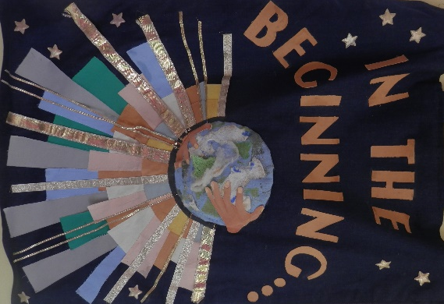
2

The Old Testament
3 | 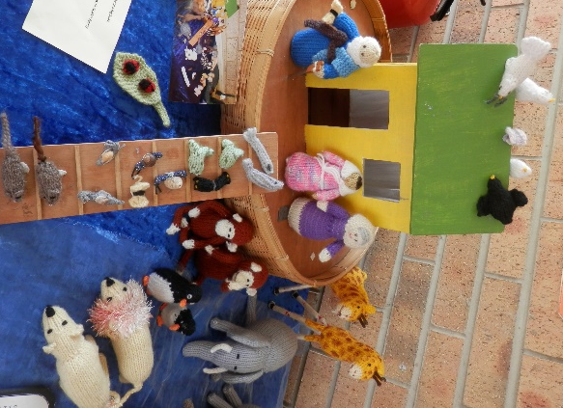
4
5 | 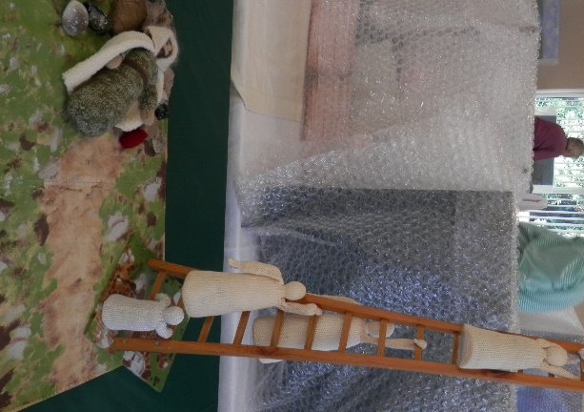

6
7 | 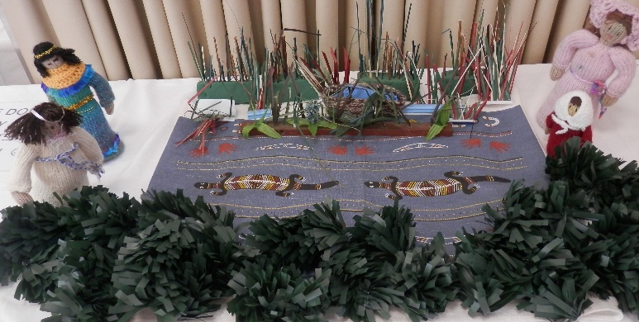
8 | 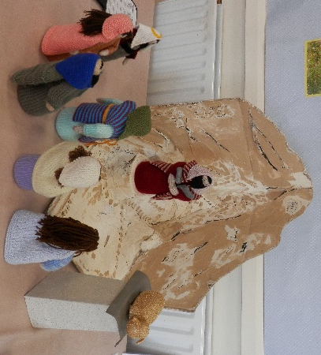
9
10
11 | 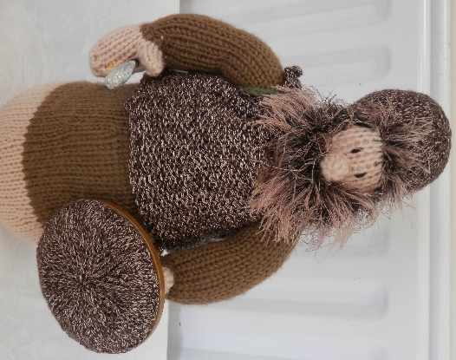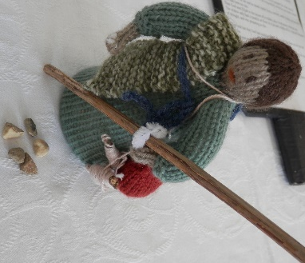

12 | 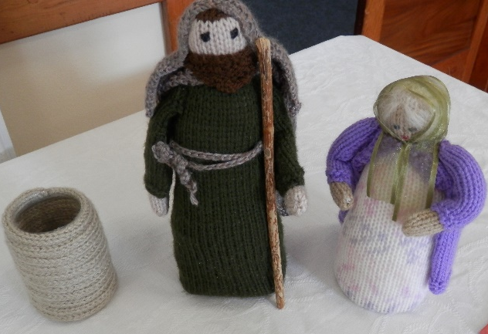
13a | 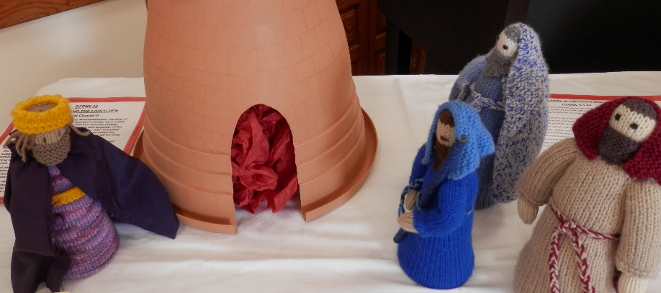
13b | 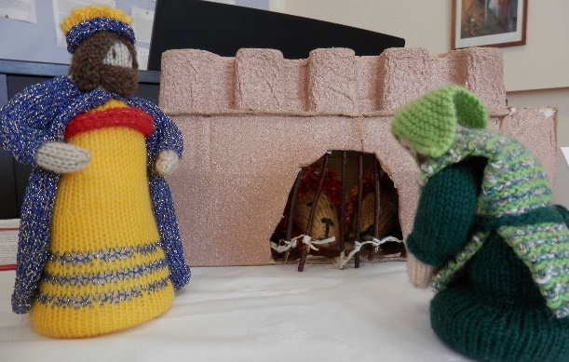
14

15 | 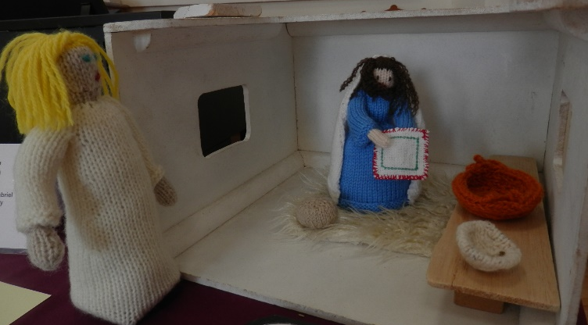
16 | 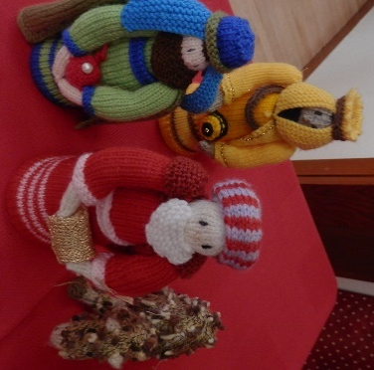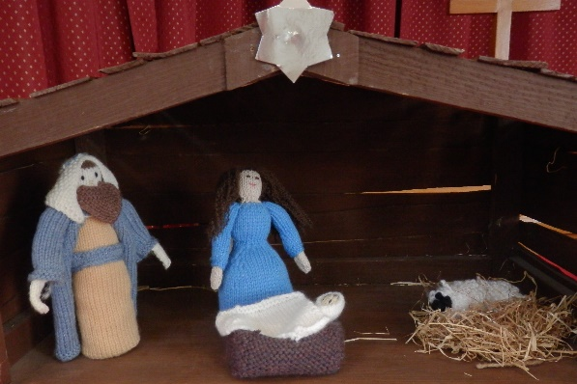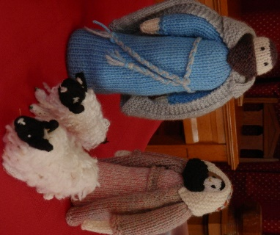
17 | 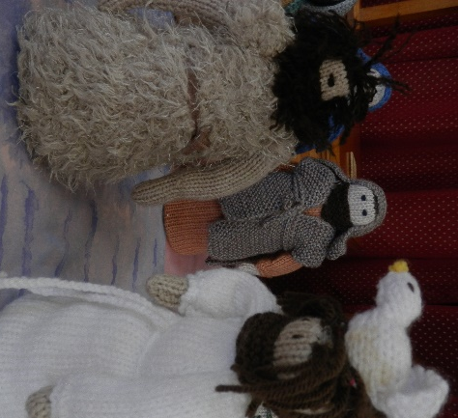
18
The New Testament
19 | 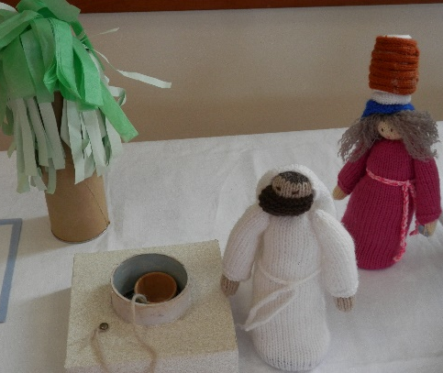
20 | 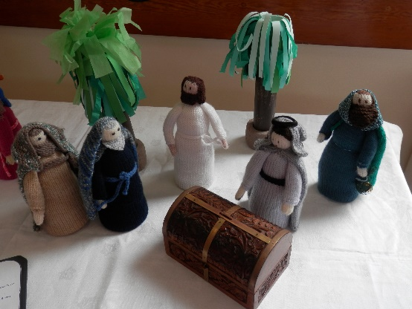
21 | 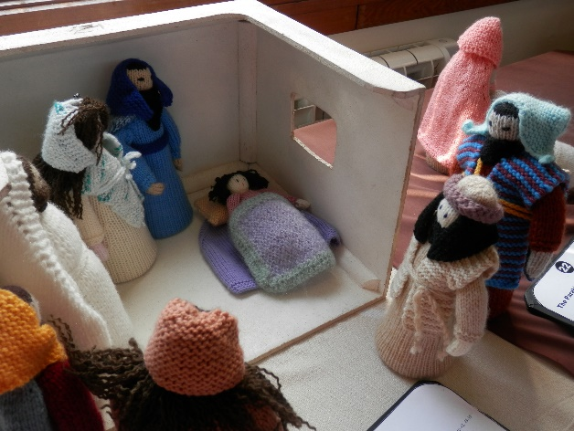
22 | 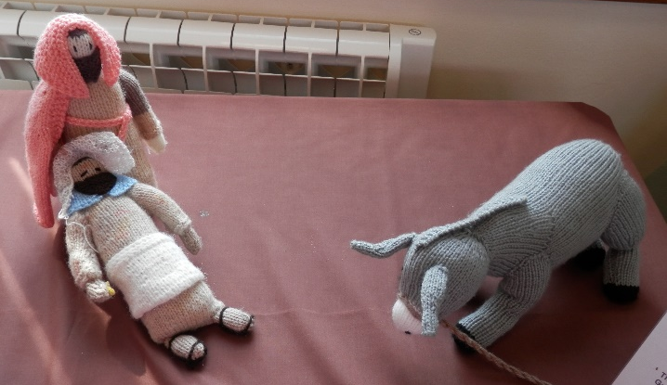
23 | 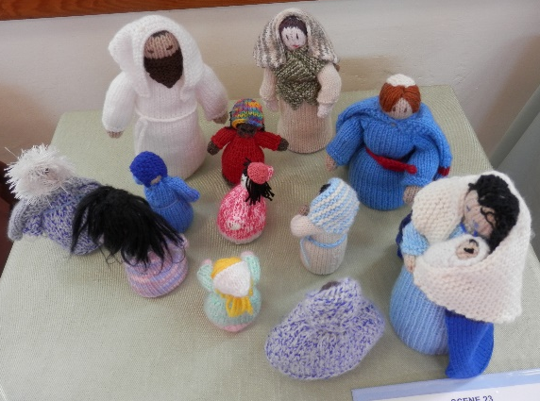
24 | 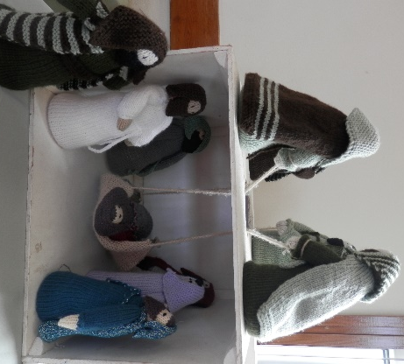
25 | 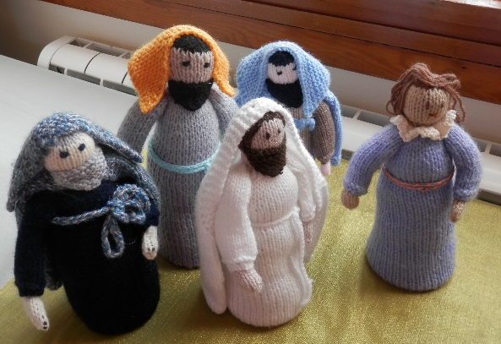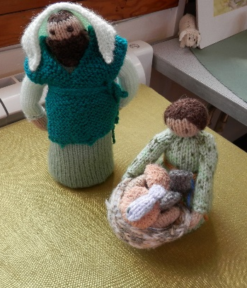

25a | 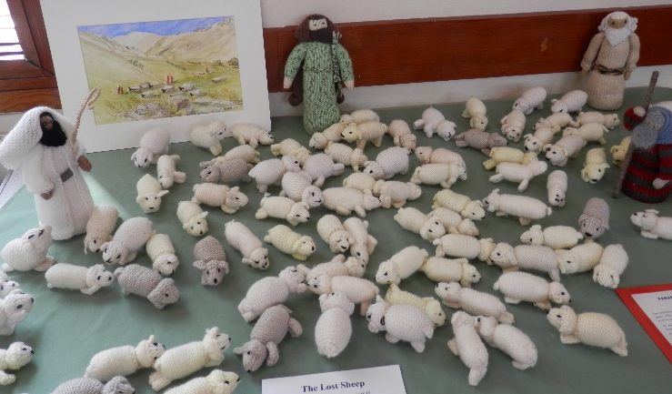
26 | 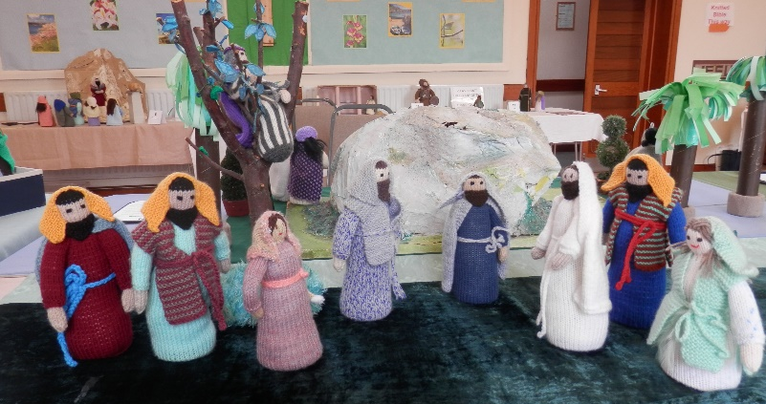
27 | 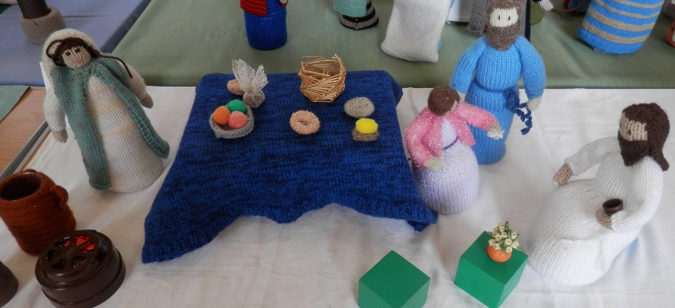
28 | 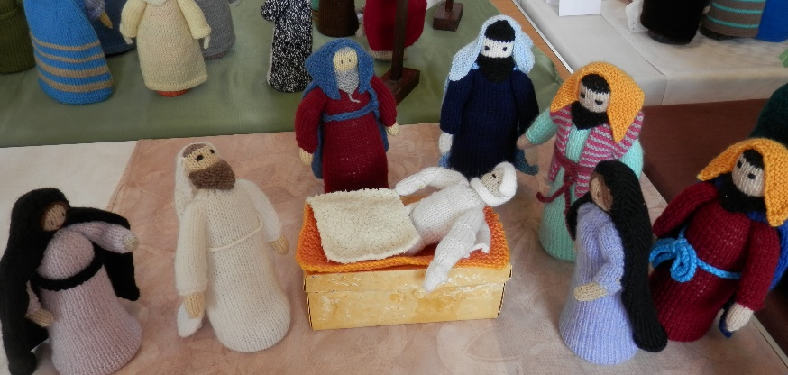
29 | 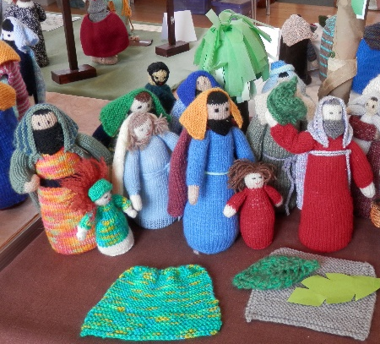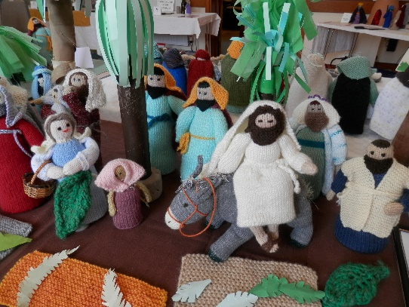

30
31 | 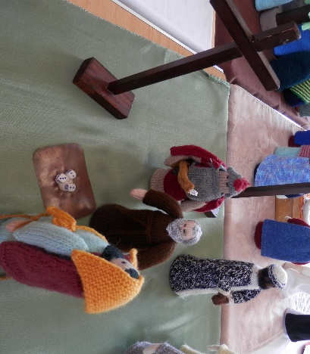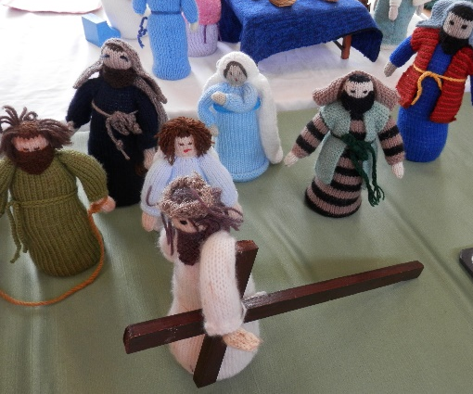
32
33

Wesley in Wool
Kitchen
Susanna Wesley was an extraordinary woman. Well educated, deeply religious, strong-minded, capable. She had 19 children of whom 10 lived. As well as running the home and the servants and managing the farm land. Susanna made a downstairs room into the schoolroom and taught reading and writing to the girls as well as the boys, plus the maids! The hours were 9am to 12 noon then 2pm to 5pm, each day with Susanna giving special attention to each one.

Fire!
John Wesley was 5 years old in 1709 when the Rectory in Epworth caught fire one night. All the family escaped but, standing in the garden and looking up, saw ‘Little Jackie’ in a bedroom window. A village man stood on the shoulders of his friend and reached in just as the thatch blazed and the bedroom floor collapsed. John Wesley’s mother, Susanna, saw this as God saving her son for a purpose, saying he was ‘a brand plucked from the burning’ (Zechariah 3:2)
Death Cart Alley
John went to Oxford University (and later became a tutor there) followed by his younger brother, Charles. A group of friends met to study, pray and witness together and were nicknamed ‘The Holy Club’ because of their strict rule of life, dividing up each day into hours spent praying or reading the Bible. They got called ‘Methodies’ because of this and the name stuck – we are today The Methodist Church. They had a deep concern for prisoners and befriended them, travelling with them in the death cart on their way to a public hanging at the gallows with the crowd pelting them with rotten lettuce and tomatoes.
Boat on the Storm
In 1732, wealthy Englishmen founded a new colony in America, called Georgia. John went there to be the Chaplain and Charles went to be Secretary to the Governor. Travelling by sea, there was a terrible storm and they feared for their lives. Some other travellers amazed them, praying serenely and singing joyful hymns. They were Moravians and did not fear death, believing God loved them and assured them of forgiveness. John was impressed by their faith and yearned to have that ‘assurance’.

America Indians
John dreamed of converting the native Americans in Georgia. But although they had a settlement nearby, his overtures of friendship got nowhere. However, he caused offence to the local congregation by his strictness, refusing to give communion to Sophy Hopkey and was threatened with legal action! He and Charles came home hastily, feeling failures and were depressed and disgraced. They felt they had failed God and were wretched.

Conversion
John and Charles stayed in London, in contact with the Moravians, always seeking assurance their sins were forgiven and wanting a deeper faith. In May 1738 Charles was very ill with pleurisy but had a wonderful spiritual experience and recovery. Two days later, on May 24th, John went ‘very unwillingly’ to a meeting in Aldersgate Street and at a quarter to nine felt his heart ‘strangely warmed’. He knew his sins were forgiven and ‘trusted in Christ alone’. They referred to these experiences as their ‘conversion’ and both brothers were transformed. Their preaching became dynamic!

Miners
In 1739 a remarkable friend, George Whitfield, asked John to join him in Bristol. George had been doing ‘field preaching’ at Kingswood, addressing great crowds of miners in the open air. This was unheard of! When George left for the Americas he persuaded Wesley to preach outdoors and John writes in his Journal, ‘I consented to be yet more vile’ as he preached in the open air, discovering he quickly drew a crowd and was good! Wesley preached regularly to the Cornish miners, local fishermen, Durham miners and the poor in villages and cities up and down the country.
Travelling the Country on Horseback
Wesley travelled everywhere on horseback, rarely by coach. He did a ‘circuit’ of towns and villages and people looked out for his arrival. He had a great mind, fascinated by almost everything, not just the Bible and theology. He read current philosophy, science, politics and literature and numerous pamphlets of the day. How did he have the time? He trained his horse to keep going whilst he loosed the reins and read on horseback.

The World is my Parish
Local vicars and bishops started to forbid Wesley to preach in their churches. It was strictly against the rules for clergy to preach outside their own parish. John defied that and when pulpits were closed to him, he declared ‘The whole world is my parish’ and continued preaching the length and breadth of the country, travelling miles on horseback, using every opportunity to declare God’s love and grace for every soul, finding people warmed to his message. Wesley became part of the whole ‘evangelical revival’ sweeping the country.

Local Barrow Haven
What of our area? In April 1764 Wesley records that he ‘turned aside to Barrow. When I was here last the mob was exceedingly rude and noisy: but all the people were now quiet and attentive. I was much pleased by their spirit … The next day I took boat at Barton with two such brutes as I have seldom seen’. Wesley often encountered rioting crowds, hecklers and disrupters and faced personal danger with opposition from local magistrates as well as clergy!

Worldwide with Methodism
Wesley travelled the country and Methodism spread apace, helped by one of Wesley’s closest and inspired followers – Dr. Thomas Coke. John sent Coke to America, but the ship was blown off course and landed in Antigua in the Caribbean! Coke started work there, moved to Jamaica, set up work and returned home to found the Methodist Missionary Society. Coke died sailing to India as a pioneer missionary. That world vision is truly in our bones as Methodists. Though we may never leave this country, we belong to a worldwide family of Christians.

Hymn Singing
Wesley started to organise people into ‘classes’ and published hymns to be used in such fellowship groups. Charles wrote a great number of magnificent hymns (over 7,000!) set to rollicking popular tunes of their day. Was Charles the greatest hymn writer ever known? Hearty singing was encouraged inside and outside for all Methodist gatherings. It became clear that Methodism was ‘born in song’ and the faith is learnt by singing glorious hymns with superb theology, as much as by teaching and preaching.

Medicine
Wesley’s extraordinary mission did not only include preaching and prayer. He had a deep concern for the poor and for the sick. Medicine was in its infancy and mainly to benefit the rich. So Wesley collected the very best cures he had heard about and published in 1747 a book called ‘Primitive Physic’ which sold extensively. He also had a clinic to help the poor and installed an ‘electric machine’ whose small electric shock he found very helpful! He encouraged people to meet in ‘classes’ and club together to help one another buy the medicines each needed.

Slavery and Wilberforce
In 1774 Wesley wrote a pamphlet ‘Thoughts on Slavery’ where he proposed a boycott on slave-produced rum and sugar, describing slavery as ‘dehumanising, cruel and barbaric’. He was influenced by men like Granville Sharp, Anthony Benezet and others, writing ‘Away with all whips, all chains, all compulsion’. In 1788 a diagram of a slave ship was printed showing 609 men, women and children crammed into a tiny space, head to toe, unable to sit or turn for the whole voyage. No wonder 23 out of every 100 died onboard. Just 6 days before he died, Wesley wrote to William Wilberforce, urging him to ‘continue to oppose this execrable villainy’.

Wesley Death Bed
Wesley stopped preaching in 1790, a year before his death at age 87. His friends gathered as he lay dying and he grasped each hand saying, ‘Farewell, farewell’. At the end, he lifted his arms and said, ‘The best of all is, God is with us’. He died a poor man having given away all he could but he left 135,000 members of Methodism and 541 itinerant preachers. When he was carried to his grave it is said that he left behind, ‘a good library of books, a well-worn clergyman’s gown and the Methodist Church’
Kitchen
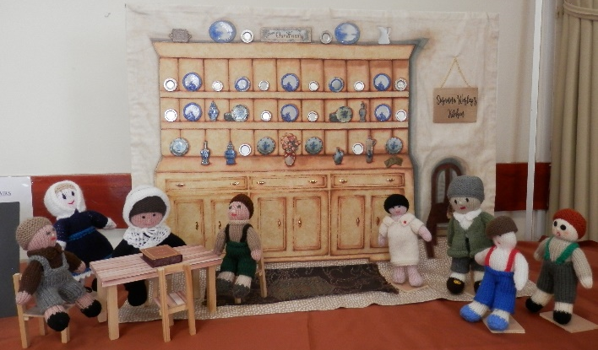
Fire!
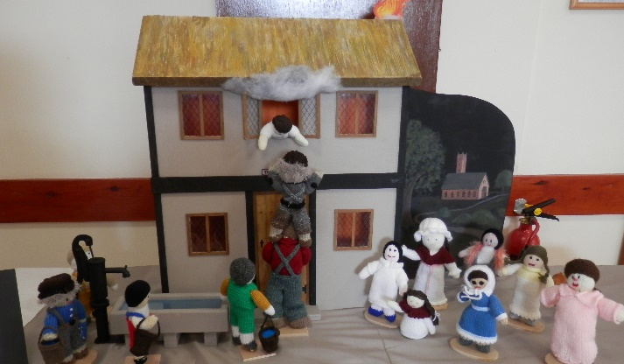
Death Cart Alley
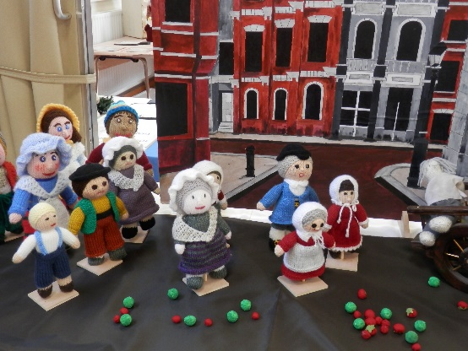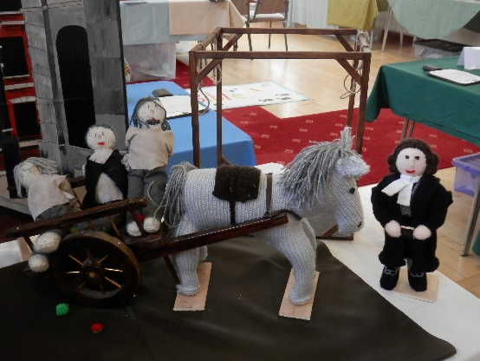

American Indians
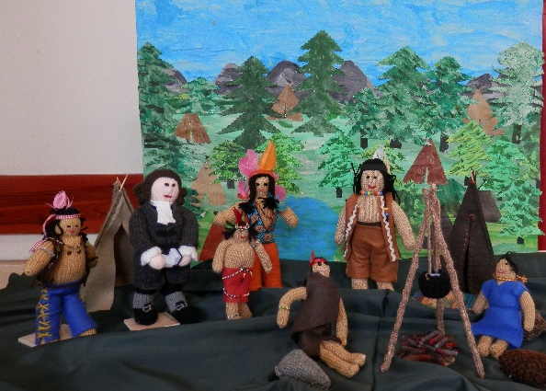

Boat on the Storm
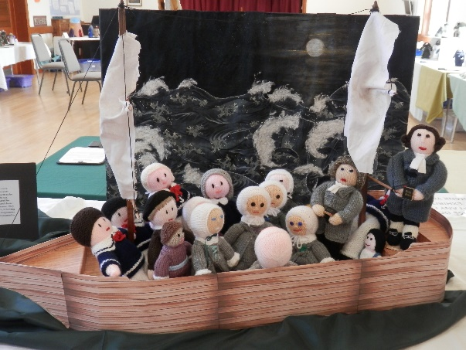

Conversion
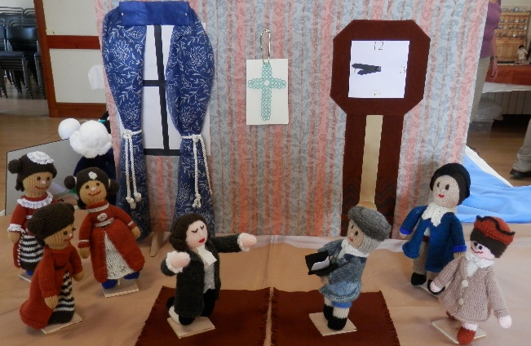
Miners
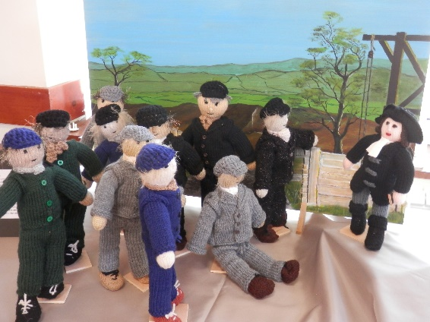

The World is
my Parish
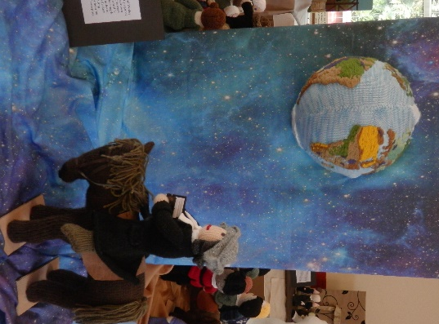
Travelling the Country
on Horseback
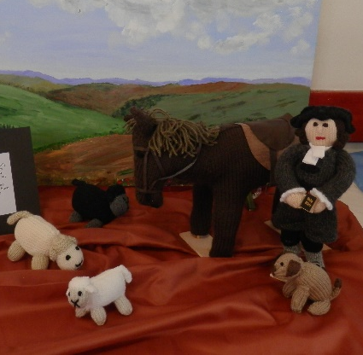

Local Barrow Haven
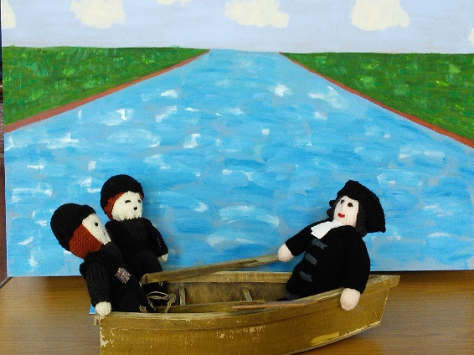

Worldwide with Methodism
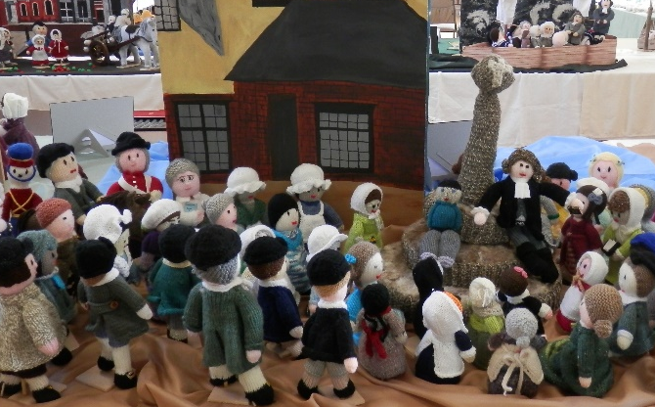
Hymn Singing
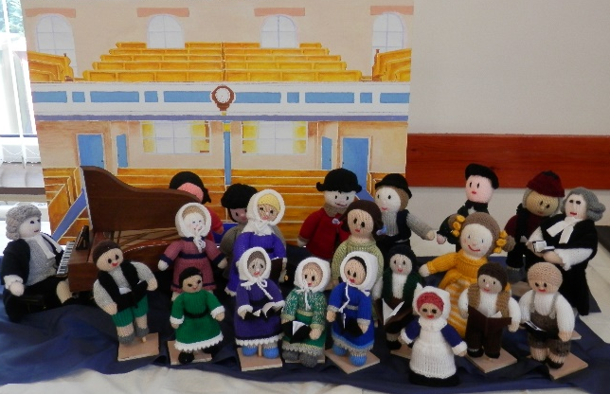
Medicine
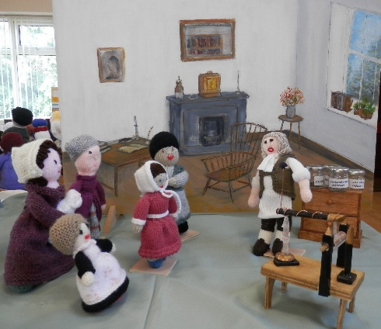
Slavery
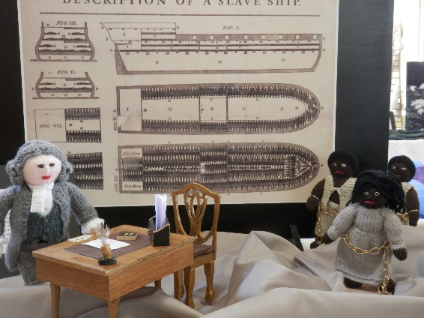
Death Bed
