Wesley in Wool

Wesley in Wool – created by members of Barton & Brigg Methodist Circuit

When we knew we were having the Knitted Bible to our churches we had an idea to make a display of the life of John Wesley to go with it. The display was designed by Jill Greenhalgh and Angela Kipling and knitted by many different people from local Methodist Churches and community groups over six months.

It contains 143 knitted figures in 15 scenes, each with their own backdrops which have been painted or crafted by different people. The scenes tell the story of the life of John Wesley, the founder of the Methodist Church.

Kitchen
Susanna Wesley was an extraordinary woman. Well educated, deeply religious, strong-minded, capable. She had 19 children of whom 10 lived. As well as running the home and the servants and managing the farm land. Susanna made a downstairs room into the schoolroom and taught reading and writing to the girls as well as the boys, plus the maids! The hours were 9am to 12 noon then 2pm to 5pm, each day with Susanna giving special attention to each one.

Fire!
John Wesley was 5 years old in 1709 when the Rectory in Epworth caught fire one night. All the family escaped but, standing in the garden and looking up, saw ‘Little Jackie’ in a bedroom window. A village man stood on the shoulders of his friend and reached in just as the thatch blazed and the bedroom floor collapsed. John Wesley’s mother, Susanna, saw this as God saving her son for a purpose, saying he was ‘a brand plucked from the burning’ (Zechariah 3:2)
Death Cart Alley
John went to Oxford University (and later became a tutor there) followed by his younger brother, Charles. A group of friends met to study, pray and witness together and were nicknamed ‘The Holy Club’ because of their strict rule of life, dividing up each day into hours spent praying or reading the Bible. They got called ‘Methodies’ because of this and the name stuck – we are today The Methodist Church. They had a deep concern for prisoners and befriended them, travelling with them in the death cart on their way to a public hanging at the gallows with the crowd pelting them with rotten lettuce and tomatoes.
Boat on the Storm
In 1732, wealthy Englishmen founded a new colony in America, called Georgia. John went there to be the Chaplain and Charles went to be Secretary to the Governor. Travelling by sea, there was a terrible storm and they feared for their lives. Some other travellers amazed them, praying serenely and singing joyful hymns. They were Moravians and did not fear death, believing God loved them and assured them of forgiveness. John was impressed by their faith and yearned to have that ‘assurance’.

America Indians
John dreamed of converting the native Americans in Georgia. But although they had a settlement nearby, his overtures of friendship got nowhere. However, he caused offence to the local congregation by his strictness, refusing to give communion to Sophy Hopkey and was threatened with legal action! He and Charles came home hastily, feeling failures and were depressed and disgraced. They felt they had failed God and were wretched.

Conversion
John and Charles stayed in London, in contact with the Moravians, always seeking assurance their sins were forgiven and wanting a deeper faith. In May 1738 Charles was very ill with pleurisy but had a wonderful spiritual experience and recovery. Two days later, on May 24th, John went ‘very unwillingly’ to a meeting in Aldersgate Street and at a quarter to nine felt his heart ‘strangely warmed’. He knew his sins were forgiven and ‘trusted in Christ alone’. They referred to these experiences as their ‘conversion’ and both brothers were transformed. Their preaching became dynamic!

Miners
In 1739 a remarkable friend, George Whitfield, asked John to join him in Bristol. George had been doing ‘field preaching’ at Kingswood, addressing great crowds of miners in the open air. This was unheard of! When George left for the Americas he persuaded Wesley to preach outdoors and John writes in his Journal, ‘I consented to be yet more vile’ as he preached in the open air, discovering he quickly drew a crowd and was good! Wesley preached regularly to the Cornish miners, local fishermen, Durham miners and the poor in villages and cities up and down the country.
Travelling the Country on Horseback
Wesley travelled everywhere on horseback, rarely by coach. He did a ‘circuit’ of towns and villages and people looked out for his arrival. He had a great mind, fascinated by almost everything, not just the Bible and theology. He read current philosophy, science, politics and literature and numerous pamphlets of the day. How did he have the time? He trained his horse to keep going whilst he loosed the reins and read on horseback.

The World is my Parish
Local vicars and bishops started to forbid Wesley to preach in their churches. It was strictly against the rules for clergy to preach outside their own parish. John defied that and when pulpits were closed to him, he declared ‘The whole world is my parish’ and continued preaching the length and breadth of the country, travelling miles on horseback, using every opportunity to declare God’s love and grace for every soul, finding people warmed to his message. Wesley became part of the whole ‘evangelical revival’ sweeping the country.

Local Barrow Haven
What of our area? In April 1764 Wesley records that he ‘turned aside to Barrow. When I was here last the mob was exceedingly rude and noisy: but all the people were now quiet and attentive. I was much pleased by their spirit … The next day I took boat at Barton with two such brutes as I have seldom seen’. Wesley often encountered rioting crowds, hecklers and disrupters and faced personal danger with opposition from local magistrates as well as clergy!

Worldwide with Methodism
Wesley travelled the country and Methodism spread apace, helped by one of Wesley’s closest and inspired followers – Dr. Thomas Coke. John sent Coke to America, but the ship was blown off course and landed in Antigua in the Caribbean! Coke started work there, moved to Jamaica, set up work and returned home to found the Methodist Missionary Society. Coke died sailing to India as a pioneer missionary. That world vision is truly in our bones as Methodists. Though we may never leave this country, we belong to a worldwide family of Christians.

Hymn Singing
Wesley started to organise people into ‘classes’ and published hymns to be used in such fellowship groups. Charles wrote a great number of magnificent hymns (over 7,000!) set to rollicking popular tunes of their day. Was Charles the greatest hymn writer ever known? Hearty singing was encouraged inside and outside for all Methodist gatherings. It became clear that Methodism was ‘born in song’ and the faith is learnt by singing glorious hymns with superb theology, as much as by teaching and preaching.

Medicine
Wesley’s extraordinary mission did not only include preaching and prayer. He had a deep concern for the poor and for the sick. Medicine was in its infancy and mainly to benefit the rich. So Wesley collected the very best cures he had heard about and published in 1747 a book called ‘Primitive Physic’ which sold extensively. He also had a clinic to help the poor and installed an ‘electric machine’ whose small electric shock he found very helpful! He encouraged people to meet in ‘classes’ and club together to help one another buy the medicines each needed.

Slavery and Wilberforce
In 1774 Wesley wrote a pamphlet ‘Thoughts on Slavery’ where he proposed a boycott on slave-produced rum and sugar, describing slavery as ‘dehumanising, cruel and barbaric’. He was influenced by men like Granville Sharp, Anthony Benezet and others, writing ‘Away with all whips, all chains, all compulsion’. In 1788 a diagram of a slave ship was printed showing 609 men, women and children crammed into a tiny space, head to toe, unable to sit or turn for the whole voyage. No wonder 23 out of every 100 died onboard. Just 6 days before he died, Wesley wrote to William Wilberforce, urging him to ‘continue to oppose this execrable villainy’.

Wesley Death Bed
Wesley stopped preaching in 1790, a year before his death at age 87. His friends gathered as he lay dying and he grasped each hand saying, ‘Farewell, farewell’. At the end, he lifted his arms and said, ‘The best of all is, God is with us’. He died a poor man having given away all he could but he left 135,000 members of Methodism and 541 itinerant preachers. When he was carried to his grave it is said that he left behind, ‘a good library of books, a well-worn clergyman’s gown and the Methodist Church’
Kitchen
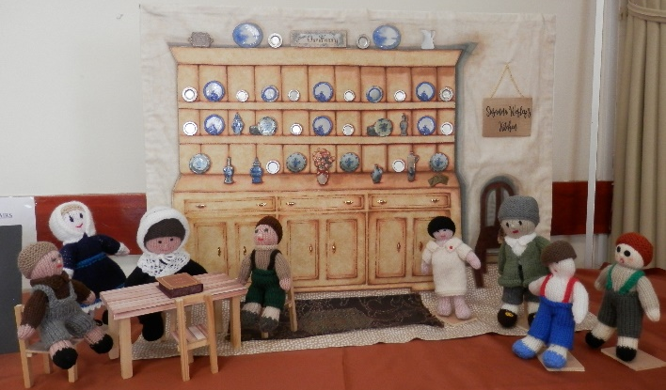
Fire!
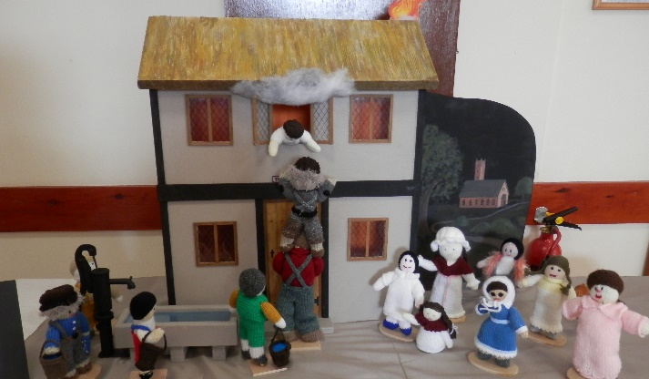
Death Cart Alley
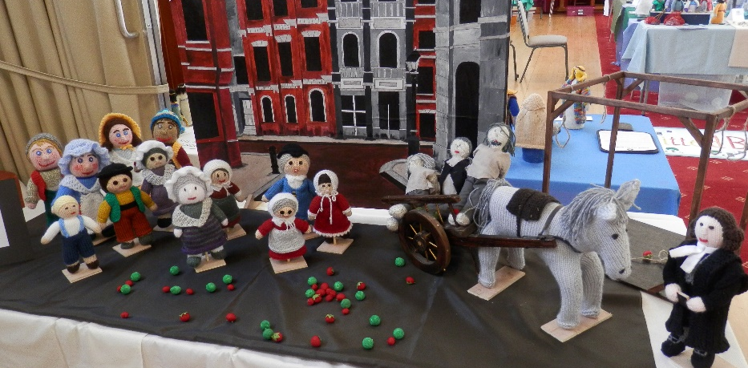

American Indians
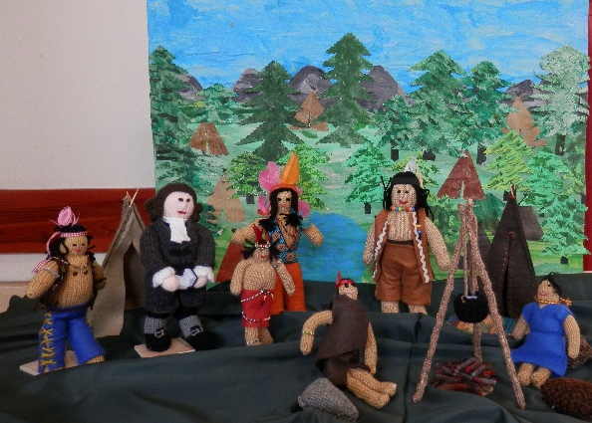

Boat on the Storm
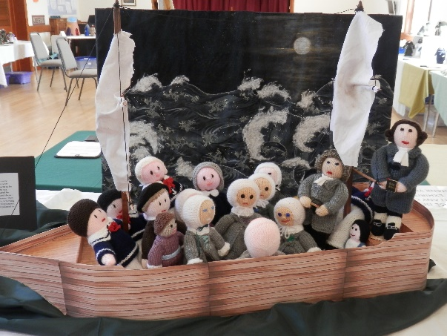

Conversion
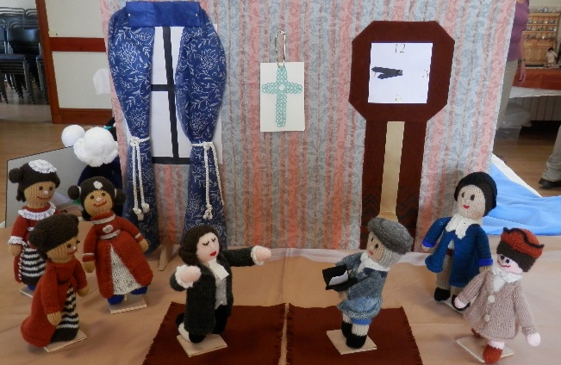
Miners
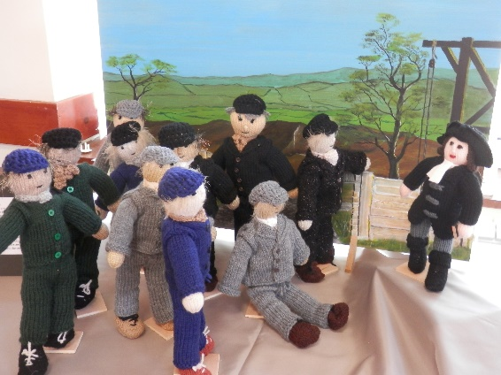

The World is
my Parish
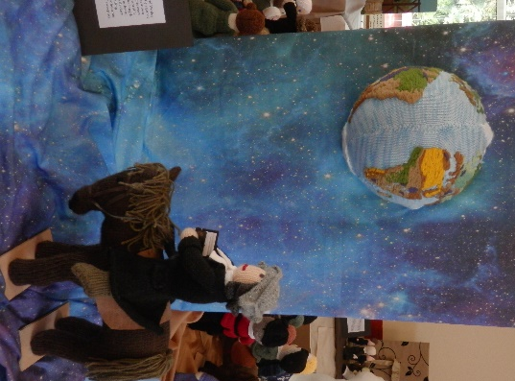
Travelling the Country
on Horseback
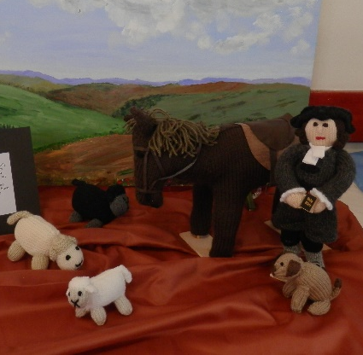

Local Barrow Haven
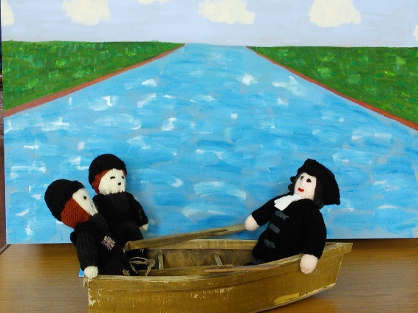

Worldwide with Methodism
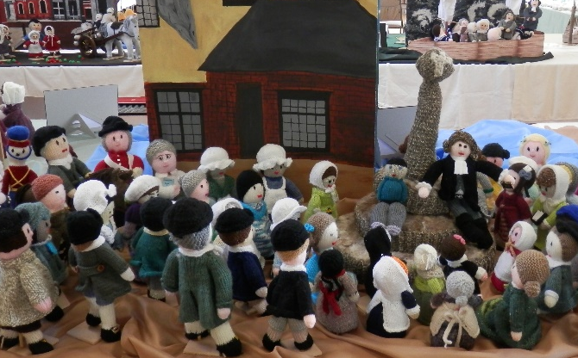
Hymn Singing
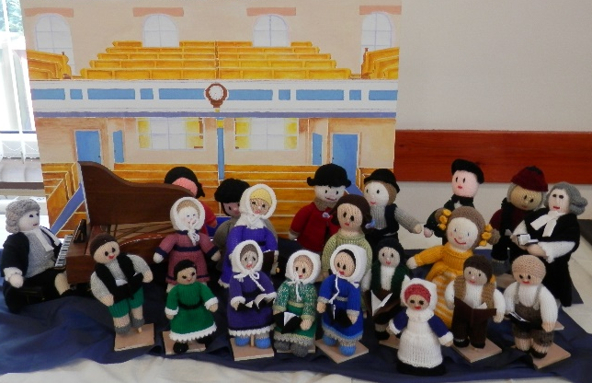
Medicine
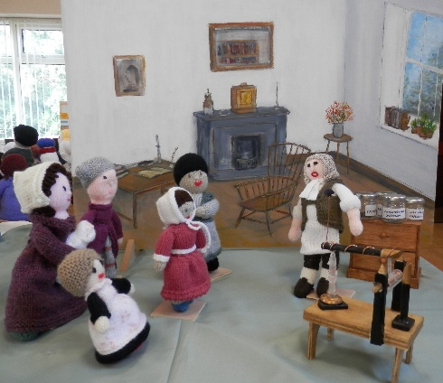
Slavery
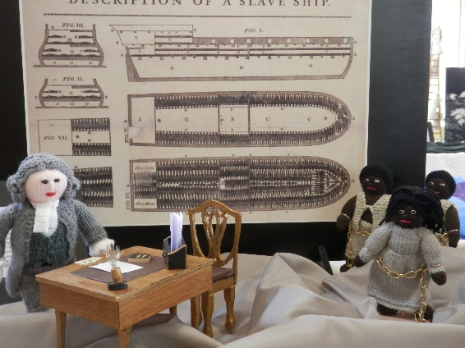
Death Bed
