MC/13/25
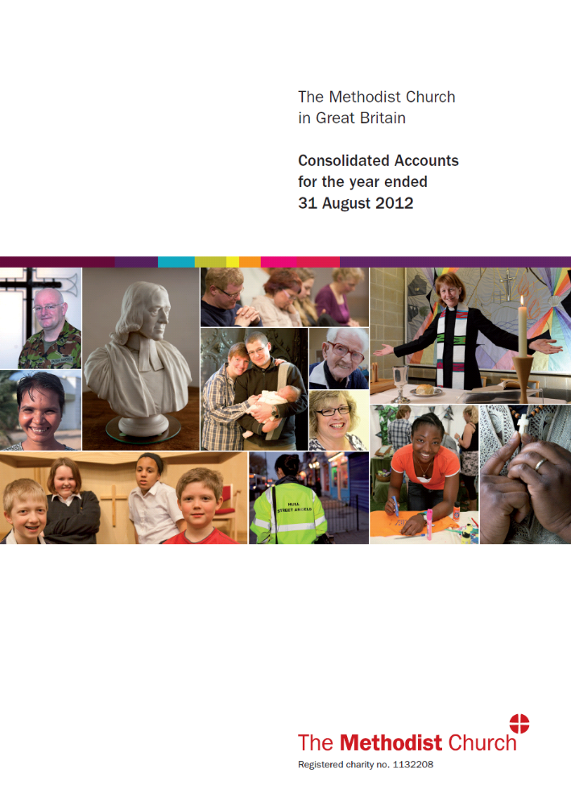

TABLE OF CONTENTS
WELCOME FROM THE REVD CANON DR MARTYN ATKINS | 3
STRATEGIC OBJECTIVES, AIMS AND PURPOSES OF THE METHODIST CHURCH IN GREAT BRITAIN | 5
PUBLIC BENEFIT REQUIREMENT | 5
STRUCTURE AND GOVERNANCE | 7
KEY ACTIVITIES | 11
FUTURE PLANS | 15
FINANCIAL REVIEW | 16
RESERVES POLICY | 19
INVESTMENT POLICY AND REVIEW | 20
RISK MANAGEMENT AND INTERNAL CONTROLS | 22
RELATED PARTIES | 23
PROVISION OF INFORMATION TO THE AUDITOR | 24
STATEMENT OF TRUSTEES’ RESPONSIBILITIES | 24
INDEPENDENT AUDITOR’S REPORT | 25
CONSOLIDATED STATEMENT OF FINANCIAL ACTIVITIES | 27
BALANCE SHEET | 29
CASH FLOW STATEMENT | 30
NOTES FORMING PART OF THE CONSOLIDATED FINANCIAL STATEMENTS | 31
REFERENCE AND ADMINISTRATIVE DETAILS | 53

Welcome from the Revd Canon Dr Martyn Atkins
In my introduction to the Consolidated Accounts last year I indicated that for several years to come the Methodist Church of Great Britain is focusing upon ‘discipleship’ and ‘mission’. Working out what this means and advocating ways whereby these foci shape the ministry and policy of the Church at every ‘level’ is a work in progress, but one in which considerable progress has been made through 2011-12.
The Conference of 2012 was presented with examples from each of its 31 Districts where new vision and energy are emerging through a renewed and creative focus on:
- ministries – lay and ordained – that enliven and deepen the life of the Methodist Church as a Christian Church committed to sharing the love of God in Jesus Christ;

- partnerships with others who share a commitment to creating healthy communities, supporting good things, and caring for the vulnerable in our society;

- utilizing Church premises to be better used for contemporary expressions of Christian worship, service, safety, and gathering places for vital and transformative conversations to be had;

- reflecting on the best use of resources and redistributing them in ways which maximize the potential to change individuals, institutions and communities for good;

- sustaining a commitment to finding apt and appropriate ways of inviting people to become followers of Jesus Christ.

The Conference reiterated its commitment to seek to configure the whole Church in these and other ways so that, employing its considerable but finite resources, even sacrificially, it gives substance to the aspiration of the Methodist Church to be ‘a discipleship movement shaped for mission’ today.
The resources of the Methodist Church outlined in these Accounts are, then, together with the considerably greater resources held within the Methodist Church not found in these Accounts, regarded as wherewithal for these essentially Christian and charitable purposes and foci.
Our commitments and actions arise fundamentally from our convictions as followers of Jesus Christ, and the essential goodness of God made plain in Christ. But we believe and are convinced that the actions, ministries, partnerships and commitments arising from our Christian faith and practice offer significant public benefit, to local communities and wider society, in a time when mutual care, support and respect is so much needed.
Throughout 2011-12 certain aspects of Christian discipleship and mission became the focus of the Church’s decision making, budgeting and new or continuing resourcing.
- We rejoiced in the highly successful embedding of 3Generate – our Children’s & Youth Assembly, our One Programme Participants project for young adults, and in receiving a National award for achievements in relation to youth participation.

- We adopted resolutions seeking to make our Church and churches as safe places as possible for children and vulnerable adults. Particularly, we instructed that holders of various types of offices and roles in the Methodist Church must undertake dedicated training material. We resolved that new posts be created throughout the Church relating to safeguarding issues, and committed to undertake a review of past cases in order to learn and adopt the best practices and policies in order to be as ‘safe’ as we can be.

- Recognizing our increasing diversity we are renewing our understanding of mission together as Methodist Christians in these Islands and as part of a global community of richness and need.

- We reasserted the importance of the provision of education as a major and proper part of Christian mission, and adopted proposals to support and develop our involvement with and in schools, together with partners, including the creation of more ‘academies’, particularly those focused upon the needs of poorer and disadvantaged communities.

- We agreed to further develop a commitment to wide-ranging chaplaincies, inviting every Methodist to consider how they can offer appropriate care and support in their neighbourhoods.

- We reaffirmed our commitment to seek to discover apt ways of inviting others to experience God’s love in Christ.

We shall continue to seek to live out our faith and use our resources, as gifts from God and the generosity of many thousands of people: in the words of one of our founders, ‘to serve the present age’.
The Revd Canon Dr Martyn Atkins

General Secretary of the Methodist Church in Great Britain
January 2013

Strategic objectives, aims and purposes of the Methodist Church in Great Britain
The activities covered in these accounts falls within the work of the Methodist Church. The strategic objectives of The Methodist Church in Great Britain (“The Methodist Church”) are directly linked to its aims. They are:
- Worship – to increase awareness of God’s presence and to celebrate God’s love;
- Learning and Caring – to help people to learn and grow as Christians, through mutual support and care;
- Service – supporting community development and action for justice, especially among the most deprived and poor - in Britain and worldwide; and
- Evangelism – developing confidence in evangelism and in the capacity to speak of God and faith in ways that make sense to all involved.

Public Benefit Requirement
The trustees of The Methodist Church had due regard to the public benefit guidance published by the Charity Commission in compliance with its duties under section 17 of the Charities Act 2011.

This guidance sets out two key principles:

- The organisation must have an identifiable benefit.
- The benefit must be to the public or a section of the public.

The Church exists, inter alia, to:
- increase awareness of God’s presence and to celebrate God’s love;
- help people to learn and grow as Christians, through mutual support and care; and
- be a good neighbour to people in need and challenge injustice.

The trustees consider that for these reasons the charity meets these public benefit requirements.

Progress in 2011-12

As noted in the General Secretary’s introduction to these accounts, work towards meeting the Church’s objectives in 2011-12 increasingly focused around the motif of discipleship. The following examples of how the plans for the year were delivered are based on the report presented to the Conference at its meeting in July 2012.

One theme has been exploring how in practice to honour the Conference’s instruction in Priorities to “work in partnership with others wherever possible”. Several opportunities outside the traditional partnerships of British Methodism have arisen. Some come from groups of worshipping communities outside the historic denominations, others from Christian agencies which work across several denominations. The Connexional Team has sought to ensure the Methodist Church has an accurate understanding of any potential partner, including their theological basis. The Team has also sought to identify where such agencies can provide expertise and resources in areas where districts, circuits and churches are looking for help but for which the Team is not equipped to respond. An example of a practical outcome of such work is the partnership with the Greenbelt Christian Arts Festival, where the Methodist presence was prominent.

Two major projects illustrate other aspects of progress. The following snapshots are from the staff members leading the respective projects.

The One Programme
The One Programme provides young adults aged 16-23, paid opportunities to work 15 hours per week, for a year, within a local project. Last year, there were 15 One Programme Participants across the country.
Matt Parker was based at Hart Foodbank, run by Fleet Methodist Church, which is part of the Trussel’s Trust and provides food to people in crisis. One of the aims of the Programme is to develop projects’ understanding of what it means to work alongside young people as equal partners. Matt was a young adult working within a team, where most volunteers were over-fifty. He always felt listened to and respected, and the team, in turn, valued the strengths he brought to the work, and his fresh perspective within their decision-making.
The One Programme also aims to provide opportunities to help shape specific pieces of work. The Foodbank had only just been set up when Matt joined, so he was able to be a part of it from the beginning and watch it grow from a small-scale project to one that helped more people every week. He was part of solving those initial difficulties encountered at the start of a new project, which resulted in its smoother running by the time he left.
The Programme also enables young people to develop new skills. Matt says, “I was given a lot of opportunities to work on public-speaking, which is something I find enormously nerve-wracking, but which frightens me less now. I'm much more punctual and better organised than I ever was before, and I learnt a lot about how to manage a small project.”
Finally, the One Programme aims to increase confidence and job prospects. Before the programme, Matt didn’t know what to do, felt overwhelmed, had never worked full-time, and didn't have much confidence. The One Programme gave him time to figure out what he wanted from a career, and to identify his strengths. He is now working full-time as a support worker to former rough-sleepers. He says “I really enjoy it, but I don't think I would have applied for the job had it not been for the experiences I had on The One Programme. I'm very grateful for all the people I met, and all the things that I learned.”
Play to win
The 2012 Games provided the potential for profound and long lasting benefits across the Methodist Church. Working under the banner of More Than Gold we used sport and culture to engage with the local community in fresh and dynamic ways.

Wholeness and Holiness, harnessing the feel-good factor of sport to increase grassroots and Young People's participation in the mission and discipleship opportunities that the Games brought was our aim and we achieved this across all 31 districts. Each district appointed a volunteer Super Champion who under the leadership of Ish Lennox, the project coordinator, promoted engagement within the district and nationally.
Playing sport is a regular part of life for a third of people in the UK we actively encouraged people to be more physically and spiritually fit.
We used the power of the Games to promoting community engagement across all groups in society whether through tackling social justice issues, singing the faith or through family festivals. Improving communities and expanding peoples life chances.

The Methodist Church’s commitment to the Olympic torch moment saw our biggest engagement. We initiated the Big Cream Tea, a Cornish wide event where churches hosted free cream teas and gave away gospel literature. We continued our tradition of hospitality as Methodists provided fare across the country for spectators watching the torch.
District prayer initiative, each district created a prayer symbol which travelled around the district for the 70 day period that the Olympic torch was on the move. These symbols have now been collected and are on exhibition in one of our heritage sites.
Praise Bus - a Methodist Singing the Faith initiative. This bus travelled ahead of the Olympic torch and hosted over 100 different musicians from different ecumenical backgrounds.

We provided Games Pastors, accommodation for athletes’ families and mission teams.

From the outset The Methodist Church was committed to ensuring a Legacy from our engagement with these Games. Our engagement and the lessons learned have now been compiled into a Legacy website.
With the UK set to host a number of sporting world Championships over the coming years – in what many commentators are calling a golden decade of sport – there are great opportunities for The Methodist Church as we go forward.
Structure and Governance
The entities included in this report are not a record of all the financial activities of the Methodist Church in Great Britain as they do not include local church, circuit and district accounts. The names of the entities included in this report are listed in ‘Note 1’ of the accounts on page 32 and include:

Activities managed or administered by the Connexional Team (hereafter referred to as the Connexional Funds)
Cliff College | (a separately registered charity)
Cliff College Outreach Limited | (a separately registered company)
Cliff (Methodist) Developments Limited | (a separately registered company)
Methodist International Centre Limited | (a separately registered company)
Methodist Relief and Development Fund | (a separately registered charity)
Southlands Methodist Trust | (a separately registered charity)
T Beckett (Saddler) Limited | (a separately registered company)
Westminster College Oxford Trust | (a separately registered charity)

For the purposes of these accounts these entities are referred to as The Methodist Church in Great Britain. During the year Trinity Hall Trust was dissolved as a charity and transferred into the Connexional Funds.

Structure
The Methodist Church applied and became a registered charity on 20 October 2009 (1132208 – “The Methodist Church in Great Britain”). The members of the Methodist Conference are the trustees and their names are publically available on the Charity Commission website. The Methodist Council is appointed annually by the Conference. Amongst other functions it is responsible for the adoption annually of a unified statement of connexional finances, clearly distinguishing between restricted and unrestricted funds and conforming to the law and accounting regulations so as to give an overall view of those monies and other assets for which the Council is responsible. The Council is further responsible for presenting that unified statement of connexional finances to the Conference. The names of the members of the Methodist Council are appended at the end of these accounts.
The basic governance structure so far as the Consolidated Accounts are concerned is presented in the diagram below.

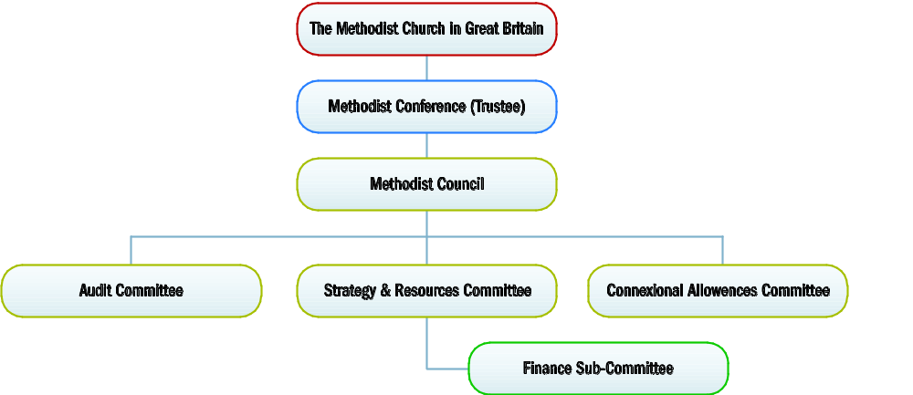

Methodist Conference
The government and discipline of the Methodist Church and the management and administration of its affairs is vested in the Conference. The Conference meets annually in Representative Session and Ministerial Session (and there is in addition a Conference Diaconal Committee). The Conference is a representative body of 306 members comprising ministers and laypersons from the 31 districts of the Methodist Church of Great Britain as well as other bodies of the Church.

The Methodist Council
The Methodist Council consists of 54 people (see page 51 for members) most of whom hold office for four years. It meets at least three times a year and its terms of reference are to:
- Continuously review the life of the Methodist Church
- Study the work of the Methodist Church and witness throughout the Connexion
- Indicate what changes are necessary or what steps should be taken to make the work of the Church more effective
- Give spiritual leadership to the Church
- Implement Conference decisions
- Report annually to the Conference, bringing to the notice of the Conference matters to which it believes the Conference ought to give urgent attention
- Protect the assets of the Methodist Church

In addition to the above it is particularly responsible for (inter alia):
- Adopting and presenting to the Conference the unified statement of connexional finances
- Recommending the budget for the Methodist Church Fund (unrestricted general reserves)
- Employing lay members of the Connexional Team and being the responsible body recommending the stationing of its ordained members
- Administering the following funds:
  - Methodist Church
  - Connexional Priority
  - World Mission
  - Mission in Britain
  - Fund for Training
  - Fund for Property
  - London Mission
  - Fund for the Support of Presbyters and Deacons
  - Sabbatical
- Making recommendations on expenditure and amounts to be contributed by the Circuits through Districts to fund the next connexional year
- Recommending minimum stipends for Presbyters, Deacons and Probationers including additional allowances to be paid to Superintendent Ministers, District Chairs and the maximum to be reimbursed from the Connexional Sabbatical Fund
- Dealing with all model trust property affairs for all Home Districts and the building, legal and financial aspects of shared schemes under the Sharing of Church Buildings Act 1969, where that act applies.
- Acting generally in relation to property affairs and constituted to discharge the responsibilities of the former Property Division.
- Ensuring that the sale, lease, rental or lending of artefacts, publications and records which are model trust property and which in the view of the Council are historically significant are scrutinised before going ahead.

Governance
Much of the day to day work for which the Methodist Council is responsible is delegated to the Connexional Secretary and other members of the Senior Leadership Group for matters relating to the objectives of the Connexional Team and local management committees in the case of the training institutions and residential centres. These local management committees report to the Methodist Council.

The following committees have an oversight / governance role in relation to the Methodist Council:

The Strategy and Resources Committee
The Conference appoints annually the Strategy and Resources Committee (SRC), a sub-committee of the Methodist Council. The SRC advises the Council in relation to all matters that are within the SRC’s terms of reference, having regard to advice from non-voting members. The Committee, which met four times in the year, has specific responsibility for detailed review and subsequent reporting to the Council on the following aspects of its work:

- Detailed examination of the annual financial statements of Connexional finances;
- Recommendation to the Methodist Council of the annual budget for the Methodist Church Fund;
- Supervision of the work of the General Secretary and Connexional Team;
- Exercising oversight of the general work of the Connexional Team and report to the Council and the Conference;
- Ensuring that a collaborative style of working is adopted throughout the Connexional Team;
- Review and presentation to the Methodist Council of the Annual Trustees’ Report and consolidated financial statements; and
- Identification and management of risks.

The Audit Committee
This is a committee of the Conference appointed on the nomination of the Methodist Council. To safeguard its independence members of the Methodist Council or the Connexional Team are barred from serving. This committee nevertheless has powers to require the Connexional Treasurers and any appropriate staff members of the Connexional Team to attend its meetings.

Meeting three times in the year and reporting annually to the Methodist Council, the Audit Committee has responsibility for:
- Advising the Council on the appointment of external auditors;
- Reviewing the consolidated financial statements of the Methodist Church;
- Reviewing, with the auditors, the consolidated accounts;
- Reviewing the effectiveness of the financial and other internal control systems with regards to monies and other assets for which the Council is responsible;
- Submitting an annual report to the Council; and
- Reviewing the effectiveness of procedures relating to risks.

Oversight committees
To assist the Council in discharging its duties there are a number of other committees, the key ones being the:

- Finance Sub-Committee of the Strategy and Resources Committee whose remit is to:
- provide expert advice on financial matters to the SRC;
- provide the core membership of the Conference Financial Committee;
- represent as the employer in discussions with the Trustees of Connexional Pension Funds; and
- to monitor and review the risk register.

In addition the connexional treasurers and some members of the Connexional Team meet regularly to consider matters of Investment Management, with particular concerns for:
  - Monitoring the performance of the Council’s investment managers (CFB); and
  - Deciding, on the basis of the requirements of the various funds (under Connexional Team management), the most appropriate investment strategy.

- The Development and Personnel Sub-Committee of the Strategy and Resources Committee whose remit is to:
  - Oversee the personnel of each Methodist Council employing body
  - Monitor the governance bodies in terms of their employment and stationing responsibilities
  - Oversee employment practices
  - To convene as an appeals panel

- Connexional Allowances Committee which is responsible for recommending allowances for Ministers and awarding grants from the following funds:
- Fund for Support of Presbyters and Deacons;
- Methodist Medical Benevolent Fund ;
- Methodist Ministers Children’s Relief Association ; and
- Connexional Travel Fund.

- Connexional Grants Committee which is responsible for:
- All Connexional grants, including the establishment of a clear published application process and award criteria
- Monitoring all grants made by sub-committees and grant streams
- Operating within annual budget set by Council
- Monitoring grants made by Districts
- Establishing clear processes for the longer term monitoring and evaluation of grant expenditure.

- The Trustees of the Methodist Relief and Development Fund whose remit is to receive, hold and transmit monies for relief, rehabilitation and development under Methodist or, ecumenical or other appropriate oversight primarily overseas.

- Local Governance/Managing Trustee Committees.

A comprehensive list of the self-accounting entities whose accounts are included into the Methodist Church Consolidated Accounts is provided on page 32. For each of them a local governance committee or group of managing trustees is appointed by the Council to oversee the entity, within the terms of responsibility delegated to them by the Council. Ultimate control in all these cases resides with the Methodist Council. Through a governance scrutiny process overseen by the SRC, the Council aims to monitor standards of governance in all the entities, which are accountable to the Council.

Appointments to the various trustee boards are approved by the Methodist Council on the recommendations of the existing board members, following a selection process that involves a skills audit and advertisement for trustees with the appropriate skills and expertise. Appointments are normally for a six-year period.

All new trustees undergo induction to familiarise themselves with the aims and work of the charity, and to ensure they understand fully their responsibilities as Board members and the organisational expectations in terms of their commitment. As part of the induction programme, trustees are provided with constitutional, governance, financial and organisational documentation. Trustees also receive regular updates and are made aware of relevant events and training opportunities.

Key Activities
In responding to the Methodist Church’s Calling, the Methodist Council organises the work of the Connexional Team in six main areas as follows:
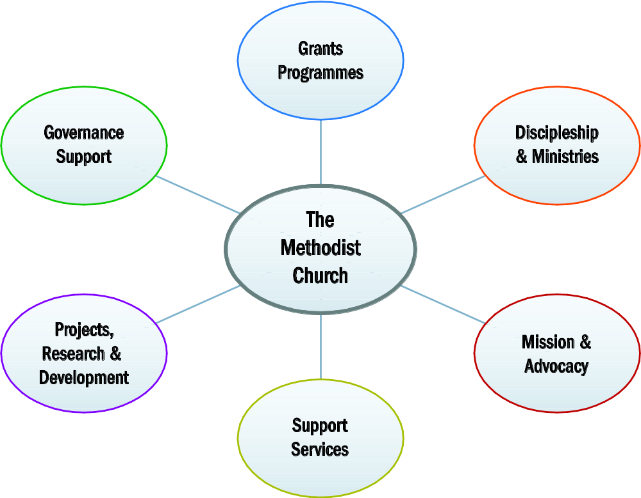

Grants Programmes
Three types of grants are available at a “connexional” level: grants to support personnel of the Church; grants to support mission and ministry work of the Church and student grants.

Mission and Ministry Grants

Mission and Ministry in Britain
The Connexional Grants Committee (CGC) assesses applications for funding for Mission and Ministry projects. In doing so the CGC assesses the application against two sets of criteria. The first allows the Committee to assess whether this project should be funded via CGC resources; the second helps the CGC assess how well planned the project is and the outcome it is likely to achieve. Funding for these grants is drawn from a variety of sources including the Mission in Britain, the Connexional Priority and the Epworth funds.
The Methodist Council, through the CGC, made 91 mission & ministry grants for specific pieces of work across the Connexion, ranging from £2,000 to £365,000. Work funded included a national arts project using storytelling, drama and visual arts to explore the richness of the Gospels with a 21st century audience. This innovative mission work combines dramatic textual analysis and exegesis with innovative styles of communication, to reveal the Bible with a contemporary impact.

Another grant was made under the Mission Alongside the Poor Programme to the Plymouth Foodbank. This has enabled the project, which works in an area of extreme socio-economic deprivation, to develop a wider range of services for local people and to include health promotion, stress management, and discipleship training to project beneficiaries.

Mission & Ministry in the World Church Grants
The CGC also administers the Church’s international grants. These are given to Partner Churches and organisations overseas to support mission and ministry in their communities. These grants are drawn from the World Mission Fund and the entire cost of a multi-year grant, where there is no break clause, is committed in the year it is approved.

Personnel Support Grants
Small grants are made to Methodist presbyters, ministers, deacons, lay employees and local preachers and their families towards the education of their children, during times of ill health and for one-off financial support. Giving for this purpose draws on a variety of funds including the Fund for the Support of Presbyters and Deacons, Trinity Hall Trust and several benevolent funds.

Westminster College Oxford Trust (WCOT) Grants
Westminster College Oxford Trust holds endowment funds for the benefit of students studying at Oxford Brookes University. Income from these funds is allocated in accordance with the appropriate terms of reference and the restrictions imposed by the donors.

Methodist Relief & Development Fund (MRDF) Grants
MRDF awards grants through local partners in their priority countries which are registered non-governmental organisations (NGOs), community based organisations (CBOs) or development offices of Methodist Churches. Humanitarian aid is only allocated through organisations which are existing MRDF partners, Methodist Churches, or through Action by Churches Together (ACT).

Property Grants
The CGC assesses applications for funding by circuits and churches for property projects which have mission aims. Grants are drawn from the Fund for Property, the Connexional Priority Fund and a number of endowment funds.

Discipleship & Ministries
Working in collaboration with districts, circuits, learning institutions and other bodies, the Discipleship & Ministries Cluster of the Connexional Team supports and develops programmes, resources and activities in the fields of formation, learning, training, theological education, scholarship, research and innovation across the Connexion. This includes developing and maintaining pathways for initial training and continuing development for a range of ministries, both lay and ordained.
- Over the past year, full-time initial ministerial training has been provided through the maintenance, management and staffing of Wesley House, Cambridge, the Wesley Study Centre, Durham and the Queen’s Foundation, Birmingham. Part-time initial ministerial training has been provided through partnerships with other institutions and programmes. In addition to resources to support learning institutions and programmes, maintenance grants are administered to support those undergoing such training.
- Opportunities for continuing development for those exercising lay and ordained ministries have been provided through induction courses, conferences and training events held across the Connexion, organised in partnership with district and regional officers within the Connexional Team.
- This year, 42 individuals completed their pre-ordination training and were received into Full Connexion and ordained at the 2012 Conference.
- Work continued on The Fruitful Field project, which aimed to provide an overview of the Church’s connexional commitments and activities in the fields of learning and development and to ensure that progress in these fields is in keeping with the needs of the Church. A final report was brought to the 2012 Conference, which resolved upon the creation of the Discipleship and Ministries Learning Network, which will take the lead in designing, offering and overseeing a range of learning pathways, opportunities, programmes and resources. Work is now underway on the implementation of the Network and the associated decisions of the Conference.
- Specialist staff supported the work of the Church with children and young people and paid staff and volunteers who work with them in communities across the country. The One Programme scheme employed 13 young people aged 16-23 in a gap year programme of learning and development.

- Chaplaincy across nine disciplines was advocated and encouraged through networks of volunteers and paid personnel

- Working with leaders throughout the Connexion to resource and strategically embed the focus on a discipleship shaped for mission through the organisation of conferences, forums, workshops and resources.
- Raising the profile of the priority of evangelism through consultation and resources to explore what evangelism for the 21st century looks like for the British Methodist Church.

Mission & Advocacy
The responsibilities of the Mission and Advocacy staff, which includes Methodist Publishing and the Joint Public Issues Team, include:
- Developing, updating and maintaining the Church’s official website at www.methodist.org.uk.

- Promoting advocacy through the publication of educational and informative material on the work of the Methodist Church including specific information on the Methodist Church Fund and the Mission in Britain and World Mission funds.

- Lobbying politicians and other public figures on issues on which the Church has particular views.

- Publishing and distributing Mission Matters, our quarterly mission journal.

- Through the World Church Relationships staff, engaging with at least 70 countries through Partner Churches.
- Through the National Missions in Appointment scheme, providing funding for a Partner Church to develop appointments of strategic mission significance by employing a member of their own church to carry out the work. The appointments are normally for a period of five years. In 2011-12 forty one appointments were funded committing a total of around £1.0m.
Sending Mission Partners across the world. Their areas of work are varied including education, agriculture and medicine, as well as pastoral and theological responsibilities. This work costs about £1.6 million per year.

- During the year we committed £0.5m on scholarship grants for Partner Churches. In addition, we accepted forty students to study in the UK, study elsewhere (‘South to South’) or as part of a training group in Nigeria.

Support Services
This area of work includes:
- Safeguarding work which is shared with the Church of England, and provides expert advice and support to all levels of the Church.

- Providing the payroll service for over 2,500 ministers, 700 lay employees and 65 personnel working overseas and paying expenses of the Conference and its committees;

- Administering the funds that are under the managing trusteeship of the Methodist Council;

- Collecting gift aid on behalf of individual churches, circuits and districts;

- Administering a system of capital property project consents that maintain the Church’s ecclesiastical exemption regarding its buildings that are listed or in conservation areas;

- Providing managing trustees (at district, circuit and church level) with a wide range of guidance and support to enable them to fulfil their responsibilities.

Projects, Research & Development
In addition to the Olympics project featured above, the team have been engaged and working on a portfolio of research and projects to support the Connexion which includes:
- The annual collection and distribution of information relating to Statistics for Mission across the Connexion
- The Missing Generation Research project
- The Venture FX Pioneering Ministries project
- The Inspire Project
- The Interfaith Relations project
- The development and sharing of information relevant to Carbon Reduction
From the 1 September 2012 the work of the Projects, Research and Development Cluster will be subsumed in the other clusters.

Governance Support
Staff in the Governance Support cluster enable the proper functioning of the Methodist Church’s legal and constitutional responsibilities as laid out in its foundational documents and subsequent constitutional materials approved by the Conference. It assists the Church to develop continually its governance arrangements, enabling it to live out ‘Our Calling’, and ‘Priorities’ in new and innovative ways.

Future plans
In the light of the decisions of the 2011 Conference and especially the centrality of the Discipleship motif for future work, the following plans have been accepted by the Methodist Council as areas for work in the year 2012-13 and beyond. The broad headings under which the work is grouped are from the General Secretary’s keynote report to the Conference.

- Contemporary Methodism: a discipleship movement shaped for mission...ministries

- continuing work on a bold and radical re-imagining of the ministries required by our Connexion and the activities and resources required to form and equip those called to these ministries and roles;
- continuing support for chaplaincies through staffing and other resources;
- continuing development and sharing of high-quality resources to deepen the discipleship of all ages, stages, and particularly those groupings least evident in our Connexion;
- continuing work on forging and strengthening partnerships with a variety of groupings and organisations that deliver our focus on discipleship and mission;
- continuing reflection upon appropriate training of local leaders, story sharing, etc;
- continuing work on all of the above through the implementation of the Discipleship and Ministries Learning Network, and through the formational, infrastructural and organisational change mandated by the 2012 Conference.

- Contemporary Methodism: a discipleship movement shaped for mission...advocacy and evangelism

- support projects giving expression to the foci of discipleship and mission: London Institute for Contemporary Christianity, Inspire, Hope Together, Greenbelt, etc;
- plan the idea of ‘Festivals’ to take throughout the Connexion opportunities to engage the discipleship movement shaped for mission in a variety of ways and means;
- provide time and space to reflect on the radically different approaches to making disciples to those with no Church background at all, and the timelines and resources required to make this a sustainable driver of change;
- continue our commitment to formal and informal, national and local, established and new patterns for ecumenism and partnerships in mission and ministry;
- work out new patterns of partnership and ministry with Methodists and United Churches around the world, enabling UK Methodists to live their discipleship on a larger map;
- sustain the Methodist commitment as a Connexion of Christian disciples to speak prophetically, clearly, courageously, affirmatively and critically to the decision-makers and structures that shape our contemporary society and its communities.

- Contemporary Methodism: a discipleship movement shaped for mission...development and personnel

- continue to develop and provide professional and inspirational Safeguarding and wellbeing material;
- after the successful Safeguarding past cases review pilot, ensure that it is rolled out across the whole Church, demonstrating transparency and pastoral care;
- oversee the third year of the Belonging Together project to produce a structured approach that delivers the Conference decisions about Equality and Diversity issues.

- Contemporary Methodism: a discipleship movement shaped for mission...financial and structural

- develop three-year budgets
- retain within the budget identified capacity for grasping opportunities to promote and resource a discipleship movement shaped for mission;
- implement new criteria for property grants that encourage developments that are clearly linked to mission and discipleship;
- implement the new financial database/management system to promote financial aspects of Discipleship and stewardship;
- provide a ‘discipleship/mission’ focus to Conference projects that will help them flourish, through clear purposes, outcomes and evaluation mechanisms

- Contemporary Methodism: a discipleship movement shaped for mission...property

- work with the United Reformed Church via the Joint Property Strategy Group to inspire new energy and shared thinking in the creative use of the Church’s physical assets;
- improve support for Districts and Circuits in dealing with property questions and issues, especially as part of the Regrouping for Mission initiative;
- develop an electronic system for the collection, storage and dissemination of annual church property records.

Financial Review
The activities covered in these consolidated accounts are those under the oversight of the Methodist Council. The Methodist Church in Great Britain is the registered charity and the Charity Commission have agreed that these accounts can properly serve as the accounts of the charity.

At the end of the year, the Church recorded net incoming resources before transfers and revaluations of £7.8 million (2011: £1.4 million). Total incoming resources for the year were £46 million, up 4% on the previous year. Total resources expended fell by 10% to £37.8 million (£42.2 million in 2011).

Charitable income
The main sources of charitable income are donations (including legacies) and the district assessment. Together these accounted for 50% of all incoming resources.

The increase in income of 4% to £46 million (2011: £44 million) is mainly due to the impact of the first time consolidation of Southlands Methodist Trust (£4m). Sales of the hymn book, “Singing the Faith” account for the increase in fundraising trading of 38%. Investment income rose by 13%. Against this there was a fall in voluntary income of 9%. Current year income includes the “donation” of the net assets of Southlands Methodist Trust upon consolidation, (2011 included £4million worth of the net assets of Westminster College Oxford Trust). If these one-off charges are excluded, the net year-on-year reduction in voluntary income is 17%.

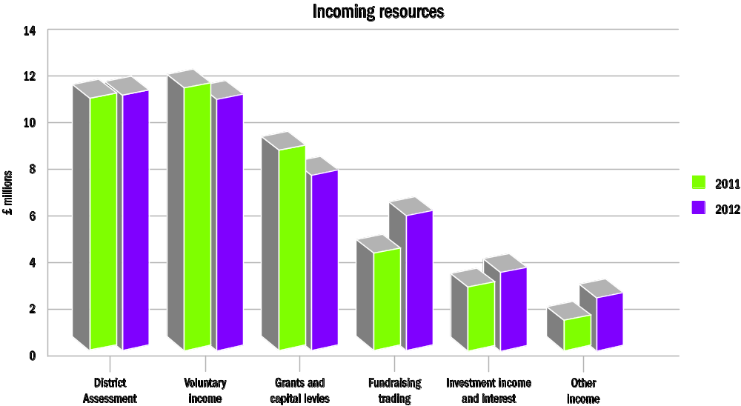

Charitable Expenditure
Overall expenditure fell by 10%. The biggest reduction has been in the area of grant giving, which fell by 33% to £13 million (2011: £19 million). Property grants saw the biggest fall (91%) reflecting one-off adjustments made in the previous year, whilst resourcing overseas mission grants fell by 22% and the other types of grants fell by 28%. This trend reflects an overall decline in the level of grant commitments. The overseas mission grants include a grant commitment write back of £1.7 million. Non charitable expenditure increased by 32%, with the biggest increase attributed to fundraising trading, an area which has grown significantly in the past twelve months due to hymn book sales.

Charitable expenditure includes a planned draw-down on restricted and designated funds (the Training Assessment and Connexional Priority Funds).

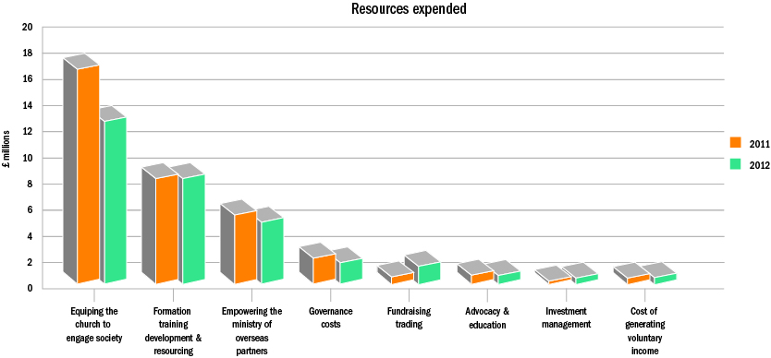

Segmental information
The accounts of the Methodist Church in Great Britain are composed of different entities as set out in note 1 (d) on page 32. These entities are engaged in different activities as follows:
- The “Funds administered by the Connexional Team” include the Methodist Church Fund, the main restricted funds (Mission in Britain, Property Fund, World Mission Fund, the Fund for the Support of Presbyters and Deacons) as well as the Connexional Priority Fund. These funds are applied towards a number of activities including the grants programme, Discipleship and Ministries work, governance, key projects of the Methodist Church (such as Belonging Together, Venture FX , District Development Enablers and Youth Participation Scheme)and Mission and Advocacy work.
- Ministerial training (Cliff College, Hartley Victoria, The York Institute and Wesley Study Centre);
- Supporting international and home students studying in London (Methodist International Centre & the Guy Chester Centre);
- Empowering people to change structures that are oppressive and unjust, supporting long term development, disaster relief, building the capacity of its local partners, education and advocacy (Methodist Relief Development Fund);
- Advancement of education, in particular teacher training and advancement of further and higher education (Westminster College Oxford Trust, Southlands Methodist Trust).
A summary of the income and expenditure is set out in the graph below: 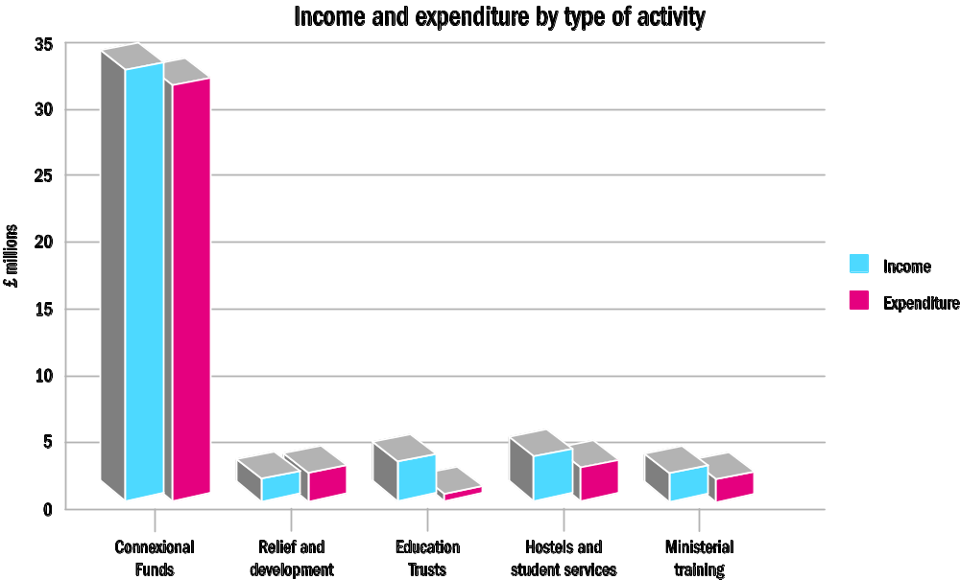

The Methodist Church in Great Britain managed reserves
The Methodist Church in Great Britain does not have a blanket reserves policy to cover its operations. Rather, the policies are set locally by the relevant trustee bodies and take into account the unique risk factors faced by each entity. These policies in relation to reserves of material amounts are outlined below.

Methodist Church Fund
The target level of general unrestricted reserves for the Methodist Church Fund operations can be broken down into working capital (£4.5m) and contingencies (£4.5m). As at 31 August 2012 the liquid assets associated with this fund were £7.3m (2011 - £7m).

Designated Funds (see note 16 of the accounts for details)
These are funds set aside by the Conference to support the work of the Methodist Church not met through district assessments. The purposes of these funds range from providing training monies, supporting local churches through property grants, funding specific initiatives such as the Youth Participation Scheme (YPS), district development enabler officers and Venture FX to setting aside monies to maintain Methodist Church House. The level of reserves is assessed with reference to the budgeted spend and expected income. Responsibility for setting the most appropriate level of reserves rests with the various committees charged with approving and monitoring outgoings from these funds.

Methodist Relief and Development Fund (MRDF) £0 (2011: £330k)
The board reviews the charity’s reserves annually, balancing the need to hold back sufficient general reserves to protect the charity’s charitable activities with the objective of maximising the funding available for those activities. These reserves and funds are invested in accordance with the charity’s investment policy.
The board has agreed the policy that general reserves should not fall below the level of £300k, to enable an orderly wind up of the charity in the event of it becoming necessary. Therefore, there is a shortfall at 31 August 2012 in general reserves of £336k. This will be rectified during the next year by the sale of an investment property, currently valued at £700k. The balance of the sale proceeds not required for general reserves will be allocated to the charity’s charitable activities over the coming period.

Cliff College £1.7m
It is the policy of Cliff College that unrestricted funds which have not been designated for a specific use should be maintained at a level of not less than three month’s expenditure. The Cliff College Committee considers that reserves at this level will ensure that, in the event of a significant drop in funding, it will be able to continue the charity’s current activities while consideration is given to ways in which additional funds may be raised.
Investment policy and review
Funds not immediately required are invested in marketable securities through the Methodist Church’s in-house investment manager, the Central Finance Board (CFB) of the Methodist Church, whose mission is to:

- Provide a high quality investment service, seeking above average returns for long term investors;
- Follow a discipline in which the ethical dimension is an integral part of all investment decisions;
- Construct investment portfolios which are consistent with the moral stance and teachings of the Christian faith;
- Encourage strategic thinking on the ethics of investment; and
- Be a Christian witness in the investment community.

To ensure that the CFB is working to the highest ethical standards, the Trustees established the Joint Advisory Committee for the Ethics of Investment (JACEI), which is made up of five people nominated by the CFB and five by the Methodist Council. The committee monitors the activities of the CFB to ensure that it complies with the ethics of the Church.

With regard to Investment Management the Investment Committee and representatives from the Connexional Team decide, after taking advice from the CFB, the most appropriate investment strategy for each fund under the management of the Connexional Team.

In addition to marketable securities, some funds hold freehold property as investments. These tend to be either given to the fund, or are redundant properties that are either rented out or are awaiting disposal. The value of these properties is small in relation to the overall amounts held in marketable securities £18m vs. £130m (2011: £11m vs. £114m).

Performance and holdings
The investments (under the management of the Methodist Church in Great Britain) as at 31 August 2012 are as follows:
CFB Managed Funds | 31-Aug-12 |  | 31-Aug-11
 | £000 | % of total | £000 | % of total
CFB Managed Mixed Fund (Charity) | 2,831 | 2.17% | 2,666 | 2.33%
CFB Managed Equity Fund (Charity) | 24,946 | 19.13% | 23,532 | 20.64%
CFB UK Equity Fund (Charity) | 19,132 | 14.67% | 13,519 | 11.85%
CFB Overseas Fund | 6,271 | 4.81% | 5,576 | 4.89%
CFB Managed Fixed Interest Fund | 3,856 | 2.96% | 3,853 | 3.38%
CFB Short Fixed Interest Fund | 5,698 | 4.37% | 5,440 | 4.77%
CFB Corporate Bond Fund | 20,946 | 16.06% | 18,459 | 16.19%
CFB Property Fund | 6,362 | 4.88% | 5,535 | 4.85%
CFB Deposit Fund | 12,563 | 9.63% | 14,919 | 13.07%
William Leech Investments Ltd | 7,981 | 6.12% | 7,708 | 6.76%
Investment Properties | 17,682 | 13.56% | 12,767 | 9.22%
Other Investments | 2,134 | 1.67% | 2,119 | 2%
Total | 130,402 | 100% | 116,266 | 100%

Total returns as at 31 August for CFB managed funds is summarised as follows:
Index | 1 year to 31.08.12 | 5 years to 31.08.12 | 10 years to 31.08.12
 | % | % p.a. | %p.a.
Equity
CFB UK Equity Fund | 9.9 | 1.7 | 6.9
CFB Overseas Fund | 9.4 | 4.4 | 7.5
CFB Managed Equity Fund¹ | 9.8 | 2.1 | 7.1
CFB Managed Mixed Fund¹ | 9.9 | 3.7 | 7.0
Fixed Interest
CFB Managed Fixed Interest Fund¹ | 10 | 8.2 | 6.4
CFB Short Fixed Interest Fund | 7.3 | 7.5 | 5.8
CFB Corporate Bond Fund¹ | 13.3 | 8.6 | n/a
Property
CFB Property Fund^{1,2} | 5.2 | -4.9 | n/a
CFB Deposit Fund¹ | 1.3 | 2.5 | 3.5
¹ Source: CFB
³ Performance to 30th June 2012

Risk Management and Internal Controls

Risk Management
The risk management policy is designed to identify and analyse operational and other risks facing the Methodist Church and, where at unacceptable levels, to take steps to mitigate the risks. The Church currently maintains a corporate risk register broken down under the following headers:

• Strategic and reputational risks;
• Financial risks;
• Compliance risks; and
• Operational risks

The SRC, working closely with senior management in the Connexional Team, periodically reviews and updates the Connexional Team’s risk register; any proposed changes to the register being agreed by Council. As part of their independent monitoring of the effectiveness of the process, the Audit Committee receives various reports from the Director of Financial Operations and the Director of Development and Personnel.

Similarly, governance scrutiny groups continue to review the risk management arrangements put in place by the governance body or managing trustees of the self-accounting entities.

Derivative arrangements have been entered into by some subsidiary entities in order to mitigate the interest rate risk arising on long term bank loans.

Internal Controls
The principal features of the systems of financial control within the Council include:
- An annual planning and budgeting process;
- Written policies and procedures which describe the operational guidelines to be followed by all members of the Connexional Team.
- Segregation of duties wherever possible; and
- An audit committee (see above for details of its terms of reference);
- Delegation of authority to spend within clearly defined limits;

For the year under review, the Council are satisfied that the major risks to which the Church is exposed have been assessed and are satisfied that systems are in place to manage and mitigate exposure to them.

The Environment
The Methodist Church takes its responsibility towards the environment seriously (as detailed in Hope in God’s Future) and has established a Carbon Reduction project, whose management group works with ecumenical partners to lead the church’s policy and action in this area. The Methodist Church has set itself an ambitious target of an 80% reduction of carbon emissions by 2050. Interim targets will need to be reviewed annually against a carbon management plan and budgets.

Our environmental goals
- Improved knowledge of the footprint of The Methodist Church and of the measures that would be most effective in reducing carbon emissions;
- Improved knowledge of further technical support that could be made available to support circuits’ adaptation of buildings;
- Further financial resources identified to support reduction in carbon emissions; and
- Better equip staff and Ministers to make informed choices to reduce their carbon footprint.

Related parties
The various parts of the legal framework within which the Methodist Church is governed allow for the setting up of separate bodies all reporting into the Conference to handle specific aspects of the Church’s work and/or discharge a specific power of the Church.

a) The Trustees for Methodist Church Purposes (TMCP) are the custodian trustees of all property held on the model trust of the Methodist Church Act 1976, except for that in the Channel Islands or the Isle of Man which is held by the Trustees for Jersey Methodist Church Purposes, the Trustees for Guernsey Methodist Church Purposes or the Trustees for Manx Methodist Church Purposes.

b) The Central Finance Board of the Methodist Church (CFB) set up by an Act of Parliament in 1960 to enable Methodist organisations to pool their assets and manage them efficiently. The Board has its own fund management department enabling it to provide professional investment management for the Connexional Team as well as other organisations within Methodism.

c) The Methodist Ministers’ Housing Society - Set up under the Industrial and Provident Societies Act 1965 and operating from the Connexional Team offices in London, the Housing Society provides housing and associated amenities for retired Methodist ministers, deacons and their partners. The Methodist Council makes regular grants from the Fund for the Support of Presbyters and Deacons (FSPD) in support of its work under Standing Order 364.

d) Other Methodist bodies with which the Connexional Team has regular dealings include the Methodist Ministers’ and Lay Employees’ Pension Trusts, and the Board of Management for the Methodist Independent Schools.

Full details of transactions with these related parties and any outstanding balances at the year-end are provided under Note 23 of the accounts.

Provision of information to the auditor
So far as the Trustees are aware, there is no relevant audit information of which the Charity’s auditor is un-aware. The Trustees have taken all the steps that we ought to have taken as Trustees in order to make ourselves aware of any relevant audit information and to establish that the Charity’s auditor is aware of that information.

Statement of trustees’ responsibilities
The trustees are responsible for preparing the Trustees' Annual Report and the financial statements in accordance with applicable law and United Kingdom Accounting Standards (United Kingdom Generally Accepted Accounting Practice).
The law applicable to charities in England and Wales requires the trustees to prepare financial statements for each financial year which give a true and fair view of the state of affairs of the charity and the group and of the incoming resources and application of resources of the charity for that period. In preparing these financial statements, the trustees are required to:
- select suitable accounting policies and then apply them consistently;
- observe the methods and principles in the Charities SORP;
- make judgments and estimates that are reasonable and prudent;
- state whether applicable accounting standards have been followed, subject to any material departures disclosed and explained in the financial statements; and
- prepare the financial statements on the going concern basis unless it is inappropriate to presume that the charity will continue in business.
The trustees are responsible for keeping proper accounting records that disclose with reasonable accuracy at any time the financial position of the charity and enable them to ensure that the financial statements comply with the Charities Act 2011, the Charity (Accounts and Reports) Regulations 2008 and the provisions of the trust deed. They are also responsible for safeguarding the assets of the charity and the group and hence for taking reasonable steps for the prevention and detection of fraud and other irregularities.
The trustees are responsible for the maintenance and integrity of the charity and financial information included on the charity's website. Legislation in the United Kingdom governing the preparation and dissemination of financial statements may differ from legislation in other jurisdictions.

Auditor

A resolution proposing the re-appointment of Baker Tilly UK Audit LLP as auditor to the charity will be put to the Methodist Council.

Baker Tilly UK Audit LLP has indicated its willingness to continue in office.

The Reverend David Gamble
Chair of the Council

Date January 2013

Independent Auditor’s Report to the Trustees of The Methodist Church in Great Britain
We have audited the financial statements of The Methodist Church in Great Britain for the year ended 31 August 2012 on pages 27 to 50. The financial reporting framework that has been applied in their preparation is applicable law and United Kingdom Accounting Standards (United Kingdom Generally Accepted Accounting Practice).
This report is made solely to the charity’s trustees as a body, in accordance with the Charities Act 2011. Our audit work has been undertaken so that we might state to the charity’s trustees those matters we are required to state to them in an auditor’s report and for no other purpose. To the fullest extent permitted by law, we do not accept or assume responsibility to anyone other than the charity and the charity’s trustees as a body, for our audit work, for this report, or for the opinions we have formed.

Respective responsibilities of trustees and auditor
As explained more fully in the Statement of Trustees’ responsibilities set out on page 24 the trustees are responsible for the preparation of the financial statements and for being satisfied that they give a true and fair view.
We have been appointed as auditors under section 151 of the Charities Act 2011 and report in accordance with regulations made under section 154 of that Act. Our responsibility is to audit and express an opinion on the financial statements in accordance with applicable law and International Standards on Auditing (UK and Ireland). Those standards require us to comply with the Auditing Practices Board’s (APB’s) Ethical Standards for Auditors.

Scope of the audit of the financial statements

A description of the scope of an audit of financial statements is provided on the APB’s website at www.frc.org.uk/apb/scope/private.cfm

Opinion on financial statements
In our opinion the financial statements:
- give a true and fair view of the state of the group’s and charity’s affairs as at 31 August 2012 and of their incoming resources and application of resources for the year then ended;
- have been properly prepared in accordance with United Kingdom Generally Accepted Accounting Practice; and
- have been prepared in accordance with the requirements of the Charities Act 2011.

Matters on which we are required to report by exception
We have nothing to report in respect of the following matters where the Charities Act 2011 requires us to report to you if, in our opinion:
- the information given in the Trustees’ Report is inconsistent in any material respect with the financial statements; or
- the parent charity has not kept sufficient accounting records; or
- the parent charity financial statements are not in agreement with the accounting records and returns; or
- we have not received all the information and explanations we require for our audit.

BAKER TILLY UK AUDIT LLP
Statutory Auditor
Hartwell House
55 – 61 Victoria Street
Bristol, BS1 6AD
Date: January 2013
Consolidated Statement of Financial Activities for the year ended 31 August 2012
 |  | Notes |  | Unrestricted Funds |  |  |  | Restricted Funds |  |  |  | Endowment Funds |  |  |  | Total |  |  |  |  | Total
 |  |  |  |  |  |  |  |  |  |  |  |  |  |  |  | 2012 |  |  |  |  | 2011
 |  |  |  | £000 |  |  |  | £000 |  |  |  | £000 |  |  |  | £000 |  |  |  |  | £000
Incoming resources:
Incoming resources from generated funds
District Assessment |  |  |  | 11,929 |  |  |  | - |  |  |  | - |  |  |  | 11,929 |  |  |  |  | 11,316
Voluntary income |  | 2 |  | 871 |  |  |  | 10,875 |  |  |  | - |  |  |  | 11,746 |  |  |  |  | 12,924
Investment income and interest |  | 3 |  | 1,186 |  |  |  | 2,484 |  |  |  | - |  |  |  | 3,670 |  |  |  |  | 3,260
Activities for generating funds
Fundraising trading |  | 4 |  | 1,718 |  |  |  | 4,817 |  |  |  | - |  |  |  | 6,535 |  |  |  |  | 4,726
Incoming resources from charitable activities
Grants and capital levies |  | 5 |  | 7,738 |  |  |  | 749 |  |  |  | - |  |  |  | 8,487 |  |  |  |  | 9,628
Other income |  |  |  | 1,044 |  |  |  | 699 |  |  |  | - |  |  |  | 1,743 |  |  |  |  | 1,874
Other income resources
Net gain on disposal of tangible fixed assets |  |  |  | 934 |  |  |  | 541 |  |  |  | - |  |  |  | 1,475 |  |  |  |  | (92)
Total incoming resources |  |  |  | 25,420 |  |  |  | 20,165 |  |  |  | - |  |  |  | 45,585 |  |  |  |  | 43,636
Resources expended
Cost of generating funds
Costs of generating voluntary income |  |  |  | 380 |  |  |  | - |  |  |  | - |  |  |  | 380 |  |  |  |  | 365
Fundraising trading |  |  |  | 742 |  |  |  | 2,155 |  |  |  | - |  |  |  | 2,897 |  |  |  |  | 2,124
Investment Management |  |  |  | 107 |  |  |  | 120 |  |  |  | - |  |  |  | 227 |  |  |  |  | 169
Charitable activities
Equipping the church to engage society |  |  |  | 7,153 |  |  |  | 6,718 |  |  |  | - |  |  |  | 13,871 |  |  |  |  | 18,224
Formation, Training Development & Resourcing |  |  |  | 7,342 |  |  |  | 2,321 |  |  |  | - |  |  |  | 9,663 |  |  |  |  | 9,656
Empowering the Ministry of Overseas Partners |  |  |  | 1,513 |  |  |  | 5,105 |  |  |  | - |  |  |  | 6,618 |  |  |  |  | 7,514
Advocacy & Education |  |  |  | 1,117 |  |  |  | - |  |  |  | - |  |  |  | 1,117 |  |  |  |  | 1,058
Governance costs |  |  |  | 3,031 |  |  |  | - |  |  |  | - |  |  |  | 3,031 |  |  |  |  | 3,126
Total resources expended |  | 6 |  | 21,385 |  |  |  | 16,419 |  |  |  | - |  |  |  | 37,804 |  |  |  |  | 42,236
Net incoming/(outgoing) resources before transfers |  | 8 |  | 4,035 |  |  |  | 3,746 |  |  |  | - |  |  |  | 7,781 |  |  |  |  | 1,400
Gross transfers between funds |  | 16-18 |  | (2,725) |  |  |  | 1,427 |  |  |  | 1,298 |  |  |  | - |  |  |  |  | -
Net incoming/(outgoing) resources after transfers and before other recognised gains |  |  |  | 1,310 |  |  |  | 5,173 |  |  |  | 1,298 |  |  |  | 7,781 |  |  |  |  | 1,400
(Losses)/Gains on revaluations and disposal of investment assets |  |  |  | 2,009 |  |  |  | 5,034 |  |  |  | 94 |  |  |  | 7,137 |  |  |  |  | 1,612
Net movement in funds |  |  |  | 3,319 |  |  |  | 10,207 |  |  |  | 1,392 |  |  |  | 14,918 |  |  |  |  | 3,012
Total funds brought forward
Total funds brought forward at 1 September |  |  |  | 40,786 |  |  |  | 85,680 |  |  |  | 12,632 |  |  |  | 139,098 |  |  |  |  | 136,086
Total funds carried forward at 31 August |  |  |  | 44,105 |  |  |  | 95,887 |  |  |  | 14,024 |  |  |  | 154,016 |  |  |  |  | 139,098

Statement of Financial Activities for the year ended 31 August 2012 - The Connexional Funds
 |  | Unrestricted Funds |  | Restricted Funds |  | Endowment Funds |  | Total |  | Total
 |  |  |  |  |  |  |  | 2012 |  | 2011
 |  | £000 |  | £000 |  | £000 |  | £000 |  | £000
Incoming resources:
Incoming resources from generated funds
District Assessment |  | 11,929 |  | - |  | - |  | 11,929 |  | 11,316
Voluntary income |  | 871 |  | 5,784 |  | - |  | 6,655 |  | 6,983
Investment income and interest |  | 1,186 |  | 2,349 |  | - |  | 3,535 |  | 3,159
Activities for generating funds
Fundraising trading |  | 1,718 |  | 4,152 |  | - |  | 5,870 |  | 4,220
Incoming resources from charitable activities
Grants |  | 7,115 |  | 1,043 |  | - |  | 8,158 |  | 9,162
Other income |  | 1,044 |  | 68 |  | - |  | 1,112 |  | 1,323
Other income resources
Net gain on disposal of tangible fixed assets |  | 934 |  | 540 |  | - |  | 1,474 |  | (92)
Total incoming resources |  | 24,797 |  | 13,936 |  | - |  | 38,733 |  | 36,071
Resources expended
Cost of generating funds
Costs of generating voluntary income |  | 380 |  | - |  | - |  | 380 |  | 365
Fundraising trading |  | 742 |  | 1,867 |  | - |  | 2,609 |  | 1,878
Investment Management |  | 107 |  | 120 |  | - |  | 227 |  | 169
Charitable activities |  |  |  |  |  |  |  |  |  | -
Equipping the church to engage society |  | 7,152 |  | 6,699 |  | - |  | 13,851 |  | 18,204
Formation, Training Development & Resourcing |  | 7,503 |  | 918 |  | - |  | 8,421 |  | 8,633
Empowering the Ministry of Overseas Partners |  | 1,513 |  | 2,716 |  | - |  | 4,229 |  | 5,065
Advocacy & Education |  | 1,117 |  | - |  | - |  | 1,117 |  | 1,057
Governance costs |  | 3,031 |  | - |  | - |  | 3,031 |  | 3,089
Total resources expended |  | 21,545 |  | 12,320 |  | - |  | 33,865 |  | 38,460
Net incoming/(outgoing) resources before transfers |  | 3,252 |  | 1,616 |  | - |  | 4,868 |  | (2,389)
Gross transfers between funds |  | (1,976) |  | 678 |  | 1,298 |  | - |  | -
Net incoming/(outgoing) resources after transfers and before other recognised gains |  | 1,276 |  | 2,294 |  | 1,298 |  | 4,868 |  | (2,389)
(Losses)/Gains on revaluations and disposal of investment assets |  | 2,014 |  | 5,005 |  | 94 |  | 7,113 |  | 1,602
Net movement in funds |  | 3,290 |  | 7,299 |  | 1,392 |  | 11,981 |  | (787)
Total funds brought forward
Total funds brought forward at 31 August |  | 40,815 |  | 75,225 |  | 12,627 |  | 128,667 |  | 129,454
Total funds carried forward at 31 August |  | 44,105 |  | 82,524 |  | 14,019 |  | 140,648 |  | 128,667

Balance sheets as at 31 August
 |  |  | The Methodist Church in Great Britain |  |  |  | The Connexional Funds
 |  |  | 2012 |  | 2011 |  | 2012 |  | 2011
 | Notes |  | £000 |  | £000 |  | £000 |  | £000
Fixed Assets
Tangible assets | 11 |  | 25,031 |  | 22,871 |  | 22,342 |  | 20,519
Investments | 12 |  | 130,402 |  | 116,266 |  | 121,450 |  | 108,084
 |  |  | 155,433 |  | 139,137 |  | 143,792 |  | 128,603
Current Assets
Stock |  |  | 165 |  | 167 |  | 164 |  | 167
Asset held for sale | 12 |  | 700 |  | - |  | - |  | -
Debtors | 13 |  | 5,813 |  | 8,366 |  | 5,461 |  | 8,029
Short term deposits |  |  | 8,607 |  | 12,426 |  | 7,310 |  | 12,271
Cash at bank and in hand |  |  | 3,609 |  | 1,787 |  | 2,352 |  | 1,463
 |  |  | 18,894 |  | 22,746 |  | 15,287 |  | 21,930
Creditors
Amounts falling due within 1 year | 14 |  | (10,942) |  | (13,093) |  | (9,920) |  | (12,174)
Net current assets |  |  | 7,952 |  | 9,653 |  | 5,367 |  | 9,756
Total Assets less current liabilities |  |  | 163,385 |  | 148,790 |  | 149,159 |  | 138,359
Creditors
Amounts falling due after more than 1 year | 15 |  | (9,369) |  | (9,692) |  | (8,511) |  | (9,692)
Net Assets |  |  | 154,016 |  | 139,098 |  | 140,648 |  | 128,667
The funds of the Methodist Church in Great Britain
Endowment funds | 18 |  | 14,024 |  | 12,632 |  | 14,019 |  | 12,627
Restricted income funds | 17 |  | 95,888 |  | 85,680 |  | 82,524 |  | 75,225
Unrestricted income funds | 16 |  | 44,104 |  | 40,786 |  | 44,105 |  | 40,815
Total Council funds |  |  | 154,016 |  | 139,098 |  | 140,648 |  | 128,667

The notes on pages 31 to 50 form an integral part of these financial statements.

Approved and authorised for issue by the Board of Trustees on 24 January 2012 and signed on their behalf by:

____________________ ____________________
The Reverend David Gamble Mr Andrew Gibbs
Chair of the Council Connexional Treasurer

 | Consolidated cashflow statement as at 31 August
 |  |  | 2012 |  |  |  |  | 2011
 |  | Notes | £000 |  |  | £000 |  | £000 |  | £000
 | Net cash outflow from operating activities | (a) below |  |  |  | (4,458) |  |  |  | (3,686)
 | Returns on investments & servicing of finance
 | Deposit interest received & investment income |  |  |  |  | 2,942 |  |  |  | 2,580
 | Capital expenditure and financial investments
 | Payments to acquire tangible fixed assets |  | (4,005) |  |  |  |  | (749)
 | Receipts from sales of tangible fixed assets |  | 3,042 |  |  |  |  | 865
 | Purchase of fixed assets investments |  | (7,478) |  |  |  |  | (13,430)
 | Disposal of fixed assets investments |  | 6,001 |  |  |  |  | 4,883
 |  |  |  |  |  | (2,440) |  |  |  | (8,431)
 | Financing
 | Increases in loan balances |  | 2,544 |  |  |  |  | -
 | Repayment of loans |  | (200) |  |  |  |  | (245)
 |  |  |  |  |  | 2,344 |  |  |  | (245)
 | Net cash (outflow)/ inflow in the period |  |  |  |  | (1,612) |  |  |  | (9,782)
 | Net cash resources at 1 September | (b) below |  |  |  | 13,828 |  |  |  | 23,610
 | Net Cash resources at 31 August |  |  |  |  | 12,216 |  |  |  | 13,828
(a) | Reconciliation of net incoming resources to net cash flow from operating activities
 |  |  |  |  |  | 2012 |  |  |  | 2011
 |  |  |  |  |  | £000 |  |  |  | £000
 | Net incoming resources for the year |  |  |  |  | 7,781 |  |  |  | 1,400
 | Gain on disposal of tangible fixed assets |  |  |  |  | (1,475) |  |  |  | 92
 | Asset based grant - Southland College |  |  |  |  | - |  |  |  | 1,168
 | Investment income |  |  |  |  | (3,670) |  |  |  | (3,260)
 | Depreciation |  |  |  |  | 278 |  |  |  | 202
 | (Increase)/decrease in stocks |  |  |  |  | 2 |  |  |  | 34
 | (Increase)/decrease debtors |  |  |  |  | 2,553 |  |  |  | (786)
 | (Decrease)/Increase creditors |  |  |  |  | (5,890) |  |  |  | 1,130
 | Non cash income 2012 -Southlands Methodist Trust (2011 Westminster College Trust) |  |  |  |  | (4,037) |  |  |  | (3,666)
 | Net cash income/outflow from operating activities |  |  |  |  | (4,458) |  |  |  | (3,686)
 |  |  | At 31 Aug 11 |  |  | Cash flow 2011 |  | At 31 Aug 12
 |  |  | £000 |  |  | £000 |  | £000
(b) | Analysis of net cash resources
 | Cash in hand and at bank |  | 1,787 |  |  | 1,822 |  | 3,609
 | Overdrafts |  | (385) |  |  | 385 |  | -
 | Short term deposits |  | 12,426 |  |  | (3,819) |  | 8,607
 | Total |  | 13,828 |  |  | (1,612) |  | 12,216
(c) | Reconciliation of net cash to movement in net funds |  |  |  |  |  |  | 2012
 |  |  |  |  |  |  |  | £000
 | Net funds at 1 September 2011 |  |  |  |  |  |  | 13,828
 | Net funds at 31 August 2012 |  |  |  |  |  |  | 12,216
 | Movement in funds in the period |  |  |  |  |  |  | (1,612)
 | Cash (outflow from decrease in liquid resources |  |  |  |  |  |  | (1,997)
 | Increase in cash in the period |  |  |  |  |  |  | 385

1. Accounting policies

- Basis of accounting
The consolidated accounts of The Methodist Church in Great Britain have been prepared under the historical cost convention, except for investments which are stated at market value and hotel properties are held at valuation, and are in accordance with the Statement of Recommended Practice: Accounting and Reporting by Charities (SORP 2005), UK Accounting Standards and the Charities Act 2011.

b) Basis of preparation
The entities included in these accounts have been consolidated based on the view of the Council of the degree of control which it exercises over the entities concerned, which is constantly under review.

- Basis of consolidation

The consolidation principles applied are based on Financial Reporting Standard (FRS) 2 and SORP 2005 which require consolidation of subsidiary undertakings as identified by the measure of control exercised. Control can be determined in the context of voting rights and/or the exercise of dominant influence over the Board or activities of the subsidiary undertaking.
All of the entities listed on page 7 are consolidated on the grounds that the Methodist Conference has the right to exercise dominant influence, and this influence is demonstrated in a number of ways, but mainly through the selection of the trustees on the boards of these entities.
All the entities which are separately registered as charities, together with their wholly owned trading subsidiaries, have been consolidated as subsidiaries on a line by line basis in accordance with FRS2 and SORP 2005.

- Accounting Policies (continued)

- The accounting / reporting structure
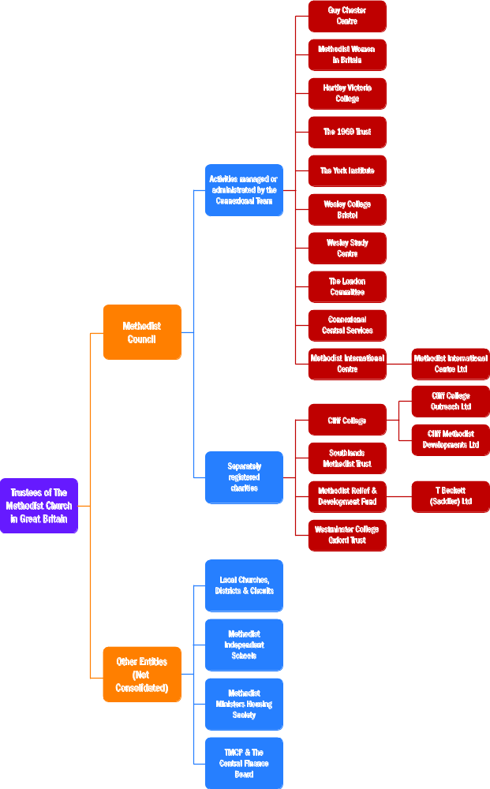

1. Accounting Policies (continued)
- Excluded entities - grounds for exclusion under paragraph 384 of SORP 2005
A number of entities have been excluded from the consolidation. These are:

Local Churches, Circuits and Districts
Methodist Independent Schools
Trustees for the Methodist Church Purposes (TMCP)
The Central Finance Board (CFB)
Methodist Ministers Housing Society

Whilst these entities might form part of the overall picture of the Methodist Church, the Methodist Council does not control their activities.

- Incoming resources
District assessment
The District Assessment is accounted for on a receivable basis.

Voluntary income
Donations, contributions and legacies are accounted for when entitlement has been confirmed, the amount can be measured accurately and receipt is certain. In accordance with this policy, legacies are included when advice has been received from the personal representative of an estate that payment will be made or property transferred and the amount involved can be quantified with reasonable certainty.

Capital levies
Capital levies are due on the disposal of property by churches, circuits and districts under Standing Order 970 of the Constitutional Practice and Discipline of the Methodist Church and are accounted for on a receipts basis.

Grants receivable
Grants receivable are included when the relevant conditions for the grant have been met.

Rental income
Rental income is accounted for on a receivable basis. Rental income is included within fundraising trading within the Statement of Financial Activities

All other incoming resources
All other incoming resources are accounted for on an accruals basis.

g) Resources expended
All resources expended are accounted for on an accruals basis. Any ensuing liabilities are recognised as soon as a legal or constructive obligation arises.

Costs of generating funds
Costs of generating funds include the direct costs of fundraising trading, investment management, custody fees and a proportion of shared and indirect support costs.

Charitable activities
Charitable activities: These include the direct costs of the activities. Where such costs relate to more than one functional cost category, they have been apportioned based on the relative size of the direct costs of the relevant service units.

Support costs: Support costs include the central functions and have been allocated to fundraising, charitable activities and governance in proportion to the directly attributable staff costs of these activities.

Governance costs
These are the costs associated with constitutional and statutory requirements and include external audit, legal advice on governance issues, district chairs, trustees’ expenses and a proportion of shared and indirect support costs.

Grants payable
Grants payable have been accounted for in full to the extent that past events have created a legal and constructive expectation in other parties that the Church will honour commitments, both legal and implied and any attaching conditions are outside the Church’s control. All grants are denominated in sterling.

h) Funds
Unrestricted funds are funds which are available for use at the discretion of the trustees in furtherance of the general objectives of the Charity.

Designated funds comprise unrestricted funds that have been set aside by the trustees for particular purposes. The aim and use of each designated fund is set out in the notes to the financial statements.

Restricted funds are funds which are to be used in accordance with specific restrictions imposed by donors or which have been raised by the trustees’ particular purposes. The cost of raising and administering such funds are charged against the specific fund. The aim and use of the major restricted funds is set out in the notes to the financial statements.

Endowment funds represent monies received from donors where there is some restriction on the use of the initial capital.

Investment income is allocated to the appropriate fund in the case of restricted funds and in accordance with the terms of the endowment in the case of endowment funds

i) Gains/(losses) on investments
Realised and unrealised gains and losses on investments are dealt with in the Statement of Financial Activities in the year in which they arise.

j) Pension costs
The Church’s defined benefit pension schemes are treated for accounting purposes as though they are defined contribution schemes on the grounds that both are multi-employer schemes and that the Church is unable to identify its share of the underlying assets and liabilities in the schemes on a consistent and reasonable basis. For defined contribution schemes the amount charged to the Statement of Financial Activities in respect of pension costs and other post retirement benefits is the contributions payable in the year.

k) Tangible fixed assets
Properties are stated at cost. The Trustees consider that the lives of the properties are so long and their residual values so high based on prices prevailing at the time of acquisition that the annual depreciation charge and accumulated depreciation is not material. Accordingly, no depreciation is provided on freehold properties used for charitable activities. An annual impairment review is undertaken for assets which are not depreciated. Any material impairment in the value of such properties, following an annual review, would be chargeable to the Statement of Financial Activities. Hotel properties are held at valuation.

In line with SORP 276 requirements, the managing trustees of the various entities have reassessed the market value of their existing land and buildings and are of the opinion that it significantly exceeds the book value of the assets.

Assets having an initial cost of £1,000 or less are written off on acquisition. Furniture & fittings, computer equipment, computer software and motor vehicles having an initial cost greater than £1,000 are stated at cost less depreciation which is charged on a straight line basis. Computer equipment and software are depreciated at the rate of 33 1/3% per annum.

Furniture & fittings and motor vehicles are depreciated at the rate of 20% per annum.

l) Heritage assets
Heritage assets are defined as assets which have historical, artistic, scientific, technological, geographical or environmental qualities that are held and maintained principally for their contribution to knowledge and culture.

Where the Church has information on the cost or value of a heritage asset then it will account for it at that cost or valuation. Where this information is not available and the historical cost information cannot be obtained the assets have been excluded from the balance sheet.

There are four Methodist Heritage sites in Great Britain which fit into this definition. These are: The Old Rectory, Epworth, Lincolnshire - the childhood home of John and Charles Wesley; The New Room (John Wesley's Chapel), Bristol - the first-ever Methodist building in the world; Wesley's Chapel & House, & The Museum of Methodism, London - John Wesley's London base, (from which he travelled 250,000 miles to preach, and the place of his death and burial) and Englesea Brook Chapel & Museum of Primitive Methodism, near Crewe - exhibitions and activities focusing on one strand of 19th century Methodism.

All these assets are under the trusteeship of a number of districts and circuits which are not included in the consolidated accounts of the Church and therefore would not be included in these consolidated accounts.

m) Investments
Investment properties are revalued by firms of professional valuers triennially, and in between by the trustees.

The market value of quoted securities is based on the middle market quotation on the relevant Stock Exchange. Investments, which are held in units in the Central Finance Board, are stated at the Board’s published valuations. Investments in William Leech (Investments) Ltd are stated at the underlying value of the net assets based on the company’s audited Balance Sheet at 31 March 2012, updated by the value of any share acquisitions (at cost) up to 31 August 2012.

Assets held for sale where the proceeds will not be reinvested in investments are included in current asset investments.

n) Stocks
Stocks are valued at the lower of cost and net realisable value after making due allowance for obsolete or slow moving items.

o) Operating Leases
Annual rentals are charged to the Statement of Financial Activities on a straight line basis over the lease term.
p) Foreign Currencies
Monetary assets and liabilities denominated in foreign currencies are translated at the rate of exchange ruling at the balance sheet date. Transactions in foreign currencies are recorded at the rate ruling at the date of the transaction. All differences are taken to the Statement of Financial Activities.

q) Irrecoverable VAT
Irrecoverable VAT has been charged to the expenditure to which it relates to within the Statement of Financial Activities.

 |  |  |  |  | 2012 |  | 2011
 |  | Unrestricted | Restricted | Endowment | Total |  | Total
 |  | £000 | £000 | £000 | £000 |  | £000
2 | Voluntary Income
 | Donations | 806 | 5,188 | - | 5,994 |  | 7,064
 | Southlands Methodist Trust/Wesley College Oxford Trust | - | 4,037 | - | 4,037 |  | 3,666
 | William Leech (Investments) Ltd | - | 688 | - | 688 |  | 651
 | Legacies | 65 | 962 | - | 1,027 |  | 1,543
 |  | 871 | 10,875 | - | 11,746 |  | 12,924
 |  |  |  |  | 2012 |  | 2011
 |  | Unrestricted | Restricted | Endowment | Total |  | Total
 |  | £000 | £000 | £000 | £000 |  | £000
3 | Investment Income
 | Central Finance Board Investments | 930 | 2,125 | - | 3,055 |  | 2,729
 | Deposits interest and other investment income | 256 | 359 | - | 615 |  | 531
 |  | 1,186 | 2,484 | - | 3,670 |  | 3,260
 |  |  |  |  | 2012 |  | 2011
 |  | Unrestricted | Restricted | Endowment | Total |  | Total
 |  | £000 | £000 | £000 | £000 |  | £000
4 | Fundraising trading
 | Sales | 1,562 | 1,222 | - | 2,784 |  | 2,364
 | Rental Income | 138 | 357 | - | 495 |  | 1,160
 | Other operational activities | 5 | 3,238 | - | 3,243 |  | 1,195
 | Advertising income | 13 | - | - | 13 |  | 7
 |  | 1,718 | 4,817 | - | 6,535 |  | 4,726
 |  |  |  |  | 2012 |  | 2011
 |  | Unrestricted | Restricted | Endowment | Total |  | Total
 |  | £000 | £000 | £000 | £000 |  | £000
5 | Grants receivable
 | Capital levies | 7,671 | - | - | 7,671 |  | 8,806
 | Other incoming grants | 67 | 749 | - | 816 |  | 822
 |  | 7,738 | 749 | - | 8,487 |  | 9,628

Note 6 Total Resources Expended
 |  | Direct Costs | Support Costs | 2012 Totals |  | 2011 Totals
 | Resources expended
 | Cost of generating funds
 | Costs of generating voluntary income | 278 | 102 | 380 |  | 365
 | Fundraising trading | 2,897 | - | 2,897 |  | 2,124
 | Investment Management | 227 | - | 227 |  | 169
 | Charitable activities
 | Equipping the church to engage society | 12,136 | 1,735 | 13,871 |  | 18,224
 | Formation, Training Development & Resourcing | 8,258 | 1,405 | 9,663 |  | 9,656
 | Empowering the Ministry of Overseas Partners | 6,237 | 381 | 6,618 |  | 7,514
 | Advocacy & Education | 783 | 334 | 1,117 |  | 1,058
 | Governance costs | 2,238 | 793 | 3,031 |  | 3,126
 |  | 33,054 | 4,750 | 37,804 |  | 42,236

7 | Grants Payable
 |  | 2012 |  |  |  |  |  |  |  | 2011
 |  | Total |  | Individual | Institutions |  | UK | Overseas |  | Total
 | Resourcing Mission at Home
 |  | £000 |  | £000 | £000 |  | £000 | £000 |  | £000
 | Non-Property Grants
 | Mission & ministry general grants | 994 |  | - | 994 |  | 994 | - |  | 1,272
 | Connexional Priority Fund | 3,462 |  | - | 3,462 |  | 3,462 | - |  | 5,238
 | Ministerial Training support | 3,090 |  | - | 3,090 |  | 3,090 | - |  | 3,408
 | Formal Relationships | 223 |  | - | 223 |  | 223 | - |  | 217
 | Chaplaincy | 42 |  | - | 42 |  | 42 | - |  | 82
 |  | 7,811 |  | - | 7,811 |  | 7,811 | - |  | 10,217
 | Property Grants
 | Standard Property Grants | 159 |  | - | 159 |  | 159 | - |  | 1852
 |  | 159 |  | - | 159 |  | 159 | - |  | 1,852
 | Resourcing Mission Overseas
 | General Grants | 1,348 |  | - | 1,348 |  | - | 1,348 |  | 2,076
 | Nationals in Mission Appt. | 1,510 |  | - | 1,510 |  | - | 1,510 |  | 673
 | Scholarships Programme | 365 |  | - | 365 |  | - | 365 |  | 509
 | World Church in Britain | 4 |  | - | 4 |  | - | 4 |  | 9
 | Lay Professional Programme | *(1,137) |  | - | (1,137) |  | - | (1,137) |  | (409)
 | Relief and other sundry grants | 1,486 |  | - | 1,486 |  | - | 1,486 |  | 1722
 |  | 3,576 |  | - | 3,576 |  | - | 3,576 |  | 4,580
 | Sundry Grants
 | Ministerial support & benefits | 1,008 |  | 1,008 | - |  | 1,008 | - |  | 818
 | Contingency grants | 122 |  | 122 | - |  | 122 | - |  | 138
 | Sabbatical grants | 92 |  | 92 | - |  | 92 | - |  | 38
 | Initial & removal grants | 35 |  | 35 | - |  | 35 | - |  | 49
 | Island travel | 14 |  | 14 | - |  | 14 | - |  | 15
 | Archives and history | 6 |  | - | 6 |  | 6 | - |  | 98
 | Hunter Rowe bequest | - |  | - | - |  | - | - |  | 1,168
 | Other miscellaneous grants | 23 |  | - | 23 |  | 23 | - |  | 85
 |  | 1,300 |  | 1,271 | 29 |  | 1,300 | - |  | 2,409
 | Total | 12,846 |  | 1,271 | 11,575 |  | 9,270 | 3,576 |  | 19,058

*Resourcing Mission Overseas grant – Lay Professional programme figure of £1,137m, includes write back of grant commitment of £1.7m.
8 | Net incoming resources before transfers
 | This is stated after charging for the year ended 31 August as follows:
 |  |  |  | 2012 |  |  | 2011
 |  |  |  | £000 |  |  | £000
 | Audit Fees:
 | Connexional Funds – payable to Baker Tilly UK Audit LLP |  |  | 47 |  |  | 47
 | Other Self accounting entities – payable to Baker Tilly UK Audit LLP |  |  | 31 |  |  | 31
 | Payable to other auditors – for audit of self accounting entities |  |  | 6 |  |  | 6
 | Depreciation |  |  | 278 |  |  | 202
9 |  | Stipends & Salary costs
 |  | The Methodist Council appointed or employed an average of 241 (2011 – 238) people during the year, and a further 98 (2011 – 117) people were appointed locally, all of whose costs were chargeable to the Methodist Church consolidated accounts as follows:
 |  |  |  | 2012 |  | 2011
 |  |  |  | Total |  | Total
 |  |  |  | £000 |  | £000
 |  | Stipends and salaries |  | 11,210 |  | 10,017
 |  | Redundancy costs |  | 305 |  | 417
 |  | Temporary staff costs |  | 141 |  | 470
 |  | Social security costs |  | 1,032 |  | 916
 |  | Pension costs (Note 10) |  | 1,940 |  | 1,922
 |  |  |  | 14,628 |  | 13,742
 | Three employees were paid £60k or more, including pension contributions, during the year (2011 – 2 employees).
2012 2011
Band 1 60,000 – 70,000 1 employee none
Band 2 70,000 – 80,000 none 2 employees
Band 3 70,000 – 80,000 2 employees none
10 | Pension costs
 | Methodist Church Pension Arrangements
 | The Methodist Council operates two defined benefit pension schemes – the Methodist Ministers’ Pension Scheme for ministers and the Pensions and Assurance Scheme for Lay Employees of the Methodist Church. The assets of the two schemes are held separately from the Methodist Church Consolidated Accounts in independently administered funds.
 | Contributions to the schemes are charged to the Statement of Financial Activities in the year in which they are payable.
 | Under the rules of the two Methodist Church pension schemes for ministers and lay employees the Methodist Council has an undertaking to indemnify the trustees against any liabilities that might arise in the proper discharge of their duties as pension trustees. No provision has been made in the financial statements to 31 August 2012 (2011 £nil) in respect of this matter.

10 | Pension costs (continued)  Alternative Pension Arrangements  The total pension costs for the year to 31 August 2012 as set out in Note 9 above reflects the costs to the employer of the two pension arrangements. There are no outstanding or prepaid contributions at the balance sheet date.
 | Methodist Ministers' Pension Scheme (MMPS)
There are 1,610 ministers who are members of the MMPS. The Methodist Council is responsible for the pension contributions of 59 of them.

An actuarial valuation of the Scheme was carried out at 1 September 2011. This revealed a shortfall of the assets relative to the technical provisions (liabilities) of £58.41 million which corresponded to a funding ratio of 83.6%. The shortfall was due mainly to unfavourable market conditions and the effect of allowing for members living longer.
The future service contribution required to be paid to the Scheme based on benefits in force at the valuation date was 22.6% of stipends.
Action taken to meet the shortfall
The 2012 Conference has agreed that the existing shortfall contributions of 14% of Stipend being paid following the 1 September 2008 valuation for the remainder of the recovery period of 9 years 4 months from 1 September 2011 should be continued. Furthermore a contribution of £1 million would be payable to the Scheme annually each September from the Pension Reserve Fund in order to eliminate the shortfall. This fund was set up following a 2009 Conference decision to establish a Pension Reserve Fund outside of the Scheme, which could be used to meet future funding deficits. The Trustee of the Scheme has confirmed that the Pension Reserve Fund strengthens the Church’s financial covenant to the Scheme.
The 2012 Conference, on the recommendation of the Methodist Council and in agreement with the Trustee of the Scheme, decided that the Church contribution rate be increased from 25.6% to 26.6% of stipends from 1 September 2012 with a further 1% increase to 27.6% from 1 September 2013. The Conference asked for a consultation with members regarding possible changes to member contributions and linking normal pension date to the future male State Pension Age to assist in the affordability of the extra contribution due from the Church from 1 September 2013.
Ongoing contribution rate
A Recovery Plan and Schedule of Contributions to satisfy the requirements of Sections 226 and 227 respectively of the Pensions Act 2004 have been agreed by the Trustee and the Conference. The Actuary certified on 18 July 2012 that the rates of contributions, as set out above and in the Schedule of Contributions, were expected on 1 September 2011 to restore the funding level to 100% by the end of the period specified in the Recovery Plan and also confirmed that the Schedule of Contributions was consistent with the Statement of Funding Principles agreed by the Trustee on 1 March 2012.
 |  | The pension charge for the year was £0.338m (2011 £0.351m).
10. Pensions cost (continued)
Pensions and Assurance Scheme for Lay Employees of the Methodist Church

The Methodist Council is the principal employer of this multi-employer defined benefit scheme for lay employees. Its employees both past and present account for more than 80% of current scheme members.
The scheme has not been accounted for as a defined benefit scheme, but as a defined contribution scheme in accordance with FRS17 but this disclosure has been included to add clarity, as the actuaries are of the opinion that it is not possible to identify on a consistent and reasonable basis, the share of the underlying assets and liabilities of the individual schemes attributable to the Methodist Church Consolidated Accounts.

The contributions by the Methodist Council and the scheme members’ contributions of the scheme were 24.1% and 8% of pensionable pay respectively.

A full actuarial valuation was carried out as at 1 September 2011 by a qualified independent actuary. The results were as follows:

A shortfall of £2.2m relative to the technical provisions (i.e. the level of assets agreed by the Trustee and the Methodist Council as being appropriate to meet members’ benefits, assuming the Scheme continues as a going concern). This shortfall is equivalent to contributions of 4.5% pa over the working lifetimes of current active members payable from 1 September 2009.

An estimated shortfall of £18.7m relative to the solvency position (i.e. the estimated level of assets needed to buy insurance policies for benefits earned to the valuation date).

The long term rate of contributions required to meet the cost of future service benefits amounts to 27.6% of Pensionable Earnings.
Agreed action
Following consideration of the valuation results the Trustee and the Methodist Council have agreed that the contributions would remain at 8% for members and 24.1% for employers of pensionable earnings.

11 | Tangible Fixed Assets
 | (a) The Methodist Church in Great Britain
 |  | Freehold Land & Buildings |  | Furniture & Fittings |  | Computer Equipment |  | Motor Vehicle |  | Total
 |  | £000 |  | £000 |  | £000 |  | £000 |  | £000
 | Cost/valuation:
 | At 1 September 2011 | 20,556 |  | 3,219 |  | 653 |  | 30 |  | 24,458
 | Additions during the year | 3,199 |  | 272 |  | 534 |  | - |  | 4,005
 | Transfers in/(out) * | 1,607 |  | (1,607) |  | - |  | - |  | -
 | Disposals | (1,152) |  | (396) |  | (19) |  | - |  | (1,567)
 | Total | 24,210 |  | 1,488 |  | 1,168 |  | 30 |  | 26,896
 | Depreciation:
 | At 1 September | - |  | 1,004 |  | 554 |  | 29 |  | 1,587
 | Charge for year | - |  | 175 |  | 102 |  | 1 |  | 278
 | Total | - |  | 1,179 |  | 656 |  | 30 |  | 1,865
 | Net Book Value:
 | At 31 August 2012 | 24,210 |  | 309 |  | 512 |  | - |  | 25,031
 | At 31 August 2011 | 20,556 |  | 2,215 |  | 99 |  | 1 |  | 22,871
Transfers out – £1.6m was transferred from furniture and fittings to land and building, being the additions to the Muswell Hill – Guy Chester property.

Included within the group’s fixed assets are a number of works of art donated over the years to Westminster College Oxford Trust (a separately registered subsidiary charity of The Methodist church in Great Britain). These are on permanent loan to Oxford Brookes University. A list of these items was compiled previously and the items were valued at a market value of £130,000 at 5 April 2009. This valuation is deemed to remain reasonable by the Trustees as at 31 August 2012.

 | (b) Connexional Funds
 |  | Freehold Land & Buildings |  | Furniture & Fittings |  | Computer Equipment |  | Motor Vehicle |  | Total
 |  | £000 |  | £000 |  | £000 |  | £000 |  | £000
 | Cost/valuation:
 | At 1 September 2011 | 18,261 |  | 3,030 |  | 539 |  | 14 |  | 21,844
 | Additions during the year | 2,880 |  | 220 |  | 476 |  | - |  | 3,576
 | Transfers in/(out) | 1,607 |  | (1,607) |  | - |  | - |  | -
 | Disposals | (1,152) |  | (396) |  | (19) |  | - |  | (1,567)
 | Total | 21,596 |  | 1,247 |  | 996 |  | 14 |  | 23,853
 | Depreciation
 | At 1 September | - |  | 852 |  | 459 |  | 14 |  | 1,325
 | Charge for year | - |  | 140 |  | 46 |  | - |  | 186
 | Total | - |  | 992 |  | 505 |  | 14 |  | 1,511
 | Net Book Value:
 | At 31 August 2012 | 21,596 |  | 255 |  | 491 |  | - |  | 22,342
 | At 31 August 2011 | 18,261 |  | 2,178 |  | 80 |  | - |  | 20,519

12 | Investments | The Methodist Council |  |  | The Connexional Team
 |  | (Group)
 |  | 2012 | 2011 |  | 2012 | 2011
 |  | £000 | £000 |  | £000 | £000
 | Market Value as at 1 September | 116,266 | 102,429 |  | 108,084 | 97,361
 | Additions | 10,866 | 16,914 |  | 7,961 | 13,160
 | Transfer out/in (see note 12a) | (700) | 457 |  | - | -
 | Disposals | (3,174) | (4,703) |  | (1,695) | (3,592)
 | Revaluations William Leech (Investments) Ltd | 97 | (581) |  | 97 | (581)
 | Net Unrealised Investment gains | 7,047 | 1,750 |  | 7,003 | 1,736
 | Market Value as at 31 August | 130,402 | 116,266 |  | 121,450 | 108,084
 | Investment comprise:
 | Investment Properties | 17,682 | 12,767 |  | 11,395 | 9,067
 | Central Finance Board units | 90,041 | 78,753 |  | 88,525 | 77,091
 | Central Finance Board deposit fund | 12,563 | 14,919 |  | 12,563 | 13,191
 | William Leech (Investments) Ltd | 7,981 | 7,708 |  | 7,981 | 7,708
 | Other Investment | 2,135 | 2,119 |  | 986 | 1,027
 | Total | 130,402 | 116,266 |  | 121,450 | 108,084

12a Transfer of assets into investments 2012 2011
£000 £000 Hazlehyrst, 7 Colney Hatch Lane, Muswell N10 as part of Guy Chester Centre 457
T Beckett Sadler as a part of Methodist Relief & Development Fund (700)

Investment property valued at £700,000 is included in current asset investments, being the value of the investment property due to be sold. It is included within current assets as the proceeds will be used for charitable purposes rather than being re-invested. The property was revalued as at 31 August 2012 by Suzanne James BSc MRICS, an RICS approved valuer for and on behalf of Sheldon Bosley, Chartered Surveyors. The share capital of the subsidiary entity T Beckett (Saddler) Ltd is owned by the Trustees for Methodist Church Purposes, which is the custodian trustee for the charity. T Beckett (Saddler) Ltd is incorporated in England & Wales

Included within investment properties are:

- 81-103 Euston Street, London, which has a mixed use: 60% for charitable purposes included in Tangible Fixed Assets and 40% for investment purposes. The value of this investment is considered annually by the Trustees in accordance with SSAP 19.

The property 81-103 Euston Street, London was revalued by I Thompson MRICS and J Williamson MRICS of GVA Grimley Limited, acting as external valuers as defined in the RICS Valuation Standards, on 16 October 2012 at £14,000,000. The Trustees have concluded that this valuation is consistent with the valuation of the property held at 31 August 2012.

- Land and buildings that were leased to Oxford Brookes University by Westminster College Oxford Trust (a separately registered subsidiary charity of The Methodist Church in Great Britain). A professional valuation was performed as at 5 April 2009. The reversionary interest was valued by Andrew Lockhart FRICS MCI Arb of VSL and Partners, Kidlington, Oxfordshire at £2,900,000 on the basis of open market value. The Trustees are of the view that this valuation remains reasonable at 31 August 2012.

The value of all other investment properties is considered annually by the Trustees in accordance with SSAP19.
13 | Debtors
 |  | The Methodist Church in Great Britain |  |  |  | The Connexional Funds
 |  | 2012 |  | 2011 |  | 2012 |  | 2011
 |  | £000 |  | £000 |  | £000 |  | £000
 | Prepayments and accrued Interest | 1,345 |  | 1,261 |  | 1,129 |  | 1,049
 | Loans to related Methodist entities | 741 |  | 989 |  | 741 |  | 989
 | Other debtors | 3,727 |  | 6,116 |  | 3,591 |  | 5,991
 |  | 5,813 |  | 8,366 |  | 5,461 |  | 8,029
14 | Creditors : amounts falling due within one year | The Methodist Church in Great Britain |  |  |  | The Connexional Funds
 |  | 2012 |  | 2011 |  | 2012 |  | 2011
 |  | £000 |  | £000 |  | £000 |  | £000
 | Accruals | 1,455 |  | 170 |  | 1,363 |  | 91
 | Loans | 714 |  | 138 |  | 500 |  | 138
 | Overdraft | - |  | 385 |  | - |  | 385
 | Tax and social security | 240 |  | 299 |  | 240 |  | 299
 | Grant commitments | 5,627 |  | 4,689 |  | 5,627 |  | 4,689
 | Other creditors | 2,906 |  | 7,412 |  | 2,190 |  | 6,572
 |  | 10,942 |  | 13,093 |  | 9,920 |  | 12,174
15 | Creditors: Amounts falling due after more than one year
 |  | The Methodist Church in Great Britain |  |  |  | The Connexional Funds
 |  | 2012 |  | 2011 |  | 2012 |  | 2011
 |  | £000 |  | £000 |  | £000 |  | £000
 | Grant commitments | 3,783 |  | 6,946 |  | 3,783 |  | 6,946
 | Loan | 5,586 |  | 2,746 |  | 4,728 |  | 2,746
 |  | 9,369 |  | 9,692 |  | 8,511 |  | 9,692

Grant commitment creditors represent grants approved that are yet to be paid. Some grants agreed in principle via MRDF, a separately registered subsidiary charity of The Methodist Church in Great Britain, for grants to project delivery partners are approved in principle for two, three or five years. These subsequent grants represent planned future commitments, but are not recognised as a liability when they are approved, as payment is conditional upon certain performance and financial milestones. As at 31 August 2012, planned future commitments under formal multi-year funding cycle approvals amounted to £0.9m (2011: £0.9m).
Included within loans is a bank loan secured by a mortgage dated 19 October 2004 over the property known as Euston House, 81-103 Euston Street, London NW1 2 EZ. The details of the loan are as follows:-
Repayment terms: over 5 years.
Interest rate: 2.5% over LIBOR.
Current quarterly repayment of capital and interest is £125k (2011: £23k)
The 2004 term loan facilities has been restructured with a new loan arrangement and Methodist Council ( appointed body of the Methodist Church in Great Britain ) has entered an agreement with HSBC bank Plc in March 2012 for term loan and property redevelopment facility amounting £2,885,000 and £2,800,000 respectively. The facilities shall be repaid by 12 consecutive quarterly instalments commencing 31 May 2012 to the extent of the redevelopment loan. The quarterly principal repayment for 2011/12 was £125k starting on 31 May 2012. The amount equivalent to the term loan shall be repaid on 31 August 2016.

Within six months period of the loan agreement, as a condition for the additional loan, part of the total loan had to be placed under an interest rate swap hedging agreement with HSBC bank Plc. The details of this are as follows:-

The purpose of the agreement is to hedge 70% of the loan against significant movement in interest rates. The arrangement is for a 5 year period ending on 31 August 2016. The interest rate swap is 0.92% on 3 month BBA LIBOR.
Interest is charged quarterly on the last calendar day of August, November, February and May.

16 | Unrestricted funds
(a) | The Methodist Church in Great Britain |  | Balance as at 31.08.11 | Movement in Resources Incoming Outgoing |  |  | Transfers between funds |  | Gain / (losses) on Investment |  | Balance as at 31.08.12
 |  |  | £000 | £000 |  | £000 | £000 |  | £000 |  | £000
 | Designated |  | 23,820 | 8,821 |  | (3,008) | (3,090) |  | 1,330 |  | 27,873
 | General |  | 16,966 | 16,599 |  | (18,377) | 365 |  | 679 |  | 16,232
 | Totals |  | 40,786 | 25,420 |  | (21,385) | (2,725) |  | 2,009 |  | 44,105
(b) | The Connexional Funds
 |  |  | Balance as at 31.08.11 | Movement in Resources Incoming Outgoing |  |  | Transfers between funds |  | Gain / (losses) on Investment |  | Balance as at 31.08.12
 |  |  | £000 | £000 |  | £000 | £000 |  | £000 |  | £000
 | Designated |  | 23,820 | 8,821 |  | (3,008) | (3,090) |  | 1,330 |  | 27,873
 | General |  | 16,995 | 15,976 |  | (18,537) | 1,114 |  | 684 |  | 16,232
 | Totals |  | 40,815 | 24,797 |  | (21,545) | (1,976) |  | 2,014 |  | 44,105
16 a | Designated Funds |  | Balance as at 31.08.11 | Movement in Resources Incoming Outgoing |  |  | Transfers between funds |  | Gain / (losses) on Investment |  | Balance as at 31.08.12
 |  |  | £000 | £000 |  | £000 | £000 |  | £000 |  | £000
 | 1. Connexional Priority Fund |  | 7,988 | 8,172 |  | (2,657) | (3,750) |  | 604 |  | 10,357
 | 2. Epworth Fund |  | 6,041 | 223 |  | (34) | (396) |  | 325 |  | 6,159
 | 3. Connexional Travel Fund |  | 219 | 9 |  | (3) | - |  | 14 |  | 239
 | 4. Training Assessment Fund |  | 2,784 | - |  | (50) | (1,770) |  | - |  | 964
 | 5. Computers for Ministry |  | 100 | 232 |  | (258) | (76) |  | - |  | (2)
 | 6. Pension Reserves Fund |  | 6,688 | 185 |  | (6) | 2,902 |  | 387 |  | 10,156
 |  |  | 23,820 | 8,821 |  | (3,008) | (3,090) |  | 1,330 |  | 27,873
 |  | 1. Connexional Priority Fund (CPF) is built from the levies charged on all capital money arising from the disposal of Methodist land and buildings held for local, circuit or district purposes and any income arising there from and is available for grants to circuits and distribution to districts.
 |  | 2. Epworth Fund. This designated fund is utilised to make grants for special projects or new initiatives which do not qualify for funding from other Methodist sources.
 |  | 3. Connexional Travel Fund. This is a Connexional fund set aside to give grants to ministers on long-term sick leave to compensate them for the loss of business mileage payments.
 |  | 4. Training Assessment Fund. This fund was set up in 2001 to cover the initial costs of training for both lay and ordained individuals.
 |  | 5. Computers for Ministry. This fund was set up following a decision of Conference to create a fund from which ministers and deacons would be able to purchase a computer for their work. In the first year, no levies were received from the districts and consequently the fund accumulated a minor deficit in the period to 31 August 2012.
 |  | 6. Pension Reserves Fund. This fund was set up following a Conference decision to create a fund to mitigate against the risk of deficits arising from the past service cost of the lay employee and ministers’ pension schemes.

17 | Restricted Funds
(a) | The Methodist Church in Great Britain |  | Balance as at 31.08.11 |  | Movement in Resources Incoming Outgoing |  |  |  | Transfers between funds |  | Gains on Investment |  | Balance as at 31.08.12
 |  |  | £000 |  | £000 |  | £000 |  | £000 |  | £000 |  | £000
 | 1. Fund for the Support of Presbyters and Deacons |  | 6,581 |  | 482 |  | (738) |  | 520 |  | 391 |  | 7,236
 | 2. Mission in Britain Fund |  | 4,857 |  | 836 |  | (2,207) |  | (1,236) |  | 139 |  | 2,389
 | 3. Centenary Hall Trust |  | 1,769 |  | 73 |  | (42) |  | 1,773 |  | 109 |  | 3,682
 | 4. Property Fund |  | 4,206 |  | 887 |  | (315) |  | (846) |  | 414 |  | 4,346
 | 5. Training Fund |  | 7,347 |  | 857 |  | (33) |  | (791) |  | 313 |  | 7,693
 | 6. World Mission Fund |  | 18,339 |  | 3,957 |  | (2,757) |  | 1,159 |  | 985 |  | 21,683
 | 7. Lay Mission Superannuation |  | 2,504 |  | 85 |  | (196) |  | (4) |  | 148 |  | 2,537
 | 8. North Bank Maintenance |  | 387 |  | - |  | (12) |  | 2,435 |  | - |  | 2,810
 | 9. London Committee |  | 9,572 |  | 275 |  | (159) |  | 158 |  | 405 |  | 10,251
 | 10. Methodist International Centre |  | 3,850 |  | 3,136 |  | (2,918) |  | - |  | 1,942 |  | 6,010
 | 11. Guy Chester Centre |  | 4,294 |  | 1,142 |  | (1,135) |  | - |  | (288) |  | 4,013
 | 12. Cliff College |  | 4,446 |  | 1,666 |  | (1,659) |  | - |  | 35 |  | 4,488
 | 13. Southland Methodist Trust |  | - |  | 4,037 |  | - |  | - |  | - |  | 4,037
 | 14. Westminster College Oxford Trust |  | 3,666 |  | 39 |  | (76) |  | - |  | 14 |  | 3,643
 | Total |  | 71,818 |  | 17,472 |  | (12,247) |  | 3,168 |  | 4,607 |  | 84,818
 | Others – 27 funds with balances < £2m |  | 13,862 |  | 2,693 |  | (4,172) |  | (1,741) |  | 427 |  | 11,069
 | Total |  | 85,680 |  | 20,165 |  | (16,419) |  | 1,427 |  | 5,034 |  | 95,887
(b) | The Connexional Funds |  | Balance as at 31.08.11 |  | Movement in Resources Incoming Outgoing |  |  |  | Transfers between funds |  | Gains on Investment |  | Balance as at 31.08.12
 |  |  | £000 |  | £000 |  | £000 |  | £000 |  | £000 |  | £000
 | 1. Fund for the Support of Presbyters and Deacons |  | 6,581 |  | 482 |  | (738) |  | 520 |  | 391 |  | 7,236
 | 2. Mission in Britain Fund |  | 4,857 |  | 836 |  | (2,207) |  | (1,236) |  | 139 |  | 2,389
 | 3. Centenary Hall Trust |  | 1,769 |  | 73 |  | (42) |  | 1,773 |  | 109 |  | 3,682
 | 4. Property Fund |  | 4,206 |  | 887 |  | (315) |  | (846) |  | 414 |  | 4,346
 | 5. Training Fund |  | 7,347 |  | 857 |  | (33) |  | (791) |  | 313 |  | 7,693
 | 6. World Mission Fund |  | 18,339 |  | 3,957 |  | (2,757) |  | 1,159 |  | 985 |  | 21,683
 | 7. Lay Mission Superannuation |  | 2,504 |  | 85 |  | (196) |  | (4) |  | 148 |  | 2,537
 | 8. North Bank Maintenance |  | 387 |  | - |  | (12) |  | 2,435 |  | - |  | 2,810
 | 9. London Committee |  | 9,572 |  | 275 |  | (159) |  | 158 |  | 405 |  | 10,251
 | 10. Methodist International Centre |  | 3,850 |  | 3136 |  | (2,918) |  | - |  | 1,942 |  | 6,010
 | 11. Guy Chester Centre |  | 4,294 |  | 1142 |  | (1,135) |  | - |  | (288) |  | 4,013
 | Total |  | 55,562 |  | 11,730 |  | (10,512) |  | 3,168 |  | 4,558 |  | 72,650
 | Others – 23 funds with balances < £2m |  | 19,663 |  | 2,206 |  | (1,808) |  | (2,490) |  | 447 |  | 9,874
 | Total |  | 75,225 |  | 13,936 |  | (12,320) |  | 678 |  | 5,005 |  | 82,524

Transfers between funds comprise reimbursement of amounts paid by one fund on behalf of another and management charges against the funds as well as adjustments resulting from a review of funds associated identifiable assets.

 | Notes on the main funds
 | 1. Fund for the Support of Presbyters and Deacons This fund exists to provide additional assistance to supernumeraries; persons who have been permitted or directed to become supernumerary; ministers', deacons’, probationers' widows or widowers and their spouses and dependent children who are in need; ministers and deacons who are in need as a result of illness or impairment, for the purpose of enabling them to continue in or resume the active work. The Fund for the Support of Presbyters and Deacons also makes grants to the Methodist Ministers’ Housing Society.
 | 2. Mission in Britain Fund This is the restricted Fund from which grants are made to support various mission and ministry initiatives across the Methodist Connexion.
 | 3. Centenary Hall Trust The trust exists to manage Methodist Church House at 25 Marylebone Road.
 | 4. Property Fund This is the ring-fenced fund from which grants are made to support various mission property development projects around the connexion.
 | 5. Training Fund Training costs have been paid centrally since September 2000. This fund is being used to enable the creation of the new Discipleship and Ministries Learning Network.
6. World Mission Fund This is the restricted Fund set up to support most of our overseas work and any related work.

7. Lay Mission Superannuation Fund The purpose of this fund is to provide a pension for retired mission partners.

8. & 11. North Bank Maintenance & Guy Chester Centre The Guy Chester Centre manages the buildings and grounds on the North Bank Estate. The fund exists to cover the capital maintenance costs of the estate.

9. London Committee This fund exists to support various mission and ministry initiatives across London.

10. Methodist International Centre This is a social enterprise which exists to support international and home students studying in London by providing affordable accommodation in a multi-cultural, multi-faith environment.
11. Guy Chester Centre – see 8 above
12. Cliff College The college was founded in 1883 to provide training for mission and evangelism to people from diverse backgrounds for mission and evangelism.
13. Southland Methodist Trust This trust aims to develop Christian and Methodist understanding and appreciation of contemporary issues of local, national and global significance for church and/or society. It seeks to enrich the life of Southlands College and the research communities of Roehampton University and the Methodist Church in ways that reflect the College's Methodist values and ethos and to benefit the wider Methodist community.
14. Westminster College Oxford Trust This trust exists to ensure that the property and assets used by the former Westminster College Oxford, and belonging to the Methodist Church, are committed to the objectives and activities authorised by the Church. The principal objects of the trust are the advancement of education, in particular teacher training and the advancement of further and higher education.

18 |  | Endowment Funds
 |  | The Methodist Church in Great Britain |  | Balance as at 31.08.11 | Movement in Resources Incoming Outgoing |  | Transfers between funds | Gains on Investment | Balance as at 31.08.12
 |  |  |  | £000 | £000 | £000 | £000 | £000 | £000
 |  | Permanent |  | 12,626 | - | - | 1299 | 94 | 14,019
 |  | Expendable |  | 6 | - | - | (1) | - | 5
 |  | Totals |  | 12,632 | - | - | 1,298 | 94 | 14,024
 |  | Connexional Funds |  | Balance as at 31.08.11 | Movement in Resources Incoming Outgoing |  | Transfers between funds | Gains on Investment | Balance as at 31.08.12
 |  |  |  | £000 | £000 | £000 | £000 | £000 | £000
 |  | Permanent |  | 12,621 | - | - | 1,298 | 94 | 14,019
 |  | Totals |  | 12,621 | - | - | 1,298 | 94 | 14,019

19 | Analysis of net assets between funds
 |  |  |  |  |  | 2012 | 2011
(a) | The Methodist Council (Group) |  | Unrestricted | Restricted | Endowment | Total | Total
 |  |  | Funds | Funds | Funds | Funds | Funds
 |  |  | £000 | £000 | £000 | £000 | £000
 | Tangible fixed assets |  | 6,195 | 18,836 | - | 25,031 | 22,871
 | Investments |  | 38,926 | 76,055 | 15,421 | 130,402 | 116,266
 | Current assets less liabilities |  | (1,016) | 996 | (1,397) | (1,417) | (39)
 | Total |  | 44,105 | 95,887 | 14,024 | 154,016 | 139,098
 |  |  |  |  |  | 2012 | 2011
 |  |  | Unrestricted | Restricted | Endowment | Total | Total
 |  |  | Funds | Funds | Funds | Funds | Funds
(b) | The Connexional Team
 |  |  | £000 | £000 | £000 | £000 | £000
 | Tangible fixed assets |  | 6,195 | 16,147 | - | 22,342 | 20,519
 | Investments |  | 38,926 | 67,103 | 15,421 | 121,450 | 108,084
 | Current assets less liabilities |  | (1,016) | (726) | (1,402) | (3,144) | 64
 | Total |  | 44,105 | 82,524 | 14,019 | 140,648 | 128,667

20 | Expenses reimbursed to the trustees of the Methodist Church in Great Britain
21 | 2012 2011  £000 £000  Travel and other expenses reimbursed £000’s 93 75  No. No.  Number of members reimbursed 85 85
21 | Central stipends administration
Stipends and allowances paid to Presbyters, Deacons and Lay Workers totalling £51m (2011 – £47m) and reimbursements from circuits and other funds totalling the same amount are not included in the Statement of Financial Activities other than in respect of the administration costs relating to the stipends and allowances of those appointed to serve the Methodist Council (Note 9).

The administration costs amounting to £33k (2011 - £40k) and interest receivable amounting to £40k (2011 - £36k) relating to the central payment of stipends are included in the Statement of Financial Activities.
22 |  | Trustees’ remuneration
 |  | The trustees listed below (12) were in the service of the Methodist Church in Great Britain (2011 – 12). Their aggregate total emoluments including pension contributions for this work and not in their role as trustees amounted to £0.516m (2011 - £0.524m). Their appointments as trustees are in accordance with Standing Order No. 210 of the Methodist Church.
 |  |  |  | 2012 |  | 2011
 |  |  |  | £ |  | £
 |  | The Revd Dr Martyn Atkins |  | 35,708 |  | 34,348
 |  | Deacon Sue Culver |  | 35,147 |  | 33,326
 |  | The Revd Anne Brown |  | 34,479 |  | -
 |  | The Revd Dr Keith Davies |  | 34,481 |  | 33,197
 |  | The Revd David Gamble |  | - |  | 33,709
 |  | The Revd Ruth Gee |  | 34,399 |  | 35,208
 |  | The Revd Kenneth Howcroft |  | - |  | 33,572
 |  | The Revd Ward Jones |  | 34,399 |  | 33,197
 |  | The Revd Loraine Mellor |  | 34,399 |  | -
 |  | The Revd Lionel Osborn |  | 34,399 |  | 33,720
 |  | The Revd Gareth Powell |  | 33,199 |  | -
 |  | The Revd Dr Elizabeth Smith |  | - |  | 33,197
 |  | The Revd Alison Tomlin |  | - |  | 27,442
 |  | The Revd Dr Mark Wakelin |  | 35,875 |  | 34,588
 |  | Ms Christine Elliott |  | 84,886 |  | 79,198
 |  | Mr John Ellis |  | 84,886 |  | 79,198
 |  |  |  | 516,257 |  | 523,900
23. Trustees and connected Persons
Outlined below is a list of those bodies considered to be main related parties, which together with the Methodist Council report separately each year to the Methodist Conference, the ultimate controlling body. Details of transactions occurring during the year and amounts owing by or to the related parties as at 31 August 2012 are given for each one as appropriate.
 | 2012
 | Income from related party | Purchases from related party | Loans to related party | Amount owed by related party
 | £000 | £000 | £000 | £000
Trustees for Methodist Church Purposes | 16 | 136 | - | 4
Methodist Ministers Housing Society^{(a)} | 84 | - | - | 640
Methodist Ministers Pension Scheme | 31 | - | - | -
Methodist Schools | 37 | - | - | -
Queen’s College ^{(b)} | 5 | - | - | 101

- The loan to Methodist Ministers Society is repayable when the related manse is sold.
- The loan to Queens College is repayable over a period of 5 years ending August 2015.

 | 2011
 | Income from related party | Purchases from related party | Loans to related party | Amount owed by related party
 | £000 | £000 | £000 | £000
Trustees for Methodist Church Purposes | 67 | 104 | - | 47
Methodist Ministers Housing Society | 68 | - | - | 640
Methodist Ministers Pension Scheme | 18 | - | - | -
Methodist Schools | 33 | - | - | -
Queen’s College | - | - | 349 | 349
In addition to this, there are the related party transactions included in the management of the Church's investment portfolio by the Central Finance Board. Also numerous transactions and balances occur between the Methodist Council, the districts, circuits and churches.
In theory the Methodist Council could have dealings with any part of the wider Methodist Church. The main activities being:
- The annual assessment on local circuits (collected via the districts) to pay for the work of the Connexional Team and other Conference activities (e.g. district chairs and committee expenses).
- The awarding and distribution of grants to other Methodist entities.
- Investment charges (TMCP, CFB).
- Claiming of Gift Aid on behalf of local churches
- Payment of ministerial and local staff stipends and salaries
- Maintaining the accounting records for various Methodist entities.

The membership for 2011/12 and for 2012/13 are listed below. New members in September 2011 are indicated with an asterisk (*), and those who are no longer members in September 2012 are indicated with two asterisks (**). New members in September 2012 are indicated with three asterisks (***).

Methodist Council:
The Revd Dr Martyn Atkins  Deacon Eunice Attwood**  Mr Gareth Baron**  The Revd Nigel Barton  The Revd Jade Bath  The Revd Christopher Briggs*  The Revd Anne Brown*  Ms Megan Bunce***  Mr Adrian Burton*  The Revd Stephen Charman**  The Revd Olufemi Cole-Njie***  Mr Stephen Cooper  Deacon Sue Culver  The Revd Dr Keith Davies**  Mr Gerry Davis  The Revd Rachel Deigh*  Ms Christine Elliott**  Mr John Ellis**  Mrs Angela Evans**  Dr Martyn Evans***  Mr Clive Falla**  The Revd David Gamble (Chair)***  The Revd Ruth Gee  Mr Andrew Gibbs  Mr John Goacher**  The Revd Ruth Goodland  The Revd Richard Hall**  The Revd Graeme Halls***  Dr Nigel Hardwick*  The Revd Novette Headley**  The Revd Paul Hill***  The Revd Graham Horsley  Professor Peter Howdle***  The Revd Dr Peter Howson**  The Revd Robert Hufton***  Ms Emma Hunter*  Mr Graham Illingworth  Mr David Ingham** | Mrs Alison Jackson  Mrs Jean Jackson***  The Revd Peter Jennings**  The Revd Ward Jones  Mr Michael King*  Mr Sandy Laurie***  Mr Tim Layhe*  The Revd Loraine Mellor*  Dr Daleep Mukarji***  The Revd Edwin Myers***  The Revd Gillian Newton*  Mrs Nwabueze Nwokolo**  The Revd Lionel Osborn  Mr Andrew Owen  The Revd Timothy Perkins***  Ms Ruth Pickles  The Revd Peter Pillinger***  The Revd Gareth Powell*  Mr Richard Saunders-HIndley*  The Revd Paul Smith*  Mr Christopher Stephens*  The Revd Dr Joseph Basappa Suray  The Revd Simon Sutcliffe**  Mr Doug Swanney*** [as from 1 November 2012]  Dr Alan Sykes***  Mr Sam Taylor* **  The Revd Alison Tomlin**  The Revd Dr Mark Wakelin  Mr Kenvyn Wales**  Mr David Walton **  The Revd David Warnock  Mr Ian White***  The Revd Susan Wigham***  The Revd Dr Stephen Wigley***  The Revd Alison Wilkinson***  Mr Arfon Williams***  Mr Richard Wills  Mr John Woosey

A full list of the trustees, being the member of the Methodist Conference is available on request from the registered office and on the Charity Commission website.
The Strategy and Resources Committee
The membership for 2011/12 and current year are listed below:
Voting Members  Mr Edward Awty (Connexional Treasurer)  Miss Margaret Best [resigned 31 August 2012]  Mr Adrian Burton  The Revd Eden Fletcher  Ms Rachael Fletcher  Mr Andrew Gibbs (Connexional Treasurer)  The Revd David Goodall [as from 1 September 2012] | Dr Ian Harrison  Ms Alison Jackson  The Revd Stuart Jordan  Mr Ken Jackson [resigned 31 August 2012]  Dr Daleep Mukarji [as from 1 September 2012]  Mrs Heather Shipman [as from 1 September 2012]  The Revd Ann Brown [as from 1 September 2012]  Mr Kenvyn Wales (Chair) [resigned August 2012]  Professor Peter Howdle (Chair) [as from 1 September 2012]
Non-voting members  The Revd Dr Martyn Atkins  The Revd Gareth Hill [as from 1 September 2012]  Mr John Ellis [resigned 31 August 2012]  Ms Christine Elliott [resigned 31 August 2012] | The Revd Gareth Powell  Mr Doug Swanney [as from 1 September 2012]  The Revd Dr Mark Wakelin [resigned 31 August 2012]  Mr Nick Moore [as from 1 September 2012]

Induction of new SRC members normally includes: conversations with the chair of SRC and the senior staff of the Connexional Team; a mentoring relationship with an experienced member of SRC; and invitations to share in the induction sessions for Council members.
The Finance Sub-Committee (FSC) of the Strategy and Resources Committee (SRC)
The membership of the committee is:
Voting Members
Mr Edward Awty
Mr Iain Farquhar
Miss Margaret Faulkner
Mr Andrew Gibbs (Chair)
Mr Malcolm Pearson

Non-voting members
Mr John Ellis [resigned August 2012]
Mr Nick Moore
Mrs Maureen Sebanakitta

The Audit Committee
The membership of the committee is:
Voting Members
Mr Rodney Betts
Mr John Chastney (Chair)
Mr Peter Mills
Ms Dzifa Tay [resigned August 2012]
Mr Andrew Whitley
Non-voting members
Mr Edward Awty
Mr Andrew Gibbs
Mr Nick Moore
Mrs Maureen Sebanakitta
Reference and Administrative Details

Names and addresses
The address of the “Office of the Conference” for the purposes of the Methodist Church Act 1976 and any other legislation is:

The Methodist Church
Methodist Church House
25 Marylebone Road
London NW1 5JR
Tel: 020 7486 5502
Web: www.methodist.org.uk

Executive Officers
The Revd Dr Martyn Atkins
The Revd Gareth Powell
Mr Douglas Swanney

Custodian Trustees:
Trustees for Methodist Church Purposes
Central Buildings
Oldham Street
Manchester M1 1JQ

Methodist Missionary Trust Association
Methodist Church House
25 Marylebone Road
London NW1 5JR

Investment Managers:
Central Finance Board of the Methodist Church
9 Bonhill Street
London EC2A 4PE

Bankers:
HSBC plc
Westminster Branch
4-8 Victoria Street
London SW1H 0NJ

Independent Auditor:
Baker Tilly UK Audit LLP
Chartered Accountants
Hartwell House
55-61 Victoria Street
Bristol BS1 6AD

Solicitors:
Pothecary Witham Weld
70 St George’s Square
London SW1V 3RD

