MC/13/30
Supporting Ministers with Ill-Health

Basic Information
Title | Supporting Ministers with ill health – Good Practice Guide Part 2
Contact Name and Details | Tony Tidey, Wellbeing Officer; 0207 467 5192 tideyt@methodistchurch.org.uk
Status of Paper | Final
Action Required | Discussion and decision
Draft Resolutions | 30/1 The Council recommends to the Conference the adoption of:  - The ‘Good Practice Guide – Supporting Ministers who experience ill health Part 2’  - ‘Living with disabilities and impairments – practical support for ministers and their Chairs/Superintendents/the MDO Warden’;  And further recommends that these documents be placed on the Methodist Church website and that reference to them be incorporated into standing orders where appropriate..  30/2 The Council recommends to the Conference the revision to guidance on holidays as set out in Appendix 1 of this report.

Summary of Content
Subject and Aims | To provide;  lawful and pastoral approaches to supporting Ministers experiencing ill health or impairment.  tools for encouraging healthy and sustainable patterns of ministry.
Main Points | Appendix 1: Supporting Ministers who experience ill health – Good Practice Guide Part 2.  Appendix 2: Living with disabilities and impairments  A revision to the guidance on holidays.
Background Context | Supporting Ministers Who Experience Ill Health’. 2010 Conference report
Consultations | Disability and Impairment Stakeholder Forum, Stationing Committee, Connexional Allowances Committee, District Chairs and the MDO Warden, Ministries Committee, Strategy and Resources Committee, Faith and Order Committee, Law and Polity Committee, A selection of Ministers living with impairment and disability, A cross section of Superintendents

Summary of Impact
Standing Orders | New standing orders are required to the effect that Ministers shall be required to abide by the provisions of the Good Practice Guide Part 2 and ‘Living with disabilities and impairments’.
Financial | Costs arising from the proposals are identified.
Legal | The proposals comply with the provisions of the Equality Act 2010 and Data Protection legislation.
Risk | Poor practice might expose Circuits to legal claims under the Equality Act 2010 and data protection legislation and might also increase the risks to the health of others within the circuit and to the mission of the church.

MC/13/30

Supporting Ministers with Ill health -additional guidance

- Background and context

1.1 In 2011 the Conference received a report 'Supporting Ministers who experience ill health - a good practice guide'. This provided general guidance about how a Minister experiencing ill health or impairment might be supported within the context of the Circuit, District and wider Connexion. The guidance included advice about supporting Ministers returning to work after a period of sickness, including examples and case studies of a phased return to work.

1.2 In addition to adopting the guide 'Supporting Ministers who experience ill health - a good practice guide', the Conference asked that further work be undertaken as set out in Resolution 49/2:

The Conference directs that further work should take place on:
- sick pay entitlements for Ministers,
- strategies for working with Ministers who are reluctant or refuse (for whatever reason) to have contact with Superintendents, District Chairs or the MDO Warden whilst on sick leave, and
- approaches to working with and supporting Ministers whose health is such that they cannot feasibly continue in active ministry but are reluctant to pursue alternatives such as ill health retirement
and authorises the establishment of a working party to take these issues forward, reporting to the 2013 Conference.

- Initial scoping and related work

  - Following the direction of the Conference, a representative working party was established consisting of the following individuals:

- A District Chair (appointed as Chair of the Working Party)
- The Chair of the Disability and Impairment Stakeholder Forum
- A Superintendent Minister
- The Chair of the Medical Committee (a practicing GP and Superintendent Minister)
- An occupational health practitioner serving on the Medical Committee
- The Methodist Diaconal Order (MDO) Pastoral Care Co-ordinator
- A member of the Strategy and Resources Committee (SRC)
- A member of the Connexional Allowances Committee (CAC)
- The Assistant Secretary of the Conference
- The Connexional Wellbeing Officer

2.2 The first task of the Working Party was to scope out its work and develop a methodology for carrying this out. It soon became clear that in order to meet the requirements of the Conference it would be helpful to examine the wider context within which ministerial ill health took place and was experienced. To this the following initial research was undertaken:

2.3 An analysis of the available data on ministerial sickness absence in the Methodist Church
This piece of work considered the duration and reason for absence as set out in Fit Notes submitted to the Connexional Team, and the nature of the data that could be extracted from this. In carrying out this exercise it was understood that short term absence was not formally recorded or reported, so it was recognised that the data available was incomplete. That said, this information showed that the reasons for ministerial absence mirrored those in the general working population, covering issues such as chronic or self limiting physical conditions, and mental health conditions such as stress and depression. Interestingly, the data did not indicate that absence levels amongst Ministers were higher than those in the general population, and were probably lower. However, anecdotal evidence would also suggest that not all longer term absence is formally recorded or reported either.

2.4 A review of academic research into ministerial health and wellbeing
Most of the published academic work available on this subject was written in an American or Australian context, and whilst confirming the developing views of the Working Party did not of itself yield any new or particularly interesting information. That said, the Working Party was very grateful for an MA Dissertation produced by a Superintendent which examined ministerial attitudes to their calling, working hours, experience of stress and pressure, and related issues. This took place by means of structured interviews across two Districts.

2.5 An analysis of published guidance on Ministerial ill health from other UK denominations
The Working Party considered guidance produced by other denominations where available, in order to benchmark its developing ideas against the experience and practice of other Churches. However, it proved difficult to access helpful material, and the conclusion was drawn (following discussions with Denominational contacts) that little was available. That said, a helpful guide had been produced by the United Reformed Church (URC).

2.6 Qualitative research from a representative sample of Superintendents
A cross section of Superintendents was asked to complete a questionnaire about their experiences in supporting Ministers with ill health or impairment, and what matters could be improved upon. This was then analysed by a research student. Not surprisingly, the feedback ranged from the positive to the negative, with issues such as the quality of communication, support and Circuit relationships being key.

2.7 Qualitative research amongst Ministers who had experienced ill health or impairment
This research was carried out via the quarterly stipend mailing, and Ministers who had experienced ill health or impairment were invited to share their positive and negative experiences of this. Interestingly, the feedback from this group raised issues which were very similar to those highlighted by Superintendents.

2.8 Research on the nature and availability of state benefits
This element of the work looked at on-line searches for relevant information on benefit provision in order to provide a picture of what was available. However, given that the awarding of benefits is so often dependent on the individual's situation it was difficult to reach any general conclusions.

2.9 Benchmarking against secular models of good practice in supporting those with ill health
The Working Party sought to identify and understand emerging good practice in supporting people with ill health in secular contexts, particularly in light of the provisions of the Equality Act 2010 and the recommendations of professional bodies. This informed the development of the proposals.

3.0 Next steps

3.1 The research phase provided the Working Party with a broad quantitative and qualitative evidence base for taking this work forward. It became clear that although the Good Practice Guide agreed by the 2011 Conference was welcomed, there was a clear need to tackle what was perceived as the more difficult or problematic issues, which it was felt existed within a vacuum - that is with no clear framework of how to deal with the often complex and sensitive issues raised by ministerial ill health. Furthermore, the Working Party was also mindful of earlier research carried out in the late 1990s by John M. Halye and Leslie J. Francis which was published in 2006 “British Methodism: What Circuit Ministers Really Think”. This indicated that Methodist Ministers frequently suffered from high levels of stress, albeit balanced by high levels of motivation and 'job' satisfaction. The Working Party was also aware of the high level of costs borne by Circuits because of ministerial ill health, let alone the impact of this on Ministers themselves, their families, colleagues, individual Circuits, the stationing process and mission of the Church.

3.2 It also became clear from the research that in the absence of an appropriate framework it was possible for Ministers, if they were so minded, to not co-operate with their Superintendents whilst unwell, and that there were few levers that the Church could use to unlock such situations. Conversely, there was evidence of both very good and very poor practice in terms of the provision of facilities such as pastoral support and keeping in touch. It was clear that in some circumstances a Minister on long term absence was resented by the Circuit, being perceived as a drain on resources, leading to feelings of frustration at the Connexion's inability to resolve the situation. This in turn could lead to potential discrimination in the stationing process after the Minister had left the Circuit. If the incoming Minister gave any hint of a possible ill health or a disability condition this might well lead to the Circuit rejecting the match (potentially leading to discrimination under the Equality Act). There was clearly a need to develop a framework for healthy and appropriate conversations about ministerial health that benefitted everyone.

4.0 Introduction to the proposed guidance

4.1 In seeking to address the issues that the Conference asked the Working Party to focus on, it recognised that it was important to look at what could be done to improve the wellbeing of Ministers. The conclusion to the chapter on signs of stress in “British Methodism: What Circuit Ministers Really Think” states: “The main conclusion to emerge from the data discussed in this chapter concerns the unacceptably high proportion of Methodist circuit Ministers who feel emotionally drained by their ministry and who display other signs of work-related stress, professional burnout or poor work-related psychological health. The warning signs are particularly visible among the younger Ministers. These findings place a particular burden of responsibility upon those who have concerns for the wellbeing of Methodist Ministers and upon those who exercise pastoral care and oversight of Methodist ministry. Such high levels of emotional exhaustion and professional burnout can be good neither for the individual ministers themselves, nor for ministry and mission of the churches served by them.” The guidance therefore starts with a section which looks at healthy patterns of work for Ministers and offers tools for Ministers, those who accompany and support them and circuits to reflect on how to increase resilience within individuals and what creates a healthy circuit environment.

4.2 Whilst the working party did not undertake a full theological reflection on these issues, behind the tools and guidance are the concept of Sabbath, the recognition that we are inter-connected in the Body of Christ and that if one suffers all share in that suffering together with the recognition that we are called to life in all its fullness. The Working Party also recognised that within our polity no Minister should be without colleagues or support.

4.3 The Working Party also recognised that all Ministers are stationed annually by the Conference through a process that looks at the gifts offered by Ministers together with their own needs and the mission needs of the circuits. Through this it recognised that there were a number of choices facing the church and the Minister if their health was such that they could not feasibly continue within that appointment and has sought to highlight some of these possibilities.

5.0 Guidance proposed by the Working Party

In light of these considerations the Working Party has prepared detailed guidance on the key issues of concern to both individual Ministers and Circuits. This is now considered below:

5.1 Sick pay entitlements for Ministers
The Conference asked the Working Party to consider whether there should be any change to the existing arrangements which provide an indefinite amount of sick leave to Ministers. In considering this the Working Party noted that generally the maximum amount of sick pay available in secular organisations was six months full pay followed by six months half pay, often available after 5 or 10 years service. In this context the open-ended entitlements available to Ministers are indeed generous. However, it must be stated that the Working Party found no evidence that this had an adverse impact on ministerial behaviour whilst on sick leave, and that generally Ministers were often anxious to get back to work with high levels of personal commitment to their congregations. In light of these findings the Working Party has not proposed any changes to the current arrangements. However,the the guidance does recognise that a Minister who is sick may not be able to continue indefinitely in their current appointment and that the burden of long term provision of stipend and housing should not be borne by the particular circuit in which they are stationed.

6.0 Good Practice Guide Part 2 (which follows on from that introduced in 2011)

6.1 Strategies for working with Ministers with poor health, on sick leave or living with impairment
The brief given by the Conference to the Working Party concerned itself with finding meaningful ways to engage with Ministers who were reluctant to have appropriate contact with their Circuits whilst on sick leave, or alternatively appeared to be in poor health and therefore unable to continue in ministry, but were reluctant to acknowledge this. In considering how to address these difficult areas, the Working Party felt that it was important to start from a positive and supportive standpoint. To do this the document 'Supporting Ministers who experience ill health -a good practice guide - Part 2' has been developed, recognising that the Good Practice Guide agreed by the Conference in 2011 now becomes Part 1 of what is offered as a comprehensive approach to ministerial ill health and impairment. Part 2 of the guidance covers the following areas:

- A consideration of what constitutes a healthy Circuit environment - it is recognised that ministerial calling and vocation flourishes most fully in a place in which (for example) individuals are treated with respect, have an opportunity to use their God given skills and have an appropriate degree of autonomy about their work. This could be described as the Circuit's responsibilities towards the Minister

- Personal health resilience and sustainability - conversely, this section looks at the Minister's own responsibilities to maintain their personal health and work in a way which facilitates a sustainable ministry.

- The context within which ministry operates, and healthy patterns of ministry - the Working Party found that maintaining boundaries for the Minister between 'work' and home life was often an issue, creating stress and pressure. This part of the Guidance looks at the context of the individual's call from God within the context of the Covenant relationship and the general work of God in the world. There then follows some practical suggestions about creating boundaries between home and work, recognising that these are individual issues which each person must interpret for themselves in conversation with others who are impacted by their choices.

- Protecting and enhancing individual wellbeing - following on from the practical guidance provided in the previous section, this element considers how an individual can foster an overall sense of wellbeing using a nationally recognised model. It also identifies the warning signs for excessive work pressure and stress.

- When things go wrong or relationships breakdown - having addressed these issues from a positive, proactive and preventative perspective in previous sections, the Guidance now turns to some problematic issues sometimes faced by Ministers and Circuits. This section looks at reasons why communication may break down, for example the effects of an individual's medical condition or the medication they are taking. Three case studies are provided in order to give practical guidance about how these issues might be addressed.

- The role of the Superintendent in dealing with ministerial ill health - the Superintendent has a key role to play in supporting a Minster living with illness or impairment, but this relationship can sometimes be problematic. This section considers practical issues related to the provision of support and suggests approaches when relationships become difficult. A simple model of collaborative problem solving is proposed in order to rebuild fractured relationships. In the case of the ill health of Superintendents, for Superintendent read “District Chair”.

- Dealing with situations where a Minister's health is such that they cannot feasibly continue in their current station or in active ministry, but are reluctant to pursue alternatives - although this is not a frequent situation, it can cause difficulties for both the Minister and Circuit when it occurs. This section provides a framework for carrying out discussions in cases of deteriorating ill health; drawing on professional advice where appropriate from medical and occupational health professionals. It also considers the role of the District Chair. It gives a framework for addressing concerns about the health of ministers who are denying ill health or who are reluctant to have a Fit Note.

- A framework for supporting Ministers who are absent on long term sick leave - this section builds upon the advice issued in Part 1 of the Good Practice Guide. It considers the issue of funding for stipends and proposes strategies for supporting Ministers with recommended reviews at three and six monthly intervals. Clearly, some Ministers will need to consider ill health retirement or other options such as a part time appointment, an appointment outside the control of the church, or going without appointment at their own expense.

6.2 However, for those Ministers whose health is such that they are likely to be unable to work for a significant period of time but medical evidence suggests that they will in due course make a recovery, the concept of a Recuperative Year is proposed. This is a facility whereby the Minister leaves their Circuit and is listed on the stations at Methodist Church House and at the expense of connexional funds. The Minister then has a year in which to pursue an agreed programme of support which facilitates their recovery and either enter into stationing or pursue different options. A model Support Plan is included as Appendix 1 of the Guidance for information, and provides support in the form of mentoring, counselling, occupational health advice and pastoral support as required in individual cases.

6.3 The Strategy and Resources Committee (SRC) has considered the financial implications of this proposal and has made budgetary provision from the Connexional year 2013/14. Provision of a Recuperative Year takes the financial and emotional pressure off Circuits and Ministers and provides space for an individual to become well and resume their ministry.

7.0 Supplementary Guidance - Practical support for ministers living with impairments and disabilities

7.1 In addition to the Guidance described above, the Working Party felt it would be helpful to provide some additional advice about how to support Ministers living with impairments and disabilities. In doing so, it wished to emphasise that it did not consider such a person to be in ill health as a matter of course. However in the research it became clear that there was a need for guidance of this nature.

7.2 The Working Party has produced a document called 'Living with disabilities and impairments -practical support for Ministers and their Chairs/Superintendents/the MDO Warden '. This guidance seeks to sensitively address the potential impact of disability and impairment on the Minister, their family, the Circuit, and how they might fulfil their calling.

7.3 The Guidance looks at the definition of disability and the legal context, recognising that this provides only a starting point when issues such as calling and vocation are factored in. It then describes circumstances when a professional needs assessment might be helpful, carried out by a qualified occupational health practitioner. Case studies are provided, together with a consideration of confidentiality protocols and ways to access funding. As an appendix to this document some notes are provided about the Church's responsibilities under the Equality Act 2010.

8.0 Other Guidance prepared by the Working Party

8.1 Guidance on holidays
The Working Party's research highlighted the importance of taking regular breaks and holidays, and the need to work in a sustainable way which included not working excessive hours. It received a number of requests to clarify the weekly working hours that were expected of Ministers, but was reluctant to do this given the differing understanding of the nature of ministry, the different patterns which Ministers adopt for healthy working, and the fact that Ministers are Office Holders, which precluded detailed prescription of working patterns and hours. However it was recognised that the current guidance on holidays in CPD was written in an age in which there were no mobile phones or emails and thus an age in which communication was harder when a Minister was not in the manse or in the church. Thus whilst it does not go as far as changing the holidays that have been agreed, it seeks to simplify the provision and seeks to highlight the need for ‘down time’ by including a reference to the provisions of the Working Time Regulations. These were introduced into UK law as a health and safety measure to place limits on working time. It considered that these regulations provided a useful framework for healthy patterns of working, as follows:

- A maximum of 48 hours per week, averaged over a 17 week reference period
- A minimum of 11 consecutive hours rest in each 24 hour period
- A minimum of 24 hours rest in each 7 day period
- A minimum of 20 minutes rest break after 6 continuous hours

In this context, the Working Party also felt that a simplification of the CPD provisions for holidays would be helpful, and has proposed the amendment set out in Appendix 1 to this report.

8.2 Dealing with stress
Although not strictly part of the brief set by Conference, the Working Party has also drawn up a further piece of Guidance which will be available on the Church website in the autumn. Given the prevalence of stress and pressure in the ministerial role, the Working Party has produced a document called 'Good Practice Guide for supporting Ministers experiencing ill health -guidance on dealing with stress in the Ministry'. This takes the model of dealing with stress drawn up by the Health and Safety Executive (HSE) and places it within a ministerial context. It looks at the demands placed upon a Minister, the control they have in their work, the support they receive, their working relationships, the overall scope of their role and how they deal with change. It proposes a risk assessment approach, and is being piloted during the 2013/13 Connexional year. The initial results are positive and it is providing a helpful framework for discussions about an individual’s experience of stress.

8.3 General risk assessment methodology
Building on the risk assessment approach described above, the Working Party has also prepared guidance on conducting general risk assessments where these would be helpful to individual Ministers and Circuits. Again, this takes the approach recommended by the HSE as a starting point. A worked example is given of a Minister returning to work following surgery and chemotherapy, showing how the ministerial role could be adapted to support her during a phased return to work.

9.0 Implementation and next steps

Subject to the agreement of the Conference to this work, a considered implementation plan will be needed to ensure that awareness of the guidance reaches all appropriate parts of the Connexion. To this end, the following is proposed:

- All Ministers, Circuit Treasurers and Senior Circuit Stewards to receive a flyer about the guidance, directing them to the Wellbeing section of the Methodist Church website, where the documents and supporting proformas will be published;
- Copies of the guidance will be available in paper format for those who have specific needs which require an alternative format;
- Training of Superintendents will take place at the Superintendents' workshops proposed for 2014 and it is hoped there might be opportunity to offer a similar workshop to Chairs of District;
- A checklist for Superintendents will be drawn up so that they have a concise guide about what actions to take and issues to consider when a Minister is on sick leave;
- A study guide will be prepared so that this information can be cascaded locally in Districts, and among Circuit Leadership Teams

10.0 Conclusions
The Working Party found much support for its work as it consulted on its proposals across the Connexion. The Guidance proposed reflects both the concerns and anxieties of individual Ministers and Circuits, placing these in a context of best practice which is informed by pastoral, vocational and stationing considerations above all else, recognising the specific position of Ministers in seeking to fulfil their calling and vocation.

***RESOLUTIONS:

30/1 The Council recommends to the Conference the adoption of:

- The ‘Good Practice Guide – Supporting Ministers who experience ill health Part 2’

- ‘Living with disabilities and impairments – practical support for ministers and their Chairs/Superintendents/the MDO Warden’;

And further recommends that these documents be placed on the Methodist Church website and that reference to them be incorporated into standing orders where appropriate..

30/2 The Council recommends to the Conference the revision to guidance on holidays as set out in Appendix 1 of this report.

Appendix 1 - Proposed revised CPD provisions in respect of holidays and working time

The Conference recognises the impossibility and the undesirability of too strict a rule on a Minister’s use of time and it also recognises the economic restrictions which make the ideal unachievable; but it recognises that the Stationing Committee works on the assumption that a Full Time appointment involves 12 sessions ( a session being a morning, afternoon, or evening) a week and considers that the application of the principles of any person’s need of rest, recreation, exercise, fellowship, and above all a full family life, would require:

1. 35 days’ holiday each year, plus the equivalent of statutory public holidays. Such entitlement would include five Sundays free of duties, of which at least two would be consecutive Sundays

2. A break of three consecutive weekdays (if possible away from home) each quarter, in addition to the 35 days holiday each year.

3. Where there is a Sunday between Christmas and New Year probationers should be free on that Sunday.

The Conference recommends each Minister to cultivate healthy patterns of family life, recreation, exercise and outside interests from the outset.

For the health and wellbeing of churches and Ministers, Ministers and circuit stewards should seek to operate within the framework of the European Working Time Regulations and encourage working practices which better enable appropriate alternative ministerial cover to be provided during absences. (The WTR was brought into force as Health and Safety Legislation and is thus designed to ensure the health and wellbeing of an individual and those who are around them):

- A maximum of 48 hours per week, averaged over a 17 week reference period
- A minimum of 11 consecutive hours rest in each 24 hour period
- A minimum of 24 hours rest in each 7 day period
- A minimum of 20 minutes rest break after 6 continuous hours

Supporting Ministers who experience ill health - a good practice guide – Part 2

Section 1 – Introduction and context to this guidance
In 2011 the Conference agreed a framework of guidance for supporting Ministers who experience ill health.
Following on from this, Conference requested that further guidance be drawn up on these issues:

- A framework for working with Ministers who are reluctant or refuse to have contact with Superintendents, District Chairs or the MDO Warden whilst on sick leave; and
- Guidance on approaches to working with Ministers whose health is such that they cannot feasibly continue in active ministry but are reluctant to pursue alternatives such as ill health retirement.

The guidance set out in this document starts from the basis of honouring the covenant relationship between the individual Minister and the Church, and recognises the overall context of the call of God, within which all ministerial activity properly operates. It also accepts that ministerial ill health may sometimes be a symptom of many different issues – for example, stress, work load difficulties, unhealthy Circuit relationships, the onset of chronic health conditions or perhaps more profoundly a loss of congruence between call and vocation. Ministerial ill health must therefore be approached sensitively, and with due pastoral concern. This underpins the principles set out in this guidance, which begins with a consideration of healthy working environments and practices, followed by advice on how to deal with specific issues. The advice contained in this guide should be read in conjunction with the document ‘Supporting Ministers who experience ill health: a good practice guide (Part 1)’, which is the primary reference document, along with the documents ‘Pastoral care in the Church’ and ‘With Integrity and Skill’, which cover issues such as confidentiality and pastoral care issues in some depth.

The ill health of a Minister can never be considered in isolation. It can also potentially affect the wellbeing of family and of colleagues within the circuit and members of the churches. This is particularly true if the sickness continues for a long period of time. The approach taken in this framework seeks to respond to ministerial ill health within this wider context and thus to ensure that there is adequate support for the Minister, their family and the circuit in what can be a challenging time for all. The framework used assumes that long term ministerial ill health is addressed within the context of the annual stationing of Ministers by the Conference and so proposes ongoing and dynamic conversation between the Connexion and the individual Minister in order that the church might support the Minister in exercising active ministry in their current context where possible, and to explore alternative options for stationing where it is not. As with every stationing conversation the needs of the Minister and their family, the needs of the circuit, and the needs of the wider Connexion all need to be considered.

Section 2 – Healthy working environments
Before looking at the detailed mechanics of dealing with difficult ill health situations, it is important to consider the wider context of health and wellbeing within the ministerial role. This guide therefore begins by providing information about what constitutes a healthy working environment (the Church’s overall responsibility) and the hallmarks of a person’s resilience and overall health (the individual Minister’s personal responsibility). This provides a helpful framework within which issues such as the breakdown of working relationships, ministerial co-operation (or non co-operation) with Superintendents, the District Chair or MDO Warden may usefully be contextualized and considered.
There is a considerable body of secular research on the key elements of healthy ways of working. Whilst this is not always applicable in a Church context, this research provides a starting point to identify healthy practices which support effective ministerial service. Some key issues that affect health and the quality of life in Circuit are shown in Diagram 1 below. Underlying each of these are the Biblical imperatives to ‘Be compassionate’ (1 Peter 3.8) and to ‘Bear one another’s burdens, and so fulfill the law of Christ’ (Galatians 6.2).

It is important that Circuit relationships embody these principles, both amongst Ministers, lay workers, members and volunteers in order to create a supportive, productive and creative environment for ministry and the furtherance of the mission of the Church. The Circuit Leadership Team has a key role in creating this healthy environment, and the individual Minister also has their part to play.

Diagram 1 – Some key elements of a healthy Circuit environment
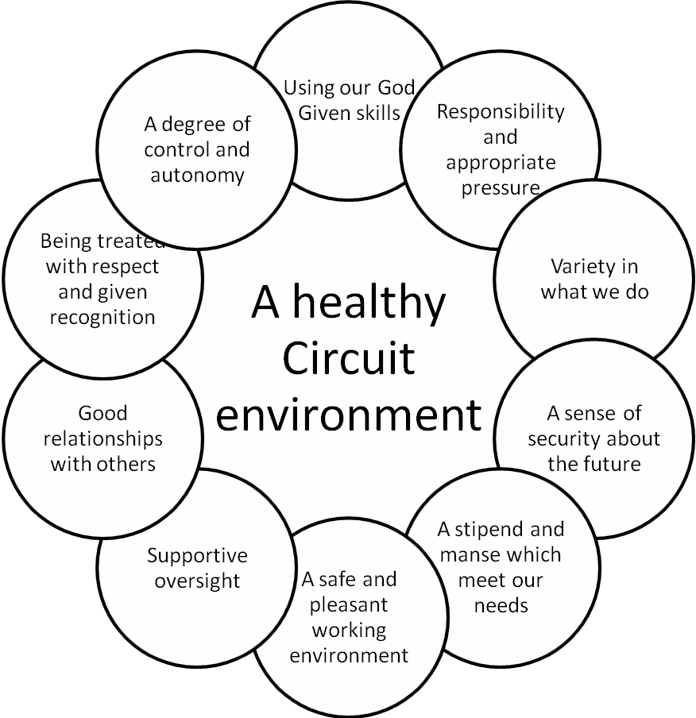
Clearly, not all the features in this diagram will have the same level of importance to all individuals, but together they give a broad picture of the positive aspects which enhance and sustain ministerial service. Conversely, where one or more elements are missing this may have a negative impact on individuals and the team.

This model can provide a useful checklist against which to examine experiences of ministry and circuit life, and to help identify key issues when things are not as they should be.
Equally, it is important that individuals think about what they bring to their ministry and circuit life, both in a positive and negative sense, and the factors that shape the development of sustainable and resilient ministries. These are the issues that individuals bear personal responsibility and accountability for. Some of these qualities are set out in Diagram 2.

Diagram 2 – Personal resilience and sustainability in Ministry: some key factors

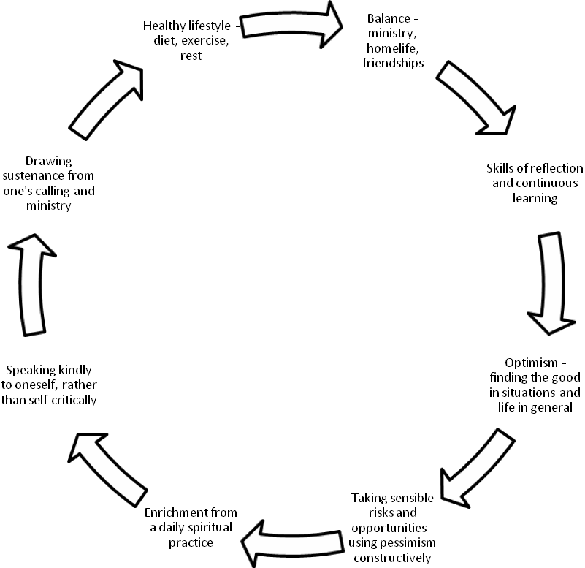
Personal health, resilience and sustainability

The various elements of this model will have different levels of importance to individuals, depending (amongst other things) on their individual temperament and personality. Equally, some elements of support will be available from within the Circuit, whilst others will best be found elsewhere. For example, in developing skills of reflection and continuous learning the Minister may sometimes wish to seek support from outside the Circuit, or indeed outside the local church structures. Equally, deacons will have the Diaconal 'Rule of Life' as a tool to enhance their resilience and wellbeing.

Section 3 - Healthy working practices

Another important factor in considering the health and wellbeing of a Minister is that of the demanding ministerial workload, and how an individual Minister is able to respond to this. Ministers have significant personal autonomy in their work, which creates its own advantages and stresses. These are now considered.

For a Minister, ‘work’ (for want of a better term) is not something that exists in isolation from the rest of the individual’s life. Rather it grows out of the person’s call to be a follower of Christ and to be an ordained Minister. This ministry is then expressed within the context of being in full Connexion and the Covenant Relationship, and is made manifest in a particular station or place of service. In Diagram 3 the Minister’s ‘work’ is therefore expressed in the orange circle, but is a constituent part of a much larger framework of vocation, calling and discipleship, and God’s involvement in the world.

Diagram 3 A context within which ministerial work and activity is located

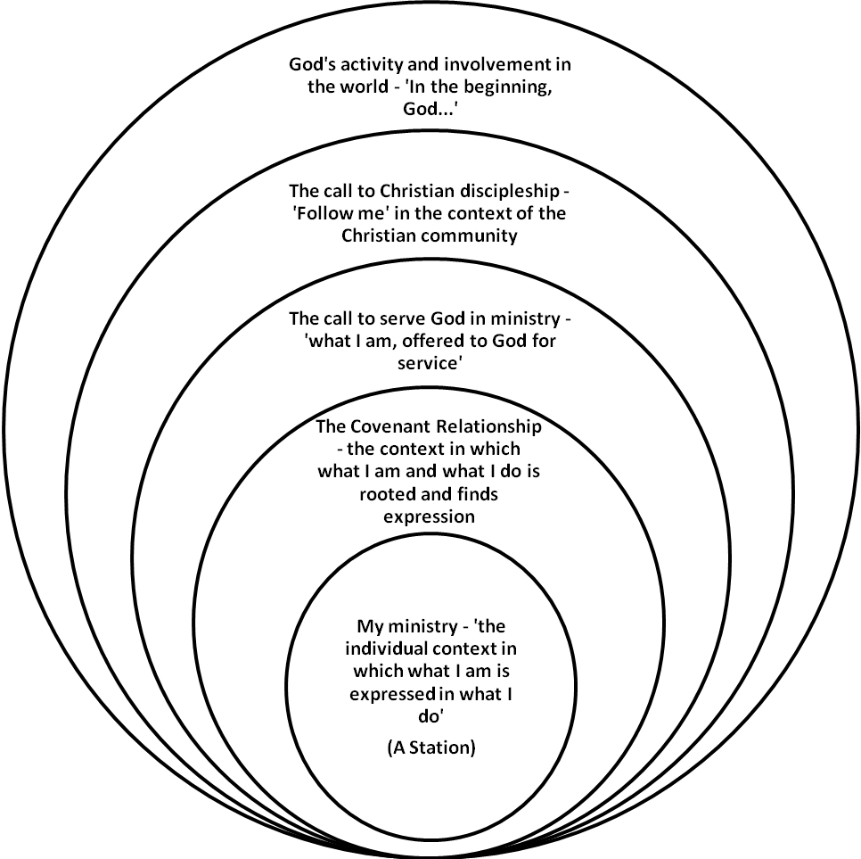

There are a range of ways of thinking about ministerial work. As a starting point, ‘work’ is defined as ‘An activity involving mental or physical effort done in order to achieve a purpose or result’. However, this definition does not capture the sense of calling or vocation that is at the hear of ministerial activity, and which has been defined as ‘A calling from God to some particular living out of the believer’s baptismal commitment. This calling is to a way of life rather than a particular job’ (Source: Merriam Webster Dictionary)

What are the implications of this?

Using the framework provided in Diagram 3 above, it could be argued that a Minister’s ‘work’ is that which is contained in the orange circle. It consists of the acts and tasks that an individual carries out to fulfil the requirements of being in Full Connexion and within a particular station within the Connexion, taking account of the Minister’s personality, gifts and sense of vocation and the needs of the Church, set within the context of the other circles in the diagram.

This framework gives the acts and tasks of ministry a context and significance not always present in secular employment. They are informed by a theological understanding of God’s revelation and activity in the world, and the individual Minister’s response to this, to ‘Follow me’ both as a disciple and a person with a vocation to serve the church in a representative way.

One of the strengths of this approach to defining ministerial work is that it powerfully shows the context within which the day to day activities of being a minister take place. Work and ministry therefore become not solely ‘what I do’, but ‘who I am’, giving a holistic or ‘whole life’ approach which can be immensely fulfilling.

That said, this approach has some negative connotations which we need to be aware of. The wonderful sense of integration of action and purpose can become a place where there are no boundaries, and the Minister is never able to switch off from ‘work’. This can lead to a feeling of being always on duty, without sufficient space for family or self. The work which was initially so enriching to the Minister becomes a constant treadmill without rest or refreshment.

Some of these issues are shared by other professions and those who are self-employed and/or work from home. It is important to note that the Scriptures speak of a Sabbath and of God resting and encourage the observance of a Sabbath as a reminder, among other things, that it doesn’t all depend on us as individuals.

Some issues to think about

In light of these considerations, it might be useful to consider the following:

- Is praying on one’s own for a member of the congregation who is ill defined as ‘work’, or something that the Minister does as a fellow disciple? Where do the boundaries lie?

- If church members who have demanding full time jobs give up two evenings a week to run a youth club should the Minister also ‘volunteer’ beyond the expectations of their Circuit role? What would be defined as Ministerial ‘work’ in this example?

- In secular employment people who hold down responsible jobs will often think about their work at the weekend and in the evening. They don’t consider they are at work. Where would the boundary sit for a Minister who is working from the Manse for much of the time, and in an idle moment turns a thorny problem over in her mind?

These issues help to shed light on the particular stresses and strains of the ministerial role, which in some ways is unique, but in others shares problems with a range of secular occupations.

Some practical suggestions

The interface between the Minister's personal life and their ministerial work will be a matter for individual ministers to work out in prayerful reflection, in conversation with family and friends, lay and ordained colleagues in the circuit and in other supportive relationships such as spiritual direction or supervision as appropriate, hopefully in a healthy and sustainable way. However, as noted above, it is always sensible to put some limits around “work” or being on duty so that family, leisure and ‘off duty’ time is protected and prioritised, as far as is possible. Here are some tips to help with this:

- Install a personal telephone line in the manse with an answering machine, and route all District, Circuit and church related calls through your ‘business' or 'church’ number. When on your day off, eating meals or having important family and friends time, make sure the answering machine is on and that the caller is able to leave messages. If you are waiting to take a call that you genuinely cannot avoid on your day off screen all calls so that you only pick up the one that relates to the urgent issue.

- Update the greeting on your 'church' line answering machine so that callers know when you are next working, and you thus manage their expectations of contact and support. If possible give an alternative number in case of emergencies.

- Ensure that the number for your personal line is only disclosed to those you want to have it, and that they are aware that the number should not be given out to anyone without your permission. Again, having an answering machine is a good idea so that you can screen calls before deciding whether to pick up – just in case a rogue work call comes through on this line!

- Have separate mobile telephones for personal and business matters in order to keep boundaries clear and ensure colleagues can easily cover if you have to take time off. Make good use of voicemail and ensure that your greeting is up to date so that people know when you are available.

- Make sure that you have separate home and' business' email addresses and make use of the 'out of office' facility to redirect people where appropriate. If you simply use one email address you will be tempted to deal with business emails on your day off when you are catching up with personal correspondence. Such an arrangement with separate personal and “business” email addresses and phone lines when you are healthy makes it easier should you become ill for the answer machine and out of office assistant to be used to appropriately divert calls and mail and for a work mobile to be given to someone else.

- Set clear limits to the working day so that you have time for rest and refreshment, and pace yourself. Inevitably these will blur from time to time, so make sure that you protect personal rest and recreation time whenever you can. Consider how you might apply the model shown in diagram 4 below to your own life.

- Ensure, where possible, that there are defined areas of the manse that are set aside for your ministerial activities. This will help you to protect and define your home life.

- If you have caring responsibilities (for example, child care or elder care) think carefully about how you will manage this and with whom it should be communicated, in order to avoid misunderstanding and to secure the support you need.

- Consider what answer to give to casual callers at those times when you are off duty.

Section 4 – Protecting and enhancing our wellbeing
In addition to the practical suggestions set out above, there are a number of more general ways that you can enhance your wellbeing, as shown in Diagram 4. You might want to think about how you can incorporate them into your life in practical ways which fit in with your daily routine.

Diagram 4 Key elements of wellbeing

- Be active
  - Seek out opportunities for physical activity in your day to day routine: you don't need expensive gym membership to do this!
  - Eat well - healthy eating supports physical activity
  - Pace yourself - take breaks in the working day, and regular holidays as provided in CPD

- Take notice
  - Take regular breaks: balance your work and home life
  - Vary your daily routine
  - Be aware/mindful of the world around you: take opportunities to do this each day

- Give/volunteer
  - Seek out opportunities to work with and serve others, outside the ministerial context
  - Look outwards, as well as inwards
  - Create connections with others in ways that are positive and nurturing

- Connect with others
  - Develop a supportive network of friends and family, and invest in maintaining this
  - Nurture your relationship with God - the bedrock and wellspring of our lives
  - Take up opportunities for social interaction in and outside work in ways that are energising rather than draining.

- Keep learning
  - Develop and use new skills - both within and outside work
  - Pursue new interests
  - Embrace change positively: seek learning opportunities, and where you are struggling make sure that you identify people who can support you in times of difficulty
  - CPD suggests that ministers cultivate hobbies and other outside interests

In terms of working hours, it is also important to be aware of the provisions of the Working Time Regulations. In broad terms, these provide for the following:
- A maximum of 48 hours per week working time, averaged over a 17 week ‘reference’ period
- 11 consecutive hours rest in each 24 hour period
- 24 hours rest in each 7 day period
- 20 minutes rest break after 6 continuous hours

These provisions were introduced as part of health and safety legislation and are designed to ensure health and well being both for the individual and for those who are around them. They should be read in conjunction with the holiday provisions contained in CPD.

Be aware of the warning signs and take preventative action
Often our bodies give us clues when we are under stress or pressure, or have lost the balance and joy in our lives. Diagram 5 offers some signs to watch out for.

Diagram 5 Some typical signs of stress
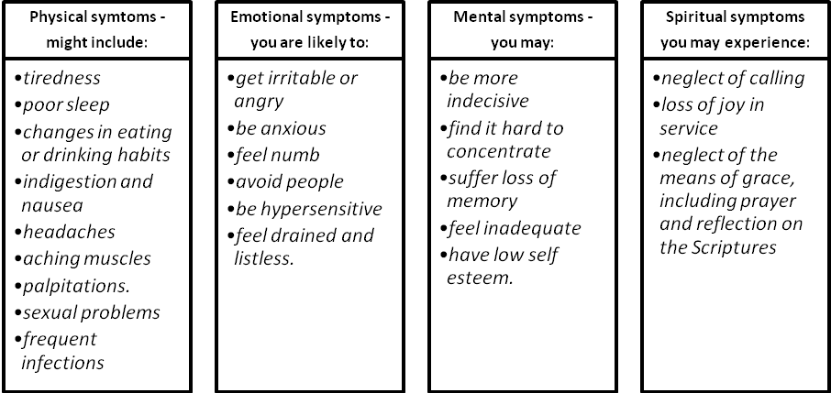

Section 5 - When things go wrong or relationships break down
The frameworks in diagrams 1 and 2 above show us what a healthy Circuit and resilient Minister might look like in overall terms. Clearly, not all of the elements described will always be present, or important. However, the models provide useful insights into understanding of some of the factors to consider when relationships break down, for example when a Minister on sick leave refuses to have contact with their Superintendent or District Chair, or in the case of a Deacon, the MDO Warden. This situation is now considered.

The importance of communication
Meaningful and appropriate communication is always at the centre of healthy Circuit relationships. In circumstances where a Minister is away from work on sick leave, and refuses contact with the Superintendent or Warden, it is essential to try to identify what is leading the Minister to behave in this way. Here are some possible reasons, together with some case studies:

- The medical condition itself – some mental health conditions such as depression tend to lead to withdrawal from social contact, and may include symptoms such as general lethargy, loss of confidence in social situations, and tiredness. In cases such as this the Minister will need help, including access to appropriate treatment, and it is important that the Superintendent finds out what treatment and support the Minister is receiving, and the likely timescale and prognosis. This may be achieved by direct contact with the Minister, but in some situations close friends or family will be very involved and will be able to offer information of this nature, taking account of appropriate confidentiality boundaries. Once clarity has been established about the nature of the treatment being offered, this will lead to the development of a strategy for retaining contact with the Minister, perhaps via the help of a third party such as the spouse or other family member.

Case study 1

A circuit steward contacted the Chair expressing concern about his Superintendent who, he said, had lost his temper at a recent meeting, been extremely verbally aggressive, dismissed several items on the agenda as being ‘not worth the paper they’re written on’ and stormed off at the end leaving a group of shocked and upset people behind him. The circuit steward was initially unaware that the Chair had received the same information from 3 other sources and was in the process of arranging to meet the Superintendent. The Chair enquired about any previous issues or possible warning signs and was told that ‘he said a few weeks ago that he was depressed by [a local situation] but that’s nothing new'.

When the Chair met with the Superintendent, he was quiet and seemed quite withdrawn. His wife was at work, he said he felt OK but admitted to having lost energy, to be finding life quite a struggle at present, though he wasn’t sure why as the stresses were no different. The Chair was aware of many of the family stresses there were, but not until the Chair was leaving did the Superintendent mention a double funeral that he’d taken 3 weeks before for a non-church couple who were of similar age to himself and his wife and which when added to his personal circumstances clearly had affected him badly.

The Chair thought that the Superintendent might be showing the early signs of illness, got the Superintendent's consent to phone the Super’s wife that evening, and subsequently put the wheels in motion for him to see his GP, be referred to the ministerial counselling service, and arrange some time off. The Chair also ensured cover for his responsibliities, and with consent, enlisted the circuit steward’s help in calming the troubled people following the meeting. In time the incident was forgotten and the Superintendent continued to have the confidence of the circuit.

- The effects of medication or other treatment – sometimes a side effect of medication or medical treatment (such as chemotherapy) can lead to the Minister wishing to withdraw socially, either because they are lacking in energy, the physical effects of treatment, or their mood has been adversely affected by the treatment regime. In such cases the suggested approach is as described above, involving the Minister themselves, close family and friends as appropriate, leading to a strategy for keeping in touch with the Minister in a way which honours their wishes, is safe for them and ensures that the needs of the Circuit are met.

Case study 2

C was having treatment for cancer, and had requested no phone calls or visitors. The Superintendent while wanting to respect this was anxious about pastoral care for C and his family, and worried that in the shock of diagnosis and entry into an extended treatment regime, they had overlooked this aspect of their needs.

In the ministerial staff meeting he raised this concern, and a colleague observed that she knew a member of the chaplaincy team at the treating hospital. By agreement, this Minister contacted the chaplain to alert her to the presence of C in the oncology unit, established that she visited the unit most days of the week, and had met C. The Minister shared the circuit staff concern about pastoral care alongside the request of ‘no visitors’, and enlisted the support of the chaplain in bridging the gap that appeared to exist between Minister and circuit.

- A breakdown in key relationships within the Circuit or District, or with the Diaconal Order – sometimes critical relationships between the Minister and certain people in the Circuit breakdown, often for a variety of factors such as differences of opinion or outlook/attitude, personality clashes, alleged bullying or harassment, or clashes in styles/understanding of ministry. This may result in the Minister not wishing, or refusing to have contact with one or more individuals. These are often the most challenging situations to deal with, and call for sensitivity by all parties.

Case study 3

N (a single person) was absent with a diagnosis of anxiety and reported not to be in the manse. With no response to phone calls, the Super sent a text expressing concern and seeking to make contact. With no reply in a week, she sent a 2nd text suggesting that a family member might make contact, and had an angry phone call from N’s friend accusing harassment and that the illness was all the church’s fault as N was the victim of abuse.

Eventually it transpired that N had been receiving ‘silent phone calls’ and a number of instances where the doorbell had been rung late at night (with the caller running away). 6 months previously N asked the circuit stewards for a review of security at the manse, which had not received any serious response, nor had the circuit stewards registered that the request was on the advice of the police to whom he had reported some initial incidents (they had been told and dismissed it as ‘kids messing about’). For reasons that were never clear, N did not make any further reports to the police or raise the matter again with the circuit stewards, but the calls had continued intermittently.

N refused to meet the Superintendent, but agreed to meet the Chair. He accepted counselling, and soon after requested a curtailment. With treatment and being removed from the situation, his health improved, and he was stationed without further problems, though manse location and security continued to be of heightened importance for him.

In cases of this nature it is important to ensure as a starting point that the Minister is receiving appropriate pastoral support. Where relationships are difficult within the Circuit it may be sensible to provide pastoral support from outside this environment, for example from a supernumerary Minister in an adjoining Circuit. Normally the Superintendent would have a key role in moving communication forward where there are difficulties, but equally, the District Chair may have a facilitative role. For Deacons, the Pastoral Care Co-ordinator has an important role to play here.

Section 6 – the role of the Superintendent in dealing with ministerial ill health
Sometimes the relationship difficulty is between the Minister and their Superintendent, resulting in the Minister refusing to have contact with that person. Although it is often tempting to invite a third person into situations of this nature, it is important to state at this point that the position of the Superintendent should be honoured within the agreed structures of the Church. Indeed the report to Conference in 2005 ‘What is a Superintendent?’ set out their oversight role clearly:

‘The Circuit requires oversight in the broadest sense of that term, and in particular (but not exclusively), through theologically informed governance, theologically informed management and theologically informed leadership’

This is further echoed in Standing Order 520 (2):
‘It is the duty of the Superintendent appointed to each Circuit to enable the relevant courts, officers, Deacons and Ministers to fulfill their specific responsibilities under Standing Orders and to ensure that they do so.’

At this point it is useful to note that, in terms of roles and responsibilities, the Superintendent has a responsibility for the Minister within the context of his or her oversight of the Circuit, whereas the District Chair (or Warden) has a wider responsibility for the Minister and the Circuit within the Connexional context, for example in matters of stationing. These distinctions provide complementary oversight and support of the individual Minister.

It is also important to understand that absence because of ill health may be for a variety of reasons, and may mask other underlying issues. This is covered in more detail in the Good Practice Guide Part 1 (see section 3.4). However, in summary, it is useful to consider issues such as family difficulties, substance abuse problems, bullying or harassment, or more fundamentally, whether the individual is facing a period of intense crisis or personal change, perhaps seeking to understand afresh their call and what this means for their service to the Church. These factors suggest that Superintendents approach matters of ministerial ill health sensitively, pastorally and prayerfully, seeking appropriate advice and support where necessary.

Section 5.3 of the Good Practice Guide Part 1 recognises that Ministers have regular contact with their Superintendent as a normal feature of Circuit life. Conversations about ill health should therefore be set within this context as a starting point, and a Minister should feel free to access support at any point. Therefore, the Minister who is unwell must initially give their Fit Note to the Superintendent. This is because the Fit Note may contain information which the Superintendent needs to be aware of (for example, a diagnosis of the condition, which impacts on any return to work strategy, or recommendations from the Medical Practitioner for a phased return to work).

In this context it must be said that it is not acceptable for a Minister to refuse to have contact with their Superintendent (and in the case of Deacons with the Warden). Equally, it is essential that the Superintendent supports the Minister and handles matters in an appropriate way, with due regard to boundaries and confidentiality. If the Superintendent does not feel that s/he has the skills to do this they should themselves seek advice and support. It is recognised that tensions may occur in any relationship, and need to be handled sensitively by all parties. Appropriate contact between the Superintendent and Minister may be maintained and indeed enhanced in a variety of ways when a Minister is absent on sick leave (or indeed when working), including by the following:

- Allowing the Minister to have a supporter present at meetings with the Superintendent when issues of difficulty or conflict are being discussed
- By the Superintendent bringing along a person who can act as a helpful outside presence for the meeting
- By holding a meeting on neutral territory, for example not in the home of either the Minister or Superintendent, but elsewhere
- By agreeing protocols for contact between the Minister and Superintendent, for example agreements on use of communication channels such as emails, telephone, text messages or faxes, timing and extent of communications, and topics which will be covered. Such measures often help to restore trust and confidence over a period of time.
- By either the Minister or Superintendent (or both) having access to an independent person who can help them to reflect on and think through their issues and concerns, and appropriate ways of behaving, such as a mentor, spiritual director or coach
- In circumstances where relationships have become particularly strained, the appropriate involvement of the District Chair/Warden to bring the two parties together in a constructive way, or if necessary a professional mediator.
- In some particularly strained situations, by the Superintendent delegating responsibility for an important conversation to someone else, who will report back to the Superintendent after it had taken place. This would not be usual but may sometimes be appropriate.

Where relationships have broken down, it is often useful to pursue a structured process of rebuilding these, and Diagram 6 provides a possible framework to take this forward:

Diagram 6 – a framework for collaborative problem solving and rebuilding relationships
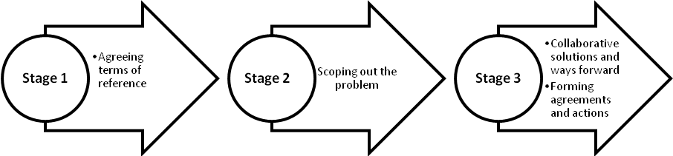
Sometimes a process of this nature can usefully be facilitated by an independent person, particularly where it is necessary to rebuild trust and rapport. However, in all situations, it is important that the outcome of any such process includes a set of written agreements about key issues, which may include the following:

- The nature, frequency and scope of contact that the Minister will have with the Superintendent and others in the Circuit;
- Where appropriate, the steps that will be taken to support the Minister in returning to work;
- The nature of any phased return to work, actions which the Minister and Superintendent commit to taking, along with timescales (see the Good Practice Guide Part 1 for more information about how to set up a phased return to work process);
- External actions and support that may be helpful, such as access to counselling, occupational health advice, supervision, coaching or spiritual direction;
- The provision of pastoral and any other support that might be required;
- Arrangements for reviewing the freshly established relationships, which may be fragile in the early days and need regular attention and support.

Ill health of the Superintendent
The guidance contained in earlier sections focuses on the relationship between a Minister and her/his Superintendent. It is useful to now consider the position when the Superintendent is the person who is ill. In these situations the individual carrying out the discussions and actions referred to above would be the District Chair, who would work pastorally and sensitively with the Superintendent. In such a situation it is possible that, for whatever reason, the relationship between the Superintendent and District Chair is problematic. If this should be the case, the District Chair is able to bring in a colleague District Chair to assist her/him in working with the Superintendent and to facilitate a positive moving forward in the relationship.
In summary, it is an unfortunate fact of Church life that sometimes relationships break down. However, the suggestions described above, together with the provisions of CPD, provide a set of tools for the supportive rebuilding of relationships within the context of ‘watching over one another in love’ (1 Peter 3.8).

Section 7 – Dealing with situations where a Minister’s health is such that they cannot feasibly continue in active ministry, but are reluctant to pursue alternatives

Occasionally situations arise where a Minister is unable to continue in active ministry due to their
deteriorating health, particularly where it is not practical or appropriate to make any reasonable adjustments to their work as provided under the Equality Act 2010. However, they may hide or mask the seriousness of their condition as they do not wish to sit down. There may be a number of reasons why this takes place, for example:

- The Minister’s sense of the call of God on their life, giving them an expectation and wish to continue in ministry, even where this causes struggle and stress for them
- A reluctance on the part of the Minister to accept that due to ill health their ministry must now fundamentally change, along with their sense of themselves and their ministerial identity
- Practical considerations, such as perceived inability to live on an ill health retirement pension, especially where they are the sole breadwinner, and issues about access to state benefits
- Concerns about housing provision if they retire
- Continuing family costs, which require a full income, such as dependent children or the cost of elder care
- Impact of a move on their family, such as proximity to schools or relatives living near by.

These situations are often very difficult and must be sensitively handled by the District Chair/Warden and other responsible persons. Whilst every situation must be looked at individually, it must be stated that if there is a perception that a Minister is unable to cope with or continue in ministry due to ill health this must be raised with the individual. Failure to do so could put either the Minister or those s/he comes into contact with in danger, particularly if the medical condition is a serious one. The Church has a duty of care to all parties in such situations.

When considering ways for ward for the individual Minister, it is often important to distinguish between a person continuing in their current station or in active ministry elsewhere. This latter option could be on either a full or part time basis, subject to the needs of the individual and the Circuit or other receiving body. That said, it is important to note that there is no automatic right for a Minister to continue on a part time basis in their current station.

When dealing with individual situations it is important not to jump to conclusions about the likely outcome of any discussions. Whilst the Circuit may have concern about the sustainability of a person's ministry, it is imperative that s/he is engaged with in a sensitive and meaningful way, without preconditions or expectations. Diagram 7 provides details of some issues which may be considered in such discussions, and a framework for doing so.

Diagram 7 – a framework for discussions in cases of deteriorating health

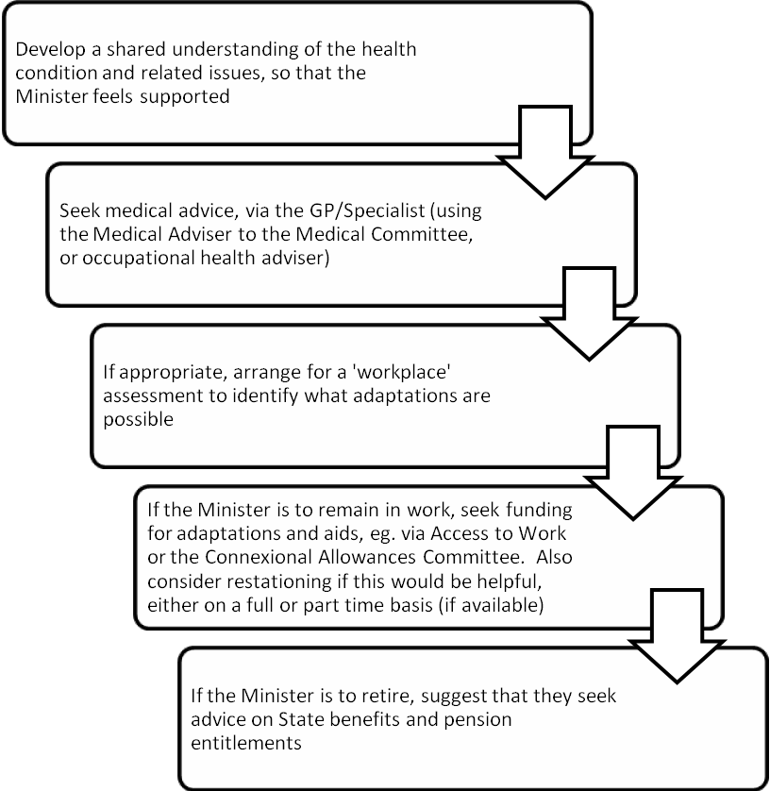

Please also see the document 'Guidance on supporting Ministers with disabilities'.

Section 8 – a framework for supporting Ministers who are absent on long term sick leave
Context
Ministers who are taking long term sick leave (defined in the ‘Good Practice guide Part 1' as a continuous absence in excess of one calendar month) sometimes have particular support requirements, thought the exact nature of their medical condition will often determine what these are on an individual basis. This section provides a framework within which support and appropriate action should be taken by Superintendents and District Chairs/the Warden of the Diaconal Order.

Guiding principles
The document 'Supporting Ministers who experience ill health - good practice guidance Part 1' agreed by Conference in 2011 provides an overall context for dealing with issues of ministerial ill health. This additional guidance is not designed to supplant any of the provisions in Part 1, but rather deals specifically and in more detail with the issues raised when a Minister is on long term absence.

Standing Order 365 states:
If at any time ...a circuit Minister, circuit Deacon or probationer has by reason of illness or injury been unable for a total of 26 weeks during the preceding 24 months to discharge the responsibilities of his or her appointment any Circuit involved shall on application be reimbursed out of the Methodist Church Fund for all sums (less the credit for Social Security benefits and statutory sickness pay) paid by the Circuit to that person under Standing Order 801(4) in respect of any continued or further periods of incapacity during the next twelve months

Therefore, responsibility for funding the stipend of a Minister passes to the Methodist Church Fund after 26 weeks of continuous absence. During the first 26 weeks of absence the individual Circuit is responsible for payment of stipend, and responsibility for provision of support to the Minister rests primarily with the Circuit (supplemented where appropriate by the District Chair/Warden of the Diaconal Order). However, once the 26 week watershed is passed, the arrangements for support and funding may shift from the Circuit to more central provision, as agreed on a case by case basis.

Strategies for supporting ministers who are taking long term absence

In some situations the reason for long term absence is clear and reasonably time bound. For example, a Minister recovering from major surgery is likely to receive relatively clear medical advice about when s/he is likely to return to ministerial duties. This may also be the case where the Minister is recovering from treatment such as chemotherapy, but will not always be so. Indeed, in some situations, such as where a Minister is absent due to significant mental health issues, or a physical condition which has not resolved within expected timescales, the course of recovery can be unpredictable and much slower than expected. However, in all situations the procedure set out below should be adopted, appropriately modified to suit the individual needs of the Minister experiencing ill health.

Step One – three month review

It is important that Ministerial absence is kept under review as provided within the Good Practice Guide Part 1. This ensures that appropriate support is provided to the Minister who is absent from the point when it is known that she/he is experiencing ill health. Sometimes people within the Circuit or the Diaconal Order will not always know when a Minister becomes ill or develops a debilitating condition. This is because not all conditions (at least at their outset) require a person to take time away from ministerial duties. However, this does not mean that the Minister is in health, and for the purpose of this guide an individual is considered to be unwell when the conditions that s/he has prevent them from carrying out some or all of their ministerial duties. This means that although Superintendents must be alert to sickness absence, they will also need to consider whether a Minister who continues to work, with or without a Fit Note, has specific support needs that can be addressed under the scope of this guidance.

Where a Minister has been absent for a continuous period of 3 months (or where they have a condition that is debilitating, even if they continue to work) the Superintendent should exercise appropriate pastoral oversight. This should take place by means of a conversation with the Minister in which the Superintendent seeks to understand the nature of their condition and how it is impacting on the Minister's life and ministry. The implications for the next few weeks and months of ministry should be considered, and the Superintendent should offer oversight in order to help the Minister understand what their needs are in the context of circuit ministry. In this conversation it will be important to discuss the Minister's current health and the likely timescales for recovery (if known). Reference should also be made to the Fit Notes which sometimes provide a diagnosis and additional information. Any existing medical evidence should discussed, for example a letter from a Medical Practitioner responsible for the Minister's treatment, and the Minister’s own perception of their condition. If necessary, the District Chair/MDO Warden should be alerted, for example where specific support is required or where concerns exist about how the Minister is coping. Having considered all the above the Superintendent will ensure the Minister is appropriately supported and that the work of the Circuit continues to be covered. The Superintendent will agree arrangements to support the Minister as a result of this conversation. This may cover (as appropriate), arrangements for pastoral support, ways of keeping in touch with the life of the Circuit (if this would aid the Minister’s recovery) and any other actions deemed necessary.

Step Two – six month review

If the medical advice indicates the Minister is likely to be off for some considerable time, not only will Connexional funding become available at 26 weeks, but in addition it will then be possible to access other Connexional support. At this point, if the Minister remains absent or is continuing to work in a limited way , with or without a fit note, the prime responsibility for supporting the Minister moves from the Superintendent to the District Chair/Warden, not least because the Connexion has a greater role to play, rather than just the Circuit. That said, any support provided by the Circuit and Superintendent may continue at this point, if appropriate.

At 26 weeks, if the Minister remains absent, the Connexion becomes responsible for providing the stipend, and the Circuit retains responsibility for providing the manse. The Minister remains stationed in their Circuit, but the Connexional payment of the stipend allows the Circuit to fund cover for the Minister, if required.

In some cases there will by this stage be a much clearer idea about when the Minister will be able to return to work. This will allow the Circuit to plan for this with the Minister, and the guidance provided in the ‘Good Practice Guide Part 1’ may be useful, for example in developing a supportive return to work strategy on a phased basis. However, in some situations there will be no clarity about if or when the Minister will be able to return to work, and for a range of reasons it may not be appropriate for the Minister to apply for ill health retirement (not least if the medical prognosis is that there will eventually be a recovery).

In circumstances where there is at this point no clarity about if or when a Minister will be able to return to work, it is also essential that a stationing conversation takes place between the Circuit and District Chair/Warden. This conversation will not focus on the Minister and their medical condition (indeed, the Minister will not be present), but focuses on the needs of the Circuit and how they might best be met. These issues are independent of the Minister and their health.

In tandem with this, the District Chair/Warden will have a separate conversation with the Minister about their health. It will be essential to review the medical and other information previously considered at the 3 month review, in light of any changes to the medical condition or health of the Minister during the intervening 3 months. At this stage it is a requirement that independent medical information is sought, and the District Chair/Warden is responsible for arranging this in consultation with appropriate Connexional officers. The medical advice sought may be in the form of a medical report based upon information from the Minister’s General Practitioner and/or any other medical practitioner treating her/him (obtained via the Medical Adviser to the Medical Committee), or an occupational health assessment. When obtaining medical advice it is essential that consent is given by the Minister to enable this information to be shared with appropriate individuals at Circuit, District/Diaconal and Connexional Team level, respecting issues of confidentiality.

Following discussion of the medical evidence, the Minister’s own experience and understanding of their condition and their future wishes, the District Chair/Warden will consider this information, along with the outcomes of the stationing conversation held with the Circuit. The Chair/MDO Warden will consider whether the needs of the Circuit and Minister are compatible. If they are, the Minister will remain in the Circuit, where they make their recovery. If there is not compatibility the Chair/MDO Warden will have a discussion with the Minister about this, and a likely outcome will be that the Minister will need to move on to another appointment. It will be important for the District Chair/MDO Warden to have a sensitive conversation with the Minister about this, including a consideration of what kind of ministry the Minister believes they will be able to exercise, both in light of their sense of calling and the medical information available. If agreement is not reached between the Minister and the District Chair/MDO Warden, the Chair/MDO Warden will ask a neighbouring District Chair to gather together a small Panel to meet with the Minister in order to review the situation. This Panel will then make its recommendation to the District Chair and the Minister, and both parties will be bound by these recommendations.

The options available as a result of the discussion between the Minister and District Chair/MDO Warden are as follows:

- The Minister and District Chair/MDO Warden explore part time working or restricted duty options (if available)
- The Minister and District Chair/MDO Warden explore full time working, possibly with restricted duties (if available)
- The Minister enters stationing in the normal way.
- Where there is the possibility that the Minister will be fit enough to return to ministerial duties within a period of time, and is therefore likely to make a recovery, the Minister is provided with a Recuperative Year during which s/he will have the opportunity to recover their health. This is considered further below.
- The Minister applies for ill health retirement

Features of the Recuperative Year

During this period of time (which might be less than a year, depending on the point reached in the stationing process when the recuperative year begins) the Minister would be notionally stationed at Methodist Church House under the oversight of the Secretary of Conference and would be without appointment at the Connexion's expense. The manse and stipend will be paid by the Connexion. It may be that the Minister will be required to relinquish the manse they occupied whilst in Circuit, and the Connexion will provide if necessary the Minister and her/his family with accommodation appropriate to their needs during this period of time.

In return for this the Minister agrees in writing to follow a detailed Support Plan (see Appendix 1 for an example). This will set out the measures the Minister will take to nurture their health, the support provided, by way of pastoral support, mentoring, spiritual direction, counselling etc., any other actions that the Connexion believes will aid the Minister in her/his recovery or are recommended by medical professionals. The Connexion will review the Minister’s progress on a quarterly basis during the Recuperative Year by means of a named individual who will meet regularly with the Minister to carry out on-going discernment of their development, including how best they may serve the Church in the future. The Minister’s existing District Chair or the Warden will work with the Minister and Connexional representatives on this, but if relationships with the Chair/MDO Warden have broken down another District Chair may be appointed for this purpose. The arrangements for the Minister during this period will be overseen by the Secretary of Conference or their nominated representative.

During the Recuperative Year much of the support which had been provided during the first 26 weeks of absence will continue to be required. For example, it would be expected that pastoral support will continue, and if necessary counselling, and on-going spiritual direction.
In addition, the following provisions may be helpful, depending on the nature of each case:

- A formal work place assessment by a qualified occupational health adviser. This would identify any adjustments or adaptations to the working environment of any future manse or other building required as a result of the medical condition
- A structured programme of mentoring with an experienced mentor assigned to work with the Minister on specific issues which have arisen as a result of their illness or condition. An example of this might be engaging the Minister in reflective work on their reaction to stress and pressure in a case where this has been a strong feature of the absence, or working on behavioural/attitudinal issues
- An on-going assessment of the Minister's health by the Medical Adviser to the Medical Committee or an Occupational Health Adviser
- Arrangements for periodic feedback from the Minister about their progress towards recovery. To this end, there will be discussions every three months, carried out by the Secretary of Conference or their nominated representative. At these, consideration will be given to the likelihood of the Minister being able to return to work at the end of the Recuperative year, and what kind of station might be appropriate, including serving in an appointment outside the control of the Church. The possibility of ill health retirement may also need to be considered.
- Planning for a phased return to work, when this is recommended by the Minister's medical practitioner

Diagram 8 – framework of support for a Minister experiencing possible long term ill health

3 Month Review
Consideration of medical information and support - by Superintendent. Further support provided
Weeks 1-13
The Circuit is primarily responsible for all elements of support, with external advice as appropriate

6 Month Review
Consideration of medical information and support. Process of discernment with District Chair involvement

Option 1 –return to work in current Circuit
Stipend paid by Connexion for remaining period of absence.
Return to work strategy developed.
Option 5 – application for ill health retirement ( This may be made at any point in the process)

Option 4 - other options for appointment (at own expense/outside control of church
Option 2 – Minister enters stationing, for either a full or part time role
Option 3 – Minister is granted a Recuperative Year - Connexion provides accommodation and stipend. Support plan agreed.

3 month review
6 month review
Fresh medical advice sought

9 month review
Plans put in place for future options

12 month review
Potential outcomes:
Re-entry to stationing
Ill health retirement
Without appmt at own expense
Appointment outside church control

Actions which may take place at the end of the Recuperative Year

Towards the end of the Recuperative Year the Secretary of Conference (in consultation with other appropriate persons) will review the progress made by the Minister, if necessary seeking fresh medical evidence. A full consideration of all the options available to the Minister will be made, including re-entering stationing, serving in an appointment outside the control of the Church, being without appointment at the Minister's own expense, and ill health retirement. There should be no expectation of any further Connexional Support for the Minister at the end of this period of time. If it is discerned that re-entering stationing is the appropriate course of action, the Minister will be expected to do so at this point (or sooner if the stationing timetable requires this). If agreement on a course of action is not reached with the Minister s/he will be required to be without appointment at their own expense.

Section 9 - Sources of further advice and guidance
Advice on sources of funding and how to arrange for appropriate medical advice to be sought can be obtained from the Guide ‘Supporting Ministers with Disabilities Part 1’ or the Wellbeing Officer. In addition the following resources may be helpful:

Information on state benefits and associated advice:
http://www.direct.gov.uk/en/moneytaxandbenefits/benefitstaxcreditsandothersupport/index.htm

Access to Work (Government Agency):
http://www.direct.gov.uk/en/disabledpeople/employmentsupport/workschemesandprogrammes/dg_4000347

Methodist Church website – wellbeing pages:
http://www.methodist.org.uk/ministers-and-office-holders/wellbeing

Supporting Ministers who experience ill health – Good Practice Guide Part 1:
http://www.methodist.org.uk/downloads/cl_well_beings_supporting_ministers131011.pdf

Appendix 1
Model Support Plan for the recuperative year

1. Parties to this agreement:

Name (Minister) Rev A

Name (Connexional Team representative) Rev B

2. Duration of this agreement:

The agreement commences on 1 July 2012 and concludes on 31 August 2013.

3. Stationing arrangements:

Rev A has curtailed his appointment at Circuit C. This curtailment takes effect on 31 August 2012, and Rev A agrees to enter the stationing process in September 2012 in accordance with the Church’s timetable and requirements.

4. Manse provision:

Rev A will remain in his current manse in Circuit C until August 2012. He will vacate this manse by the week of the first Monday in August 2012.
For the Connexional year 2012/13 he will be provided with accommodation appropriate to his needs, at the Connexion’s expense (including utility bills and Council tax). He will move to a new manse as provided in his new appointment in accordance with SO 785(5)(b).

5. Stipend and expenses arrangements

Rev A will receive a stipend for the duration of this agreement. Reasonable travel expenses will be reimbursed by the Methodist Church Fund. These will include travel to pastoral meetings, coaching sessions and attendance at medical appointments arranged by the Connexional Team or the Secretary of Conference. Any other expenses will only be paid if agreed with Rev B in advance.

6. Person exercising oversight of the Minister:

The Secretary of the Conference.

7. Person providing pastoral support to the Minister:

District Chair D.

8. Monitoring and review arrangements pertaining to this Support Plan:

Rev A will meet with Rev B as a minimum at 3 monthly interviews during the period covered by this Support Plan. Further medical evidence will be sought during the period of the Plan to ensure that he is fit to undertake a ministerial role from 1 September 2013.

9. Actions which the Minister agrees to undertake:

- To participate fully in the stationing process, and assume a new appointment on 1 September 2013, on the understanding that this may be in a location other than his current one.

- To continue to undertake regular coaching sessions as deemed necessary.

- To receive pastoral support from District Chair D.

- To submit to appropriate medical processes, either review by Interhealth or by the Connexional Medical Adviser obtaining a medical report from his GP/Specialist.

10. Outcomes which will take place at the end of the agreement:

Rev A will be stationed to a new appointment on 1 September 2013. If he declines an appointment which the Secretary of Conference deems to be suitable he will be considered to be without appointment at his own expense and will forfeit any entitlement to stipend or manse provision from that date. Equally, if he is not fit to take up a new appointment on 1 September 2013 he will be considered to be without appointment at his own expense and will forfeit any entitlement to stipend or manse provision from that date. If he is unfit to be stationed on medical grounds Standing Order 774 (9) will apply.

11. Signatures:

Minister: Date:

Connexional Team Representative: Date:

Living with disabilities and impairments – practical support for ministers and their Chairs/Superintendents/the MDO Warden

- Introduction

This guidance has been prepared in order to offer Ministers living with disabilities or impairments (and their Chairs/Superintendents/the MDO Warden) information about how to access any support they may need. This support may take the form of access to appropriate assessment services, information or advice, financial help with the purchase of equipment or adaptations, or training for themselves or those they work closely with.

In supporting Ministers with disabilities and impairments, it is important to take a proactive approach, rather than a reactive one that relies on waiting for the Minister to express their needs. Actions should be taken at an early stage, either as soon as a disability or impairment is identified or diagnosed, or when a Minister enters the stationing process/changes appointment. In the latter situation, part of the preparations for receiving the new Minister should include a consideration of any support needs the person may have.

When considering impairments and disabilities, it is often easy to focus on physical issues that are immediately identifiable (for example mobility difficulties), rather than issues that may be ‘hidden’ or not apparent, such as diabetes, asthma or mental health issues. These must be considered carefully, often by sensitive and confidential discussion with the individual Minister.
It is also important to realise that a ‘one size fits all’ approach is not appropriate. Everyone is an individual and their needs will be specific to them – support which may have worked for someone else with a similar condition may be inappropriate, however well-meaning, and the experience of living with a condition may change over time. Engagement with the Minister on an individual basis is recommended in order to provide the support solutions they need. Consideration should also be given to the needs of the Minister’s family who may have been supporting the Minister for some time.

Conversely, if a Minister has a family member who is living with a disability or impairment, both the family member and the Minister may have specific support needs. For example, a Minister who has a child with special needs may need to consider and explore the availability of specialist schooling, which could impact on stationing conversations. Whilst it is clearly the Minister who is in a covenant relationship with the Church, sensitive and appropriate support should be considered for family members. It is not possible to set down parameters in these situations, and every case must be considered on an individual basis. It is also important to bear in mind the concept of ‘discrimination by association’ introduced in the Equality Act 2010. It is considered to be direct discrimination if a Minister is treated less favourably because of his/her association with another person who has a 'protected characteristic', for example a disabled child. Whilst the primary focus of this guidance is on the Minister, family circumstances and associated support needs must be carefully considered.
It is important to consider disability and impairment issues during the transition from training to probation. Often the training institution has provided appropriate support, but this does not translate into Circuit based assistance. Therefore, it is important to have early conversations with probationers about their needs on entering the Circuit.

- Definition – disabilities and impairments, and the legal position

The term ‘disabilities and impairments’ arises from the Conference Report 2006 ‘Presbyters and Deacons affected by Impairment’ and recognises that Ministers may have a wide range of conditions, some of which will be covered by the legal definition of disability, whilst others are not. At this point, it is useful to note the actual legal definition:

‘A person has a disability for the purposes of the [Equality] Act if he or she has a physical or mental impairment and the impairment has a substantial and long term effect on his or her ability to carry out normal day to day activities’

Further advice about this can be found in appendix 1 ‘Supporting Ministers with Disabilities and Impairments – Notes on our Responsibilities under the Equality Act 2010’. More detailed information is contained in the document ‘Equality Act 2010 – Guidance on Matters to be taken into account in determining questions relating to the definition of disability’, published by the Office for Disability Issues. An electronic copy is available in pdf format at http://www.equalityhumanrights.com/advice-and-guidance/your-rights/disability/

Whilst it is always important to bear the legal position in mind, it is not always helpful to be bound by this –Ministers may have a wide range of conditions for which some form of support is desirable, either on a long term or temporary basis.

- Illness and Impairment – distinctions and overlaps.

It is recognised that some guidance in distinguishing between illness and impairment or disability may be helpful. While it is undoubtedly true that some illnesses may cause or result in a disability, it is also true that many people who would be regarded as having a recognised impairment do not have an illness, nor regard themselves as ill.

Illness, which may affect mental or physical health, is usually seen as a time-limited condition from which, with appropriate intervention, the individual is expected to recover. While a Minister may be absent from work for several months following major surgery for a non-cancerous condition, or with post-natal depression, once recovery has taken place, they are neither ill nor impaired.

The list of physical and mental impairments which are regarded as disabilities but where the individual may not regard themselves as ill includes hearing loss, speech defects, loss of or some permanent disfigurement or functional damage of a limb, dyslexia, visual impairment. While many of the physical impairments are immediately identifiable, the less apparent, e.g. dyslexia, are equally important to address once a diagnosis is made and a need identified.

Some illnesses become chronic – they last more than 6 months, may be relapsing or progressive in nature and, to a greater or lesser extent affect the individual’s ability to undertake normal day to day activities. As noted above, in the Equality Act, ‘long term’ is considered to be more than 12 months.

Many chronic illnesses lead to the person meeting the disability criteria of the Equality Act, even though some or most of the time there is no apparent effect on their ability to undertake normal day to day activities. All cancer diagnoses, relapsing cases of anxiety / depression and insulin-dependent diabetes are perhaps the most commonly encountered examples of chronic illness where the person would be regarded as meeting the criteria. In terms of supporting individuals, these impairments may be hidden by the Minister, and a sensitive, case-by-case approach is needed to support individuals as soon as the information is shared with colleagues, circuit stewards or others.

- The key role of a professional needs assessment

Sometimes a useful starting point is to gain a full and independent understanding of how a person’s condition or diagnosis impacts upon their work as a Minister, so that appropriate support can be identified and accessed. In these situations an independent assessment by an appropriately qualified occupational health professional can be helpful in understanding the nature of an individual’s condition and finding out what up to date support is available. Here are two examples relating to dyslexia.

Case study 1 – dyslexia: diagnosis during initial ministerial training

Jane has recently commenced full time training to be a deacon. She has not studied for over 20 years and feels a bit daunted by the academic aspects of her course. On the other hand, she is looking forward to the practical, ‘hands on’ parts where she can learn ‘on the job’. At school Jane struggled with her studies, and was labelled ‘slow’ by her fellow pupils, and some of the teachers. This has left a legacy of lack of confidence and humiliation, which she is finding has returned in her mind since she commenced her training.

Matters come to a head when Jane begins to study for her first assignment. She struggles with the reading she needs to master, and finds it hard to organise her research. Her tutor suggests that she has an assessment at the University disability support centre. Jane takes a number of tests and a diagnosis of dyslexia is given. The report recommends a range of support measures, including Jane being given advance copies of lecture notes and help with organising her research.

In this case study Jane is provided with support and guidance about how to organise and carry out her studies based upon the information provided in the formal dyslexia assessment. This provides a benchmark which will enable her academic work to be assessed on a level playing field with others on the course who do not have dyslexia. But what happens to Jane after she completes her course and is stationed in her first Circuit?

Case study 2 – dyslexia: support provided in Circuit

Following the support provided to her in college, Jane successfully completed her period of ministerial training with flying colours. She felt confident on entering her first Circuit appointment on the basis of this. However, things changed quickly for her once she started. Very soon after her arrival she found that she was bombarded with emails and documents, and spent increasing amounts of her time trying to keep up with the demands she faced. Unlike college, where her work could be structured to take account of her dyslexia, this was not possible in Circuit, where the work could come from a range of sources. Jane felt that she was going under, and matters came to a head when she arrived at a meeting with the wrong papers and couldn’t identify what the key issues under discussion were.

Fortunately her Superintendent spotted her difficulties and arranged for her to have a workplace assessment. This involved a qualified assessor visiting Jane at her workplace and talking to her and her Superintendent about the needs she had. This resulted in a detailed report which recommended voice activated software, the use of specific fonts for reading text and other materials to support her. In addition, training was provided for Jane on how to organise and file her emails, planning techniques and time management. Training was also provided for those who worked with Jane, for example the Circuit administrator, so that they were aware of her working style and specific needs. These measures enabled Jane to flourish in her ministry.

These case studies show that an assessment of an individual’s needs is often crucial to a successful outcome. Whilst the case studies relate to dyslexia, they are equally applicable to other conditions such as multiple sclerosis or Parkinson’s disease. Workplace Assessments are, as the name implies, usually work based ie. they take place in the manse, focussing particularly on the Study as this is where the home-based work usually takes place. Reference is also made to other places that the Minister visits such as churches in the circuit, community halls etc. but these are not usually visited.

Case studies 1 and 2 focus on very specific aids that can assist with work. However support may also be in the form of adaptations to properties to provide stair lifts, adapted toilet facilities, ramps to doors, a wet room and grab rails, as examples. The key issue is that needs must be identified by means of a formal assessment carried out by an independent, appropriately qualified professional.

In considering these assessments, it is important to realise that not only is there a legal basis for carrying them out, but that the individual Minister must feel appropriately supported and cared for by the Circuit – there must be no sense of guilt on the Minister’s part that these arrangements are being made for them, or that they are in any way a ‘nuisance’. Rather, this is part of the members of the Circuit ‘watching over one another in love’. Equally, an occupational health assessment is not always the most appropriate option to take, particularly in situations where professional medical advice (rather than occupational health advice) is required. This guide covers situations where occupational health advice is the most appropriate way forward. For information about how to obtain medical and related advice please contact the Wellbeing Officer.

- How to obtain a professional assessment

Given the wide range of disabilities and impairments, it is often difficult to know who to turn to for advice. Some conditions are represented by active user and carer groups. For example, in the field of dyslexia, the campaigning bodies usually have access to fully trained and accredited assessors, which makes it much easier to obtain robust and useful information. These organisations are often very aware of the support available, costs, and how to access it.

However, this is not the case in all situations. For example, there is no such assessor body for people living with Parkinson’s disease. Therefore, in all situations, regardless of whether a representative organisation exists, it is recommended that Districts and Circuits/the Diaconal Order use Interhealth, our Occupational Health Provider, for assessments. We have worked with Interhealth over a number of years, and have found them to be sensitive to our needs. They also work with a number of other churches and para-church organisations, so understand the ministerial context well. Further details can be found at http://www.interhealth.org.uk/uk-churches.html

Interhealth can be contacted by email on occhealth@interhealth.org.uk or by telephone on 020 7902 9000. Although based in London, they have associates throughout the UK who can carry out workplace assessments, and may sometimes involve locally based practitioners who have provided care or treatment to the Minister.

Case study 3 – obtaining a professional assessment for a Minister with a diagnosis of osteo-arthritis

Ola is a presbyter who lives with osteo-arthritis. He has been diagnosed with this condition for 10 years and has recently found joint damage in his spine. He is under the care of a very helpful NHS Consultant who has discussed with him how he can continue his work in such a way that he minimises any further joint damage. The Consultant offers to write a letter to his Superintendent which sets out some helpful suggestions for this. Whilst this intervention is welcomed by the Superintendent, she realises that the Consultant’s suggestions need to be placed within the context of Ola’s manse, equipment and layout to ensure that he receives all appropriate support. She therefore arranges a workplace assessment so that the Consultant’s suggestions can be placed in the context of Ola’s working environment and the day to day pressures that he faces.

- Protocols/confidentiality issues relating to professional assessments

A request for a professional assessment is made to Interhealth by using an Occupational Health Consultation referral form. This should usually be completed by the Chair of District/MDO Warden or alternatively the Superintendent, and to help you, model forms for presbyters, deacons and superintendents are available on the Wellbeing section of the Church website. These describe ministerial duties in a generic way, and can be amended to suit local circumstances. Once the form has been completed by the Chair/Warden/Superintendent it should be shared in draft form with the Minister concerned, who then has the opportunity to input into the contents. In the unlikely event of a disagreement over a specific point it is acceptable to show the points where perceptions differ, for example prefacing a comment with ‘The Minister states...’. In more serious instances of disagreement it is important that appropriate advice is sought within the District or Connexional Team. It is also useful to refer to the ‘Good Practice Guide for Supporting Ministers with ill health – Part 2’ where issues of disagreement are covered in more depth.

It is important that as part of the drafting process it is clearly specified who will receive a copy of the final report from the Occupational Health Adviser. It is recommended that this is the Minister themselves, the Superintendent, and if appropriate the District Chair/Warden. Other parties who have been involved in an individual situation may also be included if appropriate.

Case study 4 –dealing with mental health issues sensitively

Jean has lived with depression for most of her adult life. She is supported well by close family and friends, and has a psychotherapist with whom she has worked on a long term basis. She experiences occasional episodes where she requires medication although this is usually only on a short term basis to enable her to cope with specific difficulties. Her Superintendent has noticed that recently she has appeared lethargic when attending meetings or leading worship. He discussed this with her, but Jean did not feel that her behaviour or energy levels had been any different from normal. She felt rather threatened by his comments and wondered whether the Superintendent wished her appointment to be curtailed. For his part, the Superintendent was clear that he simply wished to ensure that Jean was coping and had access to appropriate support. However, this misunderstanding soured what had been a good relationship.
Having considered the matter further, the Superintendent decided that he wished to seek independent occupational health advice on Jean’s condition. He completed a first draft of a referral form and sought Jean’s comments. She objected to the phrase ‘Jean has appeared to be tired and lethargic recently’ but the Superintendent was adamant that this was his perception, and the main reason for the referral. Jean therefore agreed that the sentence be prefaced with the phrase ‘It is the Superintendent’s view that ...’. This reassured her and gave her a helpful context to discuss these perceptions with the Occupational Health Adviser. To further reassure her she asked that a copy be made available to her psychotherapist, and this was set out clearly in the form to avoid any confusion.

Once the form is completed it is sent electronically to Interhealth, who will then contact the Minister to make an appointment for the assessment. It is sometimes helpful for the Superintendent to be present at least for part of a workplace assessment, although this is not always appropriate.
After the assessment has taken place Interhealth prepare a report which is sent to the Superintendent/Chair/Warden as appropriate, the Minister and anyone else it has been agreed should receive it. The report remains confidential to these parties and is covered by the provisions of the Data Protection Act, the Minister being the ‘data subject’. The data subject can agree that the report be shared more widely, but is required to give permission for this.

- Actions to take after the report is received

The assessment report will contain advice and recommendations about how the Minister should be supported. The recommendations will include details of equipment and adaptations to be purchased, suppliers and costs. These will have been discussed with the Minister when the assessment took place. The Circuit (acting on behalf of the Connexion) is not required to implement all of the recommendations of the report if they are not operationally feasible but must give due consideration to them, and must be robust in doing so. Case study 3 looks into this in more detail.

Case Study 5 –Acting on the recommendations of the assessment: Parkinson’s disease

Peter is a presbyter who has been living with Parkinson’s disease for 5 years. Although there has been some deterioration in his condition his symptoms have been stable over the last 2 years. However, he has noticed that he becomes increasingly tired, particularly in the afternoons. This means that he finds evening meetings difficult.

Following discussions with his Superintendent a workplace assessment was organised. As a result of this a number of recommendations for equipment and other support were made, including voice activated software to assist with lack of dexterity in his hands. In addition, the occupational health report recommended that Peter no longer undertake evening meetings as a way of addressing his tiredness at this time of day.

Peter discussed the report in detail with his Superintendent. She was very supportive of the recommendations, but felt that it was not feasible for him to only work during the daytime. Many of his meetings had to take place in the evening due to the fact that key people in the Circuit worked full time and were only available after 7pm. Others had caring responsibilities that continued until 6pm. In light of this his Superintendent agreed that as many meetings as possible be arranged in the daytime, but where this was not feasible it was agreed with Peter that he should rest in the afternoon preceding the evening meeting so that he was less tired when he went to the meeting.

- Funding for assessments and support identified in this process

The cost of a workplace assessment is in the region of £500 plus travel expenses for the assessor. The cost of adaptations, support and training is variable, depending on the nature of the disability/impairment of the minister.

Case Study 6 –an example of support/adaptations recommended, and costs

Althea has recently started in a new Circuit and asked for a workplace assessment in light of her dyslexia and previous repetitive strain injury (RSI). The workplace assessment has recommended the following:

For the dyslexia – voice activated software, coloured slides for reading material, coloured paper for printing, mind mapping software, 3 half day training sessions on work organisation, prioritisation skills and using the new software, 1 half day awareness raising session for her Superintendent and key Circuit staff about how to work productively with a dyslexic person. The cost of this equipment and training is £1500.

For the RSI – a lightweight laptop, ergonomic mouse, wrist support and new office chair. The cost of this equipment is £600.

Central Government funding is sometimes available from a Government Agency called Access to Work. This agency is responsible for considering funding requests made by employers and related bodies. Usually they are prepared to consider funding requests made as a result of a professional workplace assessment, which is why these are a key part of the overall process. Access to Work will not usually consider requests made without the formal assessment process taking place, and generally do not fund the costs of work place assessments, or initial diagnostic reports in the case of dyslexia. Also, it should be borne in mind that given the pressures they are themselves under, Access to Work may take many months to process requests for support, leaving the individual minister potentially vulnerable during this time. For an organisation of the size of the Methodist Church, the general policy of Access To Work is that the Church must pay for the first £1000 of the cost of adaptations and equipment, and 20% of all costs above this level. Details of Access to Work can be found at http://www.direct.gov.uk/en/DisabledPeople/Employmentsupport/WorkSchemesAndProgrammes/DG_4000347

It is recognised that Ministers are stationed connexionally by the Conference and that these costs would be a significant drain on individual Circuits. In light of this the Connexional Allowances Committee (CAC) which administers grants from the Fund for the Support of Presbyters and Deacons (FSPD) and Methodist Medical Benevolent Fund (MMBF) has agreed to consider requests for funding of both Assessments and the subsequent adaptations and training flowing from them. However, there are a number of conditions attached to this agreement, as follows:

- Circuits may apply for full funding in advance of receiving Access to Work approval, but should approval and funding eventually be granted by Access to Work, all monies received from this organisation must be returned to the CAC; and

- The CAC will not fund any costs which could be met by the State by means of the Benefits system. Ministers wishing to access CAC funding are therefore required to clarify the position with the relevant Authority before making an application to the CAC. Furthermore, any application made must set out in detail any State support available and received for these purposes.

Case Study 7 – Funding of adaptations for a Minister living with Rheumatoid Arthritis

Sarah is a Deacon with a diagnosis of rheumatoid arthritis. Over the last two years she has experienced increased mobility difficulties. Following discussion with her Superintendent and the MDO Warden she has had a workplace assessment which has recommended that she be given a stair lift in her manse, an adapted car and some carer support in the early morning, due to difficulties with personal care when her joints are stiff. She has made an application to the CAC for funding for these items.
In considering her request the CAC felt that initially they could not agree any of these matters because she had not sought funding from her Local Authority Social Services Department. Sarah then approached her Local Authority who agreed to pay for the provision and fitting of the stair lift, an adapted car and the carer support she required. However, the Local Authority would not pay the maintenance costs for the stair lift, or the redecoration that was required after it had been fitted. Sarah obtained detailed costs for these items and submitted an application to the CAC, who were pleased to agree them. The CAC further agreed that they would pay the annual maintenance costs of the stair lift on production of receipts each year.

- Adjustments to working arrangements – some general issues to consider

The case studies in this guide have been written to provide examples of how Ministers might be supported in living with impairment and disability. Drawing from these examples, here is a framework for thinking about adjustments that can be made in response to specific situations and conditions.

Framework of adjustments to working arrangements

For physical health issues:
- Adaptations to the manse (eg stairlifts, rails, height adjusted kitchen units, ramps, provision of downstairs bathroom, voice activated software, specialist IT packages, periods of time set aside for rest, reduction in evening meetings attended, widened doors, ramps, internal chair lift, wet room, emergency button, key guard access, voice activated phone, hard flooring, colour enhanced doorways)
- Adaptations to the church building and equipment (eg ramps, clear signage for those with visual impairments, hearing loops, production of documents using specific fonts).
For mental health issues:
- Time off for attending counselling/psychotherapy (rather than fitting this into the regular day off)
- Provision of appropriate support from colleagues, the Superintendent, mentor, spiritual director, monitoring of work load and responsibilities.
- Evening meetings starting no later than 8pm and finishing by 9.30pm: morning meetings starting after 10am
For a range of conditions:
- Modifications to hours (meetings starting later than 9am)
- Planning of meetings (to support the specific needs of an individual who functions best at certain times of the day)
- Modification of the Circuit Plan to accommodate the needs of an individual

10. How to apply for funding

Funding requests should be made using the attached proforma. Completed forms must be sent to Ministerial Benefits, Finance Office, Methodist Church House, 25 Marylebone Road, London NW1 5JR. Each request will be considered carefully by the Connexional Allowances Committee and the minister will then be informed of the decision. Payments are made by cheque or BACS.

11. Sources of further advice and guidance

Wellbeing Officer, Development and Personnel (based at Methodist Church House) – 020 7467 5192, wellbeing@methodistchurch.org.uk

Interhealth Worldwide – email: occhealth @interhealth.org.uk or telephone on 020 7902 9000.
Wellbeing Section of Methodist Church internet site http://www.methodist.org.uk/ministers-and-office-holders/wellbeing

Access to work at Directgov website: https://www.gov.uk/access-to-work
Guidance on supporting Ministers experiencing stress – Ministerial Stress Risk Assessment (see Wellbeing website)
Guidance on General Risk Assessments (see Wellbeing website)

Appendix 1

Supporting Ministers with Disabilities and Impairments – Notes on our Responsibilities under the Equality Act 2010

This guide has been produced to assist Superintendents, District Chairs, the Warden of the Diaconal Order and Minsters themselves in understanding the Church’s responsibilities under the Equality Act for Ministers with disability or impairment. The aim is to ensure that Ministers with disabilities are supported in an appropriate and lawful way. It should be read in conjunction with the document ‘Living with disabilities and impairments – practical support for Ministers and their Chairs/Superintendents/the MDO Warden’, to which this note is appendix 1.

This guidance sets out the overall legal framework as defined under the Equalities Act 2010 and provides examples of how this might be applied both to Ministers and in wider society. Part 1 looks at the legal definition of disability, whilst Part 2 considers the duty to make ‘reasonable adjustments’ for a person with a disability.

- The Legal Definition of Disability

Under the Equality Act a person is defined as having a disability if he or she has a physical or mental impairment and the impairment has a substantial and long term effect on his or her ability to carry out normal day to day activities. Given individuals’ wide ranging experience of disability, this simple definition belies a degree of complexity, and it is useful to consider the meaning of the highlighted words.

‘Physical or mental impairment’ – impairments can arise from a wide range of conditions, for example sensory impairments affecting sight or hearing, impairments with fluctuating effects such as rheumatoid arthritis, or those with progressive effects such as muscular dystrophy. They may also result from mental health conditions such as anxiety attacks and phobias, or mental health illnesses such as depression and schizophrenia. A diagnosis of cancer, HIV infection or multiple sclerosis automatically leads to a definition of disability (from the time of the diagnosis), regardless of the severity or otherwise of the condition at that point.

Example –
A man is obese. His obesity in itself is not an impairment, but it causes breathing and mobility difficulties which substantially adversely affect his ability to walk. It is the effects of these impairments, rather than the underlying conditions themselves, which need to be considered.

‘Substantial’ - the requirement that an adverse effect on normal day-to-day activities should be a substantial one reflects the general understanding of disability as a limitation going beyond the normal differences in ability which may exist among people. In addition, consideration needs to be given to the time taken to carry out an activity and the way in which the impairment requires the person to carry out the activity. The effects of treatment and medication should also be considered, along with environmental factors and coping strategies.

Example –
A person who has obsessive compulsive disorder (OCD) constantly checks and rechecks that electrical appliances are switched off and that the doors are locked when leaving home. A person without the disorder would not normally carry out these frequent checks. The need to constantly check and recheck has a substantial adverse effect.

‘Long Term’ - a long-term effect of an impairment is one which has lasted at least 12 months or where the total period for which it lasts, from the time of the first onset, is likely to be at least 12 months.

xample –

A man experienced an anxiety disorder. This had a substantial adverse effect on his ability to make social contacts and to visit particular places. The disorder lasted for eight months and then developed into depression, which had the effect that he was no longer able to leave his home or go to work. The depression continued for five months. As the total period over which the adverse effects lasted was in excess of 12 months, the long-term element of the definition of disability was met.

‘Normal day to day activities’ - day-to-day activities are things people do on a regular or daily basis, and examples include shopping, reading and writing, having a conversation or using the telephone, watching television, getting washed and dressed, preparing and eating food, carrying out household tasks, walking and travelling by various forms of transport, and taking part in social activities. Normal day-to-day activities can include general work-related activities, and study and education-related activities, such as interacting with colleagues, following instructions, using a computer, driving, carrying out interviews, preparing written documents, and keeping to a timetable or a shift pattern. Where activities (such as work activities) are themselves highly specialised or involve highly specialised levels of attainment, they would not be regarded as normal day-to-day activities for most people.

Two Examples –
A person works in a small retail store. His duties include maintaining stock in a stock room, dealing with customers and suppliers by person and telephone, and closing the store at the end of each day. Each of these elements of the job would be regarded as a normal day to day activity, which could be adversely affected by impairment.

A watch repairer carries out delicate work with highly specialised tools. She develops tenosynovitis. This restricts her ability to carry out delicate work, although she is able to carry out activities such as general household repairs using more substantial tools. Although the delicate work is a normal activity for a person in her profession, it would not be regarded as a normal day to day activity for most people.

- The duty to make ‘reasonable adjustments’ for a disabled person

Equality law recognises that bringing about equality for disabled people may mean changing the way in which work (in its broadest sense) is structured, the removal of physical barriers and/or providing extra support for a disabled person. This is the duty to make reasonable adjustments.

The duty to make reasonable adjustments aims to make sure that a disabled person has the same access to everything that is involved in getting and doing work as a non-disabled person, as far as is reasonable. It may involve making adjustments for the individual or others changing they way they work to accommodate that person. For ministerial candidates with disabilities, we are under a positive and proactive duty to take steps to remove or reduce or prevent the obstacles they may face.

Many of the adjustments we can make will not be particularly expensive, and we are not required to do more than what is reasonable (although ‘reasonable’ is not defined in the legislation or guidance). In particular, the need to make reasonable adjustments for an individual person:
- must not be a reason not to recommend someone for ministerial training if they are deemed suitable
- must be considered in relation to every aspect of a candidate’s role, both in training and future ministry

That said, the benchmark for considering adjustments in individual cases is the ability of the Minister to carry out their Circuit ministry with appropriate support. If the Minister is unable to carry out this role a more appropriate course of action may be to apply for ill health retirement, or apply to the Stationing Advisory Committee for permission to be without appointment at their own expense and/or seek other work.

The duty contains three specific requirements. These are:

Requirement One - Changing the way things are done (equality law calls this a provision, criterion or practice).

Example

A church has a policy that designated car parking spaces are not available to anyone, and spaces are taken up on Sunday mornings on a ‘first come first served’ basis. However, a Minister has a mobility impairment and needs to park very close to the church entrance. She is given a designated parking space and this is likely to be a reasonable adjustment.

Requirement Two - Making changes to overcome barriers created by the physical features of the workplace.

Example

Clear glass doors at the end of a corridor in a community hall present a hazard for a visually impaired Deacon. Adding stick-on signs or other indicators to the doors so that they become more visible is likely to be a reasonable adjustment for the premises to make.

Requirement Three – providing extra equipment (known in Equality Law as an auxiliary aid) or getting someone to do something to assist the disabled person (an auxiliary service).

Example

A Minister is dyslexic. He finds it very difficult to read text written on white paper. The Superintendent ensures that all written communications within the Circuit are sent to him on cream paper in plain ‘Arial’ or ‘Calibri’ (rather than ‘Times New Roman’ or similar) fonts at size 14 or above. He is also provided with voice activated computer software to assist him with writing emails and computer generated documents.

9. Steps to access support for a minister with a disability or impairment

This is a simplified version of what is sometimes a complex process. The purpose of this diagram is to outline the key steps in the process only.
Step 1:The minister has a disability or impairment which affects their day to day work activities

Step 2: Consider whether you would benefit from independent occupational health advice

Step 3: Complete first draft of Interhealth referral form, send to minister for comment and once finalised email to Interhealth.

Step 4: Interhealth contacts the minister and arranges a work place assessment

Step 5: Interhealth produces a work place assessment report which is sent to named parties on referral form

Step 6: Assessment report considered and application to Access to Work for funding made if their criteria are met. If their criteria are not met seek other sources of funding.

Step 7: Application for CAC funding made to Ministerial Benefits Section at MCH

Step 8: Funding approved by CAC. Purchase of goods takes place

Step 9: Any funding received from Access To Work is passed to Ministerial Benefits on arrival

