Hi Everyone
Favourite things or not?
As I was growing up I just loved the film The Sound of Music. I still think of it as my all time favourite movie. I particularly enjoy when the children are frightened of the storm and Maria tells them to think of their favourite things.
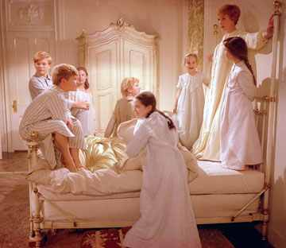
Well at times when I think about my family and friends at home and how much I miss them I think of my simple favourite things to eat.

Several of my family and friends have been very kind to send me lots of these goodies (some examples above). I have certainly appreciated them and of course have enjoyed eating them. This got me thinking once again (I do that a lot here).
Here in Bangladesh just as I would do at home I am drawn to those things which I enjoy most and try to ignore those things that maybe are not my favourites. I had tax forms to complete and kept putting them aside each evening to do something else even though I knew they needed to be finished.
When Jesus Christ was growing up in Nazareth I am sure like any boy He had favourite things. I am sure there were times when He preferred to do some things more than others. When He came to Jerusalem for the Passover however his parents found Him in the temple or as Jesus stated ‘My Father’s house’ carrying out ‘His Father’s Business.’
I am here in Bangladesh doing my Heavenly Father’s business. Whether the work includes favourite things or not it’s still my Father’s business.
Although I am working as a Community Health Advisor getting to know and getting alongside the community plays a major role in my work in the rural setting.
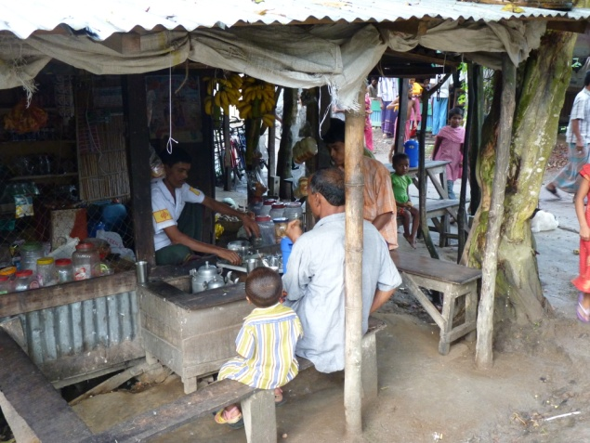
Family and community is very important to the local people here so stopping and having a cup of tea in the local tea shack even if it was not in my plan is very important to them.
Some days I have taken many cups of tea just to be able to communicate and get alongside the locals (and I don’t like tea).
Everyone here knows what I like. Two of my favourite snacks are available all over Bangladesh and are made in a few little shops in Jobarpar. These are singara (savoury) and jalopy (sweet).
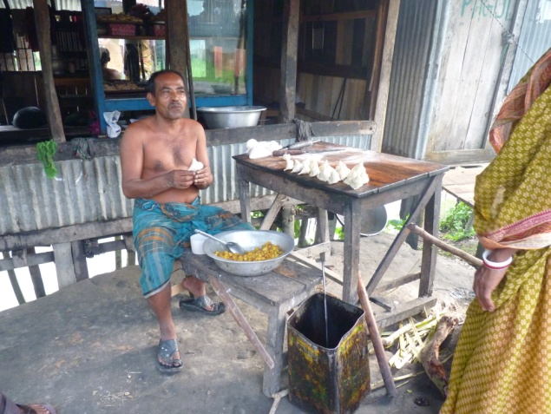
This is one of my local fast food shops. I often stop to chat to the owner and buy some of these snacks.
Several weeks ago on my way out of church a young girl came and asked me to her grandparents home for something which was to be held a few days later. I discovered it was a time of prayer for the anniversary of her grandfather’s death. I am not so keen on these gatherings as they are mostly family and I feel as if I am intruding yet I felt I should accept.
When I arrived the family were so pleased. I looked around at all the young men, women and family members who had come to support the family. This not being my favourite type of gathering made me realise that God had placed me here for a reason and for this I was blessed and thankful.
Recently an elderly gentleman we had cared for died. I was not around when this happened and as soon as I returned I called to visit his wife. She invited me to come to her home a few days later. I realised when I arrived this was going to be a big celebration I suppose a bit like a wake at home only after the gentleman had died. I was not really looking forward to it at all.
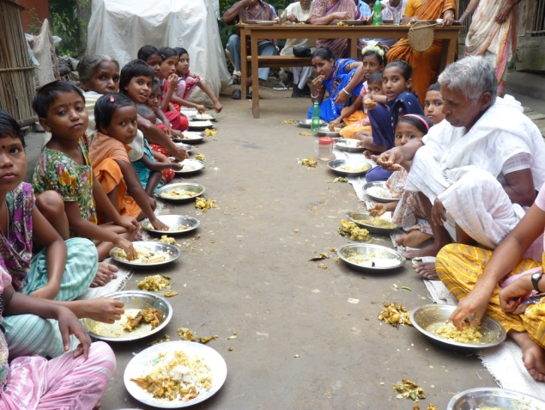
Food was served for everyone in the local community, all part of the Hindu culture. The family served and greeted us all. No one was forgotten.
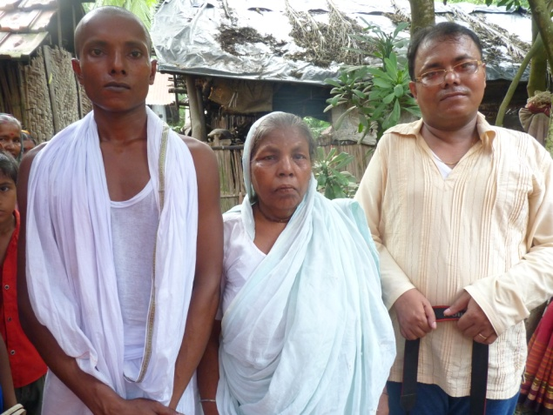
The elderly lady and her sons were all so happy I had come and even more so when I said I would eat with them. It made the visit worthwhile and made me feel very humble.
When I was training as a nurse the one area I disliked most was care-of-elderly. I also worked in this area for a while when I qualified and didn’t enjoy it at all. Nowadays however I find myself drawn to so many elderly people (maybe the fact I am no longer young myself) and enjoy it so much.
I decided to start an old-age project within the community here in St Marys Church Jobarpar. The first gathering 15 people were invited and nine people arrived. They were so pleased I had thought of something for them. We discussed what they would like to do and we have arranged some visiting speakers for every month. It was very encouraging as most of them are widows or widowers. It is great for them to meet in an informal setting and of course they enjoyed the tea and cake at the end.
God has used me in areas I would never have even dreamt possible. The fact He has brought me to a land with so many rivers and ponds and I am totally terrified of water is amazing in the first place. God’s ways are certainly not our ways I have realised that more and more.
I still struggle communicating as I just cannot grasp the Bangla language. I do the best I can however when I read this saying of one of my favourite little ladies it really made me ponder and think.
“Spread the love of God through your life but only use words when necessary.”
― Mother Teresa
So from my favourite and non-favourite things I finish this link letter. Once again thank you for all your prayers and encouragement to me over the past few months.
Thanks for
- The opportunity to be in a rural community and be so involved in the lives of the local people
- The training I carried out a few weeks ago which was so well received by the community nurses
- The encouragement received by so many people recently
- The opportunity to visit a very ill young woman in a slum area in Dhaka
Prayers for
- The family of Ashit one of my nurses who died last week (I will give an account of him in my next letter)
- The many people I have come in contact with recently who need more help than I can give them
- Preparations for my furlough
- My Mum that she will make a full recovery from her stroke
My next letter will be sent from home as I will be on furlough from 17th Nov-13th Jan.
Pat
‘It is not what we think we can do anything of value by ourselves. Our only power and success comes from God.’
2nd Corinthians 3:5 NLT

