VISIT TO THE IGLESIA EVANGELICA METODISTA UNIDA DEL ECUADOR (IEMUE)
Quito, Santo Domingo de los Tsáchila, Pastocalle, El Quinché
27 October -7 November 2011

Purpose of Visit:
- To provide interpreting support for Revd Michaela Youngson’s liturgy workshops and general interpreting support throughout the visit.
- To meet with the two Nationals in Mission of the church whose work is funded by the MCB’s World Mission Fund and with CLAI (Council of Latin America Churches), a partner organisation of MCB located in Quito
- To attend the Church’s General Assembly and establish a relationship with the new Bishop.

Brief background of the IMUE

The United Evangelical Methodist Church in Ecuador (IEMUE) chose to assume a Methodist identity in 2011. The IEUME comprises of 20 churches, and thanks to unification its membership has doubled in the last 12 years of leadership under the now Bishop Emeritus, Dr Salomon Cabezas. The churches include indigenous Christian communities, such as the Tsáchila community in Santo Domingo de los Tsáchila. A great achievement for the church has been to help 80% of its Presbyters complete theological training. The church is set in the context of a country that is experiencing economic growth under the current, left-leaning President of Ecuador, Rafael Correa. The church works extensively with local government on a number of social projects, including poverty alleviation (especially among indigenous and Afro-Ecuadorian communities), education, sexual health, children, domestic violence and supporting people with disabilities. The Church’s recently elected Bishop is now Bishop Silvio Cevallos.
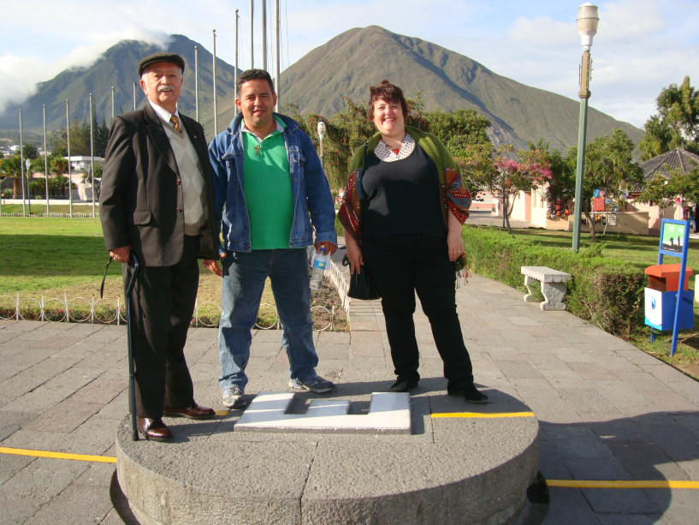
Friday 29 October
Michaela and I met with Bishop Salomon Cabezas (extreme left), now Bishop Emeritus and Revd Freddy David Gonzalez Jacome (middle), a Methodist Minister located in the tropical town of Guayaquil and a National in Mission (NMA). His role as an NMA is to develop mission and evangelism among the local community. He explained that the work his church does in the local community aims to support the entire family. They support up to 40 children, by helping those who are being abused, giving them Christian education, supporting their schoolwork and until recently, running a feeding programme (the external funds for this have now dried up). They also host workshops for parents on domestic violence, human rights, sexual health and Ecuadorian law (in conjunction with local police and authorities).

Saturday 28 October
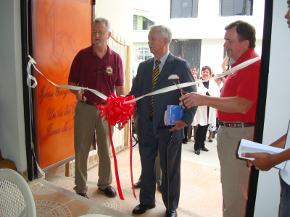
Today we travelled to the town of Santo Domingo de los Tsáchila (the indigenous community native to that area) to visit the newly built Methodist church, lead a liturgy workshop and participate in a special service to mark the opening of the church. The feedback from the workshop was that the church is keen to develop its own lectionary and had gained new insight into liturgy. The participants were also clearly passionate about being a welcoming church, and value people from different indigenous traditions such as the Tsáchila, members of which are part of the church. It was clear that this local church is keen to develop its own lectionary and liturgy.

Revd Norberto Rivas, the church Minister, said that they would greatly welcome teams of volunteers from MCB to help them complete other building work (a mission team from the United Methodist Church had recently helped them complete their church building). They need more funding to complete the first and second floor of the church, the top floor being the future manse and the second floor the children’s ministry and dinning hall.

Monday 30 October
Today we met with the CLAI. We learnt of their priorities for the next three years - a broad program including challenging violence, particularly domestic, teaching about sexual health and rights, migrant rights, challenging racism and divisions in society and much more. The focus of this ecumenical work is to work together in world transforming, practical mission rather than on organic unity or doctrinal debates.

Tuesday 31 October
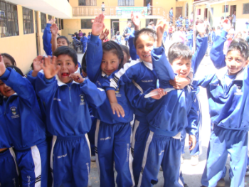
In Pastocalle, the local church El Sembrador (the sower), runs a state built and part state-funded school. The school is in urgent need of a further $10,000 because new government legislation dictates that they must build more classrooms to accommodate two more years of education for pupils. The school started off with just 20 pupils from the area and the number has now grown to 203. Students receive Christian education as well as follow the national curriculum. It is the most affordable school in the area (parents pay anything they can afford) and the children are given breakfast and lunch. Teachers at times have forgone their salary due to a lack of funding. The children are encouraged to join extra-curricular clubs such as joining the media, dance and art club. The School also hosts regular workshops for parents on different issues (e.g. health, etc). There is great potential for a link with a Methodist School in the UK through the school’s media club because the children have been taught to use the internet and manage multimedia resources.

Wednesday 2 November
El Quinché is a town that has many elderly and homeless people and people with physical disabilities. Revd Silvio Felix Cevallos Parra, Minister of the Church and a National in Mission told us about the work that the Restauracion y Vida (restoration and life) Church is doing in the local area to support people with disabilities, in cooperation with the recent national government initiative that seeks to improve their quality of life. Part of his work as an NMA is to mobilise his church to encourage those whom the initiative helps to sign up to it and he has been jointly campaigning with local authorities to promote the programme. Those who sign up to the programme can then access medical treatment and receive welfare benefits. Revd Silvio shared with us his vision of expanding this social outreach to support the elderly and the homeless in the community.

General Assembly Highlights: Thursday 3 – Sunday 6 November
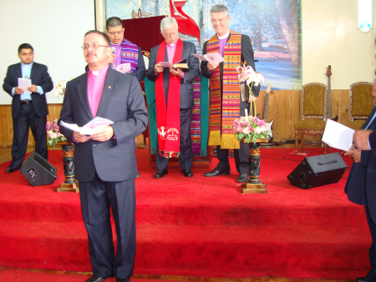
Some of the highlights of the General Assembly included Bishop Salomon Cabezas’ report on the last 12 years of his time as Bishop and the youth report that summarized some of the great work the youth is doing in building relationships with other churches in the Andean Region and in consolidating their Methodist identity. The outgoing president, Sofia Balseca shared that the most urgent need was for a musician to train youth in local churches to play music they can relate to. Young people are leaving the church because churches are not able to sing and play more modern worship songs.

During one of the sessions, the Assembly was also divided into groups to discuss the progress of the church in several key areas, including questions on what impact the church has on society, how decision-making structures could become more democratic, as well as many others. One of the challenges they continue to face is helping local churches understand what their Methodist identity means and how this shapes their daily mission.
The new Bishop of the church was inducted on Sunday 6 November. His name is Silvio Cevallos Felix Parra, also one of the church’s NMAs. We had the opportunity to speak about the needs of the church and the ways in which we could develop our partnerships. One of the church’s priorities is to meet the current deficit in minister’s stipends. Bishop Silvio is also going to visit the London District next September and participate in Michaela’s induction as District Chair as a way of continuing the relationship. Furthermore we spoke about the need for volunteers in mission to visit the IEMUE and support them in various building and short-term social projects. He also enquired about available funding for training and I reminded him about the group training programme and about the regional programme already set up in conjunction with the Methodist University in Sao Paulo, as well as the Scholarship and Leadership Training programme.
Volunteering
Various people we met from the church requested short-term volunteers from MCB go and support the church in various capacities. Some of the requests included volunteers to work with children, volunteer teams to support building projects and a request for a musician to teach modern praise and worship music to youth in local churches around Ecuador.

Outcomes
- To suggests linkages between the IMUE and MCB in terms of volunteers in mission, EEPS and Methodist Schools

- The MCB could assist the IEMUE in consolidating its Methodist identity.

- Continue ongoing conversations with Bishop Silvio Cevallos concerning the grants available to partner churches and the process of application.

- Propose a recommendation for a special grant to help the church meet ministerial stipends as a way of offering some immediate support to the new Bishop who has inherited this deficit.

Sandra Lopez, Partnership Support Officer
16.11.11

