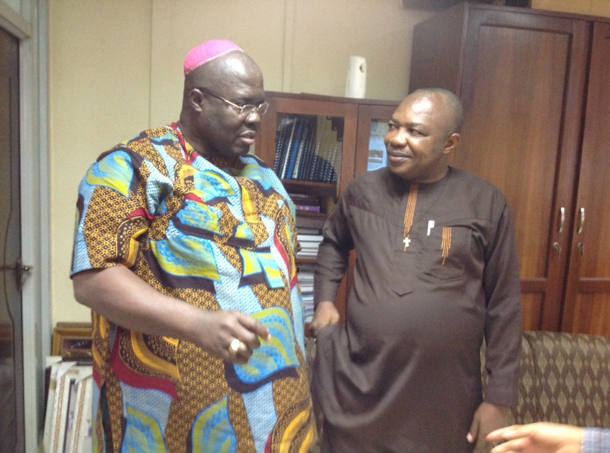Partnership visit to Nigeria 24th July – 5th August 2016

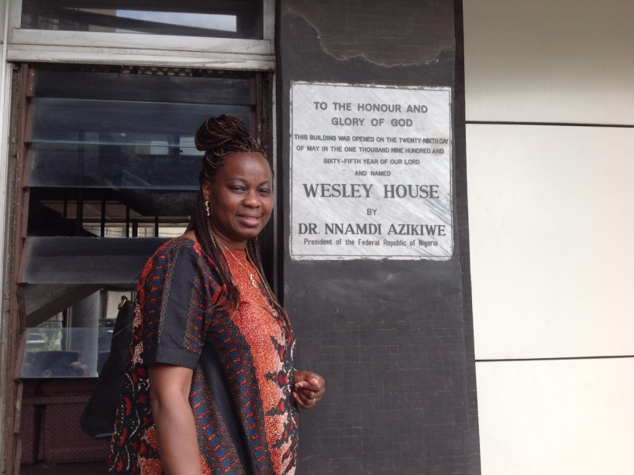I arrived in Lagos on Friday and the weekend was drenched by tropical rains and power cut. Thank God it was cool enough to sleep despite the lack of electricity. On Monday I was at the Connexional Office in Lagos to meet with MCN leaders. Unfortunately a tragic accident occurred at Owerri, Eastern Nigeria; four people dead and fourteen injured. They had just completed a Sunday school teachers training for 500 participants at Sagamu in Western Nigeria. Their vehicle was involved in a head- on-collision close to Owerri, Eastern Nigeria and became a write-off. May their souls rest in peace? What a loss to the church, hence the unhappy atmosphere at MC Nigeria headquarters during my visit. I later met with Bishop Amuta –the Director of Evangelism, he mentioned the slow uptake of Alpha courses though it has a promising future. Afterwards I had a meeting with Bishop Opoko, the Secretary of Conference. We discussed various partnership issues including the World Methodist Conference about to take place in Texas. The Prelate had travelled to Owerri urgently.

MC Nigeria Bishop Opoko and Bishop Amuta

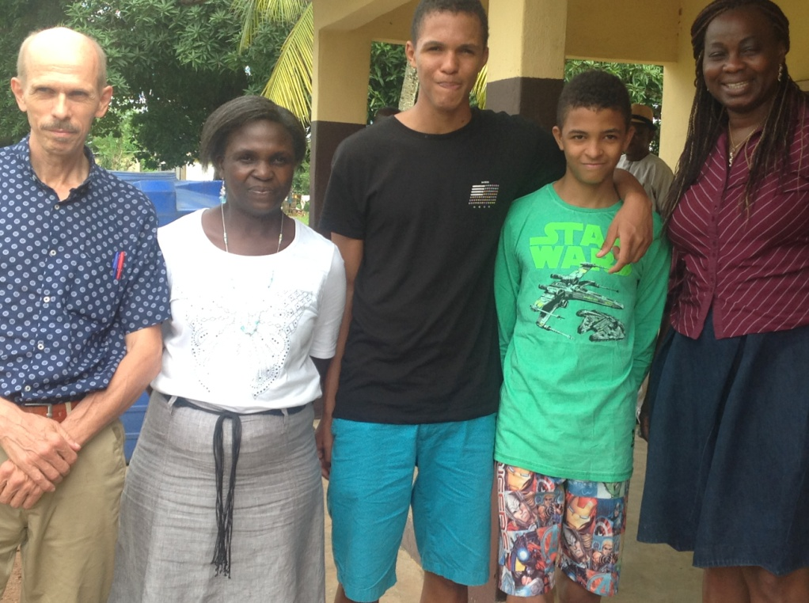The next day was a very long day for me. I left for the airport at 05.30 hours, landed Owerri at 09.00 hour and travelled to Umuahia to Ros’s former house. Ros was a British Mission partner that served in Uzuakoli for about 35 years. After collecting her stuff, we travelled to Uzuakoli Royal Hospital to see Hans Van der Corput, another MCB mission partner serving at the hospital. It was very busy as usual and he was working tirelessly having just resumed work after his family holiday in Holland. The hospital had recently expanded as a result of personal and corporate donations. Wesley Guild UK still works closely with the hospital particularly in the up-skilling hospital personnel where possible. Hans works three days at Royal Methodist Hospital and another three days at Ros Colwill Hospital few miles away. In spite of the various challenges, the mission hospital serves its communities as best as it can. The Royal Methodist Hospital has just over 130 beds for surgical, medical, gynaecological and paediatric patients. There is great demand to start a nursing school however this would require much capital to construct the necessary infrastructure.

Bunmi at MCN Connexional office, Lagos

I was accompanied by Chief Okorie – the Hospital administrator during my hospital tour. I commented on the mounting paper records for patients due to lack of space but he replied that computerising the records would require permanent power supply for continued access. It would be challenging with irregular power supply especially during rainy seasons. Maybe in the near future, God could provide funds for solar power.

The Van der Corput family with Bunmi at Uzuakoli

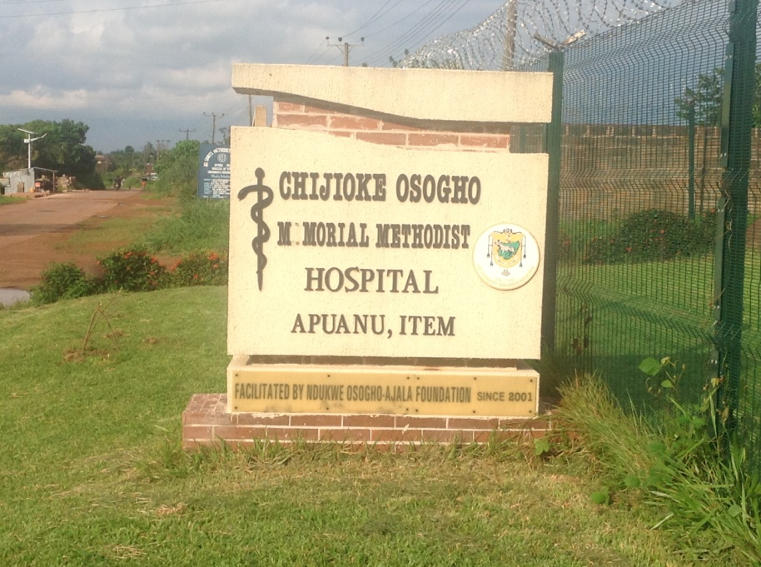 After lunch we proceeded to Item, a lovely village some kilometre way from Umuahia to see one of the National in Mission recipient serving as a resident doctor. Item clinic is small, beautiful, well kept and powered by solar panels. It has few beds and related facilities. We had discussions on seeking medical personnel on part-time basis such as a pharmacists, surgeon etc to boost its services. Also short term volunteers would be much welcome at the clinic. By the time I got back to the hotel, it was past 18.00 hours; I was exhausted however it was a very fruitful day!

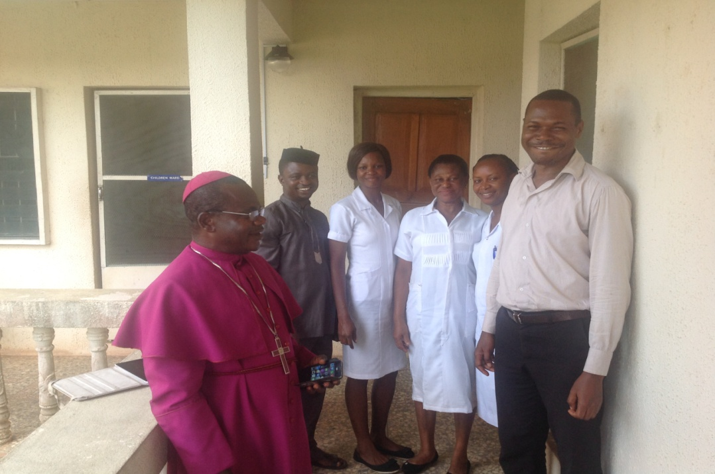The following day, we visited the Motherless babies’ home. These were children that either lost their mothers at birth or they were incapable of caring for them post-partum. Often there were no close relative to step in. The children’s ages admitted at the home ranged from two months to three years. On very rare occasions abandoned babies were brought in, they were cared for until foster parents were eventually found. The children were supported by carers at the Motherless Children’s babies home for up to three years after which the father or guardian receives the child back. The number of children in residence during my visit were twelve plus the carers who were volunteers paid little stipend. The Matron was Mary Vander Corput and the home is being managed managed by donations from well wishers.

Item Clinic Staff with Bishop Eze and the resident doctor is a NMA recipient

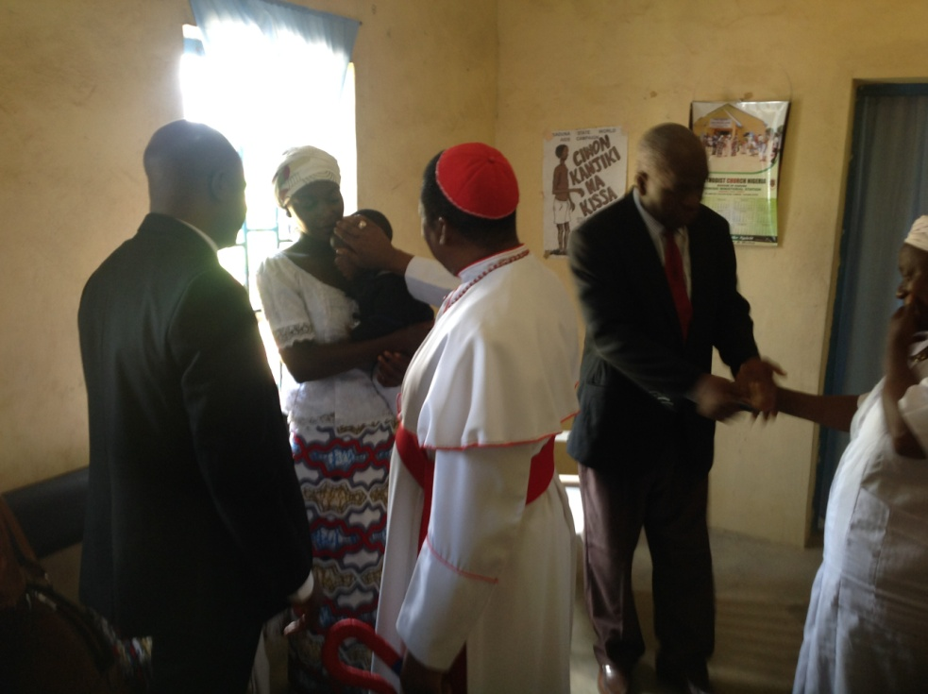Afterwards we visited Ros Colwill Hospital - a local cottage hospital started in the ninety thirties when the leprosy colony was a big community. This hospital was for those not living within the compound because the locals refused to attend the same clinic as the lepers. There were currently three consulting doctors, a hospital administrator, laboratory staff and nurses. There were also medical, surgical and paediatric wards and gradual expansion of the hospital has been taking place. Hans Van der Corput performs surgical operations three days a week and Ros Colwill was a board member until she ended her mission service this year.

Bishop praying for a sick child at the clinic

Later I visited Ozuzu-oke retreat centre. There were about six twin chalets for guests and the location was very tranquil and appropriate. There was still more work to be done such as improving its landscape, improving signage and publicising its potentials etc. There were few Methodist ministers already trained to manage the retreat centre as well as promote spiritual contemplation. We were hosted by Mary and Hans for lunch and I met Marcel and Maurice both on holidays in their residence.

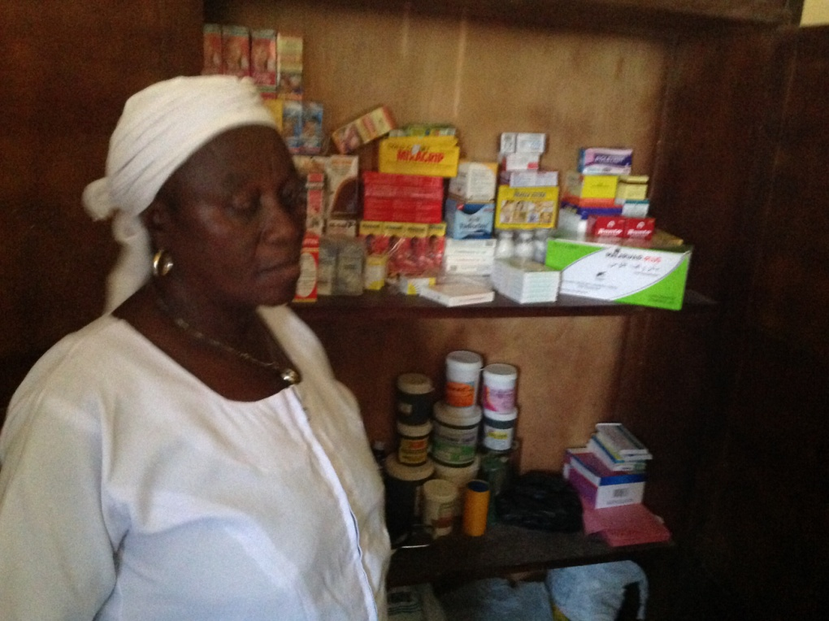**Visits to Northern Nigeria 29th July – 5th August 2016** I travelled by air to Kaduna and arrived late in the night. The following Saturday morning at 8.00am Archbishop Idoko and Dr Pious – an Orthopaedic surgeon at the Ahmadu Bello University Hospital along with the driver travelled from Kaduna to Galadima Clinic, about 150 kilometres away. We met Esther the midwife and a deaconess helping at the clinic. The clinic offers primary health care to the community dwellers - mostly preventive, curative and child delivery services. Unfortunately part of the clinic caught fire sometime ago and the roof was in need of major disrepair, deterring community members from using its services. The Methodist Church Kaduna fund raised and engaged the services of some of its members to renovate the building. When I visited, work was still ongoing however Archbishop Idoko asked for financial assistance to equip the newly built laboratory and help procure basic tools to help the midwife and two trained community health workers serve the community. The clinic has been a mission priority for the Theological College for years because it offers the students placements for diaconal services especially in a very rural set up.

Essential drug supplies for Galadima Clinic, Kaduna State

We then travelled to the Theological College at Zonkwa where Rev John Shettima has been the Rector. Rev Shettima is an ex-SALT student with a Masters degree in Interfaith at St Paul’s University, Nairobi. The college had progressed immensely since my last visit. A functional borehole supplies the College with water and a Lister generator was purchased to supply power. There was ongoing renovation of classrooms, hostels and chapel. A small library was operational though many more books are welcome. The College has now been connected to the national grid and a multipurpose hall erected was being constructed by funds from MCN Connexional Office. The building construction was not yet finished. The idea was to rent out the hall for income generation as well as serve as a Community Centre for various activities.

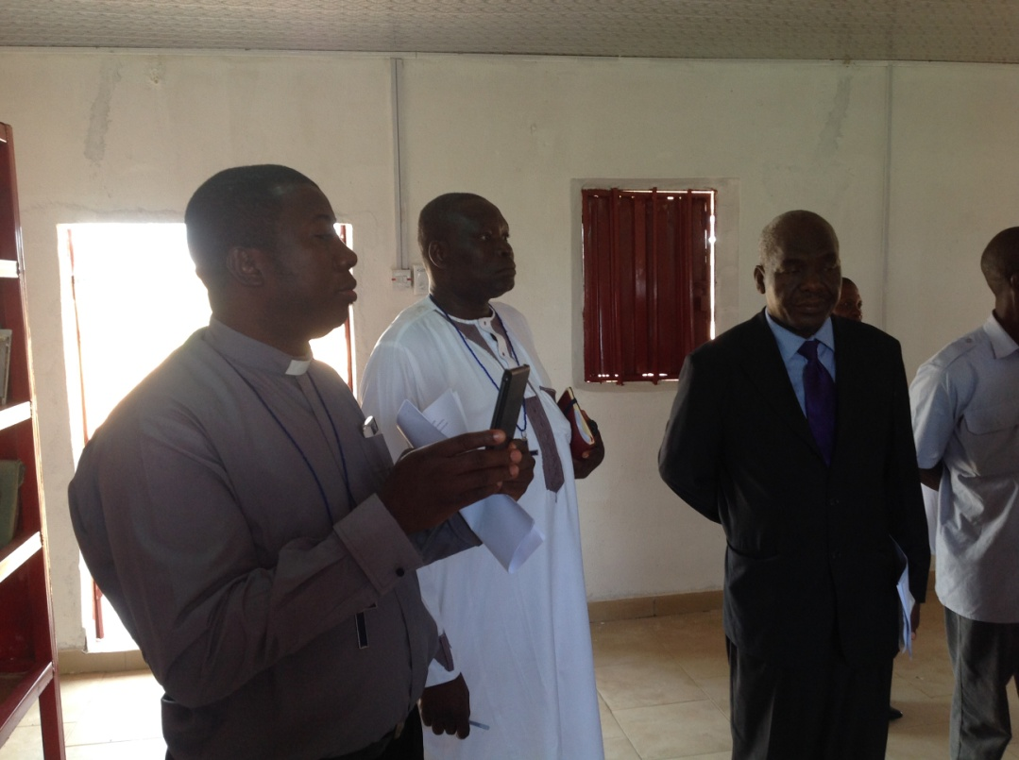Even though the school has the support of the MCN Conference, student number was dwindling due to limited courses at Certificate level. A recent revamp by the Theological Board has endorsed teaching of short and varied courses to attract more indigenes. Zonkwa is in Kaduna State where Christians endured discrimination as a minority religion for a while. This led to conflicts in the past and ongoing tension exist. However the institution seeks to serve the community and express the love of Christ in spite of the prevailing situation. Therefore MCB has given this partnership priority to support its vision for making Disciples of Christ.

Staff of Zonkwa Theological College in the new Library

I had a tour and visited the newly revamped library which was small but essential, more resources were still in need to improve its research capabilities. Imet with the College staff since the students were on summer holidays. We prayed together, had lunch and later travelled back to Kaduna.

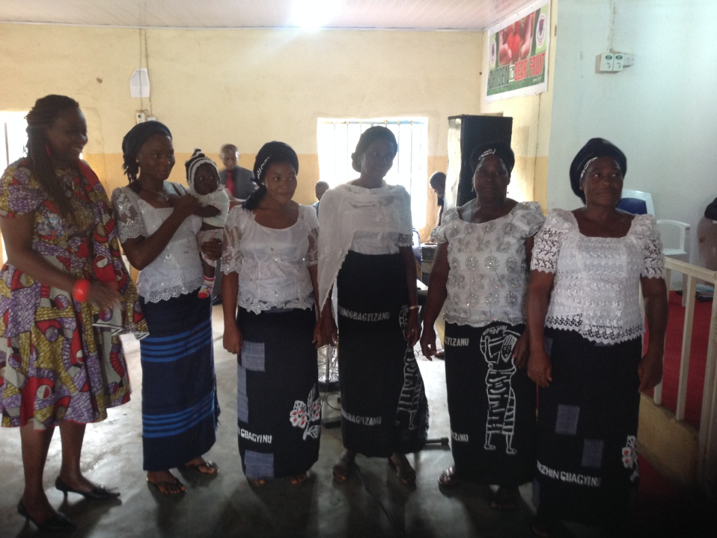

On Sunday we travelled to Methodist Church Damishi at Sabo on the outskirts of Kaduna City. It was an indigenous and vibrant church with a large congregation celebrating their youth week. The archbishop decided to worship at this circuit instead of the Cathedral. The youths led worship and also preached from John 15. The youths, men and women all had choirs that sang during the service. There was lots of rejoicing and celebrations afterward. Afterwards we visited the community clinic supported by the church. It was opened in 1998 to deliver affordable health services to the rural dwellers. It offers antenatal, post natal, curative and preventive medicine with limited diagnostic tools and drugs supply. There were ongoing challenges to deliver the services due to personnel and financial constraints. However I had further discussions with Archbishop Idoko the Diocesan leader about fund raising ideas.

MC Damishi women leaders

**Visit to PROCMURA representatives (Programme for Christian – Muslim Relations in Africa)**

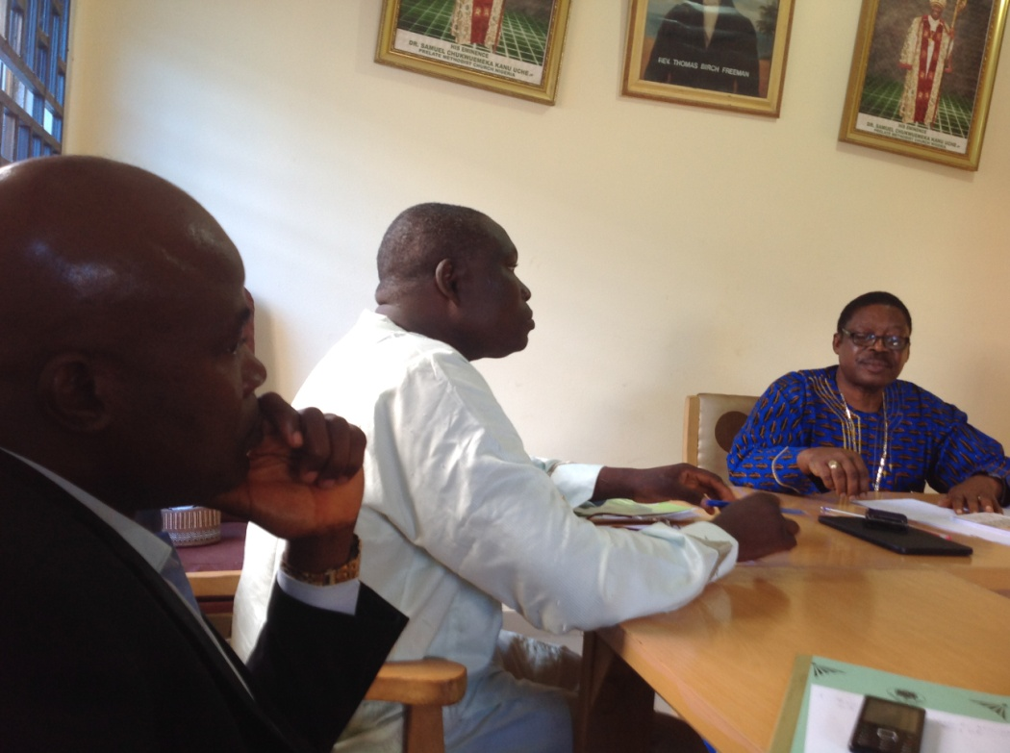There was a meeting with PROCMURA officers at the Methodist Cathedral in Kaduna. Eight people attended the meeting namely 1)Joshua Mallam – PROCMURA West Africa Regional Rep; 2)Mallam Abdulahi Sufi – Interfaith Mediation Centre; 3&4) Sanusi Sirajo and Samina Dauda – Network of Practical Peace, Kaduna; 5) Rev John Shettima – Methodist Minister; 6) Simon Agada – Lay President of Kaduna Methodist Diocese; 7) Archbishop Oga Idoko – MC Nigeria; 8) Bunmi Olayisade – MCB Partnership Co-ordinator.

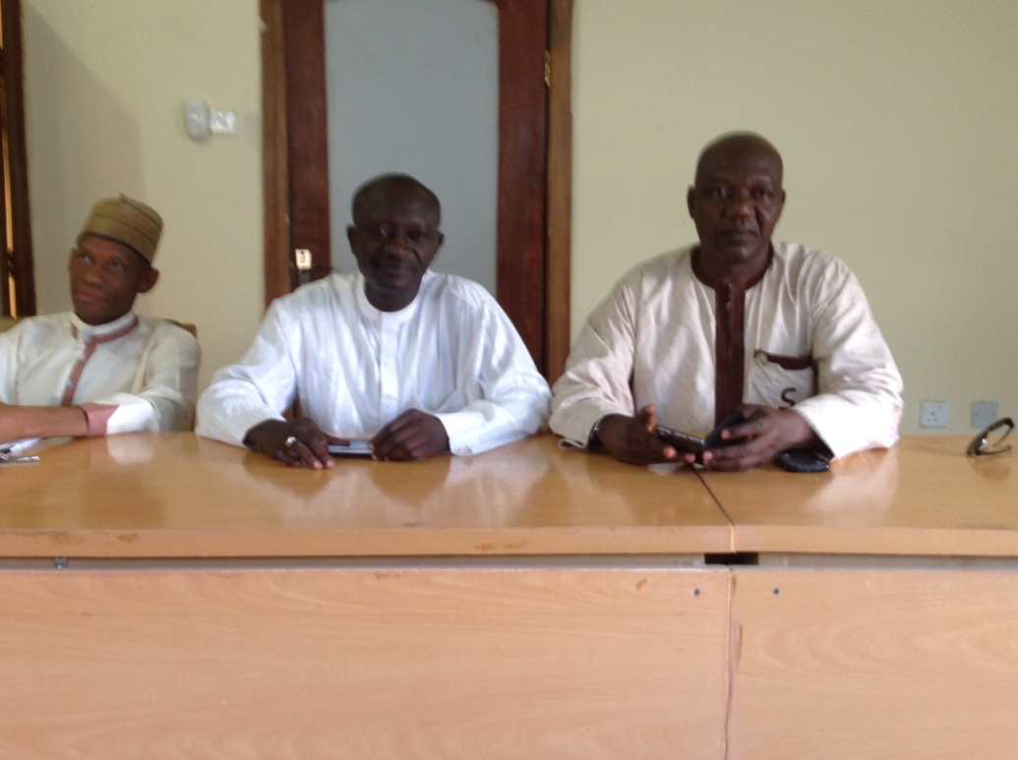Few years ago, Kaduna was ridden with religious violence but now life appeared to have improved immensely though some tensions still existed as voiced during our meeting. Following the establishment of Kaduna Centre for the study of Christian-Muslim Relations by the Anglican Bishop of Kaduna at the time, Josiah Idowu-Fearon; enlightenment workshops and seminars were started. The vision was to address ignorance on both sides through education, orientation and transformation of the society by improving peaceful co-existence between Christians and Muslims to the glory of God. In recent years with concerted efforts from the Centre; there has been a focus on peace, unity and security and these were priority during all engagement. Between 1987 and 2004 there were eight violent attacks, many started and later escalated into religious violence because religious leaders did not promptly engage with the populace to promote peace. Violence was often fuelled by indiscipline, ignorance, politics, bad communication, irresponsible journalism, poverty and unemployment etc. Losses were reported from both communities, there were lots of internally displaced families, destroyed livelihoods and properties, burnt down churches and mosques and no-go areas evolved resulting in a divided society.

MC Kaduna members at the meeting chaired by Archbishop Idoko

PROCMURA members from the Muslim Community

The persistent work of promoting collaboration by PROCMURA has yielded significant progress in Kaduna. MCB gave a grant of £10,000 for the interfaith training of clergy plus other targeted people in the society to promote peaceful co-existence in 2013. In addition, Network of Practical Peace, a Muslim agency implemented few initiatives on youth exchange across communities, encouraging friendships between fractions and sponsoring group visits across the divide. Also the Regional Centre based in Kaduna now offers Certificate and Diploma courses. PROCMURA is not a new organisation, it started in Southern Nigeria as far back as 1959 but its headquarters was moved to Nairobi, Kenya in later years.

**Boko Haram terrorist campaign**

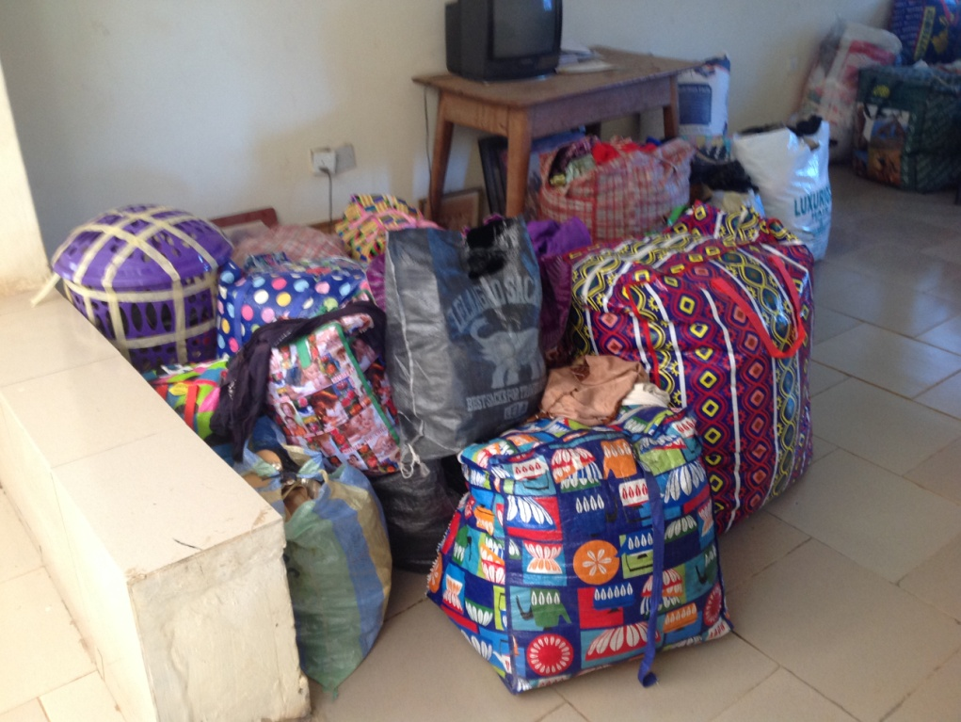The experience of religious violence in Kaduna helped residents understand and sympathise with the displaced families affected by Boko Haram insurgencies. It was reported that about 2 million displaced families were living in various camps around Borno State and many more people living with various host families. There are still persistent challenges in knowing the true magnitude of the problem particularly as 70% of the country lives in poverty and most of them are in Northern Nigeria. During the meeting it was reported that no more government camps existed in Kaduna state but as many as 66 children were being managed by a concerned lady in Kaduna. Many more moved in with relatives or returned back home. The Interfaith Mediation Centre has ongoing connections with displaced families and most of the affected victims were still in need of health care, education and food. Many Christians were reported to be scarred to stay within the camp because of victimisation and lack of trust. The main thrust of PROCMURA was to focus on relations not just dialogue and for each religious faction to acknowledge its beliefs without compromise yet respect the views of the other. I hope to receive more update about the ongoing conflict situation caused by Boko Haram terrorist particularly following the recent assertion by Boko Haram in the media. I plan to work more closely with MC Nigeria and PROCMURA with regards to increasing street children begging on the streets as a result of persistent conflict in the region.

Donations for displaced families affected by insurgency

Psalm 39 7-8, 12: *And now, Lord, what do I wait for? My hope is in You.*

*Deliver me from all my transgressions; Do not make me the reproach of the foolish*

*Hear my prayer, O Lord, and give ear to my cry: Do not be silent at my tears;*

*For I am a stranger with You, a sojourner, as all my fathers were....*

Thank you

Bunmi Olayisade

Africa Partnership Coordinator

August 2016