Partnership visit to Ghana from 17th – 23rd March 2016
Aims – To meet with the senior leadership group of Methodist Church Ghana (MCG)
To visit Ankaase Methodist Hospital, Ghana
Prepare for MCB mission partner, Pat Jamison, starting her mission service at Ankaase Hospital as a Community Nurse
To meet Nationals in Mission recipients and ex-SALT students

Accra visit
- Meeting with Mr Enoch Osafor – Director of Health, MCG
I arrived at Accra late Thursday night even though Sierra Leone is geographically not far from Ghana. I had to travel first to Liberia before heading back to Ghana by flight. I was grateful for the warm welcome at the airport and was driven directly to the guest house. The next morning I met with the Director of Health – Mr Enoch Osafor – who has been very helpful in the arrangements for Pat serving at Ankasee Methodist Hospital.
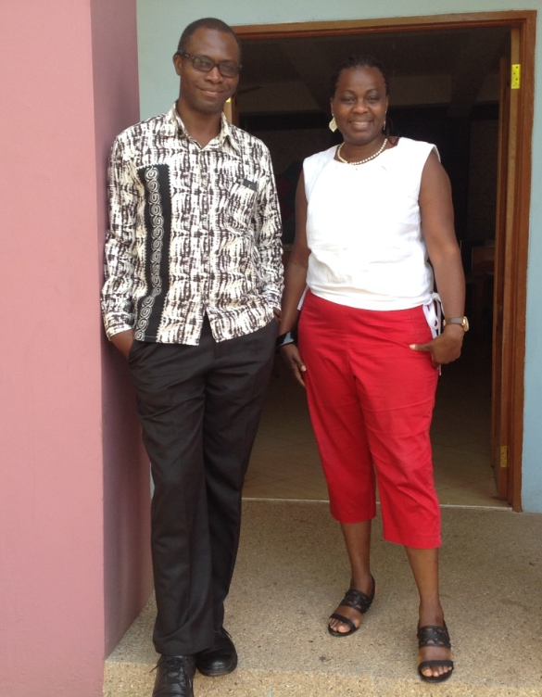
Health is one of MCG’s mission priorities. MC Ghana has two mission hospitals – both outside Accra plus twenty clinics scattered all over Ghana. The health services delivered at these clinics vary in standards depending on medical personnel present and facilities available at base. The clinics were sometimes short staffed often because the government medical staff provided have limited clinical skills that have to be trained on the job. MCG clinics treat between 3,000 – 12,000 patients quarterly depending on location, personnel, facilities and resources.

Mr Osafor explained that MCG plans to use its medical facilities as catalysts for community development and its mission activities. Four of the clinics have community health workers who focus on health promotions and planning. These practitioners engage with community leaders and government services to encounter community transformation. The plan is to identify development centres of excellence and to increase collaborations between the mission hospitals, community health centres and clinics. MCG wishes to appoint a medical doctor under the NMA (Nationals in Mission Appointments) programme which would help bridge gaps and improve services in the rural areas.
Enoch and Bunmi at Kumasi on the way to Ankasee

- Meeting with senior leaders of MC Ghana – the Presiding and Administrative Bishops
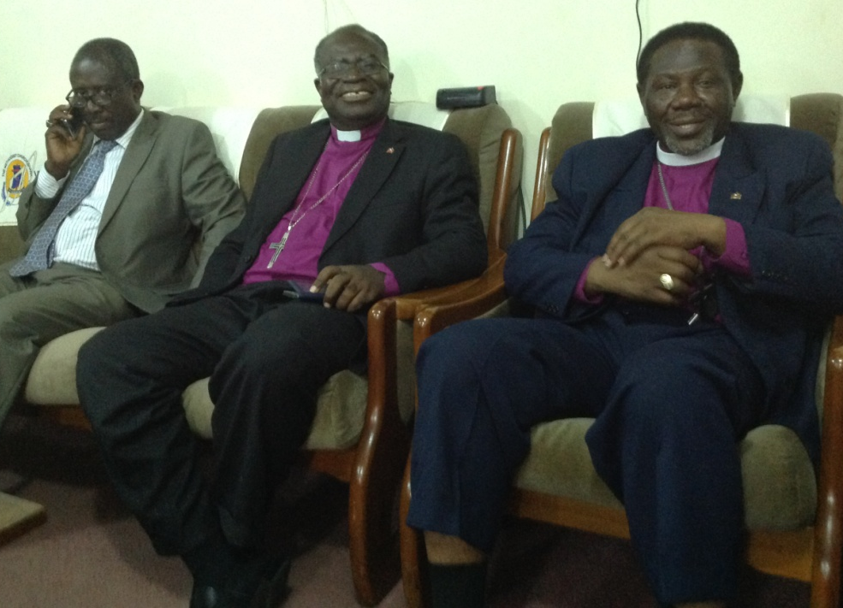
I met with Bishop Titus Pratt – the Presiding Bishop and Bishop Asamoah-Okyere – the Administrative Bishop and lay President. I expressed my gratitude for the wonderful hospitality received and was glad to confirm that the MCB mission partner – Pat Jamison, due to serve at Ankasee Hospital – would hopefully strengthen our partnership further. All preparations for her arrival were in place and I travelled on Monday 21 March to meet with her colleagues and also saw her abode at Ankansee.

Bishop Pratt confirmed that the 2016 annual grant had been received and MCG was very thankful. In addition, he elaborated that mission in the Northern region would take priority; unfortunately, I was unable to visit there on this occasion. However, it would be great to share stories about its Northern mission activities in supporting the Blind School and Lawra Clinic which promotes good nutritional practice in the Northern region but is prone to drought. A Methodist Bishop based at Tamale in Northern Ghana supervises the mission activities as well as its mission station at Burkina Fasso that supports anglophone residents. The members of the mission stations were particularly vulnerable with the recent attacks by Al Quaeda and Boko Haram in Niger, Mali and Cote d’Ivoire. However, MCG hopes to strengthen its leadership and offer more practical support. It is a miracle that Ghana has escaped terrorist attacks so far and I believe the prayers of the people plus good border control have helped.
MCG leaders – Lay President, Administrative and Presiding Bishops

- Palm Sunday at Mount Olivet Methodist Church, Danmason, Accra
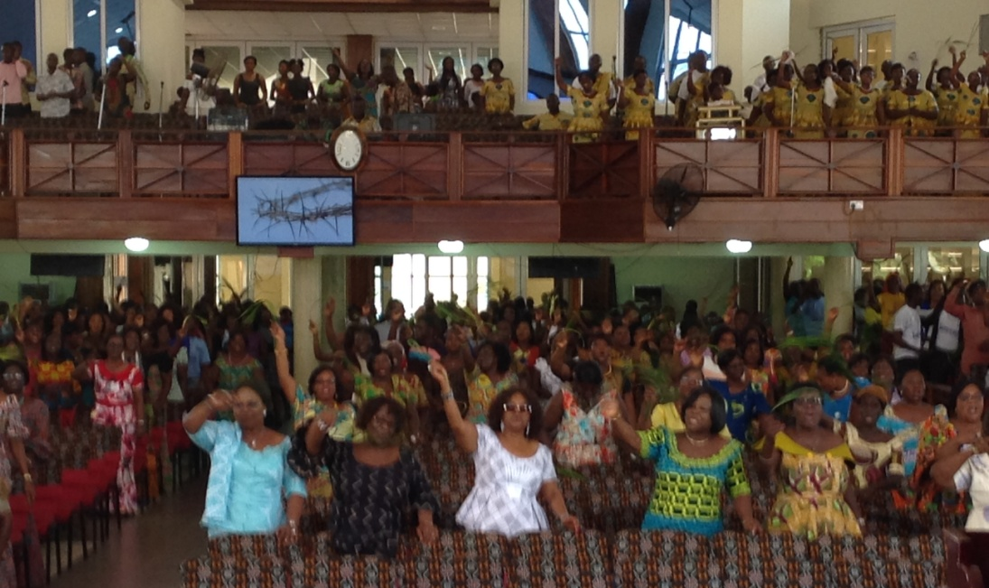
It was another early start; attending the 7.30am English service which was a vibrant and joyous service that ended at 9.15am to make way for the second service. The church was almost full and most people had the palm leaves for celebration.

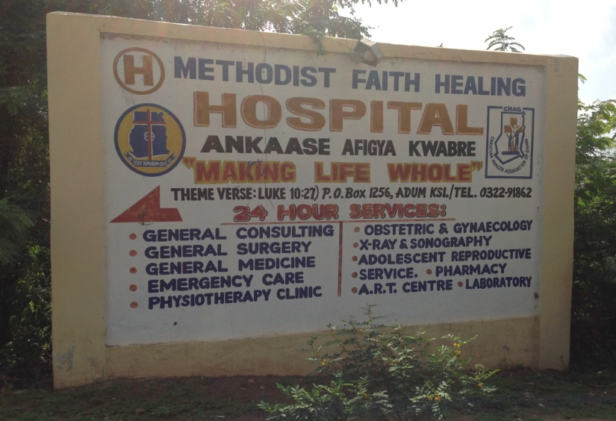
The children, youths and adults rejoiced, prayed and sang during service. The children went out on a street procession singing and cheering aloud with palm leaves Hosanna - blessed is He who comes in the name of our Lord. We jointly prayed for forgiveness and declaration of faith followed by thanksgiving. The sermon was based on John 12: 14-16 and the preacher asked if we would be available for the Master’s use just like the donkey? Even if it was on a short notice, would you be humble enough to obey and take directions from Jesus? We worshipped God, dancing with palm leaves and presented our gifts of thanksgiving. It was great celebrating the start of the Holy week in a festive atmosphere.

Visit to Ankaase Methodist Hospital
It was an early start, I was up at 4.00am to catch the first flight to Kumasi. Mr Osafor and I were met at Kumasi airport by Mr Joseph Amankwah - CEO of Ankaase Methodist Hospital – and later travelled together by road to Ankasee. I was to have met an ex-SALT student lecturing at MCG university near Kumasi, but he was unable to make the appointment.

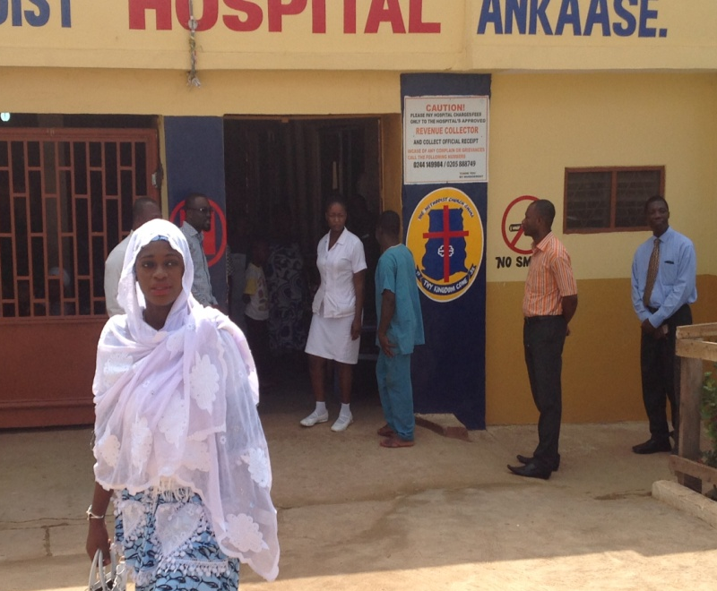
Ankasse Hospital was located at the centre of the community. Its facilities serve about 55,000 residents living in adjoining communities around and within Ankasee. Without any government financial grant, the hospital was expanding its buildings and infrastructure to meet the demands of its services and patients. The hospital has a strong community health outreach team responsible for disease prevention, vaccinations, health education, disease outbreak investigations and control. Also on site was a nursing school and the CEO, Mr Joseph Amankwah hopes to enlarge its nursing school facilities so as to accept and train more nurses. It was good to see the thriving rural mission hospital self financing and expanding. A good model for Africa health mission. Invitation of short term medical volunteers , nursing teachers and several skilled personnel were welcomed.

We later arrived back to Kumasi airport after which heavy rains started that prevented further flights into Kumasi. After several hours at the airport, we heard the announcement that the flights were cancelled so we proceeded to the bus station to board a public bus back to Accra. I arrived at my hotel at 2.00am – mission is always possible.

- MC Ghana Street kids and Hope for Teens programmes
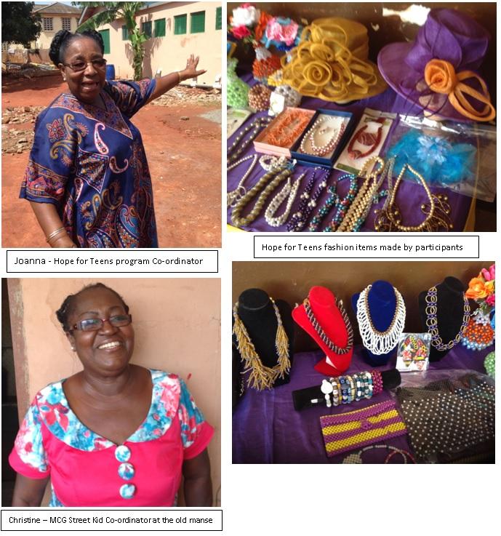
Sometime in 2015, there was a fire explosion at a petrol station at the heart of Accra city, many homes and livelihood were damaged and people lost their lives. Many of the street kids supported by Methodist Church Accra District were affected by the incidence and they approached Christine after they had lost their posessions and had no where to sleep. Christine approached the church leaders and an unkept manse about to be reallocated was released for the children’s use. Otherwise the church building was the only alternative for them to sleep in overnight during heavy rains.

Christine asked for some financial support to improve the unkept residence but she was turned down because of no prior budget allocation. She said she did not know what to do but as she slept she got the idea to ask people for two bags of cement each. When she got to the vacant residence, the street boys had cleared the compound but the courtyard was flooded. During my visit, work was still ongoing and she prays and hope that job completes soon to provide warm shelter and a safe dwelling for street kids.

Few yards from there, on the same church premises was located the Hope for Teens Skills Training Centre - a centre for training vulnerable girls. Hope for Teens programme Coordinator, Joanna N Acheampong is sponsored by the World Mission Fund under the National in Missions initiative. There were four additional teachers teaching 75 students. Some house wives have joined as part-timers to learn bead work, decorations, fashion and catering. The final year students sat for their national vocational examinations on Friday 18th March after which they could apply for work or proceed for higher certificates in education. I had the privilege of meeting and chatting with the girls. Few of them wanted to join the Police Catering department, one was planning to seek work in tailoring and another wished to start a small business with the help of a relative.

- EPMB President with team met with MCG Presiding Bishop and team
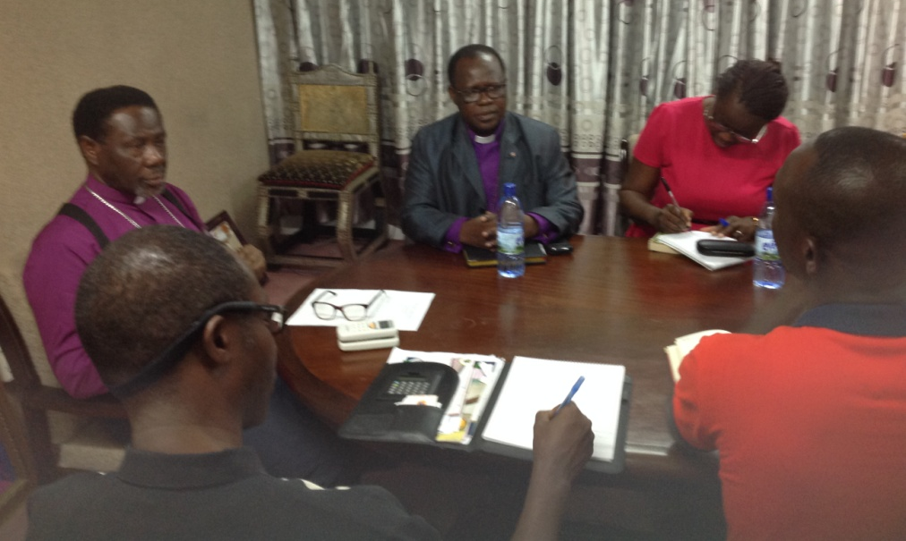
MC Britain kindly funded a cross-culture visit by Benin Methodists to visit MC Ghana mission hospital and other programmes. EPMB President was very grateful for the World Mission Fund grant released late 2015 and he said the delegation appreciated the experience they had in Ghana. He visited me whilst in Accra to give an update and consolidate other future plans. At the Accra meeting, Rev Alagbada discussed with Bishop Pratt on key issues:
- EPMB has less than 100 ministers whereas MC Ghana has many more ministers, including several bishops. There was a request for ministerial exchange to increase the number of English ministers in the Benin Methodist Conference as well as care for the Anglophone communities in Benin.
MCG and EPMB teams meeting in Accra
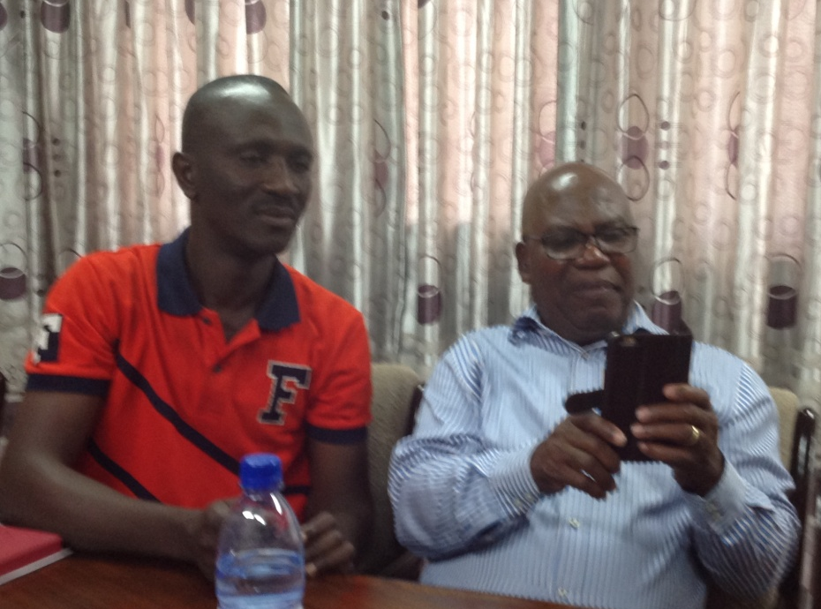
- There was also a proposal to develop bi-lingual ministers and seek participants shall be discussed at its next Council meeting and other details worked out. If MCG adopt the proposal, a minister and an evangelist would visit Benin to survey and brief the July GPC.

MCG also agreed to offer personnel support plus the following exchange of ideas:
- Agriculture – support and insight on developing EPMB landed assets to produce food and cash crops, consider different agro-pastoral initiatives, job creations and vocational training for youths
- Education – develop school twinning and summer visits to improve language skills and networking amongst the students. EPMB team also visited Cape Coast high schools that won 2015 awards for top three students in West Africa examinations.
- Health – PBS Hospital Porto Novo senior management visited Ankaase Hospital to understudy Mission hospital administration and personnel management. The team was led by Mr Michael Tettey – the PBS Hospital Administrator and MCB mission partner. There are still lots to learn and do.
Methodism is known for its social action – helping the poor, serving the community and sharing the love of Christ in word and deed. May we respond when He calls?
Constant and Michael Tettey –EPMB team members

2 Chronicles 6⁴⁰ – Now, my God, I pray, let Your eyes be open and let your ears be attentive to the
prayers made in this place.

Thank you
Dr Bunmi Olayisade
Africa Partnership Coordinator

