Partnership visit to Sierra Leone from 11th – 17th March 2016

Aims – To meet with Methodist Church Sierra Leone (MCSL) senior leaders
To visit Nixon Memorial Methodist Hospital, Segbwema
To meet Nationals in Mission recipient and ex-SALT students
To visit MCSL mission programmes
To assess the post – Ebola situation and discuss MCSL’s recovery proposals

Freetown visit
- Meeting with Bishop Albert Beah – President of MCSL Conference
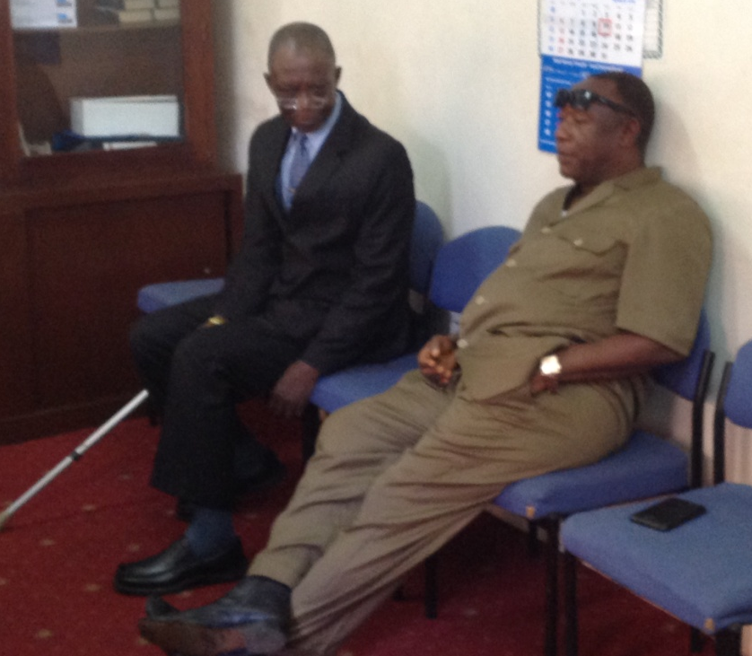
It was heartnening to meet Bishop Beah following his prolonged and though slow recovery from a stroke since November 2015. I met him in his office at 12.00 noon on Saturday 12 March 2016 defying all odds by making phone calls with his right hand and at the same time, typing on his computer because his left arm was unresponsive from earlier paralysis. He was excited to see me and still passionate about MCSL affairs since he took the reins of MCSL leadership in 2015 despite his ordeal. I shared greetings and good will from the British Methodist Conference and prayed for his complete recovery in Jesus’ name. He said he had a nurse assigned to assist with his medication and his nephew deferred his university studies to act as his daily carer. He enquired about a possible visit to Ghana for further rehabilitation and professional care. I promised to raise the issue with the Presiding Bishop of MC Ghana – Bishop Titus Pratt - to consider what assistance could be offered to support his full recovery. Bishop Beah was in good spirits despite the tough reality of living as a recovering stroke patient. Glory be to God!
Bishop Beah in his office discussing with a politician
Luxolo with Siya – both NMA recipients

- Meeting with MCSL women leaders
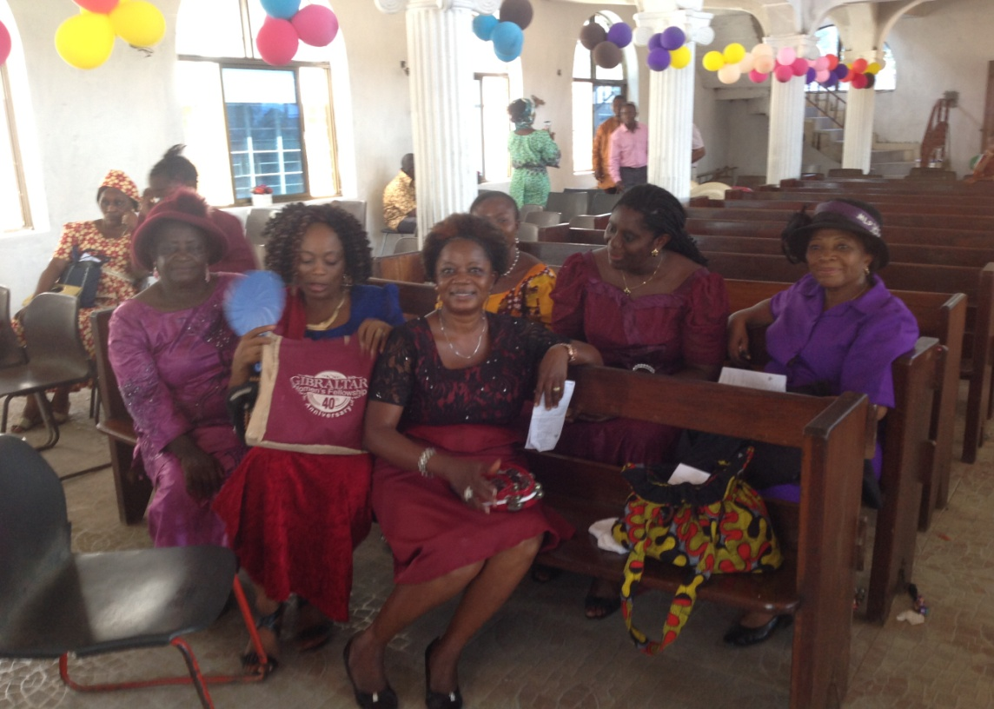
Balmer Methodist Church, Freetown celebrated its 41st Annual Sunday School Thanksgiving service on 13 March 2016 and it was a beautiful day. The children led the praise and worship, read the bible passages, recited scriptural verses and presented a drama. The service was great and the guest speaker spoke on the importance of raising godly children and the need to introduce them to scriptures earlier on in life. Lots of activities and celebrations, it was not surprising that the service lasted four hours.
Balmer Methodist Church, Freetown – Women Fellowship
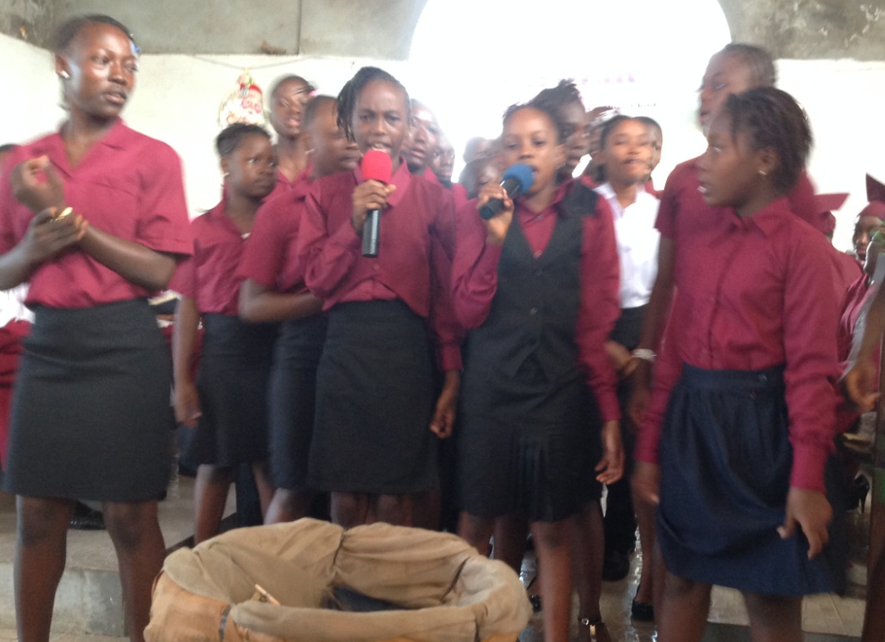
After the service I met with women leaders. They had recently participated in a group training organised by Cliff College and funded by the World Mission Fund. The training was specially requested by Bishop Beah to help MCSL cope with its post Ebola recovery. The women commented on the week long training though impinged by the International Women’s Day - a national holiday in Sierra Leone. The women gave pleasant feedback commenting that the training was relevant and timely. It focussed on biblical leadership styles, explained different learning methods, encouraged alternative teaching as well as embracing different approaches by others. During the training, they participated and listened to peer assessments, permiting others to highlight their weaknesses. They benefitted from the prayer table and the mirror was made available for reflections to help focus on person issues. I asked them to consider what next? How could they pass on the skills and knowledge for succession planning? The women left full of gratitude and excitment. I am sure they are thinking how best to extend God’s kingdom in spite of prevailing
challeges. What a mighty God we serve?
Balmer Methodist Church, Freetown youths

- Meeting with MCSL leadership at the Conference office on Monday 14 March 2016 at 10 am

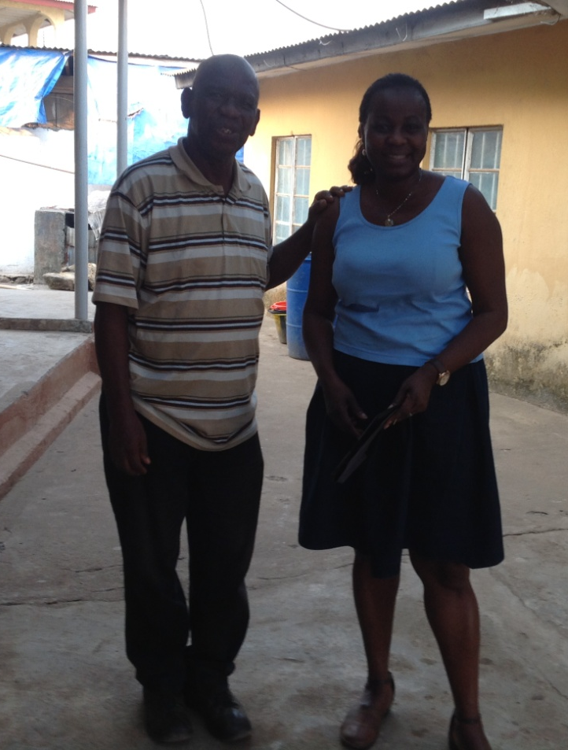
I joined the early morning devotion held at the Bishop’s office and later met with MCSL leaders – eight in total. Rev Beah welcomed me and introduced me to the other heads of department. MCSL has a four year strategic plan and its mission priorities were ministerial training, health, income generation, education and development.
- Ministerial training could take place at the department of Christian education, Kenema Polytechnic. This would support the training on mainland Sierra Leone if the arrangement succeeds
- Address staff recruitment challenges at Nixon Memorial Hospital, Segbwema
- Promote community health and emergency delivery services at MCSL clinic at Freetown
- Seek support for MCSL Agricultural Skills training centre for young farmers. Volunteers and special skills professionals welcome
- Support Bo printing press for local hymn book production in addition to other church resources as an income generating idea for self sustainability

On our way to Segbwema, we branched at Bo and I met with Rev Mattia – an ex-SALT student. He returned from the Gambia and was helping with the resuscitation of the Skills training centre for vocational students. Bo has two promising Methodist High Schools with great academic reputations. There is therefore high demand for non-academic students wishing to pursue the academic line.
Rev Mattia (ex-SALT student) with Bunmi at Bo

- Nixon Memorial Methodist Hospital (NMH), Segbwema visit
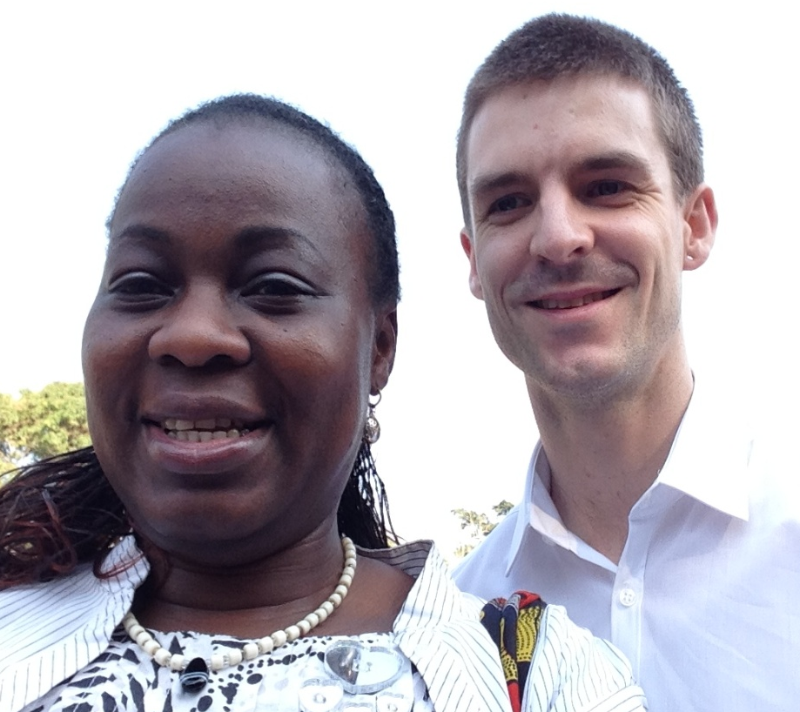
At 7.30am prompt, the drums went on alongside singing, it was time for early devotions. Over two hundred nursing students and hospital staff met in the hall to start the day with prayers. There was dancing, singing and finally we sang a hymn from the Songs of Praise. How refreshing to start a beautiful day together in God’s presence. We were later introduced to the students and staff at the assembly and the Principal welcomed us to NMH.

Afterwards we had a brief tour on our way to meet with the Paramount Chief of Segbwema. Dr Tom Kenny accompanied us as the volunteer newly starting at Segbwema hospital. He was serving as a Physician - though he has a preference for paediatrics. He plans to serve for six months after recently obtaining a diploma in Tropical Medicine at Liverpool University. During the walkabout, I saw the solar panels recently installed to give 24 hours electricity supply and John Saffa – NMH Hospital Manager - also showed me the generator provided by Methodist Church Ireland. This kicks in when the solar batteries are being recharged. Staff and nursing students expressed their gratitude for the support.
Bunmi with Tom at Segbwema, Sierra Leone

Meeting with NMH senior staff at Segbwema
Staff were very appreciative for the World Mission Fund grant sent during the height of the Ebola crisis to assist with staff salaries. This was especially helpful as explained by the Principal because the hospital was quarantined three times, the nursing school was closed down twice and there was no revenue to pay staff salaries. It was particularly difficult because the hospital also lost five senior medical staff even though none of them got infected at the hospital. They were infected off site when caring for relatives or friends.
After prolonged discussions, the praise points mentioned were:
- Support from Sierra Leone government to provide a mortuary and to fence the hospital. Both projects have started but might stall when funding runs out
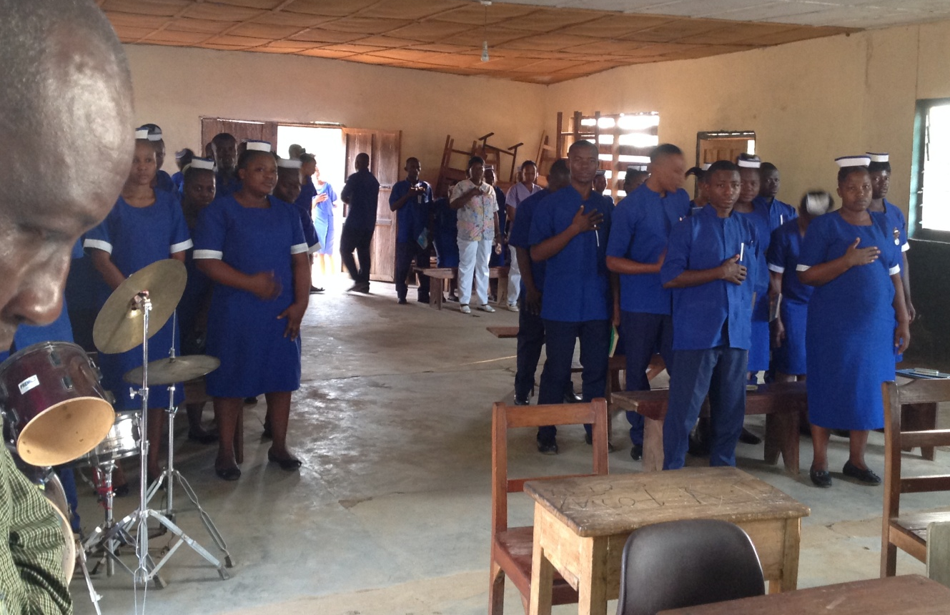
- Several donors helped with hospital supplies such as Physical Protective Equipment items and drugs. They have installed wash hand basins and toilets, and supplied laundry to improve sanitation and personal hygiene. This was to ensure that emergency response to highly infectious diseases could be handled appropriately, if required.

- Few partners including Friends of Nixon have assisted NMH with staff training among other things.

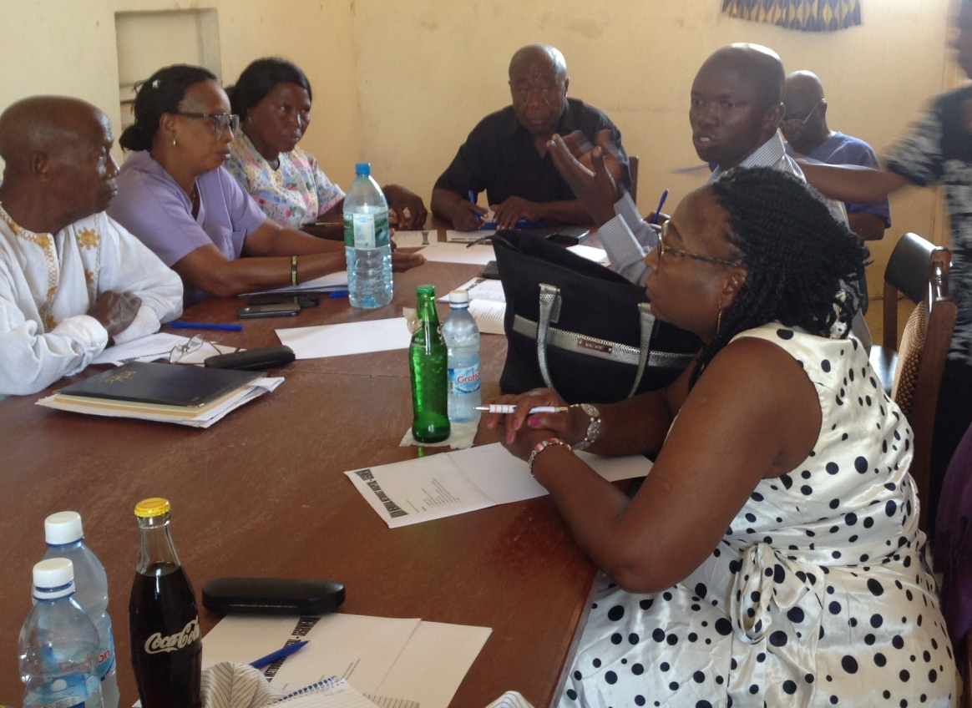
Areas of concern
- The hospital has been severely understaffed following the loss of experienced senior medical staff due to the Ebola pandemic. There is currently only one medical doctor – Dr Missa –who is responsible for the whole hospital and he was delighted to have Dr Kenny on board. During my visit, he was at a mandatory workshops for all medical practitioners of highly infectious diseases following two unconfirmed sporadic Ebola cases in Sierra Leone. There are still vacancies for a surgeon, an anaesthetist, a pharmacist, an occupational therapist and for more staff nurses. The Paramount Chief commented on the urgent need for hospital personnel to relieve NMH staff and was glad to see Tom volunteering.
Student nurses at morning devotion in Segbwema, Sierra Leone
- The Nursing School thanked God for the 243 nursing students enrolled this year. However a Principal Nurse tutor with a Masters degree is urgently needed to lead the school, as recommended by the national Nursing Board.
- Also, the government has requested for the upgrade of the nursing school to start training Registered Nurses by 2018, as opposed to Community Health nurses. A computer suite and internet should be available on site.

Meeting with Sierra Leone Christian Aid Country Manager
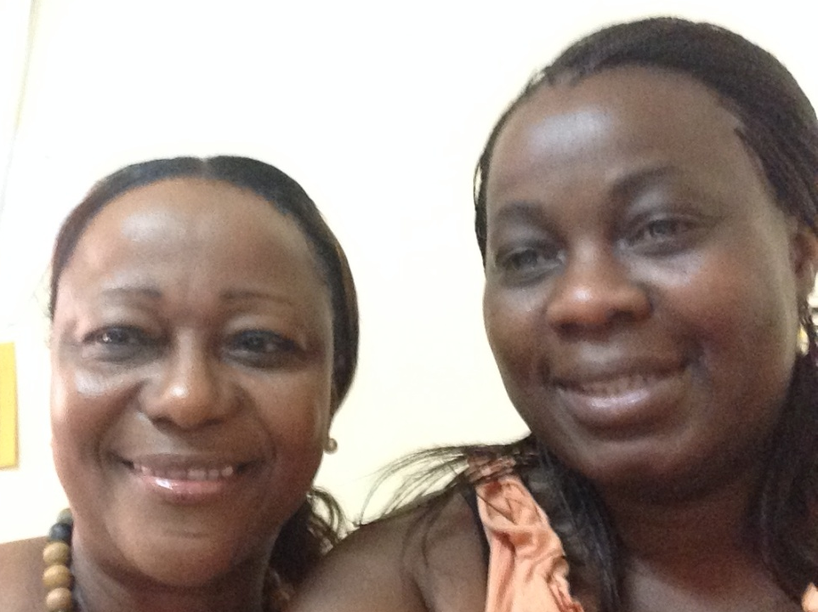
In the past there has been conserted effort to work alondside Christian Aid to support the Methodist Church Sierra Leone (MCSL). I believe the post-Ebola crisis offers a great opportunity to work together in establishing MCSL’s mission and development programs. At the moment, MCSL Development department is severely understaffed and Bishop Beah has requested for National in Mission Support for a Finance/ Programme Manager to assist Mr Francis Musa – the acting Development Manager – who is doing an amazing job but is currently overstretched. Jan – Christian Aid country manager – has agreed that the need to jointly support MCSL and has promised to help with the recuitment prosess for the post holder. He has also helped to draft a job description for the post. Since Chrsitian Aid does not implement and monitor projects, upskilling partners such as MCSL would be significant to its operations in Sierra Leone.
Jan – Christian Aid Director with Bunmi in Freetown

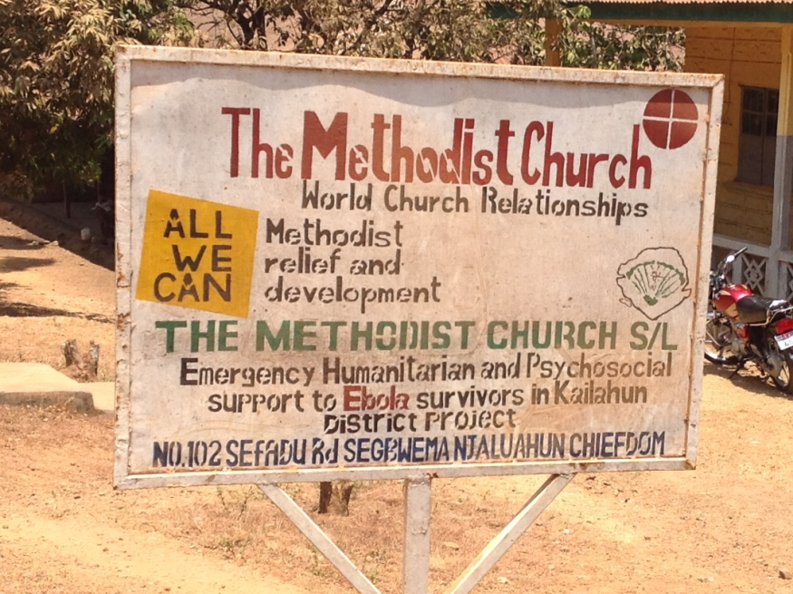
I later met with the Christian Aid Policy & Programme Manager who was very impressed with the contributions and activities of MCSL during the Ebola crisis and commented on the respect that the communities have for faith organisations. MCSL was also commended for its visual role in supporting flood victims in Freetown after the emergency grant was sent by the World Church Relationship Office in November 2015. These actions have promoted the contributions by churches and Christian Aid now considers MCSL as a key partner in Sierra Leone. The future plan is for Christian Aid to work alongside MCSL staff to help strengthen its development strategy, assist with fund raising initiatives and encourage income generating projects. There is a possibility to send a volunteer to work directly with MCSL, when resources are available and agreed in the UK.

Debrief with Bishop Beah
- MCSL has started an audit report. Mr Joseph Syl-Bauns accompanied us to NMH and to check the WCR-All We Can project. He was carrying an audit report on all sectors so as to improve documentation and accountability to the Conference and partner, as well as devise appropriate systems. Mr Syl-Bauns was the Deputy Auditor General for Sierra Leone before retiring years ago and now works as a MCSL consultant.
- Bishop Beah plans to pursue partnership initiatives with other institutions as partners with Kenema Polytechnic for MCSL ministerial training outside Freetown
- Ex - SALT student Rev Spaine: MCSL requested the possibility of training few MCSL ministers in Nigeria and Ghana at Masters level since Rev Spaine was still expected back in Sierra Leone after his training at Queen’s Foundation, Birmingham
- MCSL renewed its request for MCSL support from MC Nigeria - for Connexional Business Development Manager as previously considered
- Further group training for the women after the last successful one
- Request for Skills centre and printing press support to generate fund and job creation for youths
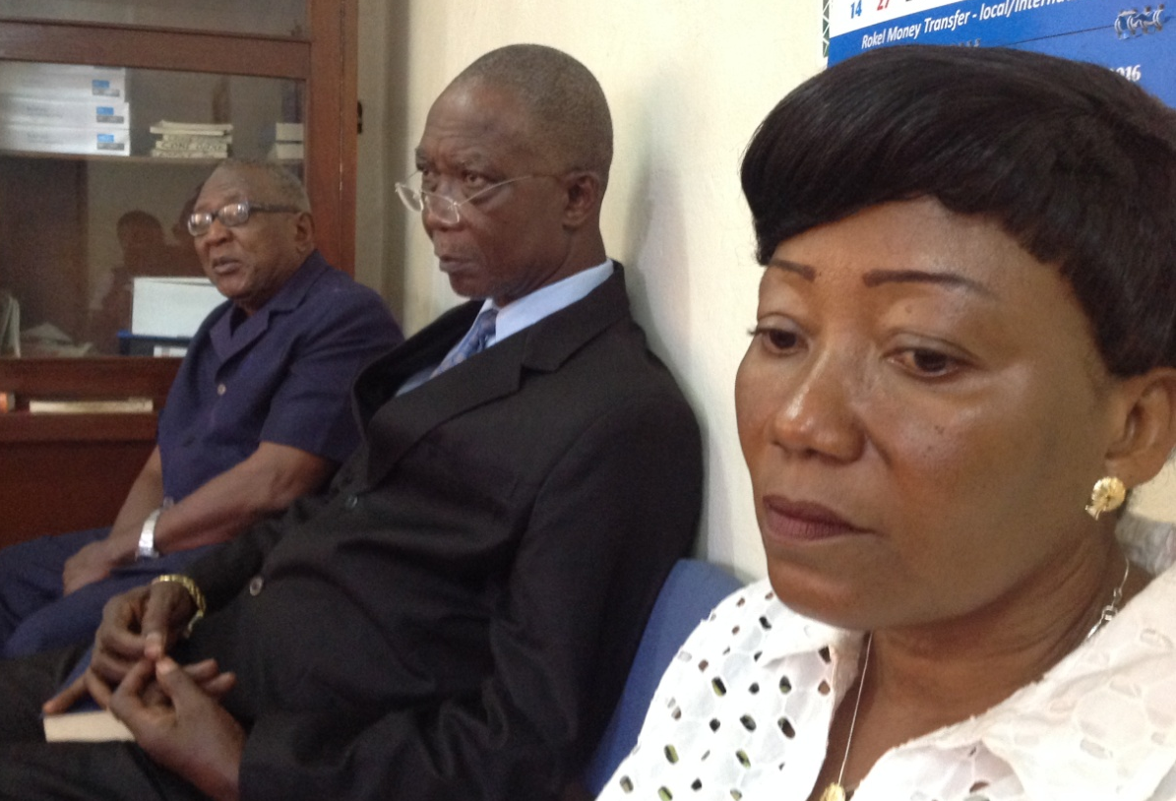

1 Timothy 1⁶ – And the grace of our Lord was exceedingly abundant, with faith and love which are in Christ Jesus

Thank you
Dr Bunmi Olayisade
Africa Partnership Coordinator
MC Sierra Leone devotions at the Connexion Office in Freetown

