Partnership visit to Cameroon
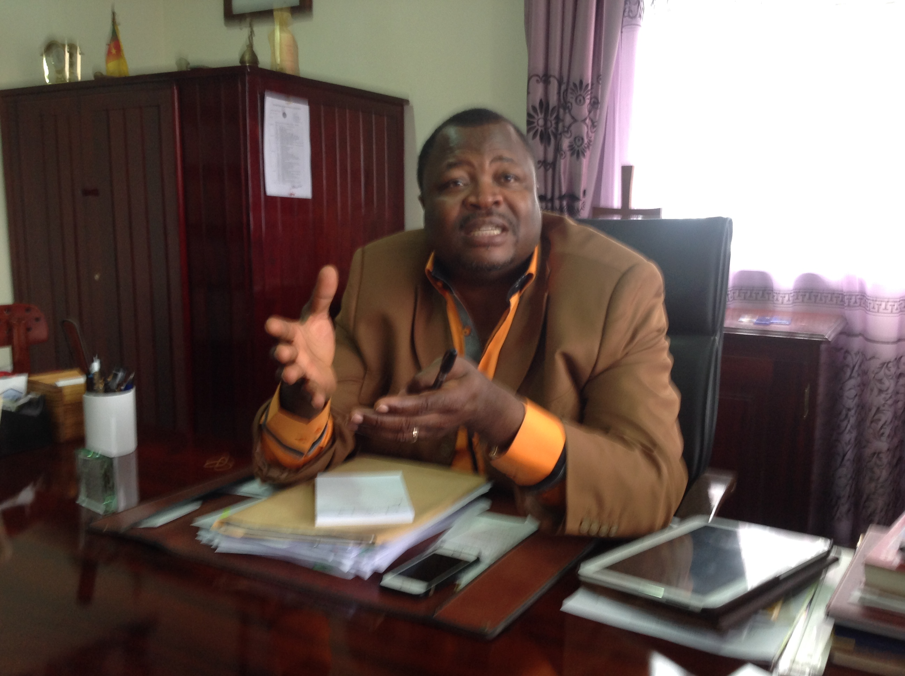
Rev Samuel Forba – New Moderator of PCC
10 - 17/3/15
Aims
- To meet with the newly appointed Moderator of Presbyterian Church Cameroon (PCC) to discuss partnership issues and to attend his induction at Buea, Cameroon
- To meet with British Methodist mission partners serving at the Presbyterian Theological Seminary, Kumba
- To enquire about the effect of Boko Haram terrorism in Northern Cameroon and its environ

I arrived in Douala late in the evening and was picked up by Daniel Chapman and the vehicle driver. We travelled for about two hours to Buea where I was invited to dine with Rev Samuel Fonki Forba at his residence. We had a brief discussion over dinner and I also met Deacon Maryline Slowe from the London Methodist District there. She was a former course mate of Fonki at Queen's Foundation Birmingham and was invited to the ceremony too.
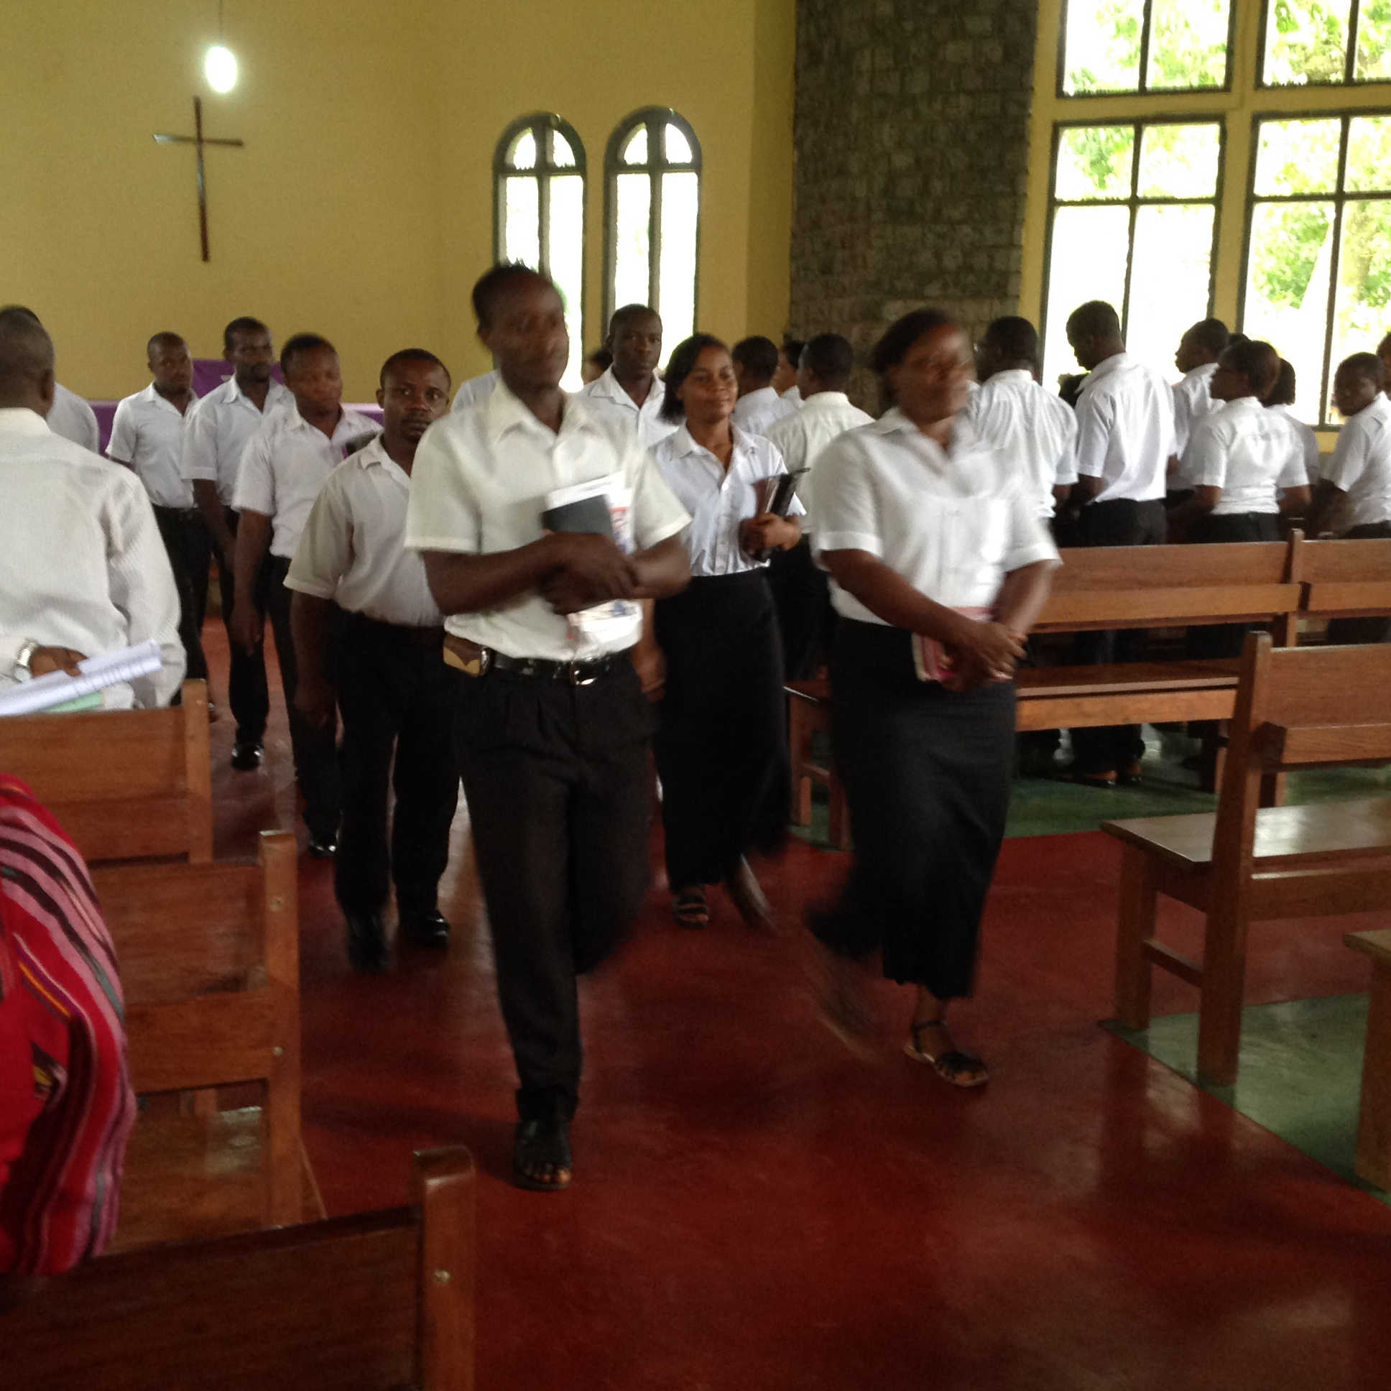
Theology students at PTS, Kumba

Boko Haram terrorism in Northern Cameroon
With regards to the situation, as the new Moderator Rev Fonki encouraged all Presbyterian Churches in Cameroon to organise special services to pray for the victims of Boko Haram and national stability. The Council of Protestant Churches in Cameroon also had ecumenical services as well as ran food programmes until 4/4/15. At one of the refugee camps visited in Northern Cameroon; there were more than 6,000 people living in deplorable conditions and there were other refugee camps in Northern Cameroon but no interviews allowed. It was reported that over 1.5 million Nigerians were said to have migrated from Northern Nigeria to Northern Cameroon. The recent spate of terrorist attacks by Boko Haram terrorists in the region made Chad very supportive and offered military assistance against the formation of an Islamic state. In the month of February 2015, eight heads of states met in Yaounde, capital of Cameroon to develop strategic defence alliance and the meeting was considered a success. Everywhere in Cameroon particularly in the North was filled with road blocks and thorough border checks. Commerce has been affected terribly and whole villages deserted after terrorist attacks. Eight hundred Muslims were killed in a mosque in Northern Cameroon recently and Rev Fonki requested contact with PROCMURA to promote interfaith dialogue and assist the Muslim minority in Cameroon. Rev Fonki plans to send me an update soon and be introduced to Prelate Uche of MC Nigeria for joint action.
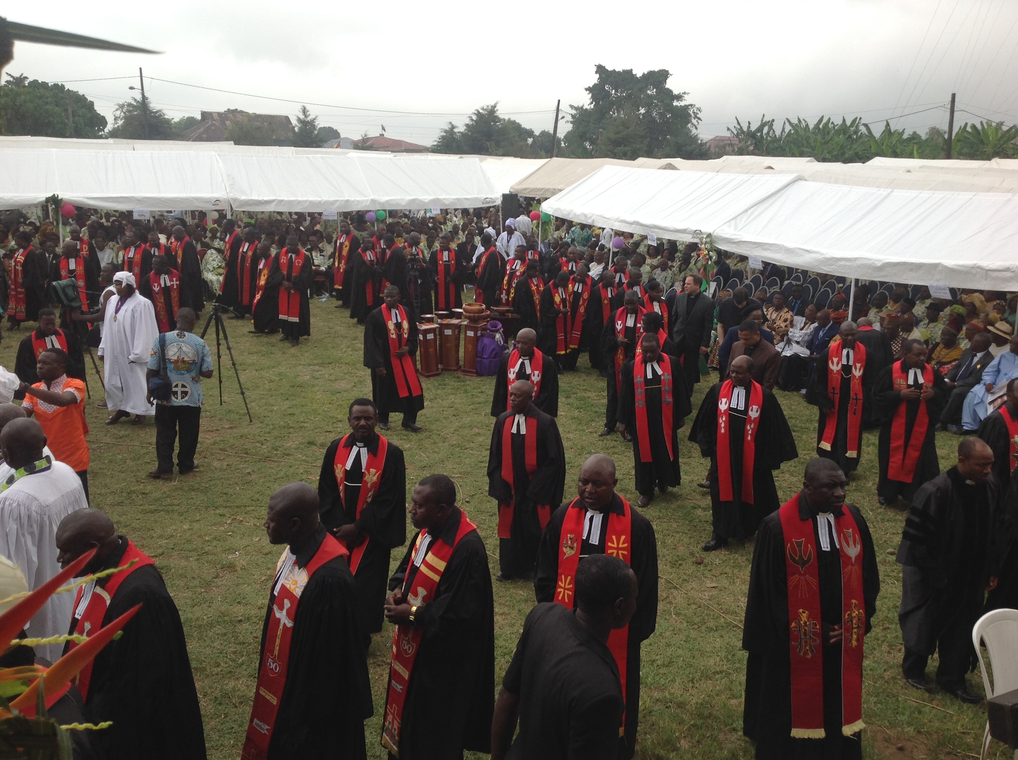
PCC ministers on induction day in Buea

Partnership issues between the Presbyterian Church Cameroon and Methodist Church Britain
One of the subjects discussed was the use of the grant process as a strategic tool and options available between us as partners. The popular grants are Nationals in Mission Appointments and Scholarship And Leadership Training opportunities for potential leaders of PCC. New applications are annually sent to partners and Rev Fonki should contact me for any clarification or further explanations about the procedures. General grants are offered as and when required for one-off projects or start up programmes maintained by partners. All grant applications would be sent to the Moderator’s office and all requests from PCC should be approved by him before posting back to the World Church Office.
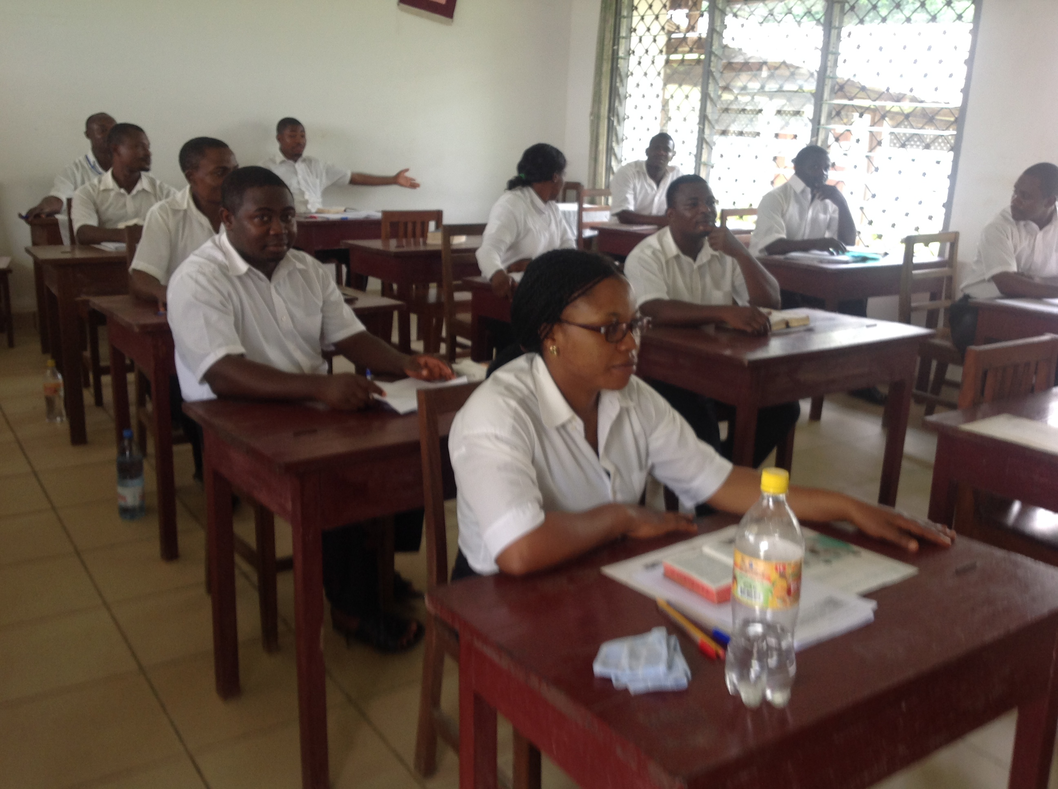
PCC Theology students
Rev Fonki then mentioned the ongoing problems with the poor internet signal affecting both internal and external communications. The former Moderator, Rev Asana had requested assistance earlier but more information was needed to be considered for financial support. Rev Fonki gladly offered more information particularly since the computer department on site was about to move from the old chapel to another administrative block making it perfect timing to lay new cables for better internet service. The old chapel was constructed with iron sheets when the missionaries arrived in Buea in the 19th Century and Rev Fonki wishes to have it converted back for staff gathering and for use as a chapel. Funds were raised at the induction service to achieve this goal.
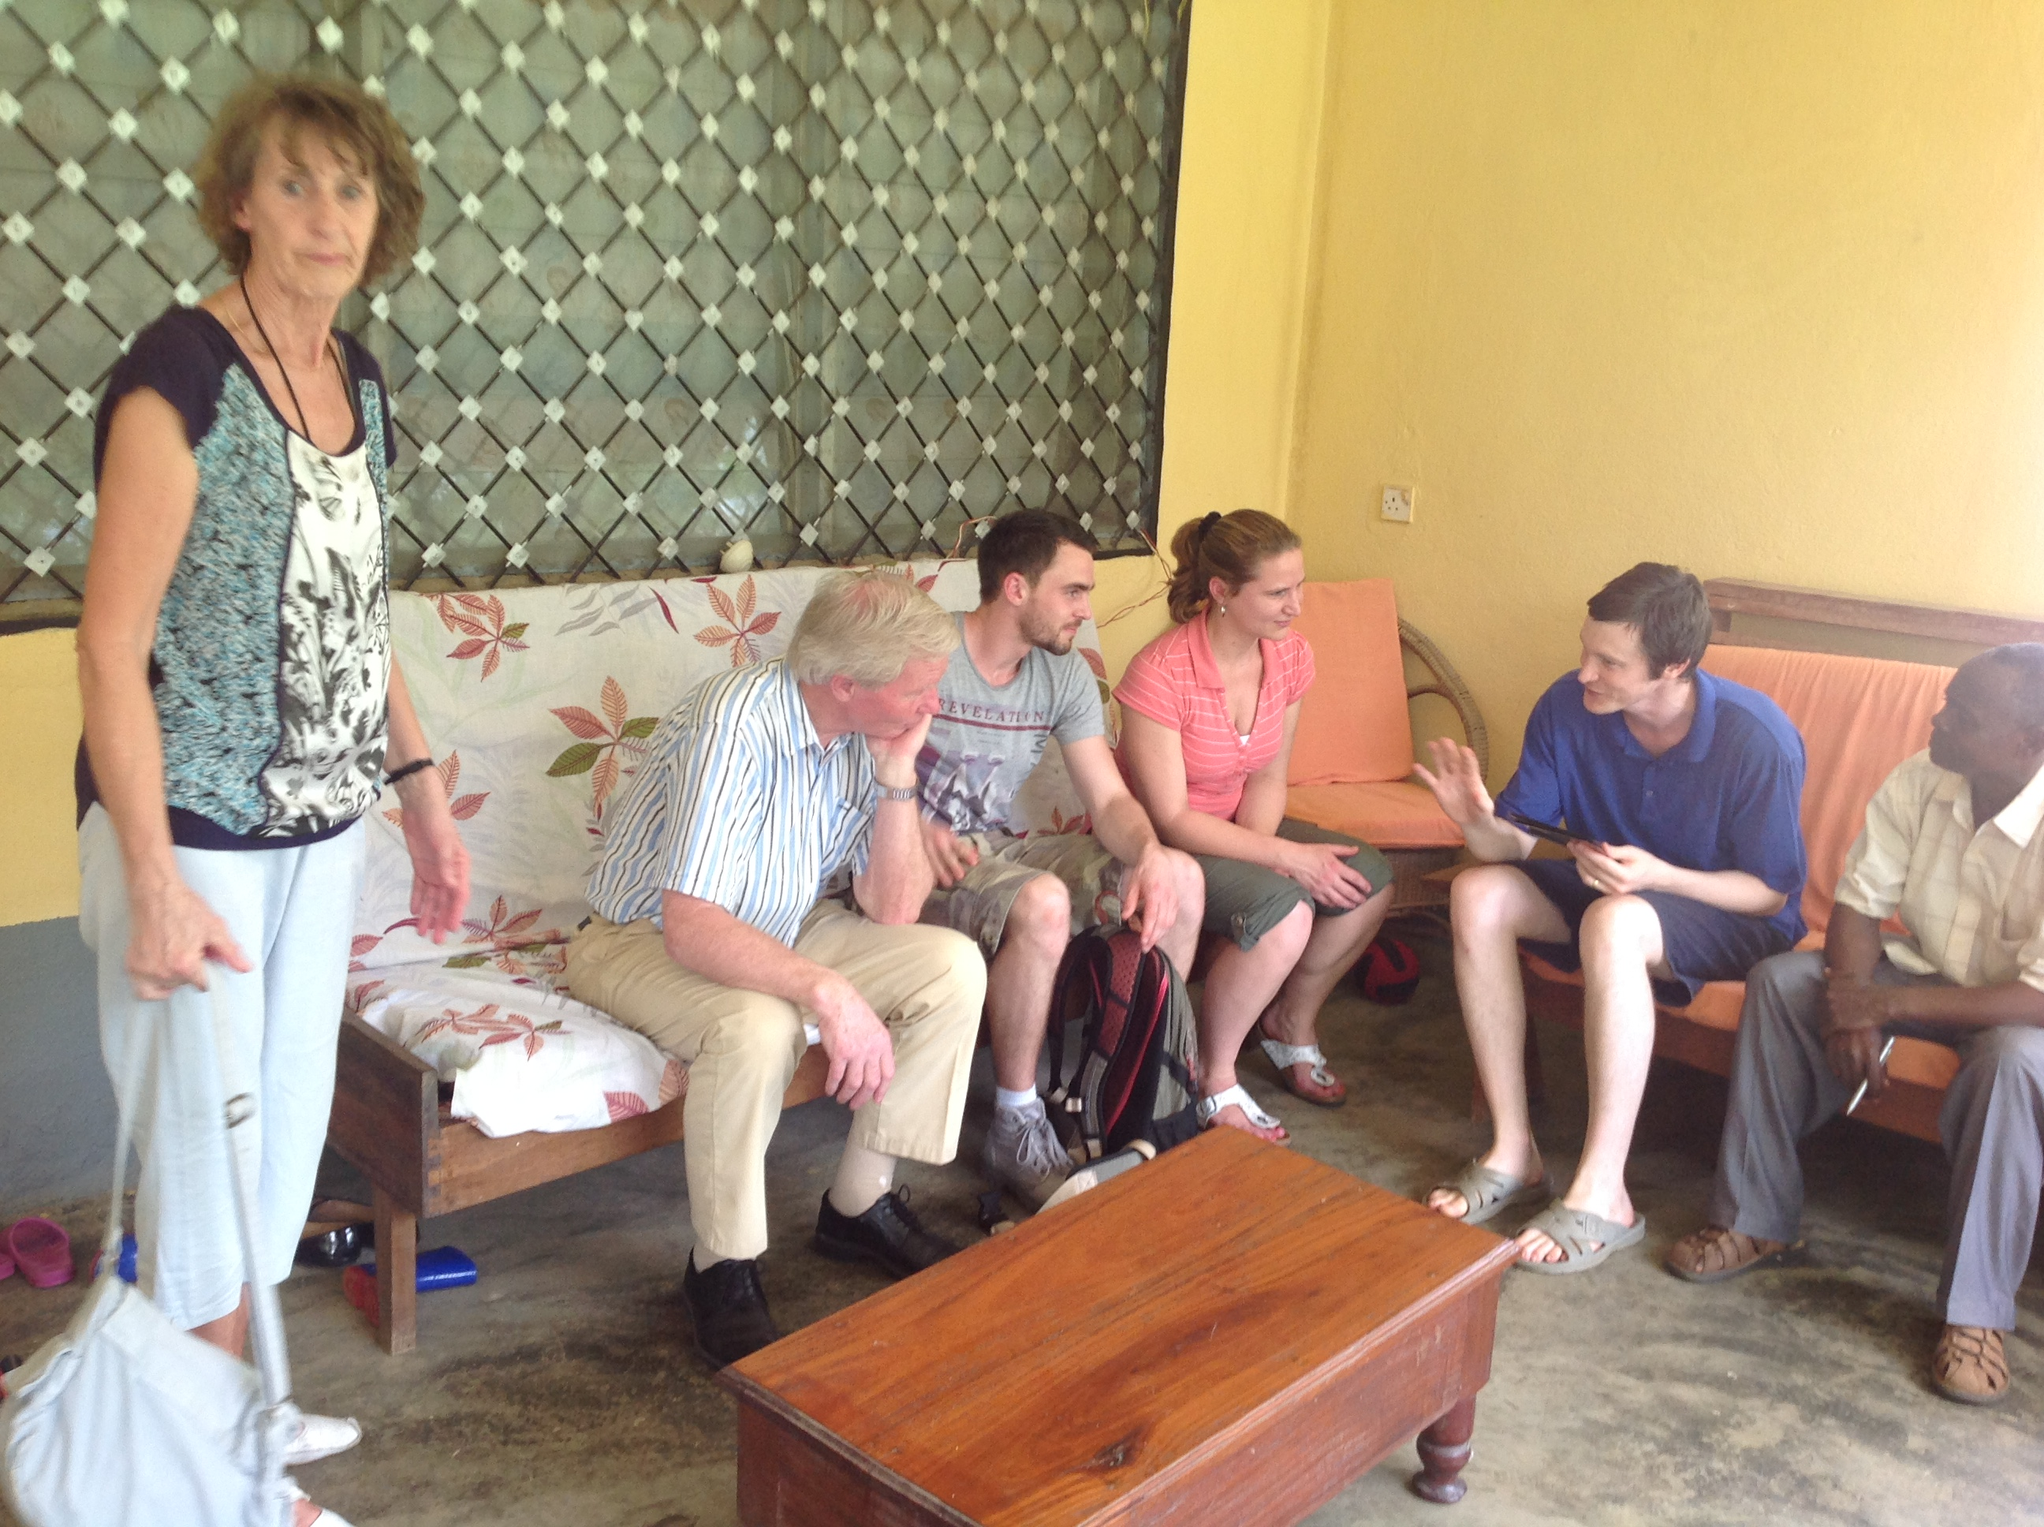
Rev Stoke and family with Daniel -former mission partner of Mission 21 also visiting Kumba
Rev Fonki confirmed that his mission priorities were
- Ministerial and leadership training as well as mission personnel exchanges
- Communication - Internal and external
- Self sustainability by promoting income generation programmes e.g. he is considering the development of a six mile piece of land owned by PCC in the rural area. He hopes it will offer youths employment and the revenue supports other PCC projects.

Mission personnel exchanges
Rev Fonki welcomed short term volunteers and interns to work with PCC particularly at its health centres, theology, schools (English and Science) and in social work. Technicians and health workers are most welcome to up-skill locals. He also asked if Cameroonian ministers could serve in Britain as part of an exchange programme. There is an existing programme with Germany where ministers serve for four years and return to Cameroon thereby improving exposure and experience of Presbyterian ministers. Later
I met Rev Stoke and his family that served at PTS Kumba for ten years and built the current manse Daniel and Grace's family are residing in. They are Dutch mission partners and taught Rev Fonki, who attended the induction with their children born in Cameroon over twenty five years ago. Rev Stoke was a lecturer and his wife helped at the seminary.

Meeting with MCB mission partners - Daniel, Grace, Kwame and John
I started the day with worship in the school hall at 7am and met with staff and students. The students led the service and afterwards news and updates were shared. It was an opportunity to be introduced to staff and students of the Presbyterian Theological Seminary and I brought greetings from the World Church Office on behalf of the British Methodist Conference. I later attended Grace’s Year one Theology class and I was invited to sit in and listened as she taught the New Testement. It was an interesting class....her lesson was based on Luke 1 - Elizabeth's seclusion during pregnancy - Was it cultural, or did she stay private due to the unusual event? Later in the book of Luke, the discussions focussed on John the Baptist’s message about repentance, the kingdom of God at hand, judgement and baptism. He had both Jew and Gentile audiences. Two of the questions asked were why was the spirit of Elijah referred to as John the Baptist and why did Jesus not save his cousin from his brutal ending?
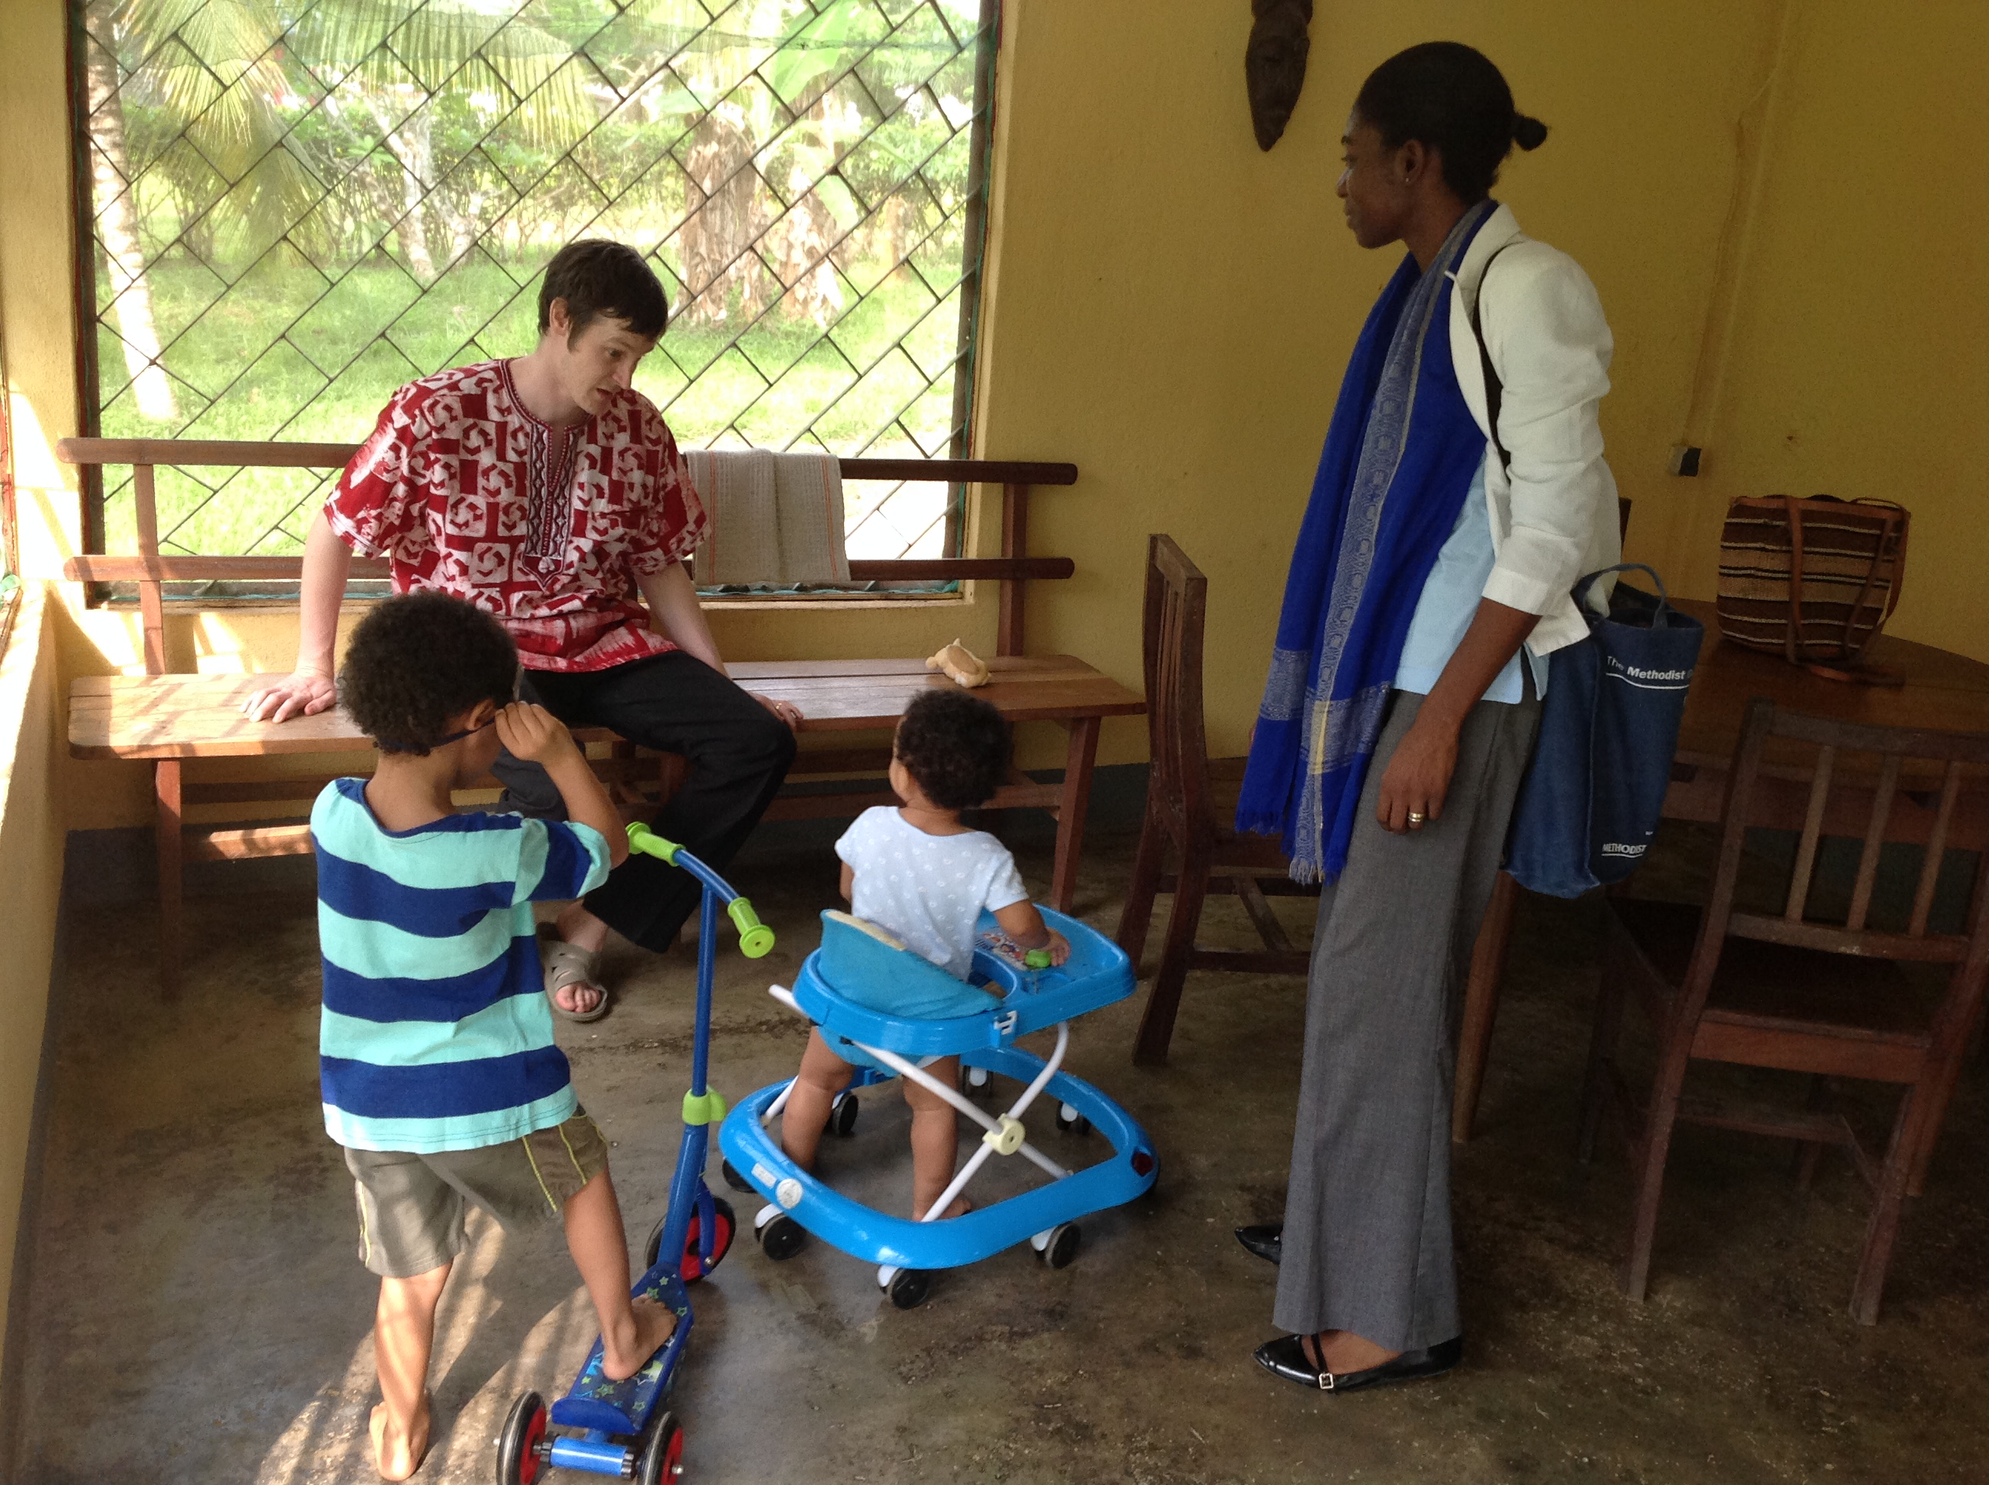MCB mission partners -Daniel, Grace, Kwame and John Chapman
Later that afternoon, I also attended Daniel New Testament’s Year 3 class. It was a more invigorating class with lots of discussions and participation. I was asked to contribute but I mostly listened and two questions asked by students that sprung to mind were “Was Jesus's birth immaculate and why did Abraham pay for the land when God promised Him Canaan? At the end of the session my contribution to the discussions was that it was easier to change opinions than convictions because your belief and value systems stem from your convictions. Our Christian journey should be influenced by personal encounter with Christ based on the truth (of scripture) rather than opinions or interpretations because truth is eternal but interpretations could change from time to time....
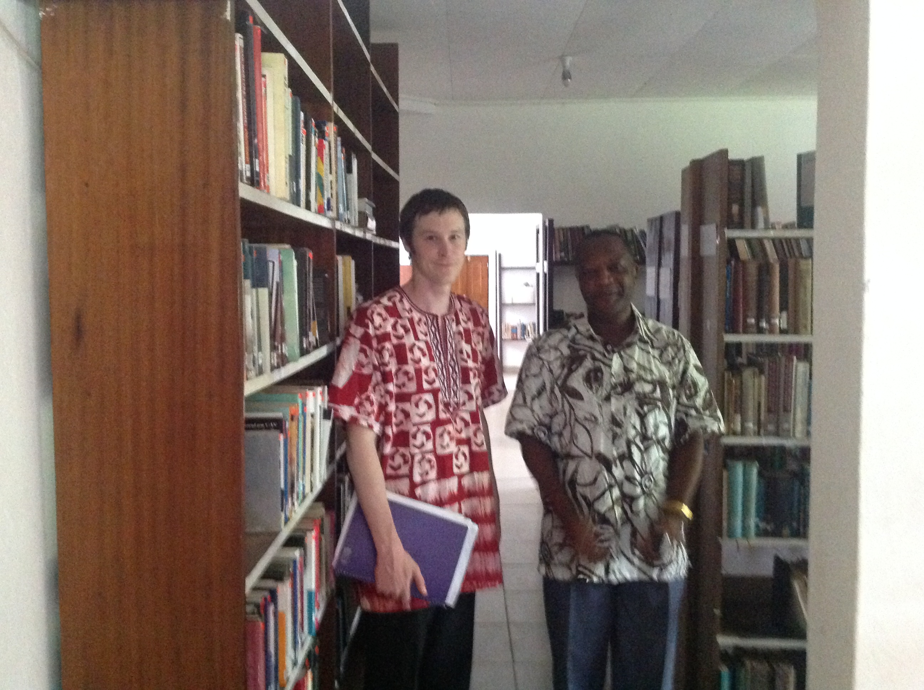
Daniel with Rev Nyuki (PhD scholarship student)

I later visited the library where resources were in short supply. I met Rev Nyuki who helps with library services in addition to lecturing at the Presbyterian Theological Seminary. He has recently obtained a scholarship funded by the World Mission Fund to pursue his PhD degree at Pretoria University by distance learning. He was so excited about his scholarship plus the ability to work at the same time. He helps the students a lot and asked for assistance with books and related resources for the new library.
I later saw the newly installed generator that supplies the seminary with electricity when government supply fails particularly during the rains. This helps students carry out research and prepare for examinations, among other things such as pump water on site. The generator was purchased by a general grant from the World Mission Fund. I later attended the evening service with staff, student and staff family members where the dean offered his gratitude on behalf of all.
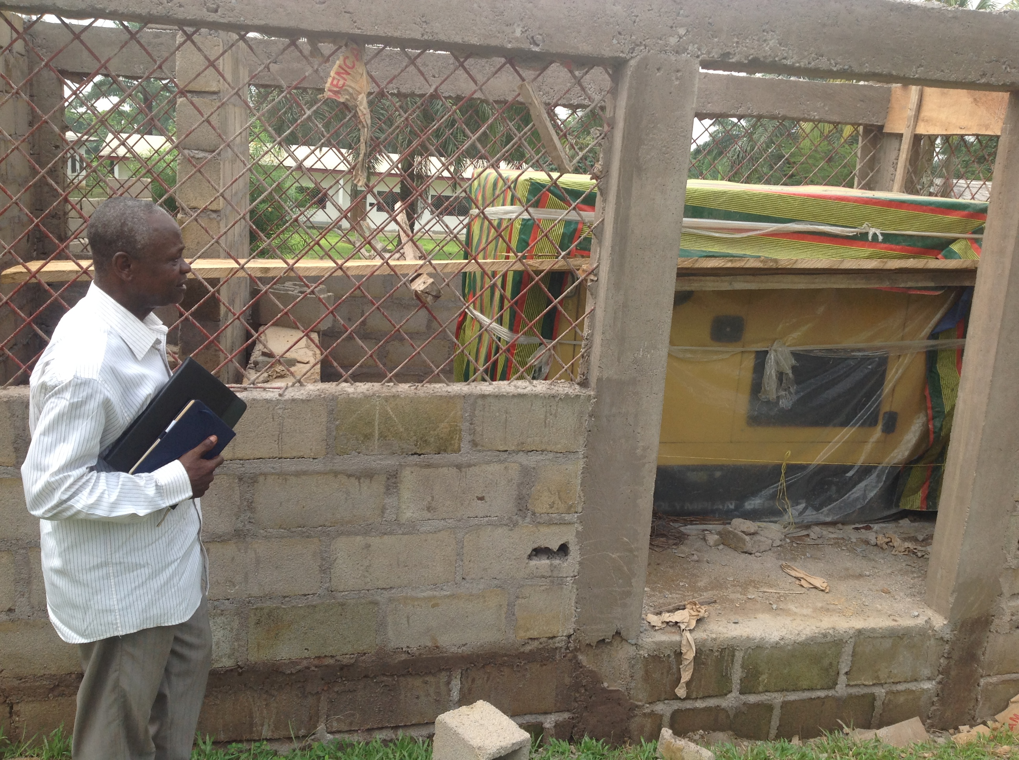Rev Dr Muyo Joshua – Dean of PTS, Kumba standing beside the new generator donated by MCB for power and water supply

Daniel and Rev Nyuki – a SALT student

Induction ceremony for PCC Moderator on 15th March 2015
This took place in an open air arena with over 410 PCC ministers plus guests and church members. Traditional dignitaries, politicians, ecumenical and international partners were also present. The service started at 9.00am and ended around 3.15pm. It was a vibrant services with lots of singing, choral presentations, holy communion, good will messages from partners plus presentations from various churches. Past Moderators, Synod Clerks plus spouses were present and took active parts in the induction process. Rev Samuel Fonki is married to Rev Dr Perpetua Fonki (an ordained minister and an academician at the Presbyterian Christian University). They both have a son – Samuel Fonki Jr who is currently a teenager doing his A levels. The Synod Clerk – Rev George Fochang is married to Rebecca Fochang, a school teacher and they both have a son, Emmanuel Fochang an Engineering undergraduate at one of the universities in Cameroon.
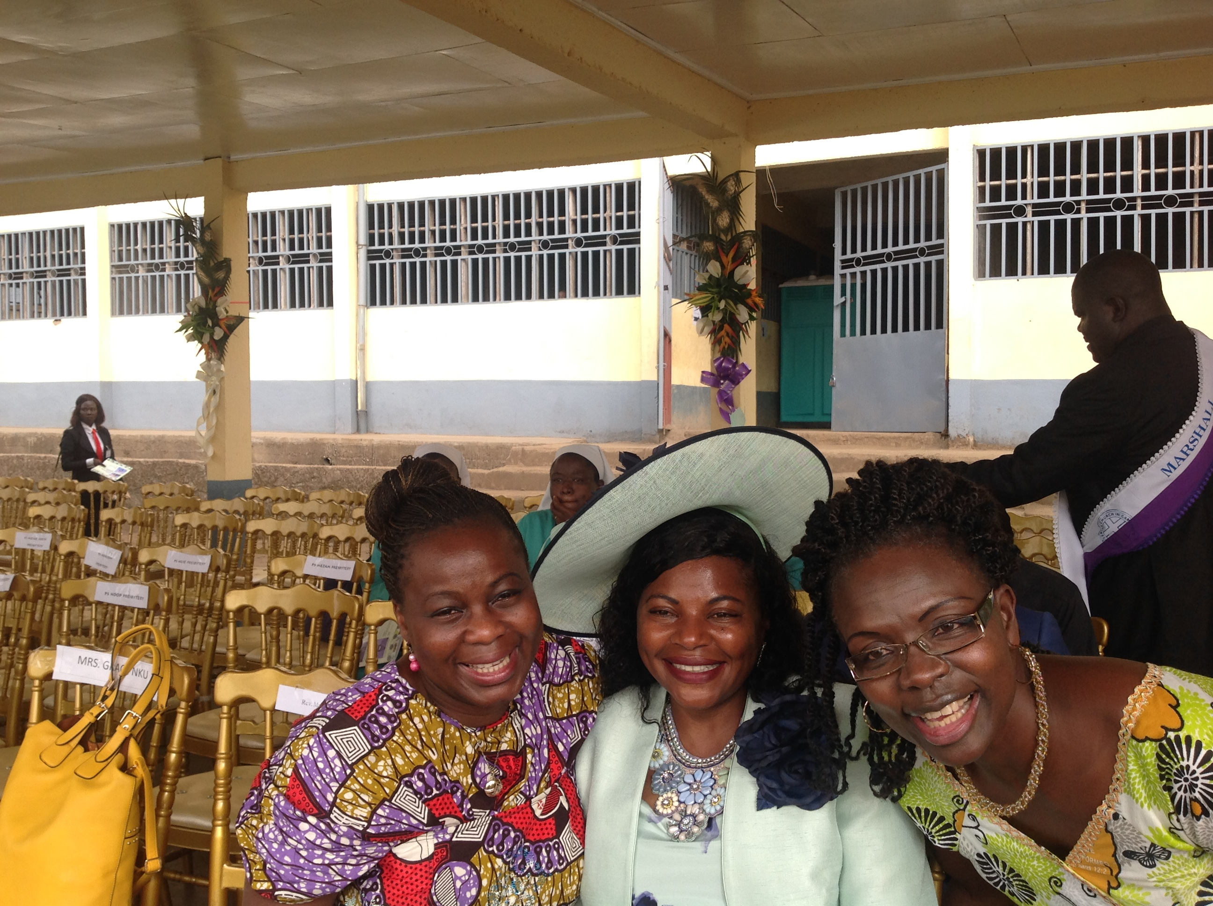 Bunmi with Dr Perpetua Fonki (PCC) and Dr Sandra Afanou (Mission 21) at Buea
Rev Fonki’s sermon was based on Romans 12 verse 2 and titled Be transformed transformers. He encouraged the church to unify and seek continued transformation by God’s word and Spirit. He commented on the significant role of the church in partnering with the government to fight terrorism in Northern Cameroon caused by Boko Haram. He also admonished the Church to seek solutions to Africa’s socio, economic, political and religious hardships as well as its uncertain ecumenical environment. He said, “When are we going to attain consciousness that war is not the solution for Africa’s freedom from poverty, greed and neo-colonial rule? Beloved how are we going to remain committed in recreating and transforming God’s world as a post Jubilee Church? What kind of Church do we want the Presbyterian Church in Cameroon to be? What kind of Christians do we want to be in the nation of Cameroon? Who are we called to be? ....We must formulate a new agenda that will enable us see every circumstance as an opportunity for service. Let us shed His light abroad, making use of every opportunity to shine that light to the farthest and darkest extents of this dying world. It is time to move from the superficial to the supernatural. God wants to bring spiritual
transformation within our lives; He wants to renew us and use us as transformed transformers“.

Thank you.

Dr Bunmi Olayisade
Africa Partnership Coordinator
April 2015

