Zimbabwe Report

Name: Megan Thomas
Country of travel: Zimbabwe
Dates of travel: Thursday 20 November – Wednesday 3 December 2014
Aims of visit: The aims of our visit to Zimbabwe were to meet, visit, explore and share with the Methodist Church in Zimbabwe. To travel with our hosts from the Youth Department around Zimbabwe sharing with various groups, organisations, churches and people and learning from one another.
Visit Itinerary
Thurs 20 Nov: Depart from London Heathrow
First three days stayed at the Matthew Rusike Children’s Home
Fri 21 Nov: Arrival
Sat 22 Nov: Relaxed lunch executive- meet with the Connexional Youth Council executive over lunch to outline the programme
Sun 23 Nov: Service at Glenview then in the afternoon meet with Vavambi Y.A (meet the young adults there)
Mon 24 Nov: Travel to Byo via Great Zimbabwe (meet greater Bulawayo youth at Main Street, sleep at Lalani lodges)
Tues 25 Nov: Hwange tour (National park) and sleep at Hwange National Park
Wed 26 Nov: Tour Victoria Falls and sleep at Victoria Falls rest camp
Thurs 27 Nov: Travel to Gweru (and visit the youth centre) and sleep at Ndhlela centre
Fri 28 Nov: Travel Phakame high school (and meet the students there) & Vungwi
Sat 29 Nov: Travel to Harare and visit Chihota, one of their rural circuits, sleep there
Sun 30 Nov: Service at Chihota and meet the youth and then travel back to the Matthew Rusike Children’s Home
Mon 1 Dec: Relax at Matthew Rusike Children’s Home. Go into Harare city centre and meet with the presiding Bishop. Farewell dinner with Harare youths at Borrowdale
Tues 2 Dec: Departure
Wed 3 Dec: Arrive back at London Heathrow

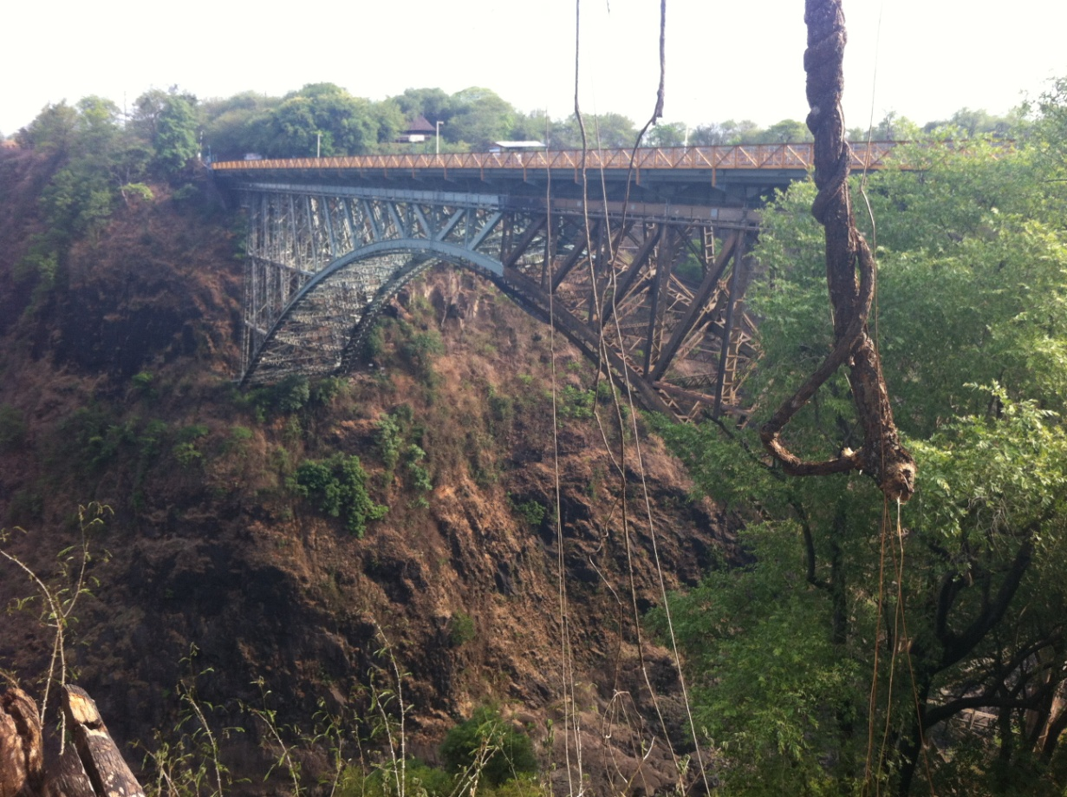
Introduction to country/Church: Zimbabwe gained independence in 1980. Its population is just over 13 million and the country covers 150,871 square miles. This, compared to Britain’s population of 60,800,000 and area of 88,745 square miles, might indicate the vastness of the country’s savannah. Zimbabwe’s capital Harare is a vibrant commercial and financial city and is said to be modeled on London. Zimbabwe has other large cities such as Bulawayo and Gweru which we also visited during the trip. Zimbabwe has 16 official languages, but the most common are English, Shona and Ndebele. Zimbabwe is also home to one of the Seven Wonders of the World, the Victoria Falls. These gigantic waterfalls mark the borders of Zimbabwe and Zambia and can be crossed via a connecting bridge.

The bridge at Victoria Falls joining Zimbabwe and Zambia

The Methodist Church in Zimbabwe is a lively and active denomination and we certainly experienced this during the trip. The churches are full of people of all ages and have a variety of organisations that people really value, such as the Boys’ and Girls’ Christian Unions, the Methodist Young Disciples, choirs, committees, Sunday Schools and small groups. The Youth Department oversees the work with children and young people and holds each district accountable for that work that it does within these areas. They also have a Connexional Youth President, Brenda Muzuve. Her term of office runs for three years, is part time and on a voluntary basis. A Youth Vice-President works alongside the Youth President in representing children and young people in the Methodist Church of Zimbabwe.

Overall experience and a few highlights
“What did you expect?”
This is one of the first questions that came my way after landing in sunny Zimbabwe. I had no answer. What do you expect from a country that you know little about? From a climate that is really alien to you? From people you had never met before?
One thing that has made a big impact on me is the hospitality and generosity of our hosts. We were hosted by the Methodist Church in Zimbabwe Youth Department for the 12 days of our trip. They did a great job of putting together an itinerary that enabled us to meet a huge variety of people and experience many different things.
The trip brought with it many amazing experiences. I’m going to share a few with you that really challenged me and taught me a lot.

The Matthew Rusike Children’s Home
At the very start of our trip we stayed at the Matthew Rusike Children’s Home, a place that provides residential care facilities for orphaned and vulnerable children. We were welcomed here as family. The home sits on the outskirts of Harare and as a result has the same challenges that many do in this area of lack of electricity and running water.
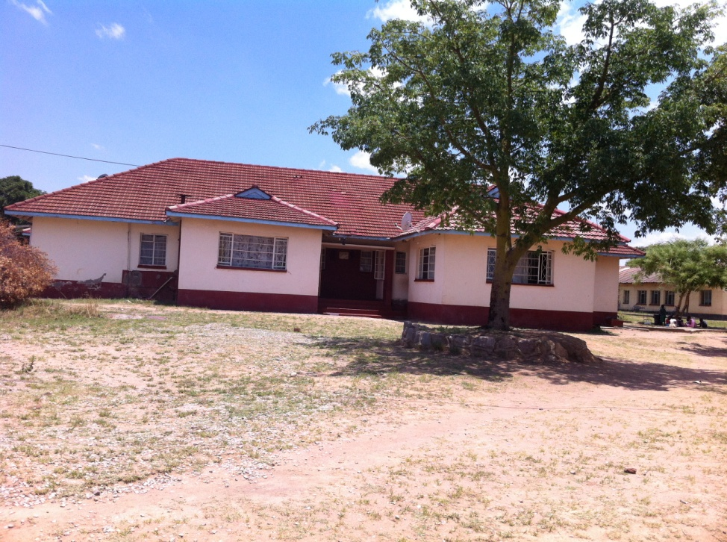
During our stay, the home was without electricity and water for two weeks. We learnt that this was not unfamiliar; sometimes they could go months without both! We asked what challenges the home faced. At the top of the list was financial requirements, followed by electricity and water. We could only imagine how difficult it would be to feed all the children at the home without any power. However, something that really struck me here was that through it all, our hosts were not only gracious and worked with a smile but they were continually checking if we were comfortable. The hospitality we experienced here will stay with me forever and has challenged me in my own hospitality. Whilst staying here we had the privilege to meet some of their children and young people. This is where we met Lucky, who had been brought up at the home and was a previous Youth President. We also had the opportunity to meet the youngest child they have at the home who is just over six months old. The story we were told here was that the child’s mother had tried to sell her, and as a result was now in prison for 25 years. I found this very difficult to hear that a mother and daughter had been separated and it made me wonder how desperate that mother must have been to want to sell her baby. In Zimbabwe these questions were not asked but a heavy prison sentence was imposed. The work that the children’s home does is truly amazing and I pray that it will continue. When we returned there towards the end of our trip, we said that we were ‘home’. We came to see the Matthew Rusike Children’s home as our home in Zimbabwe because of the generosity and hospitality we experienced there.
Our ‘home’ the house we stayed in at the Matthew Rusike Children’s Home

Phakame High School
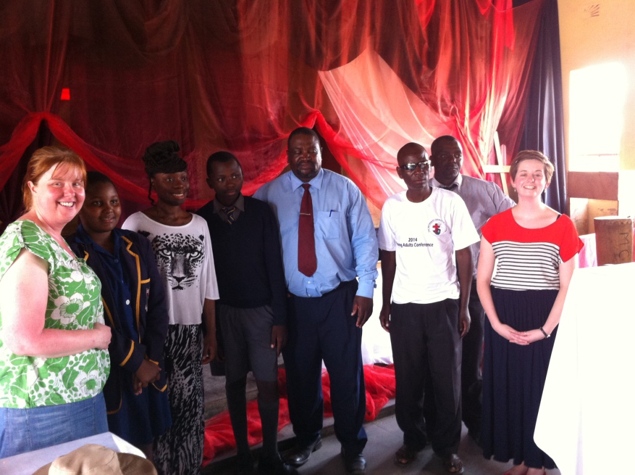
The visit to Phakame High School was a real highlight for me. The interaction with the young people there is something I will remember for the rest of my life. En route to visiting the school, our hosts told us that we had about 40 minutes to talk to the students about hard work and taking school seriously. Having very little preparation time scared me, especially as word had spread that we were “inspirational and motivational speakers”! However, as a team under pressure we pulled together an interesting way of sharing on these topics and did the assembly in the style of an interview. The reason that this stands out so much for me is not only because we were addressing around 400 students, but because this was youth work. It was us talking to young people about things that could change their lives. I found that this moment encouraged me as we had some students ask some really interesting questions. I found this moment special because if we encouraged just one out of the 400 students to work that little bit harder and go for the things that they didn’t think were possible before, then we would have done what were we supposed to. We encouraged. I felt that everything came together this day and that we were able to speak across cultures and bring a message to the young people of Zimbabwe.
Our visit to Phakame High School. With 2 students and the Principal of the High School.

The rural area
Towards the end of our trip we had the privilege of staying with a family who lived in the rural area of Chihota. I was apprehensive about what the visit might bring, just because we had not been told much about it. The journey there was long and the roads very uneven. But yet again, our welcome was amazing. Our hosts came out singing, dancing and playing instruments and it was almost like a party! In fact, the whole stay was like a party. I’d had quite a few worries about how I would cope in the rural area, but everything was completely fine. Yet again the overwhelming generosity and hospitality of people was just amazing and I think it was because of this that I felt more at ease. During the evening we all congregated in the kitchen. After eating we had some stories from the GoGo (an older lady in the community). All their stories had a moral message and aimed to teach us how to live better lives. We heard a story of a hare and a baboon (teaching us about trust) and one involving a ghost (making clear the command not to kill).
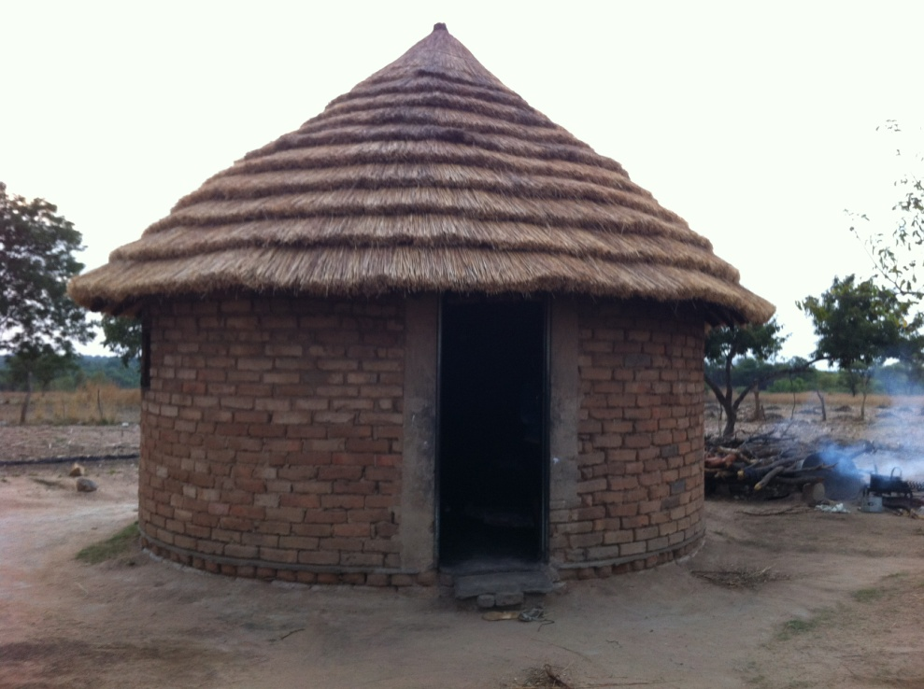

The kitchen and our bedroom

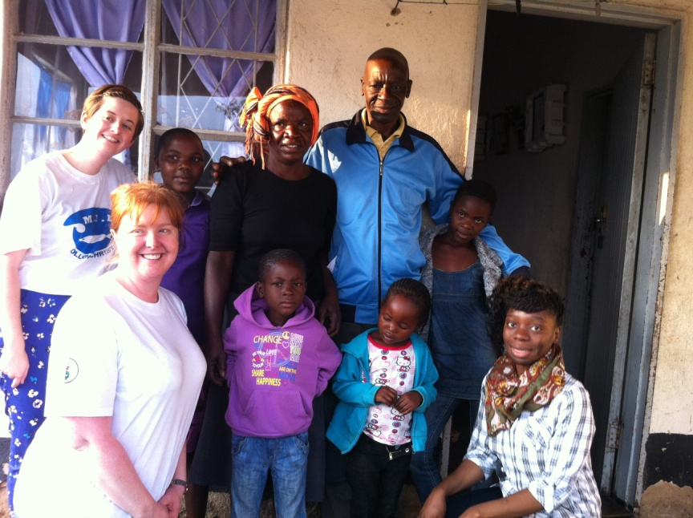
Later we had another very enjoyable singing and dancing session, and finally we went to sleep. They made sure that we had enough blankets to be comfortable, even if that meant that they went without. Once again, the generosity of people to complete strangers was very moving. In the early hours of the next morning, we were up and attempting to plough the fields, pump water and explore the surrounding areas. Every time we passed someone’s home, people would come out to greet us. We were welcomed with hugs and handshakes. Given how apprehensive I had been about my time in the rural area, it turned out to be one of my more enjoyable days. It challenged my thinking about the things we hold dear in our Western world, and also the things that I take for granted such as running water and flushing toilets. I feel very lucky that I was able to experience true Zimbabwe culture and truly rural life. I was sad to leave Chihota and the people there but knew that I had learnt so much from them in how I should appreciate the things that I have. The rural life also challenged me in the things that make us truly happy. Is it our phones? Laptops? Clothes? Or is spending time with people; being a community and talking to one another?
Us with in the rural area with our host family.

Worship
I love to dance and I love Church. So you can image how excited I was to discover that church in Zimbabwe combines two of my loves. At almost all of the meetings we attended, dance was an inevitable. We were told that African people worship God not only with their mind and soul but with their whole body and this was very true. The worship we experienced was nothing like anything I had been a part of before. There is a type of freedom in their worship to express themselves in a beat or movement and if someone gets up and starts ‘busting a move’, it’s highly likely that someone else will join in too. Before you know it, there’s a party! That is the best way I can describe their worship, like a party. They are celebrating God and their love for him and it’s absolutely amazing. Coming from quite a traditional church, it took quite a bit of encouragement for me to get up and join in, but once I was up I didn’t want to sit down. The thing I love about this type of worship is that you can get up and dance around and no one will look at you twice or think that what you’re doing was inappropriate. For me, experiencing this was really special as back in Britain I do dance in worship, yet it has been met with some reservations by people. Seeing and being a part of this worship has really encouraged me to continue dancing in church because that is the way that I choose to worship God.
Summary
I have shared with you a few bits that stuck out for me, but actually the entire experience was eye-opening. We also had an amazing time at Hwange National Park and Victoria Falls, but the sole purpose of the trip was to experience, share and learn from the Zimbabwe Methodist Church and I really feel we have done that. Wherever we were we asked to address these various groups, telling them about ourselves and about Methodism in Britain. Whilst most of the time improvising what to say, I found myself repeating something which sort of just came out. I said that we are brothers and sisters in Christ. It doesn’t matter if we are in the Great Britain, in Zimbabwe or somewhere else in the world, we are all joined together in Christ and are one body. We are all disciples and are here to support and help one another in our journeys. Although this was something that seemed to come out of my mouth on a bit of a whim, I really felt this in Zimbabwe! I felt that I was a long lost sister who had come home. I felt the fellowship of Christians and specifically I felt the fellowship of Methodists. This trip has made me think about my own hospitality; how I welcome people, how we as a church in Britain welcome people, how we share with one another and how we relate to one another as Christians. We are brothers and sisters in Christ and are here to support and help one another on our faith journey. “So we, though many, are one body in Christ, and individually members one of another.” (Romans 12:5)
I want to go back to the first question that I was asked, “What did you expect?” I can now tell people what to expect. They can expect a lot of hot weather, a lot of pictures, some very interesting food, some challenging moments, some inspiring moments, overwhelming generosity and an amazing, life-changing experience.
