Partnership visit to Zambia – 8th – 16th July 2014
It was great to arrive in Lusaka after fourteen hours journey via Dubai! I later met Valerie Clarke – member of Church of Scotland at the guest house. She hopes to travel to Kitwe to meet Glen and Wendy Lund and family. They are mission partners jointly funded by Church of Scotland and the British Methodist. The next day I met with Roger – Administrative Secretary of UCZ, the Synod Bishop and Peggy – the General Secretary of UCZ.

Partnership meeting with UCZ
- UCZ plans its 50thanniversary celebration in January 2015 and has invited MCB ex-mission partners and dignitaries to the event
- UCZ has embarked on its capital project as a form of investment for its pension fund and for self sustainability of its mission initiatives
- UCZ was very appreciative of the NMA grant recently approved to support its university personnel as well as ongoing NMA programmes – Peggy was most grateful
- Consolidated plans with Roger to meet Gill and Mike at the airport plus travel arrangements to Mwandi and Choma to meet mission partners and see UCZ’s mission programmes
- Peggy enquired about Corrymeela’s conflict resolution course requirements for SALT plus application plans for church leaders group training in Zambia to optimise UCZ’s human resource
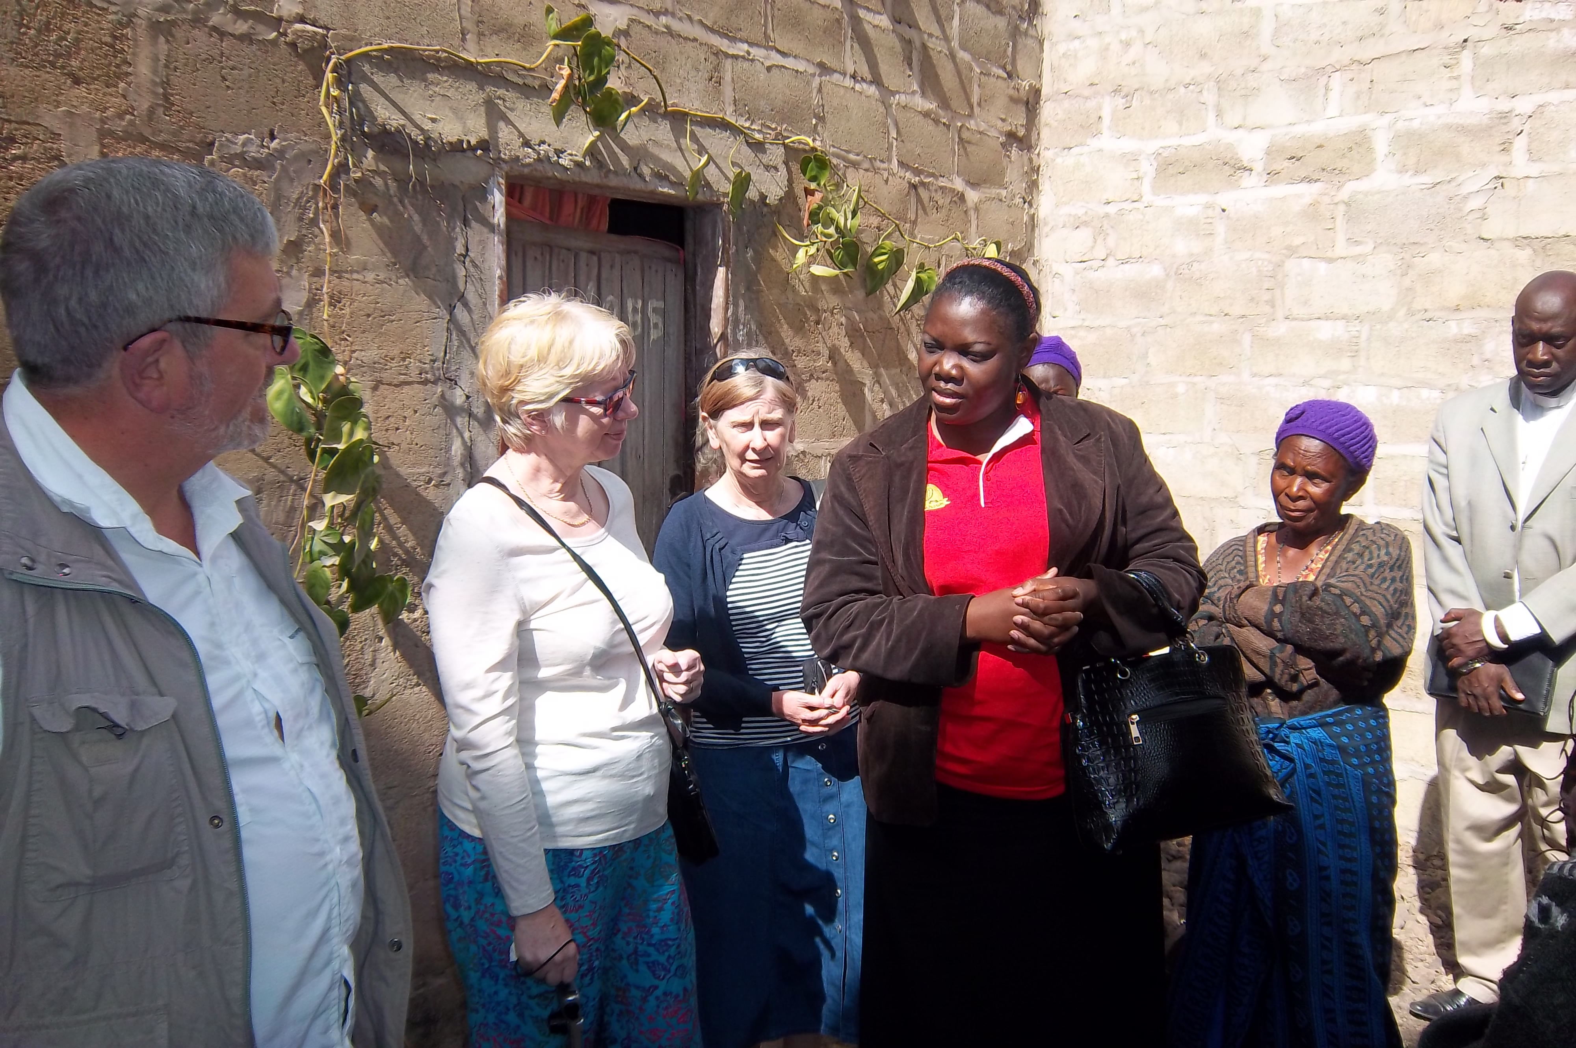
Gill and Mike with Zambian widows at Mapalo -Zambia
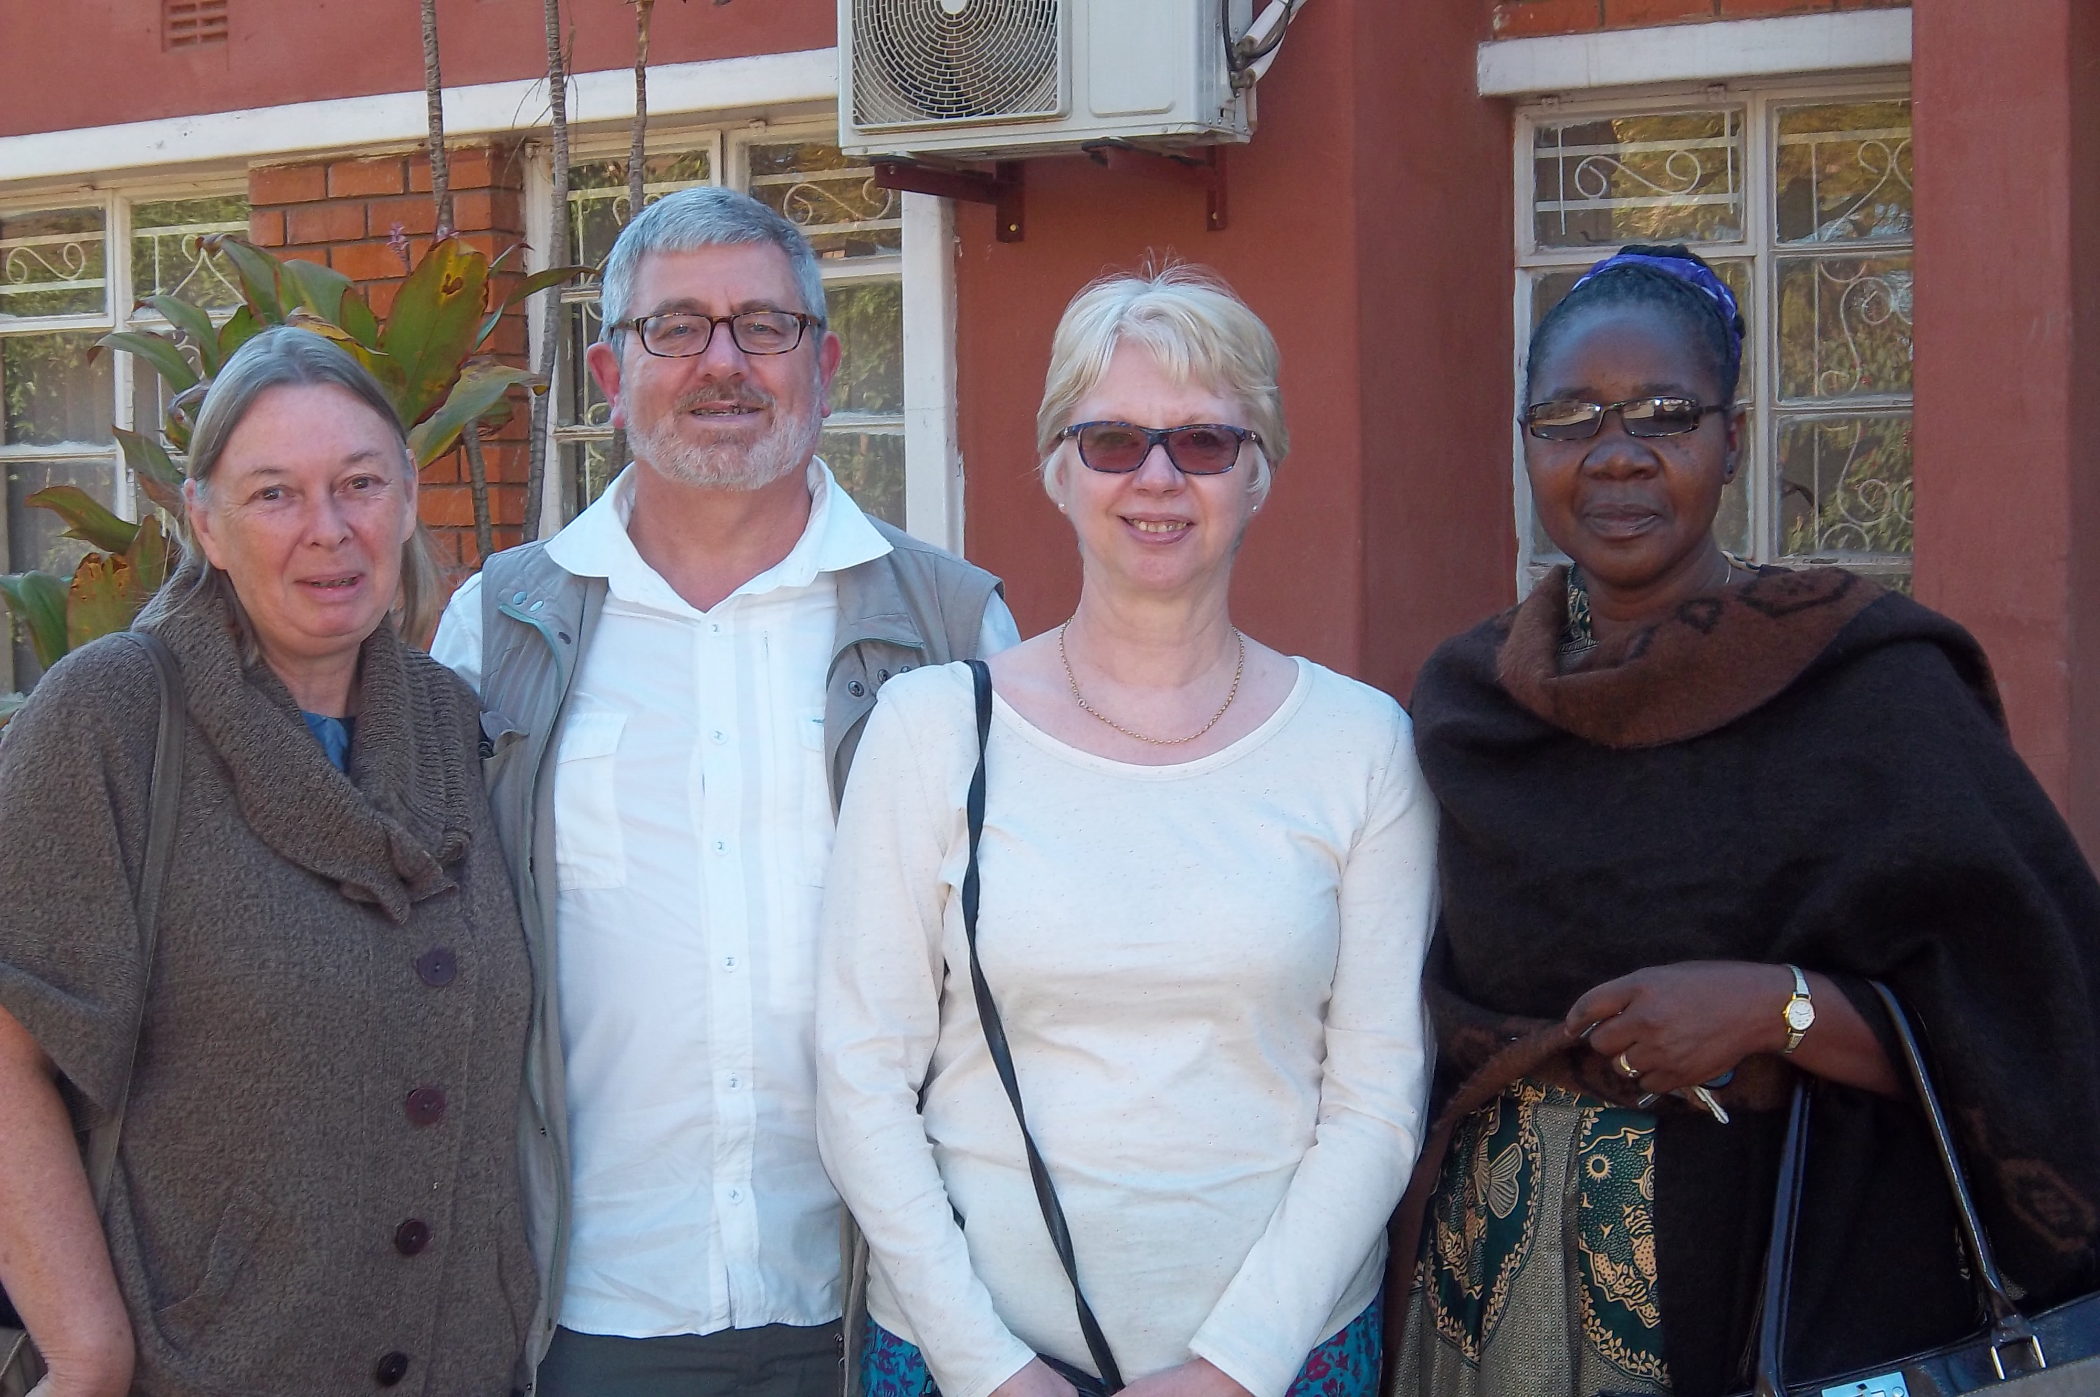
Jenny, Mike, Gill and Peggy at UCZ office

- Visit with Gill & Mike Dascombe to one of UCZ mission initiatives
The United Church of Zambia has various self help projects spread all over the ten provinces of Zambia. The projects are managed by participants and supported by UCZ Community Development department. The self-help group we visited near Lusaka had 12 widows as group members and they have been working together for up to five years. Over the years, birds and pigs were raised as well as maize for sale and home consumption. Generated income has helped pay school fees, provided meals, improved living standard such as purchasing pipes for pipe-borne water. The women testified of increased confidence, happier disposition plus being empowered to ask local government officials about their entitlements. The group has been regularly visited by a UCZ deaconess and she offers professional advice on animal husbandry and business management or contact appropriate professional.

- UCZ Kafue Health Centre visit
UCZ has eight nationwide primary health care units – one of which was the Kafue Health Centre located about 60 kilometres from Lusaka. The unit serves 250,000 residents living within a 55 kilometre radius. Staff comprised of three paramedics and six nurses though the laboratory personnel was seconded to serve there by the government. Primary health care is expected to be free therefore Kafue Health Centre delivers maternal and neonatal health care, vaccinations, HIV testing as well as outpatient care such as treatment of malaria, gastroenteritis, tuberculosis etc. Midwives conduct routine clinical tests, manage 2-3 maternal births daily, offer family planning, plus health and nutritional information. This health centre also serves 740 boys boarding at Kafue Boys School nearby. Once a month the UCZ HIV mobile clinic visits Kafue Health Centre and its surroundings and support people infected and or affected by HIV/ AIDs (reported infection rate was 17 – 21%). Obtaining ARV and tuberculosis drugs proved challenging and cancer drugs expensive. Gill and Mike being Pharmacists were interested and curious about medication supplies and availability.
There is a district ambulance for emergencies though it covers 155kilometre radius. The free health care service delivery has been beneficial to the surrounding communities though an urgent request was to replace the broken down oxygen unit for the neonatal ward to improve survival rate.

- Kafue Boys Mission School visit
This school started on this site in 1939 by a Primitive Methodist couple from England. It is a highly reputable boarding school for boys offering both junior and senior schools. There were 740 boarders plus 40 staff living on site. The first church building constructed in the 1940s still stands strong though now in need for expansion due to increased student numbers above 400 boys. Every fortnight there is school assembly and on Sunday mornings the boys meet between 7.30 am – 8.30 am releasing it for the community as from 9.00am. The school offers science, art, commerce and vocational training to its students and has one of the highest success rates nationally. During my visit the Principal mentioned that the new school curriculum included ICT as compulsory subject therefore proficient ICT teachers willingly to teach the boys for short or long periods are welcome. We seized the opportunity to see the new deep fryer purchased by UCZ for the school to relieve the boys from spending time collecting woods for the kitchen; the kitchen staff were very appreciative.

Gill, Mike and I later met with Peggy to discuss partnership issues before proceeding to Mwandi with our mission partners -Keith & Ida Waddell. I went on to have a meet with Rev Kangwa Mabuluki – Principal of the Theological Education by Extension Zambia to discuss ongoing partnerships as well as the Pan African TEE roundtable with partners planned for Ethiopia later in the year.
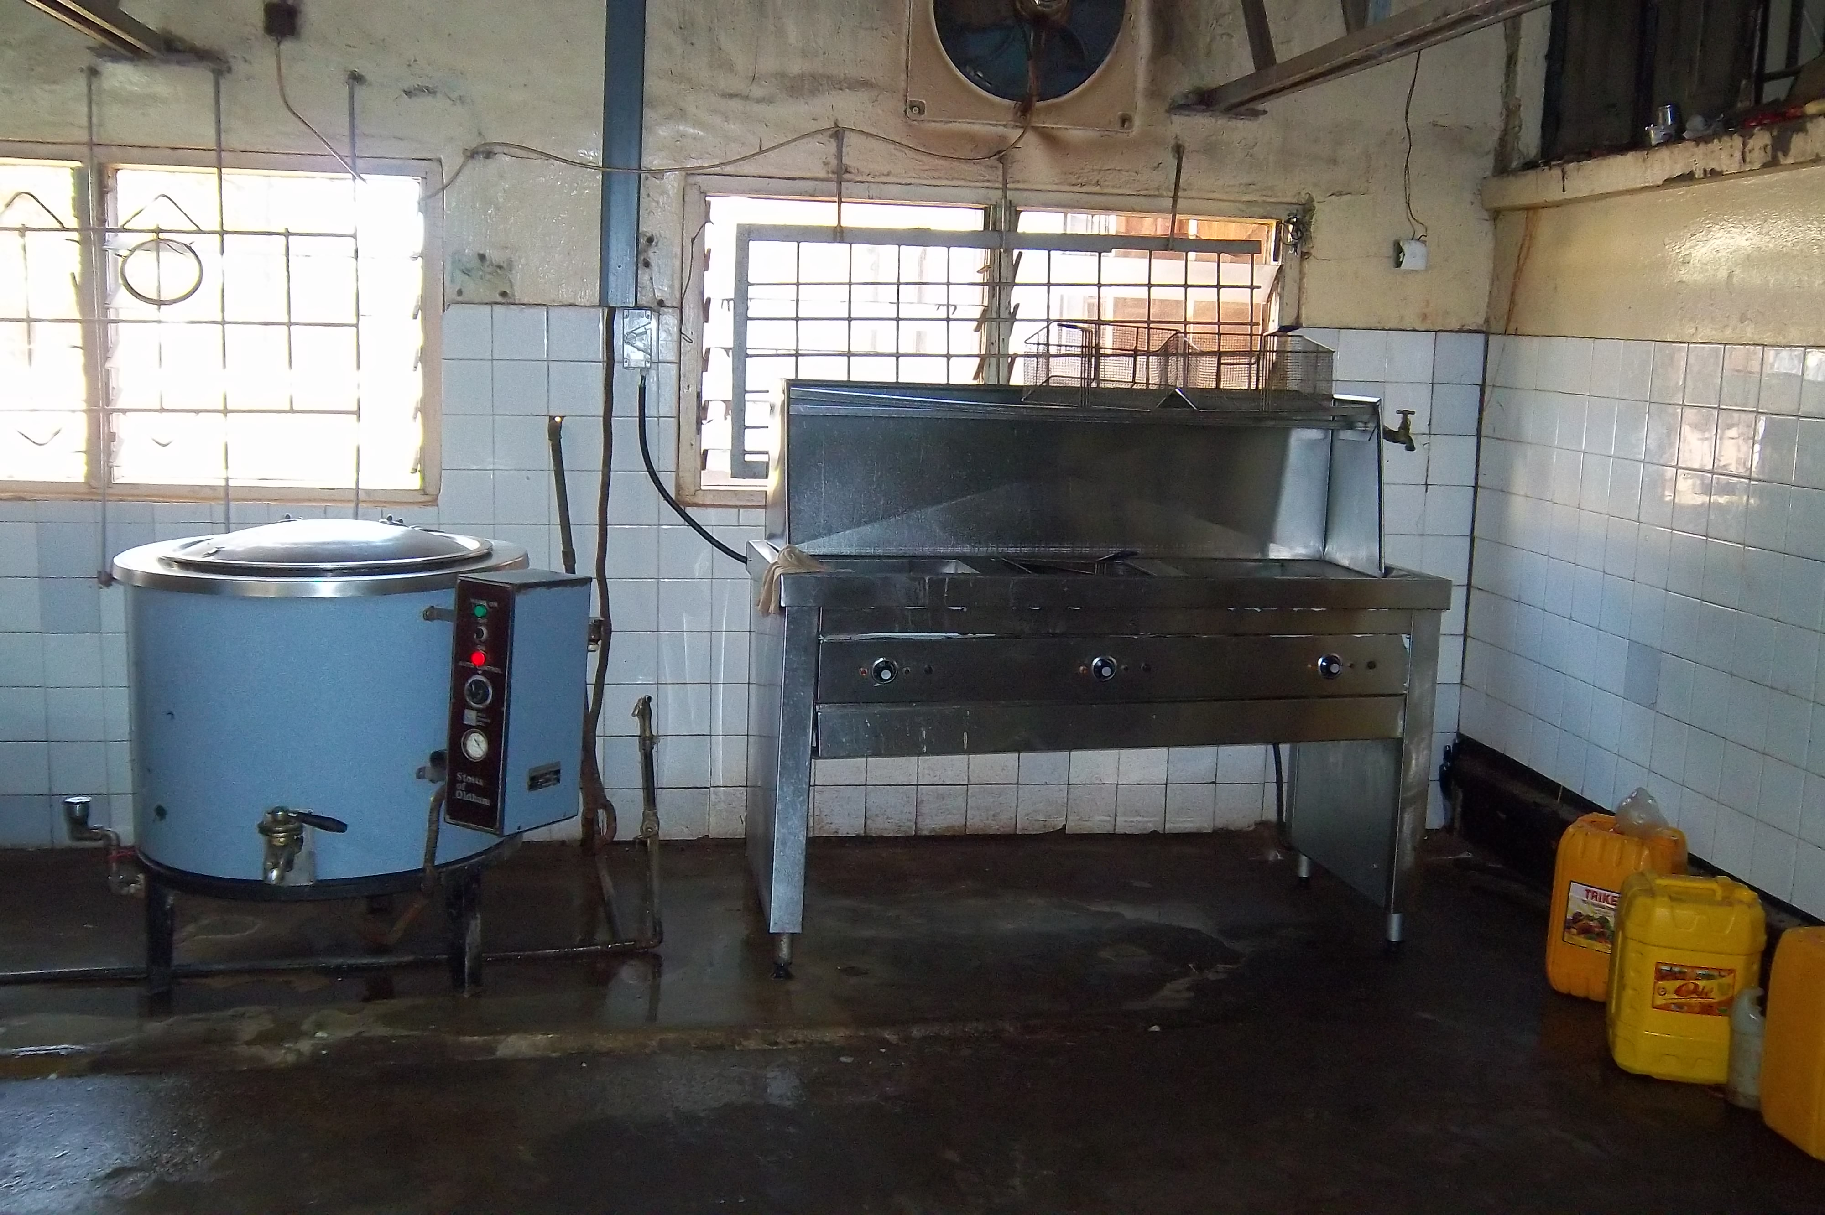
New school’s fryer bought by UCZ

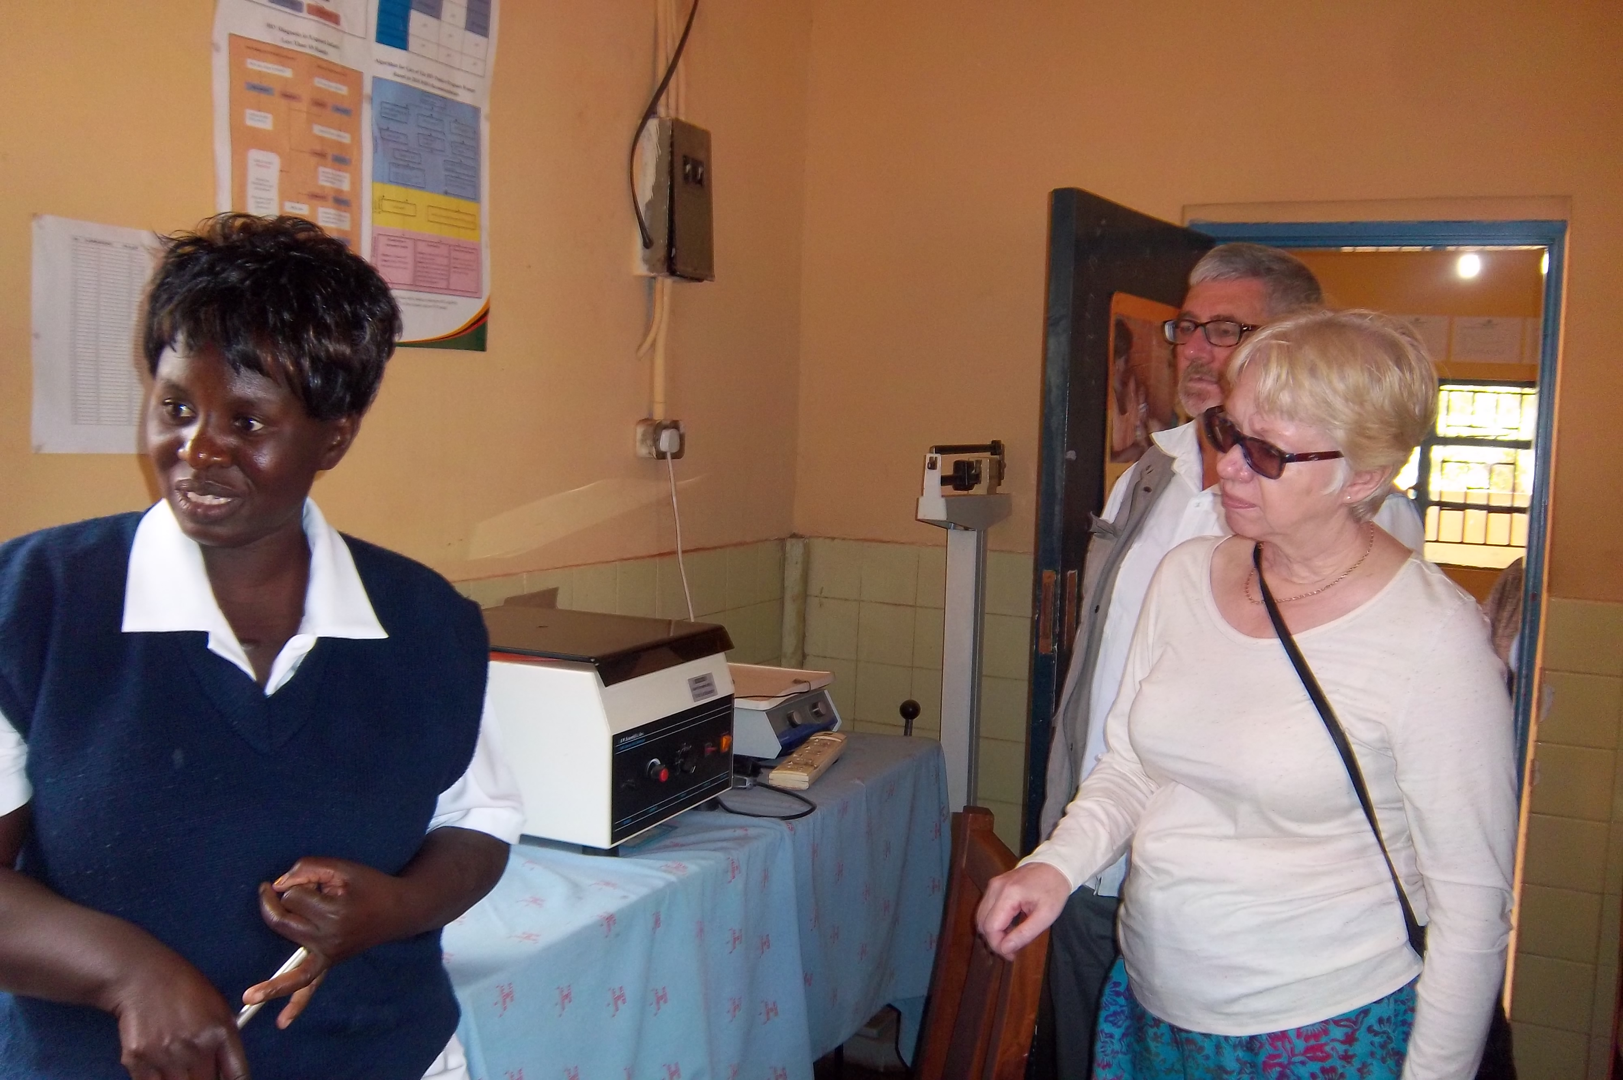
At Kafue Health Centre, Zambia

Mission Partner visit at Chodort Training Centre, Choma
I arrived in Choma after five hours drive with Jenny from Lusaka. The next day we worshiped at a local United Church of Zambia service and we met with the Consistory’s Bishop. Jenny’s contribution since becoming the Principal of the Training Centre was commended and further progress has been made with a class room block and residential properties built by the help of their German partner. The project aims to promote self-reliance by using proceeds for staff salary along with increasing the number of vocational modules delivered at the training centre for school dropouts.

Jenny and I visited Rev Silwenga – one of the UCZ ministers that leads a growing and vibrant church. There were two Sunday services plus other mid-week services. He spoke of how the church was growing and supporting 150 orphans, the elderly and the vulnerable in its community. The wife is a deaconess and has progressed in her career by obtaining an additional qualification in Community Development. She serves at the church and works as a regional social worker. She raised the concern about the under-utilization of deacons and highlighted the need for UCZ to review its whole syllabus so it could be recognised by the government.

Jenny was a qualified Social Worker in the UK for 20 years and taught as well as developed a curriculum for Deacons training at UCZ Theological College at Kitwe for six years before she became Chodort Principal. She has submitted the proposal to teach a Diploma course in Social Work at Chodort Training Centre for UCZ Synod’s consideration.
UCZ is keen to liaise with MCB diaconal order on this issue.

Chodort’s vision as a training centre
Jenny works with 19 Chodort staff. Fees accrued from students are insufficient to run the school yet the students are in dire need to acquire new skills because they were unable to continue in mainstream education. The courses include carpentry, tailoring, masonry, joinery, ICT skills and catering. Following suggestions from staff and ex-students, Chodort is now considering offering a Diploma course in Social Work with Christian Ethics. This should increase intake particularly since demand for ICT skills is now reducing.
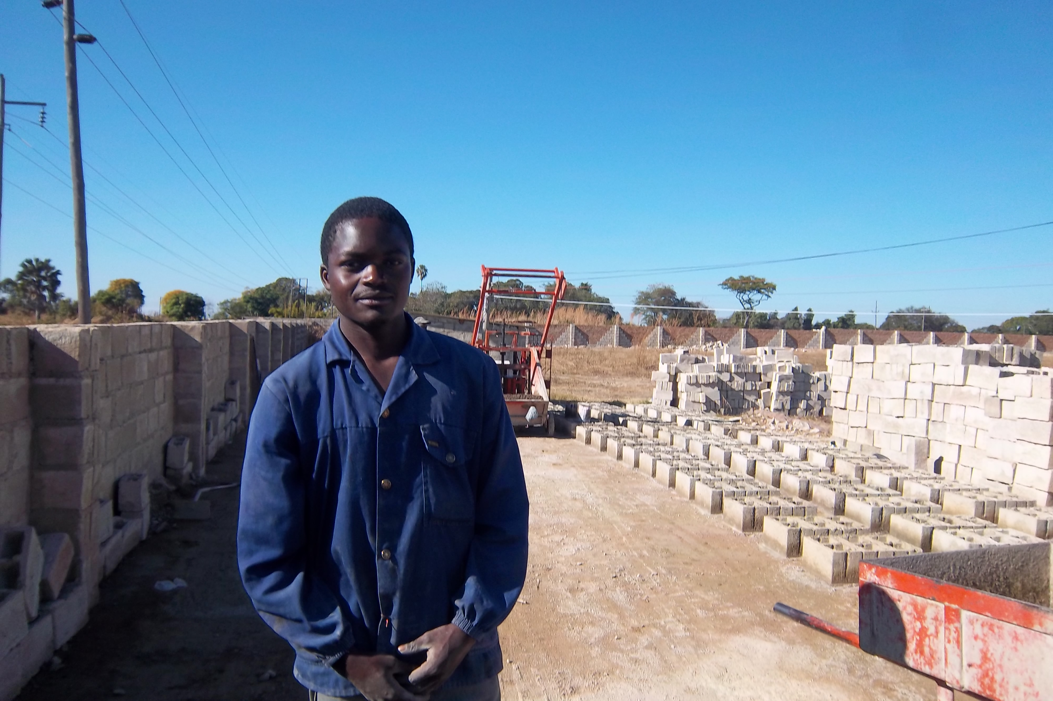
Student on the construction site in Choma
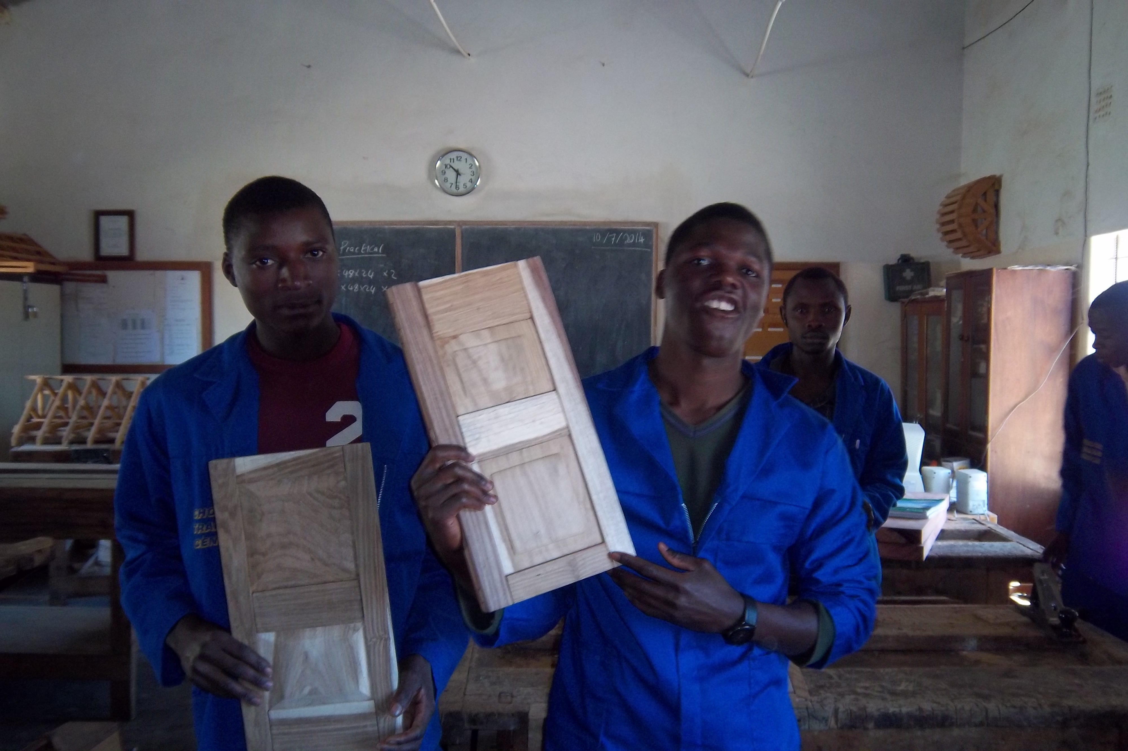
Carpentry students at UCZ Chodort training Centre

Chodort training centre was constructing few residential houses to provide employment and offer masonry skills to youths. The finished properties are to help generate funds especially to pay the minimum wages required by law plus other initiatives. Chodort is still seeking support from partners as part of its 50thanniversary celebration so as to leave a mission legacy for the upcoming generation that transforms lives and serves the community.

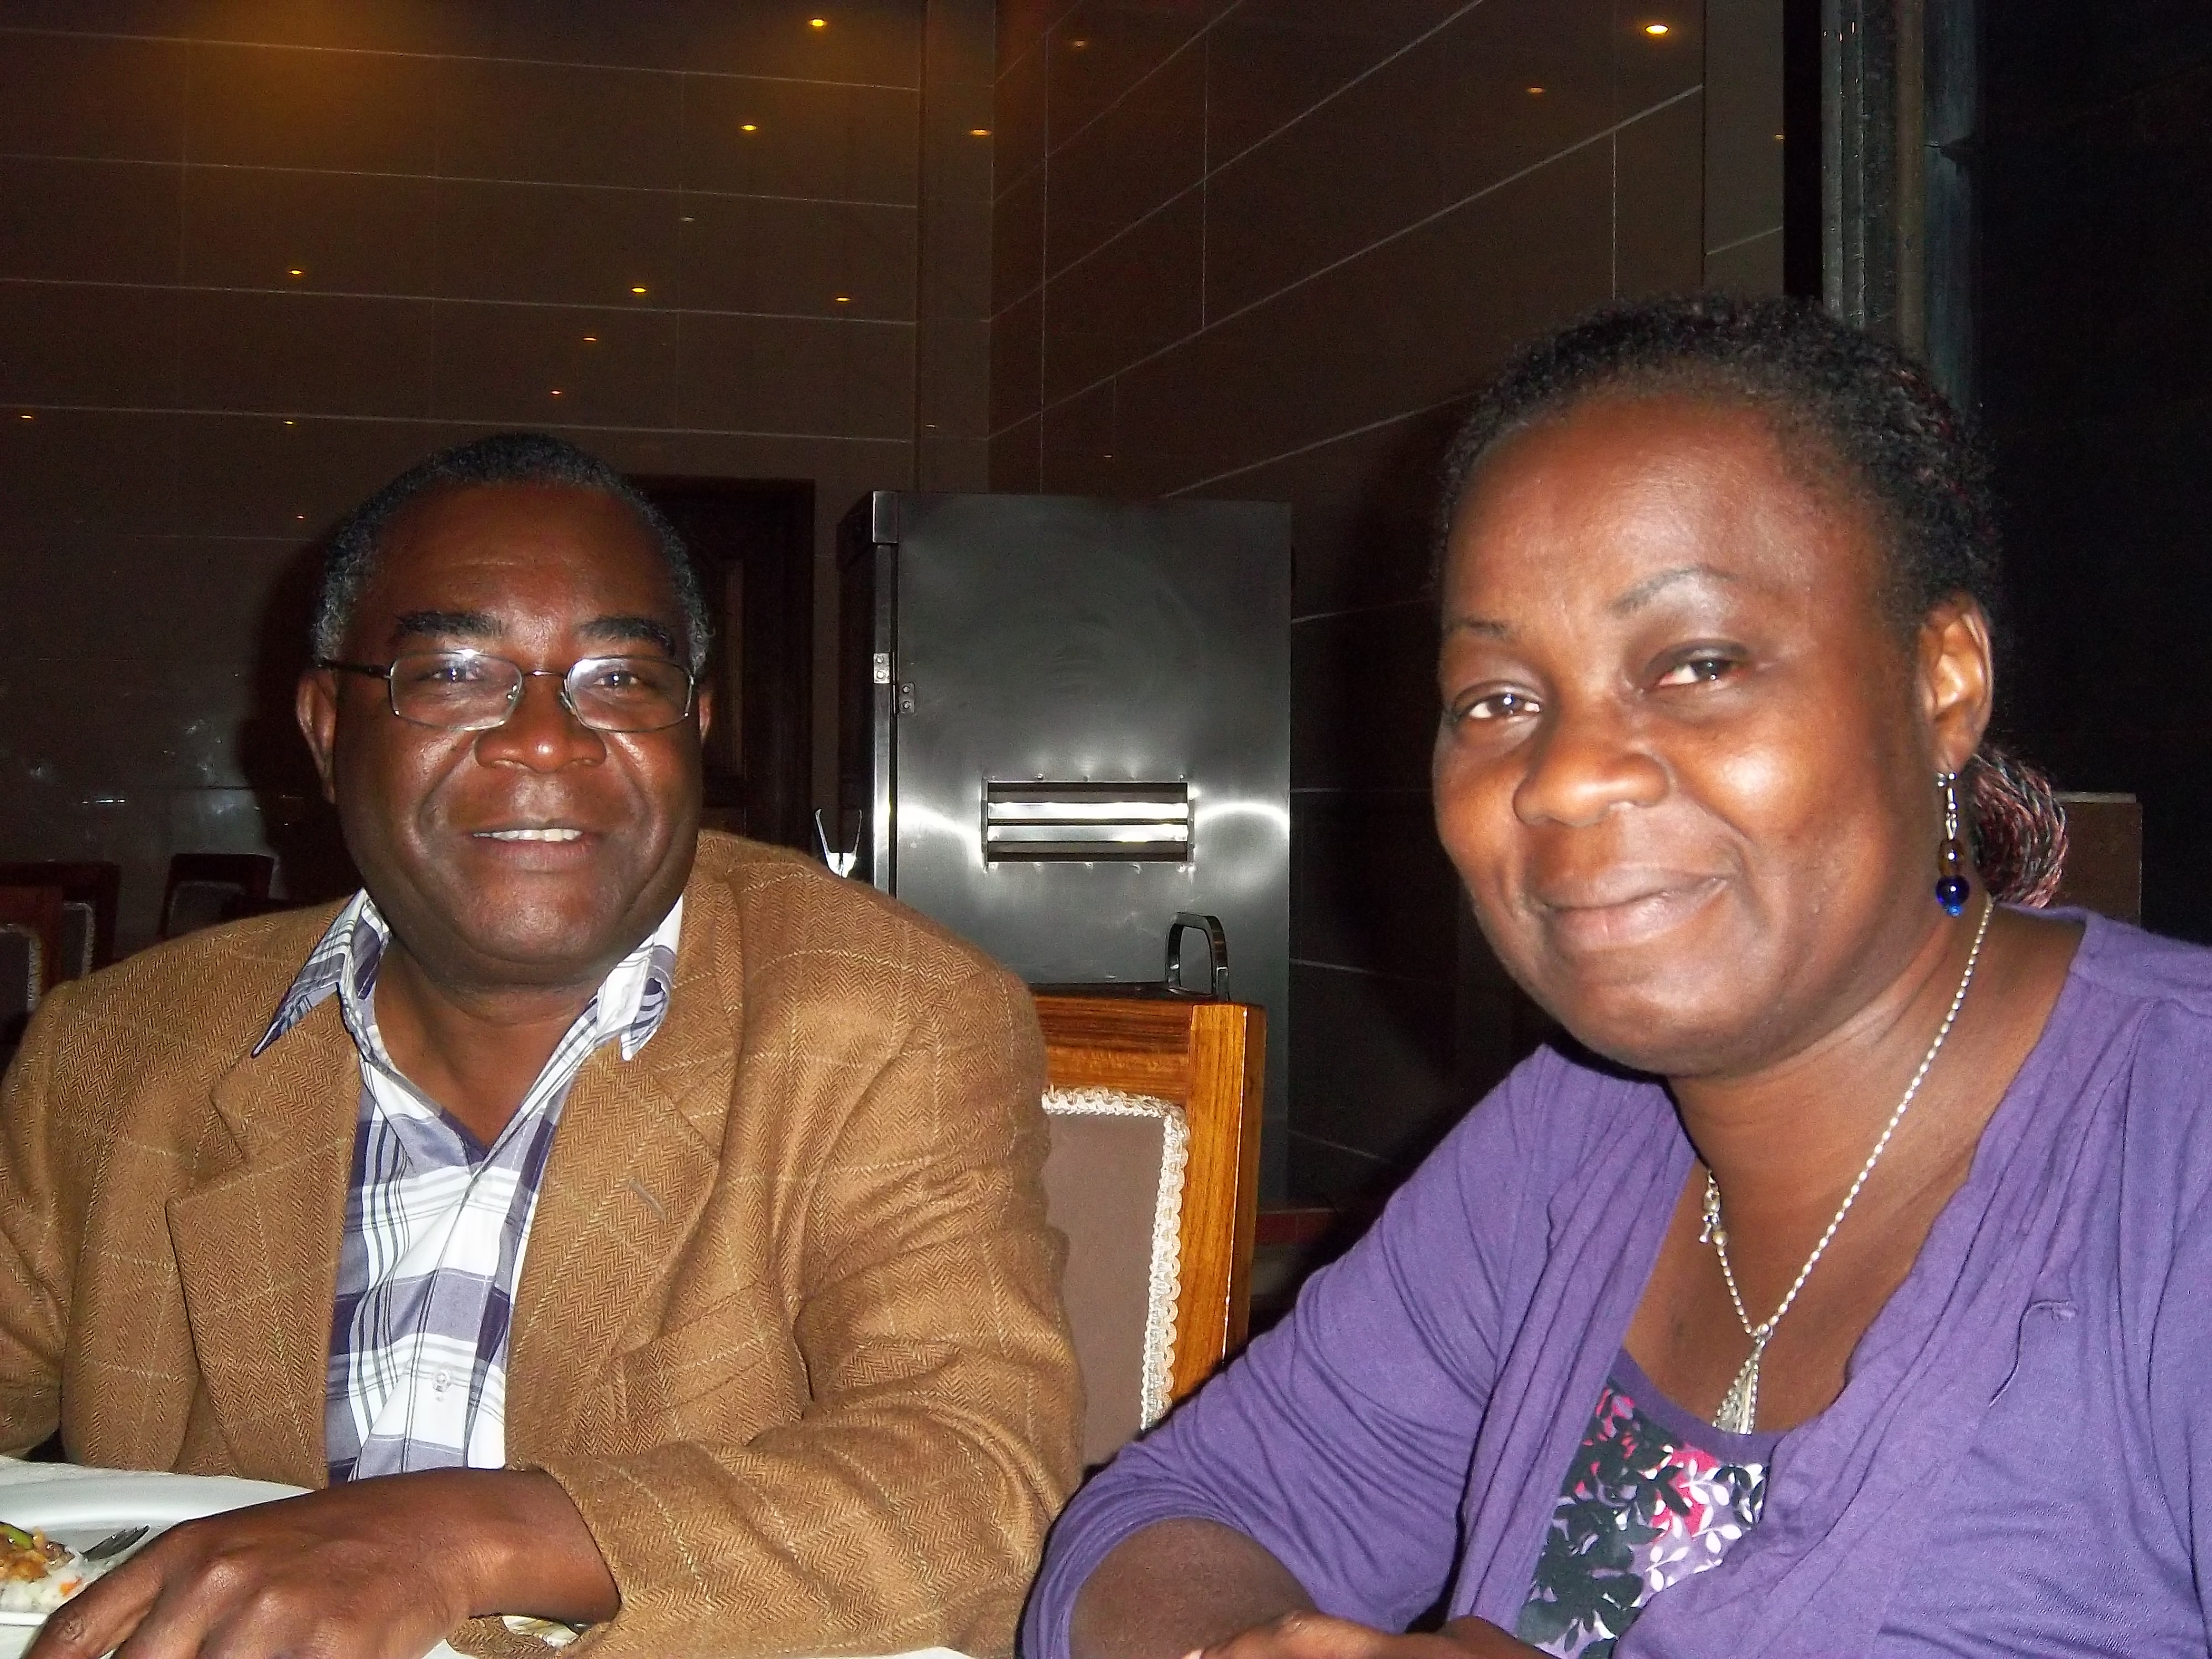
Rev Mabuluki- Principal of TEE Zambia with Bunmi

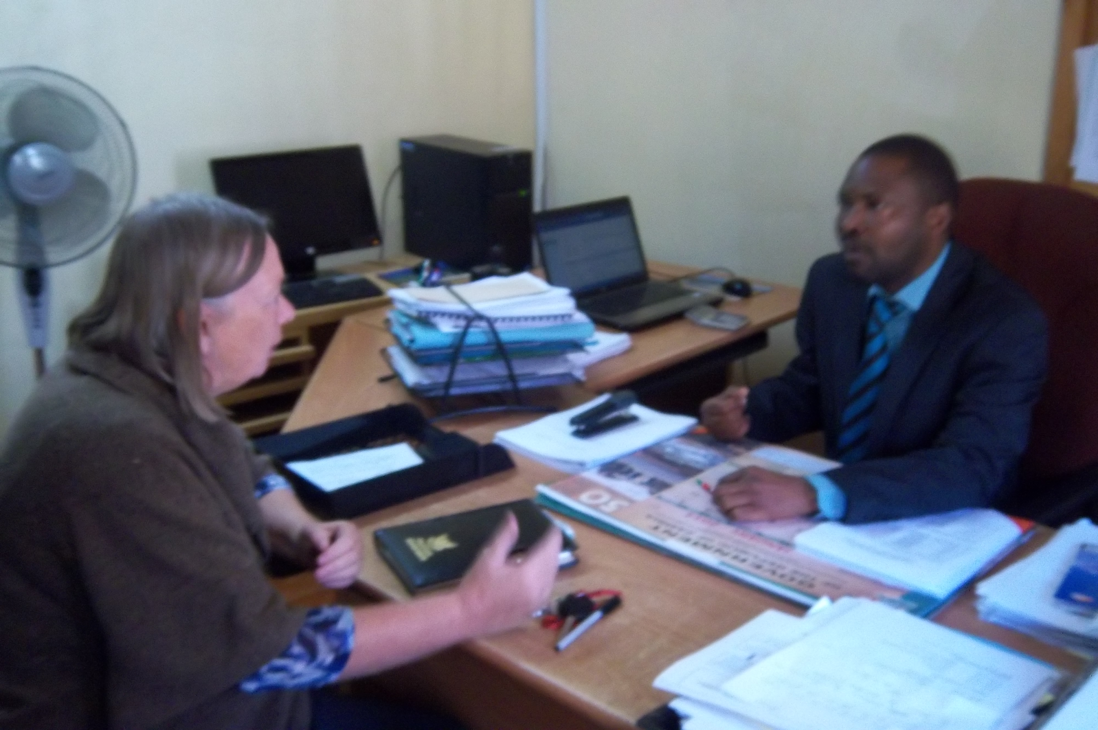
Jenny with Innocent Kangwa - UCZ Internal Auditor (NMA grant recipient)

I had to the opportunity to meet with UCZ’s Internal Auditor – a beneficiary of the Nationals In Mission Appointment grant. As a chartered accountant, he works closely with UCZ Synod office to offer advice of budget issues, funding capital projects, assessing income generation opportunities and reviewing departmental finance operations. He is on several UCZ boards for schools, health, colleges etc. Jenny has approach him for his professional advice on running Chodort Training Centre by adopting a viable financial model to pay staff minimum wage and stay in profit whilst training students. UCZ was very grateful for his services because he has brought significant positive contributions to the synod and promotes accountability and transparency in UCZ’s dealings.

1 Corinthians 10²²⁻²⁴: Everything is permissible but not everything is beneficial. Everything is permissible but not everything is constructive. No one should seek his or her own good but the good of others.
R 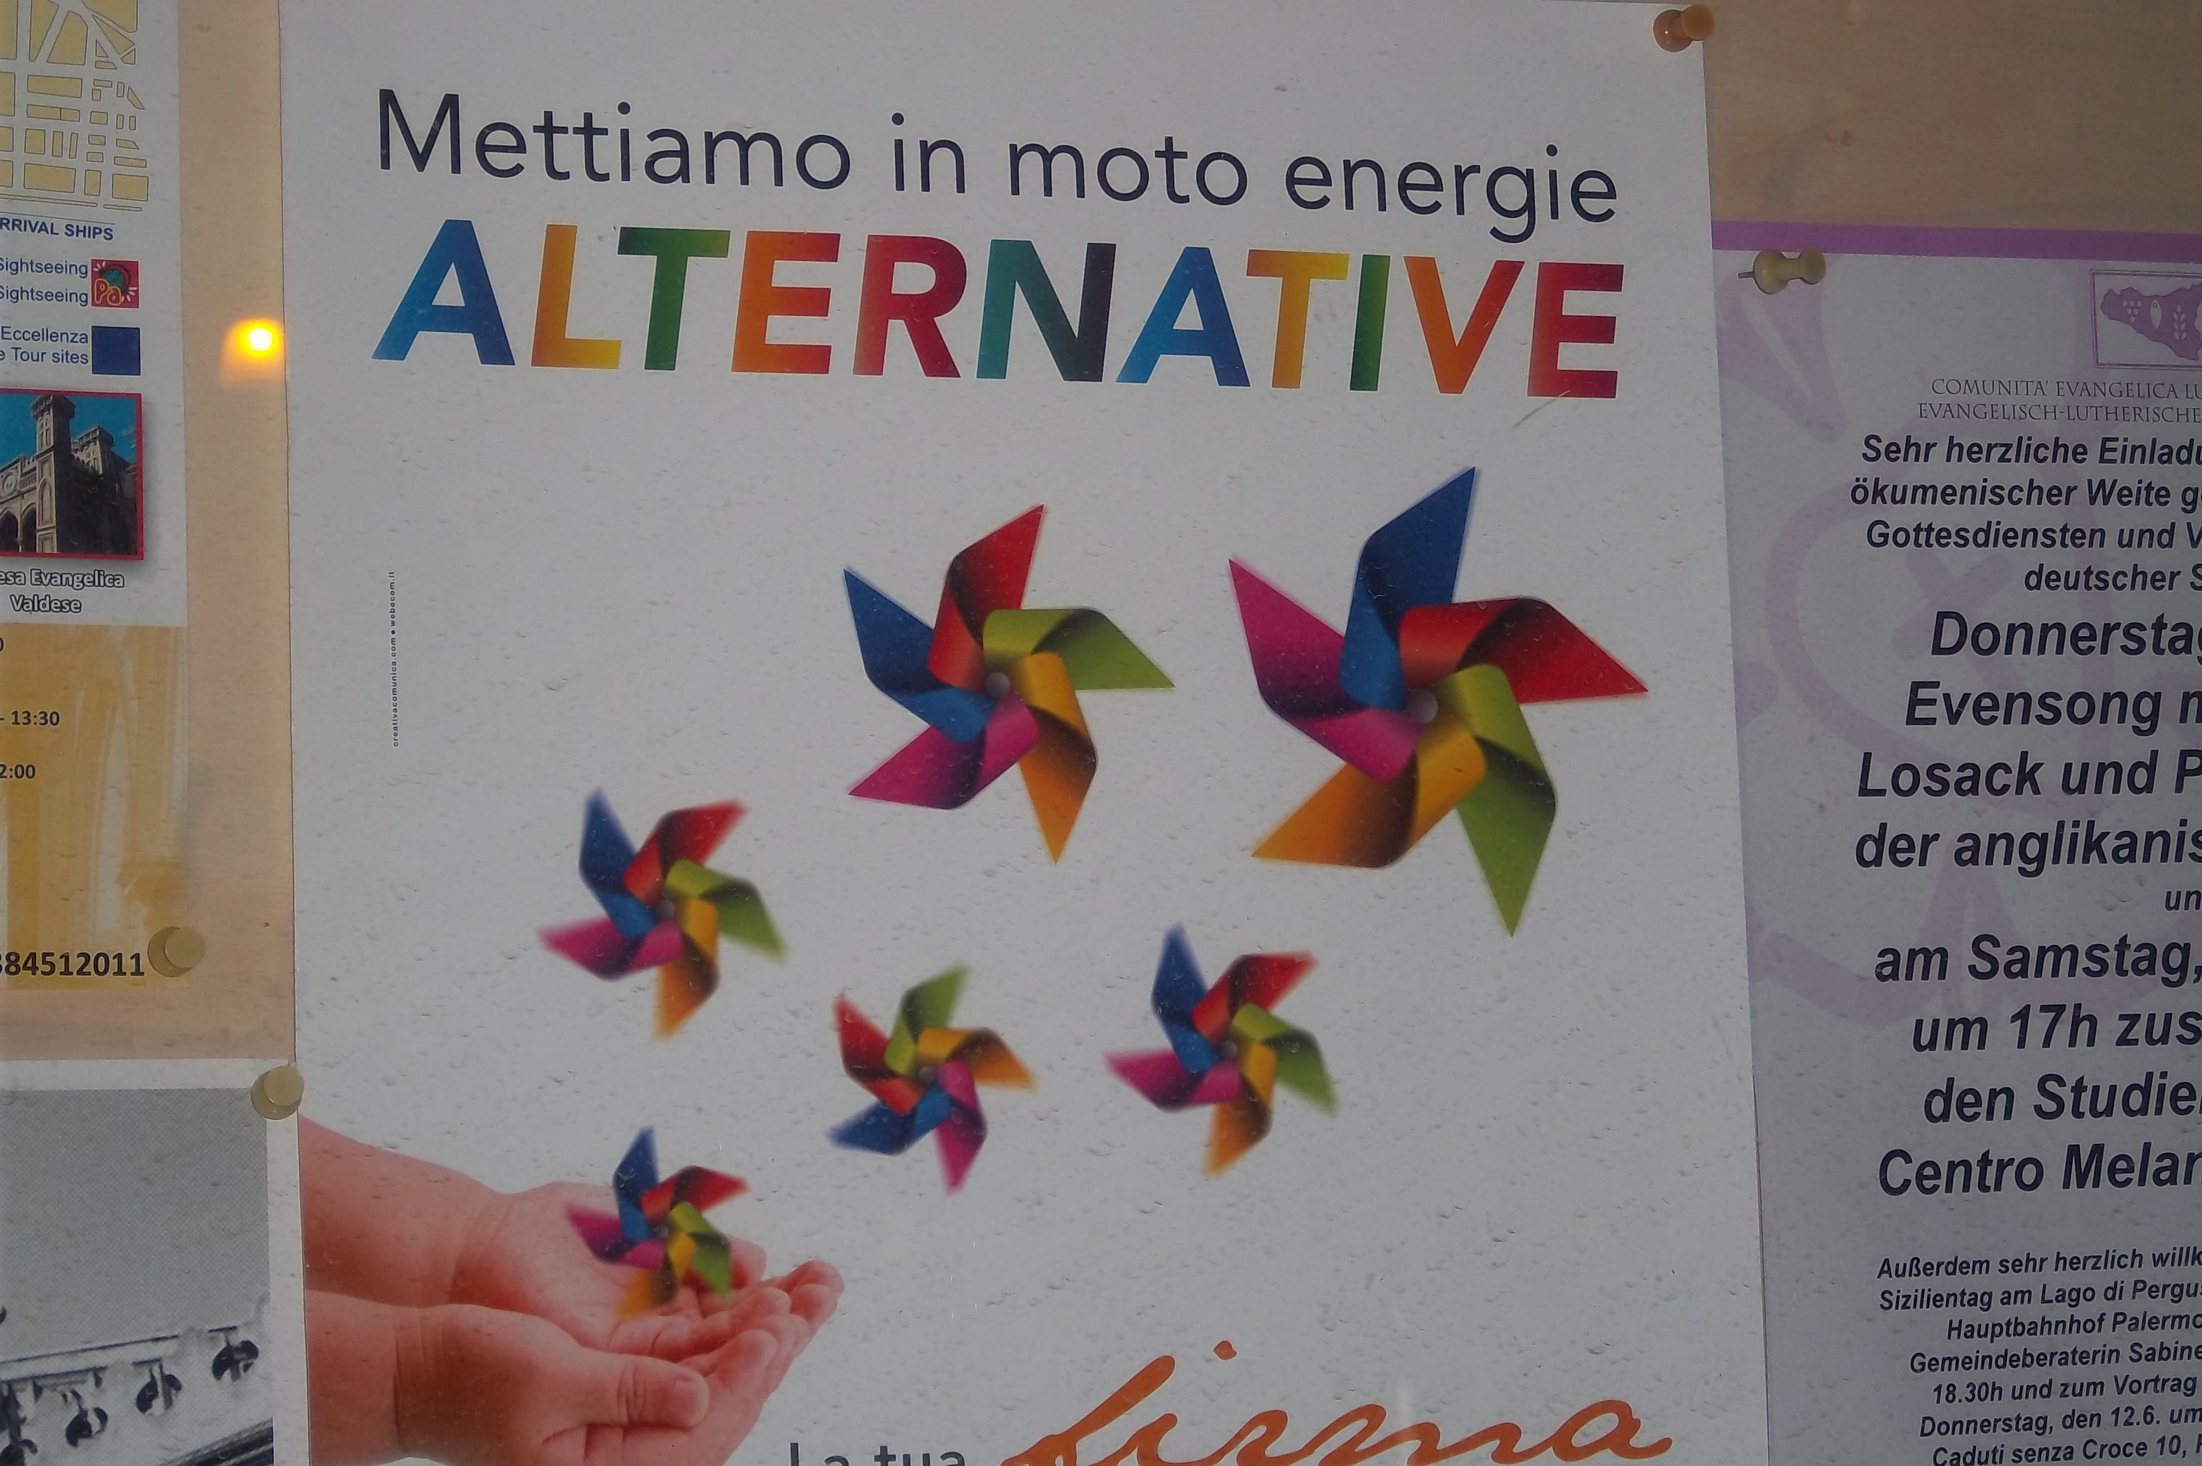

Promoting alternatives to human trafficking

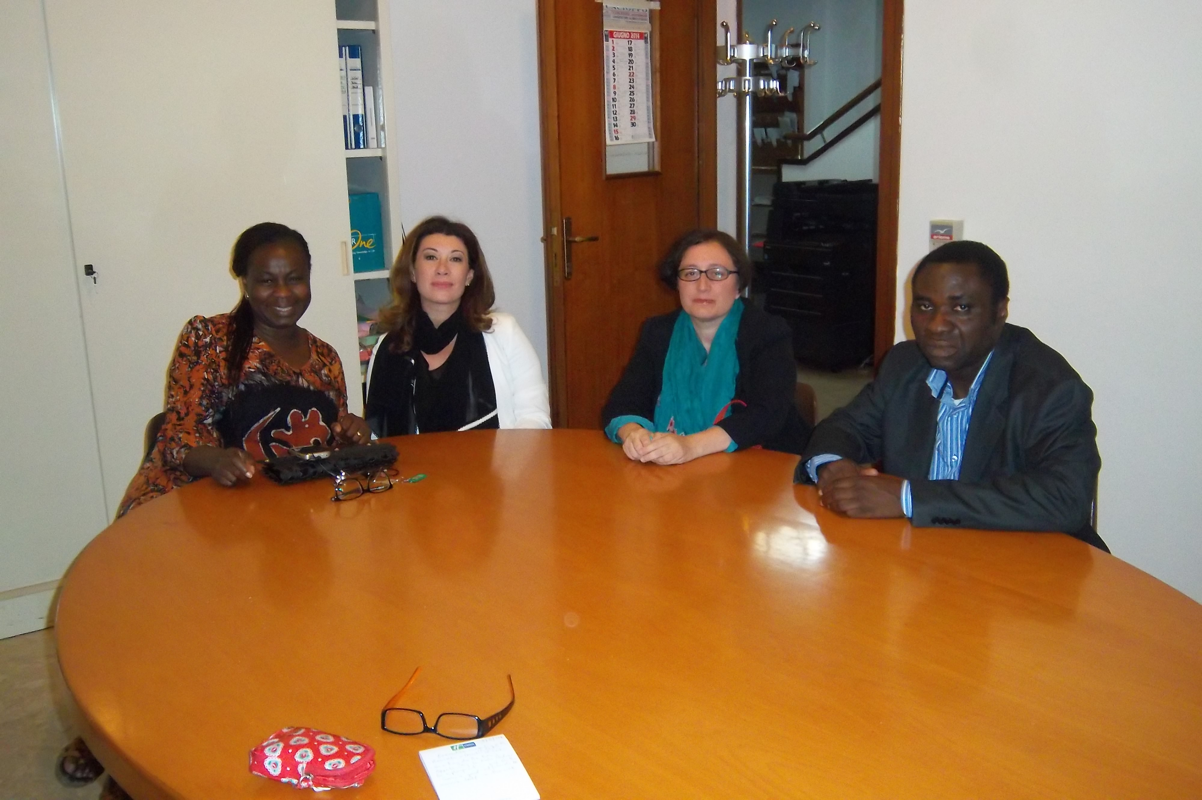

Pilgrims of the Earth executive members

Dr Bunmi Olayisade
Africa Partnership Coordinator
July 2014

