**2016 Sunday Prayer Worship for**

**the Peace and Reunification of the Korean Peninsula**

Together with the Churches of the World

**KOREA:**

**TOWARDS UNITY IN THE BOND OF PEACE**

“***Make every effort to keep the unity of the Spirit through the bond of peace”***

(Ephesians 4:3)



Sunday, August 14th, 2016

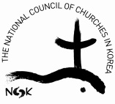

**National Council of Churches in Korea**

**Reconciliation and Reunification Committee**

|  |
| --- |
| **Theme/ Lectionary**  KOREA: TOWARDS UNITY INTHE BOND OF PEACE  “*Make every effort to keep the unity of the Spirit through the bond of peace”*  (Ephesians 4:3) |

**Goals**

|  |  |
| --- | --- |
| 1. To pray, with all the churches of the world, for the reconciliation and healing of the divided Korean peninsula 2. To overcome the South/North antagonism and conflict by opening an interaction between North and South 3. To foster an environment which will see peaceful reunification of the Korean peninsula by concluding a Peace Treaty 4. To create a spirit of cooperation and solidarity among the churches of the world who pray for peace and reunification of the Korean Peninsula as well as for peace in the global village |  |

**Background**

|  |  |
| --- | --- |
| 1. August 15 is celebrated as Liberation Day in Korea, the day that signifies Korea’s Liberation from Japanese colonization. 2. In 2013, the WCC 10th General Assembly meeting in Busan, Korea passed a resolution that the churches of the world will annually observe each Sunday prior to August 15as a “Sunday of Prayer for the Peaceful Reunification of the Korean Peninsula.” 3. The Reconciliation and Reunification Committee of the NCCK drafted this liturgy in the hopes that each church could apply it with reference to their own situation. 4. The Joint Community Prayer for the Peaceful Reunification of the Korean Peninsula was prepared by both the NCCK (South) and the Korean Christian Federation (North) together 5. In 2016 the NCCK together with global ecumenical community has embarked on a Korea Peace Treaty campaign which will last until 2018. Korea peace treaty will be a corner stone establishing the permanent peace system in the Korean peninsula. |  |

**2016 Sunday Prayer Worship for**

**the Peaceful Reunification of the Korean Peninsula**

Order of Worship

**Sounding of the Gong** (Praying for the presence of the Trinity God- 3 strikes)

**Call to worship** (Please stand)

*Liturgist:* Holy Spirit, Lord and giver of life: At the beginning of time you gave every

living thing the breath of life.

***Congregation:* Come, Creator Spirit, and renew the whole creation.**

*L:* Holy Spirit, Spirit of unity, reconcile your people. Give us wisdom. Give us grace. Give us a vision of your breadth and length and height to challenge our

stubbornness and bring us humbly together.

***C:* Come, Holy Spirit, reconcile us.**

*L:* Holy Spirit, Spirit of peace: You break down barriers of language, race and culture,

and heal the divisions that separate us.

***C:* Come, reconciling Spirit, and unite us all in the love of Christ.**

*L:* Holy Spirit, transform us and sanctify us as we take up our cross in your name.

Give us the gifts we need to be your servants in spirit and truth.

***C:* Come, Holy Spirit. Come into us.**

**Opening Hymn -** Come Now, O Prince of Peace

**

*L:* God, who calls us to peace and reunification! May the will of God be accomplished

on this earth, your justice established, and may this divided Korean peninsula

become one!

***C:* God of the Holy Trinity, please be with us.**

(Please be seated)

**Confession of Sin**

L: Love and faithfulness meet together; righteousness and peace kiss each other. (Psalm 85:10)

Lord, you are our peace, you speak to us of peace with justice.

But we have stood silent as mute witness to injustice and abuse of the rights and   
dignity of people around us. Forgive us our silence and our reluctance. O God,

***C:* Have mercy on us.**

*L: Peace I leave with you. My Peace I give you*.(John 14:27)

Lord, we lament that we, your children, who have learnt from your life the values

of truth, love, compassion and forgiveness, have not been true ambassadors of

reconciliation and peace. We have not raised our voices against armed conflicts

that seek to avenge historic injustices and disputes; nor have we protested

against huge amounts spent on militarization and nuclearization, or raised an

alarm at the increase in the availability of small arms and light weapons that add

to senseless killing and violence. Teach us, Lord, to be your peace in a broken

world of hatred and selfish greed. O God,

***C*: Have mercy on us.**

L: Have unity of mind, sympathy, love, a tender heart, and a humble mind(1 Peter 3:8)

Our hearts are burdened as peace and security in Asia has persisted as a major

concern for several decades. Peace talks and negotiations in many forms and

stages are taking place but many of these peace processes are taking too long to

consolidate and materialize. We place in your care the Korean Peninsula. We join

with our brothers and sisters in Korea, and beseech you for mercy. God help us to,

“purify ourselves, as we are filled with hate, anger and violence, grant us inner

courage to reflect on our true past, face the hidden truth, and reunite with those

who suffered unrighteous death. Give our weak selves the Holy Spirit, let us not

give up our pursuit for forgiveness, reconciliation and unification.” O God,

***C:* Have mercy on us.**

**Assurance of Pardon**

*L:* Christ is our peace; those who are divided he has made one. He has broken down

the barriers of separation by his death and has built us up into one body, with God. To all who repent and believe he has promised reconciliation. So live as people reconciled.

**Response: Halle, Halle, Hallelujah**

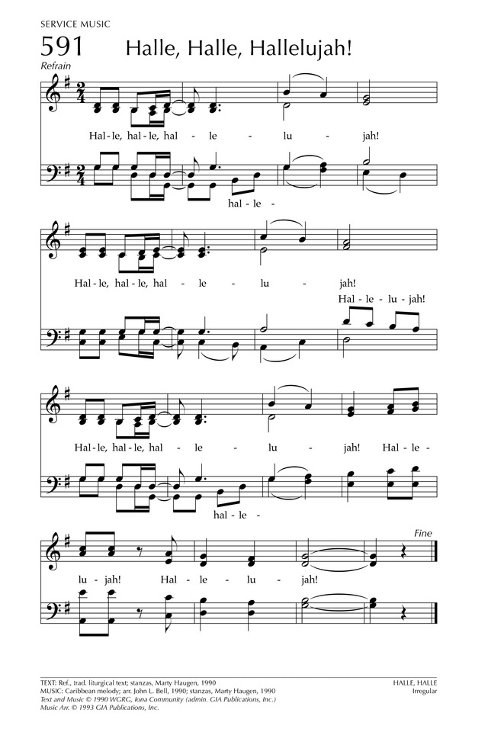

Hearing the Word

**Responsive Reading**

***Psalm 133***

*L:* How good and pleasant it is when brothers live together in unity!

***C:* It is like precious oil poured on the head, running down on the beard, running**

**down on Aaron’s beard, down upon the collar of his robes.**

*L:* It is as if the dew of Hermon were falling on Mount Zion. For there the Lord

bestows his blessing, even life forevermore.

***All:* How good and pleasant it is when brothers live together in unity!**

**Old Testament Reading**

***Ezekiel 37:15 -22***

*The word of the LORD came to me: “Son of man, take a stick of wood and write on it, ‘Belonging to Judah and the Israelites associated with him’ Then take another stick of wood, and write on it, ‘Ephraim’s stick, belonging to Joseph and all the house of Israel associated with him.’ Join them together into one stick so that they will become one in your hand.“ When your countrymen ask you, ‘Won’t you tell us what you mean by this?’ say to them, ‘This is what the Sovereign LORD says: I am going to take the stick of Joseph – which is in Ephraim’s hand – and of the Israelite tribes associated with him, and join it to Judah’s stick, making them a single stick of wood, and they will become one in my hand.’ Hold before their eyes the sticks you have written on and say to them, ‘This is what the Sovereign LORD says: I will take the Israelites out of the nations where they have gone. I will gather them from all around and bring them back into their own land. I will make them one nation in the land, on the mountains of Israel. There will be one king over all of them and they will never again be two nations or be divided into two kingdoms.*

**New Testament Reading**

***Ephesians 4:2 -4***

*Be completely humble and gentle; be patient, bearing with one another in love. Make every effort to keep the unity of the Spirit through the bond of peace. There is one body and one Spirit – just as you were called to one hope when you were called.*

**Sermon - ”Unity in the Bond of Peace”**

Thanksgiving and Response

***2016 Joint Prayer for the peaceful reunification of the Korean Peninsula***

God, ruler of history!

Thank you for letting the churches of the South and the North share the joys of independence with the same longings again this year. The Lord's grace that led us to share this common prayer filled with yearnings from past promises for a peaceful unification is indeed great and amazing. Please accept our earnest desires for you Lord.

Seventy one years ago, our country again found its once lost country and welcomed the joys of independence. Having patiently waited with righteous efforts, we trusted God, the ruler of history, and hoped that the day would one day come. With shouts of victory resonating over the whole of Korea, how can we ever forget that overwhelming day when the triumphs of independence surged up in thirty million souls?

Gracious God!

Such a short-lasting joy, our people came to a dead end of a harsh road filled with division, separation, war and armistice. Through meetings and talks, paths to reconciliation were created and through economic cooperation, dreams of common prosperity were once built. But now, the walls in our hearts have become higher than ever. There is no knowing of the depths of the rivers of mistrust and the valleys of anger that we would have to cross. Lord, take pity on this misfortunate country.

Though the Lord has given the church a responsibility to take care of peace, the people did not serve such command fully. Christians were called to be apostles of peace but instead they have created conflict. As they do not even acknowledge each other as their own people, they do not bother to bear hearts to love. Lord, we confess our wrongs and sins, please forgive us.

God of love and peace!

The distance between the North and South has become unfathomable, but we believe that the day will come when we will need each other. Though our hearts have been ripped to pieces, we realize that it is not far to where we would heal each other's pains and encourage one another. Amongst the tension of the great powers, we are certain that the day will come when we sing songs of self-existence and independence.

Lord, make one this separated country and gather all those families who have been scattered everywhere. Let the children of North and South eat from one bowl, and youths to sing songs for a hopeful humanity from one desk. Let the footsteps of the people's coexistence lead from Hallah to Baek-du and the waves of peaceful co-prosperity surge from Dokdo to the West Sea.

Thus let the people in this safe and peaceful peninsula nourish the happiness that should be granted to all the seventy million people. And from that oneness, let the people serve all over the world with greater vigor and spirit. We pray in Jesus' name.

August 15, 2016

National Council of Churches in Korea Korean Christian Federation

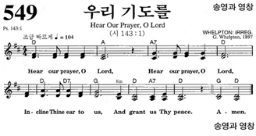**Response to Prayer - Hear Our Prayer, O Lord**

**Offering**

**Offering Hymn - I Am Thine, O Lord**

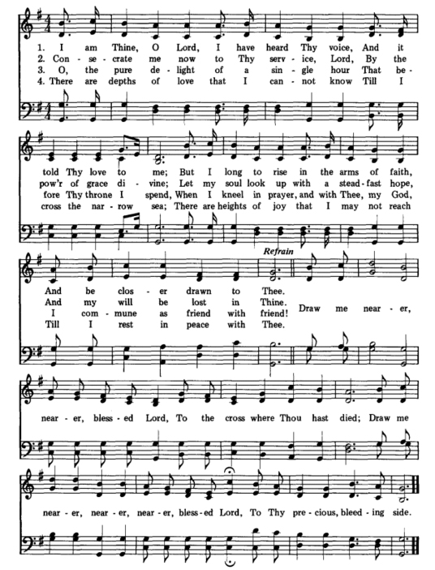

Sending to the World

**Sharing of Peace**

L: We need new life, new hope, and new vision to rebuild the community of

reconciliation and peace, and to regain our unity in the bond of peace. The LORD

says, “Peace I leave with you, my peace I give to you; Not as the world gives do I

give to you.” The Peace of the Lord be always with You.

***C:* And also with you.**

All: Let us as we depart share with one another a sign of reconciliation and peace.

(Everyone exchanges the sign of peace according to one’s own custom.)

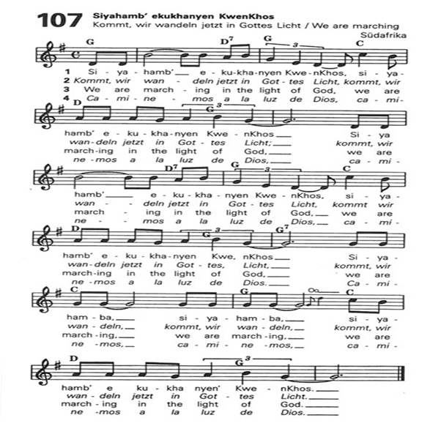**Closing Hymn - We are marching in the light of God**

**Blessing (unison)**

All: May the Christ who walks on wounded feet walk with you on the road. May the

Christ who serves with wounded hands stretch out your hands to serve. May the

Christ who loves with a wounded heart open your heart to reconcile and love

overcoming division. May the Christ who heals the wounded nation bring you

together to unite. Amen.

**\*This worship resource is based on the 2016 Asia Sunday liturgy**

**produced by the Christian Conference of Asia.**

|  |
| --- |
| Concluding note from NCCK to our partners:  If you have used this service, we thank you. Please send a brief note to Christie at christiecatherine4@gmail.com so that we will have a record. In addition, if you would like to give any suggestions for improvement, NCCK would very much like to hear them. |