Tu’a ‘Ofa ‘atu
Report of World Church Visit to Tonga – June-July 2017
The Rev Dr Adrian Burdon
Superintendent Minister of the South Fylde Circuit
It was Wesley Day, 24May 2000, that Janet and I took our leave of Tonga after over seven years of working as mission partners with the Free Wesleyan Church of Tonga. I had been Principal of Sia’atoutai Theological College, Janet had been Head of Economics at Queen Sālote College for Girls. As our transport pulled away from the college a Police car screeched to a halt in front of us and out leaped one of the Queen’s Ladies with a last-minute gift. At Fua’amotu Airport we were bidden farewell by every one of the two hundred theological students and friends who had followed us on our final journey.
I realised, of course, that my return seventeen years later was never going to pass unnoticed. I had not expected what happened though. Making my way down the aircraft steps into the sunshine and onto the tarmac I was suddenly aware that I had been joined by an airport official who was gently steering me away from the crowd of fellow travellers with the bidding to come follow him through a ‘special door’. Finding myself in the VIP entrance, being greeted by the Rev Dr ‘Ahio. President of the Free Wesley Church and former colleague, I was relieved of my passport and given a cup of coffee. Sometime later, my passport was returned, all formalities having been completed on my behalf, my luggage had been claimed and I was invited to make my way with the President of the church away from the airport and into town. It was to be made clear to me on number of occasions over the next two weeks that I was not just a visitor, but I was a member of the family who had come back home.
The purpose of my being in Tonga was to attend the 94th annual Conference of the Free Wesleyan Church of Tonga as representative of the Methodist Church in Britain. The Conference was to take place on the distant island of Vava’u a few days after my arrival and so my first few days were spent reacquainting myself with the main island of Tongatapu and meeting again with old friends. It was a joy to visit Sia’atoutai Theological College, meet staff who were my colleagues and some who had been my students. On Sunday morning I joined the college staff to lead worship at Centenary Church in Nuku’alofa, I being given the task of preaching the sermon – in Tongan of course. To my right sat His Majesty King Tupou VI who, after the service, was very gracious about my use of very rusty Tongan language!
As if the 32 hours of flying from Manchester to Tongatapu were not enough, a further hour’s flight was required to get me to the location of the Conference. The roll call of those present revealed that the Conference delegates numbered almost 800 people from within Tonga, and from New Zealand, Australia and the United States. A further 1200 people accompanied these delegates as members of choirs and church groups who were also present for the Conference. 2000 people had descended upon the usual population of Vava’u and the miracle of hospitality ensured that all were housed and fed for the length of the Conference. One of the major issues to be discussed at the Conference centred upon the decline in attendance and participation in the church of young people. There were the usual financial reports and opportunities for mutual encouragement of the various groups from across the Pacific.
The highlight for me came on Sunday afternoon when I was privileged to preach at the Conference service at which thirteen new ministers were ordained. The greatest joy was that four of them had been my students seventeen years previously.
There have been some significant changes in the country in seventeen years. The nation is now a democracy, with open and free elections, instead of the benign feudal system that it had previously been. It was interesting to see how that was working. Maybe the only country to make that transition bloodlessly and by deliberate determination in recent years, the government and people of Tonga are still getting to grips with the demands of democratic government. There are new health-drives and people are being encouraged to eat more healthily, to do more exercise and to stop smoking. There is concern for how the internet and modern technology might interfere with the maintenance of the otherwise very traditional society and yet the positive benefits of such technology are to be welcomed.
It was great joy to be back in Tonga after seventeen years. It was a great delight to find that many of the senior leaders in the church were my former students. The greatest joy was meeting those who had been students and who, according to their culture, had been deferential and distant when we lived amongst them, but who were now able to greet me and stand alongside me as a brother in Christ.
And their message to the Methodist Church in Britain?
Tu’a ‘Ofa ‘Atu – we extend our loving greetings to you.

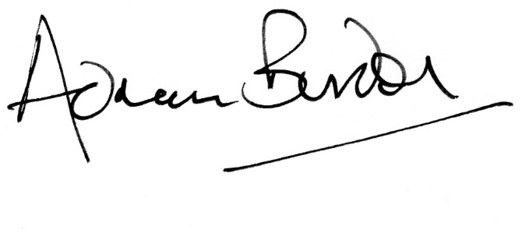

The View from the Pulpit of Centenary Church, Nuku’alofa
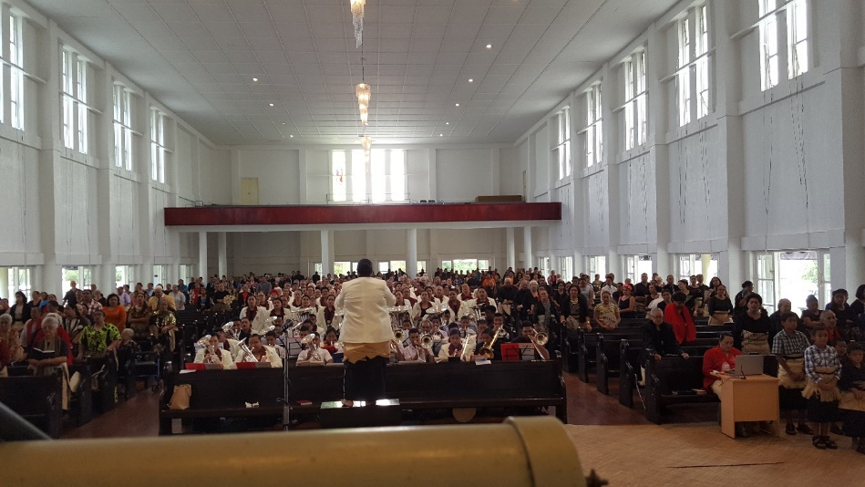

Outside our former home – the Principal’s resident at Sia’atoutai Theological College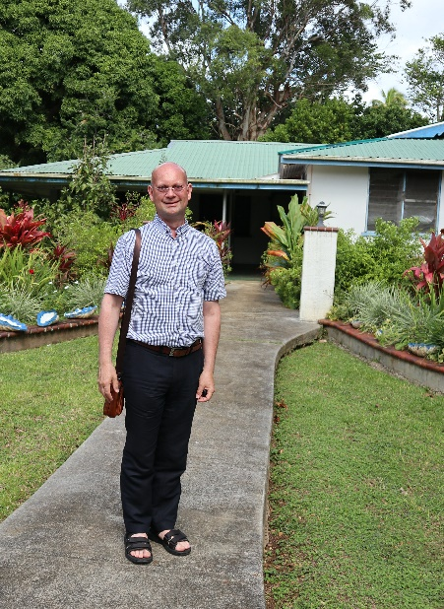
Students from Sia’atoutai Theological College at the Ordination Service
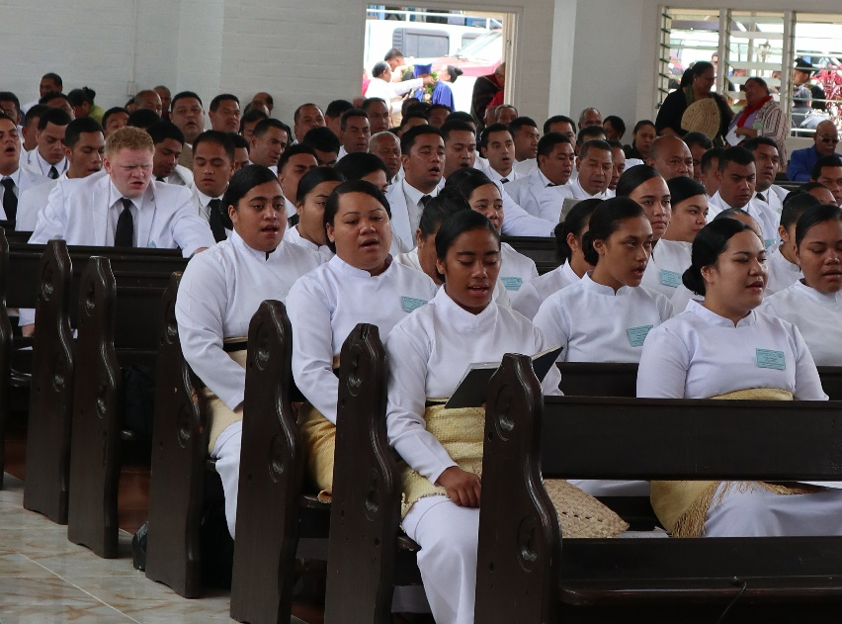
King Tupou Vi inducts the Rev Dr ‘Ahio as President of the Free Wesleyan Conference

Taking my leave (again) from The Rev Dr ‘Ahio and his wife Loukinikini
