Visit to the Methodist Church in Cuba.
December 2019
I have been hearing about revival in the Methodist Church in Cuba for a number of years, and my recent visit to Cuba did not disappoint my expectations. I had the privilege of visiting our partners there with the Chair of the Newcastle District and the District’s Evangelism and Mission Enabler, Revds Stephen and Elaine Lindridge. Their two adult children, Ruth and Sam, who are involved in local youth work, accompanied us.
The purpose of the visit was to:
- Conduct my first partnership visit to the church
- Support the Newcastle District in deepening their partnership with the church.
- To learn about how the church has grown over 10% year on year since the election of Bishop Ricardo Pereira in 1999
- To experience vibrant Cuban worship
- To learn more about some of the limitations the church must operate under in its context.

The Power of the Holy Spirit
It was evident to our British delegation that the key to church growth in the Methodist Church in Cuba is the Holy Spirit. The Holy Spirit was so tangible and present in every cell group, mission and church we visited (I will explain this structure as little later on). The Holy Spirit was evident in every person we met, from the people in the congregation to the missionaries, the worship leaders, the ministers, the superintendents, the Bishop and everyone we saw serving God using their gifts, time and talent.
We saw no evidence of this lively, Cuban-infused worship being a mere show or performance. What we experienced was heart-felt worship for God, heart-felt gratitude to God and a passion for God that just bubbled over in worship. Those in the congregation were not spectators of worship being led by the extremely talented singers and musicians: each person was truly a participant, and worshiping as if there was only an audience of one: God.
Bishop Ricardo Pereira Díaz
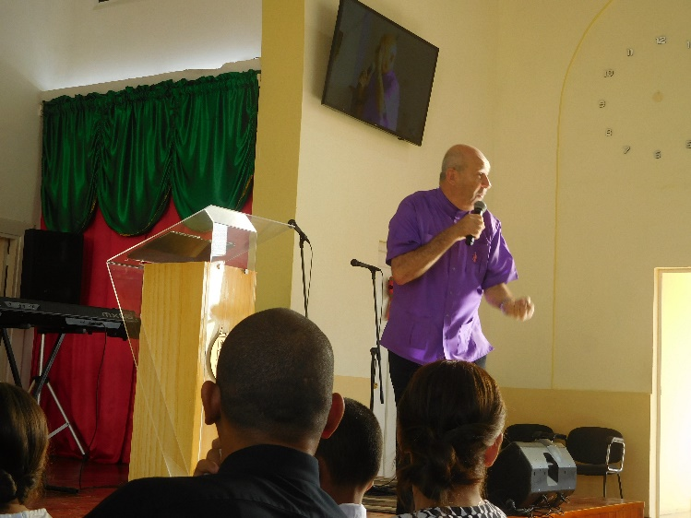
The head of church, Bishop Ricardo Pereira, encourages and teaches its leaders to have a vibrant relationship with the Holy Spirit. He shared his testimony of how he was a local Methodist pastor in the Pinar del Rio District (western Cuba), and felt envy at seeing two young men being filled with the Holy Spirit at his church. He spent an entire night until three in the morning, asking God to also fill him with the Holy Spirit. He told God, “I will not stop praying until You do so”. At 3 am, he was baptised in the Holy Spirit and a great revival in this western province ensued. Not because of a man, but because of the baptism of the Holy Spirit in that man. I wondered whether we as a church in the UK are as hungry as this for the Holy Spirit, and at the possibilities of what God could do if we were completely and utterly filled with God’s Spirit!

Dedication, humility and love
Cuban Methodists love to serve God with their hearts. No task seemed to be too beneath anyone we met, no task seemed too big an ask. I may be generalising here, but I find that in the west we are very protective of our time, energy, privacy and position. In the Cuban Methodist Church, God comes first, over personal desire and even personal need, at times over family needs. Does Jesus not say in Luke 9:23-24: “…If anyone would come after me, he must deny himself and take up his cross daily and follow me. For whoever wants to save his life will lose it, but whoever loses his life for me will save it.”?
We saw church members faithfully attending weekly services, weekly prayer meeting, weekend fasting and prayer meeting, Bible study, lay workers training, worship services…Cubans dedicating their days to God and not leaving space for worldly things. We met Cuban brothers and sisters who waited on us at the Methodist guest house, serving as security guards and caretakers, only to find out that they were also lecturers at the church’s lay workers seminary. We met Cuban Methodists full of the love of God, always ready to greet us with a smile and a heart-felt, genuine welcome. We witnessed a church that helps its members walk in humility. For example, it ensures that several people lead worship during a service, and not just a single worship leader, to avoid the trappings of pride and ‘stardom’.
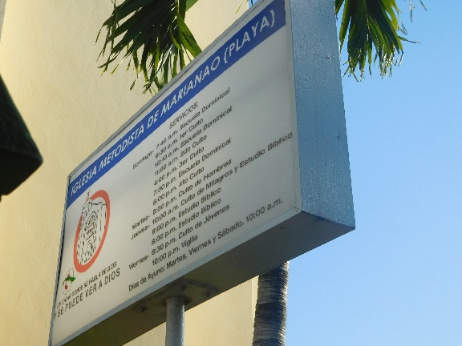
What struck us all was that this Christian, fruit of the spirit behaviour was clearly not an act. It was clearly not just ‘put on’ for this group of visitors from Britain. We experienced this love and saw this humility and dedication in every local church and mission, in every service or prayer meeting we attended. We saw it in every formal and informal moment of fellowship with church leaders and with those serving in practical ways in the church. Every single person we met served with a deep sense of joy and gratitude to God for all the Lord has done for them.

The sign outside the Methodist Church of Mariano, the Bishop’s local church in Havana, displaying the list of weekly church activities (I count 13, and three fasting days!)

Testimony
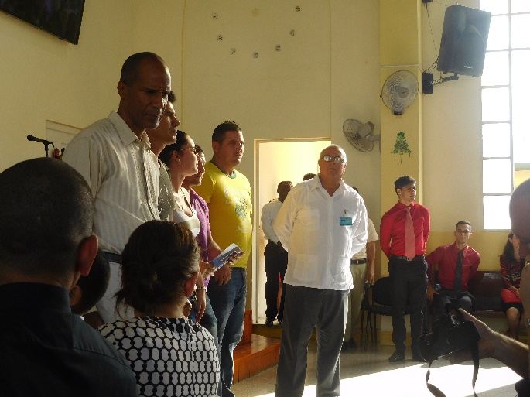
Cuban Methodists are very good at sharing their faith story! We were blessed to hear many testimonies of how God had touched their lives and how they had met Jesus. We heard many stories of how God has touched the young and the elderly, both of whom had grown up in state education, which educates Cubans extremely well, but teaches them that there is no God. However, we heard a wonderful testimony of an elderly man in his 90s, who had been a Cornel in the Cuban army and a lecturer on Marxism. He resisted Christ for many years, much to the suffering of his wife who became a Christian years before him. However, God touched his heart one day and he came to believe in the Living God. His wife had been heavily involved in witchcraft or santeria (Cuban witchcraft based on the worship of the Saints and African ancestral worship) but Jesus delivered her from the oppression of this belief and delivered her. We heard testimony after testimony of people who had been staunch members of the communist party coming to Christ, and people who had been involved in witchcraft or even santeria priests themselves, being delivered by the saving power of Jesus Christ. Everyone seemed ready to share what God had done for them and their families, everyone ready with an answer as to why they love God the way they do and why they are the way they are.
Cubans responding to an alter call for salvation. This is a regular occurrence and a normal part of church services in Cuba

United in one vision
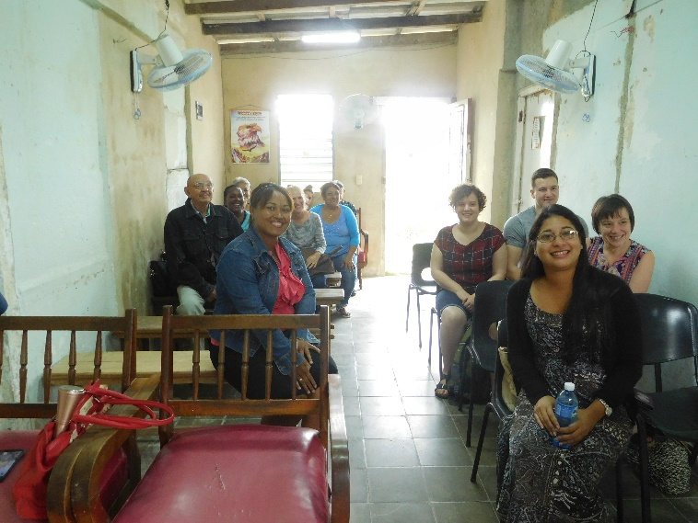
Something else that struck me during our visit was the deep sense that this is a united church, focused on one vision. The vision is to win Cuba for Christ. The fuel of this vision is prayer and the guidance of the Holy Spirit. The enacting of this vision is done by a Cuban people who are sold out to that vision, above their own needs and comforts. We met missionaries who had sacrificed space in their own homes to enlarge the space for the people in their mission to meet or to extend their home so that it could be big enough to become a church. We met Cubans who were using the wisdom of the Holy Spirit to ensure they did mission in a way that suited the local context. We visited a militarised area in Cuba, which had traditionally been very difficult to evangelise and the Gospel had not been well received by the community. In part because of the hardness of heart against the Gospel of Jesus Christ, in part because several evangelical churches had not built up a good reputation and witness in the community. The missionary assigned to this area prayed and sought the Holy Spirit’s guidance as to how to make an impact there. The Holy Spirit showed him that the church had to establish a credible testimony in the community which would open the doors to the preaching of the Gospel. The mission started serving the community, building up a good witness for a year, before they started preaching the gospel earnestly. The congregation now has about 20 members, with members ranging from those who were staunch members of the Communist party and former Army Colonels, to those previously involved in witchcraft. Praise God!
A Cuban Methodist mission, on its way to becoming a recognised Methodist Church

Structure
Revd Aimara and her husband (third and second from the right) who shared with us that she had felt supported as a woman in ministry by the church
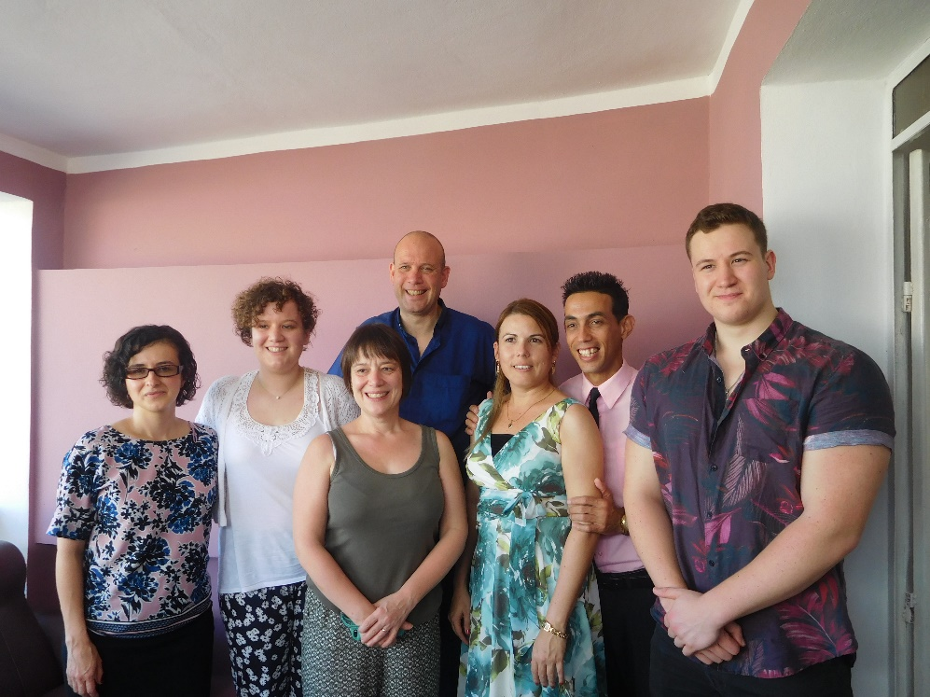
Although we saw a very charismatic church and one with a lot of freedom of expression in their services, the Methodist Church in Cuba is by far a disorderly church. There is a lot of order in the services: everyone knows their place and knows what needs to be done for the smooth running of the service (which is much needed given the large size of many churches). There is also a lot of structure in how they grow as a church. A church goes through two stages before becoming a church. It starts off as a cell group hosted in the home of a missionary. Missionaries are those members of the church not yet ordained but trained as lay workers and who feel called to evangelise to a community not yet touched by the Gospel message. Once the cell group has more than 20 members, it will become a mission, and once the mission has between 30-40 baptised members, it can become a church. We were privileged to visit a number of missions that were almost ready to become churches. We visited the mission a lay pastor in a town on the outskirts of Havana, who shared that he was planning to extend his own home in order to convert part of it into a church. The level of commitment and investment of this lay pastor and many others we met challenged us deeply.

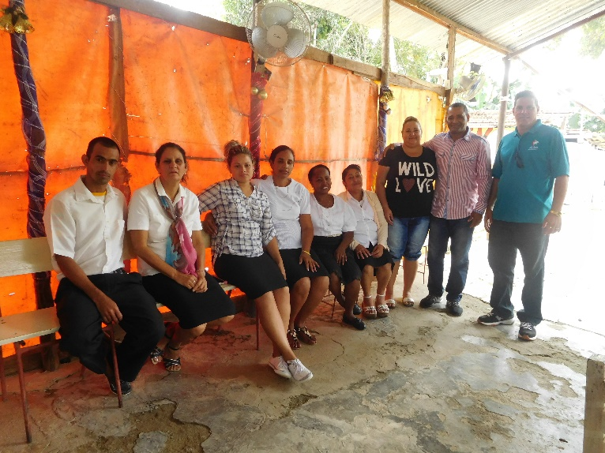
We also noted that the majority of missionaries we met and heard about, were women! We are encouraged that despite living in a context where chauvinism is culturally strong, women were given leadership roles and valued for their ministry. We were privileged to meet female ministers and better understand the importance of their roles in growing the church. We heard testimonies from the women’s federation about how Methodist women in very rural Cuba were on fire for God and spreading the gospel in their communities. We met the only female superintendent, who felt that the church had affirmed and encouraged her ministry.
The Methodist Church in Cienfuegos has established 13 missions in the Cienfuegos province. Here are some of the missionaries, who were also serving us when we had lunch with the minister of the main church

Theological education
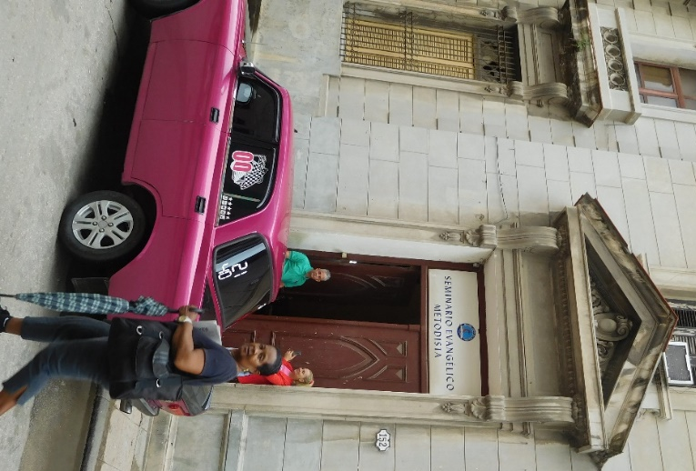
The Methodist Church in Cuba has two main training centres for its ministers and lay workers. The Methodist Seminary is located in Old Havana and each student must commit to preliminary extension studies in their district for two years before being allowed to take the theological degree at the seminary. Students there share a very convivial student lifestyle, with students sharing a dorm room with 20 others, and scare IT resources. When essay deadlines loom we were told that students form long queues outside the IT room in order to type their essays up and use the internet. The physical library is small, although students have access to over 15,000 digitised resources. The Seminary receives funding almost exclusively from externals partners in the US, although students will contribute a token amount of $2 for their studies. This may sound like nothing, but when Pastors in the Methodist Church earn only $15 a month, this is a significant commitment.
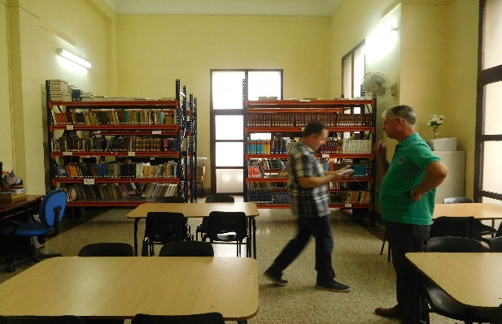
The seminary would welcome resources written from British Methodism to enhance their library.
We also visited the seminary for lay workers, where the church offers theological courses, lay workers training for all ministry areas, and English. The courses are held in the evenings and many members of the church will travel to the seminary straight from work and stay there until well past 9 in the evening! This is a church hungry to learn from God and praise Him.
Vibrant, authentic worship
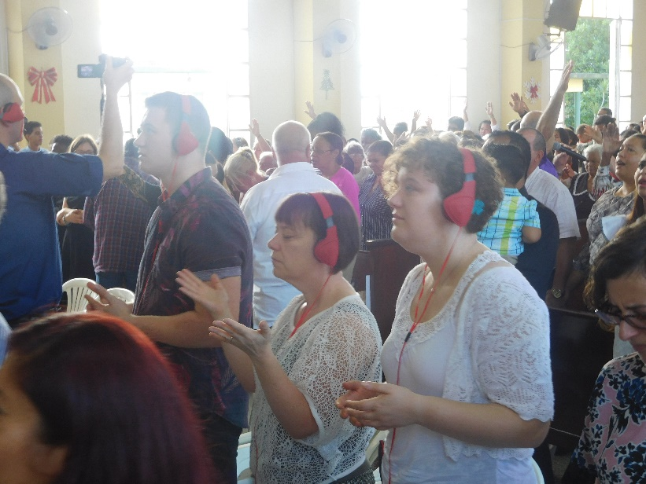
Part of the reason why the church has attracted so many new members is that it fundamentally changed its liturgy in 1999. Before then, the church used liturgy in Anglo-American Methodist traditions. However, when the church renewed its liturgy to give place to Caribbean and African infused worship, worship which allowed Cubans to dance freely before the Lord their God, this attracted many people to local churches and missions. The Lindridges and I joined our Cuban brothers and sisters for vibrant worship and witnessed authentic worship to God in every place we visited, whether it was in a small rural mission or a large established church. At no point did the charismatic worship feel like a performance-these were ordinary Cubans, singing, praising, raising their hands and dancing to God with their whole selves, body and soul. It was a beautiful sight to see Christians worshiping God so openly and unashamedly.

Conclusion
Cuban Methodist are people of love, joy and gratitude to God. Yet they live out their faith under harsh economic and political limitations. There is very limited scope for the church to have an income generating project as a result of these limitations. The desire to do this exists, as does the need, given that ministers only earn $15 a month. It is by the grace and provision of God that despite this, those who feel called to ministry don’t count it as an obstacle to answering Gods call in their life. Food, petrol and other essentials are set at state prices, which are unaffordable for most Cubans, which is why the black market is so prolific. There are restrictions enshrined in Cuban law concerning the building of new church, which is currently against the law-a great challenge considering the rate of growth of the church! Yet with all these restrictions, not only has the church continued flourishing since the revival that started in 1999, but it has built a respectful and open relationship with the state, and has found favour with the state when government officials have witnessed the difference that the church is making. Lives in many communities are being transformed because the church has preached the saving Gospel of Christ to them. Young people have stopped feeling disenfranchised and pursuing unhealthy lifestyles and are instead worshiping God in church. People oppressed by witchcraft and god-absent Marxists-Leninist teachings, taught to Cubans from the beginning of their education, are being set free indeed by the Son. Marriages are being transformed, relationship healed. Those that were once dancing Cuban son and salsa only for themselves and for the world are now dancing, singing and praising God.
May we chose to learn from our Cuban brothers and sisters to not only listen to the Holy Spirit but obey His voice. May we chose, like our Cuban brothers and sisters, to live a life of intimacy with Christ that leads to spiritual abundance, faith, love, peace and joy, and ultimately, the expansion of Gods Kingdom in the Methodist Church in Britain.

Sandra Lopez, Partnership Coordinator for Latin America and the Caribbean
January 2019

