PARTNERSHIP VISIT TO BRAZIL-December 2017
This was my first time visiting the Methodist Church in Brazil, and the aim of the visit was to get to know the church better, find out about its joys and challenges and visit a number of local churches to experience what church looks like locally and in different contexts. The Methodist Church in Brazil has over 250,000 members and is divided into 8 ecclesiastical regions and two missionary regions, each lead by a Bishop. It is the only Methodist church in the region to have active females Bishops.
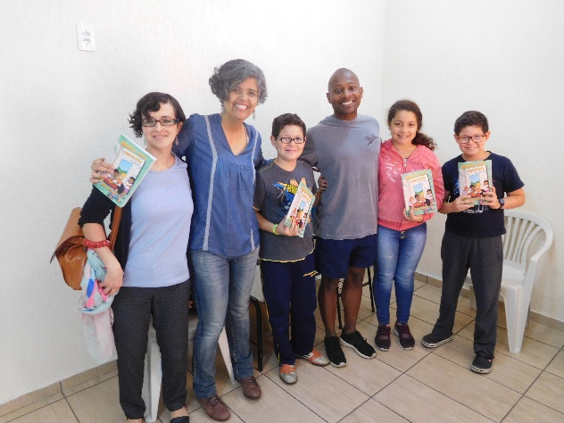
My host during the visit was Revd Jonana d’Arc Mereiles. She is the National Secretary for Life and Mission and is responsible for the areas of social action, administrative action, education and missionary actions.
Christian Education has a high priority for the church and the church develops a Sunday School programme and resources that are for the entire church, not just for children. Sunday School, or Escuela Dominical in Portuguese, is for every age group. The Sunday School resources are developed around a common theme, and age appropriate leaders handbook and workbook are developed accordingly. In many churches, Sunday School takes place after a short celebration and welcome, and then all the members go off to their respective classes. In the evening, another service serves as the main Sunday worship. I was privileged to visit a church that had a strong Sunday school on my first Sunday in Brazil. It was a joy to see all ages studying the word of God and to see the enthusiasm with which young and old shared and learnt the word of God together. There was a hunger for more of God’s word that I believe we can all learn from.
Rend Andrea Fernandes, second left, Sunday School Coordinator.
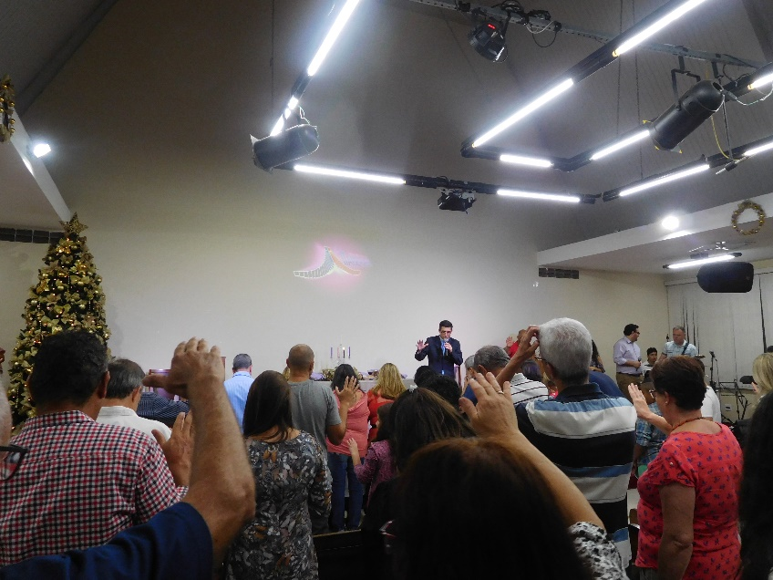
In the evening I was taken into another church that has a strong small groups programme. I had heard from a number of people who have in depth knowledge about the church that small group programmes were strong and fruitful for the Methodist Church in Brazil, so I was curious to find out more. Developing small groups has been the strategy that Revds Tiago and Laura, an ordained couple who pastor a Methodist Church in the town of Itaberaba (north of Sau Paulo) have used to grow their church numerically but crucially, qualitatively. For the last 7 years, they have been teaching their congregation about small group discipleship, training leaders and overseeing 12 small groups. These small groups meet the needs of all ages, from adults to youth, to children and family groups. It has been a way for the church not only to meet the needs of its existing members, but to welcome new Christians, to disciple them, help mature their faith and encourage them to commit themselves to membership of the local church. It has been used as an evangelistic tool for those who would not normally step inside the church building, but initially would be more willing to enter someone’s home. Revd Tiago uses resources produced by the national church for leading small groups as a foundation for the content of their small group Bible study, but has adapted them to meet the needs of his local community. He emphasized many times that this was crucial for church growth through small groups and I was blessed to see the fruit of this growth as we stayed to worship God in the evening service. The service was vibrant and there was an obvious and vocal passion for Christ and joy at being in God’s house together. There was much joy and celebration as they welcomed over 10 new members to the church.
Pastor Tiago praying over new members
Another person I met doing a different type of work for the church is Revd Maria do Carmo or ‘Pastora Kaká’ as she is affectionately known in Brazil. We met at her home in an outer neighbourhood of Rio de Janaeiro called Duque de Caixas, an area with a high rate of gang-related crime and drug trafficking. Rio de Janeiro is a colourful, vibrant and sprawling city. It has over 13 million inhabitants and is a city of celebration and parties, but also of violence. Many Brazilians I spoke to said that violence in the favelas has recently increased, with conditions becoming increasingly precarious for the poor because of the Temer government scaling back resources that had been invested in social programmes by the previous Lula and Rouseff governments. Rio is also the home of the largest number of Methodists in the country.
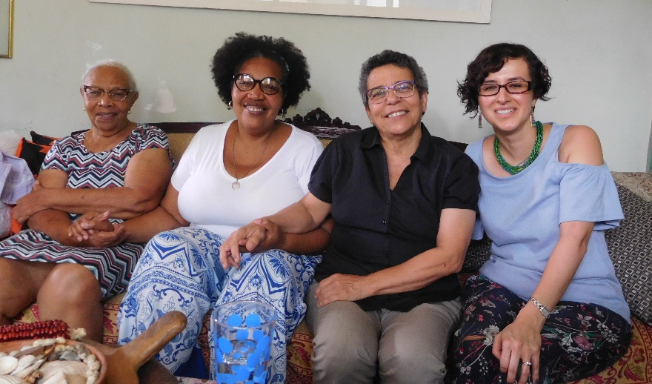
Pastora Kaká, is a national in mission appointments postholder, working with three youth offender institutes in Duque de Caxias, The majority of youth offenders were caught on drug trafficking charges or related violent crimes, and maintain their gang affiliation while incarcerated. However, in Pastora Kaká’s sessions with the young people, she teaches them to leave their gang affiliation and enmity at the door, and focus on what unites them: the saving Gospel of Christ. She shared stories of hope and of tragedy with me. Testimonies of how some young people had been able to turn their lives around after serving their term, and were now doing well in life or even better, were serving and worshiping God at a local church. Other stories she shared were of tragedy, of young people being murdered during incarceration, of distraught mothers seeking support and comfort after learning the fate of their son or daughter. Through good times and in bad, Pastora Kaka continues to support young people, their families and staff at the institute, giving testimony of the hope the young people can have through Jesus Christ. She asked me to thank the Methodist Church in Britain for supporting her ministry.
Pastora Kaká, second from left
While in Rio I also got the chance to meet with the church’s newest regional Bishop, Bishop Paulo Rangel. We discussed what work we might be able to partner with in Rio, and explored the possibility of sending an Encounter World volunteer to work with the church’s Shade and Fresh Water (please run this through google translate for English) children’s programmes in the favelas, run by the coordinator for the programme, Keila Guimaraes. If anyone is interested in finding out more, please do get in touch!
I also spent a day at the Igreja Metodista do Brasil’s headquarters in São Paulo. There are approximately 25 members of staff employed there, and I got a chance to meet Bishop Stanley Morales, the Secretary for the council of Bishops and find out more about the current state of the church nationally. It was fascinating to hear about their church planting programme in areas of Brazil that have no Methodist presence. These areas are known as ‘missionary regions’, and sit alongside the other 8 regions of the church. The largest number of Methodists are located in Rio de Janeiro, but there are many parts of Brazil where there are no Methodist churches. Through their church planting programme, church planters are selected to live in these areas and start house churches from scratch, bringing souls to Christ, developing discipleship for this new community and growing the church.
Left to right: Revd Joana d’Arc, Sandra Lopez, Revd Kaká, Bishop Paulo Rangel, Keila Guimraes
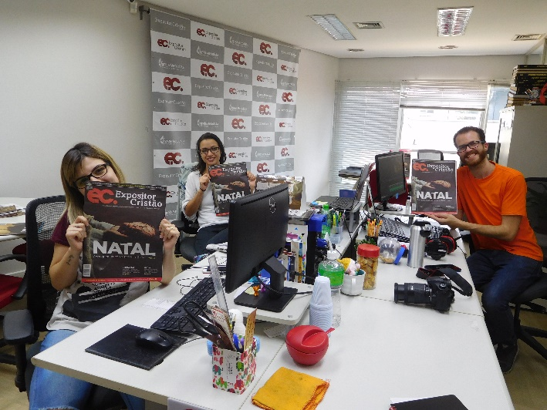
I also met with their communications team and learnt about some of their publications such as Expositor Cristão (expositorcristao.com.br/) , a church magazine that has won national prizes as a Brazilian Christian magazine. I also learnt about No Cenáculo, the Upper Room devotional produced in Brazil for the church. It was fascinating to hear about how it is used as an evangelistic tool as well as a devotional tool, and how several other denominations use it for daily devotionals or evangelism.

Communications team

On another day, I visited the Faculty of Theology (FaTeo) located within the Methodist University of São Paulo. My predecessor, Revd Thomas Quenet, was key in encouraging the Faculty to offer theological education to Methodist Churches in the region that did not have a theological seminary of their own or who were emerging churches who felt that the theological education offered by other denominations did not meet their development and learning needs. The fruit of this joint work was Sol Andino or Andean Sun, a theological programme run by the FaTeo in Ecuador, Chile and Peru to support the continuous training for lay and ordained church members. The project has been particularly beneficial for the United Methodist Church in Ecuador, where over 400 lay and ordained church workers have benefited from the Sol Andino programme since 2012. The Methodist Church in Britain has been supporting the programme through the World Mission Funds’ Scholarship and Leadership Group Training grant (SALT) since 2012.
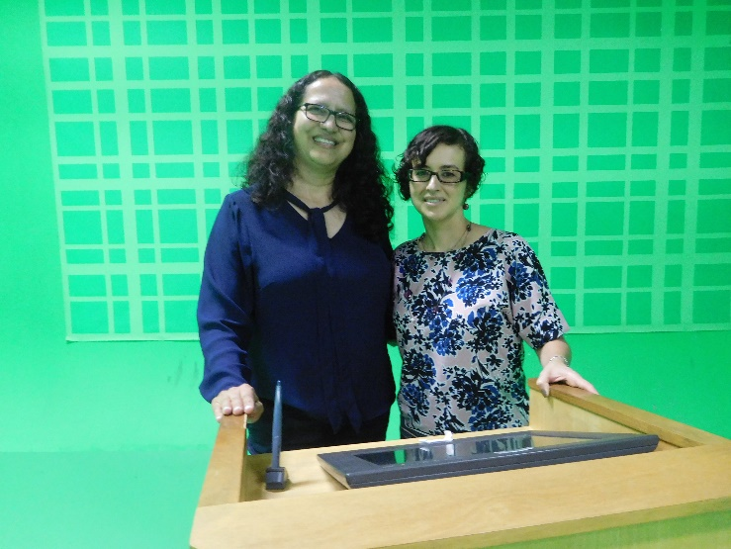
Another programme that the SALT group training programme has been supporting is a women’s empowerment programme run by the Faculty’s Otila Chaves Centre for women’s studies. Brazil is a huge country, so there is a limit to how many women can physically participate in the programme that is hosted three times a year by the Faculty. However, in collaboration with the Methodist University’s communications team, the programme and topics covered are recorded onto a DVD and sent to local churches all over Brazil as well as streamed live so that women from all over the country can access the course. This has allowed thousands of women to benefit from this empowerment course, to feel connected to other women across the connection and to grow in confidence in their value and worth and ministry as women. The Coordinator of the programme, Revd Dr Margarida Ribeira, thanks the Methodist Church in Britain for its support and reiterated several times how important this partnership is to them. They would warmly welcome any women from the UK who would like to take part in the empowerment programme in the future.
From left: Dr Margarida Ribeira and Sandra Lopez in the recording studio where the DVD’s for the women’s empowerment programme are produced
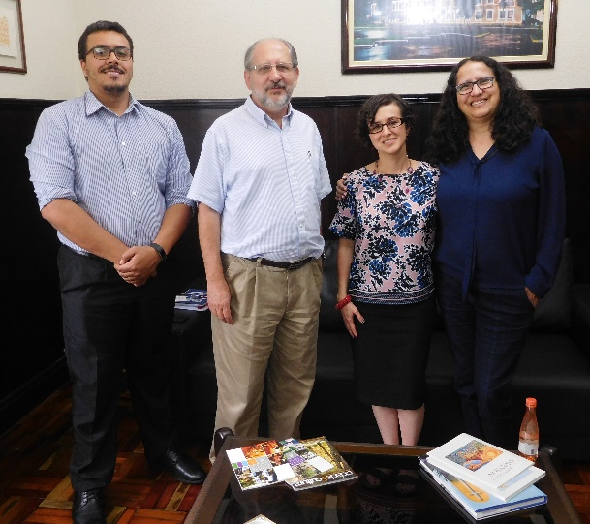
It was also very good to meet with Demetrio Soares, the coordinator for international relations at the Faculty, and Revd Dr Paulo Roberto Garcia, the head of the faculty, to explore ideas for further joint work. They are keen to develop partnerships and exchange visits to Cliff College and Queen’s College, and I hope to follow up on this when I return to the UK. They are also keen to offer their theological training through Sol Andino to other emerging partner churches in the region.
I spent my final Sunday in Brazil with Revd Andrea Reilly, a United Methodist Women’s missionary who is the key contact person for Latin America. She visits women’s groups all over the continent to offer empowerment training and help create partnerships across churches but also organises group visits from United Methodist Women to partners across the region (Methodist partners and other organisations) through the Ubuntu Journeys, which enable women from the United Methodist Church to visit and share with women’s groups. It was good to get a broader understanding of some of the work being done in the region, given that there is still a long way to go to affirm women’s ministry, gifts and women’s.
Left to right: Demetrio Soares, Revd Dr Paulo Roberto Garcia, Sandra Lopez and Revd Dr Margarida Ribeira
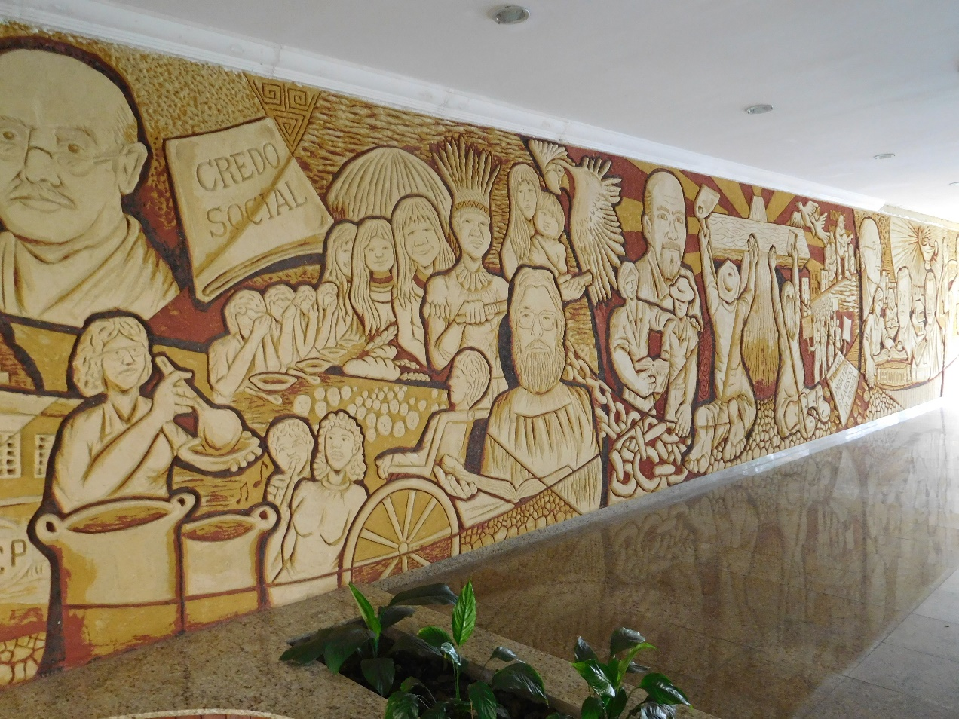
In conclusion, this was a productive initial partnership visit. Brazil is such a large country and the church is spread out over 10 regions, so I do not pretend to now have a comprehensive understanding of the situation of the entire church after just one visit! However, it gave me a glimpse of a growing church, but one that is not taking its growth for granted and is working hard to continue its work of evangelism and deepening discipleship for existing Methodists. It is church that is passionate for Christ and for seeing souls saved, and a church that is very much a Brazilian church, producing its own resources, having its own Methodist character and using its home-grown talent to develop the church. I really look forward to the next visit when I can get to know a different part of this church!

A mural at the Faculty of theology, charting the history behind the Methodist Church in Brazil

Sandra Lopez, Partnership Coordinator. 19.12.2017

