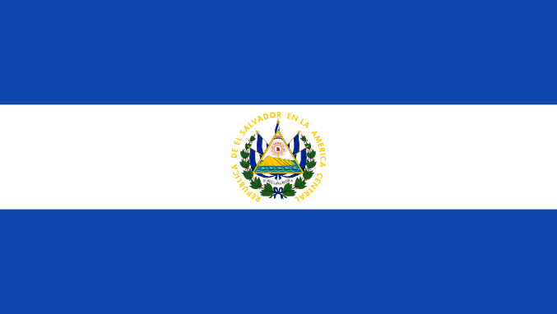

Partnership Visit to El Salvador
February 2017

The Iglesia Metodista Evangelica en El Salvador (IEMES) is celebrating its 23 year of existence. The church was started by Hispanic United Methodist Missionaries but became an autonomous church and continues as such to this day. The church works extensively with the United Methodist Church, particularly through its numerous Volunteer in Mission teams who visit the church and support it in building work, children’s camps and other activities throughout the year. Until recently, the General Board of Global Ministries (the UMC’s mission board), the Methodist Church in Britain and North Carolina’s Duke Divinty College supported theological training for Central America Methodist Churches which were held in El Salvador. Students from IEMES, and the Methodist churches in Guatemala and Nicaragua received theological training and this has strengthened the ministries of the lay pastors who lead the majority of local Methodist churches in these countries. The IEMES currently has two ordained ministers and it is hoped that this course of study will pave the way for more lay pastors to be ordained.

The majority of churches in IEMES are located in Ahuachapán, a town in western El Salvador with just over 110,000 inhabitants. It is located in the main agricultural area of the country and is known for coffee production. It is also a town where gangs are quite powerful.

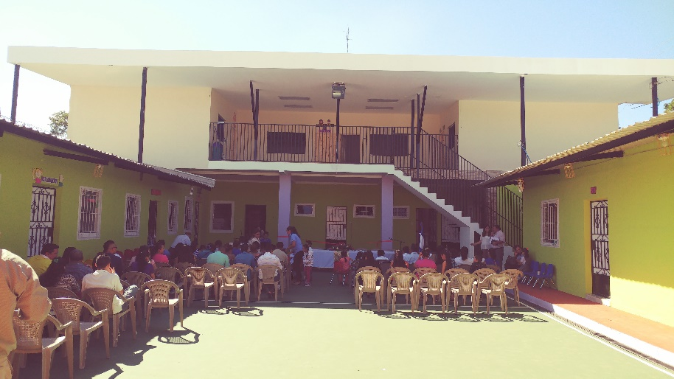
School ministry

As I arrived in Ahuachapán on the first day of my visit I was taken straight to the Methodist School which after 4 years of construction has finally been completed. There was a grand opening and ribbon cutting celebration and there was a sense of gratitude to the Lord for what had been achieved over the course of four years. This school is of particular importance in the environment they live in as its aim is to provide education and Christian education to local children who may otherwise get caught up in gangs from as young as 8 years old.

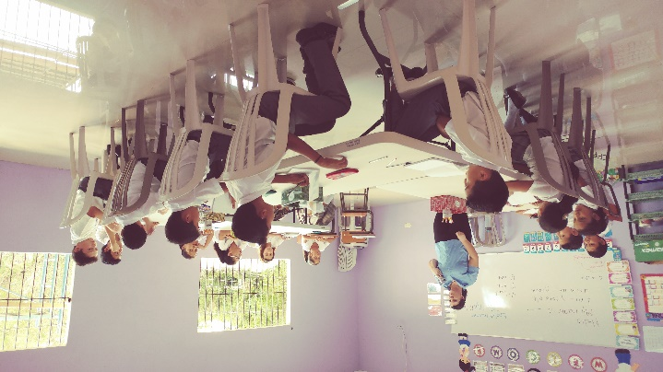
The school also offers English lessons which is vitally important for the futures of these children and it will open up opportunities for them to get better employment later on in life. Paul and Maura Cook-Collins, former British mission partners, were English teachers at the school for three years it was said to me on several occasions that their work there was highly appreciated. The school currently has one English teacher, a United Methodist Church volunteer who is there with her husband who is the VIM team coordinator for the IEMEA as is responsible for briefing teams when they arrive and helping with all organizational aspects of VIM team visits. It was wonderful to see the church fulfilling its vision of helping to raise a generation of children with deep Christian roots and help them avoid the destructive nature of gang life.
The General Seembly
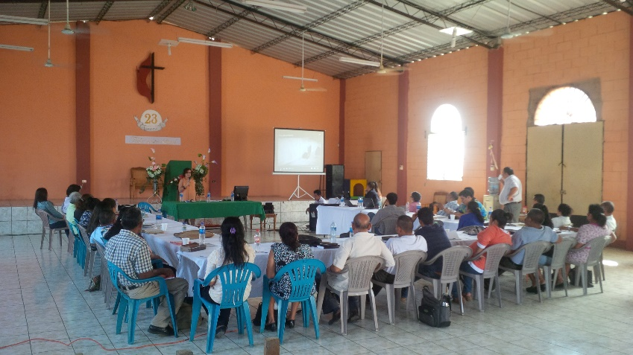
The Annual Assembly

I was invited by the church to attend the IEMES annual assembly, along with my General Board of Global ministries counterpart, Revd Edgar Avitia. One of the areas covered was migration, which is particularly important for the church given that a significant portion of illegal migration to the US is from El Salvador. The main cause of migration is the violence perpetrated by gangs. Thousands of children from El Salvador and neighbouring Guatemala and Honduras are sent alone to the US for fear of local gangs forcing their children into their ranks. Out of desperation parents will send them to the US to stay with relatives but the journey there is fraught with dangers, not to mention drug trafficking gangs, the dangerous mode of transport used to get to the US, being vulnerable to sex trafficking and more. Churches in the region and GBGM are beginning to work together to promote the following: the right to stay in country of origin, the right to safe passage, the right to welcome in host country and the right to a dignified re-entry into the country of origin. Work is already being done by several protestant churches in the region and GBGM is working with Methodist partners to develop their strategy in these four areas. I was given the opportunity to share with the church what the Methodist church in Britain is currently doing in Europe and spoke about Mediterranean Hope and the work of some local churches in the UK with migrants. I also showed them the Very British Nativity video produced by the Joint Public Issues team to give them an insight into the difficulties refuges in particular are facing in the UK.

However the main topic of concern in relation to migration for the IEMES is the 1 million illegal migrants with criminal records that President Donald Trump has pledged to deport from the US. The church was concerned because for them this would mean an influx of Salvadorians with criminal records and possible criminal intentions, coming back to El Salvador with a new found freedom to do as they please. They were concerned this would exacerbate the gang problem for their country, but they also recognized that there would be a number of these deported migrants who would not be criminals and who would need support to reintegrate back into society. The local churches pledged to offer local support to any people in this situation and would report on their work with migrants during the next assembly in 2018.

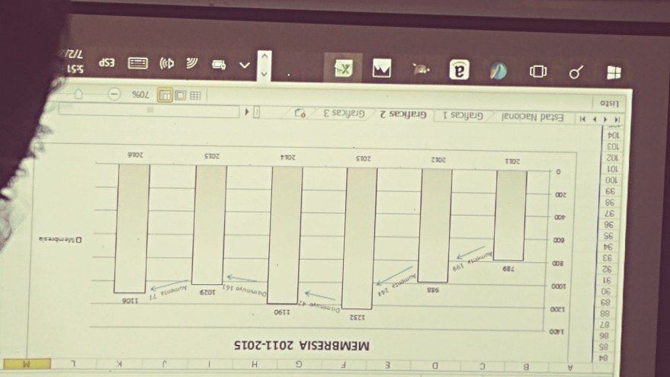
Another area that was discussed was the membership of the church. It was fascinating but also sad to see graphs of fluctuations in church memberships for every local church, which were mainly due to children being sent away to the US for reasons explained above. Revd Juan de Dios Peña spoke to me about his desire to train up cell group or ‘class’ leaders across the church to support church growth. He joked in saying that other evangelical churches en El Salvador were more Methodist than they were because they were actively using the Methodist class system and were growing! I suggested that the SALT group training programme could support the desire to train leaders in this important task so that the church could achieve its vision of growth.

As part of my short visit I was able to see some local churches and learn about the context they are in. I visited Pastor Gloria’s Church, Iglesia de la Gloria, in the neighbourhood of La Gloria! I could certainly see the glory of God in that place, through the beauty of its location and through the testimony of what God has done through the Methodist Church there. La Gloria is situated on the outskirts of Ahuachapán and I was told that before the Methodist Church established itself there, there was no running water and the road was a dirt track which made it very difficult to travel on, especially considering its mountainous terrain. What a joy it was to hear that when the Methodists arrived and asked Pastor Gloria to lead the church, they prayed that God would do great things to improve the situation for the community. By a miracle, the local authorities paved the main road and brought running water to the town! God is good and answers prayer.

What’s more, the church is full of children and young people and is thriving. Volunteer in Mission teams from the United Methodist Church have recently been helping to build the church and they are about a year away from completion. Pastor Gloria shared with me that the relationship the church has with these mission teams is very good and that she teaches her church to love them but also respect them. They see these teams as a gift and it gave me joy to hear that because I know of other situations where the relationship between mission teams and the local church is not so fruitful.
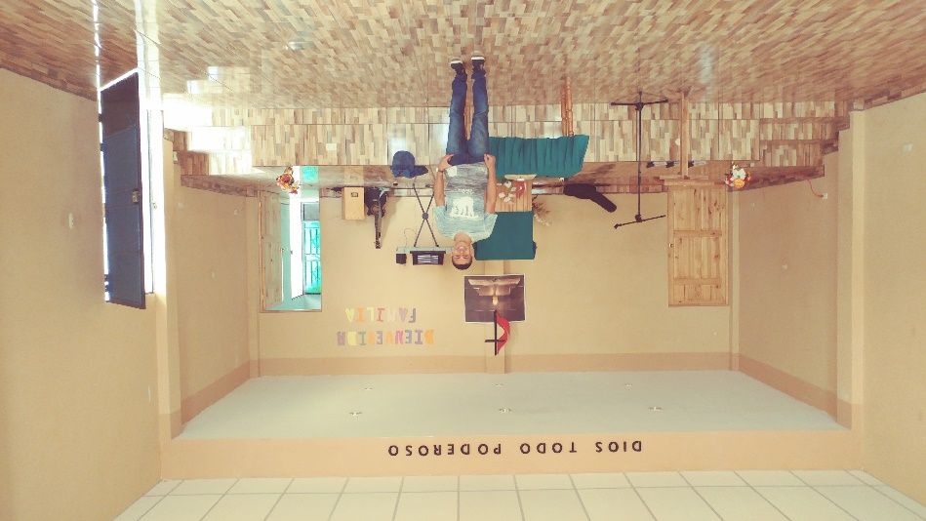
I also visited Pastor Emerson’s church which is located in a challenging area of Ahuachapán and where there is a young offender’s prison (12-17 year olds). Local churches have to develop good relationships with local gangs in order to operate safely in this area. Pastor Emerson is a lay pastor who is also the regional youth coordinator for CIEMAL (the Council of Latin American Evangelical Methodist Churches) and is a promising young leader in the region with a deep love for God and the gospel.
Health ministry

The church is also linked to two clinics: it is closely associated with a state funded community family health centre which supports thousands of people in the local community. Some of the most common ailments that the community is currently dealing with is high blood pressure, mainly due to the commonly eaten foods which contain high quantities of salt and little vegetables. Other issues include very nasty sounding insect bites that can cause heart failure between 10 and 30 years after infection (chagas disease). Dr Landaverda is the only Dr at the clinic and said the clinic was limited in what it could offer the community and desperately needed more Drs that the government says it cannot afford to employ.
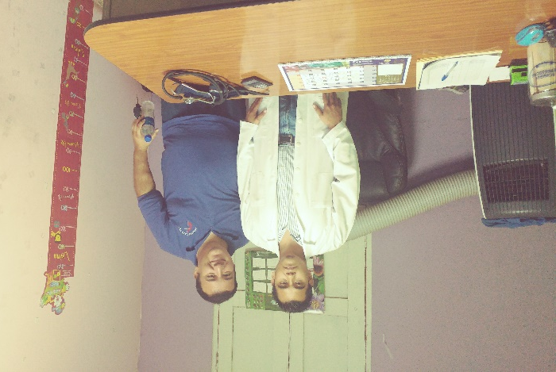
The second clinic is run by the church and the Methodist Church in Britain is currently supporting the post of the clinic’s General Practitioner through a National in Mission Appointments (NMA) grant. The Dr is called Mauricio Escobar (on the left) and he and the medical staff provide low cost services to poorer communities in Ahuachapán. Respiratory problems are a concern in this particular part of Ahuachapán. The NMA post funding is finishing in the next year and the church has put plans into place to absorb the costs of this post so that it may continue beyond the five year NMA support.

Monseigneur Oscar Romero

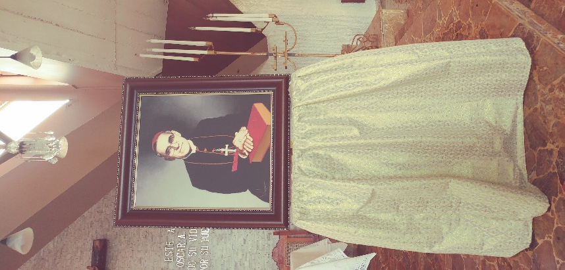
It was very moving to be taken to the church where Monseigneur Oscar Romero was assassinated in San Salvador, and to his home that has been turned into a museum and place of pilgrimage. Oscar Romero was assassinated on the 24 March in 1980. He regularly denounced the social injustice of the dictatorship at the time during his sermons and it is almost certain that this was why he was assassinated. He was loved by Salvadorians and declared in one of his sermons “if they kill me, I will live on in the lives of the Salvadorian people”, knowing full well that his life was under threat. His death contributed to the triggering of a bloody civil war as revolutionaries took up arms against the US backed dictatorship. The war lasted 12 years and caused the death of approximately 75,000 Salvadorians. Oscar Romero is respected and revered across denominations in El Salvador and continues to be an important symbol of social justice for the country.

Future partnership strategy

- To work on a SALT group application in 2017 with the church for training class/cell group leaders to strengthen the church and encourage growth.

- To keep updated in the issue of migration and deportation from the US that will affect El Salvador and how the IEMES deals with the issues and supports returning migrants.

- To follow up on the continuation of the current NMA funding Dr post at the Methodist Clinic.

Sandra Lopez, Partnership Coordinator for Latin America and the Caribbean, 22.02.17

