A peep into 21st Century Monastic Community living at Kloster Marinsee in Germany
Aim – To participate in the Pop-up monastery project organised by the Ecumenical Forum of European Christian
Women – 8-14 August 2015
My story...Beautiful scenery, stunning building, well kept landscape and a magnificent cathedral tree at the centre of the convent! Finally I am here in the convent to experience monastic living in the twenty first century. Myself with other twenty six women from Europe, I can't wait; so full of excitement. What is it like being a nun? How do I fill my day with no television for a week? How do I cope with silence? We are women from different traditions, cultures and background, how do we gel? Huh... lots of questions running through my mind. I guess I have been influenced by the film - 'Sound of Music' and maybe I am a bit like Maria - unable to cope with rules. Well, we shall see as the days go by. First thing first, let's go have dinner having waited for hours at Amsterdam and Hannover airports... waiting for other participants to arrive so we could travel together to Kloster Marinsee. Here we are!

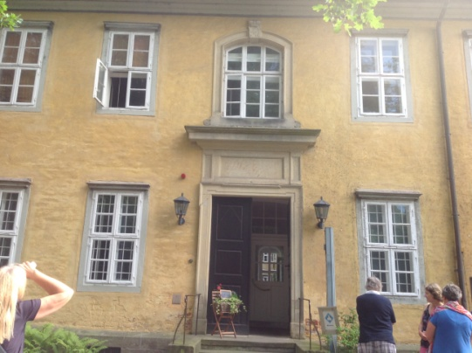
After meal, we went for prayers and had the chance to meet my fellow sisters – we were the last to arrive as it was late in the day. We sat on chairs in a round circle and later picked one of pictures scattered on the floor to explain our expectations for the week. I chose a picture of a cracked glass; an opportunity to peep and experience life in the Convent - Sister Act 2 coming alive again!

Later we were formally welcome Abbess Baerbel Goercke, the current leader of the Cistercian order at Kloster Marinsee. I was excited to meet this young looking, cool, smiling nun. She was a palliative nurse, now practicing as a theologian and as the leader of the Kloster community (with its staff) since 2003. The Kloster has been in existence for over 800 years - long before the reformation that took place five hundred years ago.

The Lord had preserved the Kloster Community down through the ages (notably through two world wars) as it has always been a place for nuns to pray for salvation and peace of the community. It is an open community and the nuns serve at schools, hospitals, social work etc. In addition, there is an herbal garden located behind the buildings by a stream to offer remedies to patients since the Middle Ages. Today the convent is still open to Protestant single women, which include widows and divorced women willing to contribute to prayer, music, art etc or relevant skills to the community.
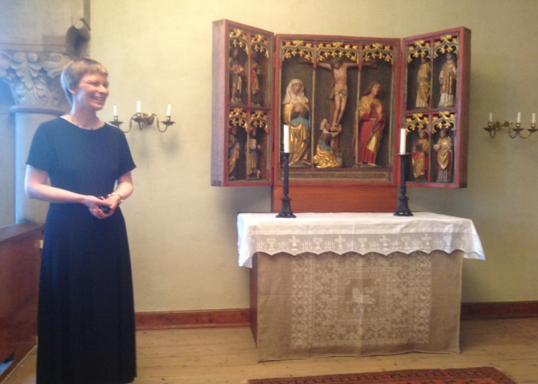
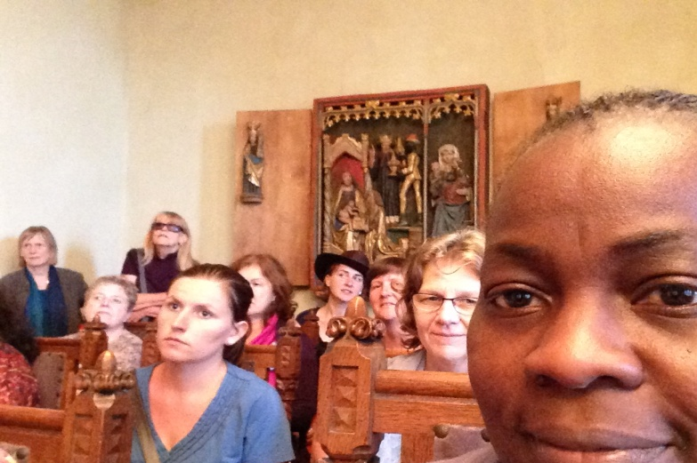
After the introduction, we all introduced ourselves – quite a number of women from various parts of Germany of course: few more from Switzerland, Austria, Serbia, Moldova, Romania, Ukraine etc. and four from the UK - two from Scotland and two from England. Sian is a beautiful, pleasant and shy young lady from Warrington, near Liverpool. She is a youth worker with the Methodist Church and was sponsored by Methodist Women in Britain. Kate is a middle aged lady, another Methodist based in Edinburgh whereas Fiona works for the Church of Scotland. I was sponsored by my wonderful office – the World Church Relations Office in London. We all shared briefly about our backgrounds, denominations, occupations and the age range was from 23 - 73!

It was getting late, we quickly went for our keys when the gathering was over and straight to our rooms! It was a pleasant surprise- I had a beautiful, spacious bedroom with a stunning view of a peaceful and quiet environment. I woke up to birds singing including an owl at night. The sun rays were streaming into the room in the early summer day, the air was cool and fresh, what more could one ask for? I had my quiet time and got ready for breakfast! The last time to chat with friends at breakfast before ‘mandatory silence’ commenced from 22.00 - 10.00 hours for the rest of the week.

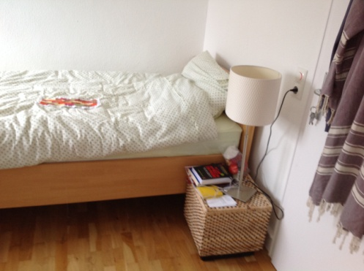
Later that morning, we attended the church service at the church within the Kloster with people from the community joining us. Guess what? You guessed right - we sang Joyful, joyful we adore thee, God of glory, Lord of love... it was brilliant! Only I could not openly rock to the music as in Sister Act 2 film but I was grinning and moving to the rhythm in my head – I was happy. We sang other hymns in German and English as well as the readings and messages in both languages - how considerate! Following the service, we were treated to tasty cakes made with pears and I got Chococino - another new experience for me. I wanted it all .

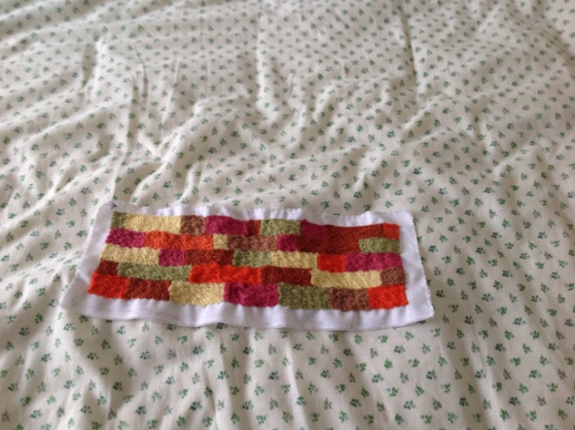
Time for lunch! With the guidance of the facilitators, we took turns to lead prayers at meal times and listened forthe notices. I was happy to let lunch go having stuffed myself up earlier. We had vegetarian meals throughout and the meals were very tasty. However being a carnivore (not omnivore), it was new experience for me. I was happy to try new stuff though I often struggled with the meals with no trace of meat. Once the Abbess thought I was watching my weight and assured me the wraps had low calories. I informed her that my figure already shows that I am not that calorie conscious through I should be. This new experience was good for me and my body was singing Halleluiah for not overindulging myself with wrong food choices.

After lunch, we had the options to either attend an embroidery or painting workshop. I enrolled the embroidery class and was very slow at first, in fact the last to get it right. However I was determined to finish my piece which I was achieved in the end. It now seats in front of my TV at home to remind me of PUM – Pop Up Monastery!
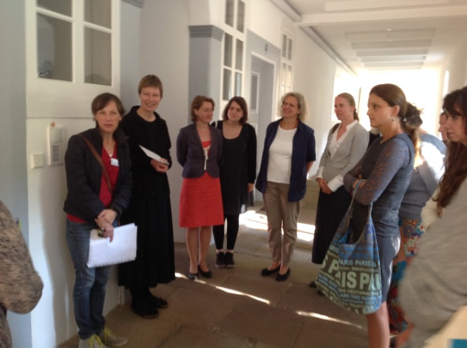
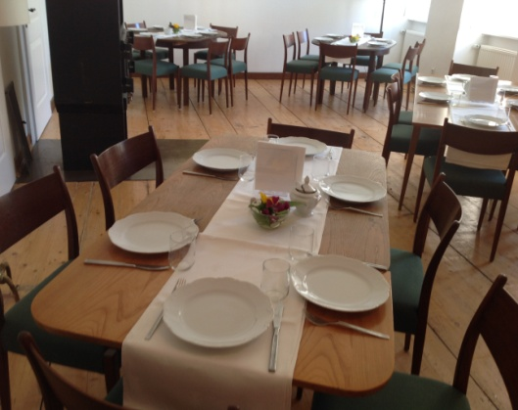
As indicated at the start, monastic lifestyle is full of routines and repetitions. The daily routines formed the rhythm - prayer in the church at 18.00 hours, dinner afterwards and Vigil under the Tree Cathedral from 19.30 – 20.00 hours (only on Monday). We had Holy Communion served at the end. We poured out our hearts in prayer for Europe, joining the prayer tradition of over 800 year at this Cistercian order. We remembered Natalyia from Ukraine and prayed for peace in Ukraine. We also remembered Greece and we prayed for especially those caught up by the national debt situation through no fault of theirs. We prayed for constant loss of lives of migrants travelling from Northern Africa into Europe and those from Syria into Greece. The bible says the prayers of the upright are a delight to the Lord! We asked God to heal our land and revive the church once again. Now it was time for bed, silence was no problem – I wanted my bed.

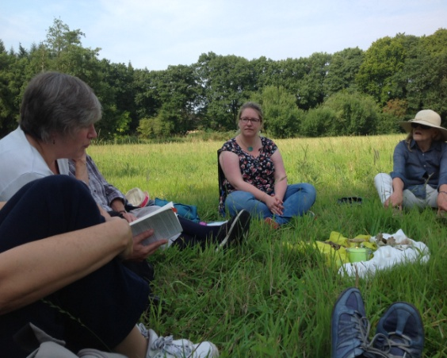
I am sure by now you have an idea of our practice; up for morning exercise at 07.00 hours, had lovely and wide variety of choices for breakfast at 07.30 – 08.00 hours. Then we attended the joint morning prayers at the Prayer room for the next 30 minutes before proceeding for morning duties until 10.00am. Each day a notable female saint or an important woman in the Bible was our focus. Remember all this time we were expected to be in silence though we could nod and smile. My morning duty was cool - clearing the dining tables and setting up for lunch! I had a great teacher, the wonderful kitchen staff who was very patient with me as I sometimes mix up the position of knives and forks whilst daydreaming.

After 10.00 hours we can SPEAK – silence over! We were to attend either a singing workshop or Nature & Spirituality sessions. I cannot read music and unable to discern if I am singing auto, tenor or sopranos, therefore I might not be helpful to my colleagues. I sing by hearing and sing harmoniously like most Africans with beats running through my head, so I chose Nature and Spirituality. We met in the meadows, took time to enjoy nature, silence, beautiful smells of lavender, rose and sage as well as commune with God. We also had an exercise of closing our eyes and letting our guide lead us to touch and feel trees and shrubs using other senses apart from sight. One then appreciates more the sound of streams, birds, insects, feel of nature etc. It certainly made me appreciate nature more and bless the God of creation!
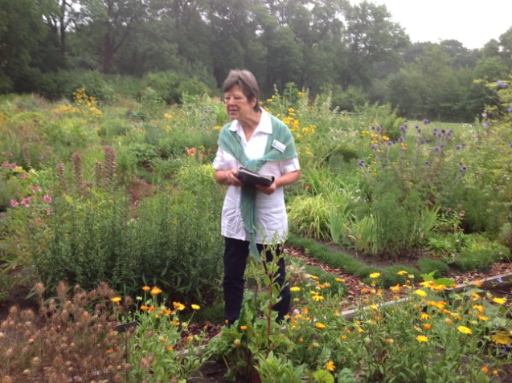
During the week we also visited the herb garden behind the Convent, we identified herbs plus their uses. It was remarkable and how herbs have been of use to patients, medical practitioners and community dwellers down through the ages. Many are still in use and effective up till date. We then had lunch and followed daily routine.

The next day i.e. Wednesday; we went on a 17 km pilgrimage walking through forests, farm lands and small villages. We alternated silence and discussions, stopped at various points to read scriptures and we discussed as we walked along the paths. It was an opportunity to know each other better as well as have time to reflect on personal issues and forecast for the future. The atmosphere was peaceful; we walked by the lake and the air very clean. I came back tired - proving how unfit I was. However I would do it again if I get the chance.
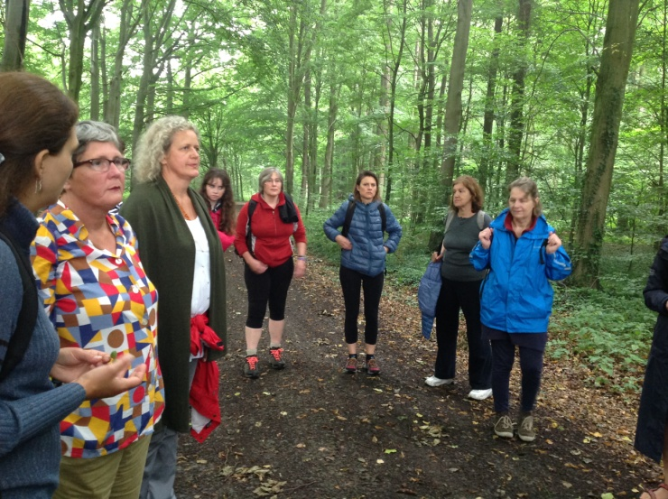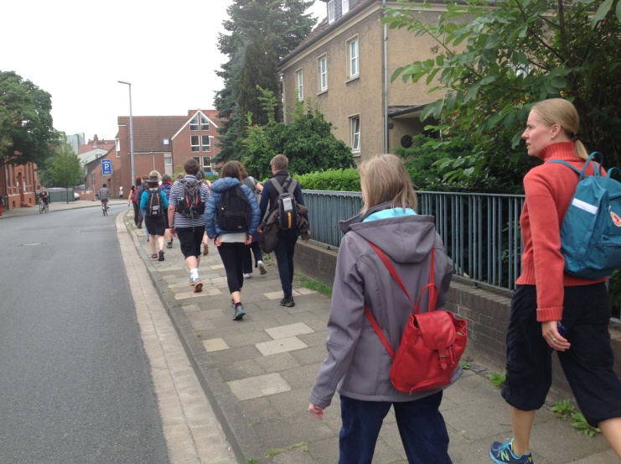
We saved the best to the last, on Thursday we rounded up our singing, painting, embroidery and spirituality/ nature sessions. By the evening, there was a brilliant choral display led by Fiona. The Abbess introduced the evening and welcomed friends of the Convent and local journalists. We were treated to lovely cakes, cold and hot drinks. We were not ashamed to go for seconds! We showed off our paintings and embroidery. It was great to have Patricia and Oktavia with us throughout, filming the encounter sensitively and participating in this wonderful experience.

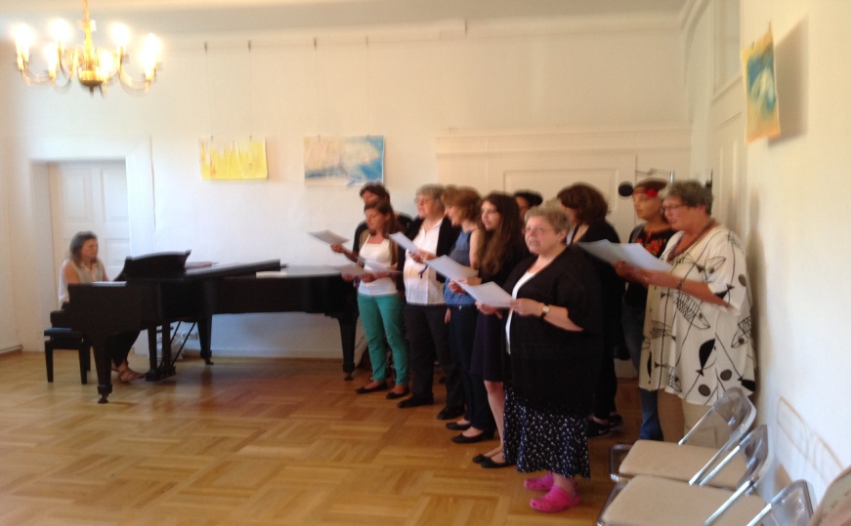
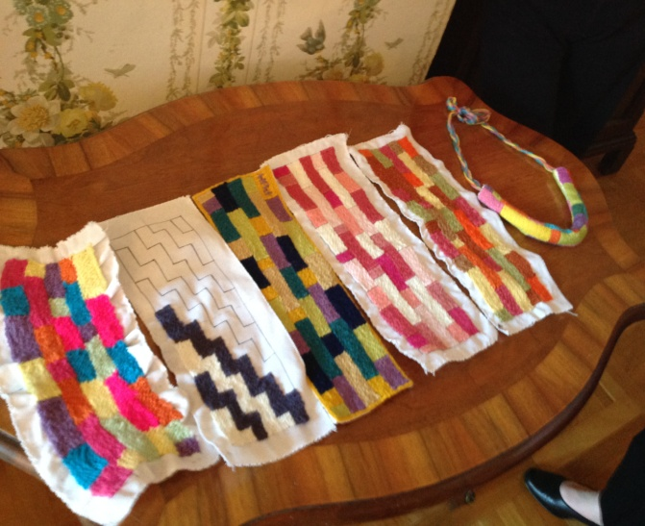

Prior to that, we found time to visit the Animal Health research institute across the road to us. We learnt how science had improved both quality and quantity of farm products in the past 200. In the 1800, a farmer produced enough to feed 10 families. Now with mechanisation and improved productivity, a farmer could feed 132 families. One of the great contributions of the institute apart from its success in cloning bovine was the storing genetic material of German food animal breeds endangered of extinction due to low productivity. The Food and Agriculture Organisation has been encouraging each country to try to maintain a gene pool of its livestock where possible to store the sperms in liquid nitrogen

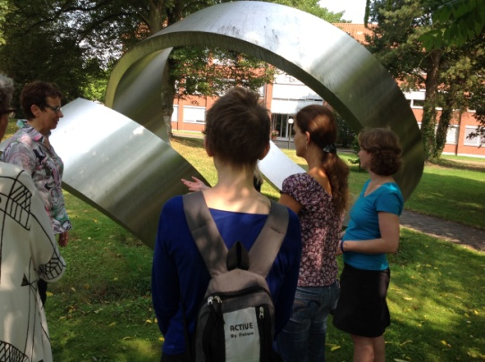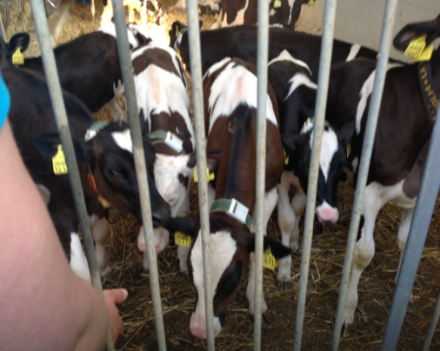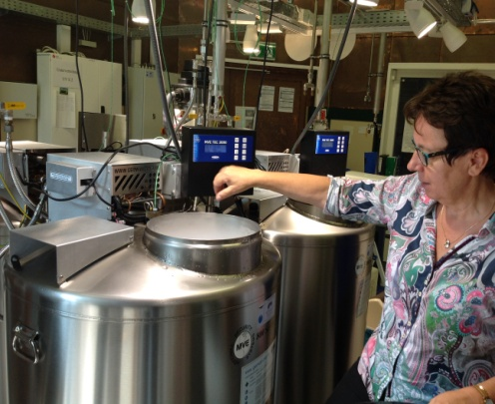

It was also noted how society is resistant to genetic engineering of animals for ethical reasons however the number of women having in vitro fertilization to have babies has risen from 10,000 women per annum in 2000 to 50,000 per annum in 2010 or thereabout. That’s life!

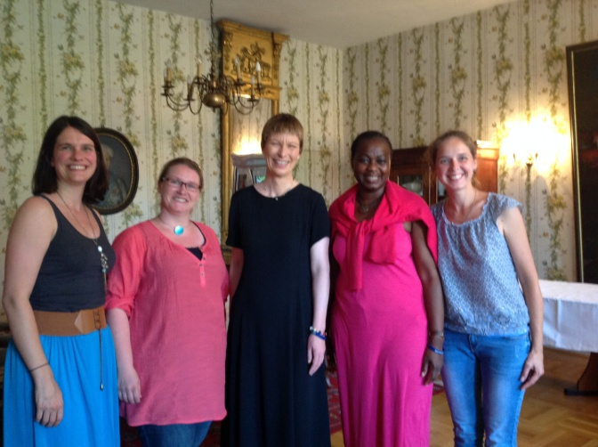
In the evening we had a wonderful buffet with lots of wine flowing. We also brought un-perishable edible foods from our countries to share. My friend Marijana brought vegetarian brandy from Serbia. I told her I would like to taste the non-vegetarian one, ha ha ha!. The festive spirit was brilliant and we ended it by seating in a big circle and shared what we would take with us - mine was the experience of living in a monastery with twenty six women of different ages, cultures, languages and ecumenical background. We sang and danced... We will walk with God my sister, we will walk with God. We will go rejoicing, till the kingdom has come... The chatting went on past midnight.

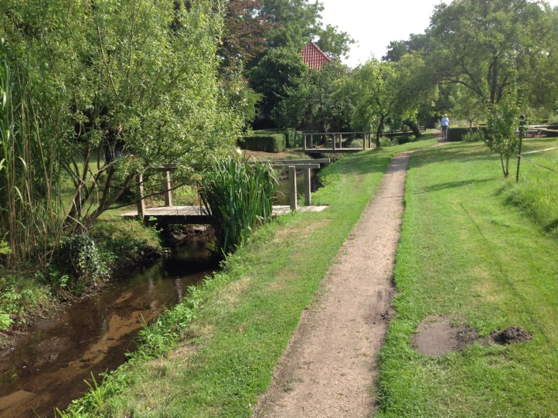
Next morning...surprise, surprise; we had breakfast without silence, checked-in online for our return journey, stripped the sheets off the bed, had the blessing in the church and said our goodbyes at the front porch of the convent. It was an amazing experience I would recommend to any woman.

Still humming.... Listen and incline your heart. Open up your heart to God. Search for peace and silence....

The spiritual journey I encountered with friends will stay with me for life. It was surreal! I am thankful for the opportunity, the hard work of the facilitators, the hospitality of our hostesses, the friendship of the ladies and my sponsorship by the Methodist Church Britain.

Romans 15 verse 13 – Now may the God of hope fill you with all joy and peace in believing, that you may abound in hope by the power of the Holy Spirit.
Thank you
Dr Bunmi Olayisade
Africa Partnership Coordinator
Methodist Church Britain

