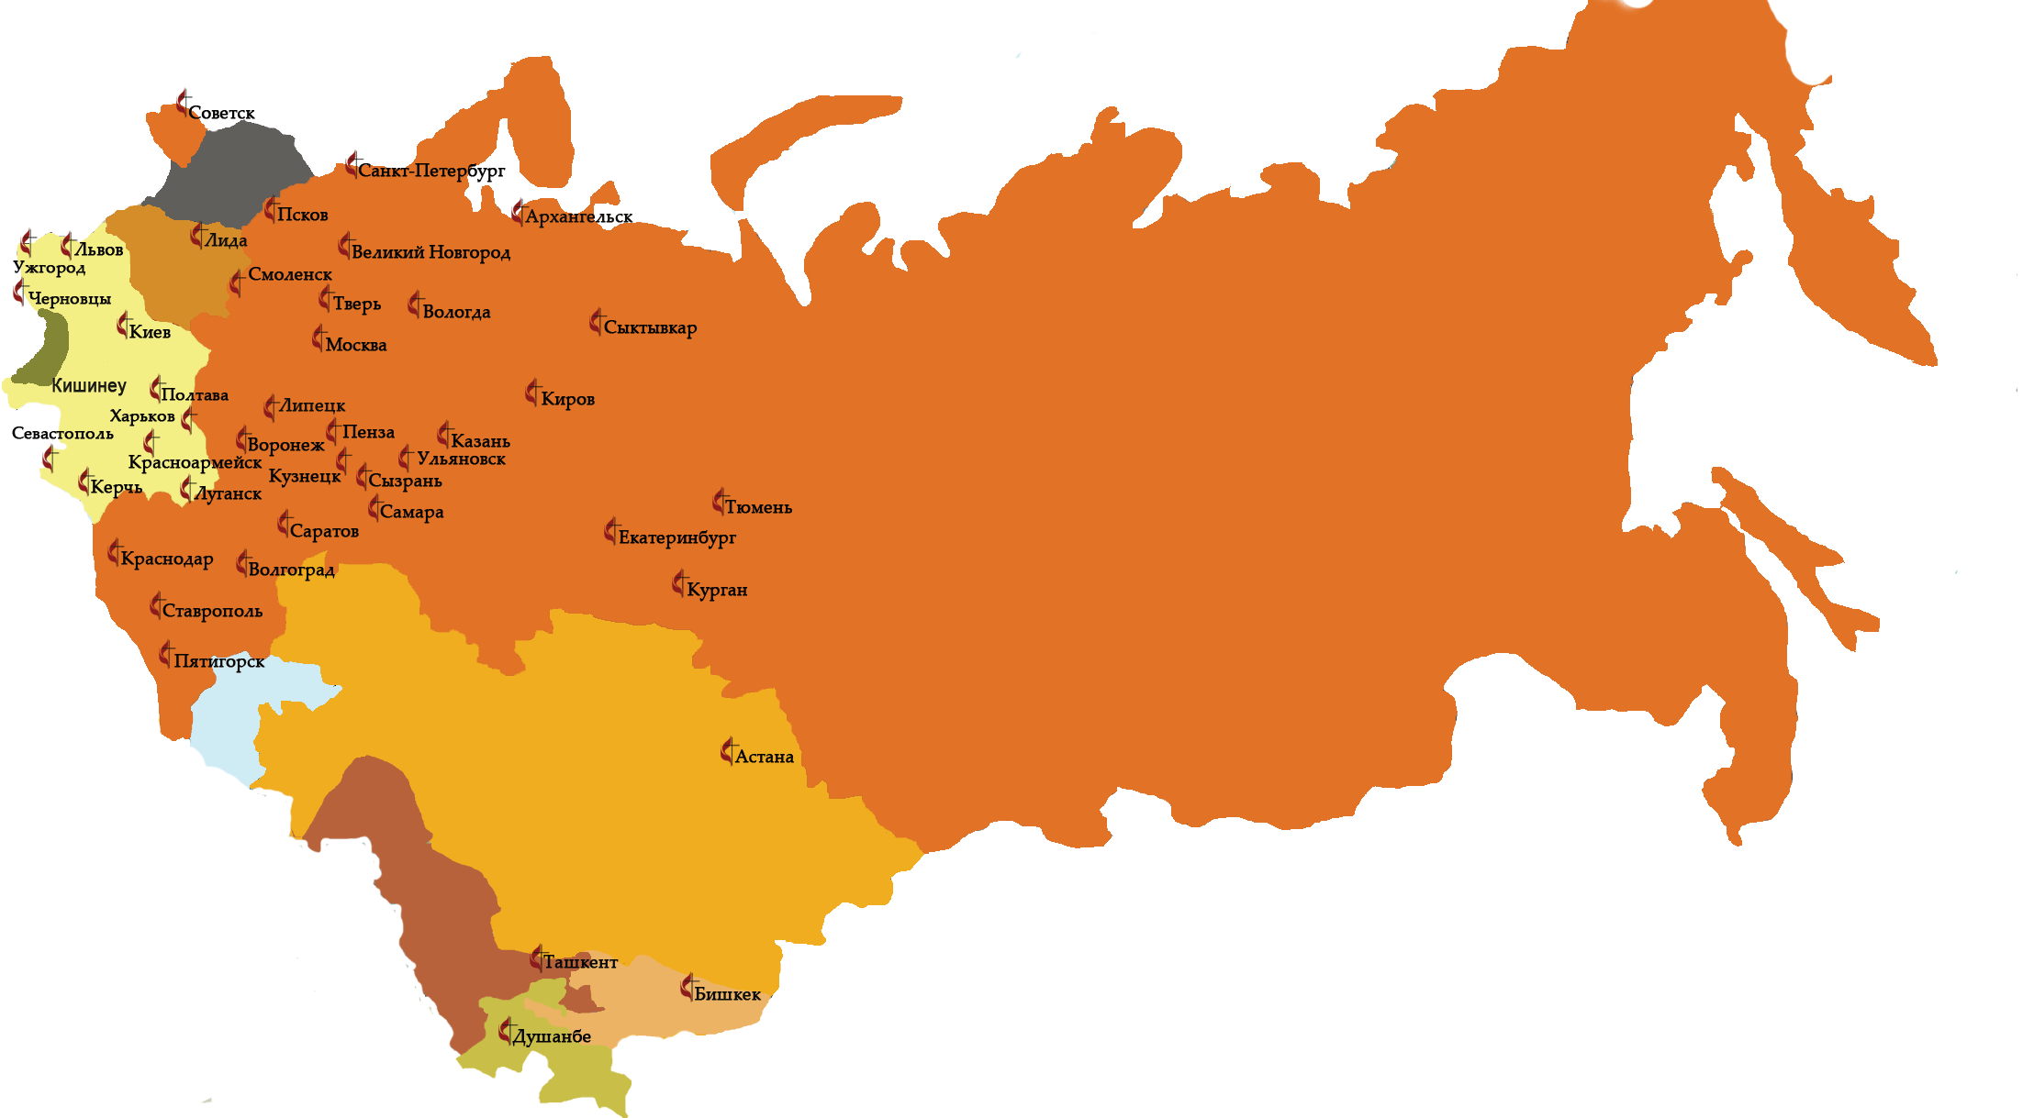
Visit Report – Russia
August 2014
David Friswell

“125 Years of Spirit Movement: Preserving Traditions, Transforming the Future”
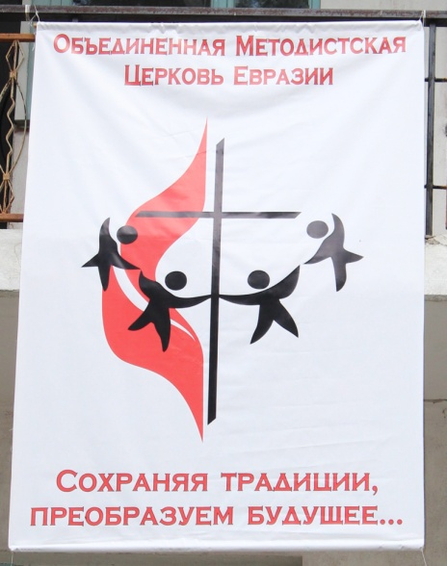
Aims: 1. To represent the Methodist Church in Britain at the 125th anniversary celebrations of Methodism in Russia and the Eurasia region.
2. To gain a greater understanding of Methodism in Russia, to meet key individuals and explore issues affecting the church in the region.

Introduction:
Methodism began in Russia with migrants from Scandinavia arriving in the north eastern areas of the region in the late 1800s. Churches grew in size and number until the changes in the political system that saw the closing of churches and the scattering of those of faith. More information on this can be found on the Boston University Russian Methodist History web pages (http://digilib.bu.edu/russianmethodism/about/)
The Festival Banner

With the fall of Russian communism in the early 1990s, new Methodist churches emerged in the UMC tradition stretching from the Baltic coast in the west through to Vladivostok in the east, the arctic circle in the north and the Urals in the south.
The Conference is led by Bishop Eduard Khegay who is of old Korean descent and from a family that suffered forced relocation and ethnic persecution during the rise of communism.
In recent months the region has seen the splitting of Ukraine with Crimea moving to Russian rule and the tensions in eastern Ukraine continuing during the time of the visit. (Although the issue of Ukraine did not form a major part of discussion or debate at the celebrations, various conversations I had with people from across the region showed how powerful the local media is at presenting different viewpoints on the situation. There were differing opinions on who was the aggressor, who was suffering because of the fighting and who was responsible for fuelling the tensions.)
The Russian Federation covers a very large area. (289 times the size of the UK) During this short visit, focussed in only two places, it was impossible to build an overall, comprehensive picture of the whole country, its economy, the people or even the churches. However the people I was able to meet and the places I was able to see gave both an impression of still being tied into an old, tired regime and yet had a real vision for all that the future may hold. Owner ship of property and cars appears to be the drive of the middle class whilst at the same time 1 in seven men are alcoholic and the average life expectancy is only 64. (Overall, a quarter of Russian men die before reaching 55, compared with 7% of men in the UK and about 10% in the United States. The life expectancy for men in Russia is 64 years, placing it among the lowest 50 countries in the world in that category.)

Itinerary:
Tue 5th August Morning flight to Moscow – four hour flight, + three hour time difference
Met at Moscow (Dom) airport by Revd Nicola Vidamour (former MCB Mission Partner in Russia and one of the interpreters for the celebrations.)
Train and metro from airport to Seminary in Moscow for overnight accommodation.

Wed 6th August Metro across Moscow to meet coach for 8 hour journey to Voronezh (approx 320 miles south of Moscow). Transfer to small local bus in Voronezh to travel 45 minutes to ‘Crystal’ Methodist Camp in the heart of the Voronezh forest.

Thu – Sat 7th-9th Programme of worship, Bible study, workshops, activities, drama, music and celebrations.

Sun 10th August Depart Crystal Methodist Camp for morning worship at Church of the Resurrection in Voronezh. Early afternoon departure for return on coach to Moscow. Arrived Moscow 23.00. Overnight at seminary.

Mon 11th August Morning visit to central Moscow. Afternoon train journey to Airport for flight to UK.

Crystal Methodist Camp:
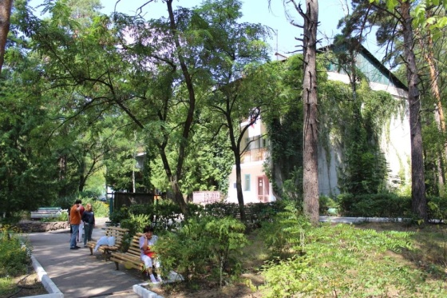
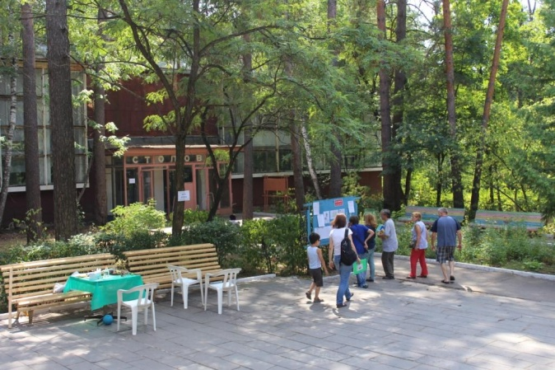
The camp was purchased by the Methodist Church a few years ago. It is a former summer holiday camp for employees of what was a state owned electronics company that ceased to trade after the fall of the communist system. There are two main buildings – an accommodation block and the main meeting / dining building. Restoration work is ongoing. The accommodation block was in good order though the main meeting block was in need of further structural and decorative work. Help on the buildings is been given by VIM work teams and through funding from the churches in Germany. The camp is set in the middle of
View towards the main meeting / dining room building
beautiful pine woods which stretches for miles around the city of Voronezh – approximately 320 miles south of Moscow. Other small log-cabin type buildings are spread throughout the camp which has a very welcoming and relaxed feel about the place. A small area of the camp has been sold off to a private buyer to help fund some of the renovation work. Opposite the camp is a large, slow flowing river offering a place to swim – and, as was the case during the celebrations, to baptise.
View towards the accommodation block

125 Celebrations Programme:
Although Methodism was established in the region 125 years ago (for which there was good cause to celebrate), the active membership has just over twenty years history of its own since the fall of the previous regime. Unlike some other former Soviet states that were required to ‘produce’ a number of Methodists from times past (eg Latvia needed to find ten elderly Methodists from before the rise of Communism to prove that Methodism had previously existed before they were allowed to register as a church), Russia was able to produce sufficient archive and heritage material to allow the church to be registered in 1992.
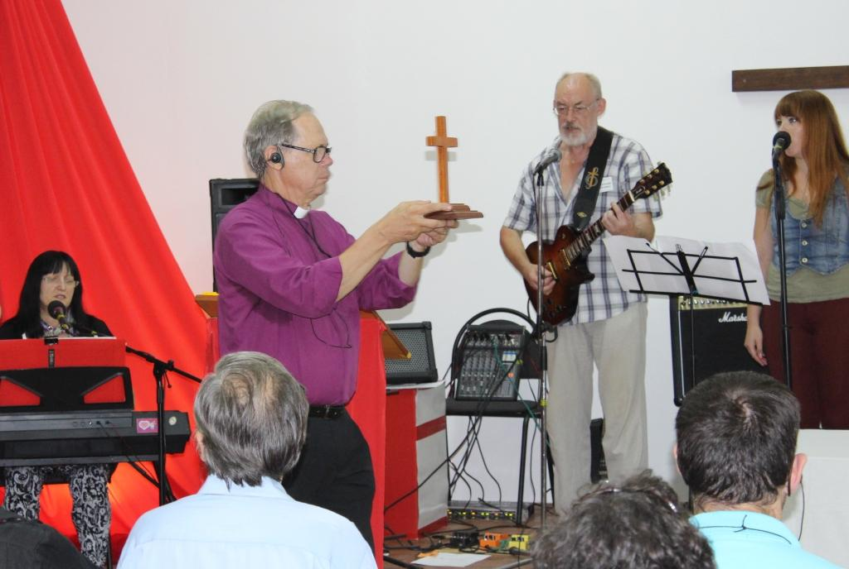
The celebrations were held at ‘Crystal’ Methodist Camp, Voronezh over a four day period. The time was a mix of celebration, festival, learning, sharing, fellowship and study. A little free time each afternoon gave an opportunity to play soccer, volley ball or table tennis, or swim in the nearby river. For those that did not so keen on physical activity the there was the option of quiet, individual meditation.
Wednesday evening began with opening worship ably led by the various worship bands, local pastors and the Bishop. A greater emphasis, than would be common in most MCB churches, is put on the praise and worship element within the services experienced. Many of the tunes were recognisable as contemporary worship songs eg Hillsong music, though the words were mainly in Russian. Preaching of the word took second place within the services and prayer was limited. However it was clear that Bible Study and prayer groups exist to offer an alternative to these having such an emphasis within worship.
Bishop Hans Vaxby bringing in the cross in the opening worship
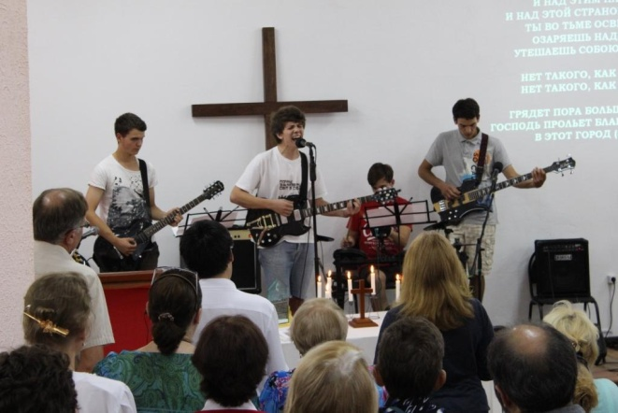
Each morning started at 08.00 with devotions led by pastors from across the Eurasia region. After breakfast the Bible studies were led by some of the invited guests with myself and Roy taking the lead on the first morning (thankfully assisted by Nicola Vidamour for both content, cultural input and of course interpretation!) The first day was focussed on the past, the second on the present and the third day on the future. However within our Bible Study we were clear to emphasise that the past can be used to form and shape the future – a theme that was well received and picked up throughout the few days.
Ukrainian ‘Boy Band’ worship group
It had been hoped that the first Bishop (Rev Rüdiger Minor) of the Eurasia Conference would have been present to lead the first days lecture, but due to various reasons he was not able to attend the festival. Bishop Hans Vaxby stood in and gave not only his lecture for the second day focussing on ‘the present’, but also the first lecture on the past outlining how far the church had come since 1894. Han’s lecture on the second day did look back over the last few years when he was Bishop of the Conference pointing out the real strength within today’s Methodist Church in Russia, its continuing growth, the commitment of the pastors and congregations along with the members commitment to social action within their communities.
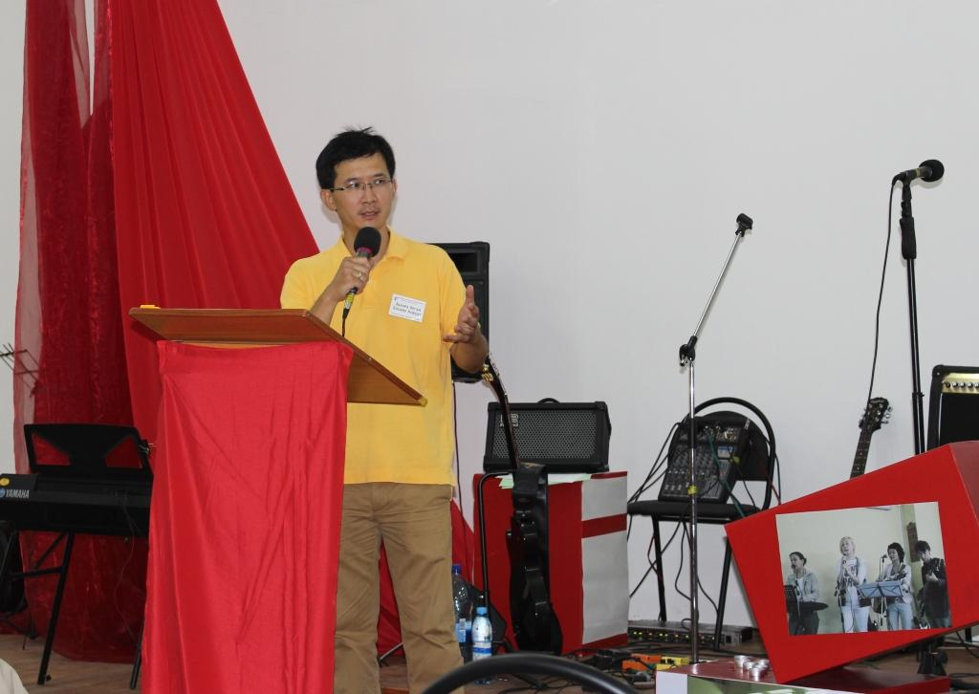
Bishop Eduard Khegay (present Bishop) gave the third day’s lecture scoping what the future church in the region might look like and what needs to be done to achieve this vision. It was very refreshing to hear a church (even one with limited numbers and resources, and covering a huge geographical area) really looking ahead at its role and mission.
After lunch each day there were organised ‘stations’ or groups looking at Russian Methodist History, Small Groups within Methodism, Social Outreach and Evangelism, and Using Music in Worship. It was possible to attend three out the four Stations during the event. I attended all apart from the
Bishop Eduard Khegay
music station. These stations gave the opportunity for input from the group leader and then questions and discussions within the group. These allowed a much greater insight into the current thinking and actions of the membership of the churches.
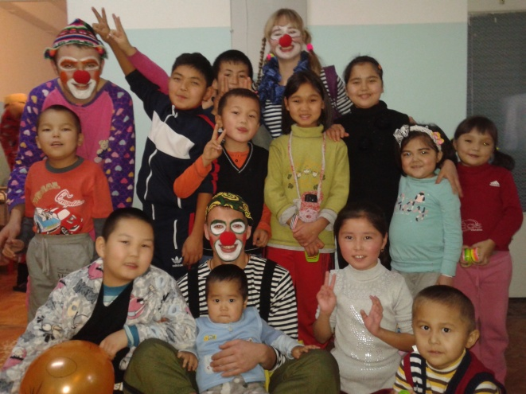
Small groups in the traditional British tradition of Methodist class meetings or house groups are currently uncommon but many received the format with real interest. Discussions quickly showed how our historic tradition could be adjusted to suit current Eurasian ways of being church. Great interest was shown in my Membership Ticket and the role of pastoral visitors.
The Social Outreach station looked at current models of outreach and discussions in the group I was in centred around what is (or isn’t possible) in areas like Kyrgyzstan where Christians are not allowed to speak of their faith outside their church building, cannot distribute Bibles or any other Christian literature and cannot work with children. It was very interesting to hear how opportunities were found to share the Gospel and the results/effects of this work in colleges and hospitals.
The hospital clowning ministry of young Kyrgyzstan Pastors
The Russian Methodist History project is being led by Sergei Nikolaev who also heads up the work at the seminary in Moscow. This work is being supported by Boston University with more digitised records being added to the web on a regular basis. Although there was less time for conversation during this station it was clear that many families had been deeply affected by the dispersement of ethnic groups in the Great Purge of the late 1930s

After lunch small workshops were held – mainly craft activities but also a short music workshop. This workshop led by the DS Irina Mitina of Southern Russia & the Caucasus (now including Crimea) used both Russian and English music of differing styles showcasing the range that can be used within worship. Irina became a Christian and Methodist later in life having spent some years as a rock, Jazz and opera singer. She is full of life and character and highly skilled both as a musician and a singer. She would be an interesting person to bring across to the UK if we were looking for someone to increase the diversity of world music within our own tradition.
District Superintendant Irina Mitina attempts ecclesiastical break-dancing

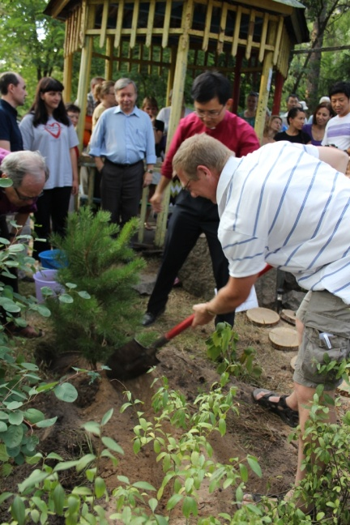
Dinner and evening worship (including lengthier sermons!) were followed by prayer groups for the first two evenings and then a musical drama focussing on Jesus knocking on the door of our hearts and the seven deadly sins! I was told that the drama was written by a Russian playwright but that the setting to music and the song lyrics were the recent creation of the musician and worship leader at ‘Resurrection Methodist Church’ in Voronezh. Despite its length it was brilliantly delivered by local church members.

The closing worship of the festival took place on Saturday evening culminating in a tree planting ceremony to remember the anniversary. It was an honour to be one of the three overseas guests involved in the planting and maybe one day I will return to see a fully grown tree next to the stone with the plaque.

Sunday morning worship was in Voronezh itself at the Resurrection Methodist Church. This is an interesting church as it has a special ministry to African university students who have received scholarships to study in Russia. On the Sunday we attended, a number of the students were leaving after finishing their studies and were presented with certificates and gifts. Mainly from West Africa these young people first have to learn Russian before they can both study and participate fully in worship. However they are fully accepted and integrated into the life of the church and were able to ‘field’ a high quality music group for part of the service.
Tree planting ceremony
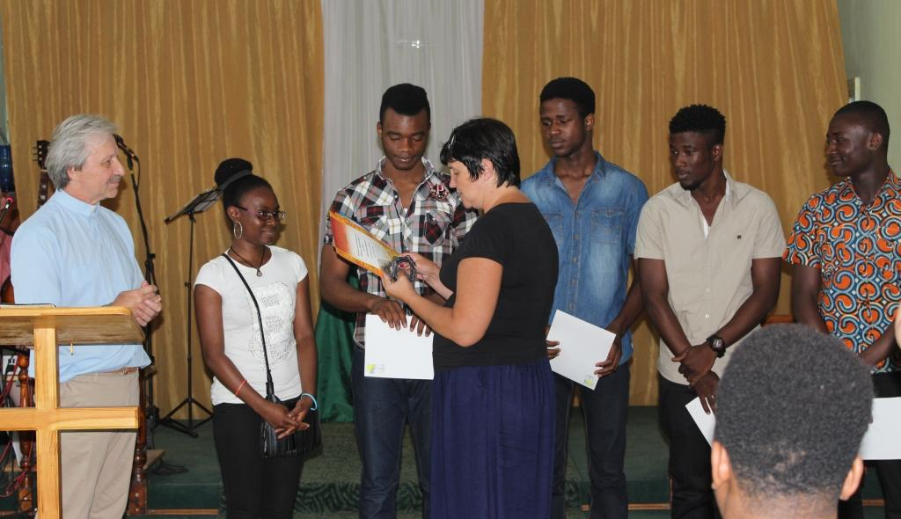
Sunday afternoon and evening were spent on the long bus journey back to Moscow – arriving back at the seminary at around 23.30. The following morning Nicola acted as tour guide for Roy, myself and the two German women and took us to briefly see a few of the sites in the centre of Moscow. The early evening flight home was delayed resulting in missed train connections in the UK and an overnight stay in London before returning home.
African university students at Resurrection Church, Voronezh
Conversations:
Unlike many overseas visits where the itinerary is such that there is constantly somewhere else to move on to and someone else to meet, this visit had the real advantage of spending quality time with people for the Russia and across the Eurasia region. This gave the opportunity to start to build relationships with specific people and engage in much deeper conversations about the life and work of the church across the region.

Conversations ranged from talking about the Ukraine situation through to Methodist Heritage in the UK – and everything between! Some of the best conversations were with the group from Bishkek. Yulia is one of ‘our’ NMAs working in the university teaching paediatrics. However she is also involved in a very active ministry to the students. Working in a country that limits the chances to share a Christian faith she is able to support a hospital visiting ministry, run regular ‘forum’ meetings for students interested in Christianity and support overseas students from across the Asia region. I wasn’t able to find out how she found the time to do all this – but the fruits of her work were with her in the group that she brought to the festival.
One of these young people was a young Indian man who had finished at the university in Bishkek a year ago. Coming from a Hindu background, whilst at university he felt called to commit his life to Christ due to the encounters he had with Yulia and her work. However due to pressure from his family back home in India he was unable to make a public commitment at that time. Now a junior doctor and more independent from his family, he made the journey especially from India to Voronezh to be publically baptised. This took place at 07.00 in the nearby river and was a deeply moving experience with around 40 people from the festival supporting him along with the Bishop and his own Pastor from Bishkek performing the ceremony.

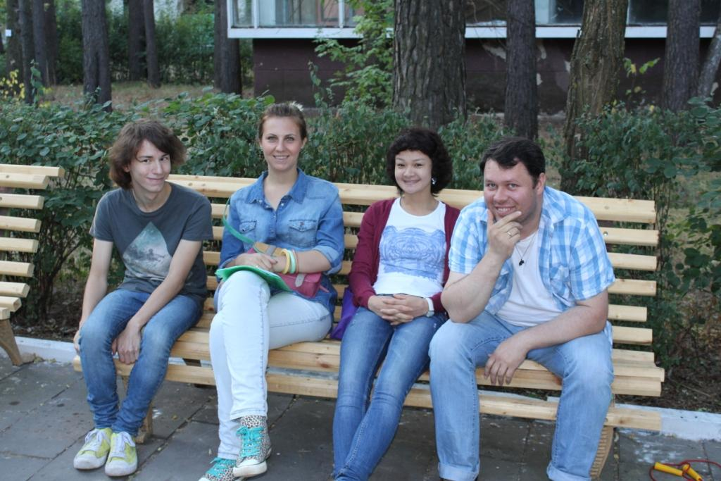
I took the opportunity to spend time talking to a number of young pastors from across the region. The term ‘pastor’ covers a number of roles and may or may not mean that the person is ordained in our usage of the word. Some pastors are more like local preachers while some can be youth workers etc. However, a common thread that quickly became obvious was the dedication and commitment of these young pastors. They are all focussed on evangelism and bringing people into the faith and the church. Their vitality is infectious and it really showed how important it is for a church to have young adults in these leadership roles so that real relationships with others of a similar age can be built.
Church leaders from across the region

With the reason for the celebrations being an historical one it was perhaps not surprising that many participants were interested in their Methodist Heritage. I have experienced similar conversations with Methodists from Latvia where those from churches where their ‘current’ history only dates back around twenty years, there is a real desire to learn more about their ‘historic’ heritage. This helps to explain why they have some of the traditions and practices as Methodists along with underpinning the special nature of the denomination. It is clear for them, that to know about the beginnings of Methodism, enables them to be ‘better’ Methodists. Being in a UMC environment it was interesting to hear the British Methodist church being called the ‘grandmother’ church. It was clear that within Britain we don’t understand or use our past as much as we should to shape our current and future work.

The camp ministry appears to work well in the UMC Eurasia context. The fact that the church has its own dedicated camp centre puts this ministry high up its priorities. Those attending the camps are usually a mix of young Methodists and those who are non-Christian. I was told that they have a well developed mentoring system where individuals who are not part of the church are mentored by one of the young Methodists. In the States they are beginning to take this further through the ‘Eli’ programme which offers training and support for mentors in return for a year’s commitment to participate in the camp ministry and mentoring other young people. There were some similarities with the OPP programme within MCB. Many of the Eli mentors have themselves been on the receiving end of being mentored at the camps in the past.

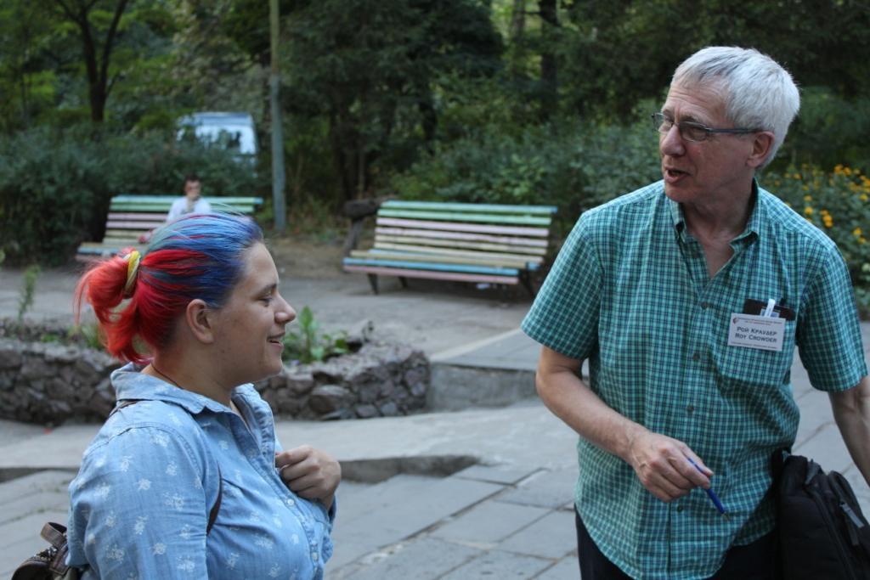
MCB support and relationship:
The details of our financial support for the region are available through the Grants paperwork. However it was good to see the work of an NMA in action! (as mentioned above).
In some ways it is difficult to discern how the relationship between MCB and a UMC Conference should play out. What became much clearer to me whilst at the Festival is that our relationship is much more about being a small church in a large Europe region and how we interact with our Methodist sisters and brothers (of whatever Wesleyan or Methodist background) across that region of which we are part. We may
Roy Crowder wondering if he might look younger with blue and red hair!
be seen as the historic ‘mother’ or ‘grandmother’ church but
we are also very much part of the today’s church across the region.

Personal Reflections:
This was a visit that I came home from both fired up and yet somewhat saddened.
Fired up: because the five days had ended up being a time of personal renewal and revitalisation as I experienced a church that was alive, enthusiastic and committed to sharing the love of Christ in ways that were very much appropriate to the culture and circumstances in which it exists.
Saddened: because these were not the signs of life and hope that I find in our church here in Britain. I appreciate it is easy to make sweeping statements and take experiences out of context but I do feel we have much to learn when it comes to being a confident church that is clear of its purpose, can relate well across the age ranges and brings life and hope into its work.

For further details and images please see:-
http://www.umc-eurasia.ru/en/125th-anniversary-spirit-movement-preserving-traditions-we-transform-future-umc-eurasia-festival

