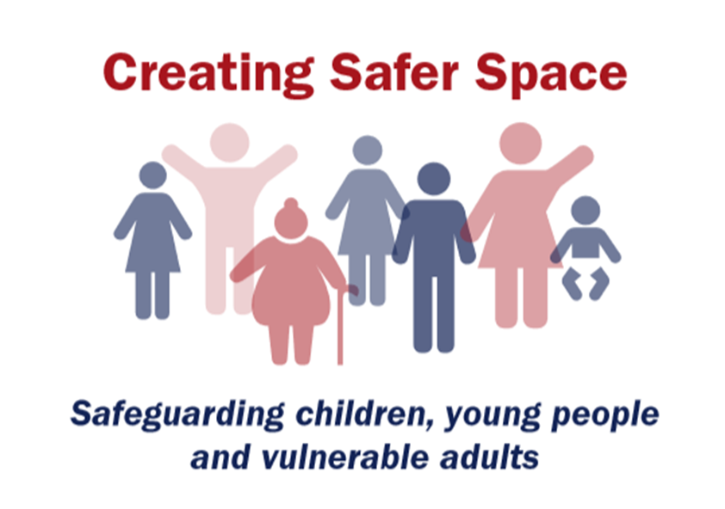
Name:
has completed the
CREATING SAFER SPACE FOUNDATION MODULE 2020 EDITION
Safeguarding training on
Date:
Aims of the Foundation Module 2020 training is to support you to:
- appreciate how safeguarding is everyone’s responsibility and fundamental to the culture of a flourishing Church
- have a better understanding of good safeguarding practice within the Methodist Church, and understand its unique position in creating a safe space for all
- promote awareness and extend an inclusive welcome to those who have experienced abuse
- recognise, respond, record and refer relevant concerns about the safety and welfare of a child or adult, and recognise blocks to good practice
- learn from evidence from the Methodist Past Case Review (2015-17) and note the current national context

Signed: | Name:
Role: | Circuit:

