A brief history of the Methodist Church in Britain

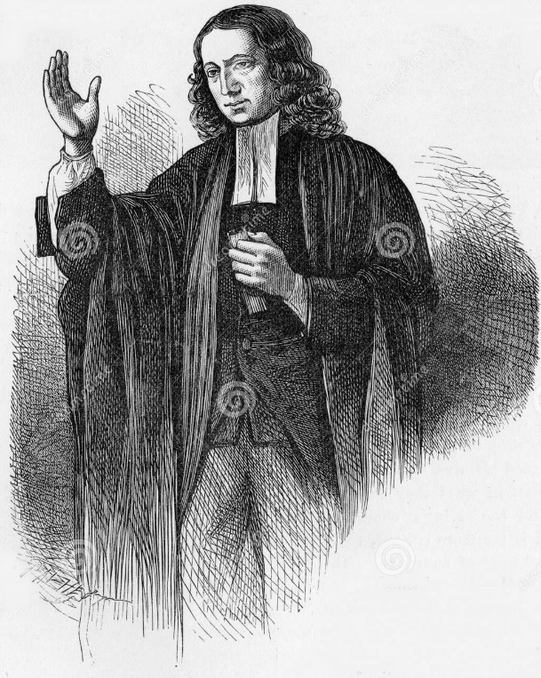
Image by Awcnz62 | Dreamstime.com on Unsplash

Methodism began during the 18th century evangelical protestant revival. This was the time of the agricultural revolution. There was rapid population growth and an increasing gap between rich and poor. It was also the age of the beginning of the British Empire.
There was spiritual renewal across Europe and North America. Protestant denominations and church numbers increased. The Methodist Church grew out of the ministry of John and Charles Wesley, taking the gospel to those who were not part of the Church of England’s parish system. They established local classes and societies and organised a conference of those who followed their preaching.

In the 19th century, the industrial revolution brought even more population growth and social change. There was urban growth and a further increase in the gap between rich and poor. The Methodist movement split into different churches. Legal restrictions against non-conformist Christians were removed and church numbers grew rapidly.

The Methodist Church also began missionary work across the British Empire, becoming a global church. The Church was active on social issues, including campaigning against the problems caused by alcohol, deprivation issues within cities, and for the establishment of trade unions.

At the start of the 20th century, the Primitive, Wesleyan and United Methodist churches came back together, forming the current Methodist Church in 1932. The missions in cities developed a social work outreach. Overseas Districts become autonomous Conferences, working together through the World Methodist Council. Methodist Homes was established in 1943 and has become the largest charity care provider in the UK. The Methodist Church began the ordination of women in 1974. In 1978, the Methodist Conference declared racism a “direct contradiction of the Gospel of Jesus”. From 1981, Methodist and Ecumenical Leadership Racism Awareness Workshops began under the leadership of Sybil Phoenix and the Revd Vic Watson. The Methodist Community and Race Relations Committee was established in the 1980s. This became the Racial Justice Committee in 1995, then the Committee for Equality, Diversity and Inclusion in 2014, before the adoption of the Strategy for Justice, Dignity and Solidarity in 2021.

In 2003, the Methodist Church signed a Covenant with the Church of England with “the goal of full visible unity”. The Methodist Church in Britain is now a multi-cultural church, with members who have come from the Methodist family from around the world.

In 2021 the church affirmed that there are two understandings of marriage and made practical provisions for both the view that marriage can only be between a man and a woman and the view that marriage can be between any two people. This has enabled same-sex marriages to be conducted in Methodist churches.
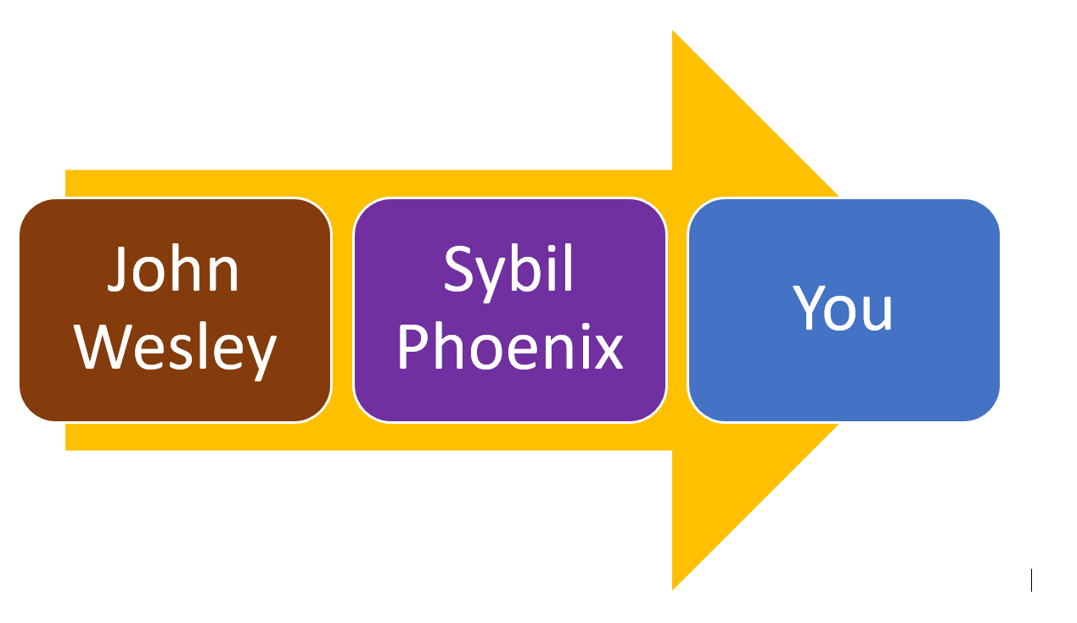

Social Justice
For John and Charles Wesley, good works were a core part of Christian living, along with prayer and Bible study. Caring for the poor, prisoners, widows and orphans was an important part of a Christian life. Methodists did not only care about welfare, they also aimed to ensure justice. John Wesley was influenced by Olaudah Equiano. His last known letter urged the abolition of 'that execrable villainy' slavery. The Wesleys influenced prison reform and, inspired by Susanna Wesley, were pioneers in education. John Wesley wrote about theology, politics, music, marriage, slavery and medicine.
Methodists were to work to improve the lives of others. John Wesley taught to "Make all you can, save all you can, give all you can." Throughout its history, the church has responded to the social problems of its day. In the 18th century, this included reaching out to those who were not part of the parish structure of the Church of England and faced legal restrictions, and opposing slavery. In the 19th century, the church campaigned against alcoholism and was active in forming trade unions. Children's Homes were set up to provide for children living in the street and the charity National Children's Home (NCH) was founded in 1869. In the 20th century there was social work outreach in cities and Racism Awareness Workshops in the 1980s. NCH became Action for Children, in recognition of the provision of a range of services to support children in the home.

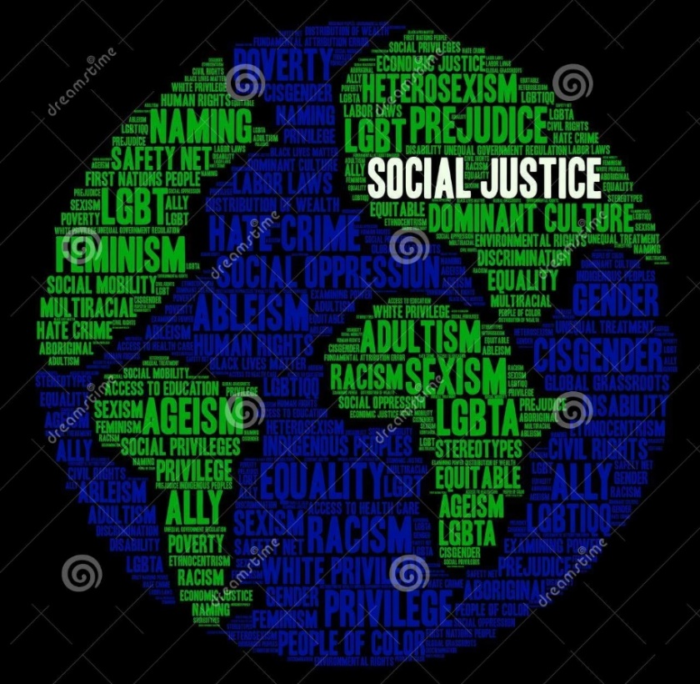

Image by Arloofs Dreamstime.com on Unsplash

Our Calling as Methodists today

Our Calling as the Methodist Church today is to respond to the gospel of God's love in Christ and to live out its discipleship in worship and mission. We do this through Worship; Learning and Caring for one another as Christians; Service to those in need and challenging injustice; and Evangelism to share the good news of Jesus Christ with others.

This requires a culture where we care for one another, are inclusive, and are connected to one another by being centred in God. We all depend on one another and the relationships we have are mutual. This places ‘belonging’ at the heart of church life. Methodists believe God’s grace is offered freely to all people. Hospitality, openness and welcome for all are key to demonstrating God’s grace and love for all. This welcome needs to include opportunities for each person to participate fully as ourselves. John Wesley taught that the Holy Spirit changes us and we become “perfected in love” and “filled with the love of God and neighbour”. So we seek relationships with a deep appreciation of one another, in which we discover God working in and through us all.

There has never been a perfect Christian community. Broken relationships, discrimination and exclusivity have all been part of the life of the Church. This is still true today. Tragically, there have been incidents of discrimination, coercive control and abuse of power which have not been challenged. Our Church falls a long way short of the interdependent Body of Christ we are called to be by God. Within the Church, some people are not accepted, respected and treated as equals. This must change.

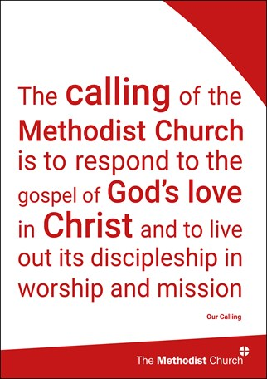
As the Methodist Church, we are called to engage positively with wider society and with our local communities. Many of us have experiences at work and in our communities which can help us all learn to relate respectfully to each other within the Church. By having positive relationships with others across difference within the Church, we also learn more about the world around us. This learning can equip us to engage with our neighbourhoods, workplaces and society today.

