WEEK OF PRAYER FOR CHRISTIAN UNITY
an introduction by David Carter

These resource notes are intended to help preachers and worship leaders who are planned to take services during the Week of Prayer for Christian Unity (18 – 25 January) and wish to acknowledge it, whether primarily in the intercessions or throughout the whole service.

- Origins of the Week of Prayer
- Other prayer resources
- Suitable hymns
- Texts and Preaching
- Methodism and the Ecumenical Movement
- Looking forward
- Supporting theological resources
- Some useful quotations
- The spirituality of the Ecumenical Movement and the Week of Prayer for Christian Unity

- Origins of the Week of Prayer

In 1908, the Revd Paul Wattson, then an Anglican priest, suggested an octave, i.e. eight days, of prayer for Christian Unity. In the 1930s, the French Catholic ecumenical pioneer Fr. Paul Couturier popularised the idea in his native Lyon. He realised that Christians from other churches could not be expected to pray for unity specifically under the Pope, as previously advocated by Wattson, who had been an Anglican papalist, so he proposed prayer for unity ‘as Christ wishes and by the means which he desires’. He believed that all Christians could pray this, bearing in mind the Lord’s own prayer in John, chapter 17.

Even before 1908, there had been stirrings of conscience in the Christian world about its divisions. In 1740, for example, a Scottish revivalist recommended praying for all churches.

From Lyon, the practice spread rapidly across the world and was eventually taken up both by the World Council of Churches and the Roman Catholic Church. Every year, a different country, through its national ecumenical organisation, produces some material for prayers, services and reflection during the week and this is then widely used. See Singing the Faith Plus for information about the 2024 Week of Prayer for Christian Unity.

Alongside the Women’s World Day of Prayer, usually held in early March, the Week of Prayer for Christian Unity is now the most globally widespread of all such acts of intercession and reflection. It reminds us of the importance of learning from Christians in all other denominations and countries.

- Other prayer resources

Apart from the material supplied through CTBI, there are updated versions of the prayers used by Fr. Couturier, which may be reproduced free of charge. These include both prayers of confession and intercessions. For further information, contact David Carter (see below).

- Suitable hymns

Relatively few hymns have been specifically written for an ecumenical context but many express suitable ecumenical sentiments. Wesley’s Christ from whom all blessings flow (StF 676, H&P 764) with its reference to ‘rendering all distinctions void’ is particularly relevant. So are Jesus Lord, we look to thee (StF 686, H&P 759) and some other Wesley hymns originally written ‘for the society meeting and parting’. Turton’s ‘O thou who at thy eucharist didst pray’ (HP 779) is particularly good in the context of a communion service. Richard Jones’ Come all who look to Christ today (StF 678, H&P 765) particularly celebrates unity in diversity.

See also other hymns in the Life and Unity in the Church section of Singing the Faith (StF 675-692).

Singing the Faith Plus also highlights hymns published on the site that explore the realities of accepting diverse views and concerns within a united Christian community.
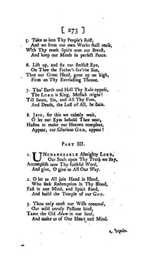
Charles Wesley did write a hymn that reflects John 17: 21, ‘Unchangeable, Almighty Lord’ (left). Originally included in Wesley’s Hymns and Sacred Poems (1742) as one section of a longer text, it is headed ‘Striving together for the faith of the gospel’ and also alludes to Isaiah 37: 16 and Jeremiah 32: 39. It was not included in Singing the Faith, Hymns and Psalms or even the 1933 Methodist Hymn Book. But if you have access to earlier Wesleyan hymn books (the 1877 Wesleyan Hymn Book has it, #505), it contains some beautiful verses for meditation. See also Hymnary.org. Verse 2 reads:

O let us All join Hand in Hand,
Who seek Redemption in Thy Blood,
Fast in one Mind, and Spirit stand
And build the Temple of our God.

- Texts and Preaching

John 17: 20-26 is the supreme text but far from the only one that can be fruitfully explored in the context of prayer for Christian unity. It is helpful to look at that reading in the context of what is said both about the unity of Christ and the Father and the inextricable link with mission.

The Letter to the Ephesians as a whole is the great epistle of the Church, though particularly important are Ephesians 1: 3-10, which sets unity firmly in the context of God’s plan for uniting all things in Christ; and Ephesians 4: 1-16, with its teaching on the spirituality of unity, diversity of gifts and the common calling to maturity in Christ.

Other texts/passages that are illuminating from the point of view of particular aspects of the search for unity include:

Psalm 133

Ezekiel 37: 15 – 28
This passage about the eschatological reunion of the kingdoms of Israel and Judah follows immediately on from the famous passage about the dry bones.

John 10: 16
‘Other sheep I have which are not of this fold’ etc.

Acts 2: 42 – 47
On the fundamentals of unity

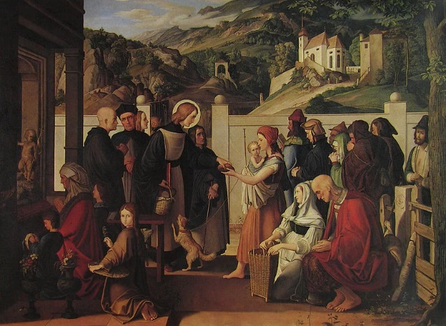
Acts 4: 32
On being of one heart and mind (remembered in the
old Guild motto ‘One heart, one way’) (Picture right:
‘Saint Roch giving alms’, by Julius Schnorr von
Carolsfeld)

Romans 12: 1 – 13
(Especially v.10 about ‘preferring one another in
honour’.) This gives a chance to consider how far the
basic virtues of daily Christian relationships within a
particular local congregation also apply to our
relationship with Christians of other traditions and
denominations.

Romans 14
About the treatment of those who are ‘weak in faith’ and the love and consideration to be shown to others when we cannot agree totally with them. Verse 15 (‘If your brother is being injured by what you eat, you are no longer walking in love’) repays very careful thought as to what it can mean today in an ecumenical context.

1 Corinthians 3
Especially vv. 21-2: ‘All things are yours, whether Paul or Apollos or Cephas or life or death or the present and the futures, all are yours and you are Christ’s; and Christ is God’s.’

1 Corinthians 12
(Especially. v.13.) Has key teaching on being baptised into the one body and all drinking of the same Spirit.

Philippians 2: 1 – 11
Noting especially the first few verses before the Christ hymn, since these stress humility and ‘looking to the interests of others’, and chapter 4: 1 – 8.

Revelation 7: 9 – 17
The unity of the martyrs from across the nations (and now, we would add, denominations), a theme strongly stressed by the late Pope John Paul II, even more so by Pope Francis.

- Methodism and the Ecumenical Movement
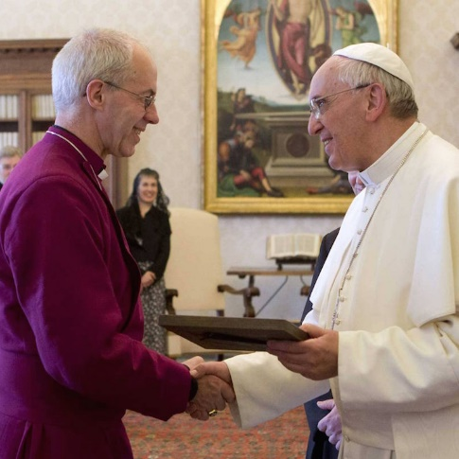
Even before the modern Ecumenical Movement, Methodism affirmed the value of learning from other Christian traditions and Wesley recommended many writings, both Roman Catholic and Protestant, to his preachers in his Christian Library. In his famous Letter to a Roman Catholic, he said, ‘If we cannot think alike at least let us love alike.’ (Pictured left: Pope Francis and the Archbishop of Canterbury, Justin Welby, meeting at the Vatican in 2021)

In 1820, the Wesleyan Conference called on the Methodist people to ‘ever maintain the kind and catholic spirit of primitive [i.e. early] Methodism towards all denominations of Christians holding the Head’ [i.e. holding the basic doctrines of the Trinity and the divinity of Christ].

In 1840, William Shrewsbury, a missionary returning to work in Britain, wrote his Scriptural Account of the Wesleyan Methodist Polity, defending Methodism’s connexionalism against the attacks then being made on it by churches in the ‘independent’ tradition (Baptists and Congregationalists), and also by high church Anglicans. He called on Methodists not to respond in like manner but always to seek to see the best in other Christians and their churches.

Later, when the modern Ecumenical Movement began, Methodism was at its forefront through the work of such people as John R. Mott and John Scott Lidgett. Methodism from the end of the Second World War sought closer relations with the Church of England and the other Free Churches, taking part also since the late 1960s in dialogue with Roman Catholics. Methodists have joined in United Churches, usually with Anglican and/or reformed churches, in India, Canada, Australia and some other countries. We have played our part in the World Council of Churches and national councils of churches. Many local Methodist churches form part of local ecumenical partnerships and joint churches, particularly but not exclusively, with Anglican and URC churches. In addition to this, the Anglican–Methodist Covenant (2003) pledges both denominations to work more closely together. In 2008, a report to the Methodist Council reiterated the principle that we should work as closely as possible in mission with other Churches.

In 2015, the Methodist Church in Ireland entered, under its covenant with the (Anglican) Church of Ireland, into full inter-changeability of presbyteral ministry, an agreement that has stimulated interest both here and in New Zealand. Similar proposals continue to be under consideration (now sadly delayed) within the Church of England and British Methodism and certainly deserve prayerful consideration in the Week of Prayer for Unity. An important point to note is that both Churches concerned consider their closer unity to be a contribution to a fuller and wider unity of all Christians and their Churches.

- Looking forward
The prospects for further progress towards Christian unity have improved over the last few years.

One key factor is that more and more Churches have in the last few years joined Churches Together in England as a sign of their desire to share in witness to the Gospel together. Orthodox, Pentecostalist, ‘black-led’ and ‘new’ Churches have been particularly among their number. In the past, they have not always been keen on working with other Churches, but now they are far readier to share with others and be engaged in the one mission of Christ in his Church.

A second key factor is the extraordinary ministry of Pope Francis, who has a deep regard for all Churches, in which he sees the presence of the Spirit moving people to service of the least and poorest. He reaches out to the whole range of Christendom and enjoys close relationships with Pentecostal pastors as well as with Orthodox bishops and patriarchs. I have material available on his ministry, ecumenical and evangelical, that I am happy to share with anyone. (Contact details below). Most recently, he has called for ‘synodality’ in the Church; consultation on key modern issues with all the people of God, lay and ministerial, not just his fellow bishops. He is very keen on the widest possible links and sharing, something that resonates with our own ‘connexionalism’. A large synod of leading Catholics met recently in Rome. It included laymen and women as well as clergy. The Pope looked to it to see what reforms and changes may help the whole Catholic Church be more faithful in mission, witness and service. On 6 October 2023, The Tablet (Roman Catholic journal) quoted the Pope as saying to the synod: ‘Let us walk together, not only Catholics but all Christians, all the baptised, the whole people of God, because only the whole can be the unity of all.’

Pope Francis’s 2020 encyclical (letter to the whole Church) is entitled in Italian Fratelli Tutti (‘All brothers and sisters’). The title instantly reminds us of Christ’s words: ‘Inasmuch as you have done this for the least of my brethren, you have done it for me.’ The letter is subtitled: ‘On fraternity and social friendship’. The pope calls for a ‘universal love that promotes people (I suspect a better translation into English would be ‘affirms’). Chapter 4 is entitled ‘A heart open to all the World’. It is vintage Francis, calling us back to Christian basics in love of God, our fellow human beings and God’s creation.

- Supporting theological resources

The most recently Conference-approved statement on the Methodist understanding of the Church, Called to Love and Praise (1999)* includes quite a bit of material relevant to the search for Christian unity. See especially Section 2.4 on the marks of the Church as ‘one, holy, catholic and apostolic’; and Section 3.1 on ‘Sharing in Unity’. Paras 3.17-9 deal with the concept of the Church as communion/koinonia, i.e. the view that the Church is essentially a sharing in the communion that God the Father establishes with us through his Son and his Spirit and in which we then share also with all others whom God invites to share that communion and to share in God’s mission to the world. This concept of Church as communion has become the major building block in modern ecclesiology (doctrine of the Church) across the major denominations.

*Called to Love and Praise: Statements and Reports of the Methodist Church on Faith and Order, vol 2, 1984-2000, part 1, pp 1-63 (Methodist Publishing House)

- The spirituality of the Ecumenical Movement and the Week of Prayer for Christian Unity

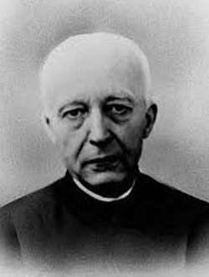
This can be particularly well studied through a volume of essays
commemorating the 50th anniversary of the death of Paul Couturier
(pictured right), a key pioneer of the Movement. Woodruff, M (ed)
The Unity of Christians: The Vision of Paul Couturier (2003)
ISBN 0 851910 33 5. As well as material on Couturier himself, the
volume also includes an essay by Fr. Francis Frost on ‘Christ in the
Hymns of Charles Wesley: A spirituality for the unity of Christians’,
and articles on interdenominational ecumenical communities, such
as Chemin Neuf (New Way).

My article comparing Couturier and William Shrewsbury is available by e-mail attachment (contact details below). In it, I show how both men were utterly loyal to the claims and the discipline of their respective Churches, yet, at the same time, believed they had much to learn from other Churches. They both called upon the members of their own denominations to repent of any disdainful attitudes towards others and to conduct themselves humbly in listening to the witness of Christians from other traditions.

Some useful quotations

‘In order to unite, you have to love one another, in order to love one another you have to know one another, in order to know one another you have to go to meet one another.’ (Cardinal Mercier, a Belgian, and the instigator of the first modern ecumenical dialogue, with a group of Anglicans, which took place at Malines in Belgium, 1921 – 26).

‘It is by promoting holiness within its own limits that each church may most effectively benefit other churches . . . This is the scriptural way to provoke to love and to good works.’
(William Shrewsbury, Wesleyan Methodist minister, writing in 1840)

‘How can we love the one Christ without loving his very historic and mystical extension in His own Church . . . How can we love as brothers (and sisters) in Christ all those marked by his baptism without suffering as we admit that the family of the baptised is a broken one’?
(Paul Couturier, Roman Catholic pioneer of the Ecumenical Movement)

‘Visible Christian unity will be attained when the praying Christ has found enough Christian souls of all communions for him to pray freely in them to his Father for unity.’
(Paul Couturier)

David Carter is a local preacher in the Bristol and South Gloucestershire Methodist circuit. He has had an interest in the Ecumenical Movement and Christian unity since his undergraduate years, when a group of Roman Catholic fellow students first aroused his interest in another major Christian tradition. David has been a member of the Methodist-Roman Catholic committee, 1990 – 2013, and was Secretary of the Churches Together in England Theology and Unity Group, 1995 – 2016. If you have questions relating to ecumenical matters, contact David on p. 0117 956 5447
or via e. david@carterbristol.eclipse.co.uk.

