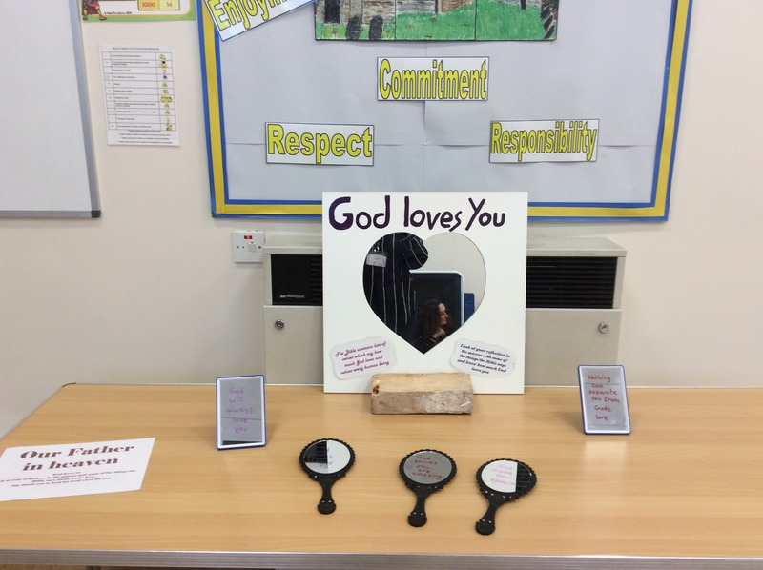

Prayer Station 1
Our Father in heaven
God loves us and says we can call Him Father. This prayer station reminds us of this.
Mirror with words written on them with permanent marker.
‘Nothing can separate you from God’s love’
‘God thinks you’re amazing’
‘God loves you’
‘God will always love you’

Look in the mirror and read the words if you can.
God is our Father and cares for us. Say thank you to God for God’s love for you.

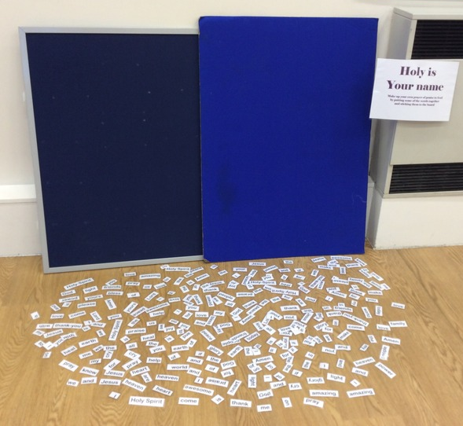

Prayer Station 2
Holy is your name
Write a prayer of praise to God
Have a number of different words with Velcro backs which children can make into their own prayer of praise to God by sticking them on a board.

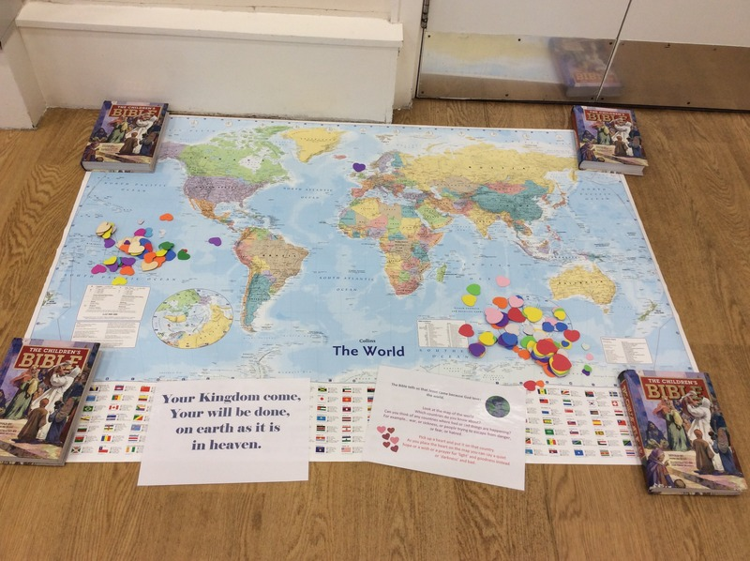

Prayer Station 3
Your Kingdom come, Your will be done on earth as it is in heaven
Praying for the world – that it would become more like God created it to be.
Map of the world – think of countries you have heard about or places where people might need prayers. Put a heart shape on the map on that country.

Prayer Station 4
Give us today our daily bread
Use plasticine or play doh to make your favourite food or other thing. As you draw thank God for it. Pray for people who don’t have enough – ask God to help them. Ask God to help you to think of ways you could help them.

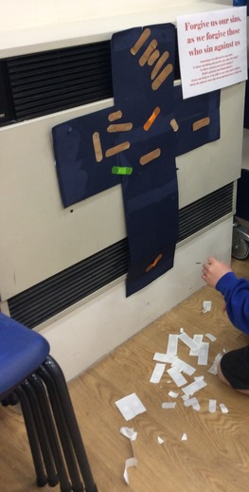
Prayer Station 5

Forgive us our sins as we forgive those who sin against us
Large cross shape and plasters.
Is there anything you need to say sorry for, to God or to other people?
Is there anything you need to forgive?
Hold a plaster and think about it and then stick the plaster onto the cross – Jesus can help us to say sorry and to forgive others.

Prayer Station 6

Lead us not into temptation but deliver us from evil
God can protect us.
Write or draw some of the things that frighten or worry you on rain drop shapes. Pray that God will help you to not to be afraid and surround you and protect you with his love. Then put the drop in the umbrella, leaving your prayer with God.

