Guidance Notes for The Co-operative Bank Community Directplus Account
These guidance notes are for Methodist charities that are not registered with The Charity Commission because they are excepted from registration under the Charities (Exception from Registration) Regulations 1996, which is due to last until 31 March 2031.
A Community Directplus account must be opened online and all supporting documents have to be uploaded to the Co-operative Bank website.
You will also need to upload a letter from Legal and Constitutional Practice (LCP) to support your application. To request a letter, please email LCP at LCP@methodistchurch.org.uk
The letter contains specific information that the Co-operative Bank require excepted Methodist charities to provide in order to open a Community Directplus account and your application will be rejected if you are not registered with the Charity Commission and fail to attach this letter.
If you are registered with the Charity Commission, you do not have to request a letter as you meet the Co-operative Bank’s standard requirements.

If you are ready to apply, please follow the steps below:
1. Click here to start, or if this link is not working search for ‘Community Directplus’ on co-operativebank.co.uk/business
2. Once on the Community Directplus webpage, click on “Apply for an account”.
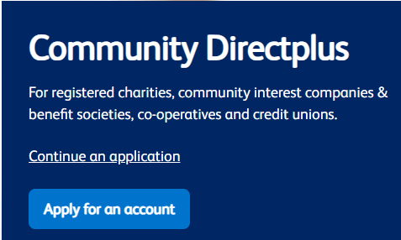
3. Read the “How to apply” and “Before you apply” sections which outline the various requirements.
4. Under “Apply”, answer the question: “Does your organisation have eleven or more Key Individuals?”
If the answer is “No”, you will continue with a digital application.
If the answer is “Yes”, and your charity has eleven or more Key Individuals, you cannot use the digital application process and you will have to download an application form to complete manually. You can access a PDF version of the manual application form once you confirm that your charity has more than eleven Key Individuals.
5. Under “Are you a …” please select the box that states that you are a “Registered Charity”. The Co-operative Bank has advised that you should select this option even if you are not a registered Methodist charity, as this is the only way an application can proceed.
Your answers should be as follows:

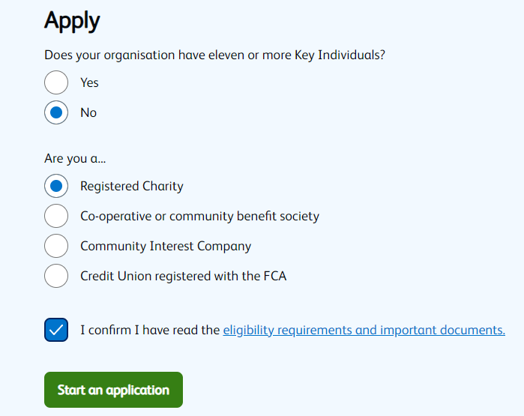

6. Click on “Start an application”.
7. Under organisation type, please select “Registered Charity”.
8. The governing document for all Methodist churches is the Constitutional Practice and Discipline (CPD) and the Co-operative Bank have confirmed they will accept this. If you are asked to provide evidence of this document, please state that the document is too large to attach and copy and paste the following link:
https://www.methodist.org.uk/for-churches/governance/cpd/
9. Please follow the online instructions to complete the remaining sections.
If you have any queries, please contact Robert Pounds at Robert.Pounds@co-operativebank.co.uk and he will be able to assist you.

