Explore Army Chaplaincy
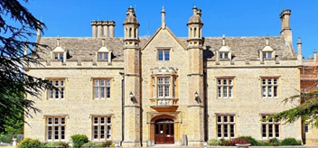
Beckett House
Course: 16 – 20 September 2024
Beckett House, Armed Forces Chaplaincy Centre, Shrivenham
The course comprises a mixture of lectures, visits, and interaction with serving chaplains and soldiers. There is plenty of time for discussion and quiet contemplation.
Optional Placement: 23 – 27 September 2024
An opportunity to experience ministry alongside chaplains at Regimental Duty.

Army Chaplains:

Caring for the Army’s People
Life as an Army Chaplain is a calling like no other. Belonging to a remarkable organisation of young men and women, sharing your life with them, and serving alongside them wherever they go brings tremendous opportunities and challenges. It is a vocation that is both demanding and rewarding and offers an adventurous journey of faith.
A Vocation as an Army Chaplain or Non-Religious Pastoral Officer
The purpose of the Royal Army Chaplains’ Department is to care for the Army’s people. Our Chaplains, who are Professionally Qualified Officers, deliver pastoral care to everyone,facilitate spiritual support and offer moral guidance to the whole force and their families irrespective of faith, world philosophy or status.

Interested in finding out more contact: Judith Ashbee
Email: Judith.ashbee855@mod.gov.uk
Mobile: 07970 506867
Air/rail fares, food and accommodation are provided.

