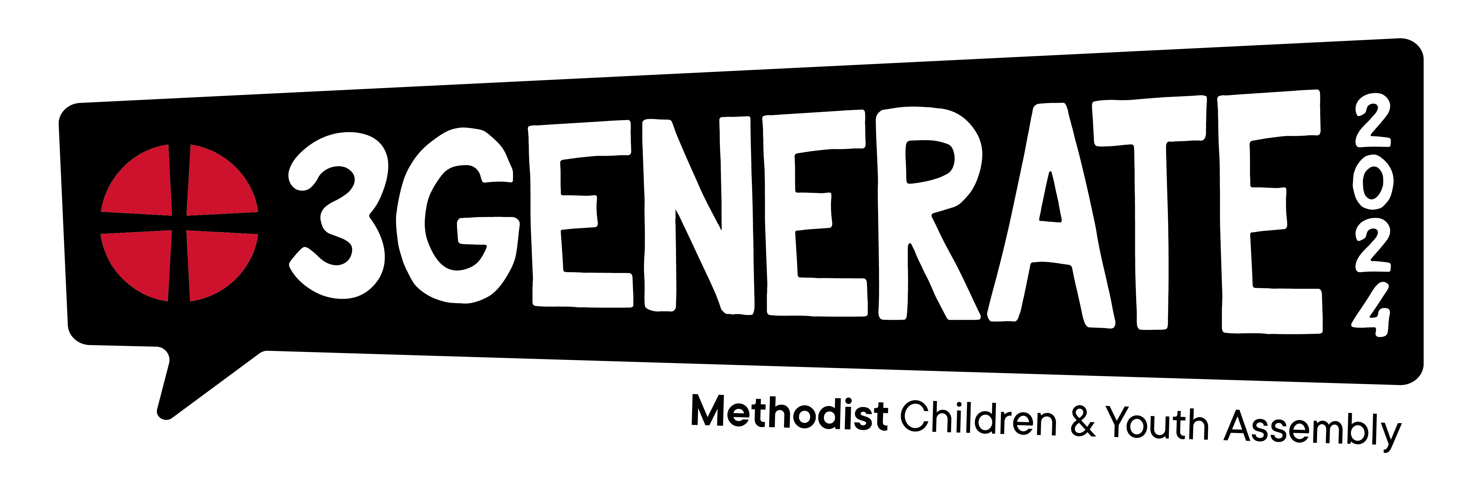
Payment (BACS) Form
Thank you for your booking for 3Generate 2024

Please complete this form and email to 3Generate@methodistchurch.org.uk
To pay via BACS, please use the following details:

Name on Account: The Methodist Church No 1 account
Bank Name: HSBC
Account Number: 20033472
Sort Code: 40-02-06

- Use the ticket reference as the BACS payment reference
- This will help us match your payment faster and avoid delays
Send payment alongside this form

Ref: 3G23XXXX

Group Name:
Group Leader (key contact):
District
Circuit
Leader’s Email:
Treasurer Name/ Who’s paying?
Treasurer email
Treasurer phone number
Booking Reference Number (on ticket email):
Example:
IK-TK01-0000XXXX
Total number of 8-23s Weekend Tickets: | £ ( x £120)
Total number of 8-23s Saturday Tickets: | £ ( x £60)
Total number of 4-7s Short Day First Child Tickets: | £ ( x £40)
Total number of 4-7s Short Day Additional Child Tickets: | £ ( x £30)
Total number of 4-7s Long Day First Child Tickets: | £ ( x £50)
Total number of 4-7s Long Day Additional Child Tickets: | £ ( x £40)
Order Total: | £
Notes:

