Equality Diversity and Inclusion Training Module

Trainers’ notes

Contents

 | Page
Getting ready for the training session
- Who can deliver the training? | 3
- Materials and equipment | 3
- On the day  - Ways of working | 4  4
- Question Park | 4
- Signing-in sheet | 5
- Being aware of, and planning for, resistance | 5
- Maintaining appropriate boundaries | 6
- Timings | 7
Delivering the training session
- Welcome | 9
- Delivering the modules | 9
- Module 1: Welcome: Working towards a fully inclusive Methodist Church | 11
- Module 2: Why is this important for the Methodist Church? | 17
- Module 3: Methodism Today | 20
- Module 4: What sort of change are we committing to? | 25
- Module 5: What does the strategy recommend? | 37
- Module 6: Opportunities for Action. What next? | 44
After the training session
- Certificates | 48

Getting ready for the training session

Who can deliver the training?

Anyone is able to deliver this training. There is no requirement to have a trained facilitator. It is recommended that there are always two people, so that one is able to act as a chaplain when required.

Trainers should complete the training themselves first, either on MCBX or within another group setting.

Materials and equipment

The materials needed to deliver the session include:

- Equality, Diversity and Inclusion Training Module PowerPoint presentation
- Computer, projection and sound facilities. The computer will need to be able to connect to the internet
- Equality Diversity and Inclusion Training Module worksheet resources
- Bibles
- Signing-in sheet
- Welcome signs
- Question Park
- Post-it notes
- Pens
- Refreshments

It is also good practice to have coloured acetate overlays available (for those who find it hard to read black text on white paper, a coloured acetate overlay can make reading handouts accessible).

The training session follows the same structure as the material in the JDS User Guide. If copies are available, it may be helpful for participants to have these to follow as they go through the training.

On the day

Trainers should arrive early to check all equipment. Check that internet access is working. To play the videos, click the blue links in the PowerPoint. You may find it helpful to open the videos that need to be played later. You can then skip past any adverts and pause the video at the start, ready to play when required. Check the projection of slides and adjust the background if required to ensure slides are legible for all participants.

To create a welcoming atmosphere, set up the room with chairs around tables. Avoid straight rows where possible. Place pens and post-it notes on each table.

Ensure there is a sign on the door and someone to welcome people personally and help them sign-in. Have refreshments ready for people when they arrive.

If the venue has facilities, set up a quiet room so that anyone who needs to go out has a comfortable, safe space to use.

Ways of working

It can be useful to agree some ways of working with the group. This works best if the group generates their own response to the questions “What will make this time together effective?” Some responses may need exploring, such as confidentiality. Having the list visible, such as written on a flipchart, means it is easy to refer back to it if needed. An example list is:
- Respect difference in views and feelings
- Be a good listener
- Challenge constructively
- Monitor our own air space
- Respect boundaries of confidentiality
- Move around if you need to
- Put mobile ‘phones on silent

Question Park

This is a useful tool to keep the session moving. If someone has a question about an issue that will be covered later or can’t be answered immediately, they can write it on a post-it note and put it on the Question Park. This can prevent a group becoming spending too much time focusing on one issue. Make sure that each table has plenty of post-it notes so they can write questions as they go.

Signing-in sheet

To comply with General Data Protection Regulation (GDPR), participants must be informed of their rights and provided with information about how their personal data is held and used. The signing-in sheet is only for use on the day, for fire regulations and to produce certificates or pass on an attendance list. After this, individuals’ personal data will not be kept.

Being aware of, and planning for, resistance

It is possible that some trainers will encounter resistance from within groups who are undertaking equality, diversity and inclusion training. It may be helpful to consider this in preparation for the training.

When individuals on an equality, diversity and inclusion training course are resistant to what is being said, it often stems from the need of the participant to:
- exert their control
and/or
- defend their weakness

Equality, diversity and inclusion material can be difficult and distressing and a resistant participant may be struggling to deal with discomfort or pain. Resistance in training can be off-putting and difficult for both trainers and other participants. These guidelines can help in preparation for handling any resistance.

Forms of resistance | Possible ways to deal with it
Asking questions not directly related to the topic | Use the Question Park
Taking issue with the details of a case study | Keep the focus on the learning objectives and avoid getting into debates about detail.  Notes that the case studies in the Module 3 quiz are all real examples from the Methodist Church, told in the person’s own words.
Controversial questions, or those that are not directly related to the topic but engender a lot of interest | Explain that while this is very interesting, there is not time to discuss it as well as covering the material in the course, and that you need to keep focused on the course
Competing with the trainer for authority | Try not to get into a competition.  Aim to use the knowledge of the person challenging you but without alienating the rest of the group
Asking questions to which you don’t know the answer | Don’t pretend to know what you don’t.  Use the Question Park and explain that you will find the answer and send it to them after the training session
Avoiding the task | Reflect on why this is happening but without blaming individuals
Noting gaps or contradictions in the content | Try to avoid a debate.  Agree to note their concern and pass it on to equality&diversity@methodistchurch.org.uk
Directly challenging the trainer | Try to avoid a one-to-one confrontation with a participant or take it personally. Aim to divert the challenge and defuse the situation. It may be useful to have a short break or to have the second trainer or chaplain take the individual for a one-to-one conversation
Questioning the legal context | Signpost them to the EDI Toolkit module on the law which may answer their questions: edi-toolkit-1-3-0923.pdf (d1yuutt686hfi0.cloudfront.net)

Points to keep in mind:

- The resistance is not a personal attack
- Resistance is the manifestation of an underlying problem. You may not be able to resolve the problem within the training session, but you may be able to improve the experience for the rest of the group
- Keep a clear focus on the learning aims and objectives
- Be available for the individual separately should they wish to share with you their difficulty with taking part in the training
Maintaining appropriate boundaries

The following points to consider may help maintain appropriate boundaries when sharing personal examples whilst leading an equality, diversity and inclusion training session.

- Stay professional. Sharing personal stories or emotions should not get in the way of delivering the training and meeting the aims and objectives.
- Stay respectful. Hold in mind those you know. Would you think it appropriate for their story to be related in this way? If not, then don’t say it.
- Share on a need-to-know basis. Participants on a training course need to know a certain amount of information. They do not need to know everything that you know. So as you plan and speak, edit what you say.

Timings

The suggested timings are for a four hour session, with a halfway break. You may need to adjust these timings depending on the size of your group, or add in extra breaks.

It is possible to complete the session in less time by having participants read some of the worksheets in advance of the session, or taking them away to read afterwards. You could also reduce the time for some activities. However, if material is left out completely, this will mean that the aims and objectives may not be met.

If material is sent electronically, please send it in an editable format, such as Word, so that participants can adjust the font, text size and background as they require.

It is also possible to adjust the structure of the session. For example, if there is a period of worship prior to the start of the training session, then some of the videos in module 4 could be used in that worship and would then not need to be repeated later. Alternatively, if a worksheet is being given to participants to read after the session, then the slide and notes that introduce that worksheet can be left until the end.

The training can also be broken down into multiple, shorter sessions as required.

There is also a version of this material written as study group notes and divided into five shorter sessions. Either can be adjusted as required.

It is important to decide the length and structure of session that will work best for your participants.

Detailed suggested timings

Section | Slides | Timings (minutes)
Welcome and introductions | 1 | 3
Module 1: Welcome: Working towards a fully inclusive Methodist Church | 2 | 1
Welcome and introduction to the course | 3 | 1
Overview of the course | 4-9 | 7
Opening prayer | 10 | 1
Module 2: Why is this important for the Methodist Church? | 11 | 1
Living out our beliefs | 12-13 | 15
What the Bible says | 14 | 10
What the Methodist Church says | 15-17 | 2
Module 3: Methodism Today | 18 | 1
The history and calling of the Methodist Church | 19-21 | 14
Equality legislation | 22 | 15
Equality in the church | 23-24 | 34
Module 4: What sort of change are we committing to? | 25 | 1
Structural, cultural and attitudinal change | 26-27 | 2
We are the church | 28-32 | 12
BREAK
We are the church | 33-37 | 30
Our own development | 38-39 | 16
Personal responsibility | 40-43 | 14
Module 5: What does the strategy recommend? | 44 | 1
Strategy for Justice, Dignity and Solidarity (JDS) | 45-50 | 14
Methodist Church Equality Impact Assessment | 51-53 | 27
Knowledge of the JDS Strategy | 54-57 | 2
Module 6: Opportunities for Action. What next? | 58 | 1
Further training and sources of support | 59-60 | 6
Question Park | 61 | 6
Summary and close | 62-63 | 3

Delivering the training session

Welcome

Slide 1
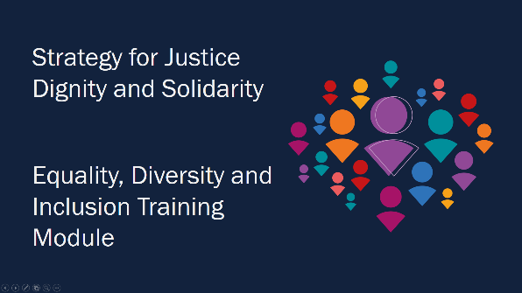

This slide can be projected as participants settle and take their seats.

Trainers should introduce themselves to participants. They should also introduce their roles, such as who is the chaplain. It may not be possible to have a chaplain and a separate space for one-to-one discussion, but it is important to ensure that there is an emphasis on care for participants. Trainers should check all participants have signed-in using the sign-in sheet.

Trainers should explain the specific details of the venue being used, including the fire exits, toilets and refreshments.

Trainers should highlight the Question Park and explain to participants what to do if they have any questions throughout the session.

Delivering the modules

Trainers should work through the PowerPoint presentation and read the script that goes alongside each slide. This script is outlined on the following pages of these notes.

If participants have questions, trainers can decide whether to discuss them at the time or ask participants to record them using the Question Park. Bear in mind that pausing the script to discuss a question will have an impact on timings.

There are materials for participants to discuss materials in breakout groups. Trainers should consider the economic and environmental cost of printing all of these materials and consider whether they could be projected or shared electronically with participants before or after the session. If they are printed, this should be kept to a minimum.

When participants are reading these materials, trainers will need to consider:

- how much time to allow
- whether participants will just read and note the material or whether they will have opportunity for discussion
- whether to have a wider discussion amongst the whole group

This will depend upon the time available and the size and needs of the group.

Module 1: Welcome: Working towards a fully inclusive Methodist Church

Slide 2 (1 minute)
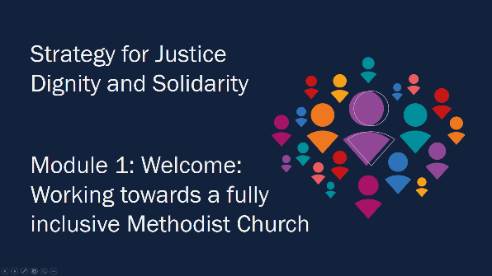

“Welcome to this foundation module course on Equality, Diversity and Inclusion. We all have our part to play in reflecting God's love.”

Slide 3 (1 minute)
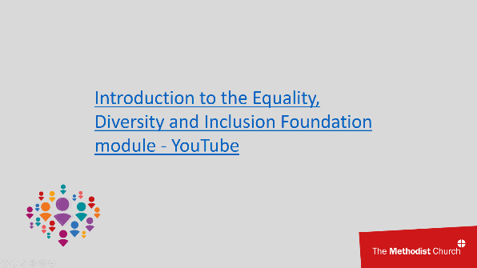

“Let’s listen to what Revd Jill Marsh, Inclusive Church Implementation Officer, has to say to us as we begin this course.”

Slide 4 (2 minutes)
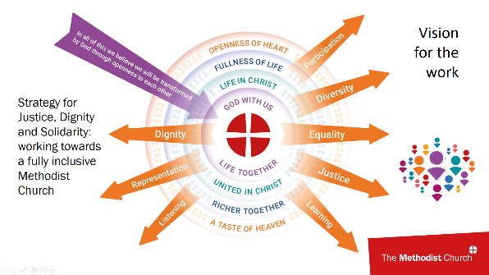

“We ask each Methodist to commit to life-long learning about the rich diversity of human life as part of our discipleship in following Jesus Christ. We do not want this course to be a tick box activity. Instead, we hope we can stay open to what we have yet to learn, so we can continue to develop as Methodists.

Case studies and stories play a central role in this course as they show real experiences, both positive and negative. The stories demonstrate how issues arise through different people’s life experiences. They help us to understand the pain of isolation, patterns of exclusion and inclusion, oppression, discrimination, joy, hope and fear. By sharing these case studies, we hope to encourage reflection, understanding and change on everyone’s part. Above all, we hope to encourage the unheard and marginalised to challenge our prejudices. This can help us all in the ongoing journey where we are still being changed into God’s likeness.

This course will outline why the Methodist Church has Equality, Diversity and Inclusion at its heart. It will consider the context of Methodism today and the changes that are needed to ensure a more equitable, diverse and inclusive church. Integral to this is the Justice, Dignity and Solidarity Strategy which was adopted by Conference in 2021. Being Christian, according to this strategy, means:
- celebrating God who made each person in God’s own image
- being disciples of Jesus who treated each person with dignity
- rejoicing in the gifts of the Holy Spirit given to all people.

The strategy also includes some mandatory actions for local churches, circuits, districts and the Methodist Council. These will help us to live together with a culture of justice and respect for all people. The tools recommended in the strategy will be explained, so that you can make use of them. These include the strategy User Guide, the Equality Impact Assessment, the Inclusive Language Guide, the Discrimination and Abuse Response Service and Solidarity Circles.

For change to occur, it is important to reflect on the content of this course and consider what commitments are needed and what further action you need to take.

As the User Guide states, this means becoming a church which:
- is free of all forms of discrimination
- celebrates the rich diversity of humanity and recognises that all people are made in the image of God
- has structures and processes which allow everyone to participate fully
- has a leadership which reflects the diversity of our membership
- offers safe spaces for the general public, and for members, to meet with a diversity of people, while still being honestly themselves
- ensures that its leaders are trained to understand issues of equality and exclusion
- listens to, takes seriously, and acts upon any reports of discrimination or prejudice.”

Slide 5 (1 minute)
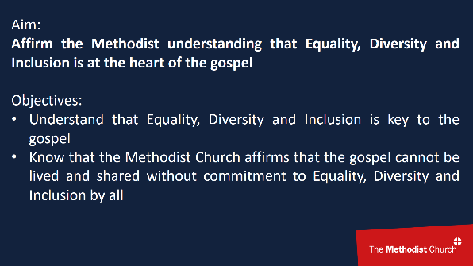

“The Aims and Objectives of the training are as follows:

Aim:
Affirm the Methodist understanding that Equality, Diversity and Inclusion is at the heart of the gospel
Objectives:
- Understand that Equality, Diversity and Inclusion is key to the gospel
- Know that the Methodist Church affirms that the gospel cannot be lived and shared without commitment to Equality, Diversity and Inclusion by all”

Slide 6 (1 minute)
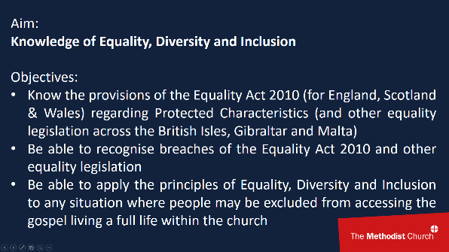

“Aim:
Knowledge of Equality, Diversity and Inclusion
Objectives:
- Know the provisions of the Equality Act 2010 (for England, Scotland & Wales) regarding Protected Characteristics (and other equality legislation across the British Isles, Gibraltar and Malta)
- Be able to recognise breaches of the Equality Act 2010 and other equality legislation
- Be able to apply the principles of Equality, Diversity and Inclusion to any situation where people may be excluded from accessing the gospel and living a full life within the church”

Slide 7 (1 minute)
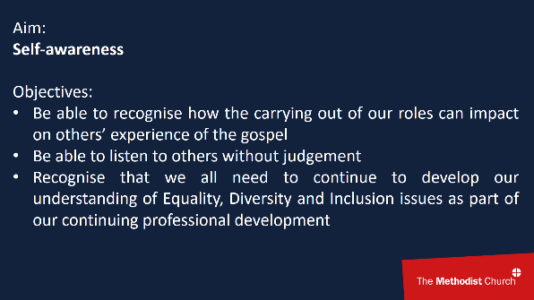

“Aim:
Self-awareness
Objectives:
- Be able to recognise how the carrying out of our roles can impact on others’ experience of the gospel
- Be able to listen to others without judgement
- Recognise that we all need to continue to develop our understanding of Equality, Diversity and Inclusion issues as part of our continuing professional development”

Slide 8 (1 minute)
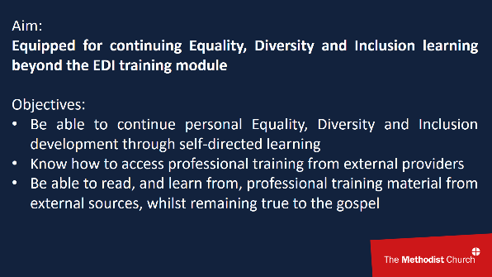

“Aim:
Equipped for continuing Equality, Diversity and Inclusion learning beyond the EDI training module
Objectives:
- Be able to continue personal Equality, Diversity and Inclusion development through self-directed learning
- Know how to access professional training from external providers
- Be able to read, and learn from, professional training material from external sources, whilst remaining true to the gospel”

Slide 9 (1 minute)
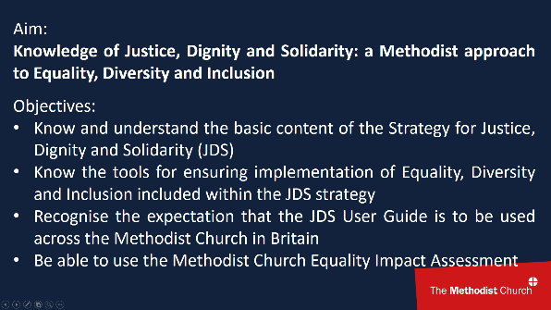

“Aim:
Knowledge of Justice, Dignity and Solidarity: a Methodist approach to Equality, Diversity and Inclusion
Objectives:
- Know and understand the basic content of the Strategy for Justice, Dignity and Solidarity (JDS)
- Know the tools for ensuring implementation of Equality, Diversity and Inclusion included within the JDS strategy
- Recognise the expectation that the JDS User Guide is to be used across the Methodist Church in Britain
- Be able to use the Methodist Church Equality Impact Assessment”

Slide 10 (1 minute)
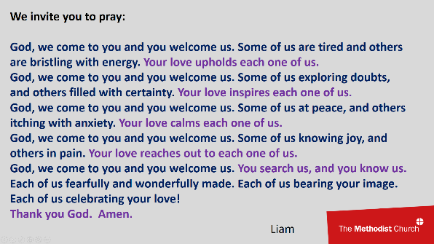

“We invite you to pray:
God, we come to you and you welcome us. Some of us are tired and others are bristling with energy. Your love upholds each one of us.
God, we come to you and you welcome us. Some of us exploring doubts, and others filled with certainty. Your love inspires each one of us.
God, we come to you and you welcome us. Some of us at peace, and others itching with anxiety. Your love calms each one of us.
God, we come to you and you welcome us. Some of us knowing joy, and others in pain. Your love reaches out to each one of us.
God, we come to you and you welcome us. You search us, and you know us. Each of us fearfully and wonderfully made. Each of us bearing your image. Each of us celebrating your love!
Thank you God. Amen.” Liam
Module 2: Why is this important for the Methodist Church?

Slide 11 (1 minute)
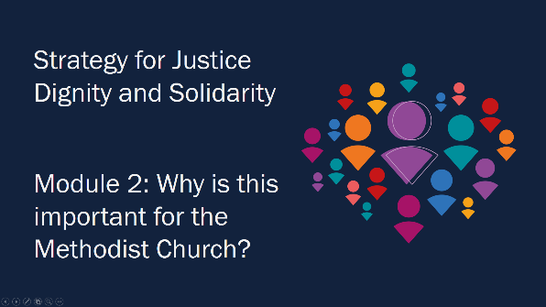

“This is important for our calling as the Methodist Church.”

Slide 12 (1 minute)
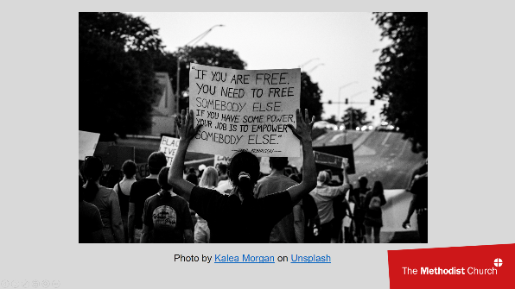

“Our calling as Methodists has always included a calling to social justice. However, we have often failed to live that out because we have excluded people based on prejudices. These might be people who live with a disability, or have a different ethnicity, sexuality, age, gender or life experience from ourselves. Sometimes we might deliberately exclude someone for one of these reasons because of a prejudice that we hold. Sometimes our biases are unconscious, and we do not realise the negative impact of our words and actions. Yet the belief that all human beings are loved by and created in the image of God is central to who we are as Christians. Our behaviour needs to bear witness to our beliefs.

Some people have said this work is about 'political correctness'. Yet the strategy for Justice, Dignity and Solidarity was written by more than 40 people, and adopted by the 2021 Conference, because of the negative impact on people's lives when we do not treat each other well. We believe that these concerns come from the Bible and are important if we want to bear witness to God's love for all people.”
Slide 13 (14 minutes)
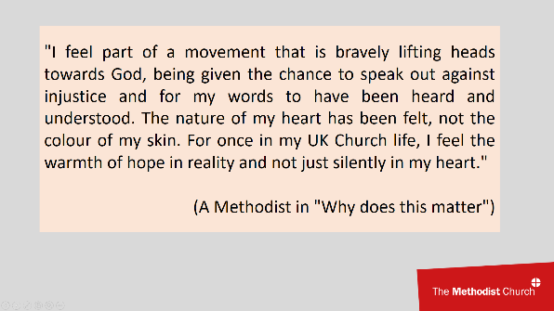

“This is about listening to, and learning from, real life experience.”

Participants to read and discuss “Why does this matter”.

Depending on group size and timings, participants could read and discuss these in their breakout groups. Alternatively, participants could share with the whole group which of the quotes impacted them or if they have any similar experiences they would like to share.

Slide 14 (10 miniutes)
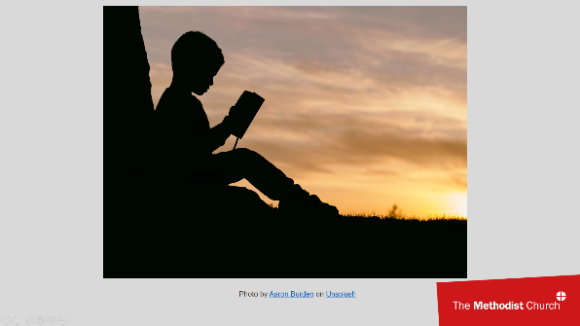

“Within the Bible there are stories of discrimination against people, including stories of enslavement, sexual violence, and considering disability to be a sin. However, there are broader and deeper golden threads throughout Scripture, which challenge these stories and point towards a God whose love is universal.”

Participants to read and discuss “What the Bible says” in their breakout groups.

Depending on group size and timings, participants could look up the Bible references and discuss the material in their breakout groups and share their reflections on the Bible references.

Slide 15 (1 minute)
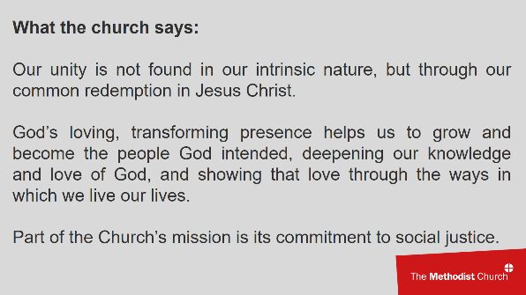

“The Faith and Order Committee agreed several theological reflections on Equality, Diversity and Inclusion. It notes that in Galatians 3:28- 29 we are told our unity is not found in our intrinsic nature, but through our common redemption in Jesus Christ. If one part of the body suffers, the whole suffers. We have to work with those we might disagree with, or who have a different Christian experience to us. It also says how Methodists understand that salvation is the ongoing experience of God’s loving, transforming presence. It helps us to grow and become the people God intended, helping us to grow in our ability to live as Jesus did, deepening our knowledge and love of God, and showing that love through the ways in which we live our lives. Part of the Church’s mission is its commitment to social justice. It concludes that the Church’s commitment to matters of equality, diversity and inclusion is founded on the belief that God’s love is universal.”

Slides 16-17 (1 minute)
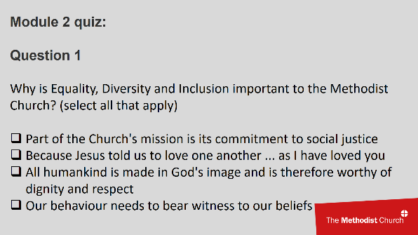
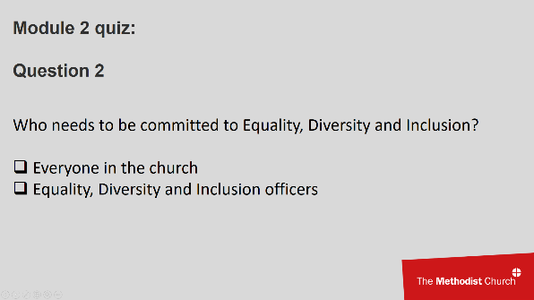

“Question to participants: Why is Equality, Diversity and Inclusion important to the Methodist Church?”
Answer:
Question 1: All are correct answers

“Question to participants: Who needs to be committed to Equality, Diversity and Inclusion?”
Answers:
Question 2: Everyone in the church
Module 3: Methodism Today

Slide 18 (1 minute)
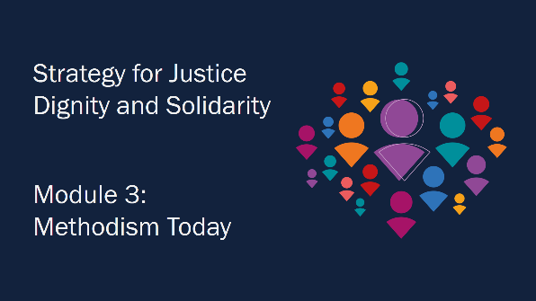

“As the Methodist Church, we inherit the traditions of the church in the past but also need to consider the context of our society today.”

Slide 19 (1 minute)
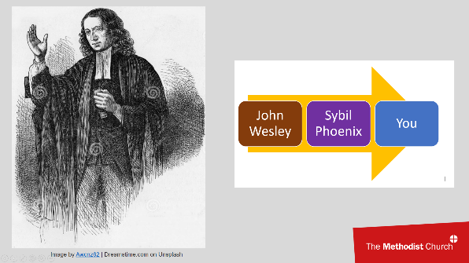

“We belong to a Church with a rich history in promoting welfare and working for justice and equality: from the Wesleys, who campaigned for the abolition of slavery and for prison reform; to work against alcoholism and the promotion of trade unions; to the work of 1980s anti-racism campaigner Sybil Phoenix. And of course the Church has continued to challenge injustice and to raise awareness of important issues. This work is continuous, and we’re all part of it.”

“Question to participants: What other examples of social justice work from Methodist history can you think of?”

Slide 20 (12 minutes)
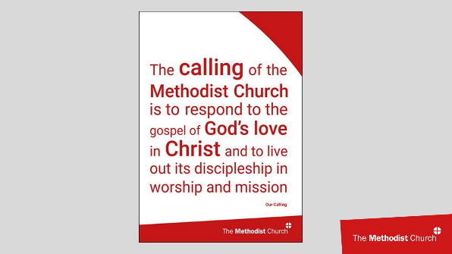

“This requires a culture where we care for one another, are inclusive, and are connected to one another by being centred in God. We all depend on one another and the relationships we have are mutual. This places ‘belonging’ at the heart of church life. Methodists believe God’s grace is offered freely to all people. Hospitality, openness and welcome for all are key to demonstrating God’s grace and love for all. This welcome needs to include opportunities for each person to participate fully as ourselves. John Wesley taught that the Holy Spirit changes us and we become “perfected in love” and “filled with the love of God and neighbour”. So we seek relationships with a deep appreciation of one another, in which we discover God working in and through us all.”

Participants to read and discuss “Methodism Today”.

Depending on group size and timings, participants could just read and note the material, or they could discuss in their breakout groups why our Methodist history is important to us as Methodists today.

Slide 21 (1 minute)
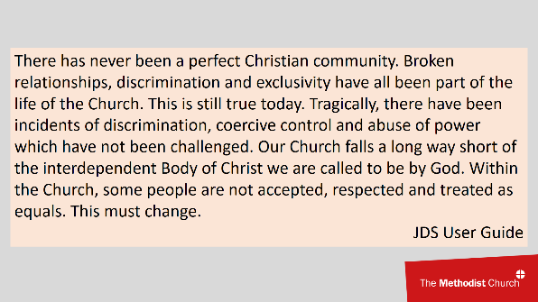

“There has never been a perfect Christian community. Broken relationships, discrimination and exclusivity have all been part of the life of the Church. This is still true today. Tragically, there have been incidents of discrimination, coercive control and abuse of power which have not been challenged. Our Church falls a long way short of the interdependent Body of Christ we are called to be by God. Within the Church, some people are not accepted, respected and treated as equals. This must change.”
Slide 22 (15 minutes)
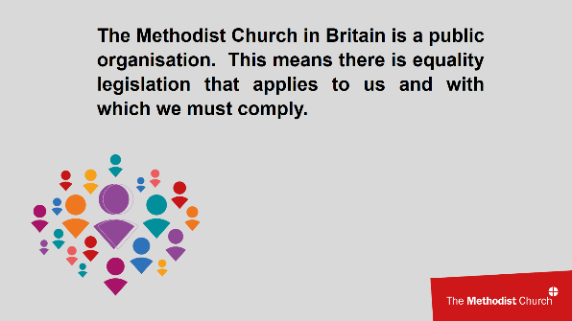

“We are called by God to be the interdependent Body of Christ. We are called to love one another and appreciate God in one another. We are called to practice justice. This should mean we go beyond the minimum standards required by equality legislation. Nevertheless, the Methodist Church in Britain is a public organisation. This means there is equality legislation that applies to us and with which we must comply.
The next section of the training will cover the principles contained within that legislation.

There is different equality law in the different jurisdictions in which the Methodist Church in Britain operates.”

Participants to read the relevant legal Jurisdiction.

Depending on group size and timings, participants may just note the legal context, or may be asked to share if they have any experience of equality legislation in other contexts, such as the workplace.

“Equality legislation sets out a number of protected characteristics or grounds, defines different types of discrimination that are unlawful, and outlines any exemptions to these rules (for example, exemptions are allowed for ‘single characteristic organisations’, such as single-sex private members’ clubs. However, these do not apply to the Methodist Church in Britain since we are not a single characteristic organisation).

The next section of this training will introduce the different protected characteristics /grounds.”

Participants to read and discuss “Protected characteristics or grounds” in their breakout groups.

Depending on group size and timings, participants could read through the protected characteristics/grounds in their breakout groups, or they could be invited to share anything which surprised them or they had not known before.

Participants to read and discuss “Introduction to discrimination” in their breakout groups.

Depending on group size and timings, participants could read through the introduction to discrimination in their breakout groups, or they could be invited to discuss in their groups how these types of discrimination might be experienced within the Methodist Church.

Slide 23 (4 minutes)
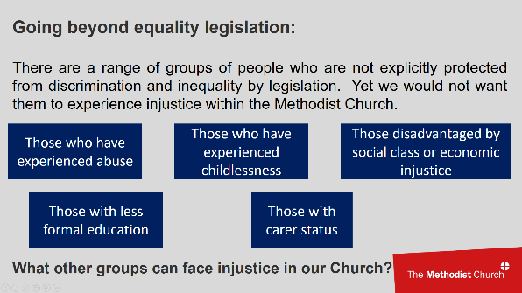

“We are called to be the interdependent Body of Christ, where all can find belonging, experience the love of God and find their identity as a child of God made in God’s image. So we need to treat all people with dignity and worth. This means more than just meeting the minimum standards of equality legislation, which apply to all public organisations.

For example, there are a range of groups of people who are not explicitly protected from discrimination and inequality by legislation. Yet we would not want them to experience injustice within the Methodist Church. These include:
- Those who have experienced abuse
- Those who have experienced childlessness
- Those disadvantaged by social class or economic injustice
- Those with less formal education
- Those with carer status (though draft legislation in Guernsey is scheduled to include carers within equality law protection from 2023).”
“Question to participants: What other groups can face injustice in our Church?”

“To ensure justice and dignity for all, it may be helpful to apply the principles that underlie equality legislation to these groups, or to anyone who faces injustice or exclusion within our churches. This list is not exhaustive. No area of human difference should prevent anyone being treated with dignity as a child of God within the Church. We stand in solidarity with people who feel marginalised. Moreover, we celebrate and cherish diversity as intrinsic to God's creation.”

Slide 24 (30 minutes)
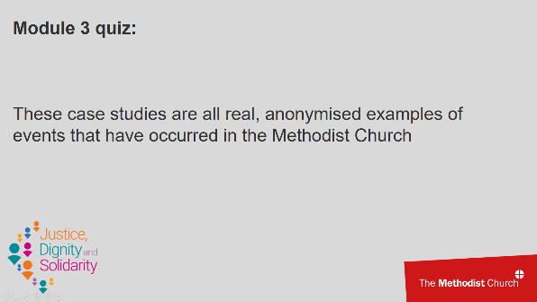

Participants to read and discuss “Module 3 case studies” in their breakout groups.

Depending on group size and timings, participants could answer the questions in their breakout groups, or there could also be a whole group discussion where participants are invited to compare and discuss the answers given by different groups.

Read and discuss “Module 3 case studies answers” with participants.

Module 4: What sort of change are we committing to?

Slide 25 (1 minute)
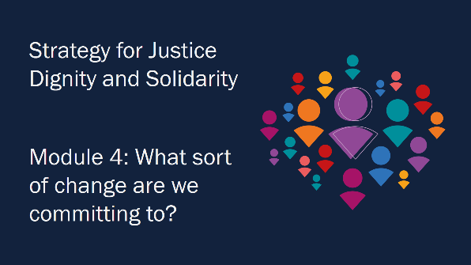

“The Methodist Church has committed to change.”

Slide 26 (1 minute)
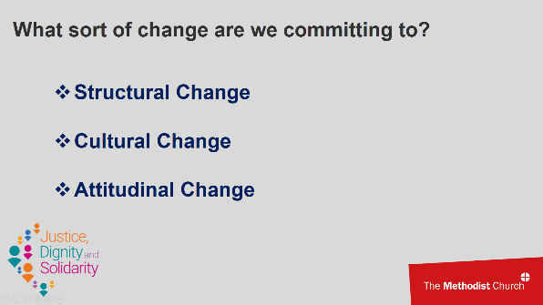

“Opening ourselves up to the change God wants to work in us, and recognising the real trauma of exclusion and disadvantage experienced by many within the Church, we need to understand the type and scale of the transformation needed.

“Structural change” means that the Church must review the way it works, accepting that previous and current ways of working have left many people excluded. Changes in our policies and organisational arrangements will be necessary. We will need to make sure that all voices are heard and that there is transparency in everything we do.

“Cultural change” can be described as change to ‘the way things are done around here’. Every individual, church, circuit, district and the Connexional team will need to reflect on the values, beliefs and assumptions we have. We will then need to learn to behave, interact, make decisions and carry out activities in ways that make it possible for a bigger variety of people to be fully part of God’s Church.

“Attitudinal change” will involve every Methodist being open to a change of heart, mind and actions. This will include listening and learning, and challenging our own assumptions. We all need to take responsibility for recognising our own fears and prejudices, and negative or damaging perceptions and behaviours. We need to learn about our own power, and how to use it to enable and strengthen, rather than control or put down, others within the Body of Christ.

With the help of the Holy Spirit, we will then reflect God’s love for all people in a way that enriches us all.”

Slide 27 (1 minute)
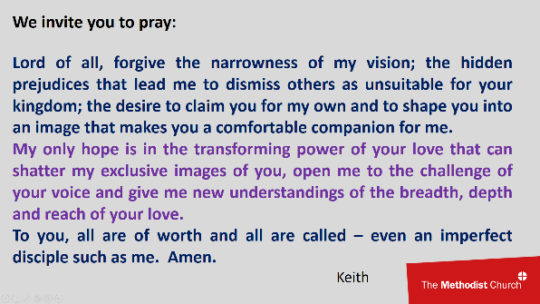

“We invite you to pray for change in our hearts, minds and behaviours.

A prayer:
Lord of all, forgive the narrowness of my vision; the hidden prejudices that lead me to dismiss others as unsuitable for your kingdom; the desire to claim you for my own and to shape you into an image that makes you a comfortable companion for me.
My only hope is in the transforming power of your love that can shatter my exclusive images of you, open me to the challenge of your voice and give me new understandings of the breadth, depth and reach of your love.
To you, all are of worth and all are called – even an imperfect disciple such as me.
Amen.”
Keith

Slide 28 (1 minute)

“Methodism understands itself to be a connexional Church. Connexionalism is identified in terms of belonging, mutuality and interdependence. All Christians are essentially linked to one another; no local church is or can be an independent unit complete in itself. At the heart of such interdependent relationships is conversation, which implies a resolve to listen, as well as to speak, to overcome differences and move towards shared understandings. The practice of Christian conferring characterises the way in which Methodists make decisions, theologically reflect, and enter into relationships within and beyond the Church.

In order for change to be meaningful, it has to have an impact right across the church; and this change must be seen and demonstrated in our structures, our culture and in our attitudes. We the Church, the body of Christ, must imbibe and inhabit the way of Christ so that our corporate personality and expectations demonstrate an inclusive “oneness”.
“Because there is one loaf, we, who are many, are one body, for we all share the one loaf.” (1 Corinthians 10:17)”

Slide 29 (5 minutes)
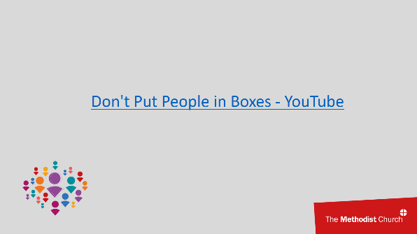

“Let’s view the following video and reflect on what it means to be a connexional church.”

Slide 30 (3 minutes)
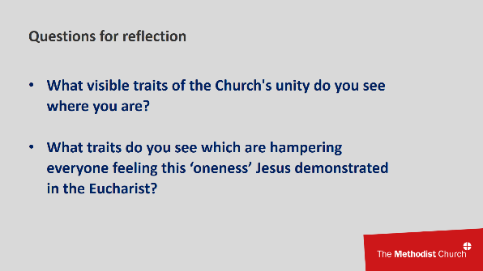

“Question to participants: What visible traits of the Church’s unity do you see where you are?”
“Question to participants: What traits do you see which are hampering everyone feeling this ‘oneness’ Jesus demonstrated in the Eucharist?”

Slide 31 (1 minute)
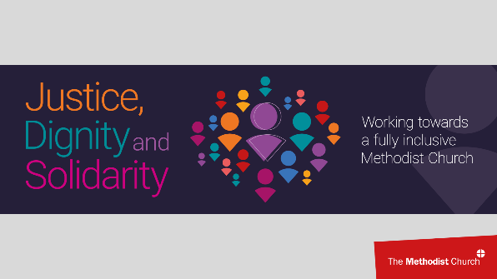

“Our Church culture is often first encountered by what someone sees and experiences, and it is an expression of what's really going on below the surface. It can best be understood by observing the behaviour, the attitudes, the value and belief system of those who belong.

Organisational culture can be defined as a system of shared meaning held by members that distinguishes the organisation from other organisations. The main traits of the culture can be either strong or weak. In a strong culture the main values are intensely held and widely shared. Where culture is strong, people do things because they believe it is the right thing to do. The majority of the people in the organisation believe in them and the attitudes, experiences, beliefs and values of the entire organisation is closely tied to the mission and programmes of that organisation.

We are the Church!”

Slide 32 (2 minutes)
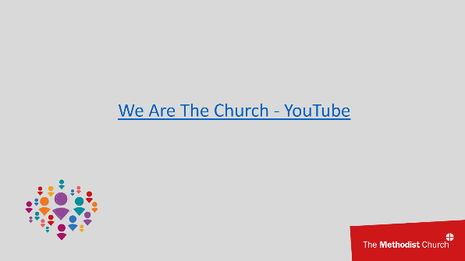

“Let’s view the following video and reflect on what it means to be the church of God.”

BREAK
This is the mid-point of the training. You may need to include other breaks at various points in the training, depending on your group and time allocated.

Slide 33 (20 minutes)
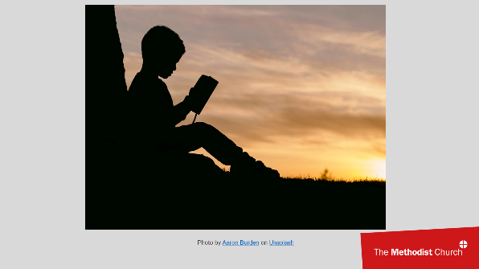

Participants to read and discuss “Module 4 We are the church” in their breakout groups.

Depending on group size and timings, participants could read the materials and Bible references and discuss the questions for reflection in their breakout groups. They could be invited to share with the whole group anything of particular interest from their group’s discussion.

Slide 34 (4 minutes)
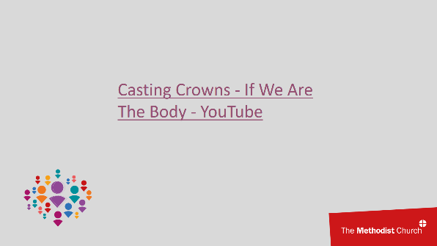

“Let’s view the following video and prayerfully reflect on what it means to be the Body of Christ.”

Slide 35 (1 minute)
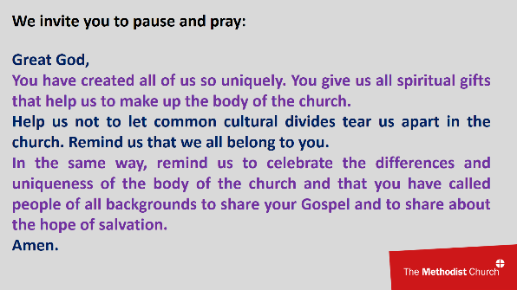

“We invite you to pause to pray:

Great God,
You have created all of us so uniquely. You give us all spiritual gifts that help us to make up the body of the church.
Help us not to let common cultural divides tear us apart in the church. Remind us that we all belong to you.
In the same way, remind us to celebrate the differences and uniqueness of the body of the church and that you have called people of all backgrounds to share your Gospel and to share about the hope of salvation.
Amen.”

Slide 36 (3 minutes)
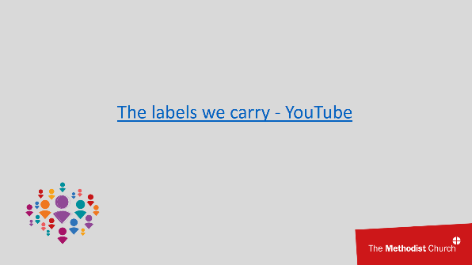

“Let’s view the following video and prayerfully reflect on the way we can quickly label others or be labelled ourselves by others.”

Slide 37 (2 minutes)
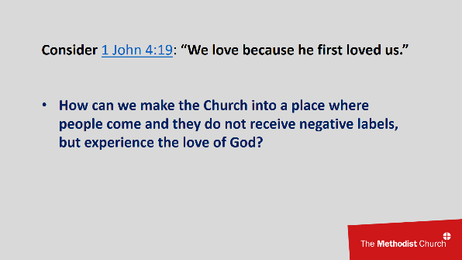

“Consider 1 John 4:19 : “We love because he first loved us.”

“Question to participants: How can we make the Church into a place where people come and they do not receive negative labels, but experience the love of God?”

Further question: “You might have noticed that in the video the negative labels were white writing on black labels, and the final positive one was black writing on a white label, which stood out against the dark clothing. What are your thoughts about that?”

Slide 38 (2 minutes)
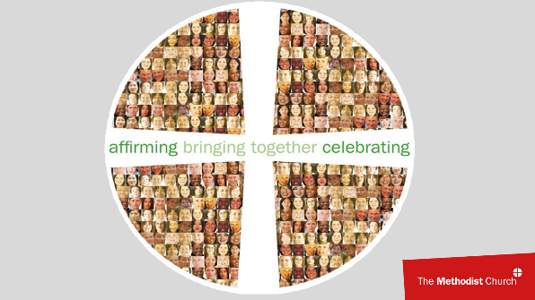

“In this next section we consider our own development and how we can get the learning and development that’s right for us.
We can follow up this introductory module by using some of the resources listed later in Module 6.
These resources are drawn not just from The Methodist Church in Britain, but from a range of contexts; therefore it is important to be able to draw out valuable learning through engaging in a critical thinking and evaluation process. Someone with critical thinking skills can understand the links between ideas; determine the importance and relevance of arguments and ideas; recognise, build and appraise arguments; identify inconsistencies and errors in reasoning; approach problems in a consistent and systematic way; and reflect on the justification of their own assumptions, beliefs and values.

Critical thinking -taking time to closely consider, evaluate and assess- helps us to question and overcome our natural inclinations and biases. We may read, see or hear something which may contain valuable content or inspire us, but one single element of the content may distract us from the learning process and from benefitting from the broader valuable content. This kind of 'dissonant' element can make us resistant to incorporating new information and ideas, because our attention is focused on resolving a specific issue. There might be several reasons for this, including context, natural preferences, theological understanding, threat to our already established thinking.

In 2007, virtuoso violinist Joshua Bell went busking in an experiment to see if the public would recognise one of the finest talents in the classical music world.
He posed as a street musician, dressed in a baseball cap and a long-sleeved T-shirt. He opened his violin case and took out his $3.5 million violin, threw a few dollars in the case to encourage others, as thousands of other street musicians have done before. He played for 45 minutes. Almost nobody stopped to listen. Was it because they didn’t like the music? Not likely. People all over the world pay more than $100 a seat to listen to Bell perform. They simply didn’t assign a lot of value to this “street musician”.
In fact, out of 1,097 people that walked past Bell, only 27 gave any money and only seven actually stopped and listened for any length of time.”

Slide 39 (14 minutes)
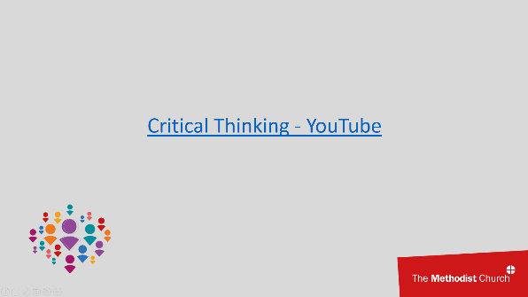

“Let’s view the following video and reflect on how we can use critical thinking to continue to learn about equality, diversity and inclusion, despite having differences of theological conviction with one another.”

Slide 40 (4 minutes)
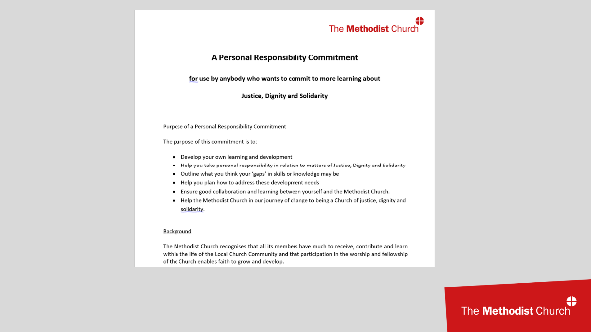

“In this next section we have an opportunity to commit to a personal process of making Church a fully inclusive place.
You can be part of making this Justice, Dignity and Solidarity strategy so much more than a list of actions interspersed with a sprinkling of desired results. The reason Conference voted unanimously for this Strategy is because division is not just evident in the world, but also in the Church.
If the Church had a brand, what would this look like or say? It would certainly include the word ‘unity’. How does the Church model, stand for and fully embrace unity? How do we personally make sure that Church is so much more than a place, a body, an experience that just matches your expectations, perspectives, values, likes, dislikes, wishes, hopes and dreams, but is a place, for everyone to feel and know the all-encompassing love of God, a place where all are valued and respected?
In the Bible, God leaves no doubt of the tremendous value placed on every single human life. God's love for us is relentless, immeasurable, and infinite. The Church is to fully reflect God's heart and intention to bring all creation into the knowledge and experience of that love.
We can all help develop our ‘brand’, our calling, our hope! And we can help to champion it right where we are, adding our energy and personal resources and joining in co-creating real, visible and tangible unity. To do this will involve commitment across a number of areas of life. These are willpower; thoughts and focus; emotions; beliefs; decisions; vocabulary; prayer.

Signing up to a Personal Responsibility Commitment is the next step on the journey.”

Participants to read and discuss “Personal Responsibility Commitment” in their breakout groups.

Depending on group size and timings, participants could just read and note the Personal Responsibility Commitment, or they could discuss in their breakout groups the value of every Methodist making a commitment such as this.

Slide 41 (2 minutes)
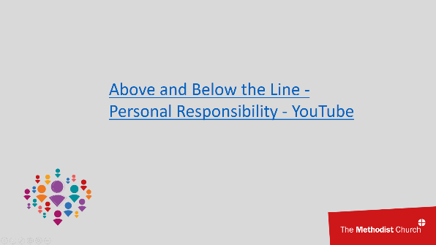

“Let’s view the following video and reflect on the importance of recognising personal responsibility.”

“That video shows the importance of recognising personal responsibility for the things you can do, without necessarily taking total responsibility for a situation. It may be true that others have a lot of responsibility for things that have happened, but we can expend a lot of energy focusing on that and not contributing to positive change. This is not good for our well-being and energy levels.

On the other hand, if we focus on ourselves when we do not have control, this can be negative for our mental health. For example, asking “What am I doing that is causing this?” when in fact it is being done to me.

So we need to recognise where our thinking is, and focus our energy on those things that lead to positive change, enhance our well-being and energise us.”
Slide 42 (1 minute)
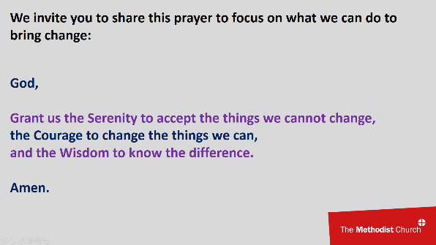

“We invite you to share this prayer to focus on what we can do to bring change.

God, grant us the Serenity to accept the things we cannot change,
the Courage to change the things we can,
and the Wisdom to know the difference.
Amen.”

Slide 43 (7 minutes)

“The Methodist Church recognises that all its members have much to receive, contribute and learn within the life of the local church community and that participation in the worship and fellowship of the Church enables faith to grow and develop.
Through the ‘Strategy for Justice, Dignity and Solidarity’ the Methodist Conference has committed:
- for the rich diversity of people within the Methodist Church to be recognised as a cause for thanksgiving, celebration and praise
- to eradicate all discrimination and coercive control within the Methodist Church, and for all people to be treated justly and with dignity across the breadth of the Methodist Church
- for a paradigm shift (a profound change) in the culture, practices and attitudes of the Methodist Church so that all Methodists are able to be full participants in the Church’s life.

The Purpose of Personal Responsibility Commitment is to:

- develop your own learning and development
- help you take personal responsibility in relation to matters of Justice, Dignity and Solidarity
- outline what you think your ‘gaps’ in skills or knowledge may be
- help you plan how to address these development needs
- ensure good collaboration and learning between yourself and the Methodist Church
- help the Methodist Church in our journey of change to being a Church of justice, dignity and solidarity.”

Participants to read and discuss “Exemplar Personal Responsibility Commitment” in their breakout groups.

Depending on group size and timings, participants could just read and note the example, or they could discuss in their breakout groups what the positive impact might be of this individual completing their personal learning. If there is time, participants could even be invited to complete a Personal Responsibility Commitment within the session.

“Unlike the other modules, there is no quiz to complete at the end of this module.
The learning has been too personal to be checked using a quiz. However, this module has only been a part of our learning. Our commitment now is to continue learning about the diversity of God's people as part of our own personal development and discipleship, whether that be by using the Personal Responsibility Commitment or in another way. We cannot learn all we need to through this one training session, but hopefully we have been energised and equipped to continue in our journey.

If you have a leadership role within the Methodist Church, you are responsible for Equality, Diversity and Inclusion within your area of responsibility, including whatever learning and development you require in order to be able to meet that responsibility.

The next section of this training returns to the Strategy for Justice, Dignity and Solidarity and our collective journey as a church towards Structural, Cultural and Attitudinal change.”
Module 5: What does the strategy recommend?

Slide 44 (1 minute)
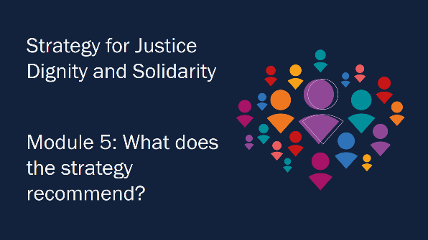

“What does the JDS Strategy recommend?”

Slide 45 (1 minute)
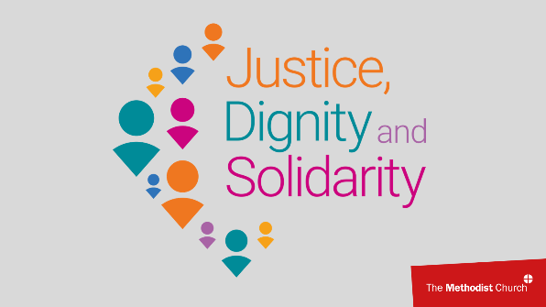

“The Strategy for Justice, Dignity and Solidarity that was approved by Conference in 2021 aims to create “a profound change in the culture, practices and attitudes of the Methodists Church so that all Methodists are able to be full participants in the Church’s life” and includes “mandatory actions for local churches, circuits, districts and the Methodist Council, designed to embed a culture of justice and respect for all” with the expectation that “each church, circuit, district, and the Methodist Council will use the same strategy for this work”.
This is a very far-reaching commitment.
The strategy is far more than just mandatory training. It is thirty-seven pages long, of which less than half a page covers mandatory training.
There is also a User Guide, which covers the principles of the strategy. The expectation is that this is to be used across the Methodist Church in Britain.
There are also a series of new terms and names for processes included within the strategy. The upcoming pages will explain these terms and processes, so that we are all familiar with them as they become embedded in our work in every area of the church.”

Slide 46 (2 minutes)
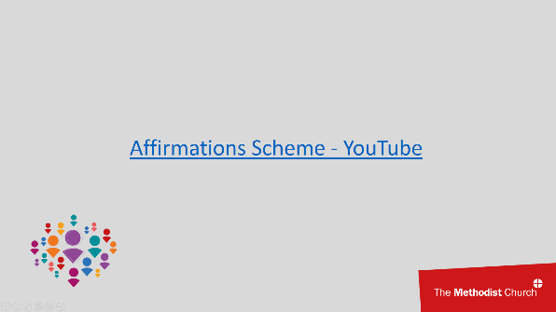

“Recommendation 2 b) of the Strategy for Justice, Dignity and Solidarity calls for a scheme to capture good practice and acknowledge strengths within churches that are open and inclusive. Churches will outline what they do to ensure they are inclusive and develop plans for the future. These examples can then encourage others to also move forward.

Let’s listen to what Deacon Ramona Samuel has to say to us about the Affirmations scheme.”

Slide 47 (3 minutes)

“Recommendation 2 c) of the Strategy for Justice, Dignity and Solidarity calls for a review of the language we use in communications and worship, both within the church and when we communicate externally. The aim is to avoid the use of language that is derogatory or marks people as different where this is not relevant, and instead use language that affirms the humanity and identity of all.

The Inclusive Language Guide is published on the Methodist website.

Let’s listen to what Revd Jill Marsh has to say to us about the Inclusive Language Guide.”
Slide 48 (3 minutes)
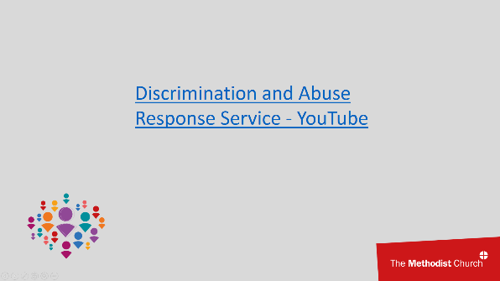

“Recommendation 4 a) of the Strategy for Justice, Dignity and Solidarity calls for a Discrimination and Abuse Response Service for people to disclose situations of discrimination or exclusion and be supported pastorally in deciding how to respond. The process will support and empower people through any decisions and actions that may be required to bring justice and healing, including restorative justice or a formal complaint if appropriate. The system will also allow instances of discrimination to be tracked, so that patterns can be identified and avoid being repeated.
There is also the Personal Responsibility Commitment. Although this can be used by any and all of us committed to our own learning, it can also be used so that people who have caused discrimination or exclusion can be supported to accept the situation, learn and change their behaviour in line with the expectations of a just and inclusive church.
In addition, the church will develop a Critical Incident Resource to provide support to those who need to respond to instances, so that there is a structured and consistent approach.

Let’s listen to what Revd Farai-Mapamula has to say to us about the Discrimination and Abuse Response Service.”

Slide 49 (2 minutes)
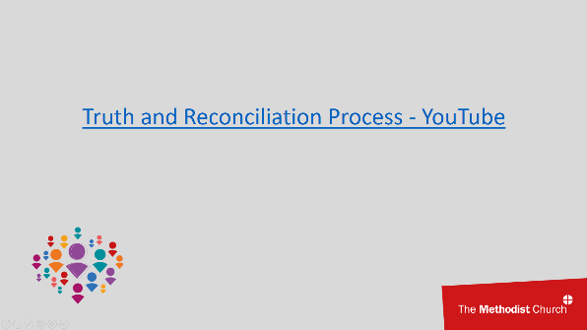

“Recommendation 4 e) of the Strategy for Justice, Dignity and Solidarity calls for a Truth and Reconciliation process. This process will apply to a particular system or procedure within church life. The process will be to listen to those who have experienced discrimination, to acknowledge the injustices and failures within the system, and to transform systems and procedures in a way that brings healing and justice.
Let’s listen to what Bevan Powell, Equality, Diversity and Inclusion Advisor, has to say to us about the Truth and Reconciliation process.”

Slide 50 (3 minutes)
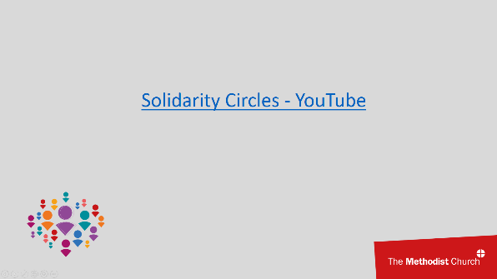

“Recommendation 4 f) of the Strategy for Justice, Dignity and Solidarity calls for Solidarity Circles with opportunities to meet. These will provide an opportunity for people in the church who share a particular characteristic to meet together. This will be a chance to support one another and to identify concerns that need to be addressed and can be raised with church leaders.

Let’s listen to what Rachael Lowe and Nick Palfreyman from the ‘Living with Disability’ Solidarity Circle have to say to us about Solidarity Circles.”

Slide 51 (5 minutes)
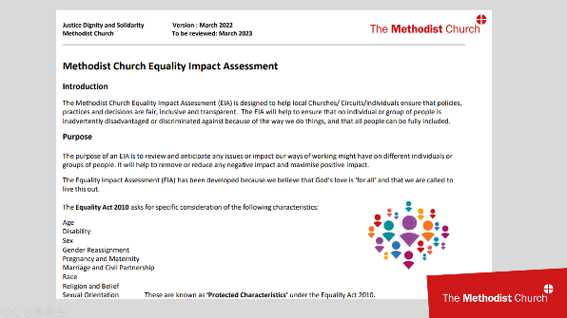

“Recommendation 4 f) of the Strategy for Justice, Dignity and Solidarity calls for an Equality Impact Assessment to audit and measure the impact of our activity and decision-making in any context. This will support adherence to the Church’s values and mandatory equality legislation.

Equality Impact Assessments are common across the public sector and many industries.
The Methodist Church’s assessment has been developed to be used within individual churches, as well as larger-scale projects. It is available on the Methodist Church website.”

Participants to read “Equality Impact Assessment” in their breakout groups and have a copy accessible while they view the next video.

Slide 52 (20 minutes)
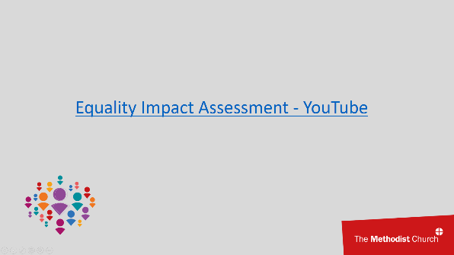

“Let’s view a video that shows an example discussion of how to complete the assessment.”

Depending on group size and timings, participants could just read and note the assessment, or they could discuss examples of how it could be used in a church context.

Slide 53 (2 minutes)
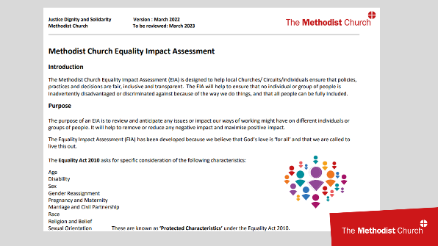

“In the administration of the church, we have many structures and complete many tasks. These might be to do with staffing, or property, or communications, or paperwork. They may include reviews or audits. Hopefully the Spirit is in all of our work. But not all of our actions are directly commissioned by the Bible.
An Equality Impact Assessment may feel like a piece of paperwork that comes from the professional world outside of the church. Yet it has a Biblical commission. In Acts chapter 6, the Greek widows complained that they were receiving less than the Hebrew widows. This led to the commissioning of Stephen -sometimes referred to as the first church steward- and six others to do the administrative work of the church. This freed up the disciples to focus on preaching the gospel. It was also to ensure that, within the early church community, there was equality and justice amongst different groups.
Assessing the work that we do, in order to ensure equality of impact, is part of our original Biblical commission to be the church of God. It is fundamental to the mission of the administrative elements of the church.”

Slides 54-57 (2 minutes)
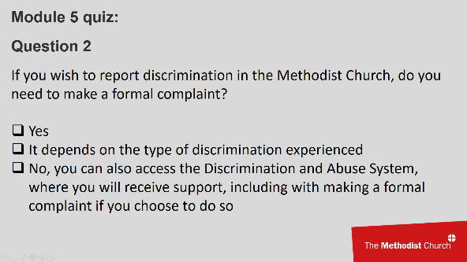
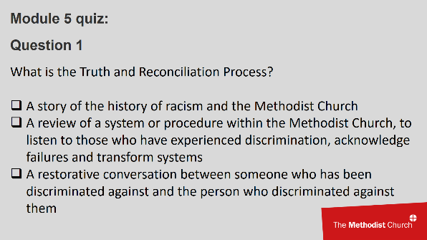

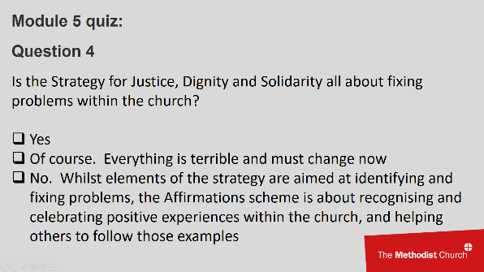
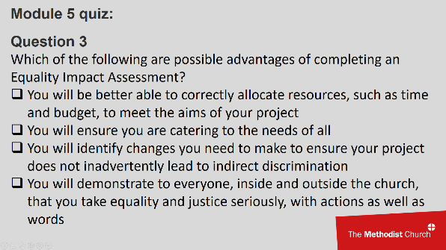

“Question to participants: What is the Truth and Reconciliation Process?”

Answer:
Question 1: A review of a system or procedure within the Methodist Church, to listen to those who have experienced discrimination, acknowledge failures and transform systems

“Question to participants: If you wish to report discrimination in the Methodist Church, do you need to make a formal complaint?”

Answer:
No, you can also access the Discrimination and Abuse System, where you will receive support, including with making a formal complaint if you choose to do so

“Question to participants: Which of the following are possible advantages of completing an Equality Impact Assessment?”

Answers:
Question 3: All are correct answers

“Question to participants: Is the Strategy for Justice, Dignity and Solidarity all about fixing problems within the church?”

Answers:
Question 4: No. Whilst elements of the strategy are aimed at identifying and fixing problems, the Affirmations scheme is about recognising and celebrating positive experiences within the church, and helping others to follow those examples

Module 6: Opportunities for Action. What next?

Slide 58 (1 minute)
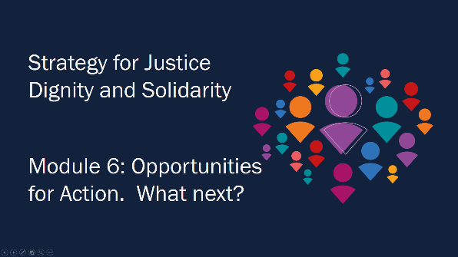

“We come towards the end of this training session but this is not the end of our learning.”

Slide 59 (5 minutes)

“There are lots of opportunities within the church for further training, development and study and we hope you will engage further.”

Participants to read and discuss “Further learning and sources of support”.

Depending on group size and timings, participants could simply note the sheet, or be invited to discuss which of these sources of further learning they might wish to consider.

All of the worksheets can be sent to participants electronically. This worksheet in particular would benefit from being shared electronically since it contains links that can be followed directly from an electronic document.

Slide 60 (1 minute)
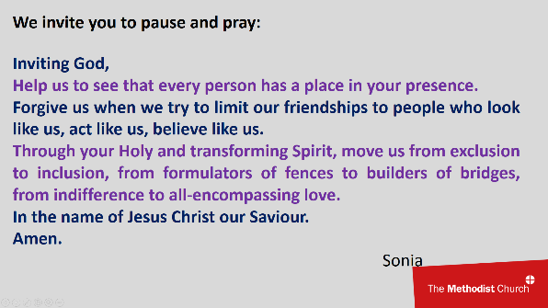

“We invite you to pause and pray:

Inviting God,
Help us to see that every person has a place in your presence.
Forgive us when we try to limit our friendships to people who look like us, act like us, believe like us.
Through your Holy and transforming Spirit, move us from exclusion to inclusion, from formulators of fences to builders of bridges, from indifference to all-encompassing love.
In the name of Jesus Christ our Saviour.
Amen.”
Sonia

Slide 61 (6 minutes)
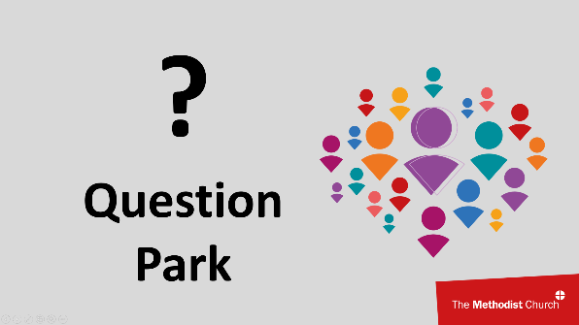

Questions: Review the Question Park with participants and discuss any questions that have not been covered as part of the training or discussion.

Slide 62 (1 minute)
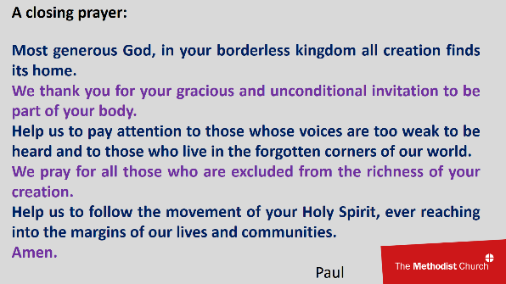

“A closing prayer:

Most generous God, in your borderless kingdom all creation finds its home.
We thank you for your gracious and unconditional invitation to be part of your body.
Help us to pay attention to those whose voices are too weak to be heard and to those who live in the forgotten corners of our world.
We pray for all those who are excluded from the richness of your creation.
Help us to follow the movement of your Holy Spirit, ever reaching into the margins of our lives and communities.
Amen.”
Paul

Slide 63 (2 minutes)
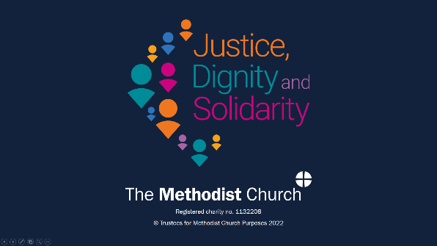

“Having spent time on this course, it may be helpful to complete a Personal Responsibility Commitment if you've not already done so. This may help you to consider gaps you're aware of in your learning, and what you want to now do so that this training makes a difference.
The Methodist Church in Britain believes that by implementing the actions outlined in the Strategy for Justice, Dignity and Solidarity we will ensure the Church is positioned to improve the experiences of all people and enable us to go well beyond legal compliance to the place we hope and believe for in our declaration ‘Your kingdom come your will be done, here on earth as it is in heaven. Our commitments to equality diversity, and inclusion are ongoing, and we’re learning more every step of the way. We are pleased that you are making this journey with us by completing this module. Learning and growth often occur when we share our thoughts with others. Having done this course, please discuss with others in your church, Circuit, District or team, whatever has inspired or challenged you. Through shared conversations, you could agree what changes need to happen where you are, and how such change might be brought about.”

After the training session

Certificates

At the end of the session, check that everyone has signed-in.

Complete a certificate for everyone who has taken part. This can be a physical certificate or an electronic copy.

Those taking part will need to confirm to someone that they have completed the training. For employees, this will be their line manager. For church stewards, this will be their church council. For local preachers, this will be their circuit local preachers’ meeting. You can pass on the attendance sign-in sheet to those who are keeping these records.

