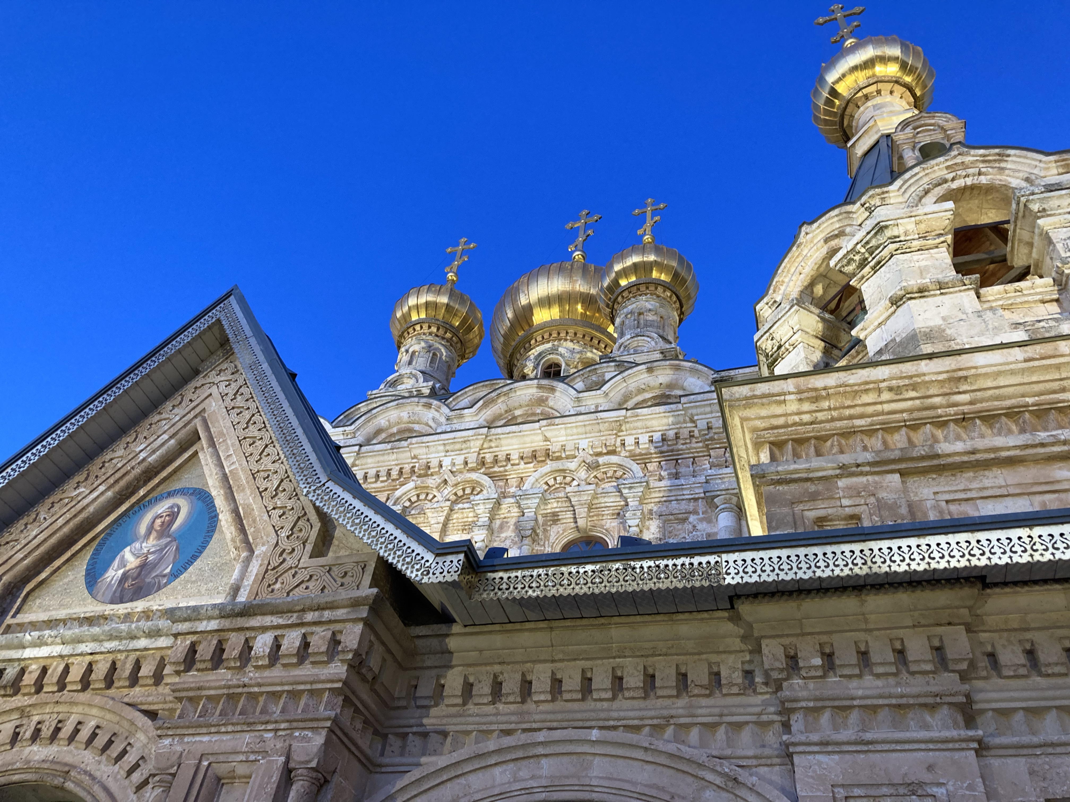
Living Christianity in the Holy Land
A twelve day visit to Israel Palestine with a focus upon the Christian Community of the Land.

18th - 30th January 2023.

For further details, a brochure and programme please e-mail: john_d_howard@hotmail.com

