Methodist Council – Brexit and beyond

Contact Name and Details | Rachel Lampard, The Joint Public Issues Team  lampardr@methodistchurch.org.uk 07854 265 068
Status of Paper | Final
Action Required | For discussion
Resolution | None

Summary of Content

Subject and Aims | This paper is presented to the Methodist Council as an opportunity to consider the challenges of Brexit to our Church and to our country.  It asks a number of questions, including:  - What does the impending exit from the European Union feel like from where you are in Britain (or beyond)?  - The paper advocates that the Church can prepare and respond:  - through prioritising the needs of particular local communities. What does this mean in practice, for our priorities, our stationing, our evangelism, and our habits as churches?  - through truth-telling. What are the truths that you believe the Methodist Church should be telling?  - through looking beyond our borders. What does this look like?  - “Without a vision the people perish”. How can the Methodist Church help reanimate a vision for the UK?

Introduction
Barring more surprises, the UK will be leaving the European Union on 29 March 2019.

Our Church is as divided as the rest of society. Whilst many in leadership positions (and so perhaps most of the membership of Methodist Council) voted to remain, polling suggests that of those who identify as Methodists, half voted to leave.
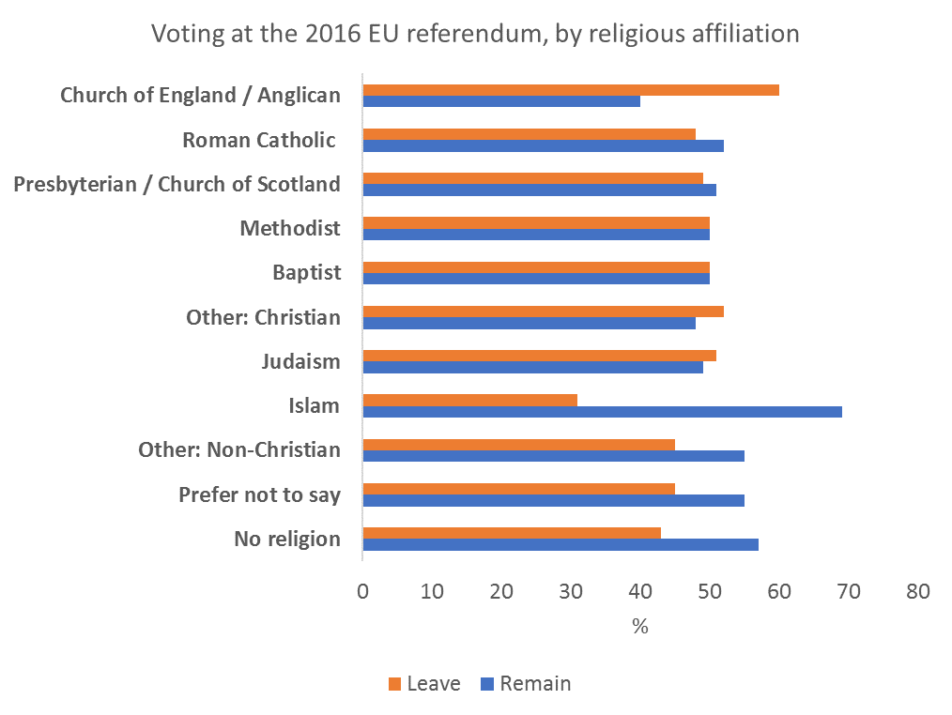http://www.brin.ac.uk/wp-content/uploads/2017/05/Voting-at-2016-referendum-by-religious-affiliation.png

This is not peculiar to our own denomination: in the Church of England, all but one of the House of Bishops supported Remain; 60% of Anglicans voted to leave.

People in leave-voting parts of the country will most likely already be aware of the sentiments in their churches and beyond. But it is a reminder to those of us in positions of influence or decision-making, in Remain areas or with Remain friendship groups, that many of our members voted differently.

The lack of agreement amongst Methodist people is one of the reasons that the Church, along with other denominations and organisations, has struggled to “speak out” into the current political turmoil. Methodists and other Christians in good conscience could find themselves on either side of a binary issue. During the Referendum campaign the Joint Public Issues Team produced resources seeking to inform people as they went to vote. The call was that the debate should be rational, truthful and respectful and to reiterate the Church’s belief that xenophobia or racism was unacceptable.

In the immediate aftermath of the referendum vote, the Methodist Conference agreed a statement, to be read in all churches the following week, which warned against increased racism. Local churches have held discussions about what Brexit means. The Joint Public Issues Team produced its “Conversation Welcome” series to encourage groups to hold difficult conversations. The Church has felt comfortable engaging with issues of racism and in trying to broker constructive conversations. We have not engaged with either the complex political and economic substance of leaving the European Union nor perhaps more importantly have we engaged with the social and cultural currents that led to Brexit and continue to shape our nation.

Now as we face one of the greatest peacetime changes to our economy and political identity, as a fallible group of people called together into the Church and inspired by God’s grace, we look to our responsibilities at this time. This paper is presented to the Methodist Council as an opportunity to consider the challenges to our Church and to our country.

What role for the Church?
The Brexit result is a crystallisation of many long-term trends: between the different life experiences and hopes of old and young; between those who felt they had benefited from globalisation and those who felt left behind; between what are termed the “anywhere” people (those who are comfortable with multiculturalism, flexible, mobile) and the “somewhere” people (those with a rootedness and identity with a single place). These divisions were not caused by Brexit, but were brought to light, and perhaps hardened, by a referendum which offered a binary choice where the answer appeared to speak to one side of the division.

Analysts have identified other divisions. The strategy of the two referendum campaigns has been characterised as a vote between the head and the heart: the remain campaign put across an argument of facts and economic benefit which spoke to the head; the leave campaign gave an vision that spoke to the heart. Languages of the head speak past languages of the heart, and vice versa.

There are divisions between what people value, but also what is accorded value by society. The idea of “elites” may have arisen within a society which privileges education, and therefore accords little esteem to those without it. This sort of divide is often invisible to those on the other side of it. For people who feel their values or their culture have been dismissed, “taking back control” may have been seen as one way of asserting human dignity which had been lost in other ways.

Since the beginning of the last century the UK’s political parties represented divisions along class and economic lines. The Brexit vote divided the electorate along a different cultural divide. How the UK political system will adapt to this new and potent cultural division is still unknown. The rise of new and sometimes racist political movements throughout Europe make this uncertainty within our politics all the more worrying.

If we are looking at a country where questions of hopelessness, a lack of self-esteem, trust or dignity are driving our politics, surely the Church has a role?

Prior to the 2008 banking crash we enjoyed a period of consistent economic growth, low inflation and - for the US and UK at least - economic stability. This period, known as the Great Moderation, was believed to be the post-cold war norm that would ensure that living standards would rise from generation to generation.

Even during these good times, while the economy grew, the proceeds were not being shared equally. While the poorest incomes stayed flat, the richest rose quickly. The gap was magnified by the value of investments, especially housing, rocketing, further disadvantaging those on low incomes who were unable to invest.

In the run up to the crash, employment was rising but adult poverty levels stayed flat. The proliferation of low-quality jobs meant that even skilled workers often needed support from the benefit system. Child poverty fell but mainly due to targeted in- and out-of-work benefits.

From 2010 onwards these benefits were progressively cut. Despite employment returning to its previous pattern of growth, poverty - and child poverty especially - has risen and the number of people in poverty in the UK is expected to reach an unprecedented 5 million next year.

The promise of the Great Moderation was that families who did their best would have a decent, even increasing, standard of living. In November the UN Special Rapporteur gave a damning indictment of poverty in the UK, showing that that for huge swathes of families that promise is far from their reality. Universal Credit is both the mechanism for delivering huge cuts to benefit levels and a demonstration of the huge disconnect between policy makers. It was designed by the wrong people, those who knew nothing of poverty, to do the wrong thing. It has focused on behaviour change, rather than ensuring people have enough to eat.

If we are looking at a country where the poorest are still experiencing the brunt of the economic crash, and this looks to continue or be worsened beyond Brexit, then surely the Church has a role?

And then we look beyond our borders to the wider world. For the UK the EU has never fulfilled the same high moral purpose as it has, say, for Germany. But it has helped to decrease the possibility of war in Europe, provide support for those countries looking for a new compass after the fall of Fascism and Communism, and be a significant change agent for international climate change negotiations and international aid. Internationally we will continue to face challenges of global agreements on climate change, on the movement of peoples around the globe, and the need to work for justice and peace in the face of repression.

If we are looking at a world where our international bodies are not always fit for purposes, but the challenges are only increasing, then what is the role of the Church?

This paper suggests there are three ways in which the Methodist Church can respond to Brexit and beyond – through the local church, through truth-telling, and through orientating ourselves beyond our borders.

The local church – all are welcome
The role of the local church in communities beyond Brexit will be crucial.

There are clearly communities that have felt abandoned, by the Church as well as other institutions. Are there ways in which we can prioritise Christian presence in those places? Churches are (or can be) places where everyone is welcomed and heard, and everyone is esteemed because they are children of God, they are welcomed unconditionally and accepted just as they are by God’s grace. Clearly to do this we have to do a lot of listening and change our practices towards those who have been excluded.

What does this mean in practice, for our priorities, our stationing, our evangelism, and our habits as Churches?

There are also practical implications for our churches. At the time of writing we do not yet know the terms under which we will leave the EU, but most commentators, even those politicians who long for the sunny uplands of a hard Brexit, agree that at least in the short term things will be tough. Cuts to welfare expenditure and local authority funding means that there will little capacity for mitigating the consequences of economic pain.

At the time of writing, the changes to our trading relationship are planned for 2021 – although there are scenarios where this could happen much earlier or later. At that point the relatively predicable and stable food prices experienced by the UK for the past 20 years are likely to become more volatile. With 1.3 million people visiting Trussell Trust foodbanks alone already, this may lead to more families being in desperate need.

How can our churches, working with others, provide practical help and support, even beyond what is happening now?

Local churches and individual Christians are most people’s experience of church, and local churches are where we as a connexional church can learn about our country. To our shame, the divisions revealed by Brexit were not previously apparent to all of us.

How can we use the gift of connexionalism better to understand what people and our country are facing?

Truth-telling – speaking up and speaking out
Commentators agree that the impact of Brexit is likely to hit hardest those who are least resilient. Churches, and Christians working in communities, are already present in offering support for people who are hungry, homeless, trapped in debt, lonely. The need for such services will not diminish and is likely to increase.

Our role as the Methodist Church will be to stand in the gap, but also to speak out prophetically about the injustices we see in society. To do so we need to listen to those affected, and enable them to speak with their own voices. The growth of Poverty Truth Commissions around the country, including those supported by Methodist Churches, is to be welcomed and encouraged. How can we ensure that we lift our eyes above the immediate horizons to speak prophetically and enable others to do so too?

Some people have felt that the referendum legitimised views which denigrate others because of their race or religion. The Methodist Conference spoke out against racism in the immediate aftermath of the vote, and has for many years been clear that it is a denial of the gospel.

In the face of a rhetoric of “taking back control”, of nationalistic tendencies, and opposition to the other members of the EU, how can our Church listen to people’s fears but clearly and confidently speak and act against all forms of racism and xenophobia, including Islamaphobia and anti-semitism?

As a member of the EU, Britain benefited from being part of a block which spoke, spent and acted powerfully on issues such as climate change and human rights. The Church may increasingly need to speak out about these concerns.

How can we find new ways to do so internationally?

The discourse around the referendum and the negotiations themselves have revealed a failure in political processes of which we, as a country, should be deeply concerned. Building up trust again will take time. All Christians are called to political participation and we have a responsibility not to dismiss politics as a way of organising our country, but to re-engage. Churches can promote meetings with MPs, open meetings to discuss issues of concern. And crucially we can model rational, well-informed conversations. Our conversations around marriage and relationships show that even when we disagree we can listen, learn and love.

What do our experiences have to offer into the political process? Do we need additional resources to help churches take on this role?

Internationalism – looking beyond our borders
For many people who voted remain, there is a sense of mourning that we are walking away from, rather than towards, international co-operation. There is much to be pondered on about how nations relate to each other in the Bible, but one lesson from Isaiah is that nations are to be, through God, blessings to each other.

We need, with humility, to show that we are not turning our back on the rest of the world. Relationships, which we have perhaps taken lightly, now become opportunities for serious and meaningful engagement. We are members of the Conference of European Churches and the Churches Commission on Migrants in Europe. Both of these relate strongly to the European Commission, but also to non-EU bodies such as the Council of Europe. We may need to sit humbly in rooms of Europeans discussing EU business. And beyond Europe, we are members of the World Council of Churches. The United Methodist Church and the Methodist Church in Britain this year renewed their 50 year Concordat, committing to finding ways in which we can be blessed and offer blessings beyond national borders.

The border in the island of Ireland has been frequently in the news. There are fears that the Brexit deal will impact massively on the economic wellbeing of border areas and companies that rely on cross-border trade. But it may also play into the hands of paramilitaries who might profit from smuggling and capitalise on the raised tensions caused by the reintroduction of a more distinct border. The divisions caused by a rise in nationalism evident in the rest of the UK have a particularly toxic and dangerous dimension within Northern Ireland, and the Brexit negotiations have contributed further to the breakdown in relations between former Executive partners the DUP and Sinn Fein and their supporters. Over and against this, Churches in Ireland continue to work hard to encourage communities to engage with each other, trying to foster peace and reconciliation rather than let division and potential conflict increase.

In what ways can we intentionally seek blessings in our relationships with others beyond our immediate borders?

Vision
Without a vision the people perish. It is hard to see that there has been a vision over the last two years as we have staggered towards leaving the EU. There was a vision in the creation of the EU – peacebuilding and solidarity – but arguably this has dissipated over recent decades. Those who argued for leaving the EU had a vision of taking back control, but have often failed to engage with reality. Where will this vision come from? Crucially for us now, what role does the Church have in building a vision?

Can we speak of our vision of a society that welcomes the stranger, where those who are the poorest are at the centre, which values each generation, which shares a single planet fairly, which works for global peace, and where there is greater democratic participation?

Locally and nationally can we embed these hopes in our work and mission, working for a world where God’s justice reigns? Internationally what does it mean to have a vision of a country that does not turn its back on the world, but works for peace and justice?

Can local churches and circuits, embodying Christ in community, be places where all people will be heard, accepted and find hope, together having conversations about difficult things, respectfully, honestly and holding each other in love?

The calling of the Methodist Church is to respond to the gospel of God's love in Christ and to live out its discipleship in worship and mission, through worship, learning and caring, service and evangelism. Responding to Brexit is not an additional element of Our Calling. Rather, through the mission of the local church, through talking about the love of Jesus, and through tackling injustice we can respond to the immense and immediate challenges we face.
Questions

- What does the impending exit from the European Union feel like from where you are in Britain (or beyond)?

- The paper advocates that the Church can prepare and respond:
  - through prioritising the needs of particular local communities. What does this mean in practice, for our priorities, our stationing, our evangelism, and our habits as churches?
  - through truth-telling. What are the truths that you believe the Methodist Church should be telling?
  - through looking beyond our borders. What does this look like?

- “Without a vision the people perish”. How can the Methodist Church help reanimate a vision for the UK?

Given the demographic of our church, with older people more likely to vote leave, the Methodist Church as a whole was probably more remain than the UK population.
Eg in The Road to Somewhere: The Populist Revolt and the Future of Politics, David Goodhart
The leaders of the main churches in Ireland issued a joint statement in relation to Brexit https://www.irishmethodist.org/news/22-november-2018/brexit-church-leaders-joint-statement
The Methodist Church, working as part of the Joint Public Issues Team, has identified these six “hopes” in its workplan

