HOMELESSNESS AND HOUSING GATHERING
BIRMINGHAM 8.2.20

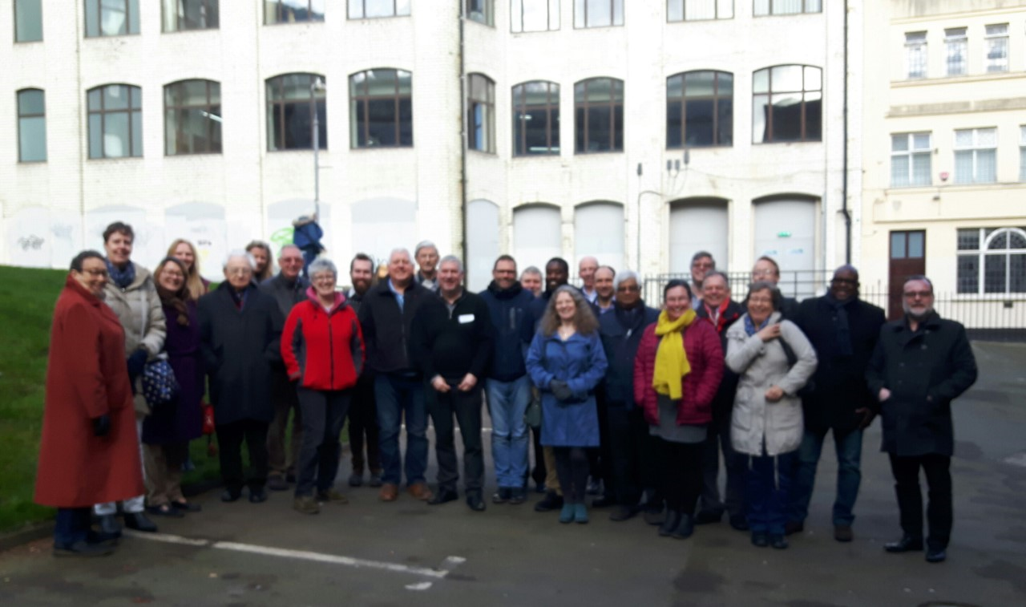

"In the UK, for every Methodist member there are two people who are homeless - defined as those sleeping rough or in temporary accommodation. This figure (around 320K) is a 4% increase on the previous year.
That was the background for a Methodist gathering on Housing and Homelessness at Carrs Lane in Birmingham on Saturday, led by Rev'ds Ian Rutherford and Mike Long. I was impressed by the depth of experience in the room. People deeply involved in activities to combat this scourge both in and beyond the church gathered to share ideas.
Several things struck me. One was that churches tend to focus efforts on the respite - eg providing homeless shelters. We were encouraged to think about how we might also work in the areas of reduction (tackling root causes); recovery and reconnection. A simple coffee morning can be a route to reconnection if we are willing to be truly welcoming to a wide range of people.
Another was that no-one comes off the streets as the result of the efforts of just one organisation. It's essential to work in partnership. This was a contribution from Jon Kuhrt, Faiths Advisor in the Ministry of Housing Communities and Local Government. Jon also urged us to avoid naivety. Only by combining grace and truth can we help people's situations be transformed.
Finally, we don't have to start with a huge scheme to set up a hostel. One starting point is when we choose what to do with an empty manse. We no longer have to get the maximum rental value - we can combine with partners to provide lower cost housing to someone in need."
RACHEL PARKINSON
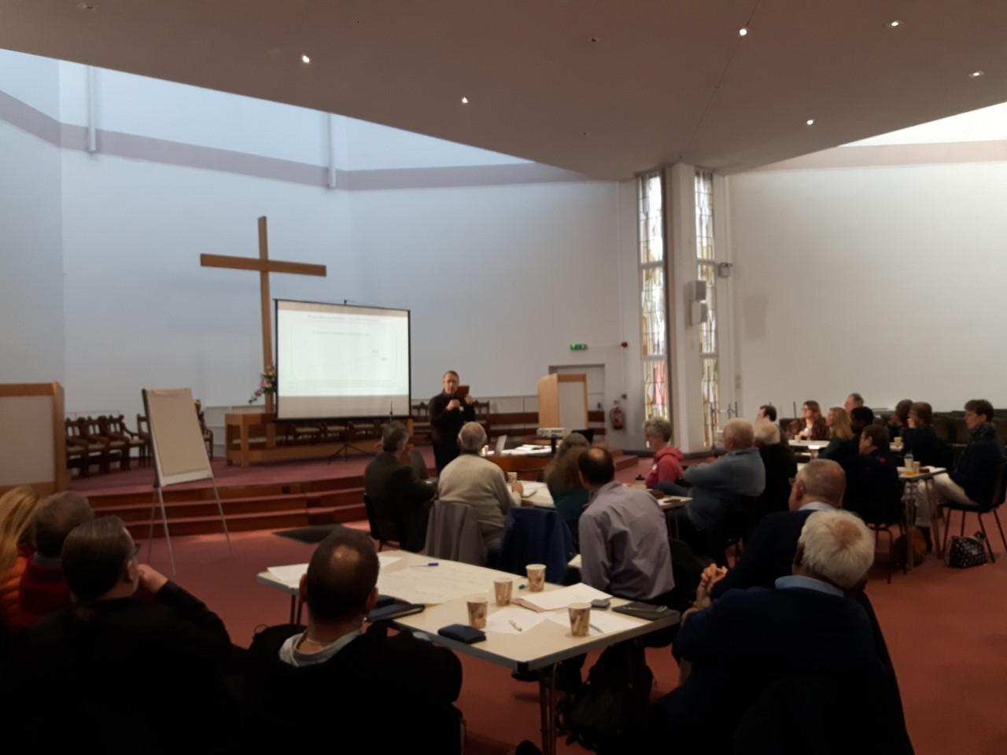

Jon Kuhrt brings a perspective from the Ministry of Housing, Communities and Local Government
#homelessnessandhousing

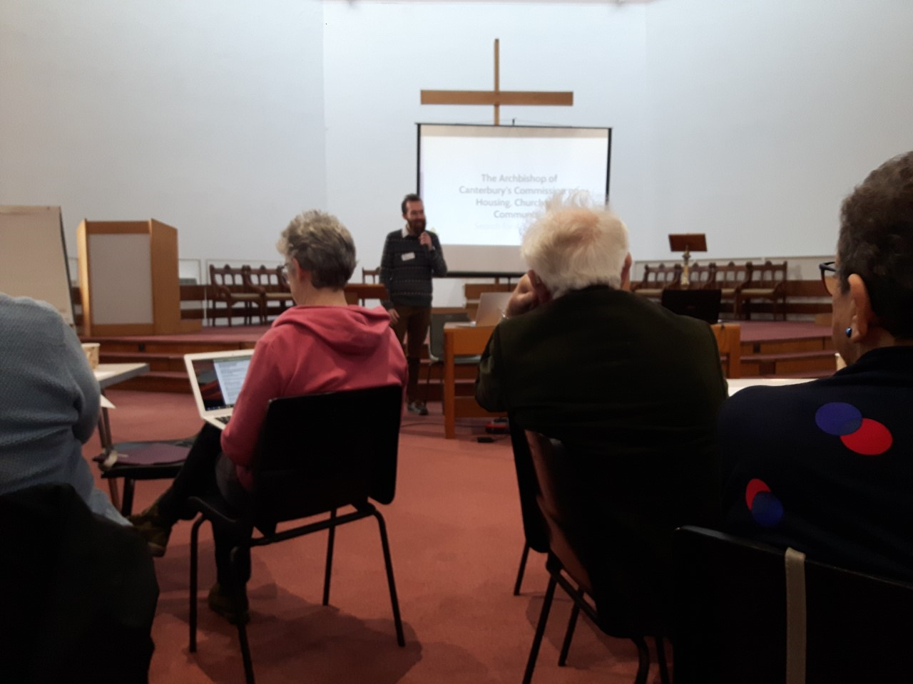

Dan Simpson shares some of the work being done by the Archbishop of Canterbury's Commission on Housing and Community
#partnershipworking

