Paintings, Prayers and Carols for Christmas 2020

FOR CHRISTMAS 2020
This will be a Christmas like no other. Even if some churches are able to re-open in early December, normal services will not resume any time soon and communal carol singing will, sadly, be impossible. Yet we are learning new ways of worshipping, using technology to explore, express and share our faith, and to connect with others: Christmas is not cancelled!
This online resource comprises eight pictures from the Methodist Modern Art Collection with words from Singing the Faith, the current authorised hymnbook of the Methodist Church of Great Britain. Thanks go to Laurence Wareing, editor of Singing the Faith Plus, for his invaluable assistance.
Like all good Art, the Nativity pictures in the Collection are not just visually attractive. They are often thought provoking and sometimes challenging. The Management Committee of the Collection hope these images and the words that accompany them will enrich your devotions this Christmas.

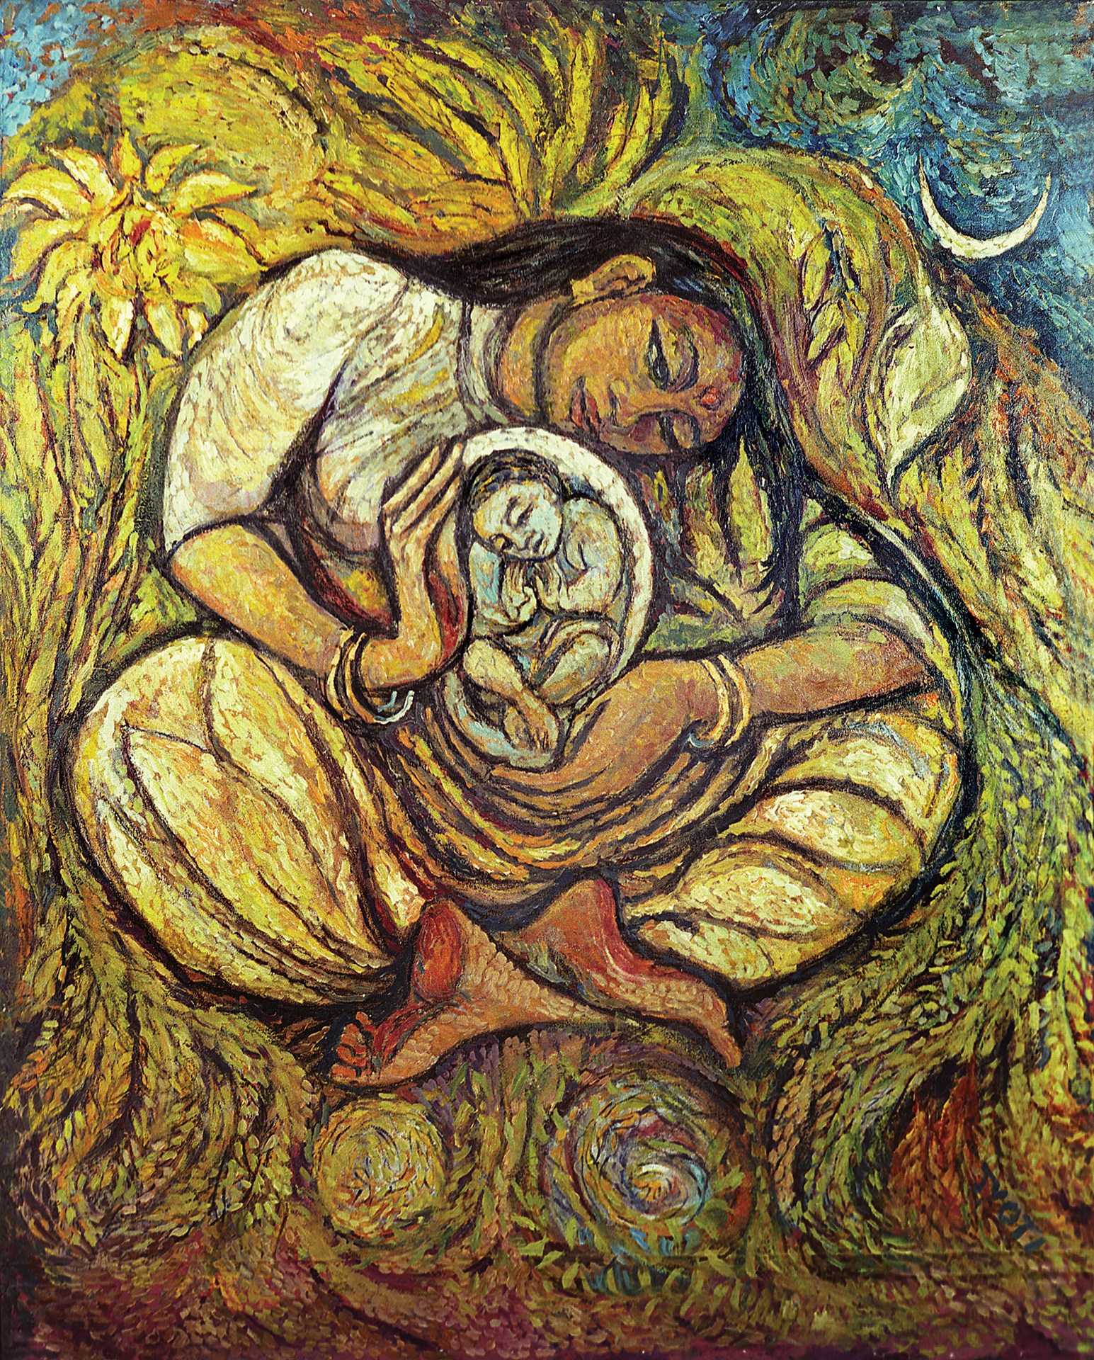
Jyoti Sahi - Dalit Madonna
Oil on canvas, laid down on board. 147.5 x 118.5 cm
from the Methodist Modern Art Collection © TMCP, used with permission. www.methodist.org.uk/artcollection
The Christmas Story starts with Mary. Here we have the beautiful Dalit Madonna by Indian artist Jyoti Sahi whose gorgeous glowing golden colours feel so warming at this time of year. In it Mary’s expression is loving, but pensive.
Luke tells us that an angel delivered extraordinary news to Mary “You have found favour with God. You will conceive and give birth to a son, and you are to call him Jesus... He will be great and will be called the Son of the Most High.” (Luke 1:30-32). Mary’s response is inspiring: “I am the Lord’s servant,” Mary answered. “May your word to me be fulfilled.” (Luke 1:38)
A PRAYER
Wise and Holy God, our lives do not always run according to the plans we make for them. Help us always to trust you and to praise you as Mary did. Amen.

Gillian Collins has written a hymn that follows Mary throughout her life:
REMEMBERING MARY
Mary, joyful mother, resting from the birth,
Do you sense the future for your Son on earth?
Angels, shepherds, wise men, all foretell a King,
But like every mother, you'll know suffering.
Mary, anxious mother, searching for your boy,
Jesus does not mean to anger or annoy.
He's still in the temple, asking questions deep.
This disturbing memory ponder now and keep.
Mary, hurt, excluded, standing in the cold,
Jesus inside preaching, challenging and bold,
Seems now to belittle all your love so free.
Who will be my family? Those who follow me!
Mary, watching sadly by the cruel cross,
Who can know your thoughts now, grieving in your loss?
Was it all for this, then? All your years of care?
He cries, "It is finished!" You weep with despair.
Mary, new disciple, in the upper room,
Waiting, watching, praying – Spirit's coming soon.
Mother of the Christ-child, suffering, faithful, true,
We have now a Saviour. God be praised for you!
© Gillian Collins (Reproduced from Singing the Faith Plus, with permission)

A PRAYER
Loving Lord Jesus, you chose to be born into a human family. We pray for family life this Christmas. May families be places of safety, security and love, even when family members cannot be together physically. Amen.
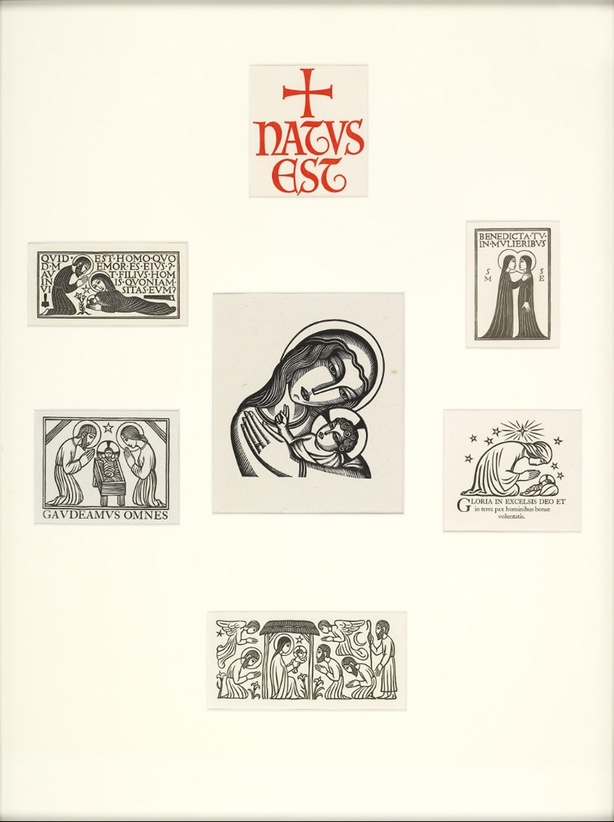
Philip Hagreen - Natus Est (He is Born)
Six small prints on paper, mounted together
from the Methodist Modern Art Collection © TMCP, used with permission www.methodist.org.uk/artcollection

These simple, elegant woodcuts illustrate Jesus’ birth and are supplemented with liturgical texts and a quotation (top left) from Psalm 8. There are various views of the holy family, one with the shepherds worshipping at the stable. At the top right is Mary’s visit to her cousin Elizabeth, the future mother of John the Baptist. At the top centre is the proclamation “Natus Est” (He is born).
CHRISTIANS AWAKE

Christians, awake, salute the happy morn
whereon the Saviour of the world was born;
rise to adore the mystery of love,
which hosts of angels chanted from above;
with them the joyful tidings first begun
of God incarnate and the Virgin's Son.

Then to the watchful shepherds it was told,
who heard the angelic herald's voice, 'Behold,
I bring good tidings of a Saviour's birth
to you and all the nations upon earth;
this day has God fulfilled his promised word,
this day is born a Saviour, Christ the Lord’.

Like Mary, let us ponder in our mind
God's wondrous love in saving humankind;
trace we the Babe, who has retrieved our loss,
from his poor manger to his bitter cross;
treading his steps, assisted by his grace,
till our first heavenly state again takes place.
(Words by John Byrom)

The mystery of the Incarnation – that our infinite God could be born a man – is something which we may have to ‘ponder in our mind’ every Christmas. It stands at the heart of Christianity and can, perhaps, only be accepted by faith. Charles Wesley suggests even angels could not understand it:

Stupendous mystery!
God in our flesh is seen
(While angels ask, how can it be?)
And dwells with sinful men!
Our nature He assumes,
That we may his retrieve;
He comes, to our dead world He comes,
That all thro’ Him may live.

(Words by Charles Wesley available in The Unpublished Poetry of Charles Wesley Volume III, p106)

A PRAYER

Holy God, who is so much bigger than our human understanding, we thank you and praise you for the birth of Jesus, Immanuel, God with us. Amen.

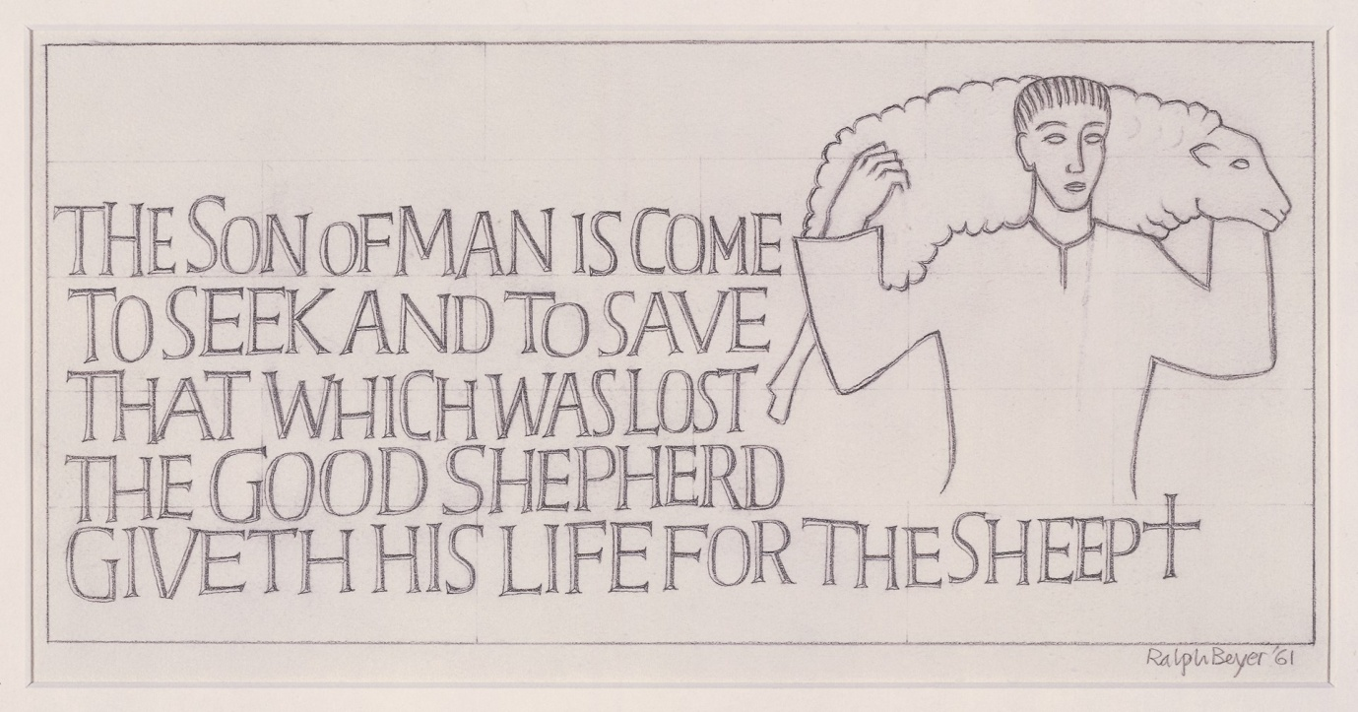
Ralph Beyer - The son of man is come
Pencil on paper. 20 x 38 cm
from the Methodist Modern Art Collection © TMCP, used with permission. www.methodist.org.uk/artcollection
This image reminds us that the baby in the manger, who is visited by local shepherds, is Christ the Good Shepherd. This understanding of God is based partly on the parables (Luke 15:3–7 and John 10:1–18), partly on Psalm 23 (‘The Lord is My Shepherd’) and partly on Isaiah (40:11) and Ezekiel (34:2–31).
This is a pencil study for one of the Tablets of the Word, eight large carved stone blocks around the nave at Coventry Cathedral, which its architect, Sir Basil Spence, commissioned from Ralph Beyer. The Methodist Modern Art Collection Management Committee hopes it will be on display in the cathedral next year as part of the celebration of Coventry as UK City of Culture.
The traditional Christmas carol that springs to mind is one that has been sung for more than 325 years:

WHILE SHEPHERDS WATCHED THEIR FLOCKS BY NIGHT

While shepherds watched their flocks by night,
all seated on the ground,
the angel of the Lord came down,
and glory shone around.

'Fear not,' said he (for mighty dread
had seized their troubled mind),
'glad tidings of great joy I bring
to you and humankind.

'To you in David’s town this day
is born of David’s line
a Saviour who is Christ the Lord
and this shall be the sign:

'The heavenly babe you there shall find
to human view displayed,
all meanly wrapped in swaddling bands,
and in a manger laid.'

Thus spake the seraph; and forthwith
appeared a shining throng
of angels praising God, and thus
addressed their joyful song:

'All glory be to God on high,
and to the world be peace;
goodwill henceforth from heaven to earth
begin and never cease.'
(Words by Nahum Tate)

A PRAYER
Loving Lord, we thank you that throughout the year, even when we walk through the valley of the shadow of death, you are with us, guiding and comforting us like a good shepherd. Amen.
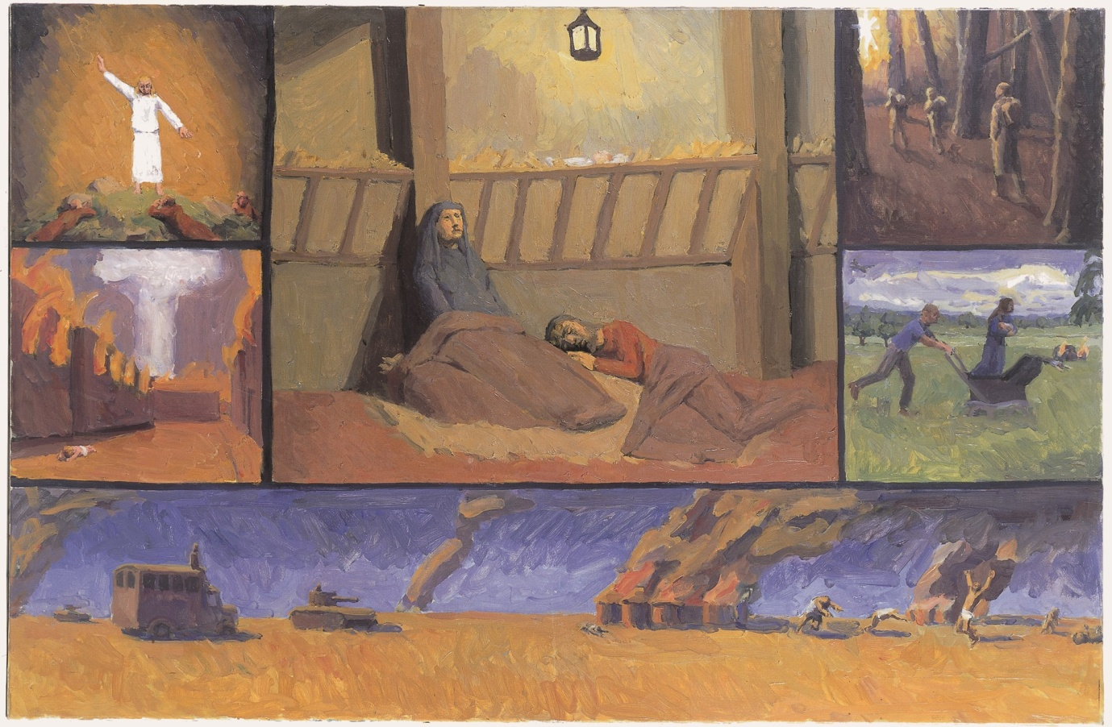
Francis Hoyland - Nativity polyptych
Oil on canvas. 90 x 120 cm
from the Methodist Modern Art Collection © TMCP, used with permission. www.methodist.org.uk/artcollection
This is a picture of startling juxtapositions. The central Nativity image is flanked by four smaller ones and one long horizontal image across the bottom. The top left image shows the announcement to the shepherds; top right, the Magi’s journey (three unregal figures, back-packing, through dangerous-looking Lickey Woods in Birmingham); middle right, the Flight into Egypt with Joseph pushing a pram through Richmond Park. The remaining images portray the Massacre of the Innocents. The middle left shows it as a nuclear attack; the wider one across the bottom shows it in terms of the warfare in the Congo when Hoyland painted the picture.
The angels proclaimed peace on earth to the shepherds (Luke 2:13) but warfare continues up to the present day. The picture reminds us again of the sufferings of others and calls us to prayer.
IT CAME UPON A MIDNIGHT CLEAR
Yet with the woes of sin and strife
the world has suffered long;
beneath the angel strain have rolled
two thousand years of wrong;
and man, at war with man, hears not
the love-song which they bring.
O hush the noise, ye men of strife,
and hear the angels sing!
(Words by Edmund Hamilton Sears)
A PRAYER

A prayer originally written for Remembrance Sunday by a former President of the Methodist Conference, the Revd Barbara Glasson.
God of peace and gentleness, we remember with deep sorrow the fault, fear, and failure that repeatedly leads to the forming of enemies, the escalation of hatred and to war. We repent of our complicity in cycles of violence for colluding with anger or defaulting to patterns of hostility. We pray, as we remember those who have suffered as a result of our forgetfulness or our inhumanity one to another, that we may also disarm our desire to overpower, capture or vanquish. Help us to resist peacefully every form of violence so that we can follow you in ways of gentleness and justice, continually resolving to form life-giving relationships, strengthened by the forgiveness of Jesus, the fearlessness of the Spirit, the transforming love of the Creator. Amen.

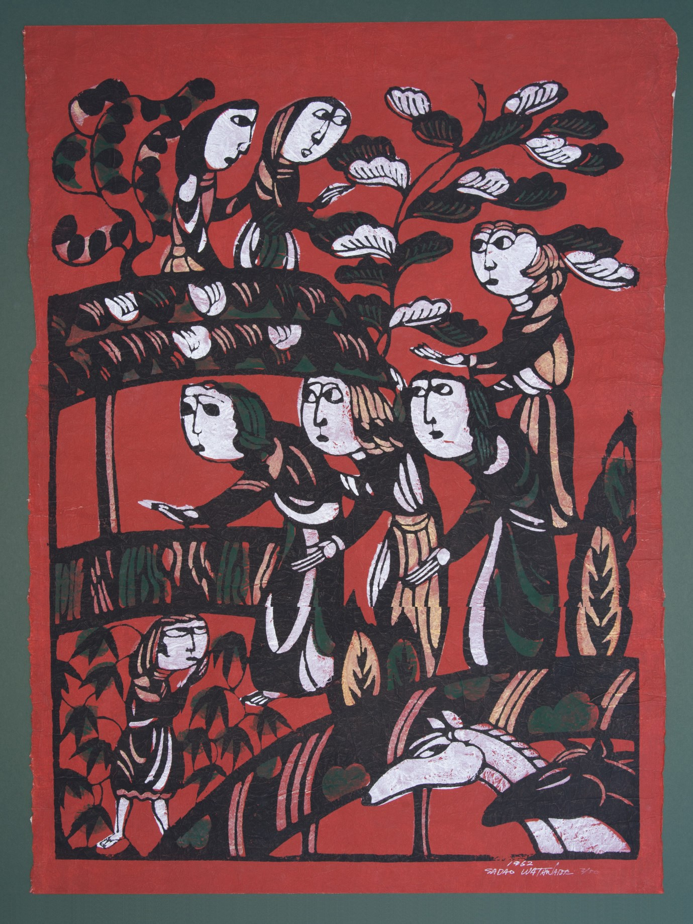
Sadao Watanabe - People visit the stable
Stencil: natural pigments and ink on paper. 80 x 59 cm
from the Methodist Modern Art Collection © TMCP, used with permission. www.methodist.org.uk/artcollection
This is a picture whose significance is identified by its title. We can see people gathering, and see animals that might live in a stable (or have been moved out to accommodate unexpected guests there), but we cannot, with certainty, recognise the characters in the story: an angel? a shepherd boy? This might make a good Christmas parlour game. The people express, perhaps, serious purpose rather than great joy or excitement.
As Japan’s foremost Christian artist, Watanabe’s main aim was to reach his compatriots with the Christian message. Not only is his work executed in a traditional Japanese medium (with natural pigments and ink on paper) but his Biblical themes are depicted in a Japanese setting.

O COME ALL YE FAITHFUL
O come, all ye faithful,
joyful and triumphant,
O come ye, O come ye to Bethlehem;
come and behold him,
born the King of angels:
O come, let us adore him,
O come, let us adore him,
O come, let us adore him, Christ the Lord!
(Words attributed to John Francis Wade)

A PRAYER

Lord Jesus Christ, we cannot gather in all the ways that we normally would to celebrate Christmas this year, but in the silence of our hearts we offer you our adoration, thanks and praise. Amen.

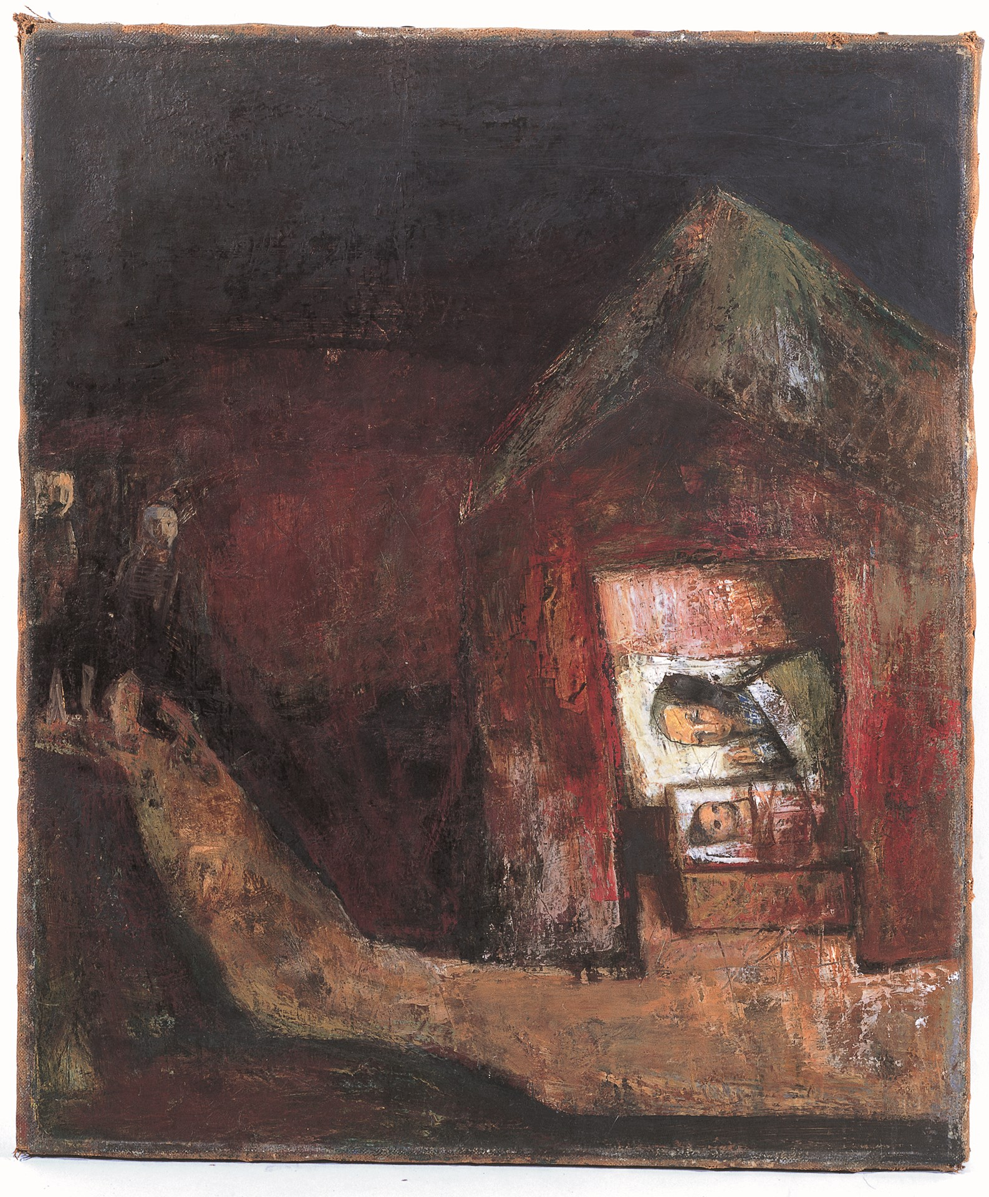
Albert Herbert – Epiphany
Oil on canvas. 77 x 65 cm
from the Methodist Modern Art Collection © TMCP, used with permission. www.methodist.org.uk/artcollection

Matthew’s Gospel tells us: After Jesus was born… Magi from the East came to Jerusalem and asked “Where is the one who has been born king of the Jews?”…. On coming to the house, they saw the child with his mother Mary and they bowed and worshipped him. (Matthew 2: 1,11).
Although kings might expect to be bowed to, the word ‘worshipped’ shows that the Magi acknowledged Jesus as much more than just a king.
Herbert shows the Magi at the extreme left of the painting, not as richly dressed kings, but perhaps as wise, old men. They seem to be bare headed – have they removed their hats as a sign of respect? They make their way along the track leading to the simple stable where the baby Jesus in his manger is shown with Mary in a glowing interior.
In the Western Church, Epiphany is a festival that concerns the manifestation of Jesus to the Gentiles. Although born King of the Jews, it is clear from the start of the Gospel narrative that he is born for all people.

O COME ALL YE FAITHFUL
Lo, star-led chieftains,
Magi, Christ adoring,
offer him incense, gold, and myrrh;
we to the Christ-child
bring our hearts' oblations:
O come, let us adore him,
O come, let us adore him,
O come, let us adore him, Christ the Lord!
(Words attributed to John Francis Wade)

A PRAYER

Lord Jesus, thank you for the inspiration of the Magi who travelled so far to worship you as the Lord of all people. Amen.

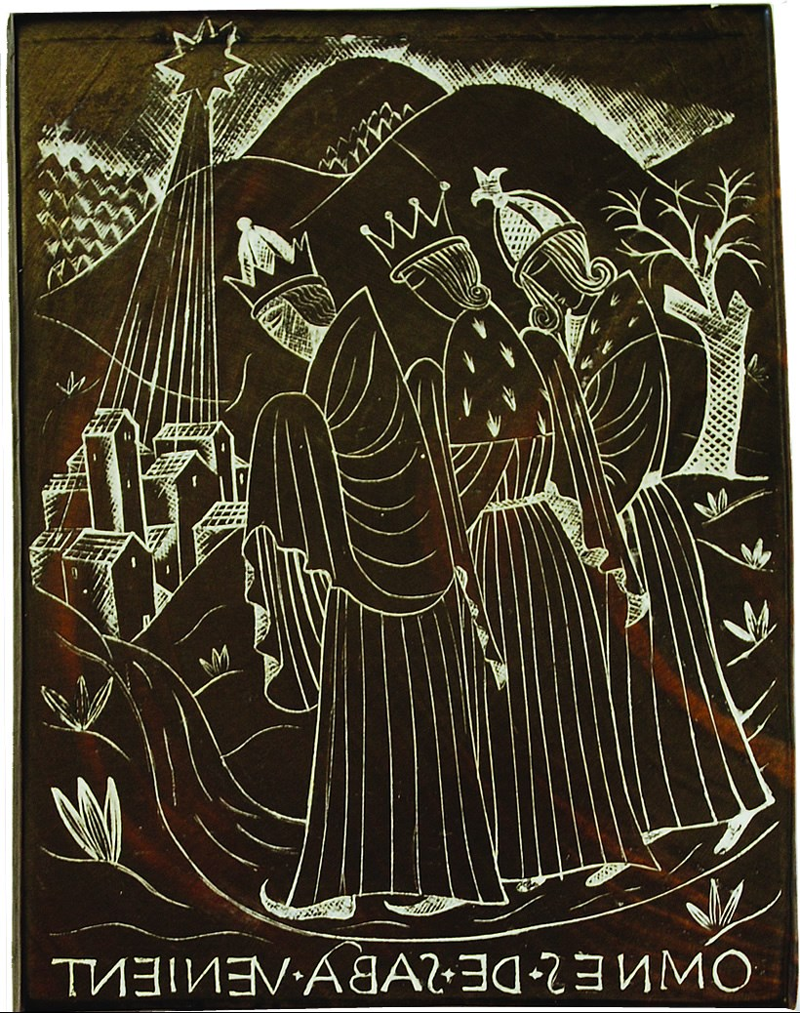
David Jones - Three Kings
Engraved woodblock (image reversed). 10 x 8 cm
from the Methodist Modern Art Collection © TMCP, used with permission. www.methodist.org.uk/artcollection
Jones’s woodblock takes the same story from Matthew as Albert Herbert’s ‘Epiphany’, but illustrates different aspects of it.
These travellers are definitely richly dressed kings, and although we can see the star they are following, we cannot see Jesus. They are still travelling, on foot, heads bowed, in faith.
The words, inscribed in reverse, ‘Omnes de Saba Venient’ are known from early Epiphany carols and come from Isaiah’s prophecy (Isaiah 60:6): All shall come from Sheba bringing gold and frankincense, and showing forth praise to the Lord.
The Bible does not say the Magi are kings, that there are three of them (only three gifts), or even specify their gender. However, the tradition that they were three kings is reflected not only in Jones’s work, but also in one of the UK’s favourite Christmas carols, written by an Episcopalian rector from Pennsylvania in 1857:
WE THREE KINGS OF ORIENT ARE
We three kings of Orient are
Bearing gifts we traverse afar
Field and fountain, moor and mountain
Following yonder star
Refrain:
O Star of wonder, star of night
Star with royal beauty bright
Westward leading, still proceeding
Guide us to thy Perfect Light
Born a King on Bethlehem's plain
Gold I bring to crown Him again
King forever, ceasing never
Over us all to reign
Frankincense to offer have I
Incense owns a Deity nigh
Prayer and praising, all men raising
Worship Him, God most high
Myrrh is mine, its bitter perfume
Breathes of life of gathering gloom
Sorrowing, sighing, bleeding, dying
Sealed in the stone-cold tomb
Glorious now behold Him arise
King and God and Sacrifice
Alleluia, Alleluia
Earth to heav'n replies
(Words by John Henry Hopkins)
A PRAYER
Lord Jesus Christ, we acknowledge you as King and God and Sacrifice. Alleluia! Amen.
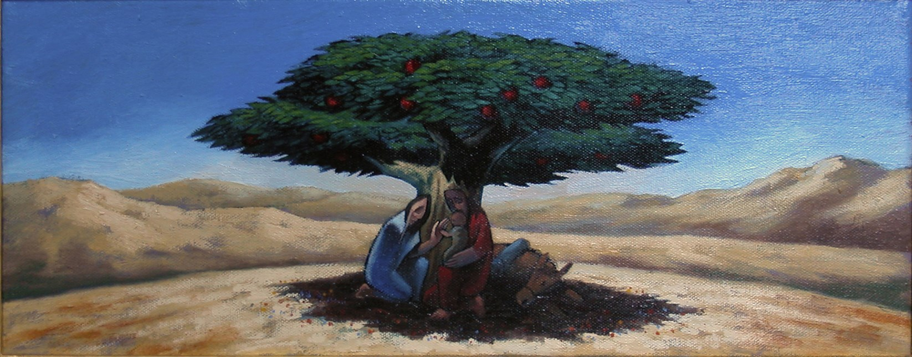
Nicholas Mynheer - Rest on the flight to Egypt
Oil on canvas. 20 x 50 cm
from the Methodist Modern Art Collection © TMCP, used with permission. www.methodist.org.uk/artcollection
Matthew’s Gospel moves straight from the stories of the Nativity and the Visit of the Magi to the story of the Flight to Egypt in which Joseph is told by an angel in a dream: “Get up, take the child and his mother and escape to Egypt” (Matthew 2:13). At Christmas, a time associated with being at home together, we remember the millions of people today who, like the Holy Family, have been forced to flee from their homes for an uncertain future. We realise that although, for many of us, everyday problems can be put on pause over Christmas, for many more those problems continue into the New Year and beyond.
THE REFUGEES
Down the road run refugees,
a child and father and mother;
scared by what they’ve left behind
and what they fear to discover.
Move and move and move along
in fair and foulest weather.
Stop a bit but don’t stay long;
you might be wand’ring for ever.
Hunted out like criminals
and kept at distance like lepers,
cursed and criticised by those
who look and laugh at their papers.
At their back run twenty more
and twenty thousand come later;
twenty million follow these:
each year the number gets greater.

Drought and famine force them out,
and war-torn nations eject them;
folk like us with nothing to fear
see fit to doubt or deride them.
Jesus and his parents fled
from Herod’s imminent danger;
still he wanders with the crowds,
a frightened, nationless stranger.
Who will help the refugees
to cease their endless walking,
while the ones who claim to care
continue endless talking?
(Reproduced on Singing the Faith Plus, with permission, from the Innkeepers & Light Sleepers collection/ songbook/ CD (Wild Goose Publications, 1992)
Words & Music John L. Bell & Graham Maule, copyright © 1992 WGRG, c/o Iona Community, Glasgow G5 9JP, Scotland. International Copyright Secured. All Rights Reserved. See Wild Goose Resource Group)

Responding to the challenge in the final verse, we may want to use this prayer, adapted from the Intercessory Prayers in the Methodist Liturgy for Migrants and Refugees:
Lord, we bring to you the weeping and wailing of the mothers of this world, waiting for their children who have disappeared in the sea, in the desert, in uncertainty. We bring to you refugees, men, women and children, from the war zones of this world, who are fleeing hunger and poverty, in the hope of a better, more secure life. We bring to you our lament for those who have died stranded at our borders, those who have died fleeing through deserts, mountains and seas. We call upon you and we join in the cry of those who have died seeking justice and a better world.

Lord, we bring to you our shame for turning away and remaining silent. We have enough to eat in Europe - and do not see that we also create the causes of hunger. We are insatiable and do not realize that is the cause of many wars. We’re silent, when we should speak and act.

Lord, we bring before you our political leaders, who are not making decisions about mere numbers, but about the destiny of many human beings. Sharpen their awareness of how things are interrelated. Keep their consciences alert. Let them develop rules that are guided by humanity and a vision of peace.

Lord, give us the strength to bear witness to the suffering of your children on the run, on their way to us, at our borders, in refugee camps and among us, in detention, waiting to be deported, in fear of the dangers that lie ahead, in mourning for those who have died. Help us, Lord. Amen.

