Conscientious Objectors
Conscientious Objection in South Warwickshire
Philip Spinks
Of all the grounds on which such a claim (of exemption from conscription) could be made, conscientious objection was the most emotive; it was a concept difficult for a large proportion of the public to accept, understand or, in some cases, actually believe. To profess himself a conscientious objector, a man had to be both committed to his reasons for doing so and prepared to withstand vilification, humiliation and harassment by his countrymen and, frequently by his government.
Of the European nations that went to war in 1914 Great Britain was unique in that it had a professional army, and one much smaller (about 250,000 men) than those of the other major belligerents. Britain’s allies and the Central Powers alike depended upon conscription for their large armies. The highly successful pre-First World War reforms of the British Army had resulted instead in a two-tier system – a well equipped and well-trained professional army supplemented by a Territorial Force.
Although some expected the war to ‘be over by Christmas’, it was apparent from a very early stage that hostilities would be lengthy. Lord Kitchener, the Secretary of State for War, predicted that it would last for at least three years. His call to arms for a volunteer army received an unprecedented response but when, by early 1915, volunteer numbers began to dwindle it became apparent that conscription was the only alternative, even though the pre-war reforms had been expected to negate this course of action.
On 5 January 1916 The Military Service Bill was presented to Parliament and after much deliberation, passion and wrangling was passed nineteen days later. The Act became operative on 2 March 1916. From the beginning Asquith has assured the House of Commons that exemptions would be made for some conscripts, “in cases of hardship owing to financial, business or domestic obligations”. The Act also included exemptions for conscientious objectors – the first time any such allowance has been made in the history of conscription. But this was defined as “Conscientious objection to the undertaking of combatant service.
The No-Conscription Fellowship and the Fellowship of Reconciliation, among others, “gave moral and sometimes material support to those who sought exemption on conscience grounds when conscription eventually arrived. In particular they supported absolutists.
Nationally there were about 16,250 conscientious objectors during the war. It has been suggested that, of that number only 350 absolute exemptions were given.
Conscientious Objectors were seen as “unpatriotic, cowardly and treasonous” and according to an Army Office “demeaned in every public place throughout the land, he was subjected to the scorn of intimate friends, and became an outcast, spurned sometimes even by his own family.
All claims for exemption from military service under the Military Service Act, whether on the grounds of conscience or for any other reason, had to begin in a local tribunal of which nationally there were about 1800. Each was made up of local people (usually councillors and persons of note, including women and a workmen’s representative.) They were supported by a clerk and a military representative.
For claims made by conscientious objectors there were three decisions that would be arrived at either by the local tribunal or after appeal to the appeal tribunal: an absolute exemption; a non-combatant exemption (where a man would enter the army but be employed on non front line duties such as supply, transport and medical); or a refusal.
However passionately they felt about their claim they would have to persuade a possibly unsympathetic, and sometimes hostile, bench of fellow citizens to excuse them from military service. They had to appear in person at the tribunal which was held in public.
For those of a long-established religion the course could be smoother as “Military Representatives were, in effect, instructed not to oppose Quaker applications.
(Quakers were respected by many, if not actually admired, for their overt pacifist stance during the previous 250 years. They were not totally free from vituperation as it was alleged that “they had totally ignored Christ’s teachings on wealth and become one of the richest communities in Britain but were escaping the responsibilities of wealth exaggerated by the doctrine of non-resistance.)
Although the Church of England and Roman Catholic Church recognised this as a just was, and therefore did not encourage their members to claim conscientious objection, some adherents nevertheless did so.
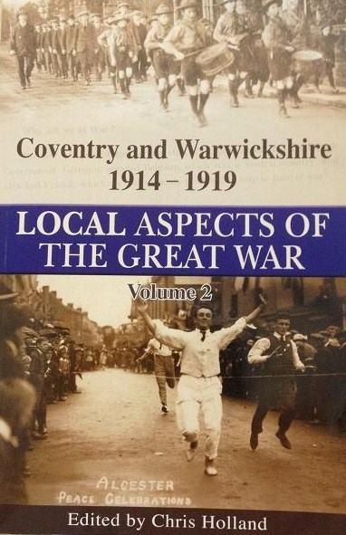
A myth has evolved that droves of conscientious objectors refused to fight for their country during the First World War; this was evidently not the case, either nationally or locally. They knew such a stance would bring them possible ostracism by their communities, not just for the war’s duration but for long afterwards.
[The above are extracts from the chapter Conscientious Objectors, Conscientious Objection in South Warwickshire by Philip Spinks from the book Local Aspects of the Great War: Volume 2]

