Maundy Thursday – ‘My God, my God, why have your forsaken me?’

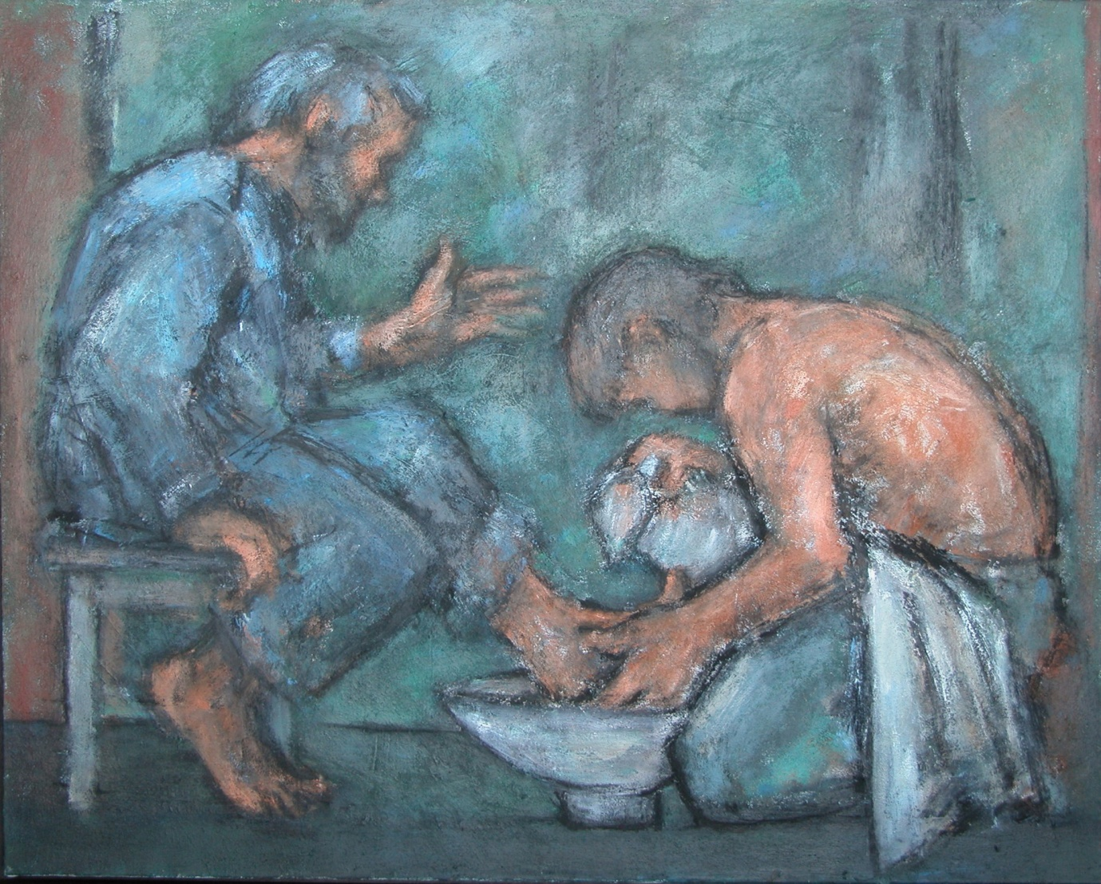
Ghislaine Howard - The washing of the feet
Image Copyright © Trustees for Methodist Church Purposes. The Methodist Church Registered Charity no. 1132208. This and other images from the Collection are available to view online at https://www.methodist.org.uk/our-faith/reflecting-on-faith/the-methodist-modern-art-collection/browse-the-collection/

GATHERING IN GOD’S PRESENCE

If you would find it helpful, light a candle as a symbol of God’s presence with us. As we reflect on Jesus’ words, you may find it helpful to place a bowl and towel on a table.

Psalm 22
Plea for Deliverance from Suffering and Hostility
¹ My God, my God, why have you forsaken me?
Why are you so far from helping me, from the words of my groaning?
² O my God, I cry by day, but you do not answer;
and by night, but find no rest.

⁹ Yet it was you who took me from the womb;
you kept me safe on my mother’s breast.
¹⁰ On you I was cast from my birth,
and since my mother bore me you have been my God.

Suggested hymn: All the room was hushed and still (StF 266) (11/16)

1 All the room was hushed and still,
and when the bowl was filled
he stooped to wash their feet.
And when it was complete,
he said, this is what I'm asking you to do,
this is why I'm kneeling here beside you.
This is what I want my Church to be,
this is what I want the world to see --
who it is you follow.
Love each other,
one another.
Love each other
in the way that I have loved you.
Walk together,
and whatever comes,
love each other in the way that I have loved you.

2 Let the room be hushed and still,
let us go to where he kneels
and join him as he serves,
and learn his ways of love.
He said, this is what I'm asking you to do,
this is why I'm kneeling here beside you.
This is what I want my Church to be,
this is what I want the world to see --
who it is you follow.
Graham Kendrick (b. 1950)
Words and Music: © 2009, Graham Kendrick / Make Way Music Ltd, PO Box 320, Tunbridge Wells, Kent. TN2 9DE UK. <www.grahamkendrick.co.uk> Used by permission.

Opening Prayer
Lord Jesus,
on this night you faced your own temptation in the Garden of Gethsemane;
and yet you prayed ‘not my will, but yours, be done.’
On this night you washed your disciples’ feet, and broke bread with your friends;
your actions saying ‘not my will, but yours be done.’
On this night your friends betrayed you,
showing the anguish of ‘not my will, but yours be done.’

Despite feeling alone, abandoned, betrayed,
you carried on
determined to fulfil God’s will,
determined to complete your purpose,
determined that your sacrifice would set us free.
And we are thankful – beyond words.
Amen.

WE LISTEN FOR GOD’S WORD

Matthew 27: 45-49
From noon on, darkness came over the whole land until three in the afternoon. And about three o’clock Jesus cried with a loud voice, ‘Eli, Eli, lema sabachthani?’ that is, ‘My God, my God, why have you forsaken me?’ When some of the bystanders heard it, they said, ‘This man is calling for Elijah.’ At once one of them ran and got a sponge, filled it with sour wine, put it on a stick, and gave it to him to drink. But the others said, ‘Wait, let us see whether Elijah will come to save him.’

Questions for Reflection
- Think of a time when you have felt abandoned – how did you feel?
- How does it feel knowing that even Jesus felt abandoned in this moment?
- Where do you believe God was in this moment?
- What does it mean for you that Jesus carried on, even through his doubt and betrayal?

If you are worshipping with someone, and it’s safe and appropriate to do so, read John 13: 1-20, and take the opportunity to wash each other’s feet.

Alternatively, you might like to listen to the following piece of music: ‘Lacrimosa’ from ‘Requiem in D Minor’ by W.A. Mozart https://www.youtube.com/watch?v=k1-TrAvp_xs

A Time of Prayer

‘My God, my God, why have you forsaken me?’

Lord Jesus,
by your cry of desperate honesty,
rid us of superficial faith
which is afraid of the dark.

Not so that we might be justified pessimists,
but so that we might discover profound joy,
give us, when we need it,
the courage to doubt,
to rage,
to question,
to rail against heaven
until we know we are heard.

We do not ask for easy answers
to hard times;
there are many who can offer these.

We ask for a sense of solidarity,
that will be enough
to let us know
that we do not walk or cry alone;
that will enable us to go through the dark
and find light again in the morning. Amen.*

The Lord’s Prayer
Our Father in heaven, hallowed be your name,
your kingdom come, your will be done,
on earth as in heaven.
Give us today our daily bread.
Forgive us our sins as we forgive those who sin against us.
Save us from the time of trial and deliver us from evil.
For the kingdom, the power and the glory are yours,
Now and forever. Amen.

Suggested hymn: My song is love unknown (StF 277, vv.1-5) (11/28)

1 My song is love unknown,
my Saviour's love to me,
love to the loveless shown,
that they might lovely be.
O who am I,
that for my sake
my Lord should take
frail flesh and die?

2 He came from his blest throne,
salvation to bestow;
but they made strange, and none
the longed-for Christ would know.
But O my Friend,
my Friend indeed,
who at my need
his life did spend!

3 Sometimes they strew his way,
and his sweet praises sing;
resounding all the day
hosannas to their King.
Then 'Crucify!'
is all their breath,
and for his death
they thirst and cry.

4 Why, what has my Lord done?
What makes this rage and spite?
He made the lame to run,
he gave the blind their sight.
Sweet injuries!
Yet they at these
themselves displease,
and 'gainst him rise.

5 They rise, and needs will have
my dear Lord made away;
a murderer they save,
the Prince of Life they slay.
Yet cheerful he
to suffering goes,
that he his foes
from thence might free.

Samuel Crossman (c. 1624-1683)

SENDING OUT

Through your wounds, we are healed.
Through your sacrifice, we are free.
Through your death, we are alive.
Through your eternal presence, we are never alone.
We go into the day
to bring the hope of your presence
to a waiting world.
Thanks be to God. Amen.

Some material, copyright © Wild Goose Resource Group, www.ionabooks.com, used with permission.
Other material copyright © Ian Worsfold
CCLi No: 1144191

