Good Friday – ‘Father, into your hands I commend my spirit.’

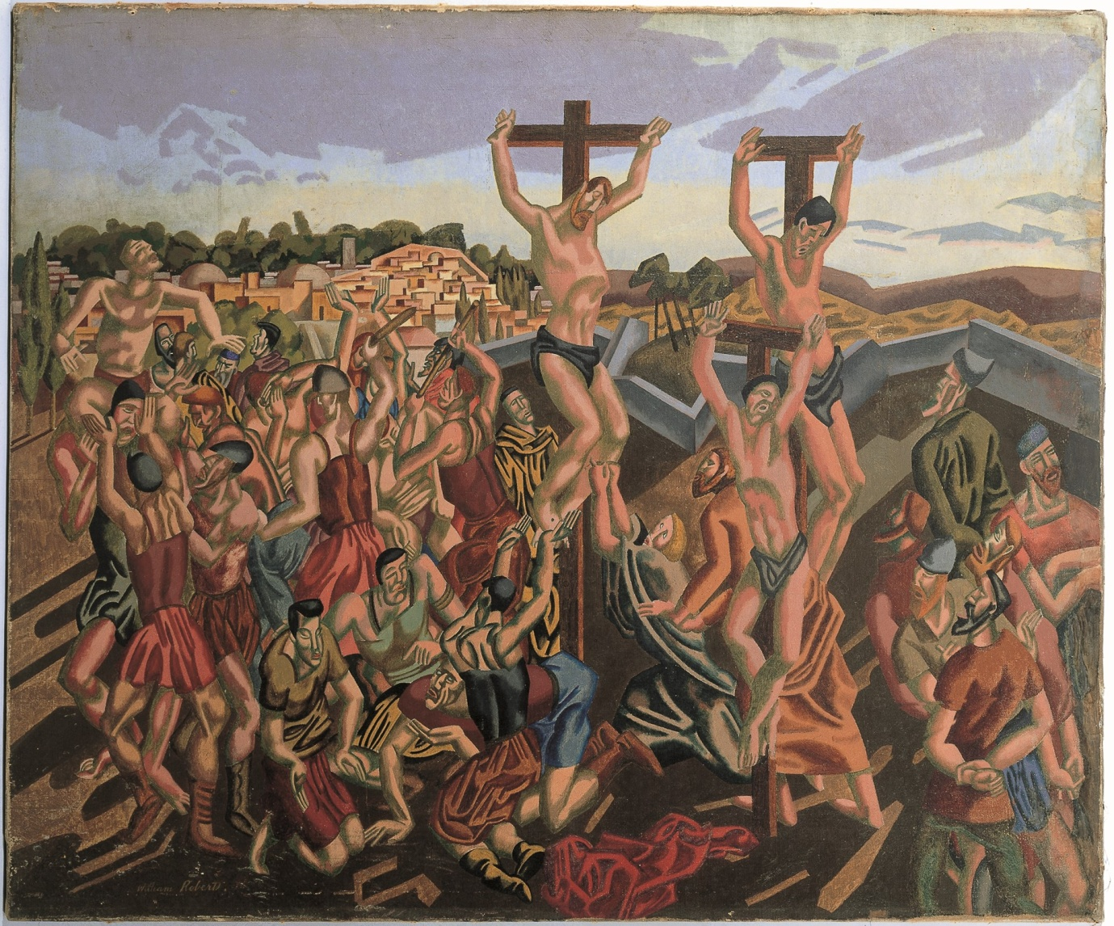
William Roberts - The crucifixion
Image Copyright © Trustees for Methodist Church Purposes. The Methodist Church Registered Charity no. 1132208. This and other images from the Collection are available to view online at https://www.methodist.org.uk/our-faith/reflecting-on-faith/the-methodist-modern-art-collection/browse-the-collection/

GATHERING IN GOD’S PRESENCE

If you would find it helpful, light a candle as a symbol of God’s presence with us. As we reflect on Jesus’ words, if you have one available, you might like to light an incense stick and watch the smoke rise.

Call to worship

Isaiah 53: 1-5
¹Who has believed what we have heard?
And to whom has the arm of the Lord been revealed?
² For he grew up before him like a young plant,
and like a root out of dry ground;
he had no form or majesty that we should look at him,
nothing in his appearance that we should desire him.
³ He was despised and rejected by others;
a man of suffering and acquainted with infirmity;
and as one from whom others hide their faces
he was despised, and we held him of no account.
⁴ Surely he has borne our infirmities
and carried our diseases;
yet we accounted him stricken,
struck down by God, and afflicted.
⁵ But he was wounded for our transgressions,
crushed for our iniquities;
upon him was the punishment that made us whole,
and by his bruises we are healed.

Suggested hymn: Come and see, come and see (StF 270) (11/20)

1 Come and see, come and see,
come and see the King of love;
see the purple robe and crown of thorns he wears.
Soldiers mock, rulers sneer
as he lifts the cruel cross;
lone and friendless now, he climbs towards the hill.
We worship at your feet,
where wrath and mercy meet,
and a guilty world is washed
by love's pure stream.
For us he was made sin --
oh, help me take it in.
Deep wounds of love cry out
'Father, forgive.'
I worship, I worship
the Lamb who was slain.

2 Come and weep, come and mourn
for your sin that pierced him there;
so much deeper than the wounds of thorn and nail.
All our pride, all our greed,
all our fallenness and shame;
and the Lord has laid the punishment on him.

3 Man of heaven, born to earth
to restore us to your heaven.
Here we bow in awe beneath your searching eyes.
From your tears comes our joy,
from your death our life shall spring;
by your resurrection power we shall rise.

Graham Kendrick (b. 1950)
Words and Music: © 1989, Graham Kendrick / Make Way Music Ltd, PO Box 320, Tunbridge Wells, Kent. TN2 9DE UK. <www.grahamkendrick.co.uk> Used by permission.

Opening Prayer

Saviour of the world,
What have you done to deserve this?
And what have we done to deserve you?

Strung up between criminals,
cursed and spat upon,
you wait for death,
and look for us,
for us whose sin has crucified you.

To the mystery of undeserved suffering,
you bring the deeper mystery of unmerited love.

Forgive us for not knowing what we have done;
open our eyes to what we are doing now,
as, through wood and nails,
you disempower our depravity
and transform us by your grace. Amen.*

WE LISTEN FOR GOD’S WORD

Luke 23: 44-49
The Death of Jesus
⁴⁴It was now about noon, and darkness came over the whole land until three in the afternoon, ⁴⁵while the sun’s light failed; and the curtain of the temple was torn in two. ⁴⁶Then Jesus, crying with a loud voice, said, ‘Father, into your hands I commend my spirit.’ Having said this, he breathed his last. ⁴⁷When the centurion saw what had taken place, he praised God and said, ‘Certainly this man was innocent.’ ⁴⁸And when all the crowds who had gathered there for this spectacle saw what had taken place, they returned home, beating their breasts. ⁴⁹But all his acquaintances, including the women who had followed him from Galilee, stood at a distance, watching these things.

A Time of Reflection

Picture the scene of Calvary.
Where are you in relation to the cross?
Why do you picture yourself in that place?
What do you want to say to Jesus right now?
What does Jesus want to say to you?

As you picture the scene you might like to listen to the following piece of music: ‘God So Loved the World’ from ‘The Crucifixion’ by John Stainer. https://www.youtube.com/watch?v=X5Akz6J8Rw0

A Time of Prayer

‘Into your hands I commend my spirit.’

Go, silent friend,
your life has found its ending.
To dust returns your weary, mortal frame.
God, who before birth,
called you into being,
now calls you back,
his accent still the same.

Lord Jesus, we let you go.

You cannot cling to life for ever,
nor can we cling to a dying frame,
nor do we grudge you
that peace which passes all understanding
which you have promised us.

So go to heaven,
where you will welcome
those who die in your faith,
whose death, with your death, we remember.

Tell them that we love them,
that we miss them,
that they are not forgotten.

And cheered by the prospect of a day
when there will be no more death or departing,
and all shall be well
and all shall be one,
may they who have died before us
be among the first
to welcome us to heaven
where, with you enthroned in glory,
and in the company of the blessed virgin Mary
and all the saints,
we will share the everlasting feast of your family.

Till then,
keep us in the faith,
fill us with hope,
deepen us through love,
to the glory of your name. Amen.*

The Lord’s Prayer
Our Father in heaven, hallowed be your name,
your kingdom come, your will be done,
on earth as in heaven.
Give us today our daily bread.
Forgive us our sins as we forgive those who sin against us.
Save us from the time of trial and deliver us from evil.
For the kingdom, the power and the glory are yours,
Now and forever. Amen.

Suggested hymn: My song is love unknown (StF 277, vv.1-6) (11/28)

1 My song is love unknown,
my Saviour's love to me,
love to the loveless shown,
that they might lovely be.
O who am I,
that for my sake
my Lord should take
frail flesh and die?

2 He came from his blest throne,
salvation to bestow;
but they made strange, and none
the longed-for Christ would know.
But O my Friend,
my Friend indeed,
who at my need
his life did spend!

3 Sometimes they strew his way,
and his sweet praises sing;
resounding all the day
hosannas to their King.
Then 'Crucify!'
is all their breath,
and for his death
they thirst and cry.

4 Why, what has my Lord done?
What makes this rage and spite?
He made the lame to run,
he gave the blind their sight.
Sweet injuries!
Yet they at these
themselves displease,
and 'gainst him rise.

5 They rise, and needs will have
my dear Lord made away;
a murderer they save,
the Prince of Life they slay.
Yet cheerful he
to suffering goes,
that he his foes
from thence might free.

6 In life no house, no home,
my Lord on earth might have;
in death, no friendly tomb
but what a stranger gave.
What may I say?
Heaven was his home;
but mine the tomb
wherein he lay.

Samuel Crossman (c. 1624-1683)

SENDING OUT

A cross:
a symbol of despair and death.
Jesus’ cross:
A symbol of hope and life beyond death.

And so we proclaim:
neither death, nor life,
nor angels, nor rulers,
nor things present, nor things to come,
nor powers, nor height, nor depth,
nor anything else in all creation,
will be able to separate us from the love of God
in Christ Jesus our Lord.

And may God bless us,
the Father, the Son and the Holy Spirit. Amen.
(Based on Romans 8: 38-39)

If you lit a candle at the beginning of your worship, extinguish it now, and watch the smoke rise, as a symbol of Jesus offering his spirit.

Some material, copyright © Wild Goose Resource Group, www.ionabooks.com, used with permission.
Other material copyright © Ian Worsfold
CCLi No: 1144191

