Easter Sunday – He is risen! Hallelujah!

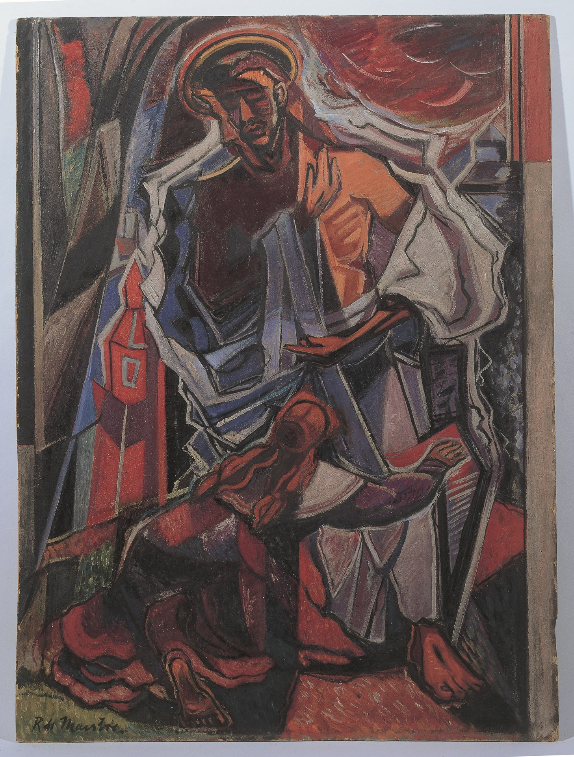
Roy de Maistre - Noli me tangere (Touch me not)
Image Copyright © Trustees for Methodist Church Purposes. The Methodist Church Registered Charity no. 1132208. This and other images from the Collection are available to view online at https://www.methodist.org.uk/our-faith/reflecting-on-faith/the-methodist-modern-art-collection/browse-the-collection/

GATHERING IN GOD’S PRESENCE

If you would find it helpful, light a candle during our call to worship as a symbol of Jesus’ resurrection. You might like to place a cross on a table with a white cloth underneath, or perhaps a vase of flowers if you have one.

Call to worship

The risen Christ came and stood among them and said:
‘Peace be with you.’
Then the disciples rejoiced when they saw the Lord.
Christ is risen!
He is risen indeed. Hallelujah!
(Based on John 20: 19-20)

Suggested hymns: See, what a morning (StF 309) (14/09)

1 See, what a morning, gloriously bright,
with the dawning of hope in Jerusalem;
folded the graveclothes, tomb filled with light,
as the angels announce Christ is risen!
See God's salvation plan,
wrought in love, borne in pain, paid in sacrifice,
fulfilled in Christ, the Man,
for he lives: Christ is risen from the dead!

2 See Mary weeping, 'Where is he laid?'
as in sorrow she turns from the empty tomb;
hears a voice speaking, calling her name;
it's the Master, the Lord raised to life again!

The voice that spans the years,
speaking life, stirring hope, bringing peace to us,
will sound till he appears,
for he lives: Christ is risen from the dead!

3 One with the Father, Ancient of Days,
through the Spirit who clothes faith with certainty;
honour and blessing, glory and praise
to the King crowned with power and authority!
And we are raised with him,
death is dead, love has won, Christ has conquered;
and we shall reign with him,
for he lives: Christ is risen from the dead!

Stuart Townend (b. 1963) and Keith Getty (b. 1974)
Words and Music: © 2003, Thankyou Music. Administered by worshiptogether.com Songs, excluding UK & Europe, administered by Kingswaysongs, a division of David C Cook <tym@kingsway.co.uk> Used by permission.

Opening Prayer

Jesus Christ, we greet you!
Your hands still have holes in them,
your feet are wet from the dew;
and with the memory of our names
undimmed by three days of death
you meet us,
risen from the grave.

We fail to understand how;
we puzzle at the reason why.

But you have come:
not to answer our questions,
but to show us your face.

You are alive
and the world can rejoice again.
Hallelujah!*

WE LISTEN FOR GOD’S WORD

John 20: 1-18

¹Early on the first day of the week, while it was still dark, Mary Magdalene came to the tomb and saw that the stone had been removed from the tomb. ²So she ran and went to Simon Peter and the other disciple, the one whom Jesus loved, and said to them, ‘They have taken the Lord out of the tomb, and we do not know where they have laid him.’ ³Then Peter and the other disciple set out and went towards the tomb. ⁴The two were running together, but the other disciple outran Peter and reached the tomb first. ⁵He bent down to look in and saw the linen wrappings lying there, but he did not go in. ⁶Then Simon Peter came, following him, and went into the tomb. He saw the linen wrappings lying there, ⁷and the cloth that had been on Jesus’ head, not lying with the linen wrappings but rolled up in a place by itself. ⁸Then the other disciple, who reached the tomb first, also went in, and he saw and believed; ⁹for as yet they did not understand the scripture, that he must rise from the dead. ¹⁰Then the disciples returned to their homes.

¹¹But Mary stood weeping outside the tomb. As she wept, she bent over to look into the tomb; ¹²and she saw two angels in white, sitting where the body of Jesus had been lying, one at the head and the other at the feet. ¹³They said to her, ‘Woman, why are you weeping?’ She said to them, ‘They have taken away my Lord, and I do not know where they have laid him.’ ¹⁴When she had said this, she turned round and saw Jesus standing there, but she did not know that it was Jesus. ¹⁵Jesus said to her, ‘Woman, why are you weeping? For whom are you looking?’ Supposing him to be the gardener, she said to him, ‘Sir, if you have carried him away, tell me where you have laid him, and I will take him away.’ ¹⁶Jesus said to her, ‘Mary!’ She turned and said to him in Hebrew,‘Rabbouni!’ (which means Teacher). ¹⁷Jesus said to her, ‘Do not hold on to me, because I have not yet ascended to the Father. But go to my brothers and say to them, “I am ascending to my Father and your Father, to my God and your God.” ’ ¹⁸Mary Magdalene went and announced to the disciples, ‘I have seen the Lord’; and she told them that he had said these things to her.

A Time of Reflection

- What surprises you about the reaction of Mary and the other disciples?
- How do you imagine Mary felt to be the first to see the risen Jesus?
- What does Jesus’ resurrection mean for you this Easter?
- If you feel creative, why not draw a picture to reflect your thoughts today.

As you reflect on these words you might like to listen to the following piece of music: ‘The Hallelujah Chorus’ from ‘The Messiah’ by G.F. Handel https://www.youtube.com/watch?v=IUZEtVbJT5c

A Time of Prayer

We greet you, risen Christ – our hope in times of despair.
We pray for those in despair today:
worried about future employment;
worried about where the next meal is coming from;
worried about a relative in isolation.
Turn their despair into resurrection hope.

We greet you, risen Christ – our peace in times of conflict.
We pray for those in conflict today:
for those in war zones in Yemen, Syria,
and other unknown places that never make the news;
for those fleeing war, seeking refuge in Greece
and throughout the world;
for those feeling unsafe in their own homes.
Turn their conflict into resurrection peace.

We greet you, risen Christ – our healing in times of trouble.
We pray for those in any kind of trouble today:
for those who are physically unwell;
for those struggling with their mental health;
for those facing their own mortality and those who care for them;
for those who grieve.
Turn their trouble into your resurrection healing.

We thank you, Lord, that through your sacrifice,
you have triumphed over death,
opening the way to new life for all.
And so we thank you
for all those who bring glimmers of new life:
for all care workers;
for our emergency services;
for those willing to work to keep us fed;
for those whose creativity is bringing life
to vulnerable people and in remote places;
for those, such as our educators, willing to go the extra mile.
Your resurrection hope is all around us – even now.
Thanks be to you,
Risen, Lord Jesus Christ. Amen.

The Lord’s Prayer
On this day of celebration, why not sing the Lord’s Prayer?
A version can be found to accompany these words at StF 763 (31/14)
Our Father in heaven, hallowed be your name,
your kingdom come, your will be done,
on earth as in heaven.
Give us today our daily bread.
Forgive us our sins as we forgive those who sin against us.
Save us from the time of trial and deliver us from evil.
For the kingdom, the power and the glory are yours,
Now and forever. Amen.

Suggested hymn: Thine be the glory (StF 313) (13/13)

1 Thine be the glory,
risen, conquering Son,
endless is the victory
thou o'er death hast won;
angels in bright raiment
rolled the stone away,
kept the folded grave-clothes
where thy body lay:
Thine be the glory,
risen, conquering Son,
endless is the victory
thou o'er death hast won.

2 Lo, Jesus meets us,
risen from the tomb;
lovingly he greets us,
scatters fear and gloom;
let the Church with gladness
hymns of triumph sing,
for her Lord now liveth,
death hath lost its sting:

3 No more we doubt thee,
glorious Prince of Life;
life is naught without thee:
aid us in our strife;
make us more than conquerors
through thy deathless love;
bring us safe through Jordan
to thy home above:

Edmond Budry (1854-1932)
translated byRichard Birch Hoyle (1875-1939)

SENDING OUT

Hallelujah, God our Creator – all life stems from you!
Hallelujah, God our Saviour – new life springs from your death!
Hallelujah, God our Sustainer – life is continually renewed in you!
Hallelujah, Father, Son and Holy Spirit!
Bless us today and always,
may your new life flow through us
into your world. Amen.

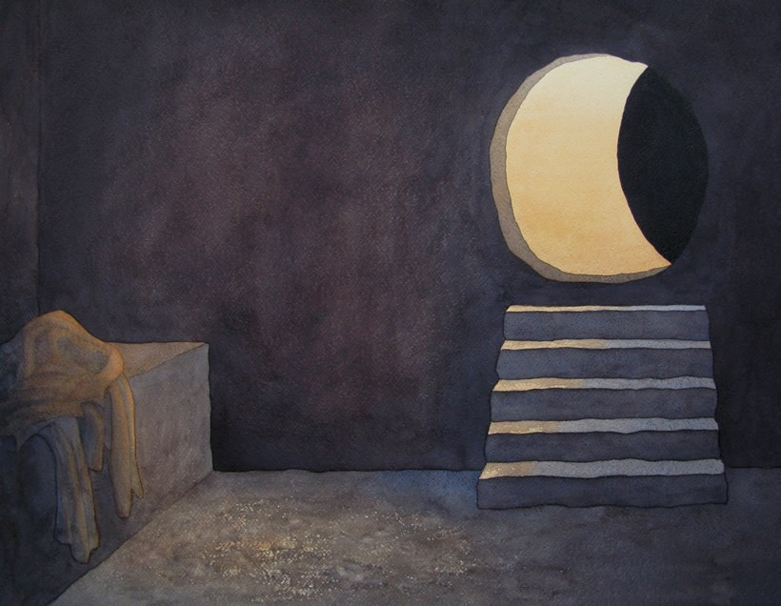
Richard Bavin - The Empty Tomb
Image Copyright © Trustees for Methodist Church Purposes. The Methodist Church Registered Charity no. 1132208. This and other images from the Collection are available to view online at https://www.methodist.org.uk/our-faith/reflecting-on-faith/the-methodist-modern-art-collection/browse-the-collection/
Some material, copyright © Wild Goose Resource Group, www.ionabooks.com, used with permission.
Other material copyright © Ian Worsfold
CCLi No: 1144191

