PALM SUNDAY

Today we offer two acts of worship; the first will be celebratory in tone, reflecting the joy of Jesus entering into Jerusalem. The second begins the series of Jesus’ Words from the Cross and leads us into Holy Week.

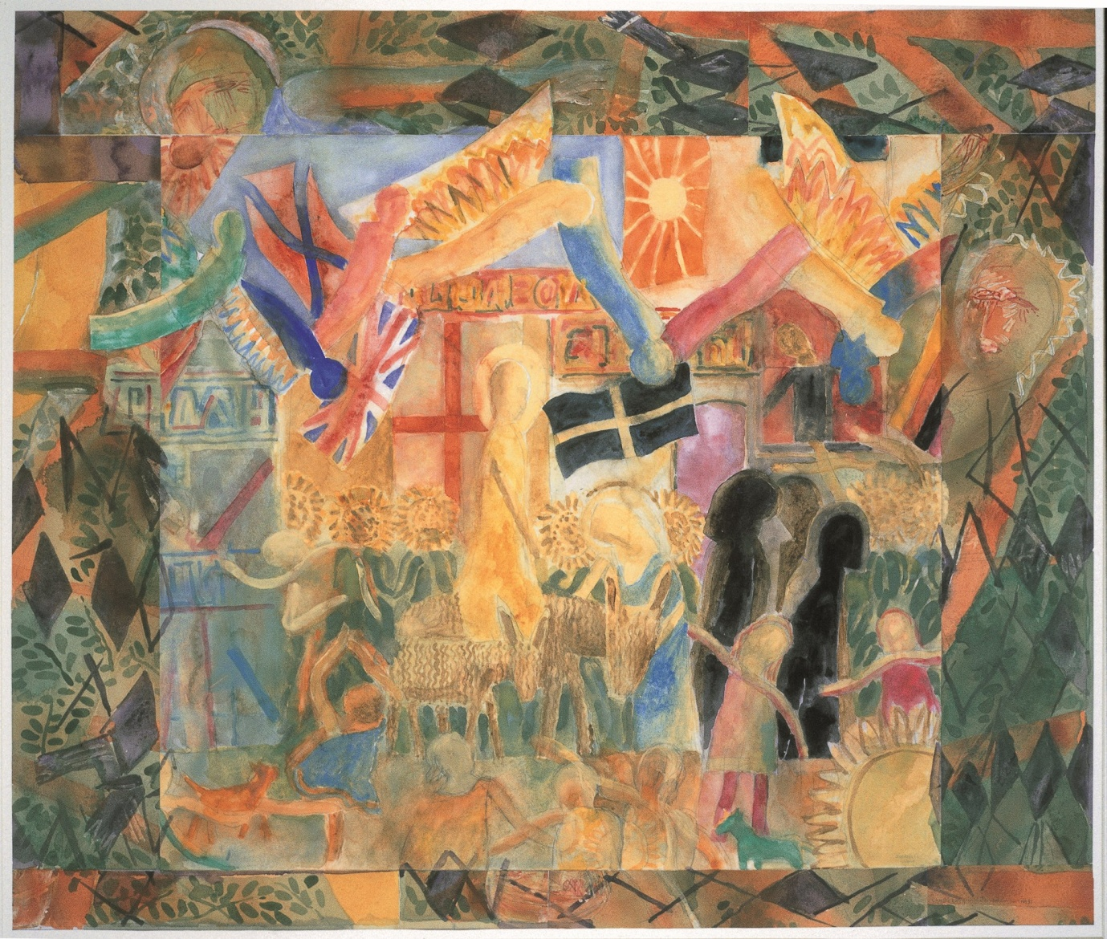
Norman Adams Christ's entry into Jerusalem Image Copyright © Trustees for Methodist Church Purposes. The Methodist Church Registered Charity no. 1132208. This and other images from the Collection are available to view online at https://www.methodist.org.uk/our-faith/reflecting-on-faith/the-methodist-modern-art-collection/browse-the-collection/

GATHERING IN GOD’S PRESENCE

If you have one available, place a palm cross on a table, and light a candle to symbolise God’s presence among us. If you don’t have a palm cross, use whatever you can to form a cross.

Call to Worship:
Rejoice, rejoice, you sons of Zion!
Shout for joy, you daughters of Jerusalem!
Look and see,
your king is coming to you.
He comes, triumphant and victorious,
yet humble and riding on a donkey.

The Lord will now save his people
as a shepherd saves his flock from danger.
Like precious stones in a crown,
we will shine in God’s own land.*
(Based on Zechariah 9)

Suggested hymn: Make way, make way (StF 264) (11/14)

1 Make way, make way, for Christ the King
in splendour arrives;
fling wide the gates and welcome him
into your lives.
Make way (Make way), make way (make way),
for the King of kings (for the King of kings);
make way (make way), make way (make way),
and let his Kingdom in.

2 He comes the broken hearts to heal,
the prisoners to free;
the deaf shall hear, the lame shall dance,
the blind shall see.

3 And those who mourn with heavy hearts,
who weep and sigh,
with laughter, joy and royal crown
he'll beautify.

4 We call you now to worship him
as Lord of all,
to have no gods before him,
their thrones must fall!
Graham Kendrick (b. 1950)
Words and Music: © 1986, Thankyou Music. Administered by worshiptogether.com Songs, excluding UK & Europe, administered by Kingswaysongs, a division of David C Cook <tym@kingsway.co.uk> Used by permission.

Opening Prayer

Gracious God, this is the day that you have made;
We will rejoice and be glad in it.
Today we greet you with shouts of ‘Hosanna!’
Today we greet you as the Creator of all that is, and as Parent to each one of us.
Today we greet you as our Triumphant King, and as the Prince of Peace.
Today we greet you as Power from on High, and as the Gentle Whispering Breeze.
Today we greet, you, One God, undivided, perfect and holy.

Forgiving God,
as we greet you with our shouts of praise,
we are aware that often, our lives shout ‘Crucify’ instead.
As we wave our palm branches in the crowd,
we are aware that often we wave our own selfish thoughts,
desires and wants before all else.
As we travel alongside you on the road,
we are aware that often we head in unsafe and unwise directions.
Forgive us, and turn our praise, our ways and our direction back to you.

God is more ready to forgive than we are to say sorry.
We hear his words of grace to each of us:
‘Your sins are forgiven.’
And we respond:
‘Thanks be to God. Amen.’

WE LISTEN FOR GOD’S WORD

Psalm 118: 1-2, 19-29
¹ O give thanks to the Lord, for he is good;
his steadfast love endures for ever!
² Let Israel say,
‘His steadfast love endures for ever.’
¹⁹ Open to me the gates of righteousness,
that I may enter through them
and give thanks to the Lord.
²⁰ This is the gate of the Lord;
the righteous shall enter through it.

²¹ I thank you that you have answered me
and have become my salvation.
²² The stone that the builders rejected
has become the chief cornerstone.
²³ This is the Lord’s doing;
it is marvellous in our eyes.
²⁴ This is the day that the Lord has made;
let us rejoice and be glad in it.
²⁵ Save us, we beseech you, O Lord!
O Lord, we beseech you, give us success!
²⁶ Blessed is the one who comes in the name of the Lord.
We bless you from the house of the Lord.
²⁷ The Lord is God,
and he has given us light.
Bind the festal procession with branches,
up to the horns of the altar.
²⁸ You are my God, and I will give thanks to you;
you are my God, I will extol you.
²⁹ O give thanks to the Lord, for he is good,
for his steadfast love endures for ever.

Matthew 21: 1-11 – The Triumphal Entry into Jerusalem

When they had come near Jerusalem and had reached Bethphage, at the Mount of Olives, Jesus sent two disciples, ²saying to them, ‘Go into the village ahead of you, and immediately you will find a donkey tied, and a colt with her; untie them and bring them to me. ³If anyone says anything to you, just say this, “The Lord needs them.” And he will send them immediately.’ ⁴This took place to fulfil what had been spoken through the prophet, saying,
⁵ ‘Tell the daughter of Zion,
Look, your king is coming to you,
humble, and mounted on a donkey,
and on a colt, the foal of a donkey.’
⁶The disciples went and did as Jesus had directed them; ⁷they brought the donkey and the colt, and put their cloaks on them, and he sat on them. ⁸A very large crowd spread their cloaks on the road, and others cut branches from the trees and spread them on the road. ⁹The crowds that went ahead of him and that followed were shouting,
‘Hosanna to the Son of David!
Blessed is the one who comes in the name of the Lord!
Hosanna in the highest heaven!’
¹⁰When he entered Jerusalem, the whole city was in turmoil, asking, ‘Who is this?’ ¹¹The crowds were saying, ‘This is the prophet Jesus from Nazareth in Galilee.’

If you are worshipping with young children, you might like to watch this short animation of Palm Sunday together: https://www.youtube.com/watch?v=lTmbTuutBgg

If you would like to make a palm tree from newspaper, here’s a demonstration: https://www.youtube.com/watch?v=9cVMM_8__aA

Questions for reflection:

- Where would you picture yourself in relation to the events of Palm Sunday? Walking alongside Jesus? In the crowd? At a distance?
- Why do you picture yourself there?
- What would you want to say to Jesus, knowing what is about to happen to him in the coming week?
- What might Jesus want to say to you?

As you reflect on these questions, you might like to listen to the following piece of music: ‘Benedictus’ from ‘The Armed Man: A Mass for Peace’ by Karl Jenkins https://www.youtube.com/watch?v=JyfIB6wUFnw

Suggested hymn: Ride on, ride on in majesty (StF 265) (11/15)

1 Ride on, ride on in majesty!
Hark, all the tribes 'Hosanna!' cry;
your humble beast pursues its road
with palms and scattered garments strowed.

2 Ride on, ride on in majesty!
In lowly pomp ride on to die:
O Christ, your triumphs now begin
o'er captive death and conquered sin.

3 Ride on, ride on in majesty!
The winged squadrons of the sky
look down with sad and wondering eyes
to see the approaching sacrifice.

4 Ride on, ride on in majesty!
Your last and fiercest strife is nigh;
the Father on his sapphire throne,
expects his own anointed Son.

5 Ride on, ride on in majesty!
In lowly pomp ride on to die;
bow your meek head to mortal pain,
then take, O God, your power, and reign.
Henry Hart Milman (1791-1868)

A Time of Prayer for God’s World
During this time of prayer, you might like to hold your cross that you placed on the table.

Ride on, oh Lord, with determination in your veins;
ride on, despite what lies ahead for you.
Ride on for those who shout ‘Hosanna’ and wave palm branches;
ride on for those whose shouts turn to ‘Crucify him!’
Ride on, ride on in majesty.

Ride on, oh Lord, with compassion in your heart.
Ride on, for those who are worried and anxious about their working life;
ride on, for those who are struggling with relationships at home;
ride on for those who are caring unconditionally for others.
Ride on, ride on in majesty.

Ride on, oh Lord, with healing in your hands.
Ride on, for those who are physically unwell;
ride on, for those who are struggling to maintain their mental health;
ride on, for those who are grieving the loss of a loved one.
Ride on, ride on in majesty.

Ride on, oh Lord, with forgiveness and love.
Ride on, as with sorrow, we nail you to the tree again.
Ride on, as with pain and anguish, you will shout:
‘Father forgive them, for they don’t know what they are doing.’
Ride on and call us again to you,
to your heart,
to your way of compassion and love
to follow you wherever you may ride.
Ride on, ride on in majesty. Amen.

The Lord’s Prayer
If you wish to sing the Lord’s Prayer, you can find a music setting of this version at: StF 763, (31/14)
Our Father in heaven, hallowed be your name,
your kingdom come, your will be done,
on earth as in heaven.
Give us today our daily bread.
Forgive us our sins as we forgive those who sin against us.
Save us from the time of trial and deliver us from evil.
For the kingdom, the power and the glory are yours,
Now and forever. Amen.

Suggested hymn: Hosanna, hosanna! (StF 263) (11/13)

1 Hosanna, hosanna, hosanna in the highest!
Hosanna, hosanna, hosanna in the highest!
Lord, we lift up your name, with hearts full of praise;
be exalted, O Lord, my God!
Hosanna in the highest!

2 Glory, glory, glory to the King of kings!
Glory, glory, glory to the King of kings!
Lord, we lift up your name, with hearts full of praise;
be exalted, O Lord, my God!
Glory to the King of kings!
Carl Tuttle (b. 1953)
Words and Music: © 1985 Shadow Spring Music / Music Services. Administered by Song Solutions CopyCare, 14 Horsted Square, Uckfield, East Sussex, TN22 1QG. <www.songsolutions.org> Used by permission.

SENDING OUT

A prayer of blessing
May the God who created us, bless us;
May the God who rides on to give his life for us, keep us;
May the God who sustains us, breath into us new life. Amen.

Some material, copyright © Wild Goose Resource Group, www.ionabooks.com, used with permission.
Other material copyright © Ian Worsfold
CCLi No: 1144191

