Quarterly Review Form for New Communities:
Congregation Name: |  | Review Date:
Review Number: |  | Respondent(s):

Please remember that the reason we start new congregations is to make new contacts, in order to make new disciples, in the hope that some of these will go on to repeat the process and start more new congregations...

1. REVIEWO
What next steps did you take to move to the next stage of the journey? What happened? What did you learn from this?

2. RESULTS_  How many people: | Add up-to-date numbers below
- Are you in relational contact with (and how frequently)? ¹
- Are attending your weekly gatherings (on average)? ²
- Have become new disciples (since your congregation started)? ³

¹ Contacts refers to the maximum number of people in a target community who know about your congregation.
² Attendance refers to your best estimate of the average (i.e. mean) number of people present at weekly worship gatherings.
³ New disciple refers to someone who was previously walking away from Jesus, but who is now walking towards Jesus.

3. PROGRESS_
Make your best guess at which stage of the journey your leadership team is currently at, by dragging and dropping the yellow circle over to the relevant blue circle which represents that particular stage.

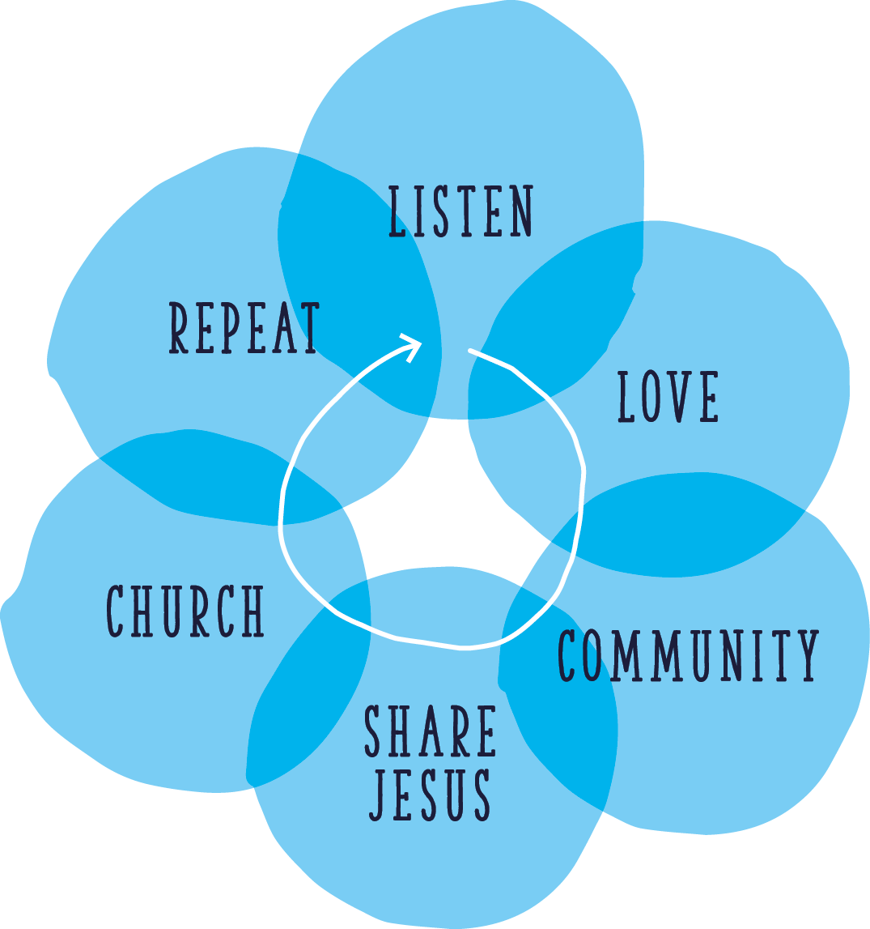

4. PLAN_
What next steps could you take to move your congregation on to the next stage of the journey (see this web-site:
https://churchsupporthub.org/fxgreenhouse/ for inspirational ideas and stories from other local congregations)?

5. PROVISION_
Do you know what it costs to run your congregation, per year? Have you communicated this to your congregation, yet?
Do they know how much is needed from them, per month, to cover these costs? Have you asked each of them to do so?

