I write this newsletter with a heart full of hope and anticipation. Maua has a very exciting development of a new CEO, Dr Salvador, who joined us in late December 2015. Dr Salvador is a surgeon who has a degree in business administration and vast experience working in mission. He is Mexican by origin but has worked in Africa for over 20 years and also in Haiti. He was also the head of the Kenya multi-hospital PEPFAR (Presidents Emergency Plan for AIDS Relief) programme from 2004. With this expertise and experience Maua Methodist Hospital is entering a phase of change, streamlining and vision. Change is often painful, challenging and some may fear and resist, but what we are seeing happening already is exhilarating.
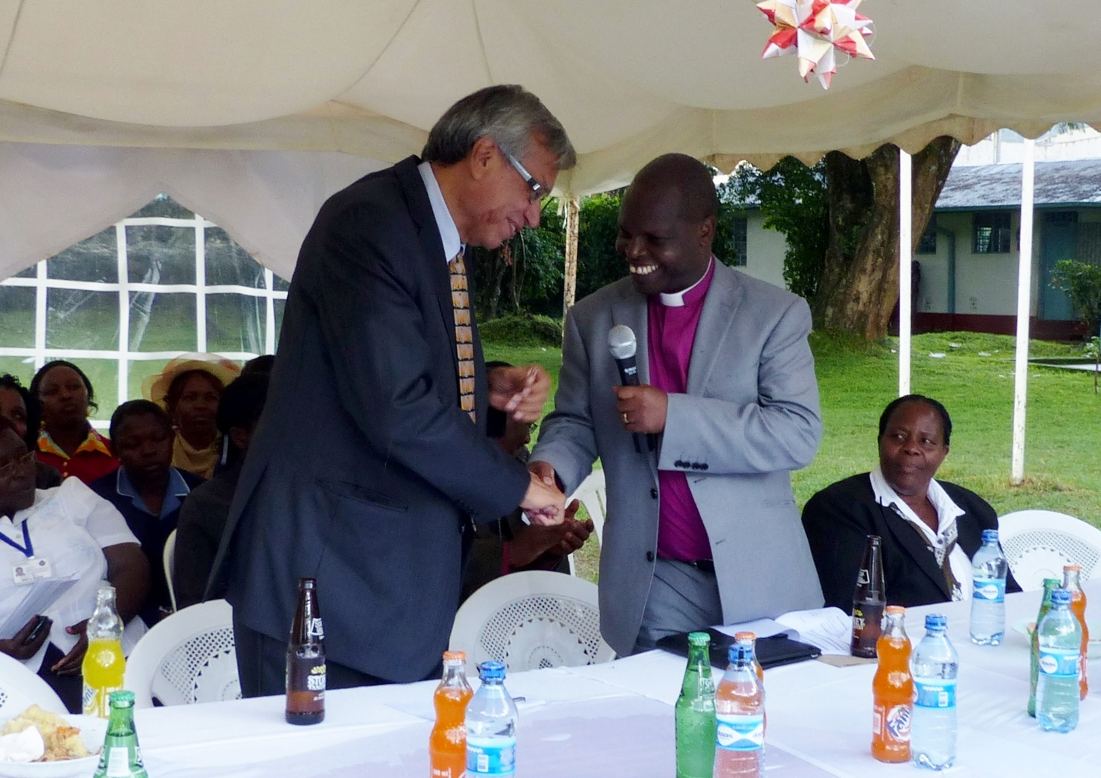
Dr Salvador being presented to the Maua Methodist Hospital staff by Presiding Bishop
Along with our Accountant, I have spent many hours at night and the weekends going through our hospital accounts with a tooth comb! In many ways our accounting system is Dickensian and still done by hand with ledgers – it was not difficult to imagine the quill pens and candles! We have gone through all the ledgers, files, bank statements, invoices etc and put all the information on computer. Despite many things being in a muddle, once teased out and untangled, all monies were accounted for and no misappropriation found.
One of the main projects we are working on, and raising money for, is a new Hospital computer system. The one we have was installed in 2003 and is now hopelessly out-of-date and did not include our accounts. Hopefully this will be updated and accounts included by the end of 2016.
Another major project Dr Salvador is spearheading is reorganising the hospital buildings to maximise use of space. Many buildings and rooms have been filled with old equipment and machines and when not spending evenings going through accounts many a happy hour had been occupied with sorting through the “junk” to separate what is useful and what needs disposing. The result of this is that our stores have been reorganised, development of an upstairs floor can take place to relocate our accounts and give them more space, and IT has been moved to a more central and spacious location. Next we hope to reorganise the laboratory and in and out-patient services to be more efficient and patient friendly.
Other new developments include recruiting a new surgeon who has been trained by Pan-African Academy of Christian Surgeons (PAACS). Dr Tony is an absolutely delightful, young and enthusiastic, Christian surgeon. He is a huge asset to the hospital, not only for his surgical skills, but also for our training and internship programmes. In the last month we have also recruited a Consultant in Family Medicine. Our physician was accepted on a 2 year training programme in UK to specialise in Gastroenterology and this left a big gap in our Medical ward coverage and internship training. The Family Medicine consultant will cover this gap and also bring Family Medicine training to Maua which will increase our scope of training and also improve the standard of care we give our patients.
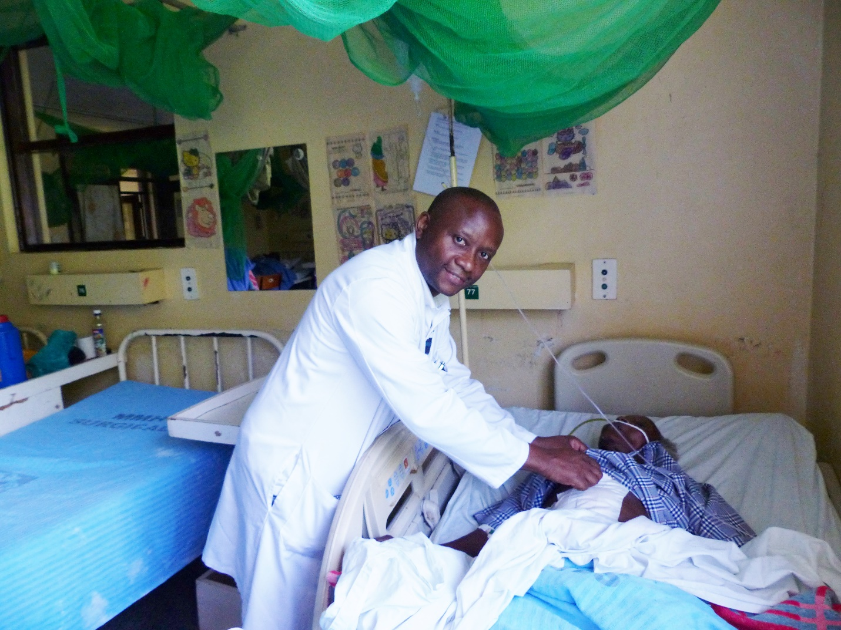
Dr Tony
The Palliative Programme continues to develop. HIV is not the national emergency it was, prevalence has stabilised at around 5.6%, but now we have many patients who have been on treatment more than 10 years and are currently facing long-term complications. We have a rise in cancers amongst our HIV patients, increased heart and kidney complications as well as patients failing their first line drugs. I have a good team trained in first-line management of HIV but am increasingly dealing with the more specialised issues that come with chronic care – this is both challenging and fulfilling. An example of this is that some of the children born with HIV, that have been in our programme for years, are now young adults and having children of their own. This is a dream we never thought possible when the programme started in 2002, when our aim was to keep the children alive as long as possible and give them a good quality of life. Those expectations have been far exceeded!! So now we have to do everything we can to have these new babies born HIV negative, and keep their parents well and strong to see their children grow up. The goal posts keep shifting and that keeps us interested and challenged and constantly thanking God for the progress that is being made in this field of medicine.
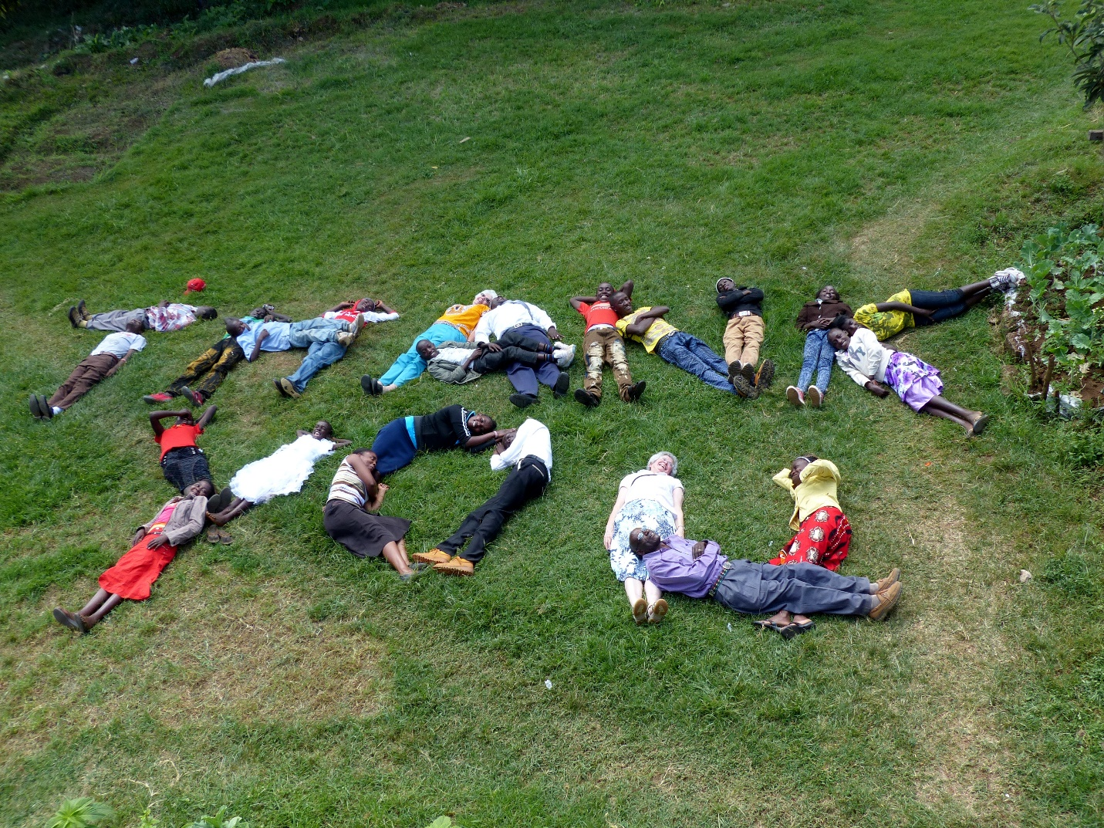
Teenagers with HIV, Palliative Staff, Sr Barbara & Dr Connie, lying in the grass to spell out “Thank you” for the support given to our ‘teens’ that has given them a chance of life and a future
This year all our interns (21), both doctor and clinical officer (a post which is something between a nurse and a doctor) are passing through our HIV training programme. This adds to our work-load but it is exciting to know we are training our future generation of medical staff well and able to manage HIV patients competently.
On a general note, I ask for your prayers for Kenya as we approach our general election next year. Already there is a lot of hype and there have been disturbances with fatalities in opposition strongholds. The elections are still 18 months away and it feels like it is going to be a long drawn out process - please pray for sanity and peace to prevail.

