Not being a great writer in the first place this is perhaps one of the most difficult newsletters for me to undertake. Where to start? Al-Shabab, Maua Methodist Hospital (MMH), personal life?
I guess I begin with Al-Shabab. The attack on the university at Garissa has been in the headlines worldwide I am sure, I hear in USA it was also reported that Al-Shabab have sworn that every city in Kenya will run red with blood, that was also reported here in Kenya but I don’t know if it reached UK. Apart from prayers for the country & sanity to prevail, prayers for the victims, prayers for the bereaved & prayers for those psychologically traumatised, what is there to say? Rumours abound, as 86 businesses and people have been named in financing Al-Shabab, 8 have been reported to originate in Maua – 1 business man and 7 to do with the miraa trade. How does that affect us here? I have no idea, it may make us safer as perpetrators want to keep Maua under the radar, or it may make us a hot spot. The advice from UK is that it is still safe to travel to most of Kenya, including Maua & certainly I have never felt any personal threat. In a newsletter last year I wrote about the uncertainty of life & how things can change so fast and we just have to live trusting in God and His faithfulness.
As a hospital we are facing a very difficult time financially. There have been a lot of challenges in the last few years with rapid changes in leadership and this year shows no sign of being different as we are already looking for a new Hospital CEO, Administrator and Medical Officer in Charge, the 3 highest positions in the hospital. This rapid change has not helped the stability of the hospital, but again we pray that if God wants Maua Methodist Hospital to continue into the future He will help to show us the way forward. In the meantime we keep trying to be faithful to our work, for myself seeing the patients in the Palliative Clinic, training continues offering a 4 day course on TB/HIV, an 18 week comprehensive clinical course on HIV, a 10 week pharmacy course on HIV and a 2 week course on Palliative Care. This year I was also asked by the CEO to assist the (new) Senior Accountant to take a close and detailed look into the financial situation of the hospital. This has taken about 10 weeks to complete and the report is not good. However, what was good is that we did not find any evidence that any money had been misappropriated, which is a great testimony to the accounts staff who had been working in difficult circumstances.
Last month I was chosen (after a pre-test and a write up of the work I do) to go on a 2 week National Advanced HIV Clinical Course held at the University of Nairobi in collaboration with the Ministry of Health and the University of Maryland School of Medicine. This was to update me as a practitioner and a teacher, but also with a view that later in the year NASCOP (National AIDS and STI Control Programme) hope to set up TWGs (technical working groups) in each county, using those of us who have been trained as leaders of the groups. These TWGs are envisaged to deal with the HIV patients who have complicated problems, especially associated now with many years of antiretroviral treatment. It was a great honour to be chosen for the course, only 1 in 5 applicants was accepted, but also to have graduated 2nd in the class of 24. I say that not to blow my own trumpet, but just to reinforce what I keep saying, that MMH is not just a backwater where your medical skills stagnate, but is at the cutting edge of medicine despite its rural location and we can stand up and be proud in the world of medicine.
On a more personal note I would like to share an experience towards the end of last year. On a Friday evening in December I was sat in a heap on the settee watching some nonsense on the TV trying to unwind after a long and difficult week. Around 8pm I got a text message from Gitonga, a colleague in our palliative department, that his son, George, a university student, had been mugged in Nairobi and been hit on the head. I sent a consolatory message back but did not take the incident too seriously. Later I was told George had been taken to a private hospital and was awaiting a CT Scan. I still took the incident a bit lightly, but was then told the scan showed an extradural haematoma (a bleed around the brain). Now I got worried & discussed with Gitonga that George needed urgent admission. That was going to cost around £3,000 but I told him to go ahead & one way or another we would find the money just so long as we saved George’s life.
A further call revealed that the private hospital would admit George but there was no surgeon and no guarantee there would be a surgeon the next day. Luckily Gitonga has a sister who works as a nurse in Kenyatta National Hospital and Gitonga managed to arrange for her to collect George and take him to KNH. With this knowledge I went to bed knowing that Gitonga and his wife Florence planned to get the first public vehicle at around 3am and proceed to Nairobi the next morning. Just before I went off to sleep Gitonga decided to send me a copy of the CT scan report & it read “massive extradural haematoma with signs of raised intracranial pressure”. At that I decided there was no time to lose, this was a grave injury with a high chance George could die. I called Gitonga & we agreed that I would drive them to Nairobi there & then.
Normally we never drive at night in Kenya but at 12.30 am we set off on our journey, praying that God would give us safety. It is one of the worst journeys I have ever undertaken. Gitonga was on and off the phone to his sister, but little was said between us. I was concentrating on driving and getting us to the hospital safely. All the while I was wondering if George was still alive or if Gitonga was hiding the worst from his wife until we reached Nairobi. Florence, sitting in the back of the car was intermittently crying, praying and quietly singing hymns. Each time she got too distressed Gitonga would calmly turn to her & tell her “we have given everything to God, whatever happens we put our trust in Him”. Gitonga only has one child, although he accepts Florence’s daughter as his own, and has withstood much pressure over the years from peers & others to take another wife and have more children. He has always stood firmly faithful to his wife and said he is grateful to God for the family he has and needs no other. Now his son’s life was in the balance and still he stood firm in his belief in God and all I could pray was “God please don’t let this great man of faith down, please let us arrive in time to see George, please spare this young man’s life”. That journey was one of the longest 6 hours of our lives, but by God’s grace at 6.30am we arrived safely at KNH.
There we found George conscious and awaiting surgery. His mother and father were able to talk to him (although now he has no recollection of them being there) & then around 10am he was wheeled into theatre. The surgery took around 5 hours, but later that evening he was conscious and able to talk. From there George has made a full and uneventful recovery, God answered our prayers, and since George had insurance recognised by KNH there was not even a hospital bill to pay!
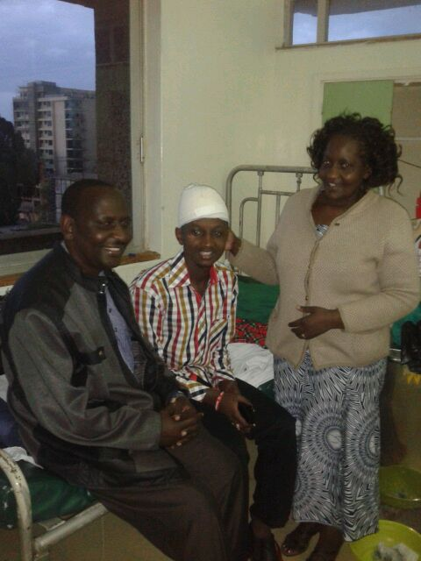
Gitonga, George & Florence
The week following George’s discharge he came up to Maua to recuperate and here I believe as Christians we can learn from the ‘Kenyan’ way of doing things. Every evening one group or another went to visit the family and give thanks to God for sparing George’s life. The Women’s’ Fellowship, the Men’s’ Fellowship, the MMH Community Health and Palliative staff, and the MMH Paediatric ward staff (Florence is the Specialist Paediatric Nurse in charge of our children’s wards). There was great rejoicing, fellowship, sharing and testimony. George shared his story with the groups which also helped him overcome the trauma of what had happened. On the Sunday he stood up in church, in front of congregation of probably 400 people, and gave his testimony and thanks to God, and he is now back at university pursuing his career.
Sometimes when I feel overwhelmed, or discouraged, or wonder what I am doing in a place like Maua, I look at people like Gitonga’s family and see such steadfastness in their Christian belief. I see the Church in action and the acknowledgement of God in our lives, not only the asking but the great thanksgiving, and then I am humbled and encouraged at the same time.
This week has also been a very exceptional one for us in Maua Methodist Hospital. On Saturday I got a text message from Jacob Ziegler saying that he, Samuel, Nora and Ronja were in Kenya and wanted to visit Maua for 2 nights. Many of you may remember their father and mother, Dietmar and Birgit, were German mission partners in Maua and were killed in a road accident in Kenya in October 2003. Dietmar was the Medical Superintendent and Birgit a theatre nurse who also set up our burns unit. Their 4 children, aged 8 to 14 years, were in boarding school at the time and thus spared the accident but tragically orphaned that day. We have had news of them over the years, and Norah has visited twice as a university student, but to see all 4 together was so special. They are all now in their 20s. Jacob is doing a gap year teaching in Kisumu, Kenya, before going to university later this year, probably to pursue a career in teaching. Ronja is still in Germany in her second year training as a physiotherapist. Samuel has done a degree in Theology and is doing youth work in Yeovil UK, and Norah has studied sociology and is currently doing volunteer work in London with asylum seekers. The 2 days has been an emotional journey for them, and us, as we have shared stories and experiences, places and memories, and remembered their parents and the legacy they left. It has also been a time of healing, events happened so quickly in 2003, and over the years many people have prayed for the children and wondered how they are doing. I can say they are such remarkable young adults, full of life and energy, all of them have continued in the Christian faith, all of them have a huge heart of caring as seen by the paths they are choosing in life. Their aunt and uncle who took over their care must be so proud of them, as their parents would be.
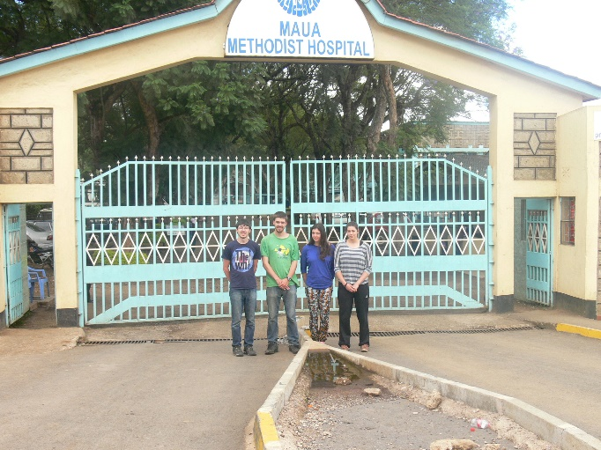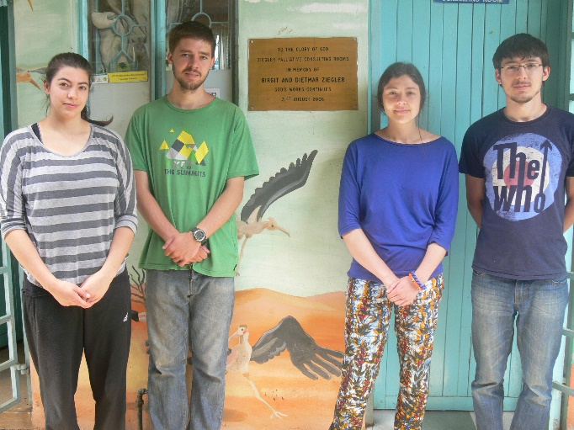
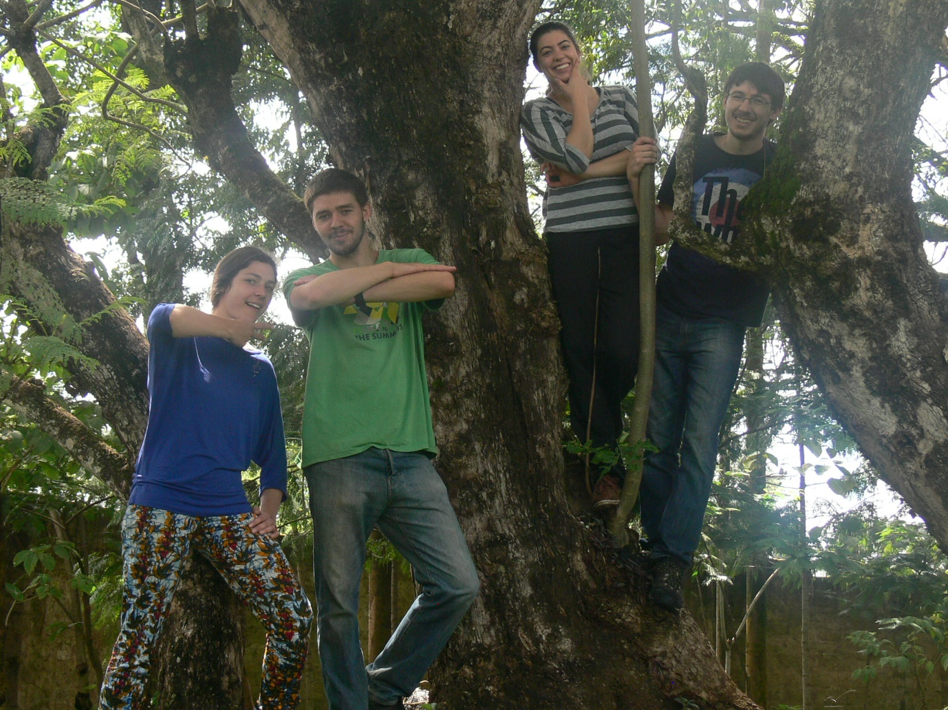
Norah, Jacob, Ronja & Samwel Ziegler
So it has been a time of tears and a time of laughter, but as we say in Kenya “God is good”, “All the time” and not Al-Shabab, nor other adversity can change that!

