News from Maua: -
As usual life is somewhat hectic in Maua but I realise I follow in my father’s footsteps whom we used to tease that if he wasn’t worried about something then he was worried why not! Not that I worry as much, but if there is not too much to do then I would wonder why not.
The main focus of my work this year has been to start setting up a training programme on HIV/AIDS for nurses, clinical officers & doctors. We have started on level one training (basic) and hope next year to extend to training on TB in the era of HIV and eventually to level two (advanced) training. This training will be opened to the North Eastern province of Kenya - at present the two established training centres are both in the Nairobi region, so this is a really exciting development. Having 10 years of practice in treating HIV in Kenya it felt so right that the experience now was not just limited to treating the patients in our programme and training the staff I work with, but extending the opportunity to all health care workers in the province. When deciding on a career way back in my youth, since my mother was a teacher I did toy with the thought of teaching (for about 1 day!) but quickly realised the idea of a classroom full of children was not my idea of fun. However, I have discovered that teaching adults is a totally different matter and I love it. The first 2 week training took place in May & our target was to increase the participants knowledge by 15% (measured by taking pre & post tests) & we reached an increase of 25%, so for our pilot run that felt pretty good.
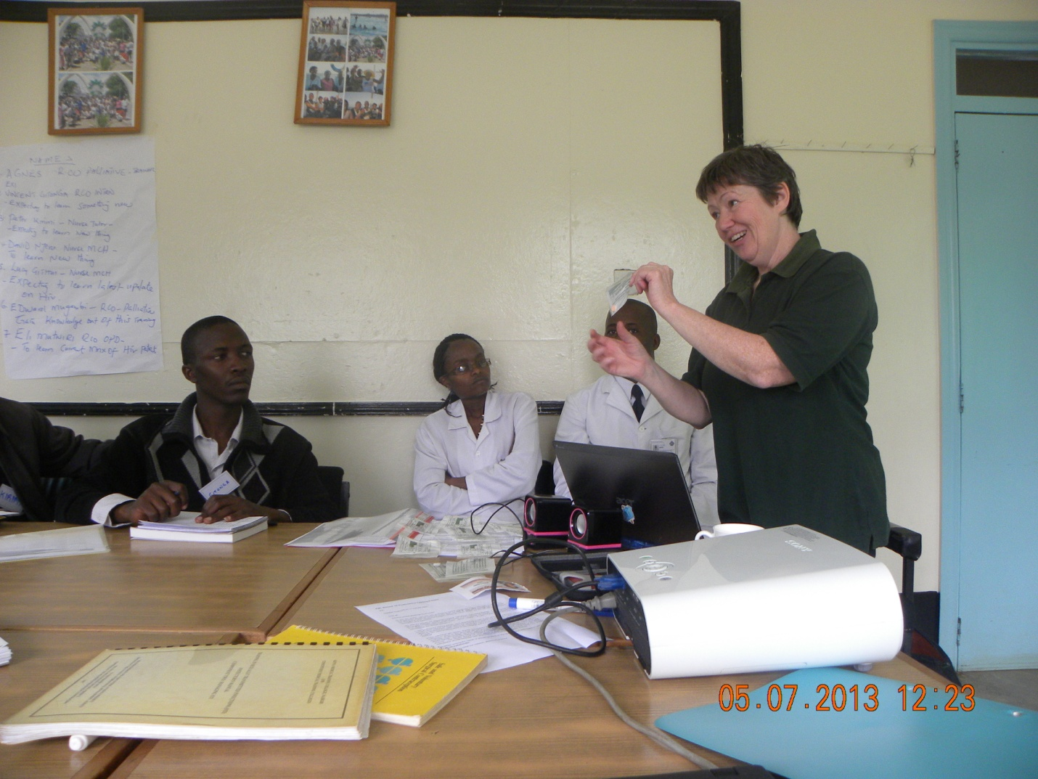
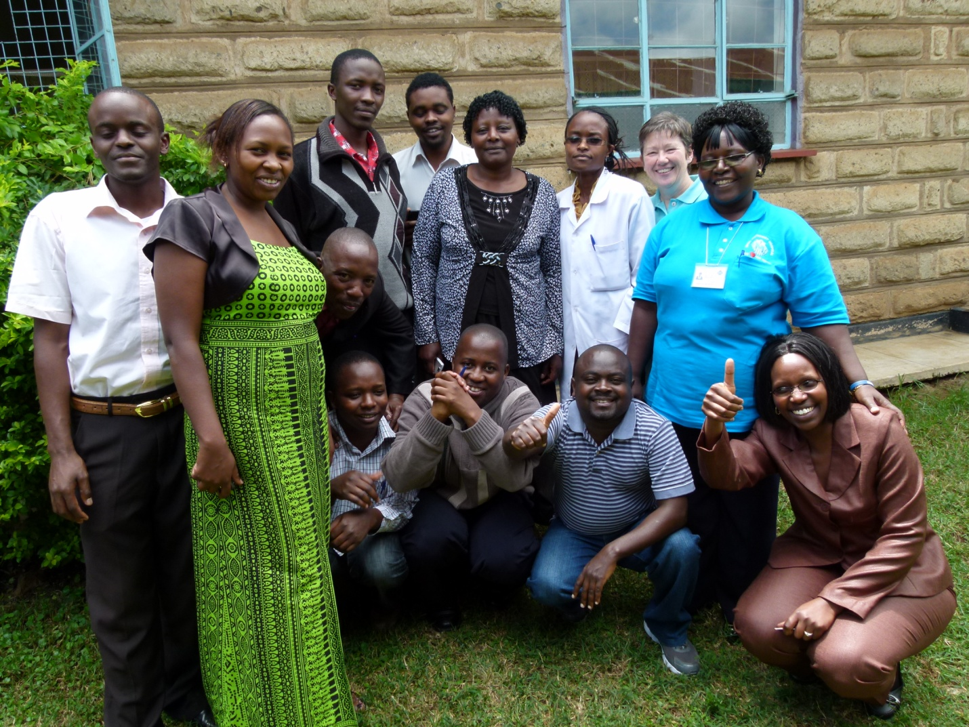
On a personal note I sadly lost one of my very dearest friends, Pat Wass, to cancer on 10th May 2013. She had been a friend for over 30 years, supported me through medical school and remained a close confidant throughout my time in Kenya. Although it was a great sadness that I could not be with her in the last days of her life, due to phone charges having decreased dramatically in Kenya I was able to keep in close contact with her husband, twice a day towards the end. The experience has made me realise all over again, on a personal level, how important palliative care is. Don, Pat’s husband was able to care for her at home until she died peacefully with him at her side – I had just spoken to him 30 minutes before she died. It was a great privilege to be able to support them both with advice & friendship in her last illness.
In place of flowers Pat’s family requested donations to go towards helping cervical cancer patients in our palliative programme. Cervical cancer is much more common in patients with HIV, and although we have an excellent screening programme, many of the women cannot afford the basic first line treatment of cryotherapy. This is unfortunate as it is often curative & we have the machine available, the only one on our province, & the treatment costs just around £50. In Pat’s honour we will offer this treatment to as many ladies as we can. Last year I was at a Palliative Care Conference in Nairobi & that, along with losing Pat, has given me a new resolve not only to enter into HIV training but also to start a course, within Maua Methodist Hospital at least, specifically on palliative care, which is after all the subject of my masters degree.
Realising that all work & no play makes Jill a dull girl, at the end of May I had to attend a big conference in Nakuru to discuss the progress of our palliative care programme with the donors. Unfortunately Barbara’s birthday fell during the conference, but I promised her we would have a couple of days off afterwards to go to Ol Pejeta conservancy. The lodges inside the conservancy are very expensive so we stayed in a Benedictine monastery & visited the conservancy on a day ticket for 2 days. Ol Pejeta has 4 of the last remaining 7 northern white rhino in the world (classified as extinct in the wild) & we think this is one of them, although it could be one of the more common but still very much endangered southern white rhino. Sadly in the last 2 weeks 7 white rhino have been poached in Kenya, & poaching is going on at an alarming rate in South Africa as well. It is also unbelievable that the cheetah is now classified as endangered. To think of these majestic animals becoming extinct is so painful, & we know how precious every sighting of them is. God’s creation is truly incredible if only humans could find a way to live in harmony with what we have been entrusted.
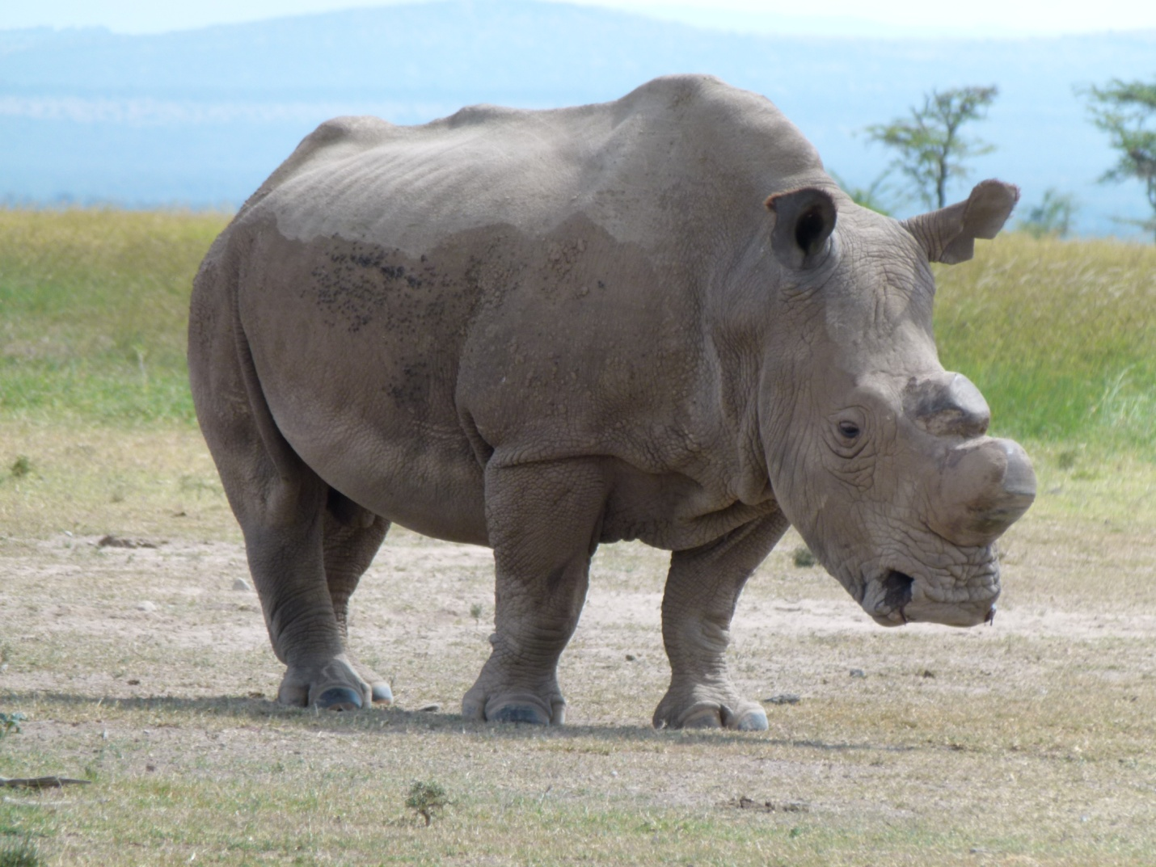
On a more positive note, the general election which took place earlier this year was an epic event in the history of Kenya. We all waited with baited breath, some friends asked if we intended to stay in Kenya in case of violence. Well, we did not plan to leave, even last election Maua was very peaceful, but this time the media & politicians all preached peace over & over again, & other than very isolated skirmishes it all went off well. Even the contesting of the result in the courts was conducted with dignity & people waited patiently & peacefully for the final outcome. Despite the pending case of our President in the Hague I feel we had the best outcome of the election for the future of Kenya – lets watch this space!
I give thanks for all the prayerful support given by so many in UK for our work here in Maua.
Claire

