Today we held our clinic for families with children who have HIV. Children 14 years and under attend the clinic with their guardians (32 children attended today). Despite the nature of their illness and all the social and psychological problems they experience (many of the children have lost either one or both of their parents), the clinic tends to be a happy place. Staff give health talks to the children and guardians, and there is time to play ball games, colour pictures or play on the swings. A group session is held at midday where patients share experiences and get to know one another. Disclosure of their diagnosis is done slowly over time with counsellors helping the guardians to talk to the children about why they attend the clinic and have to take medicines all the time when other children, even some of their brothers and sisters do not. Bringing families together helps both the children and guardians know they are not alone facing the problems of living with HIV. Some years ago when the HIV clinic started I asked one 14 year old boy if he thought he was the only teenager to have HIV. Sadly he told me yes, he knew no one else of his age with HIV. We linked him up with some other teenagers, and as a result started a group of youngsters with HIV meeting every school holidays to meet together and support one another.
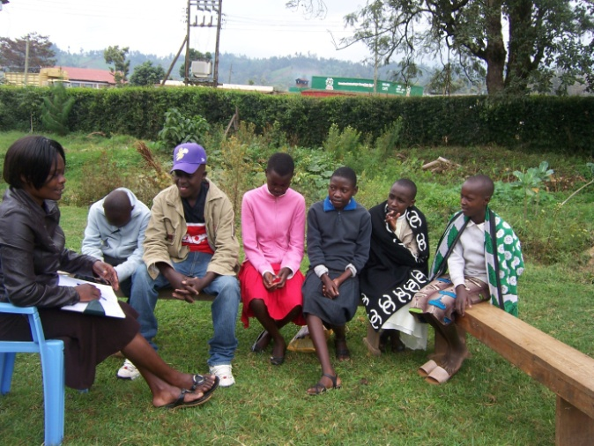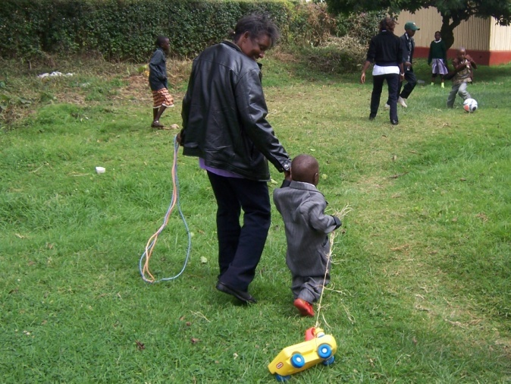
Youngsters with HIV in group discussion Time to play
As I said, on the whole it tends to be a happy clinic; children are amazingly robust and have an amazing ability to cheer up the adults around them. But today Jediel attended the clinic. Jediel is a 14 year old boy, who looks about 10. Last May Jediel used to sit in the waiting area by himself, a small figure hunched over, looking up each time the clinic door opened, wishing to be seen next so he could escape as soon as possible. I cannot show you a picture of Jediel as I have no guardian to sign permission to use his photograph, but let me tell you Jediel’s story.
I have known Jediel since he was 6 years old. He first came to the clinic with his mother, but unfortunately in 2004 people still had a lot of stigma about HIV and did not come to the clinic until very late. Jediel’s mum was very ill when she presented to us and sadly she died a few weeks later. Jediel’s mum never told us who Jediel’s dad was, he does not know and neither does his family, so Jediel was left an orphan. At first it was a bit hard to identify who was going to be Jediel’s guardian, but soon an aunty of his took him into her home and treated him like her own child. For the next two years things went well for Jediel, he was put on anti-retroviral treatment (ART) for HIV, he gained weight, attended school and seemed a happy well-adjusted child despite all he had been through.
Then one clinic day Jediel did not attend his appointment. After a few days of looking out for him we sent one of our volunteers to his home to find out what was the problem. We got the devastating news that Jediel’s aunty had gone to Nairobi two weeks previously and died suddenly whilst there. We were unable to find any details of what had happened to her, but now Jediel’s problems really started with a vengeance. Jediel’s father was not known, he had suffered the loss of his mother, now he suffered the loss of his beloved aunty, and he had to cope with living with HIV. Jediel’s grandfather wanted nothing to do with Jediel and chased him from his family home. Jediel’s other aunties and uncles would allow him to stay a few days with them but no-one would take him in and give him a permanent home. When he did stay with any of his relatives they would not share cups, plates or spoons with him, he had to eat alone, he had to wash his clothes himself, separately from the others and he was not allowed to play with any of the other children. The extended family ostracized him out of fear because of his HIV infection.
We tried hard to talk to Jediel’s grandfather to get him to encourage other members of the family to care for Jediel, but although we were given many promises and reassurances, the reality was that no-one wanted Jediel. It was all we could do to get anyone to help with his food and clothes, but love and nurture was just not there. School is free now in Kenya, but books and uniforms have to be bought and Jediel’s grandmother did what she was able to keep him in school, but she could not go against her husband’s wishes and offer Jediel a loving home. As a consequence Jediel’s attendance at the clinic became erratic and his adherence to treatment very poor. Eventually we had to stop his ART altogether as it was felt that more harm than good was being done, but we continued to see Jediel and encourage him that we were still there for him.
When Jediel reached 12 years old it was clear his condition was deteriorating badly and he did not have much longer to live. We had a team discussion, discussions with Jediel himself and it was decided to put him back on ART hoping that he was now old enough to come to the clinic regularly and take the drugs by himself. Unfortunately he was unable to always attend the clinic and his adherence to the ART was not brilliant to say the least. Although his condition did improve it was clear earlier this year that if Jediel was going to survive he needed a change in treatment that has to be approved at top Kenya Ministry of Health levels. I took his case to Nairobi at that level in May this year, but was told that Jediel had to attend the clinic for 3 months with no missed appointments or missed medications, and that then I had to do drug resistance testing to see which drugs could still work for Jediel. Neither task was going to be easy! Drug resistance testing costs Ksh 40,000/= (£340). Where was a 14year old orphan going to find money like that?
Coming back from the meeting in Nairobi I met Jediel and told him the situation. I told him his drugs were no longer working well, but he knew that himself from the way he was feeling. When I told him I had been all the way to Nairobi and talked to top Health Officials about trying to find some different drugs for him his eyes dilated visibly. I then told him that we would have to find Ksh 40,000/= for a special blood test to find out which drugs might be able to help him, and his shoulders slumped and a blank look of despair took over. After all Jediel has been through in his life I could not give up there. I told him he had to agree to come to the clinic for 3 months with no missed appointments or missed medications, and if he did that, if he showed us he wanted to live and was ready to make it happen, then we would find the money for his blood test. Now Jediel started crying. I had never seen Jediel cry before, not when his mother died, not when his aunty died, not even when I had to break the news his ART was no longer working and his own future was very uncertain. He started crying when he was told we had gone all the way to Nairobi to fight for his case, and we were willing to look for a sum of money he could not even imagine to try and save his life. I wondered when was the last time Jediel had heard someone say “We are going to do everything in our power to help you because we care about you.”
As Jediel left my room I could see a new look of determination in his face. I wondered what I thought I was doing making promises of £340 to a patient, where did I think the money would come from? Well, all I could do was trust God, but I knew at that point if I had to pay it myself there was no way I could let Jediel down, if he kept his side of the agreement then he would get his blood test.
In June I came to UK to visit my family for a 3 week holiday. I had a call from a teacher at Withington Girl’s School where I attended in the 1970s. They had held a dance competition and raised over £3,200 for the HIV work in Maua. God had answered my prayers and now I knew how I could do Jediel’s test! I was able to go to a school assembly and share with the staff and pupils at least one of the plans I had for the money they had worked so hard to raise. When I came back to Maua and checked Jediel’s file I found he had done exactly as we had asked. We did his drug resistance testing and got the results this week. Now I have to take those results to higher levels and see if we can get the life-saving drugs he so desperately needs.
Today I saw Jediel in the clinic. He is still attends on his own, he is still very small for his age, he is still quite unwell. However there is something different about Jediel, a new hope in his eyes. We do not know, and Jediel does not know, if we will manage to get the drugs he needs, or if we will be able to get them in time. But after years of being pushed around different family members, being ostracized, shown little or no affection, Jediel now knows there are people fighting for his life. He knows that some young people in a country many miles away cared enough to raise money for his blood test. He knows that doctors and nurses in Maua Methodist Hospital care enough to travel 600km on his behalf to try and get the drugs he needs. Some argue why we should still have mission hospitals in countries like Kenya. Jediel is why. In a government system, by now Jediel would almost certainly have died, but more importantly, because of our mission we have been able to show Jediel that God has not abandoned him; there are people who care about him, love him and want to help him. Whatever happens to Jediel in the next few months, he will not be isolated and alone. Let us pray that we will be able to save Jediel’s life, but even more, let us pray that Jediel and others in our HIV clinic continue to feel God’s love through our work for as long as they live.
Dr Claire Smithson
Mission Partner & Medical Doctor, Maua Methodist Hospital

