Dear Church friends,
This letter will be about big events that are happening just now, for Chodort, the United Church of Zambia (UCZ) and Zambia itself.
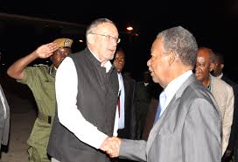
Firstly, the sad news that our president, Michael Sata, died on 29th October, just 5 days after Zambia celebrated its 50th Year of independence. Michael Sata headed up the Patriotic Front a left of centre party which campaigned for minimum wage and improved infrastructure. He is succeeded for three months, until the general election in January 2015, by Guy Scot the vice president. Mr Scot cannot run for president as his parents were not born in Zambia, so there will be jostling for position in the party amongst the 3 or 4 main candidates. The late president will lie in state till 11.11 when the burial will take place.
The 50th anniversary of independence was a big occasion in itself. Men and women wore shirts and dresses made from material in bright Zambian colours proclaiming the anniversary, and bunting and banners decked every shop and government building. This happy occasion was marred by two things however. One, that the President was in hospital in London and could not attend, and the other that 26people, mostly children, died on their way to celebrations when their boat capsized on Lake Kariba. The boat was, as is often the case here with all forms of transport, dreadfully overloaded, taking 34 people in a 14 seat boat.
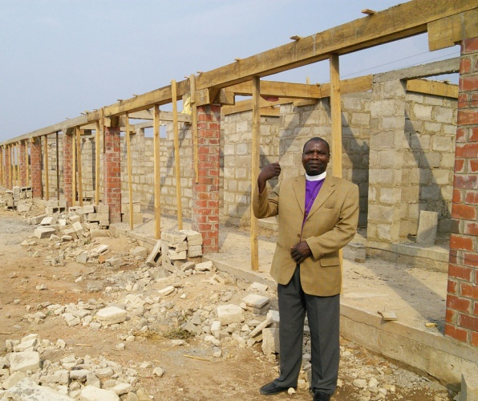
A big event that happened the first weekend in November was the retirement of Rev Mundemba who was the minister for St Stephens where Chodort Training centre is located. As well as being a good supporter and friend of Chodort, Rev Mundemba is very special because 33 years ago she was the first woman to be trained and ordained in Zambia for UCZ. UCZ now has a high proportion of women ministers, not least of them being Rev Dr Peggy Kabonde our General Secretary and ministers and friends from all over Zambia attended this very special occasion.
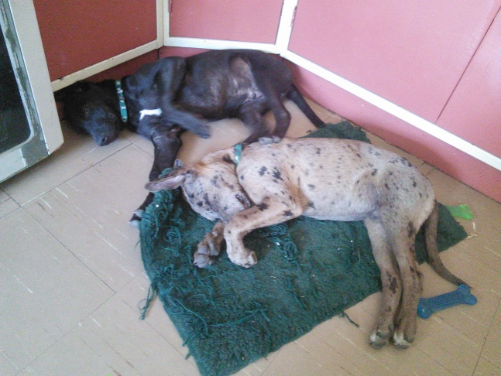
Another big event for Chodort is the raising of the first classrooms on the new college site. They will have teachers studies and toilet block too. It looks as if it will be finished this year and we will be able to open to a grand fanfare in 2015. Here is a picture of Rev Mutale Mulumbwa our Synod Bishop as he viewed the site last month. Being the only building on the new campus it is quite isolated though, and needs extra security guards at night. We hope to cover the cost of this with short courses in 2015 and start a full programme in 2016. Two added security guards who are a bit less costly are Rocky and Jet. They are young brothers of the four legged variety who are staying with me at the moment until we can train them suitably. They are just 18 weeks old now but will each team up with a new college classroom guard on their night round. when they are about 6 months old. When they are “off shift” they will guard my house.
With just a few weeks to go our tailoring and carpentry students are working hard for exam week which begins on 24th November. Most of them will sit a theory exam, and then all will take the practical test over two days. Those who don’t take the theory exam are our students who are not confident in reading and writing. This is usually because they left school at an early age, or in one case, did not attend at all. We are pleased to be part of an institution which gives those who have had few chances in life the possibility of proving themselves and getting a qualification
Finally We are also officially adding Peter Mukupa to our management team. Peter has been acting production manager for over 6 months now and has done a fine job. When I first came to Chodort carpentry production was making a substantial loss, but thanks to a lot of hard work from our volunteer Malcolm Evans earlier this year and the diligence of peter, we are now on target to make a small profit which will be ploughed back into training. We are also appealing through Challenges Worldwide for a marketing advisor to help us market our products effectively.
Items for praise
- For the long service and good example of Rev Mundemba
- For the classroom project taking shape under the watchful eye of Mr Siakasassa. The project manager
- For a steady stream of orders for production, despite raising our prices.
Items for prayer
- For continued progress for Mr Mwango’s health. .
- For the decisions we make about the use of the new college classrooms and the new courses, that we will have wisdom and insight.
Every good wish to you all,
Jenny
Jenny Featherstone

