Raising educational standards: The relocation of Waciwaci District School, Lakeba, Fiji
“Outstanding”, said acting head teacher, Inoke Covutimabula, in reply to the question: describe the past educational performance of Waciwaci Primary School? “But that was in the 1970s and 1980s, since then we have been underperforming”. It is little wonder. Waciwaci (pronounced Wathiwathi) District School in Lakeba, in the far eastern Lau group of islands, Fiji, has a very neglected, trade wind-swept, ‘sorry-for-itself’ feel – there’s no electricity during school hours, all classrooms leak in the rain, and every window has missing or damaged louvers.
And all the staff and students are fed up with the conditions. And thus far... none of the above would ordinarily make the headlines for an educational establishment in outer-island Fiji, but the remote Lakeba-based primary school is topping one national league table, and making headlines in the process.
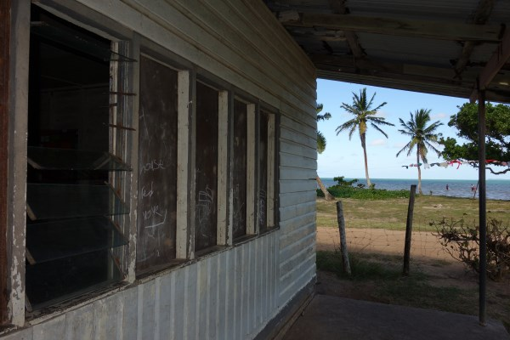
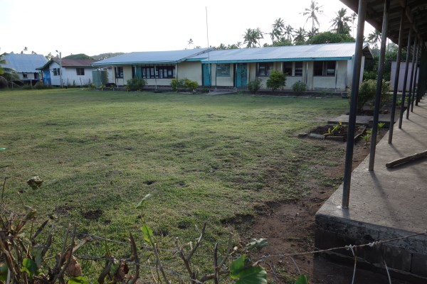
Making waves
Waciwaci District School is just 20m from the rapidly encroaching sea, and the four-classroom school has recently been given the accolade of being the first school in Fiji to be identified for relocation because of climate change. For many years, school reports have recorded regular inundation from the sea. “The school playground floods 4-6 times a term,” said Covutimabula, “and the inside of the kindergarten classroom [recently built with EU money in 2008] is often awash with water”. Outdoor lessons are obviously disrupted by the flooding, but extensive inundation - when the water reaches the backs of the classrooms – brings school closure, and the students are sent home.
Waciwaci District School and its playground
“Children have a natural attraction to water, and when floods close the school, the children inevitably are drawn back to the water-logged compound to play,” said Class 5/6 teacher, Mereani Leweniqila. “But the flooding brings out centipedes that crawl onto walls and window sills – and they are especially dangerous to the children”.
One of the four primary classrooms, showing missing louvers and boarded-up windows; beyond is the sea.
Centipedes are much feared in Fiji as they can give a nasty, venomous bite – very painful to healthy adults, but potentially life-threatening to a child.
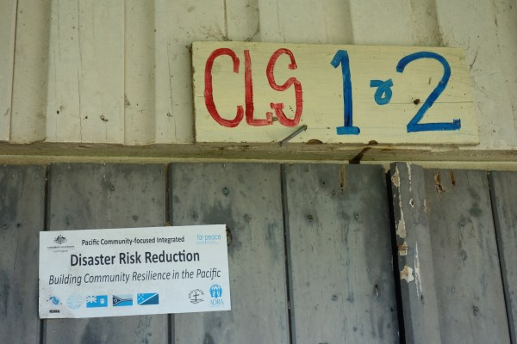
Pigs are also kept close to the school, and again villagers expressed concern that during flooding the risk of children contracting leptospirosis is that much greater. Even during dry conditions, the consequences of flooding are still present. Regular inundation has caused divoting damage to the playground, and with the uneven playing surface, children often injure themselves during games.
And the legacy of the damp is not just confined to the outdoors. Teachers find that it is particularly difficult to maintain and store educational resources in the classrooms.
Disaster Risk Reduction sticker on a classroom door
Last month, the two feeder communities of Waciwaci village and Waitabu village held a fundraising event (soli) to purchase new educational materials for the youngest members of the 63-strong school community. “There’s no point patching up the building when the school is about to move, so we have decided to spend the money on educational resources for the kindergarten that they can take with them,” said the headman of Waciwaci village, Sikeli Marau, whose four nieces and nephews attend the school. The flood-prone kindergarten classroom also serves as the school library, but inside the classroom, noticeably, books are in very short supply.
The harsh environment is intensified further by the wind. Waciwaci village is located on the south-east coast of Lakeba Island, and exposed to the full force of the unrelenting south-east trade winds. Admittedly, the constant ‘breeze’ may be refreshing on a hot day, but it’s bitterly cold in inclement weather. “The students often sit shivering in the damp and windy conditions,” said Class 1/2 teacher, Varanisese Domoni, the longest serving member of staff - she started in 2010. “With broken winds there is no protection for them against the wind”.
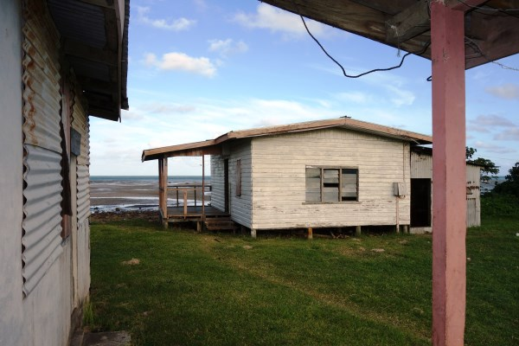
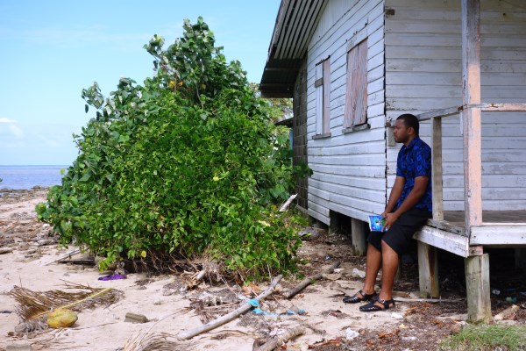

The acting head teacher sits on the porch of the staff quarters closest to the sea. At high tide, waves break under the now-abandoned property.
Two of the three staff quarters have been rendered uninhabitable and abandoned on the authority of the Ministry of Health.

Previously, the teachers also faced environmental challenges outside school hours. The three staff quarters are located even closer to the shore than the school. Two of the properties are now abandoned – the first last year, and the other at the start of 2015. Currently the abandoned property closest to the sea is used as the dining area for those students who live 15-minutes walk away in Waitabu village, a distance too great to go home for lunch.
School assessments
In 2002, a coral seawall was built to help stave off the effects of the advancing sea, but it wasn’t long before that was washed away. Then in 2004, after many years of pleas and rebuff, a team of education officials was visiting Lakeba Island - to deliver routine maintenance grants - when they were caught in a king tide at Waciwaci primary school. Only then was there the realisation of the seriousness of the situation; something had to happen. Now, some ten years later, conditions have worsened, the erosion of the shore is accelerating, and there is urgent need for action.
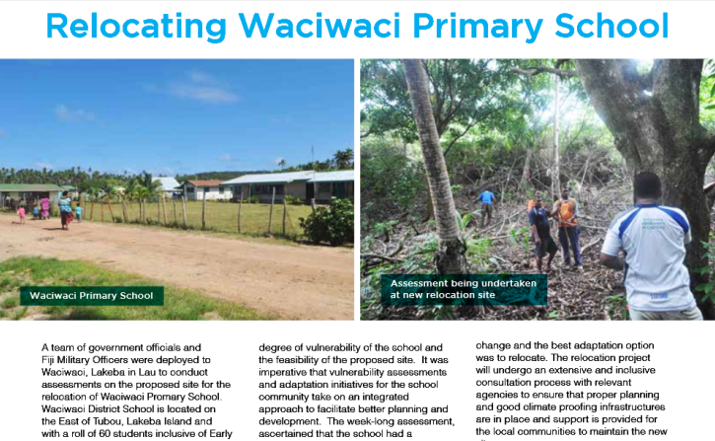
Mid-last year, at the request of the Office of the Commissioner Eastern, a team of eight government officials and military officers were deployed to Waciwaci to undertake a full week-long assessment of the proposed new relocation site. The technical representatives came from the Republic of Fiji Military Forces, the Ministry of Education, the Mineral Resources Department, Department of the Environment and the Climate Change Division of the Ministry of Foreign Affairs.
Extract from the quarterly newsletter of the Climate Change Division of the Ministry of Foreign Affairs, August 2014

It is hoped that such an integrated approach to the vulnerability assessment will facilitate, not only better planning for the proposed school, but also aid the overall success of the relocation – a good-practice approach for all potential relocation projects.
Student statements
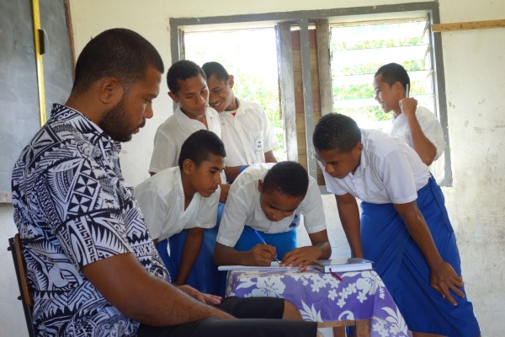
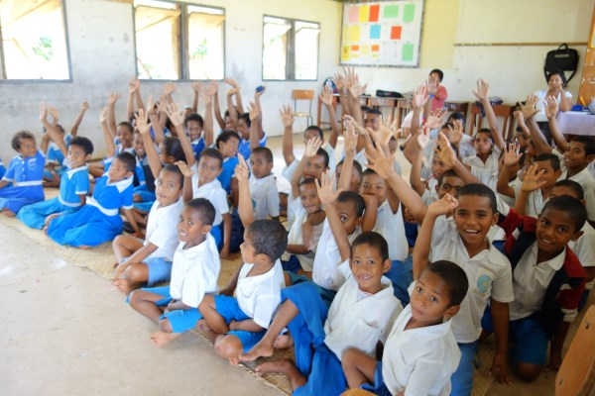
As with any community-focused development, the ultimate success of the project rests with the receptiveness of the direct beneficiaries to the proposal, i.e. the students and staff of Waciwaci District School – do they want to move? Seeking the active participation of every stakeholders is vital, therefore. All of the 45 gathered students, on the last afternoon of term, eagerly and promptly raised their hands when asked did they want their school to relocate: “Yes!” was the resounding, instant cry. It took a little longer for each student, some as young as six, to sign the obligatory participation list, individually!

Keen to move and to put their name to it!
Why do you want to move? Because: “access to good education guarantees a good job”; “to get away from the flooding during high tides”, and, “for better school infrastructure”. “New buildings!”
Prayer Points:
- Pray for the students and staff of Waciwaci District School - that they remain safe in their current location, while awaiting the school relocation.

- Pray for the implementing agencies, and all involved in the relocation task in Fiji - that they may be thorough and prompt in their work.

- Give thanks for the commitment of teachers worldwide, dedicated staff who often persevere under arduous circumstances; think especially of those who continue to teach in areas of conflict, and during times of adversity.

- Pray for the students whose education has been disrupted by Tropical Cyclone Pam in the Pacific, or literally left in ruins by the earthquake in Nepal.

- Give thanks for the reopening of schools in Sierra Leone, after an easing of the Ebola outbreak.

- Pray for the proposed Sustainable Development Goals, and especially for goal 4: “inclusive and equitable quality education” for all.
Plans and timetable
Progress is finally being made towards the endeavour. The Fiji government was successful in its approach to the European Union for funding, and with the release of monies for the project pending, the communities of Waciwaci and Waitabu have already agreed the lease of land for the new site. They are now excitedly putting forward design suggestions for the planned new buildings.
Because the proposed site is roughly equidistant between the two villages, the mothers have come together to make arrangements for catering at the new site. It’s already settled, both villages will take it in turns - one week each - to cater for the students at lunchtime.
The staff, too, are looking forward to the move. The new facilities will include new staff quarters, but more importantly, the possibility of electricity for the first time during the school day. Discussions are underway for the installation of a solar system at the school. Currently, lessons revolve around the chalk board, and the school printer resides in the neighbouring village of Tubou, 10-minutes drive away, with printing requests having to be delivered well in advance. And, don’t even think about last-minute photocopying ‘fillers’...
However, it is hoped that sometime next year, laptops and lights will leap into action at the new school, and the lapping waves will be consigned to the history books of the students.
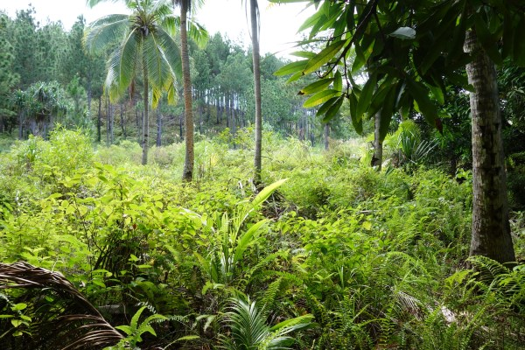
The proposed new site: turning trees into buildings and books

