February News from Rachel Ullmer, mission partner based in Lahore.

“Dear All,
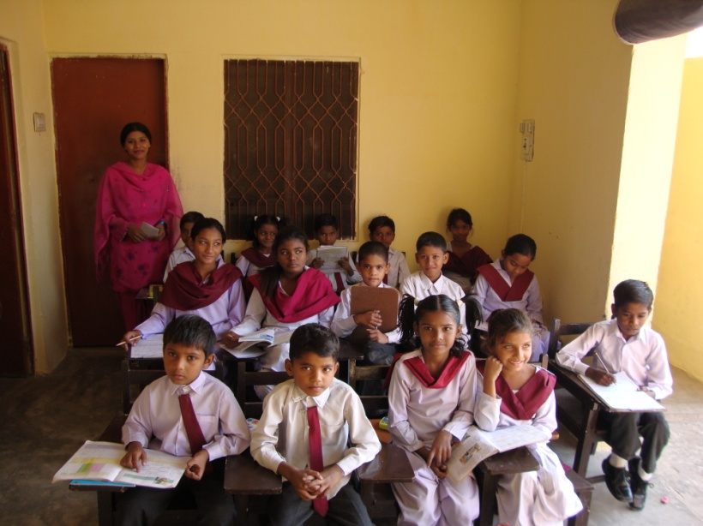
It is raining here at the moment, but the weather is warming up! We are busy at work, visiting the schools to count the children and observe lessons etc. The head teachers are getting up to scratch and discussing amongst themselves as to what we will be looking for! There is a nice lady here called Josephine who is doing most of the school administration. We have also written the curricula for the next academic year which begins in April.

I am getting on with revising Urdu and spending a lot of time sorting grammar etc.
Last Saturday I went to visit the museum with a friend. We saw an exhibition of Jinnah, the founder of Pakistan, Moghal armour, and other old coins, clothes and artefacts.
I am also busy arranging my bedsit on the compound – it was empty save for a bed and table so I have had to buy many new things. I have also got the things - clothes, iron, shelves etc.– that I left here 6 years ago and have been in store with a friend.
I have sampled the local food in the cafes, but we haven’t been to the McDonalds as someone got food poisoning there!

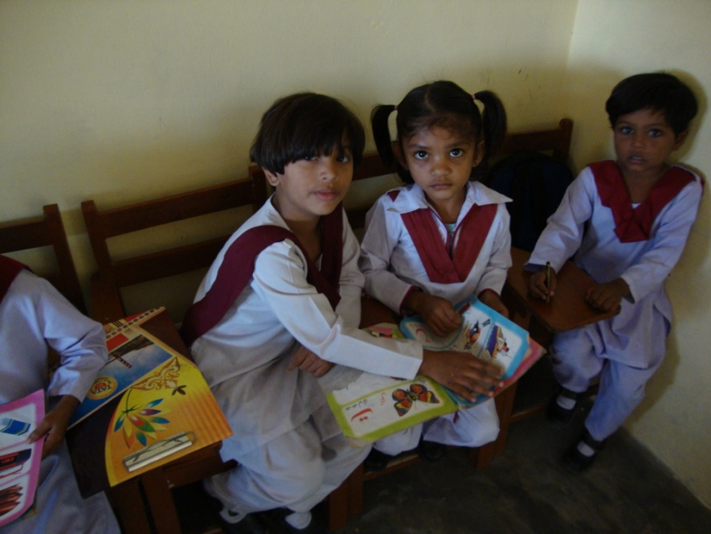
The electricity is erratic and there is a lot of groping around in the dark! I have a rechargeable fan and light, and the fridge and other electrical items are on stabilizers and surge protectors!
There is a lot to see here. New flyovers in Lahore, and a new elevated bus road that runs for about 10 Km from one end of the city to the other and only bendy buses go on it. Someone said that this road is used as a motorcycle race track at night!
It is the spring or ‘outside season’ and there are many beautiful flowers everywhere and ornamental cabbages. Lahore is the ‘city of flowers.’ It is a bit confusing though because the leaves are also falling from the trees!

I am attending the church here – the English service is at 8 am so it is an early start! Last week 2 boys were confirmed. After church we have tea and a chat. There was a big Ash Wed, service in the cathedral for the staff and school children.”

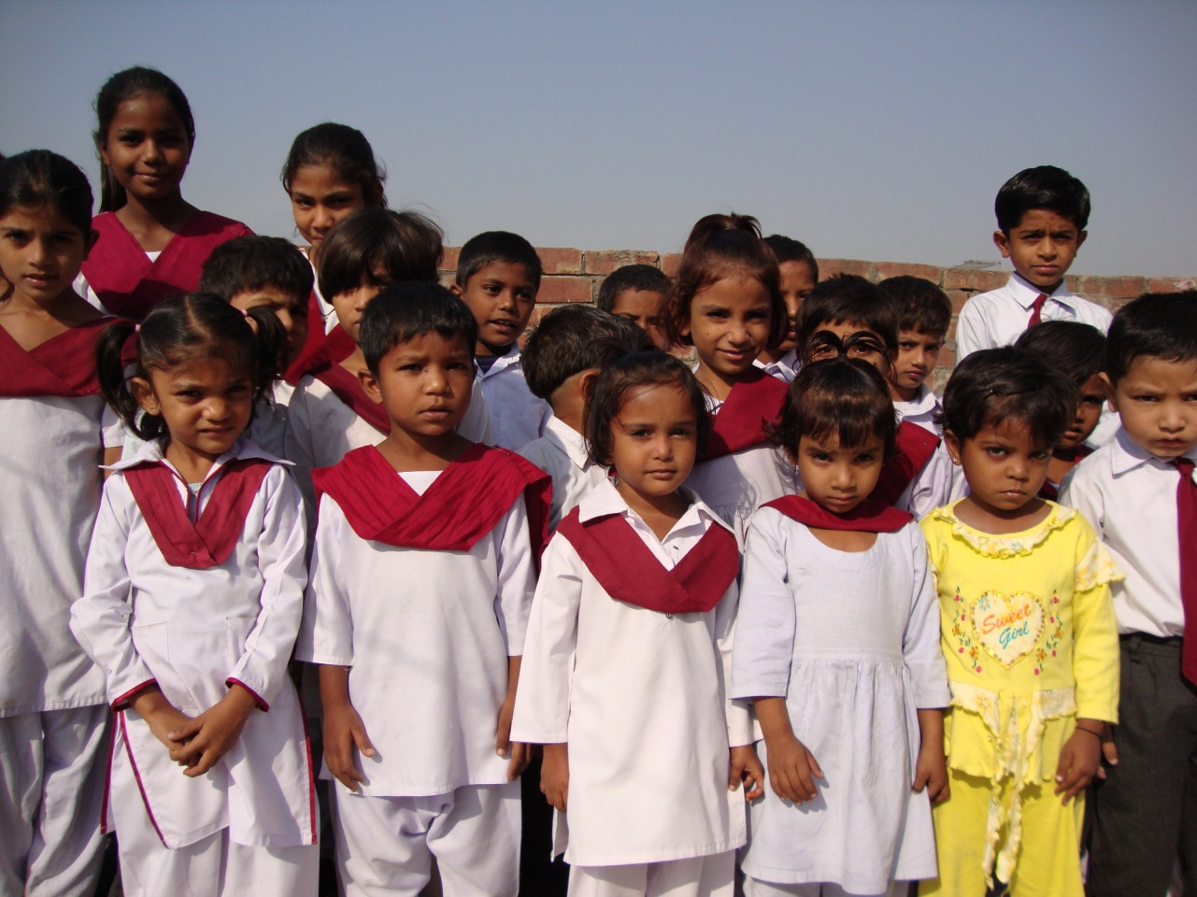

Photos: Raiwind school children

