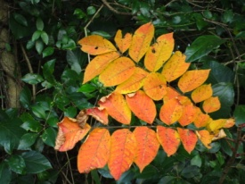
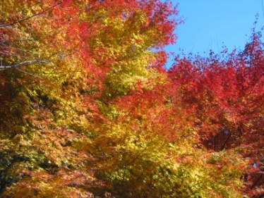
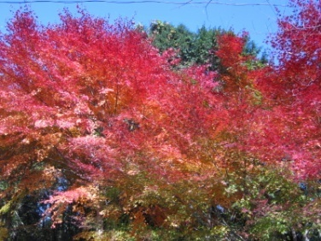
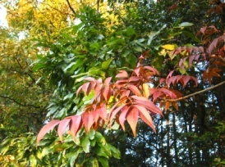
“The earth is the Lord’s”

Nagasaki, Nov. 2017

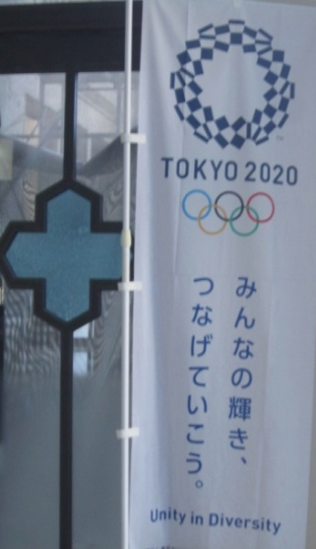
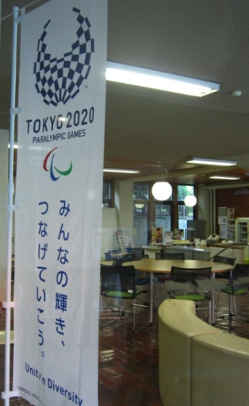
Life in Nagasaki continues busy. It was a shock when the local supermarket started playing Christmas carols as background music on November 1st, but practising for Christmas events is now well underway, as is the countdown to when we need to be ready. On a larger scale, Japan has been counting down to the Tokyo Olympics almost since it was decided to hold them here, and these banners on campus show the blue-and-white logo. The countdown to the Olympics reached the “One thousand days to go” point on the same weekend that we celebrated the 500th anniversary of the start of the Reformation. This is relevant in Nagasaki not only because of the start of Protestant churches, but also because it resulted in the Counter-Reformation within the Catholic Church which led to the formation of the Jesuit Order and the missionary impulse which brought the Gospel to Japan. (If you have seen the film “Silence” you know what happened next!)

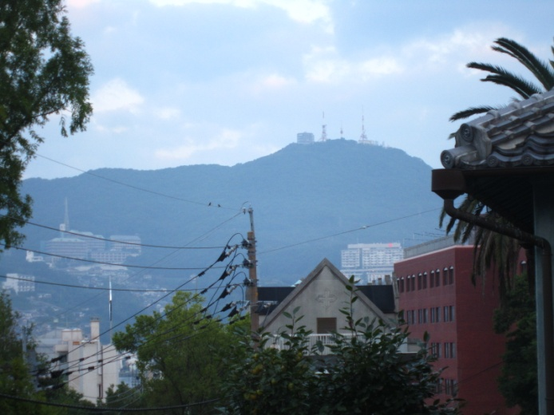
Nagasaki is very pleased with the Nobel Prizes this year, firstly the peace prize to ICAN, the International Campaign for the Abolition of Nuclear Weapons, but also the prize for literature, as the recipient, Kazuo Ishiguro, was born in Nagasaki and spent his first five years here. One of his novels, A Pale View of Hills, is set in Nagasaki, and these are the hills in question, as seen from one of my upstairs windows. The “pale view” here was caused by morning mist; we do get the same effect from PM2.5 pollution at times, and from the “yellow dust” which gets blown over from the Gobi Desert. But if that’s the worst thing we get from our neighbours, we will be grateful. We continue to pray for peace.
With best wishes,
Sheila
PS
I will be in the UK on furlough mid-February to mid-March--diary currently open!

