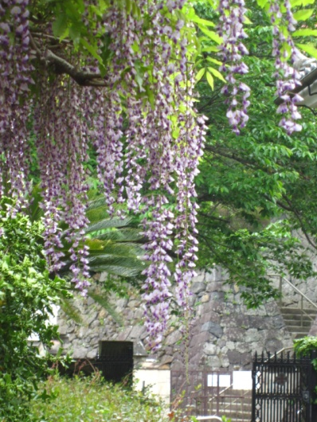
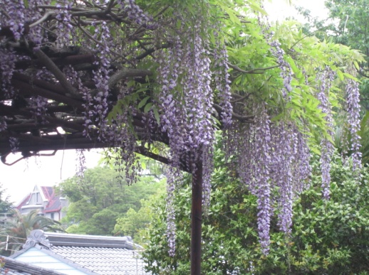
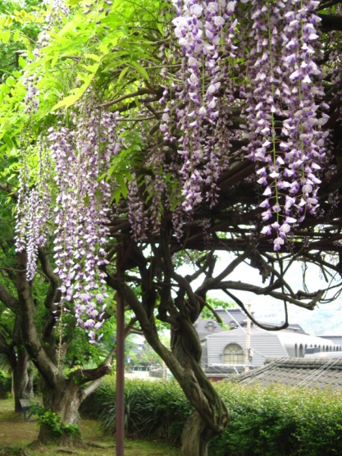
The winter is past ... the flowers appear on the earth (Song of Solomon 2:11-12)

Nagasaki, May 2016
Here in Nagasaki the season of cherry-blossom viewing has given way to the season of wisteria viewing. Whereas to enjoy the cherry blossoms, people usually take their own rugs or mats and sit under the trees, the wisteria are trained up over wooden frames and there are wooden benches underneath for people to sit on. This one is up above my home – in the middle picture, the grey slate roof belongs to the house where I live, and the building beyond, with the red roof and a cross visible in the wall at the end, is the Music Department building at the far end of campus. All of the four Kwassui campuses have buildings with red roofs and gables like this, and all of them are up hills. In the third picture, you can see the steps up to our main campus, and by the time you reach those you have already climbed up a hill from sea level, so at least some exercise is guaranteed every day.

On the main Kwassui campus, we are currently embarking on what will be three years of building work to make the older buildings earthquake proof. This is now a government requirement for schools and universities, and as these are listed buildings there are subsidies, but it will still be a major undertaking both financially and in terms of disruption. At the beginning of April, although we recognised that it had to be done, we were wondering if it wasn’t really a waste of time and money. We aren’t on a major fault line and we don’t usually feel earthquakes here! Until two weeks ago, I would have dismissed any rattling in my old, wooden house as the effect of a lorry going past. That was until the serious earthquake activity started in Kumamoto, which is on the same island of Kyushu as Nagasaki is.

The worst tremors in Kumamoto have been level 7. In Nagasaki we feel that activity at around three levels lower, and actually, even though people are saying that they have never experienced tremors at this level in their lives before in Nagasaki city, we haven't had anything here strong enough to do real damage. The second and third big quakes happened when I was in bed (well, on futon!) and were relatively short. The first one, which they later said wasn’t the main one, went on for about 30 seconds, and was the most disconcerting, partly because of the length, and partly because it was completely unexpected. We haven't had anything stronger than 4 here, and in the past few days nothing much beyond 1 (but they keep on coming – there has been one while I’ve been typing this!) But even when a tremor turns out to be not very strong, you start to wonder whether it will stop quickly or develop into something worse. In the areas that are already badly affected, 4 is enough to cause further damage, and to cause stress to the people there even if it doesn’t – and there have been more than 90 aftershocks at this level and above since April 16th, in addition to all the smaller ones in between, with more than 1,200 tremors at 1 and above so far. Relief operations are now well underway, but for the 20,000 or more people whose homes are uninhabitable, there is no immediate prospect of life returning to normal.

The cherry blossoms greeted the new students and workers when the new academic and work years started on April 1st, but now the wisteria has greeted Golden Week, when, having just got started, Japan largely stops again with four national holidays in the space of a week (April 29th and May 3rd -5th.) Kyushu would normally see an influx of tourists this week, but there have been large numbers of cancelled reservations, and although we are grateful to the many volunteers who have come instead and are giving up holiday time to help, there is concern about the adverse effect on the Kyushu economy.

Here at Kwassui, though, we have started the new academic year with hope. Student numbers are significantly up in our junior high school enrolment, and in the university English Department. Our junior and senior high school chaplain, who had gone back to her own home area last year, has come back to us, having proved by her absence how important a colleague she is. The English Bible Discussion group at the university hall of residence, which had seen the departure of all its regular members at the end of last year, has had new faces from Korea, Tibet, Thailand and Vietnam, as well as Japanese students from here in Kyushu, from Okinawa in the south and from the “snow country” of the north since we began again two weeks ago. It’s still too soon to know whether this will be a “faithful core group” year or a “wait to be surprised because you never know who might turn up” year! Either way, there are opportunities to share the gospel both with those to whom it’s completely new and those who already have faith and can do some sharing of their own.

I expect to be in the UK from mid-July to mid-September this year, so if you would like to hear first-hand about the work here, please let me know.

Blessings,
Sheila

