3-36 Higashi Yamate Machi
Nagasaki, Japan 850-0911

January 2014
Dear Friends,
Happy New Year – in Japan the Year of the Horse – but where did the last one go to? Well, briefly, in addition to the usual work and church activities…
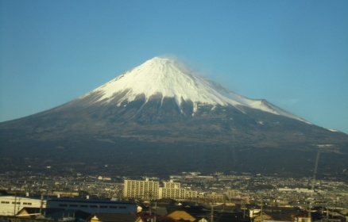
１月 In January, as this was a year when it did not conflict with university entrance exams, we were able to go to the annual Women’s Conference at Amagi Sanso, a Baptist-run conference centre on the Izu Peninsula (south of Tokyo). The long train ride proved worth it both in terms of the fellowship, spiritual content and relaxation, but also because we were blessed with good weather going both ways, and so with beautiful views of Mt. Fuji, which was to be recognized as a World Heritage site later in the year to great local rejoicing – though not as much rejoicing as when it was announced that Tokyo will host the 2020 Olympics!
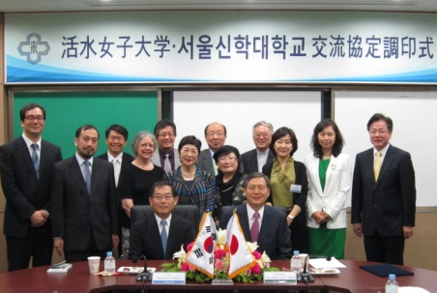
２月 February, as always, saw the end of classes for the year and final exams, but also a visit from a group of Korean professors for the signing of a cooperative agreement between Kwassui and Seoul Theological University. The current minister of Nagasaki Baptist Church, Rev. Cho, is one of their graduates, and we hope for exchange with churches as well as between the universities.
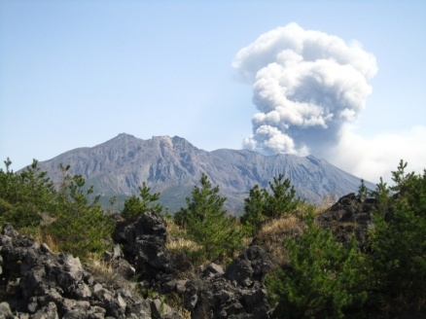
３月 March, once graduation brought us to the end of the academic year, was a time for travel in Japan. Jill, a friend since secondary school days, came to visit, and we first went south to Kumamoto and Mt. Aso (active volcano with an impressive caldera) and on to Kagoshima and Sakurajima (with another active volcano). I had been to Kumamoto several times, but to Kagoshima only for Parent Association meetings and seeing students on teaching practice, so never with time to actually visit anything, and I had never made it to Mt. Aso or Sakurajima before, so there were a lot of “firsts.” Then we went up to Okayama and on to Nara, where we didn’t quite see everything there is to see, but not far off! We went to Kyoto and Tokyo the last time Jill came, some 20+ years ago, so this was a chance to do something different, and very enjoyable.
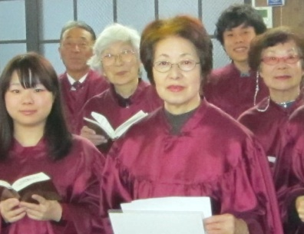
On Easter Sunday, Harumi Kamegawa, a member of our campus English Bible Class, was baptized. Harumi graduated from Kwassui’s Junior College, had a career which included several years working in America, and came back after her retirement to complete a four-year degree. While a student she was a member of the chapel choir, and after she graduated I asked if she would like to join the choir at Ginya Machi Church (where I am nominally choir director – this only means that nobody else is currently willing to do it!). Anyway, Harumi came, found the church congenial, and decided she was ready to make a commitment. We give thanks.
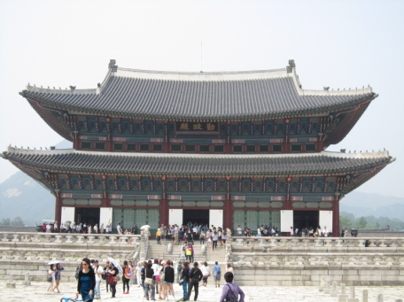
６月 In June I went with several colleagues to visit universities in Korea which have recently entered exchange agreements with Kwassui, or which we hope might do so. We met with a great deal of kindness and hospitality, and although the schedule was very full, because of the way the return flight worked out there was (again, unusually!) time for some sight-seeing in Seoul as well. The normal university schedule has become so hectic that any chance for a break is accepted with gratitude.
８月 In August, during the summer holidays, I went to Nepal with four of our students on an excellent study tour organized by Dr. Narato, who for many years served in Nepal with JOCS, the Japanese Medical Missionary Society, and since retirement divides his time between Nepal and Japan. On the first evening I was asked to speak at the house group which meets in Dr. Narato’s home in Kathmandu – it can’t be often that a British missionary has the chance to speak (in Japanese) to a group of Japanese Christians meeting in Nepal! The next morning we were able to attend a Nepali church service, with English translation provided. We went from Kathmandu to Pokhara, visiting a number of medical and welfare institutions in and between them, and had many chances to talk to Nepali people and to Japanese living and serving in Nepal. We hope to make the study tour an annual event with the aim of encouraging our students, especially the nurses, to see life that is very different from their own and to consider serving overseas in the future. And yes, we did also see the mountains – and I found far more UK foods in shops in Nepal than I ever see in Japan!
９月 By the end of summer I was more than ready for a rest, and enjoyed two weeks in September back in the UK relaxing at the home of my sister and brother-in-law. I happened to have arranged to go into Methodist Church House on the day that the worship was held to mark the beginning of the new year of the church calendar, and was invited to attend. It was a joyful and uplifting experience, and as the President, Vice-president and Youth President of Conference all participated in leading, for once I have an impression of the people to go with the names.
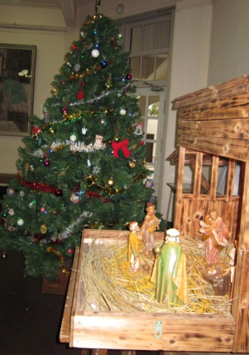
１２月 This year the English Department was responsible for leading the Christmas worship for the university, which meant that a season which is always too busy became even more so from even earlier than usual. Finding times when people could practice together, for the music, but more especially for the tableaux, was not easy. “Two wise men short of a nativity” described one of the better rehearsal attendances! Mary? At a late class! Gabriel? Part-time job! (What kinds of part- time jobs do angels do, we wonder?) But our efforts, while neither musically nor technically perfect, were reasonably competent in the end and seem to have been well received, and the overwhelming response from the participants was that they were glad to have been involved. Now we pray that in the future they will remember that at the heart of Christmas is God’s love and the coming of the Christ-child.
With best wishes,
Sheila

