Partnership visits to Kenya and Togo on 26 November – 8 December 2018

Aims

* + To visit MCK Bio-intensive Agricultural Training Centre
  + To attend MCK Women’s Conference held at Mombasa

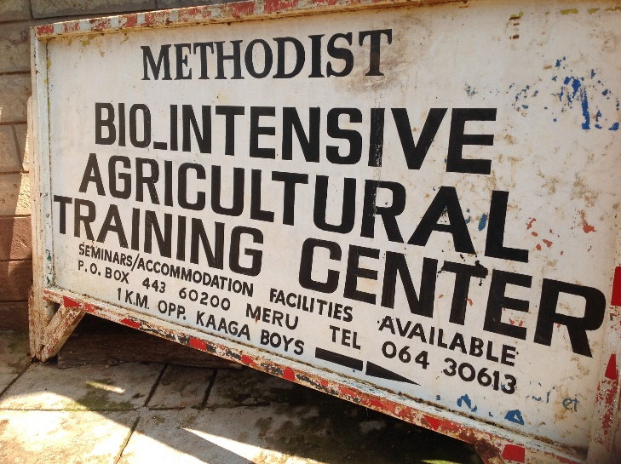I arrived at Jomo Kenyatta International Airport Nairobi, and travelled straight to the Bio-intensive Agricultural Training Centre, at Meru after an overnight flight. The centre is of priority to MC Kenya in supporting its rural ministry. It was started in the 1960s by early British Methodist mission partners and in 2005, it moved to its current site at Meru.

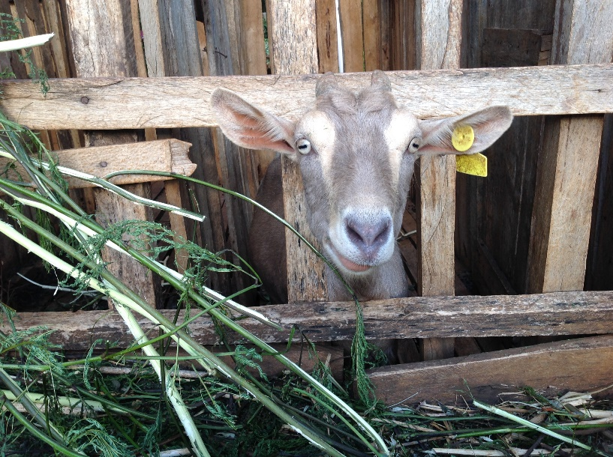Training of rural farmers, church members plus other interested parties has occurred at this training centre over the years. The centre still works closely with Meru National Polytechnic, by offering internships to its students and collaborating with its Agriculture department. The Bio-intensive Training Centre offers practical skills and cutting-edge knowledge to rural dwellers to improve food security, create employment and alleviate poverty in Kenya. The scope of learning is wide as it offers horticulture, fodder management, vegetable gardening, orchard and nursery management, fish farming and livestock management.

Lately, the centre has been cash-strapped, even though personnel continue to strive to deliver high quality training services to participants. With no government subvention, the Bio-intensive Centre strives to pay its staff wages promptly and maintain its running costs, which is remarkable in the Africa context. Its facilities are obsolete for demonstrating modern farming practises; nevertheless, it retains significant contributions in empowering rural dwellers.

A happy dairy goat at Meru

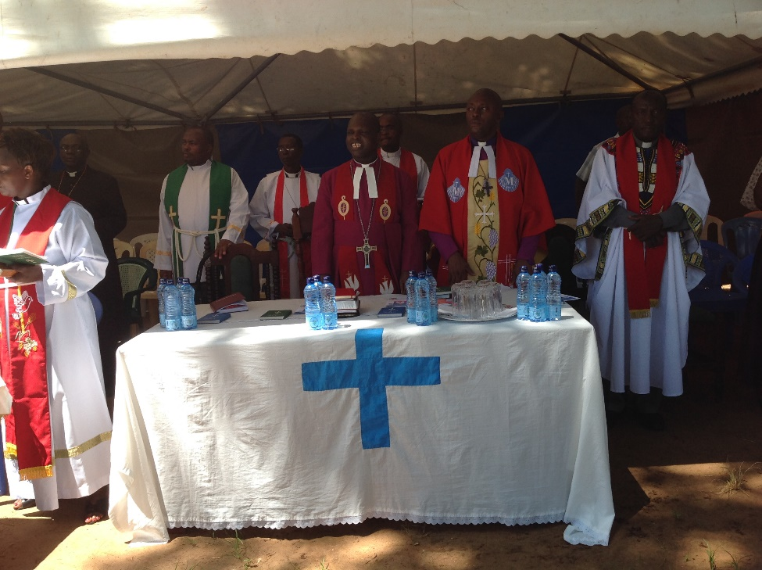I also visited a few established farmers that had received training from the centre in past years, and their commendations were very encouraging. Many requested that the centre should continue to offer important research findings, farm demonstrations and agribusiness training for existing and new farmers. Its impact on sustaining rural churches has been immense through the years, reducing dependence on the Connexion plus reversing urban-rural migration.

**Visit to Mtongwe Methodist Church (MC), Mombasa - Kenya**

I travelled back to Nairobi by road, then next morning travelled by air to Mombasa and then on a ferry to Mtongwe for a church service. Mtongwe is off the coast of Mombasa that lies in the Indian Ocean. It is the oldest city (900AD) and second largest city in Kenya with a population of 1.4 million (2016 census). As part of Mombasa County, it hosts various religious groups including Christian, Islam, Hinduism and African 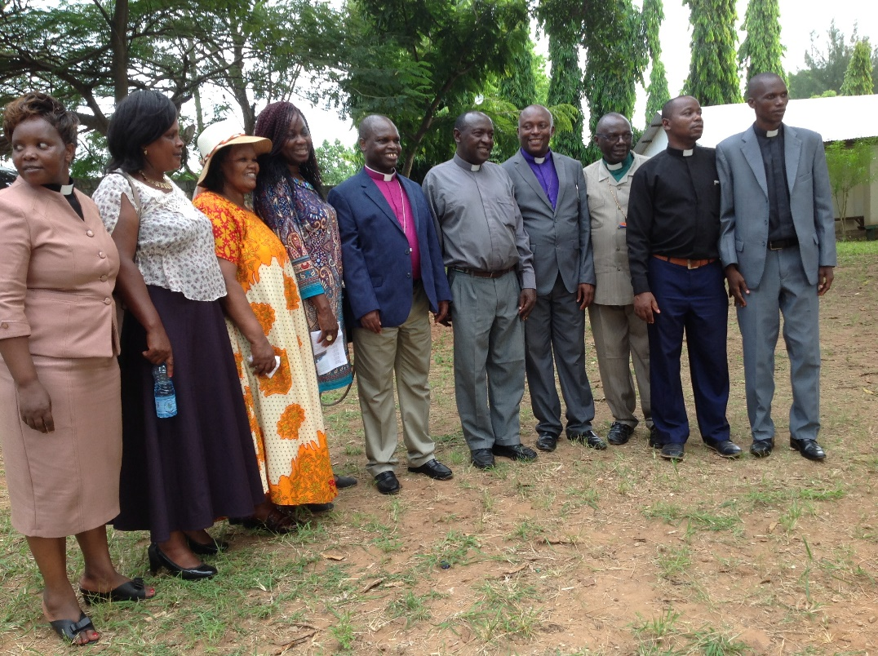traditional beliefs. Swahili is its main language of communication. Mombasa was initially governed by the Portuguese, then by the Omani and later by the British.

Fundraising activity for MC Mtongwe Manse for the new Bishop

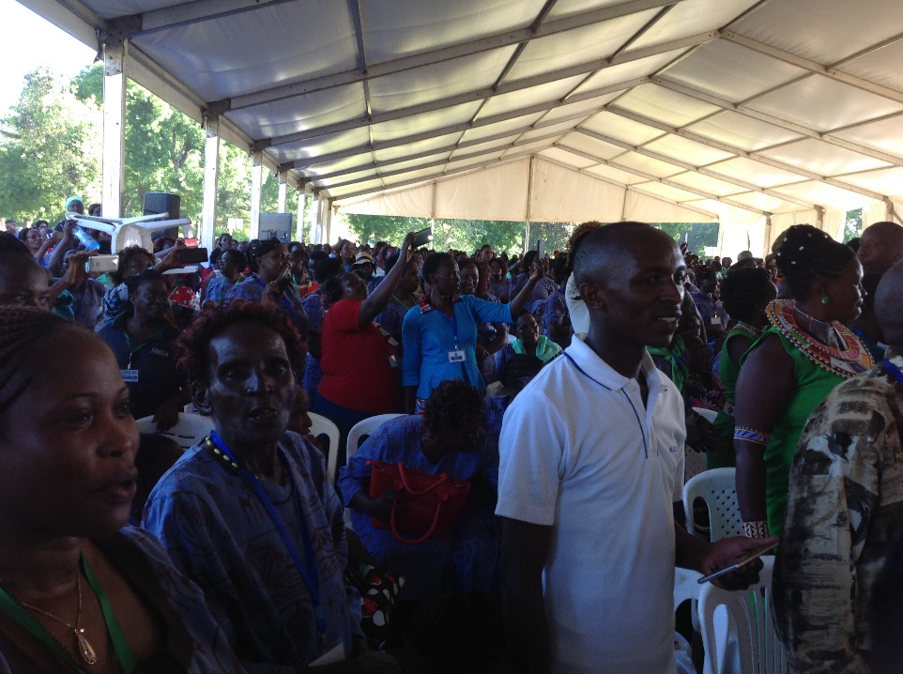Mombasa Synod is a one of the synods of MC Kenya. Mombasa Synod has nine circuits, namely Kisiwani, Changamwe, Mazeras, Kisauni, Nyali, Miriakani, Kwale, Mamba and Kinango. Kisiwani

Senior leaders of Methodist Circuit Mtomgwe, Mombasa

circuit comprises of five societies – Wesley MC, Voi MC, Samburu MC, St Johns MC and Mtongwe MC. As from January 2019, Mtongwe plans to become a Circuit and has plans to build a Manse and Sunday school building for its children ministry. The service I attended on Sunday 2nd December 2018, was a communion and fund raising service in pursuit of this vision. The locality also hosts a naval base close by.

MC Kenya is a growing church and the circuit recently planted a new congregation called St John’s MC at Mombasa. Mombasa is largely Muslims and MCK plans to continue to promote peace through peaceful interfaith initiatives to prevent clashes among locals. It was good to partake in the vibrant service that took place outside the church building, to embrace the numerous guests.

Participants at Methodist Women in Kenya Conference, Mombasa

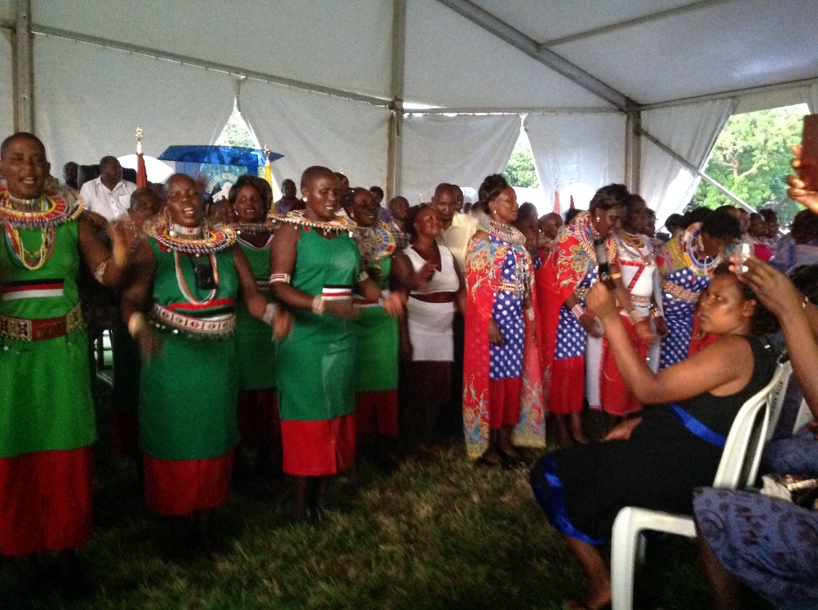**Connexional Women Fellowship at Mombasa**

An array of long buses swarmed Shimo la Tewa school premises on Tuesday 4 – 9 December 2018. More than 4,000 people, mostly women from the thirteen MCK Synods around the country including Tanzania, Uganda, Rwanda and Congo. Bishops, women leaders and guest speakers graced the occasion. The theme of 2018 Convention was, “Come let us go up the Mountain of the Lord” (Isaiah 2:3). Women representatives from each synod were in a mini procession; however, the most astounding sight were over fifty Masai women dancing for Jesus. This was fruit of twenty eight years of incarnational ministry by Rev Dr Taesoo Choi of Korean Methodist. Her representative spoke against the moral decadence growing among youths, and how the church and government should work together to offer guidance and empower them make better choices in life. She commended the positive contributions from women. The only Methodist governor in the country attended. The guest speaker was Professor Mary Kobia, the Cabinet Secretary for youth, gender and public health.

Methodist women from Masai and another Western Kenya tribe

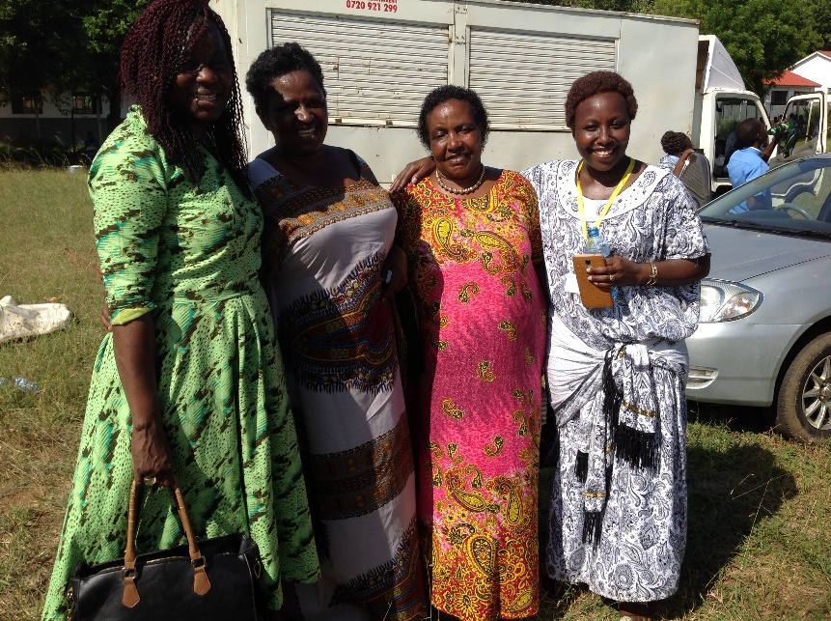Dr Esther Obasi-ike ministered on Tuesday and Wednesday 5 December, encouraging Methodists to rekindle their revival fire and mission work to positively impact society. She shared inspiring stories about ministering to divorced Muslim women seeking access to contacting their children and few often asked if Jesus could help them reconcile with their kids. Esther also spoke of the significance of evangelism at marketspaces like John Wesley did at Bristol, preaching to the miners and organising bible studies whilst converts attended nearby churches. I had the privilege of conducting the bible studies and prayer meetings on three mornings.

Bunmi with Methodist Women from FMC Rwanda in Mombasa

**Partnership visit to Eglise Protestant Methodiste du Benin**

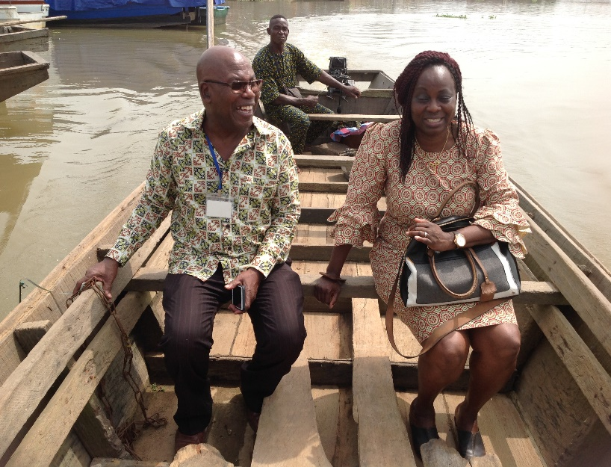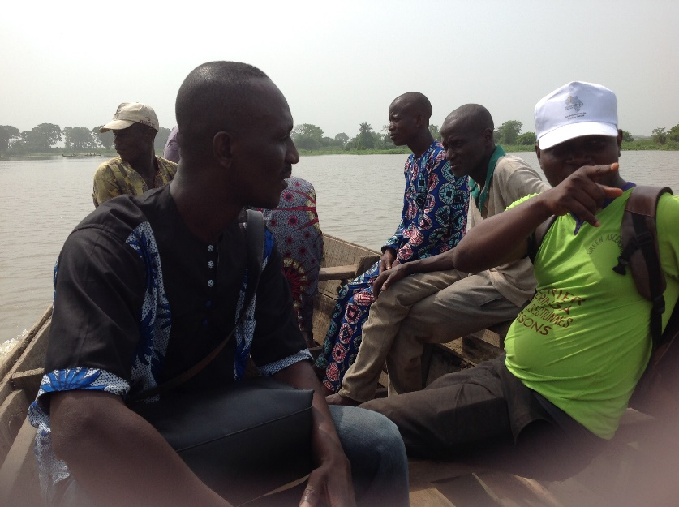I left Kenya for Benin to visit Michael, Joanna, Joelle and Janelle Tettey serving as mission partners with EPMB. They both work at the Good Samaritan Hospital as Hospital Administrator and a Midwife respectively. It was an opportunity visit them at Cotonou as they round up their mission service in Benin by 2019 before proceeding elsewhere after their furlough. I met with Rev Dr Hounsa who expressed sincere gratitude for the grants disbursed by MCB for a vaccination programme for under-fives against meningitis. In addition, the faulty equipment at Hosanna Radio has now been fixed enabling health promotions via media to surrounding rural areas to combat increased meningitis cases in Porto Novo area. Lastly, I accompanied Michael Tettey on village visits to meet rural dwellers working closely with extension workers to improve living standards.

Michael and Bunmi in a ferry to meet locals in Benin

Constance, NMA appointee liaising with indigenes

**Partnership visit to Eglise Methodiste du Togo**

I later travelled to Lome in Togo to meet Rev Grace Lawson, the current President of EM Togo. We discussed various partnership issues plus the MCB invitation to its conference following repeated visa application refusals into the UK. It will be a joy to have her in England considering her repeated visits to France and Brussels for other ecumenical meetings. She was very grateful for MC Britain’s continued support especially for its funding assistance with unexpected Pension demands plus ability to develop its evangelism strategy for Togo.

Thank you.

Dr Bunmi Olayisade

Africa Partnership Coordinator

November 2018