MC/13/10

Inter Faith Relationships in the Methodist Church
(please also refer to Corrections Sheet)

Basic Information
Contact Name and Details | The Revd Baroness Richardson of Calow – Chair of the Working Group  richardsonk@parliament.uk
Status of paper | Final
Action Required | Decision
Draft Resolution | As set out in the report

Summary of Content

Subject and Aims | The future of Inter Faith Relations in the Church – to ensure that Methodists are resourced at local and District level; to encourage theological reflection and inter faith experience in Connexional Learning centres; and to release and utilise expertise in the Methodist Church and with ecumenical partners.
Main Points | Inter faith and multi-cultural society is the context for the mission of the church.  Methodism sees good Inter Faith Relations as an important part of its engagement in society and in social action  There is need for education and encouragement at local and District levels  Theological education must include understanding of faith issues other than Christianity  Expert advice is sometimes required by the Connexional Team
Background Context and Relevant Documents (with function) | The Conference decisions over many years and past appointments of Inter Faith Officers.  The proposal to discontinue the Inter Faith post as well as the Secretary for External Relations.
Consultations | Wide consultation with interested parties including ecumenical and inter faith groups as well as individuals.

Summary of Impact

Faith and Order | Expertise of officers aid theological reflection
Financial | Increase in financial requirement leading to significant reduction in financial support in three years’ time.
Personnel | One new post to be appointed, 50% of an ecumenical post to be supported, post funded through Districts
Legal | Advice available for use of church buildings
Wider Connexional | Education and information through networks; sharing of insights and expertise from projects and inter faith centres; ministers and lay leaders educated in inter faith engagement and theology.
External (e.g. ecumenical) | Essential ecumenical involvement. Good relationships with Inter Faith and multi faith groups.
Risk | Risk of implementing nil. Risk of not implementing considerable.

MC/13/10

Inter Faith Relations in The Methodist Church
PART 1 – HISTORICAL AND CURRENT:
Conference Support for Inter Faith Relations
1.1.1 As early as 1972 the Faith and Order Committee report to the Conference gave encouragement to local churches in taking the initiative to establish ‘dialogue’ with people of faiths other than Christian. Christians were encouraged to take opportunities to observe worship with a view to deeper understanding while maintaining the distinctiveness of the Christian faith.

1.1.2 In 1982 the Conference instructed the setting up of the Inter Divisional Connexional Committee for Relations with People of Other Faiths, and in 1983 adopted a report by the Faith and Order Committee that commended the four principles of dialogue agreed by the British Council of Churches to be studied by Methodist churches.

1.1.3 A further report in 1985 on Multi Faith Worship was also adopted, the Conference encouraging Methodist people to ‘engage in multi faith dialogue with their neighbours as the first steps towards mutual understanding, tolerance and love’.

1.1.4 In 1994 in response to the Decade of Evangelism the section on building good relations with people of different faiths states ‘We have a great deal to learn from one another which can enrich us without undermining our own identities. Together, listening and responding with openness and respect, we can move forward to work in ways that acknowledge genuine differences but build on shared hopes and values'.

1.1.5 In 1997 the Conference discussed the question of the use of Methodist premises by people of other faiths and affirmed again the principles of dialogue and the value of friendship building and appropriate joint action; saying ‘encounter can be a source of harmony and positive aid towards the elimination of prejudice and tension’.

1.1.6 In 1999 the statement ‘Called to Love and Praise’ was adopted by the Conference. Mission, it said, ‘involves both evangelism and social action, and, in our day especially, engaging with people of differing cultures and religious faiths’.

1.1.7 In 2001 in the Connexional Team Development Plan, point 12 states ‘Encourages Churches to work at Inter faith and denominational relationships.

1.1.8 Also at the 2001 Conference Memorial 63 requested guidance on the theology and practice of relationships with people and communities of other faiths. The response to this came in 2004 with a report - Inter faith Relations: Exploring Principles and Practice Guidelines for the Methodist People. The Conference received the report and commended as a resource Faith Meeting Faith, a substantial report compiled by a working group drawn from the Inter Faith Relations Committee and the Faith and Order Committee

Connexional Appointments

1.2.1 The Methodist Church has appointed Inter Faith officers at Connexional level since 1986 and there have been people at District and Circuit level whose work has been recognised as significant. Ivy Gutteridge in Wolverhampton was instrumental in forming very good relationships locally. Kenneth Cracknell and Martin Forward held Connexional appointments. Elizabeth Harris was appointed in 1996 and was followed in 2007 by Joy Barrow.

1.2.2 In 2008 Team Focus proposed that there should be a 0.6 fte Inter Faith Relations Officer on a permanent contract and a 0.4 fte Inter Faith Relations Project Officer on a four year contract to 'explore how best to embed in the life of the whole Connexion, understanding and good practice in relation to inter faith issues'.

Recent Developments

1.3.1 The Inter Faith Relations Project Management Group adopted as its Mission Statement: 'Methodist people, confident in their faith, building gracious and fruitful relations with people of different religions.'

It identified two main goals:

- To articulate and implement a vision for the Methodist Church to engage with Inter Faith Relations issues, living up to the Methodist Church's commitment to have a people-centred, dialogical culture in which all have confidence to speak of God and faith in ways that make sense to all involved.

- To train and equip people within the connexion and the Connexional Team to help and support Methodists to be able to engage with religious diversity in Britain today.

It reported to the Strategic Leaders in November 2011 proposing that a full time Inter Faith Relations Officer should be appointed for the task.

1.3.2 The minutes of the Strategic Leaders Meeting of 4 November 2011 record the decision of that meeting that after the project and its funding ended in 2012 'an identified member of the Connexional Team needed to be the contact point for Inter Faith Relations to complement the brief of the Secretary for External Relations and network with related connexionally funded work...The project report's assertion that the Team post must be full time was not accepted. The future post would therefore either be a part-time appointment or part of a full-time post (or posts) covering other work too.'

1.3.3 In 2012 the Conference was informed of the recommendation to discontinue both the post of Inter Faith Officer and that of Secretary for External Relationships. In response to Memorials 24 and 25, the suggested reply was that an authorised volunteer 'might add prominence ' but that a member of the Strategic Leadership would be the point of contact for external parties to consult and that the Inter Faith Adviser within CTE would be available to Methodism. An alternative reply was adopted:

‘The Conference reaffirms its commitment to seeking positive inter faith relations and welcomes the dedicated, patient and prophetic work done towards this end by a succession of Inter Faith officers and others in many places around the Connexion.

The Conference understands that financial and organisational considerations will mean that a new means of providing a framework for inter faith work at a national and a local level will be required.

The Conference recognises that the proposals outlined in the Connexional Central Services Budget 2012/2013 Section VI(v) 42 do not provide an acceptable means of supporting inter faith work. Accordingly the Conference mandates that an expert group be established to consider the best means, within current constraints, of providing a framework for inter faith work at national and local levels.

The group will report to the Methodist Council by January 2013 providing a detailed and costed proposed solution. It will make recommendation on the reallocation of the inter faith responsibilities and duties of the Inter Faith Officer and the Secretary for External Relationships and on properly defining the volunteer and external structure required to support this.

The Conference recommends to the Methodist Council that the current provision for an Inter Faith Officer continues (on the existing 60% basis), until the Council confirms the way forward in response to the group's report. This will allow for input from the office holder and ensure continuation and handover of existing relationships.’

The Rationale for Inter Faith Work

1.4.1 British society is changing. People and communities with allegiance to faiths other than Christianity, with an increase in numbers and in confidence, are demanding their own seat at the tables where decisions are made and their own place in the field of social action. There is less need today for the ‘broker’ role that the Christian churches once played and the understanding of church as ‘host’ is no longer so appropriate. Young people grow up with friendships among those of other faiths and marriages of mixed faith are more common. This is at the same time that we see a rejection of institutional religion among Christians.

1.4.2 As we live within a world church, the tensions that are felt in Inter Faith Relations in places where Christianity is a minority faith affects relationships in Britain. International events and conflicts impact on Inter Faith Relationships at home.

1.4.3 Religious literacy is not keeping pace with the changes. There is a need to understand the differences that both culture and faith bring in order to combat sectarianism and the growth of fundamentalist attitudes.

1.4.4 Our mission takes place within the context of a multi-faith society. This may be particularly true in some areas of the country where there is a predominance of other faiths but also needs to be considered where numbers are smaller but where respect for and value of the faiths of others is important. The language of making disciples may not always be appropriate in this context, though the demand to be disciples of, and witnesses to, Christ is. Whereas at one time it was possible to see Inter Faith work as on optional extra, Inter Faith Relations are now at the heart of Christian life and witness.

1.4.5 Within the preaching and teaching ministry of the Methodist Church there is the opportunity to be true to Methodist theology and inclusive of theological understanding of the faith of others, but there is also the need to be aware of making statements that have the potential to be harmful. For example, particular care has to be exercised when New Testament exegesis can lead to unwarranted offence about Judaism.

1.4.6 There are increasing opportunities for engagement in joint social action. Examples include involvement with the Jubilee debt campaign and the work that Citizens is doing in London. Government initiatives to support local projects, while not willing to fund individual faith groups, are seeking to involve inter faith and multi-faith partnerships.

1.4.7 Opportunities for engagement also exist locally where policies are decided that affect residents. The willingness of Methodists to engage with understanding of the needs of other faiths in, for example, school provision, cultural food requirements, funeral arrangements, and religious festivals can bear witness to the hospitality and generosity of our understanding of faith.

PART 2 – THE TASK:

A series of objectives for inter faith work in the Methodist Church
These objectives were distilled from the wide-ranging submissions made to the Working Party. Appendix A sets out the process used.

Within the Methodist Church

2.1 To equip lay people, presbyters, deacons, lay workers and ministers in training (a) to explore what it means to be a Christian in a multi-faith society and (b) for engagement and encounter. This applies not only to those in areas of significant faith diversity, but also (possibly more so) for those in much less diverse contexts.

This can be achieved by:

2.1.a Continuing to produce information and resources on Inter Faith Relations through publications and via the Methodist Church website; and identifying and signposting resources produced by partner bodies.

2.1.b Identifying and drawing on the expertise of people with (a) significant knowledge of particular faiths, (b) substantial experience of working with people of particular faiths, (c) experience of Inter Faith Relations in specific contexts such as chaplaincies and (d) knowledge of particular issues in bi-lateral or multi-lateral Inter Faith Relations.

2.2 Fully embedding training in Inter Faith Relations in the culture and training of the Connexional Learning Network; to recognize and include opportunities for experience and encounter.

2.3 Maintaining the Methodist Church’s contribution to scholarly theological reflection on Inter Faith Relations, including contributions from the practitioner base, both for the benefit of the Methodist people and as part of a wider conversation with ecumenical and multi-faith partners.

2.4 Resourcing the Connexional Team on issues of, and issues that may affect, Inter Faith Relations, in particular office-holders for whom Inter Faith Relations are likely to be significant; and to have a point or points of liaison and resource on inter faith matters for the Methodist Council, the Faith and Order Committee, the Law and Polity Committee, the Ministries Committee and Joint Public Issues Team.

2.5 Providing resources for the Senior Leadership Group and the Conference for the informing and implementing of decisions; to alert the Senior Leadership Group to issues that need a response on behalf of the Methodist Church.

2.6 Resourcing, and, as appropriate, bringing together, local, district and regional advisers on inter faith matters; to ensure that every district has a nominated and sufficiently trained person in this role; to maintain an up-to-date database of such advisers; to ensure that individual Methodists committed to Inter Faith Relations locally are not isolated, but have access to a support network; to facilitate sharing of experiences and good practice, and mutual learning; strongly to encourage and resource local Methodists to be involved in their local inter faith or multi-faith bodies, and to engage, through them, with local policy- and decision-making.

Key to this will be:

2.6a Supporting, linking with, and drawing on the expertise in Inter Faith Relations in key Methodist centres and those of ecumenical partners, such as the Queen’s Foundation, the Touchstone Centre, Bradford Churches for Dialogue and Diversity, the St Philip’s Centre, St Ethelburga’s Centre and the Faithful Neighbourhoods Centre.

2.7 Awareness of, and ability to interpret in the context of British Methodism, experiences of world church partners and migrant churches in the area of Inter Faith Relations, that impact on the Methodist Church in Britain; to be aware of developments in the World Council of Churches and the World Methodist Council with regard to Inter Faith Relations.

2.8 Ensuring that the Methodist Church is up to date with current developments in Inter Faith Relations and able to interpret their significance.

External to the Methodist Church

2.9 To maintain consistent Methodist contact with key partners in other Christian denominations, e.g. the Church of England’s Secretary for Inter-Religious Affairs, the Inter-Religious Adviser for the Catholic Bishops’ Conference, the Inter-Faith Officer for Churches Together in England, and the Director of Programmes at Churches Together in Britain and Ireland; to maintain the close working relationship between the Methodist and United Reformed Churches on inter faith matters, exemplified in the joint Inter Faith Relations Reference Group.

2.10 To explore opportunities for further joint working with other denominations on inter faith matters, e.g. in provision of resources and courses, for mutual benefit.

2.11 To maintain consistent Methodist contact with, and where possible and appropriate, representation on, national and international bilateral and multilateral inter faith bodies, e.g. the Inter Faith Network for the UK, Faith Based Regeneration Network, the Christian Muslim Forum, the Hindu Christian Forum, the Council of Christians and Jews and International Council of Christians and Jews; to provide informed Methodist representation at major consultations with an inter faith dimension.

2.12 To maintain consistent Methodist contact with single-faith partner bodies, e.g. the Muslim Council of Britain and the Board of Deputies of British Jews, while also being aware of the diversity of opinion and representation within some faiths; to be in a position to respond with tact, understanding and respect where issues may arise.

2.13 To maintain a link with key policy advisers in central Government whose brief includes aspects of faith and Inter Faith Relations; to ensure that where possible the Methodist Church is represented at Government-initiated consultations with a faith and inter faith dimension; to inform, and be in dialogue with, Methodists engaging in mission and evangelism, campaigns, social action or government initiatives.

PART 3 – PRIORITIES AND OPTIONS:

3.1 Having considered the full range of needs described above, and wishing fully to affirm each of them, we feel that at the present time and within current budget limitations the Methodist Church should consider amongst its main priorities:

- the resourcing of Methodists at local and district level better to enable local inter faith dialogue
- using its resources to value, recognise and make better use of the inter faith expertise that exists within Methodist centres and those of ecumenical partners;
- the release, and utilisation ecumenically, of a wide range of expertise in Inter Faith Relations currently held within the Methodist Church.

3.2 With these priorities in mind, we considered a number of options that had been suggested as a way forward for the Methodist Church. We subjected each to a SWOT (Strengths; Weaknesses; Opportunities; and Threats) analysis and discussed each in relation to the identified priorities.

Option 1: A full time Connexional Team IFR Officer
This would build on the work established by previous officers particularly in our relations to other faith communities at national level. It would send out a strong signal both to the connexion and other faith communities that Methodism is committed to IFR work and it would embed the work in the Connexional Team. Against these strengths, it would not address the financial constraints desired, requiring funding for an open full time appointment. Moreover, the attention to Inter Faith Relations at national level has inevitably taken priority over supporting local IFR, especially at times of inter faith tensions or sensitivity, and would always be vulnerable to the same temptations. The aim to develop a stronger network among Methodist centres and those of ecumenical partners requires concentrated work that would equally be vulnerable when time is limited. If we are to strengthen work at local level and develop a stronger network, this option on its own would not be sufficient.

Option 2: A part time Connexional Team IFR Officer
Without radical rethinking about the job description, a part time post would not be realistic. The expectations around a full time officer would simply be transferred to the part time officer and the problems identified in Option 1 would be unresolved with even less resource.

Option 3: Devolve all responsibility for inter faith relations work to Districts, Circuits and local churches.
This would relieve some financial pressures and put the emphasis on more local responsibility and ‘bottom up’ IFR work. Its symbolic meaning would be hard to see in a positive light, however, by other faith communities, and might suggest to its own members that IFR was less important to the Methodist Church. Equally important, many districts and circuits would not be able to progress work on IFR without some Connexional Team support at present.

Option 4: Contribute to a Free Churches IFR Officer or team
This is an attractive option, building on the success of the Joint Public Issues Team (JPIT), and the idea has received some initial positive signals from Free Church partners. It offers an opportunity to draw on a wider range of expertise, for the Free Churches to contribute a distinctive Christian voice to issues of IFR and some scope for sharing the cost with other partners. On the other side, it may take time to establish and might mean the loss of current work. Moreover, we are conscious the JPIT has been successful in part because it is a team rather than a single officer. If finances were only to allow for one officer between the Free Churches, it might make the person less visible to Methodists and overload expectations as outlined in Option 1 but on a wider scale.

Option 5: Develop a stronger network of specialist regional centres/faith advisors
This may meet two of the priorities well. Much local IFR initiative is creative and of a high standard in terms of good practice. Some of our centres (e.g. Touchstone) are pioneering and internationally recognised. Academically and ecumenically there is considerable strength in the UK for IFR work. Yet it is the case that the links between these centres and to local work is weak and underdeveloped. With a (time limited) appointment it might be possible to strengthen the network so that we can better support local work and draw on particular expertise for the Methodist Church in its relations with other faith communities at national level. In the short term, however, this would not directly address the need for support to districts, circuits and local Methodists in their IFR endeavours and the removal of a Connexional officer could entail the loss of hard won ground and result in a lack of Connexional focus.

Option 6: Establish an IFR research unit in the Discipleship and Ministries Learning Network
Such an investment in research would be in line with the aims of the Fruitful Field report and as such ought to enable the new Network, especially its regional staff, to be central to the support and development of IFR work at regional level. In the changing scene of a multi-faith society, a research unit would provide a direct link to emerging ideas and concepts and could be built on existing work at the Queen’s Foundation. It would offer a research contribution to the ecumenical work on IFR able to draw on the work and insights of local practitioners. The Discipleship and Ministries Learning Network would seem to be a vital element in training for IFR, though there is very limited reference to IFR in the Fruitful Field Report. As the network comes into being it certainly should carry a brief for IFR support, development and training. However, as in Options 4 and 5, it will be important to maintain key areas of work in the next couple of years as other resources are being put into place. A research centre would not be able to address the need to support local work as a priority until the network is well established. Moreover, some may question establishing a research unit when much IFR research is already a feature of many academic institutions. Building stronger relationships with a variety of centres is more likely to enable the Methodist Church to find the range of expert help it needs to advise and represent it in a range of forums.

3.3 All options would, we believed, be able to achieve one or two of the three priorities better, rather than all three. What is more, we felt that the Methodist Church does not begin with a blank sheet. It has established work which needs to be built on and developed rather than abandoned. Thus what is needed is a process to move from the present position to a stronger one in which all the priorities can be met within reasonable financial constraints.

3.4 Our proposition is, therefore, a staged and co-ordinated set of proposals to achieve the proper and realistic contribution of the Methodist Church to the field of Inter Faith Relations.

A diagrammatic representation of some of our analysis can be found in Appendix B.

PART 4 - RECOMMENDATIONS:

To the Methodist Council

4.1 A full time post of Connexional Inter Faith Relations Officer be appointed for 3 years from September 2013 to work primarily with Circuits, Districts and the Discipleship and Ministries Learning Network:

- to help to set up training opportunities for ministerial students and others in leadership positions for theological reflection on inter faith issues and to enable inter faith experience;
- to create networks to promote good practice, to share insights and information and to embed inter faith involvement in Methodist churches, Circuits and Districts; and
- to encourage inter faith involvement in local social action.

4.2 Negotiations be entered into with the Free Churches Group and ecumenical partners with a view to establishing a part time (50%) post of Free Churches Inter Faith Relations Liaison Officer to create and support a team of inter faith experts, initially through conversations with the existing Methodist/URC Joint Inter Faith Relations Reference Group and to liaise with national inter faith groups, with single faith bodies and with national Government initiatives.
This post to have clear lines of communication with the Executive Leader in the Connexional Team responsible for Methodist Inter Faith Relations matters and to be available to advise other members of the Connexional Team.

4.3 A Regional Inter Faith Relations Officer (or Officers) be appointed to work alongside the Connexional Inter Faith Relations Officer for the three years of that post, gradually taking over the responsibilities. This appointment (or appointments) to be either an experienced person(s) seconded from an inter faith centre or project or a separate appointment financed by contributions from District funds.

- An initial responsibility of this officer would be to promote and coordinate the work of the various projects and centres of expertise, within the orbit of Methodism and other associated denominations, to maximize the advantage that they can bring to the work of the Connexional Team, Districts and Circuits and to the work of the Free Church inter faith expert group

This post to be managed and supported by an Inter Faith Relations Management Committee to be chaired by a District Chair.

4.4 That one of the Executive Leaders of the Connexional Team be clearly identified as having responsibility for Inter Faith Relations.

4.5 That consideration be given to including Inter Faith Week (observed annually by churches, other faiths, inter faith bodies and some local councils in November) on the list of Special Sundays in the Church’s calendar.

To the Connexional Grants Committee

4.6 That a grant be given in order that a significant residential conference may be held to inform all District inter faith advisers of their role in inter faith work, to build up a base of information about initiatives existing in the regions and to share experience.

4.7 That in the criteria used in assessing applications for grants '(b) cross cultural work' should be amended to '(b) cross cultural and inter faith work' and reference made to it under B.2 of the criteria.

To the Conference Office

4.8 That consideration be given to inviting faith representatives to the Opening of the Conference and occasionally (where appropriate) inviting one to speak.

A diagrammatic representation of the three stages of the proposed solution

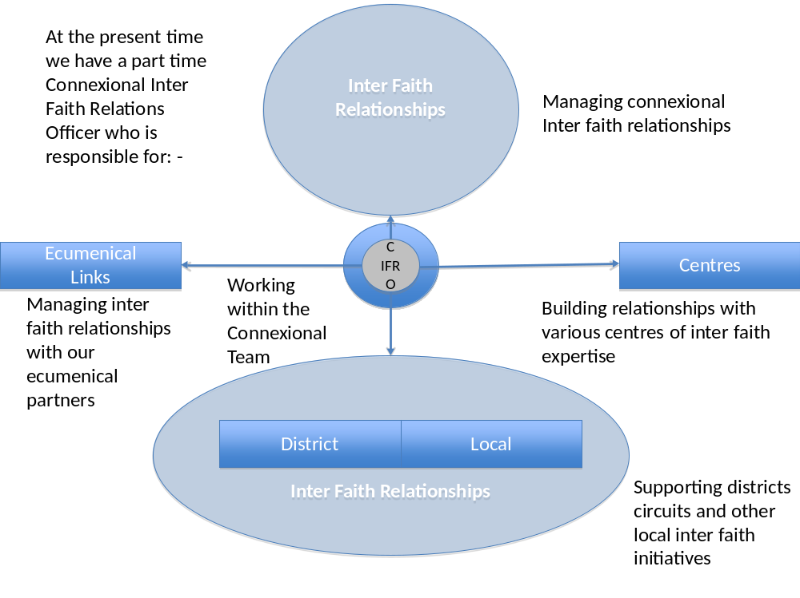

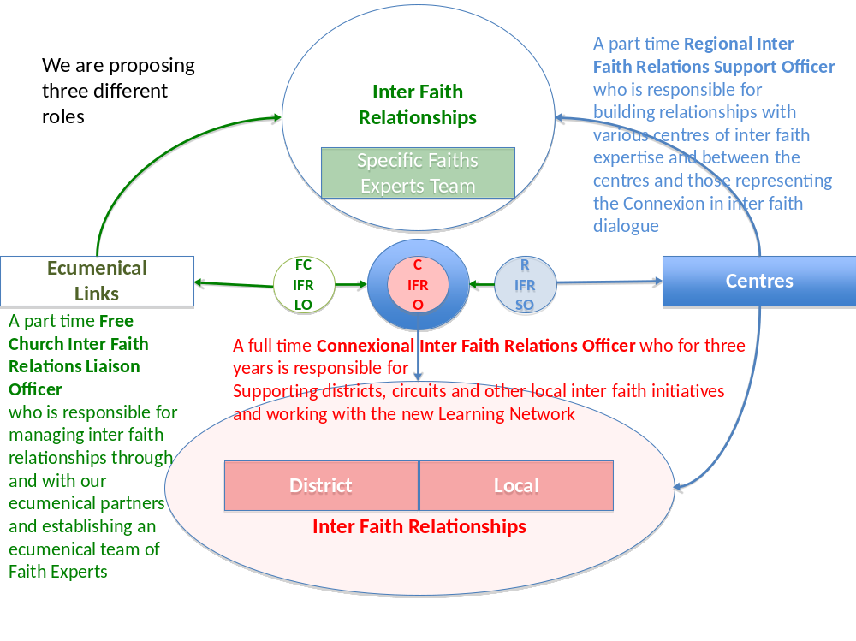

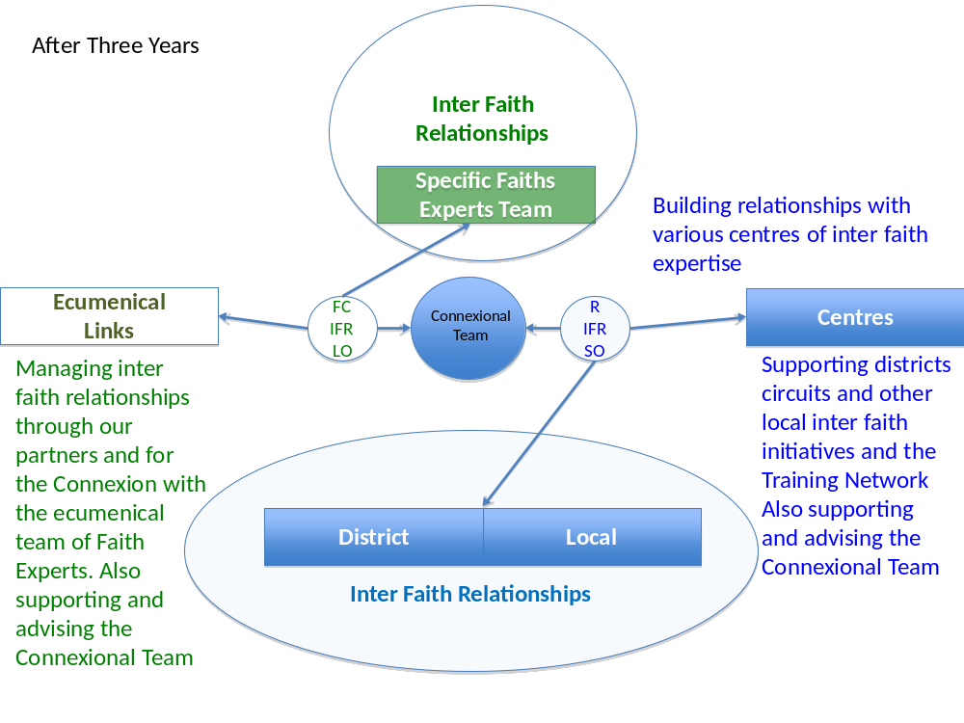

PART 5 - FINANCIAL IMPLICATIONS:

Preamble

5.1 The terms of reference for the Working Party included ‘to consider the best means, within current constraints, of providing a framework for inter faith work at national and local levels’. It is not clear to us what the ‘current constraints’ are, but it is clear that we must provide the greatest effect while being careful to spend wisely. We have attempted a solution that, while increasing the costs for the next three years, would enable significant work to continue with minimal cost to the Methodist Church Fund from 2016.

5.2 The Working Group understands that the budget for 2012-13 was agreed on the understanding that there should be no Inter Faith Officer and no Secretary for External Relations. When the Conference recommended to the Council that the Working Party be set up to consider how to support Inter Faith Relations, it also recommended that the existing officer should remain in post until the Council responded to the Working Party's report. £30,000 was then found to support this and it seems to have been the assumption that this would be sufficient to carry the work forward until May 31st. It has been interpreted to mean that there was money to pay the salary of the officer, but no budget to do the work.

5.3 If the recommendations of the Working Party are agreed by the Council, either in whole or in part, it is the judgment of the Working Party that the momentum gained by the consultations both within the Methodist Church and with ecumenical and inter faith bodies would be undermined if there were to be no Inter Faith Relations Officer in post for the rest of this current year. Any extension to that will incur additional costs over and above the £30,000 in this year's budget.

5.4 All of the figures stated below are best estimates based on existing practice and the information currently available. The Working Party is grateful for the help of Nick Moore in suggesting appropriate figures for this work.

YEAR 1 2013-2014

Connexional Inter Faith Relations Officer
Cost of advertising, interviewing and appointing £2,500
Full-time salary (assumes equivalent to existing post) £66,100
Office costs (assumes proportion of relevant overhead budgets) £1,500
Travel expenses for visits to centres, projects and Districts £2,500
Expenses of management group (but see below - shared costs) £3,000
Residential Conference (grant to be confirmed by Connexional Grants Committee)
Costs of information and publicity material (but see below - shared costs) £10,000

Free Churches Inter Faith Relations Liaison Officer
Although there is no guarantee that this will be agreed, there is a firm commitment to take this application for funding of this post to the Free Churches Group in February 2013. There may also be a possibility of inviting the URC to offer some finance.

If an agreement can be reached then it is reasonable to suppose that some measure of financial contribution should be offered towards this. It is not possible to put a definitive figure on this but 20% of a half time post would be in the region of £8,000.

If no agreement can be reached for significant funding for this post from sources other than the Methodist Church, then the role of representing Methodism in Inter Faith Relations, the gathering together of experts in the field and the task of advising the Connexional Team on Inter Faith Relations matters will become the responsibility of the Connexional Executive Officer or the Connexional Inter Faith Relations Officer.

But if the funding is agreed but not in place before the next Connexional year, the recommendation is that some contingency funding be in the Connexional budget for the year 2013-14. We suggest 50% of the half time post as contingency funding, an extra £20,000.

Regional Inter Faith Relations Support Officer
Finance to be covered by consultation with the Districts, centres and projects, though it is possible that some setting up expenses may be required.
Costs associated with establishing and maintaining a Management Group for this and the Inter Faith Officer could be shared.
Costs of information and publicity material - shared costs

YEAR 2 2014-2015
Connexional Inter Faith Relations Officer
Salary and expenses, information and publicity costs
Free Churches Inter Faith Liaison Officer
Contribution to post

YEAR 3 2015-2016
Connexional Inter Faith Relations Officer
Salary and expenses, information and publicity costs
(Residential conference - hand over responsibilities to Regional IF Officer - costs shared by Districts?]
Ecumenical Inter Faith RelationsLiaison Officer
Contributions to post

YEAR 4
Ecumenical Inter Faith Relations Liaison Officer
Contributions to post

Summary of impact on Connexional Central Services Budget (at current costs)

2013-2014 2014-2015 2015-2016 2016-2917

Connexional IFO £85,600 £83,100 £83,100 nil
Free Churches IFRLO £28,000 £8,000 £8,000 £8,000
Total £113,600 £91,000 £91,000 £8,000

Summary of impact on District Budgets
The full cost of the Regional Inter Faith Relations Support officer or officers will be met by Districts. Assuming that the post was graded at the level of the Connexional post and eventually takes on a similar workload it is reasonable to assume that a similar cost of £83,100 would be divided between the Districts – an average of £2,680 per annum.

ACKNOWLEDGMENTS
The members of the Working Group were
Richard Hamilton-Foyn – previously Chair of the Inter Faith Relations Project Management Group and one of the proposers of the Memorial from the London District
Gareth Jones - Circuit minister and Methodist Chair of the Joint Methodist/URC Inter Faith Relations Reference Group, previously Inter-Faith Development Officer for the West Midlands Faiths Forum and Methodist Trustee for the St Phillip’s Centre.
Kathleen Richardson (Chair) – previously Moderator of the Churches Commission on Inter Faith Relations
Roger Walton – Chair of the West Yorkshire District with oversight for the Touchstone Centre, Bradford
Anne-Marie Hollowman was the researcher assistant for the first part of the process

We met together on only two occasions and the rest of the consultation was by E-mail.

As Chair of the Working Group I want to acknowledge the hard work, the good humour and the expertise with which the Working Party went about its task. All members were busy people with other responsibilities who brought complementary skills and commitment and made it a joy to work together. Anne-Marie was efficient and very helpful to the group in collecting and collating the responses from people, but unfortunately was not able to continue with us to the production of the report.
We have received a great deal of help and encouragement from many people whose faithful witness to Christ is being enriched and extended by involvement in Inter Faith Relations and we hope this report and its recommendations will help to enable further the mission and ministry of the Methodist Church.

***RESOLUTIONS:
10/1 The Methodist Council receives the report.
10/2 The Methodist Council directs the Strategy and Resources Committee to prepare a budget in line with the recommendations of the report.
10/3 The Methodist Council directs the Connexional Grants Committee to consider making the grant as set out in paragraphs 4.6.
10/4 The Methodist Council directs the Connexional Grants Committee to consider the recommendation contained in 4.7 of the report pursuant to its powers under SO 213B (2) and (6)(iii) .
10/5 The Methodist Council encourages the Secretary of the Conference, in consultation with the Conference Planning Executive, to consider inviting faith representatives to the Opening of the Conference and occasionally (where appropriate) inviting one to speak.

APPENDIX A METHOD OF CONSULTATION:
We contacted
All people who were named as district advisers for inter faith work (It was notable that not all District advisors knew that they were appointed and/or knew what their job entailed!)
All who were known to any of the members of the working party to have knowledge of or interest in the subject
Anyone who had been involved with the Memorials to Conference
Ecumenical and other faith representatives
An article appeared in the Methodist Recorder inviting anyone who wished to do so to make a submission to the Group.
We asked four questions:
- In what ways is it important for the Methodist Church to engage in the work of Inter Faith Relations?
- What would be the effect if there were no Connexional Inter Faith Relations Officer?
- In your involvement in Inter Faith Relations, what do you most value from partners?
- What resources or facilities would most strengthen Inter Faith Relations?

We received responses from:
Awais Dominic  Bill Anderson  Julian Bond (Christian Muslim Forum)  Peter Colwell (CTBI)  Katharina Smith-Muller  Bruce Thompson  David Chapman  Ray Gaston  Peter and June Curtis  Paul Johns  Jonathan Arkush (Board of Deputies for British Jews)  Patrick and Deborah Darnes  David Cowling  Stephen Leah  John Summerwill | Albert Jewell  Trevor Bates  Barbara Glasson  Neil Stubbens  Kim Stilwell  Deborah Maccoby (Jews for Justice for Palestinians)  Martin Dodds  Bea Foster  Marcus Braybrooke (President of World Congress of Faiths)  Martin Wellings  Elizabeth Harris  Colin Smith  David Musgrave  Ian Bunce | Kim Nally  Mark Kimber  Pam Cram  Peter Brain (URC)  Philip Lodge  Ray Fox  Ron Bell  Susan Rowe  Wendy Kilworth-Mason  Peter Jennings  Barbara Holden  Derek McLean  Derek Norton  Michael Giles  Peter Howson  Sue Male

Conversations were held with
District Chairs  David Tatem (URC)  Celia Blackden (CTE)  Frank Cantor(Free Churches group)  Steve Huckleby (JPIT)  Rachel Lampard (JPIT)  Gareth Hill (Mission and Advocacy)  Ian Harrison (Connexional Grants)  Neil Stubbens (Ecumenical)  Harriet Crabtree (Inter faith Network) | Phil Rosenberg (Board of Deputies)  David Gifford (CCJ)  Bishop Angelos(CTBI Inter Religious Council)  Warwick Hawkins (Govt. Community Diversity adviser)  Chris Eliott  Steve Pearce  Stuart Jordan  Bala Gnanaprasagam

APPENDIX B

 | Individual | Church | Circuit | District | Connexional Team | Leadership | Conference | Wider Christian Church |  |  | Individual | Church | Circuit | District | Connexional Team | Leadership | Conference | Wider Christian Church
Inform |  |  |  |  |  |  |  |  |  | Inform
Motivate |  |  |  |  |  |  |  | N/A |  | Motivate |  |  |  |  |  |  |  | N/A
Support |  |  |  |  |  |  |  |  |  | Support
Represent |  |  |  |  |  |  |  |  |  | Represent
Option 1 - Full Time Connexional IFR Officer |  |  |  |  |  |  |  |  |  | Option 2 - Part Time Connexional IFR Officer
 | Individual | Church | Circuit | District | Connexional Team | Leadership | Conference | Wider Christian Church |  |  | Individual | Church | Circuit | District | Connexional Team | Leadership | Conference | Wider Christian Church
Inform |  |  |  |  |  |  |  |  |  | Inform
Motivate |  |  |  |  |  |  |  | N/A |  | Motivate
Support |  |  |  |  |  |  |  |  |  | Support
Represent |  |  |  |  |  |  |  |  |  | Represent
Option 3 - Devolve Responsibility to Districts & Regions |  |  |  |  |  |  |  |  |  | Option 4 - Contribute to Free Church IFRO
 | Individual | Church | Circuit | District | Connexional Team | Leadership | Conference | Wider Christian Church |  |  | Individual | Church | Circuit | District | Connexional Team | Leadership | Conference | Wider Christian Church
Inform |  |  |  |  |  |  |  |  |  | Inform
Motivate |  |  |  |  |  |  |  |  |  | Motivate |  |  |  |  |  |  |  | N/A
Support |  |  |  |  |  |  |  |  |  | Support
Represent |  |  |  |  |  |  |  |  |  | Represent
Option 5 - Develop Stronger Centre Network |  |  |  |  |  |  |  |  |  | Option 6 - Establish IFR within Learning Network
 | Individual | Church | Circuit | District | Connexional Team | Leadership | Conference | Wider Christian Church
Inform
Motivate
Support
Represent |  |  |  |  |  |  |  |  |  |  |  | Weak |  |  | Good
Proposed Solution
This simplified heat map model attempts to illustrate the impacts of potential solutions on different areas of the Church.
While the evaluation is subjective the relative areas of strength and weakness for each option are clear.

